Supporting Information
Solvated Br⁻ Disrupting Interfacial Proton Transfer in Alkaline Water Oxidation

Huimin Han^{#1,3}, Jin-Yuan Hu^{#*4,5}, Chongtai Wang^{*2}, Freddy E. Oropeza⁶, Giulio Gorni⁷, Wen-Xuan Liang^{3,4}, Hai-Wen Chen³, Yingjie Hua^{*1}, Jun-Tao Li³, Jun Cheng^{4,5}, Shi-Gang Sun^{3,4}, Yao Zhou^{*3}

¹ Key Laboratory of Electrochemical Energy Storage and Energy Conversion of Hainan Province, College of Chemistry and Chemical Engineering, Hainan Normal University, Haikou 571158, PR China
² College of Chemical and Materials Engineering, Hainan Vocational University of Science and Technology, Haikou 571126, PR China
³ College of Energy, Xiamen University, Xiamen 361005, Fujian, China;
⁴ State Key Laboratory of Physical Chemistry of Solid Surfaces, iChEM, College of Chemistry and Chemical Engineering, Xiamen University, Xiamen, 361005, China
⁵ Laboratory of AI for Electrochemistry (AI4EC), Tan Kah Kee Innovation Laboratory (IKKEM), Xiamen, 361005, China
⁶ Photoactivated Processes Unit, IMDEA Energy, Avda. Ramón de la Sagra 3, Móstoles, 28935 Madrid, Spain
⁷ Ceramics and Glass Institute, CSIC c/ Kelsen 5, Madrid 28049, Spain
#. These authors contribute equally.

The PDF file includes:
Supplementary Notes 1-5
Supplementary Figures 1-33
Supplementary Tables 1-7

Supplementary Note 1
Quantification of Ni²⁺ dissolution during EQCM cycling:
During the nickel redox reaction (NiOR), anodic dissolution of Ni²⁺ from the electrode into the electrolyte may contribute to the apparent mass loss recorded by EQCM. To evaluate this contribution, the concentration of dissolved Ni²⁺ was quantified by ICP-MS after exhaustive potential cycling. A nickel-coated quartz crystal was sequentially tested in three electrolytes: 1 M KOH, 1 M KOH + 0.5 M NaCl, and 1 M KOH + 0.5 M NaBr. For each electrolyte, the protocol comprised 500 activation cycles followed by CV measurements at seven scan rates (5 cycles per rate), yielding a total of 535 cycles. The electrolyte volume in the cell was fixed at 20 mL. Upon completion of all cycles, the electrolyte was collected and analyzed by ICP-MS to determine the accumulated Ni²⁺ concentration.
Duplicate ICP-MS analyses of the electrolytes after cycling revealed average Ni²⁺ concentrations of 0.03245 mg·L⁻¹ in KOH, 0.03425 mg·L⁻¹ in KOH + NaCl, and 0.0044 mg·L⁻¹ in KOH + NaBr (Supplementary Table 1). These values correspond to total dissolved Ni²⁺ amounts of 649 ng, 685 ng, and 88 ng, respectively, in the 20 mL electrolyte volume. Normalized to a single oxidation cycle (i.e., divided by 535 cycles), the average Ni²⁺ dissolution per cycle is 1.215 ng for KOH, 1.28 ng for KOH + NaCl, and 0.165 ng for KOH + NaBr (Supplementary Table 2).
These values are more than two orders of magnitude smaller than the maximum mass losses recorded by EQCM during NiOR (Figs. 2e-h). Therefore, Ni²⁺ dissolution and metal corrosion can be ruled out as the origin of the observed mass decrease. The EQCM mass loss instead primarily reflects deprotonation during the Ni(OH)₂ → NiOOH transition, wherein protons released from the electrode combine with OH⁻ in the electrolyte to form water that diffuses away from the interface.

Supplementary Note 2
Calculation of surface OH⁻ coverage:
The mass change (Δm) and charge (ΔQ) were simultaneously recorded by EQCM. The molar amount of surface OH⁻ species (n) was calculated from the mass change according to:
n = Δm / M_{OH-} (Eq. 1)
where 17 g mol⁻¹ is the molar mass of OH⁻.
The geometric surface area of the Ni working electrode was A = 0.1962 cm². The surface OH⁻ coverage (Γ) was thus calculated as:
Γ = n / A (Eq. 2)
expressed in units of nmol cm⁻².
To highlight differences across electrolytes, the relative changes in anion coverage were evaluated as:
Δn = n_{OH-} - n_{X-} (Eq. 3)
where X⁻ represents SO₄²⁻, Cl⁻, or Br⁻. For clarity in graphical representation, all differences were multiplied by -1 (i.e., reported as -Δn).

Supplementary Note 3
Validation of two-phase EXAFS modeling for Ni(OH)₂/NiOOH mixtures:
The EXAFS spectra of the NaBr-containing samples 1.0 and 1.2 V required a two-phases model NiOOH and Ni(OH)₂, as they clearly shows two distinct contributions in the second coordination shell (and two less-resolved contributions in the first shell). The spectrum of in KOH 1.0 V was used as the Ni(OH)₂ reference, and that in KOH+NaBr 2.0 V as the NiOOH references.
In the fit, the coordination number (N) of each shell was fixed at the theoretical value of 6, and only the phase fraction (x) was varied. This approach yielded a satisfactory fit. Fixing x to the value derived from XANES linear combination fitting (LCF) produced an inferior fit, which is likely attributable to the constraint N = 6. Using the N values obtained from independent EXAFS fits of the reference spectra did not improve the fit either, because these "references" are experimental spectra of real samples rather than ideal standard compounds. Moreover, the estimated N values of these references carry substantial uncertainties: typically 10–15% for the first shell and up to 30% for the second shell. For instance, the Ni–Ni shell of the 1.0 V reference gives N = 6(2), corresponding to an uncertainty of ~30%. The potential-dependent EXAFS fitting results for the Ni catalyst in KOH and KOH + NaBr are summarized in Supplementary Tables 3 and 4, respectively.
Given these considerations, the two-phase treatment is well justified. The phase fractions from EXAFS fitting (x ≈ 25–30% NiOOH for the NaBr samples at 1.0 and 1.2 V; Fig. 2o and Supplementary Fig. 13) agree with those from XANES LCF to within ~30%, which is reasonable for two independent estimations. In contrast, the corresponding KOH samples are well reproduced by a single-phase Ni(OH)₂ model.

Supplementary Note 4
Mulliken Charge Distribution
To characterize electron localization and distinguish the mixed-valence Ni centers in γ-NiOOH, we examine the Mulliken charge distribution. The stoichiometry of γ-NiOOH gives an average formal Ni oxidation state of +3.67. As shown in Supplementary Fig. 32, the Ni³⁺ sites exhibit Mulliken charges of approximately +1, clearly separated from those of Ni⁴⁺, consistent with preferential localization of the unpaired electron on Ni³⁺. The remaining constituent elements show Mulliken charges close to zero, indicating that the redox-active electronic density is primarily associated with the Ni³⁺ centers.

Adsorption energy
Adsorption energy ($E_{ads}$) calculations are performed to evaluate the relative thermodynamic stability of OH⁻, Cl⁻ and Br⁻ adsorption on the γ-NiOOH(010)-ml surface. The adsorption energy is calculated ass:
$$E_{ads}=E_{total}-E_{substrate}-E_{adsorbate}$$
Where $E_{total}$, $E_{substrate}$, $E_{adsorbate}$ denote the total energies of the optimized adsorption system, the γ-NiOOH(010)-ml surface, and the isolated anion. All energy terms are obtained using the same computational settings. All energy terms are calculated using identical DFT settings. The vacuum thickness in the γ-NiOOH(010)-ml surface model is set to 30 Å. Each adsorption model contains a single OH⁻, Cl⁻ or Br⁻ species adsorbed on one surface of the symmetric γ-NiOOH(010)-ml surface, leading to a charged system with a net charge of −1 e. A dipole correction is applied along the Z direction to correct for the artificial electric field introduced by periodic boundary conditions.

Water Density
The water density profiles along the surface-normal direction exhibit clear oscillations near the γ-NiOOH(010)–aqueous interface and converge to the bulk-water density away from the interface, as shown in Supplementary Fig. 33. In the bulk-water region away from the γ-NiOOH(010)-water interface, the calculated water densities in all electrolyte systems are 1.00 ± 0.05 g·cm⁻³, consistent with the density of liquid water. The oscillatory density profiles near the interface indicate interfacial water layering adjacent to the γ-NiOOH(010)-water interface. Compared with the OH⁻-containing electrolyte, the Cl⁻- and Br⁻-containing electrolytes exhibit distinct modifications in the interfacial water density profiles. In the Cl⁻-containing system, the sharper density peaks located closer to the γ-NiOOH(010)-water interface indicate a more confined interfacial water layering. In contrast, the Br⁻-containing system displays broader density peaks shifted away from the interface, suggesting a less localized but more extended interfacial water structure. These differences in peak position and peak shape suggest distinct halide-dependent modifications of the interfacial hydrogen-bond network and local solvation structure.

Supplementary Note 5
Halide adsorption on Ni under short- and long-term polarization
To compare the adsorption behavior and evolution of halide ions on the Ni surface under short- and long-term conditions, two distinct NF samples were examined. The short-term sample was recovered after oxidative reconstruction between 1.2 and 1.8 V, whereas the long-term sample was obtained after potentiostatic polarization at 1.37 V for 24 h.
The Ni 2p XPS spectrum of the long-term sample (Supplementary Fig. 25) closely resembles that of the short-term counterpart (Supplementary Fig. 11), indicating negligible change in the Ni valence state. The Br 3d spectrum of the long-term sample is shown in Supplementary Fig. 26. A direct comparison of the Cl 3d and Br 3d spectra after short-term oxidation (Supplementary Fig. 27) reveals a markedly stronger Br 3d signal relative to Cl 3d, indicating a higher adsorption affinity of Br⁻ on the Ni surface.
Raman spectroscopy further elucidates the time-dependent evolution of the Br-Ni interaction. After short-term oxidation, only Ni–O characteristic bands are observed (Supplementary Fig. 28); however, following 24 h of polarization, additional Ni–Br features emerge alongside the Ni–O peaks (Supplementary Fig. 29), indicating that prolonged polarization promotes Br-Ni bond formation.
XPS elemental mapping corroborates this trend. Compared with the short-term sample (Supplementary Fig. 30a), the long-term sample (Supplementary Fig. 30b) exhibits a more abundant and uniform distribution of Br on the surface, confirming that Br surface accumulation increases with polarization duration.

Supplementary Fig. 1 Activation of NF in KOH and KOH + NaCl electrolytes. CV curves showing the activation process of nickel foam (NF) in 1 M KOH and 1 M KOH + 0.5 M NaCl over five consecutive cycles: (a) first cycle; (b) second cycle; (c) third cycle; (d) fourth cycle; and (e) fifth cycle. Scan rate: 50 mV s⁻¹.

Supplementary Fig. 2 Activation of NF in KOH and KOH + NaBr electrolytes. CV curves showing the activation process of nickel foam (NF) in 1 M KOH and 1 M KOH + 0.5 M NaBr over five consecutive cycles: (a) first cycle; (b) second cycle; (c) third cycle; (d) fourth cycle; and (e) fifth cycle. Scan rate: 50 mV s⁻¹.

Supplementary Fig. 3 The LSV curve of NF after transfer from a KOH electrolyte to an alkaline electrolyte containing 0.5 M Br⁻, and its performance after being transferred back to fresh KOH solution.

Supplementary Fig. 4 (a-d) QV curves of the Ni electrode in 1 M KOH, 1 M KOH + Na₂SO₄, 1 M KOH + NaCl, and 1 M KOH + NaBr electrolytes (at different scan rates).

Supplementary Fig. 5 (a-f) MQ spectra at different scan speeds.

Supplementary Fig. 6 Operando Ni K-edge FT-EXAFS spectra at various potentials. (a-d) k²-weighted magnitude and fits for KOH and KOH+NaBr at 1.5, 2.0, 1.45 and 1.0 V vs. RHE, respectively.
Supplementary Fig. 7 Operando Ni K-edge FT-EXAFS real parts at various potentials. (a-d), k²-weighted real parts and fits for KOH and KOH+NaBr at 1.5, 2.0, 1.45 and 1.0 V vs. RHE, respectively.

Supplementary Fig. 8 Full XPS spectrum of the nickel electrode after polarization.

Supplementary Fig. 9 XPS of fresh Ni after polarization at 1.21.8 V: Ni 2p in KOH.

Supplementary Fig. 10 XPS of fresh Ni after polarization at 1.21.8 V: Ni 2p in KOH + NaCl.

Supplementary Fig. 11 XPS of fresh Ni after polarization at 1.21.8 V: Ni 2p in KOH + NaBr.

Supplementary Fig. 12 XRD patterns of nickel foam (NF) after polarization between 1.2 and 1.8 V (vs. RHE) in 1 M KOH , 1 M KOH + 0.5 M NaCl, and 1 M KOH + 0.5 M NaBr.

Supplementary Fig. 13 Operando Ni K-edge XAFS spectra at 1.2 V vs. RHE. (a) XANES. (b) Difference XANES. (c) k²-weighted FT-EXAFS magnitude and fits. (d) k²-weighted FT-EXAFS real part and fits.

Supplementary Fig. 14 Linear combination fitting of the Ni K-edge XANES spectrum for KOH+NaBr at 1.2 V vs. RHE. The experimental data (blue) are best reproduced by a combination of 27% NiOOH and 73% Ni(OH)₂, yielding the fitted spectrum.

Supplementary Fig. 15 The intensity ratios of the E_{g} and A_{1g} vibrational modes measured in different electrolytes.

Supplementary Fig. 16 In situ ATR-SEIRAS spectra of the Ni/KOH interface in the O-H stretching region at (a-f) 1.02-1.52 V vs. RHE.

Supplementary Fig. 17 In situ ATR-SEIRAS spectra of the Ni/KOH+NaCl interface in the O-H stretching region at (a-f) 1.02-1.52 V vs. RHE.

Supplementary Fig. 18 In situ ATR-SEIRAS spectra of the Ni/KOH+NaBr interface in the O-H stretching region at (a-f) 1.02-1.52 V vs. RHE.

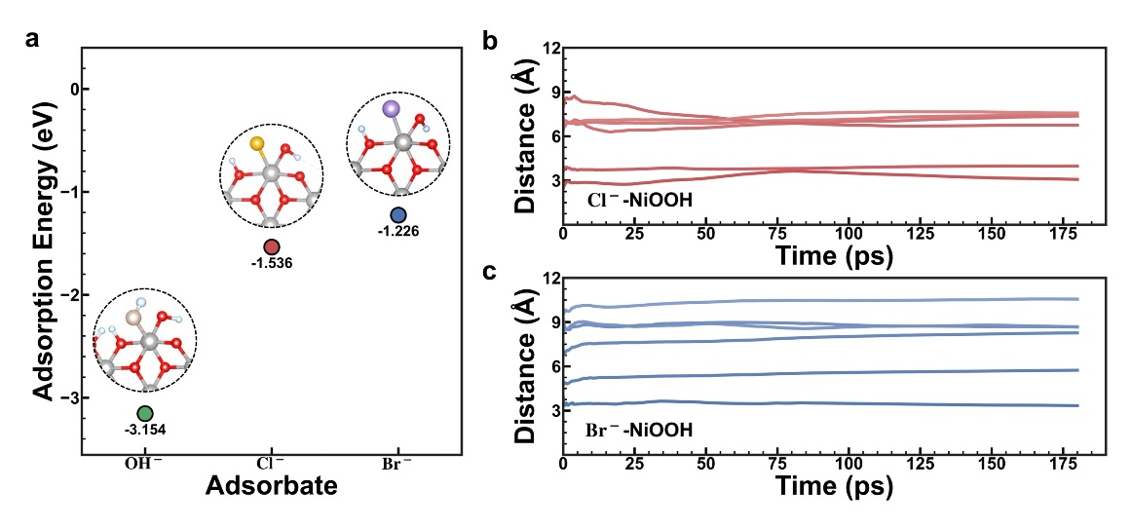
Supplementary Fig. 19 Adsorption energetics and dynamic stability of Cl⁻ and Br⁻ at the γ-NiOOH(010)-water interface. (a) Calculated adsorption energies and corresponding optimized adsorption configurations of OH⁻, Cl⁻, and Br⁻ on the γ-NiOOH(010)-ml surface. (b, c) MACE-driven molecular dynamics trajectories of the instantaneous distances between individual halide ions and the γ-NiOOH(010) surface in aqueous interfacial models containing six (b) Cl⁻ or six (c) Br⁻.

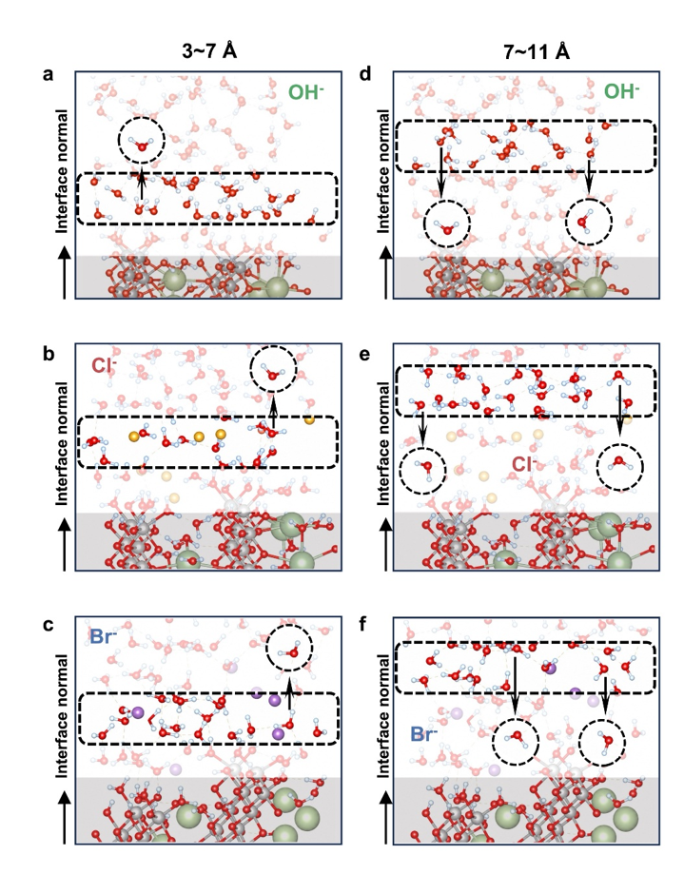
Supplementary Fig. 20 Distance-resolved representative configurations of interfacial water in OH⁻-, Cl⁻-, and Br⁻-containing systems. (a-c) Representative interfacial water configurations extracted from MACE-MD trajectories for the OH⁻, Cl⁻, and Br⁻ systems, respectively, corresponding to the distance regions 3-7 Å identified in Fig.5b. (d-f) Representative interfacial water configurations extracted from MACE-MD trajectories for the OH⁻, Cl⁻, and Br⁻ systems, respectively, corresponding to the distance regions 7-11 Å identified in Fig.5b.

Supplementary Fig. 21 Photographs of NF after 24 h of immersion in different electrolytes.

Supplementary Fig. 22 XRD patterns of nickel foam (NF) after soaked 24 h in 1 M KOH , 1 M KOH + 0.5 M NaCl, and 1 M KOH + 0.5 M NaBr.

Supplementary Fig. 23 After soaking the nickel electrode: (a) XPS full spectrum; (b) high-resolution O 1s spectrum; (c) pie chart showing the relative composition distribution of different oxygen species.

Supplementary Fig. 24 (a) XPS Br 3d fine spectrum after 24 h immersion in a KOH + NaBr solution; (b) XPS Cl 2p fine spectrum after 24 h immersion in a KOH + NaCl solution.

Supplementary Fig. 25 Fresh Ni after 24 h at a constant voltage of 1.37 V: Ni 2p XPS

Supplementary Fig. 26 Fresh Ni after 24 h at a constant voltage of 1.37 V: Br 3d and Ni 3s XPS

Supplementary Fig. 27 XPS spectra of a fresh nickel electrode after polarization from 1.2 to 1.8 V: (a) Br 3d in KOH+NaBr; (c) Cl 2p in KOH+NaCl

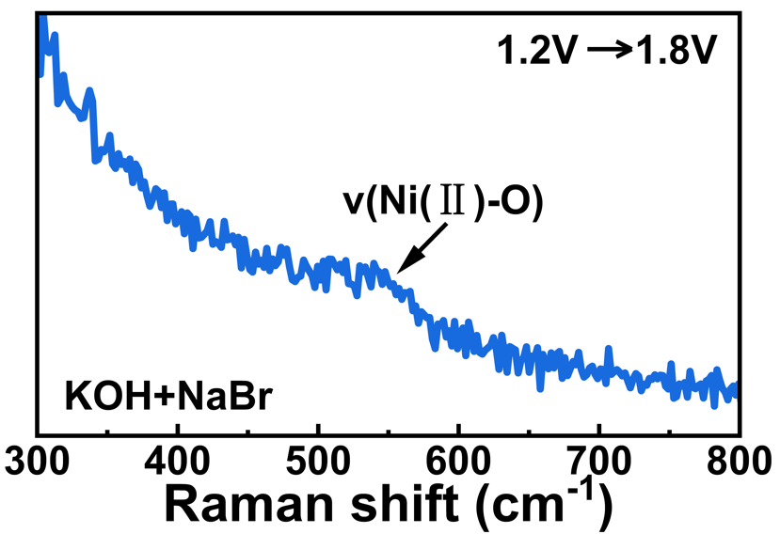
Supplementary Fig. 28 Raman spectrum of fresh Ni after polarization at 1.21.8 V in KOH+NaBr

Supplementary Fig. 29 Fresh Ni after 24 h at a constant voltage of 1.37 V: Raman spectrum.

Supplementary Fig. 30 XPS mapping of Br 3d: (a) Fresh Ni after polarization from 1.2 V to 1.8 V in KOH+NaBr; (b) Fresh Ni after 24 h at a constant potential of 1.37 V

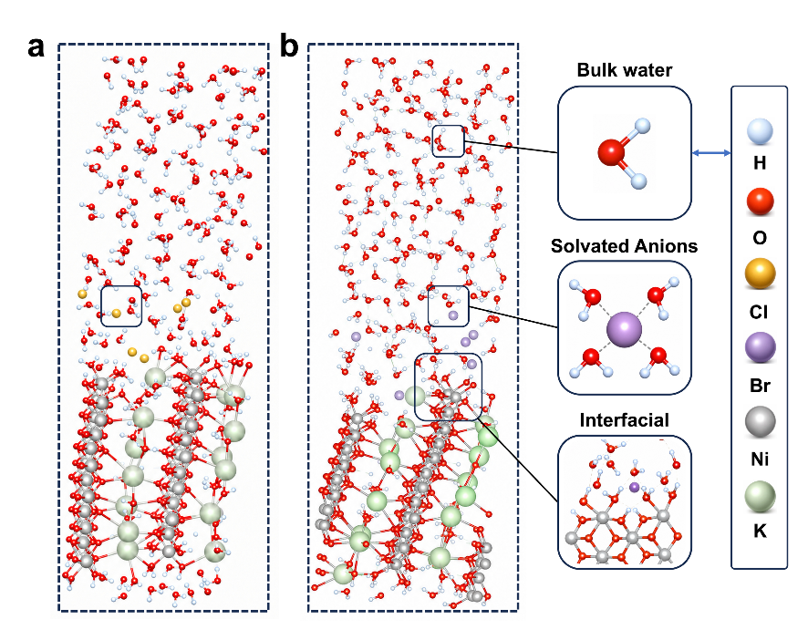
Supplementary Fig. 31 Computational models of halide-containing γ-NiOOH(010)-water interfaces. Atomic configurations of the (a) Cl⁻-containing and (b) Br⁻-containing γ-NiOOH(010)-water interfaces used for MACE-MD simulations. Magnified views of representative regions are shown for bulk water, solvated halide anions, and the γ-NiOOH(010) interfacial region. Atomic colors are assigned as follows: H, light blue; O, red; Cl, yellow; Br, purple; Ni, gray; and K, light green.

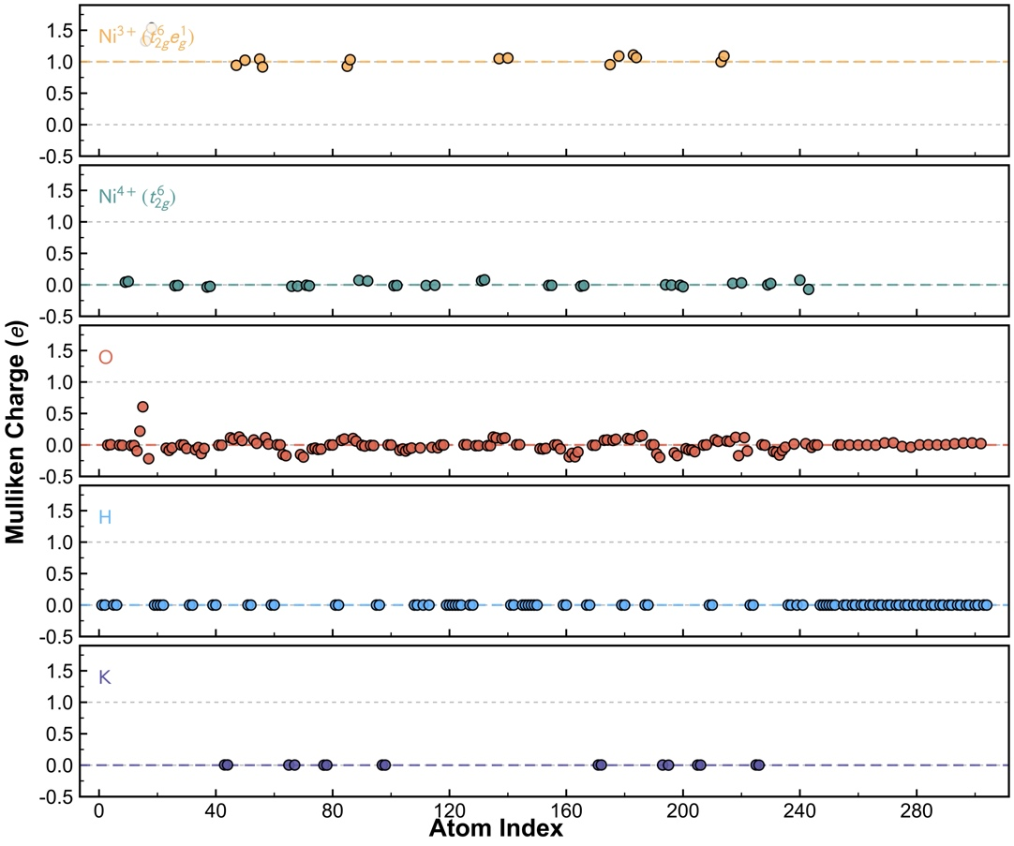
Supplementary Fig. 32 Mulliken charges of the γ-NiOOH(010)-ml surface calculated with the PBE+U functional. The Ni³⁺ and Ni⁴⁺ sites exhibit well-separated charge distributions, consistent with localization of the unpaired electron on Ni³⁺.

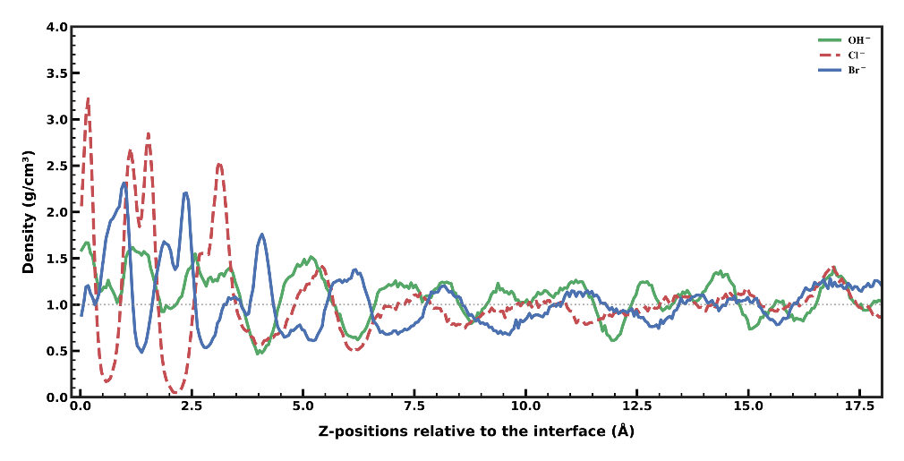
Supplementary Fig. 33 Interfacial water density profiles in different electrolytes. Water density profiles along the surface-normal z direction relative to the γ-NiOOH(010) interface in electrolytes containing OH⁻, Cl⁻, or Br⁻.

Supplementary Table 1 Total nickel content in the electrolyte after EQCM testing
Sample | KOH | KOH+NaCl | KOH+NaBr
Replicate #1 | 0.0395 | 0.0432 | 0.0043
Replicate #2 | 0.0254 | 0.0253 | 0.0045
Average (mg.L⁻¹) | 0.03245 | 0.03425 | 0.0044
The experiment was performed in duplicate. The electrolyte volume for each test was 20 mL. Nickel concentrations are given in mg L⁻¹.

Supplementary Table 2 Nickel content in the electrolyte during a single oxidation process
Sample | KOH | KOH+NaCl | KOH+NaBr
Replicate #1 | 1.48 | 1.61 | 0.16
Replicate #2 | 0.95 | 0.95 | 0.17
Average (ng) | 1.215 | 1.28 | 0.165
The experiment was performed in duplicate. The electrolyte volume for each test was 20 mL. The nickel content is expressed in nanograms (ng).

Supplementary Table 3 Potential-dependent EXAFS fitting parameters at the Ni K-edge in 1.0 M KOH
Sample | Shell | N | R (Å) | σ² (10⁻³Å²) | R-factor
KOH 1M  @1.2 V vs. RHE | Ni-O | 6.9(9) | 2.06(1) | 6(2) | 0.008
KOH 1M  @1.2 V vs. RHE | Ni-Ni | 6(2) | 3.09(1) | 6(2) | 0.008
KOH 1M  @1.5 V vs. RHE | Ni-O | 5.4(6) | 1.888(8) | 5(1) | 0.007
KOH 1M  @1.5 V vs. RHE | Ni-Ni | 3.9(8) | 2.815(7) | 3(1) | 0.007
KOH 1M  @2.0 V vs. RHE | Ni-O | 5.6(5) | 1.883(7) | 3(1) | 0.005
KOH 1M  @2.0 V vs. RHE | Ni-Ni | 5.2(3) | 2.820(7) | 4(1) | 0.005
KOH 1M  @1.45 V vs. RHE | Ni-O | 5.3(5) | 1.893(7) | 5(1) | 0.005
KOH 1M  @1.45 V vs. RHE | Ni-Ni | 4.8(8) | 2.826(7) | 4(1) | 0.005
KOH 1M  @1.0 V vs. RHE | Ni-O | 6.7(1.0) | 2.06(1) | 6(2) | 0.008
KOH 1M  @1.0 V vs. RHE | Ni-Ni | 6(2) | 3.09(1) | 7(3) | 0.008

Supplementary Table 4 Potential-dependent EXAFS fitting parameters at the Ni K-edge in 1.0 M KOH+NaBr
Sample | Shell | N | R (Å) | σ² (10⁻³Å²) | R-factor
KOH 1M  @1.2 V vs. RHE | Ni-O  x=0.38(2) | 6 | 1.93(2) | 4(2) | 0.010
KOH 1M  @1.2 V vs. RHE | Ni-Ni  x | 6 | 2.87(1) | 4(1) | 0.010
KOH 1M  @1.2 V vs. RHE | Ni-O  1-x | 6 | 2.06(1) | 4(2) | 0.010
KOH 1M  @1.2 V vs. RHE | Ni-Ni  1-x | 6 | 3.10(1) | 4(1) | 0.010
KOH 1M  @1.5 V vs. RHE | Ni-O | 5.3(8) | 1.890(9) | 5(2) | 0.008
KOH 1M  @1.5 V vs. RHE | Ni-Ni | 4.0(9) | 2.819(9) | 3(2) | 0.008
KOH 1M  @2.0 V vs. RHE | Ni-O | 5.2(3) | 1.871(4) | 2.6(8) | 0.002
KOH 1M  @2.0 V vs. RHE | Ni-Ni | 5.5(6) | 2.819(4) | 3.4(8) | 0.002
KOH 1M  @1.45 V vs. RHE | Ni-O | 5.1(8) | 1.891(7) | 3(1) | 0.005
KOH 1M  @1.45 V vs. RHE | Ni-Ni | 6(1) | 2.836(7) | 5(1) | 0.005
KOH 1M  @1.0 V vs. RHE | Ni-O  x=0.34(3) | 6 | 1.93(2) | 6(3) | 0.010
KOH 1M  @1.0 V vs. RHE | Ni-Ni  x | 6 | 2.87(1) | 4(1) | 0.010
KOH 1M  @1.0 V vs. RHE | Ni-O  1-x | 6 | 2.06(1) | 6(3) | 0.010
KOH 1M  @1.0 V vs. RHE | Ni-Ni  1-x | 6 | 3.10(1) | 4(1) | 0.010

Supplementary Table 5 Cumulative average distances between halide ions and the γ-NiOOH(010)-water interface after 180 ps of MACE MD simulation.
Interface distance (Å) | Index | 01 | 02 | 03 | 04 | 05 | 06
Interface distance (Å) | Cl⁻ | 3.08 | 4.00 | 6.75 | 7.37 | 7.45 | 7.58
Interface distance (Å) | Br⁻ | 3.34 | 5.74 | 8.27 | 8.66 | 8.69 | 10.56

Supplementary Table 6 Atomic compositions of all surface and interface models. Ntotal, Nγ, Nspecies, Nproton, and Nwater denote the total number of atoms, the number of γ-NiOOH units, the number of anions in the aqueous electrolyte (OH⁻, Cl⁻, or Br⁻), the number of interfacially adsorbed protons introduced to maintain charge neutrality, and the number of explicit solvent water molecules, respectively.
Model | N_{total} | N_{γ} | N_{spcies} | N_{proton} | N_{water}
γ-NiOOH(010)-ml | 304 | 48 | - | - | 16
γ- NiOOH(010)-water | 748 | 48 | - | - | 164
γ- NiOOH(010)-water-OH | 748 | 48 | 6 | 6 | 164
γ- NiOOH(010)-water-Cl | 742 | 48 | 6 | 6 | 158
γ- NiOOH(010)-water-Br | 742 | 48 | 6 | 6 | 158

Supplementary Table 7 Basis sets and pseudopotentials
Elements | Basis set | Pseudopotential | Explicit valence configuration
H | DZVP-MOLOPT-SR-GTH | GTH-PBE-q1 | 1s¹
O | DZVP-MOLOPT-SR-GTH | GTH-PBE-q6 | 2s²2p⁴
Ni | DZVP-MOLOPT-SR-GTH | GTH-PBE-q18 | 3s²3p⁶3d⁸4s²
K | DZVP-MOLOPT-SR-GTH | GTH-PBE-q9 | 3s²3p⁶4s¹
Cl | DZVP-MOLOPT-SR-GTH | GTH-PBE-q7 | 3s²3p⁵
Br | DZVP-MOLOPT-SR-GTH | GTH-PBE-q7 | 4s²4p⁵

