Supplementary Information

Can primary education reforms help mitigate the impacts of climate-related disasters on children’s undernutrition in sub-Saharan Africa?

Anna Dimitrova¹, Nathalie J. Lambrecht^{2,3}, Tarik Benmahrnia^{4,5}

¹ Barcelona Institute for Global Health, Spain
² Charité-Universitätsmedizin Berlin, Corporate Member of Freie Universität Berlin and Humboldt‐Universität zu Berlin, Institute of Public Health, Germany
³ Research Department 2, Potsdam Institute for Climate Impact Research (PIK), Member of the Leibniz Association, Germany
⁴ Irset Institut de Recherche en Santé, Environnement et Travail, UMR-S 1085, Inserm, University of Rennes, EHESP, Rennes, France
⁵ Scripps Institution of Oceanography, University of California San Diego, USA

Data description
Demographic and Health Surveys (DHS)
Our analysis draws on 72 DHS surveys conducted in 14 countries between 1992 and 2018. Earlier survey waves were excluded because they did not include geocoordinates for primary sampling units (PSUs), which were required to link the survey data with georeferenced disaster information. Surveys from 2019 onward were excluded because georeferenced disaster data were unavailable for these years, see EMDAT data description below. This restriction also ensured that surveys conducted during or after the onset of the COVID-19 pandemic were not included, avoiding potential confounding effects of the pandemic on child undernutrition.
Primary Schooling Reforms
Information on the introduction of free primary schooling was compiled through an extensive review of the literature. For each country, we identified whether a free primary schooling reform had been enacted and the year in which it was implemented. Countries were included in the analysis only when DHS surveys captured maternal cohorts who were of primary school age both before and after the reform, ensuring sufficient statistical power and comparability. Countries with no reform, or with reforms implemented too recently for any maternal cohorts in the DHS to have been exposed during their primary school years, were included as controls. Information on reform years and corresponding data sources is presented in Table 1 of the main text.
Climate-related disasters
Information on disasters was obtained from the Emergency Events Database (EM-DAT) maintained by the Center for Research on the Epidemiology of Disasters (CRED) at the Université Catholique de Louvain. We included all disasters recorded between January 1993 and December 2018 to align with the period covered by the survey data. Georeferenced disaster locations were retrieved from the open-source GDIS extension to EM-DAT (https://data.nasa.gov/dataset/geocoded-disasters-gdis-dataset), which provides harmonized, globally comprehensive geocoded information on disaster events. GDIS links each disaster to precise geographic coordinates, enabling spatial analyses of exposure across hazard types and countries. Primary sampling units (PSUs) were linked to disaster locations within a 10 km radius to account for DHS displacement procedures; PSU locations are shown in Figure S2. From EM-DAT, we included only climate-related disasters—floods, droughts, storms, landslides, and heatwaves—and identified 325 such events across all countries in our study period. The highest concentration of disasters between 1993 and 2018 occurred in Ethiopia and Kenya, as shown in Figure 1a in the main text. Floods were the most common type of disaster in the period (Figure S3).

Table S1. Share of women aged 15–30 with completed primary education before and after the reform.
Treated countries | Pre-reform | Post-reform
Ethiopia | 30% | 62%
Kenya | 88% | 95%
Mali | 16% | 34%
Senegal | 37% | 46%
Tanzania | 77% | 86%
Uganda | 83% | 95%
Control Countries
Burkina Faso | 15%
DRC | 83%
Lesotho | 99%
Liberia | 61%
Zimbabwe | 99%

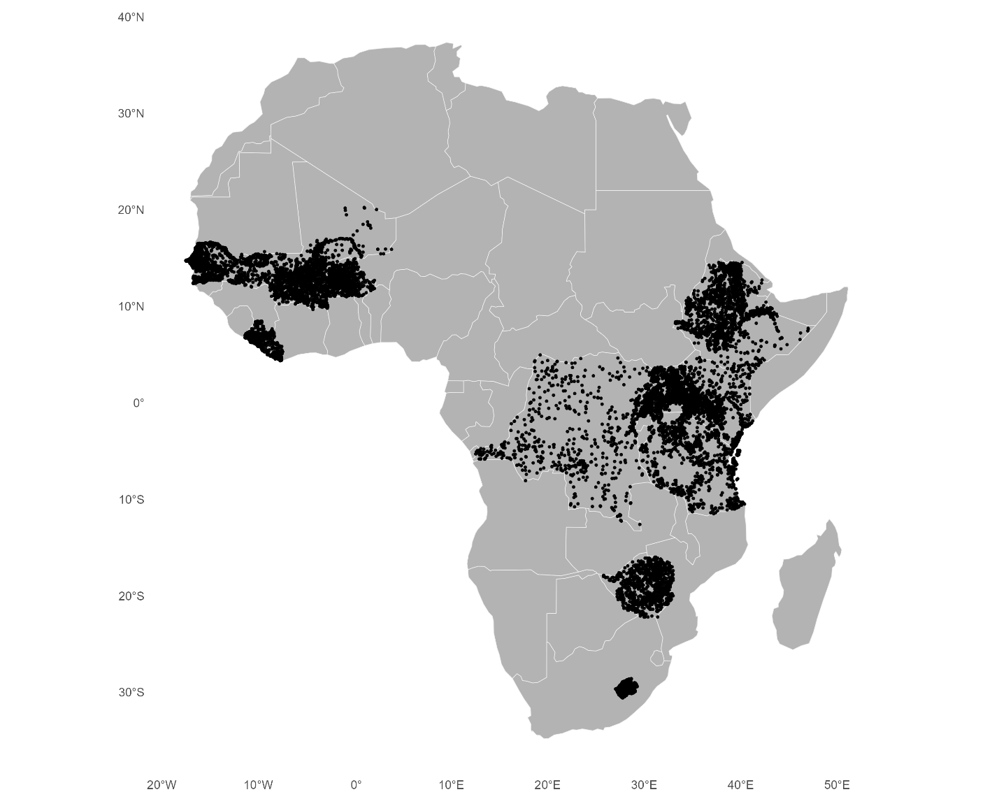
Figure S1. Location of primary sampling units (PSUs).

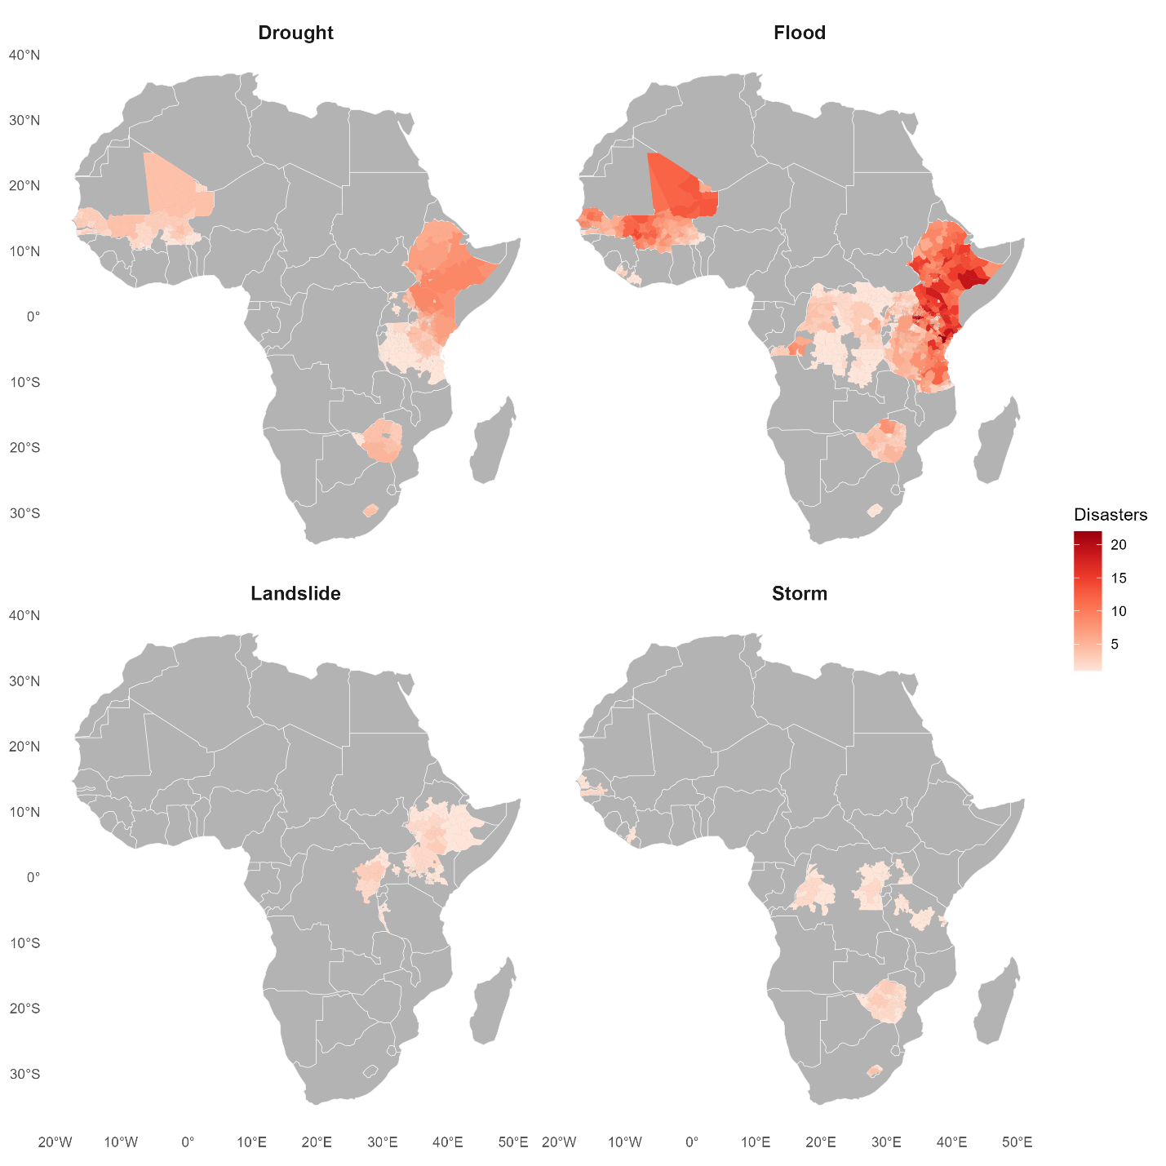
Figure S2. Number of climate-related disasters by type and administrative level 2 area, 1993-2018.

Estimation of Baseline and Predicted Probabilities of Wasting
To estimate the impact of disaster exposure on the probability of child wasting under different education-policy scenarios, we used a two-step procedure grounded in G-computation and meta-analytic risk ratios. All computations were conducted using the treated countries (Ethiopia, Kenya, Mali, Senegal, Tanzania, and Uganda), consistent with the quasi-experimental design described in the main manuscript. The code implementing these procedures is available in the project repository (https://github.com/benmarhnia-lab/EduReforms_DisasterNutrition).
- Baseline probability of wasting via g-computation
G-computation is well suited to this quasi-experimental setting because it allows us to estimate population-level counterfactual risks under clearly defined exposure scenarios. By setting disaster exposure and education-reform status to fixed values for all individuals while retaining their observed covariates, G-computation provides predicted probabilities that align directly with the identification strategy of the staggered reform design. This approach avoids extrapolation, preserves the empirical distribution of confounders, and yields interpretable absolute risk estimates that complement the pooled relative risks from the meta-regression.
Step 1: Constructing a counterfactual dataset
Following standard G-computation, we generated a counterfactual dataset in which all observations were set to “no disaster exposure”, while preserving the observed covariate structure:
- For the no reform scenario,
$${\text{disaster}}_{i}=0,{\text{reform}}_{i}=0$$
- For the reform scenario,
$${\text{disaster}}_{i}=0,{\text{reform}}_{i}=1$$
The Poisson model described in the main text was used to obtain predicted probabilities ${\hat{P}}_{0i}$for each child under this counterfactual.
Step 2: Computing the baseline probability
We computed the baseline probability of wasting as a normalized weighted mean across individuals:
$$P_{0}=\frac{\sum_{i=1}^{N}{w_{i}} {\hat{P}}_{0i}}{\sum_{i=1}^{N}{w_{i}}}$$
where $w_{i}$are survey weights re-normalized within country–survey rounds so that each survey contributes equally to the pooled estimate.
Step 3: Baseline uncertainty
Sampling uncertainty for $P_{0}$was approximated using:
$$SE(P_{0})=\frac{\text{SD}({\hat{P}}_{0i})}{\sqrt{N}}$$
and 95% CIs were computed assuming a normal distribution:
$$P_{0}^{LCL}=P_{0}-1.96×SE(P_{0}),P_{0}^{UCL}=P_{0}+1.96×SE(P_{0})$$
- Predicted probability of wasting under disaster exposure
The next step was to estimate the probability of wasting under a disaster exposure scenario using the pooled relative risk (RR) from the meta-analysis.
Let:
- $P_{0}$= baseline probability of wasting (no disaster),
- $RR$= pooled meta-analytic risk ratio for disaster exposure for each education subgroup.
We computed the probability under exposure using the standard risk-transfer formula:
$$P_{1}=\frac{RR×P_{0}}{1-P_{0}+RR×P_{0}}$$
Confidence Intervals for $P_{1}$and Absolute Differences
To propagate uncertainty in the pooled RRs, we simulated the distribution of $P_{1}$using 10,000 draws from the log-normal distribution of the RR:
Step 1: Estimate standard error of log(RR)
$$SE_{log⁡RR}=\frac{log⁡(RR_{U})-log⁡(RR_{L})}{2×1.96}$$
Step 2: Draw 10,000 simulated RRs
$$RR^{\left(b\right)}=exp⁡(N(log⁡RR, SE_{log⁡RR}^{2})),b=1,…,10,000$$
Step 3: Compute corresponding predicted probabilities
$$P_{1}^{\left(b\right)}=\frac{RR^{\left(b\right)}×P_{0}}{1-P_{0}+RR^{\left(b\right)}×P_{0}}$$
The 2.5th and 97.5th percentiles of the simulated distribution yielded the 95% CIs:
$$P_{1}^{LCL}=\text{quantile}(P_{1}^{\left(b\right)},0.025),P_{1}^{UCL}=\text{quantile}(P_{1}^{\left(b\right)},0.975)$$
We additionally computed the absolute disaster-attributable change:
$$Δ=P_{1}-P_{0}$$
with corresponding simulation-based uncertainty:
$$Δ^{\left(b\right)}=P_{1}^{\left(b\right)}-P_{0}$$
- Results
Scenario 1: Mothers without access to free primary education
- Baseline probability (no disaster):
$$P_{0}=9.08\% (95\% CI:9.04,9.12)$$
- Disaster-exposed probability applying pooled RR = 1.17 (95% CI: 1.12–1.22):
$$P_{1}=10.38\% (95\% CI:9.97,10.79)$$
- Absolute increase: +1.3 percentage points
Scenario 2: Mothers with access to free primary education
- Baseline probability (no disaster):
$$P_{0}=8.61\% (95\% CI:8.56,8.66)$$
- Disaster-exposed probability applying pooled RR = 0.96 (95% CI: 0.78–1.17):
$$P_{1}=8.29\% (95\% CI:6.84,10.00)$$
- Under this scenario, disaster exposure does not increase the risk of wasting.

Results
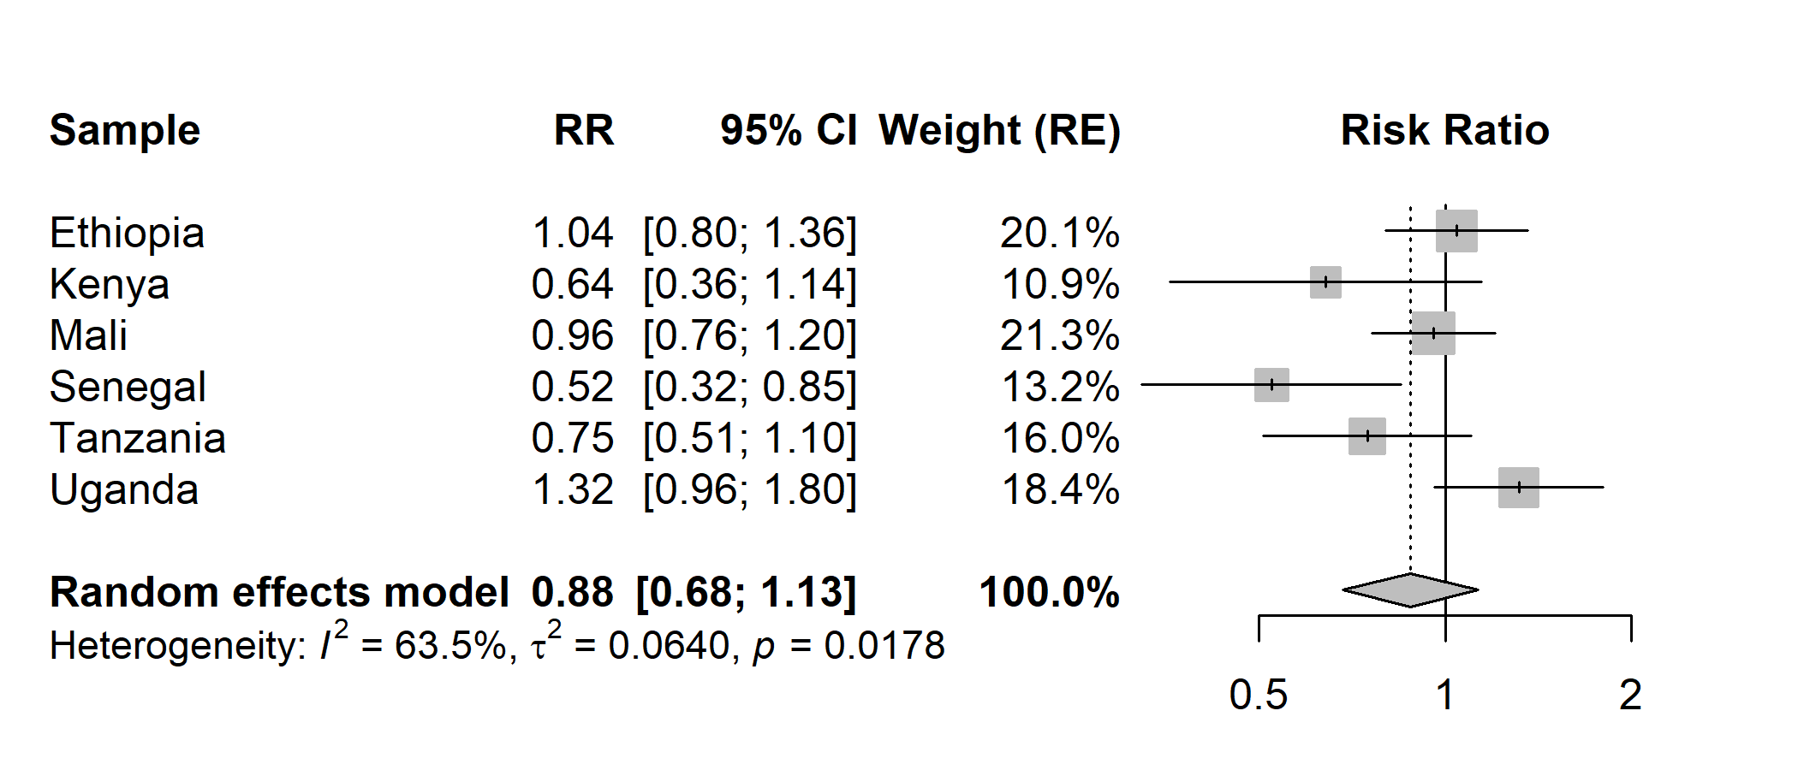Figure S3. Country-specific and pooled associations between maternal exposure to education reform and child wasting.

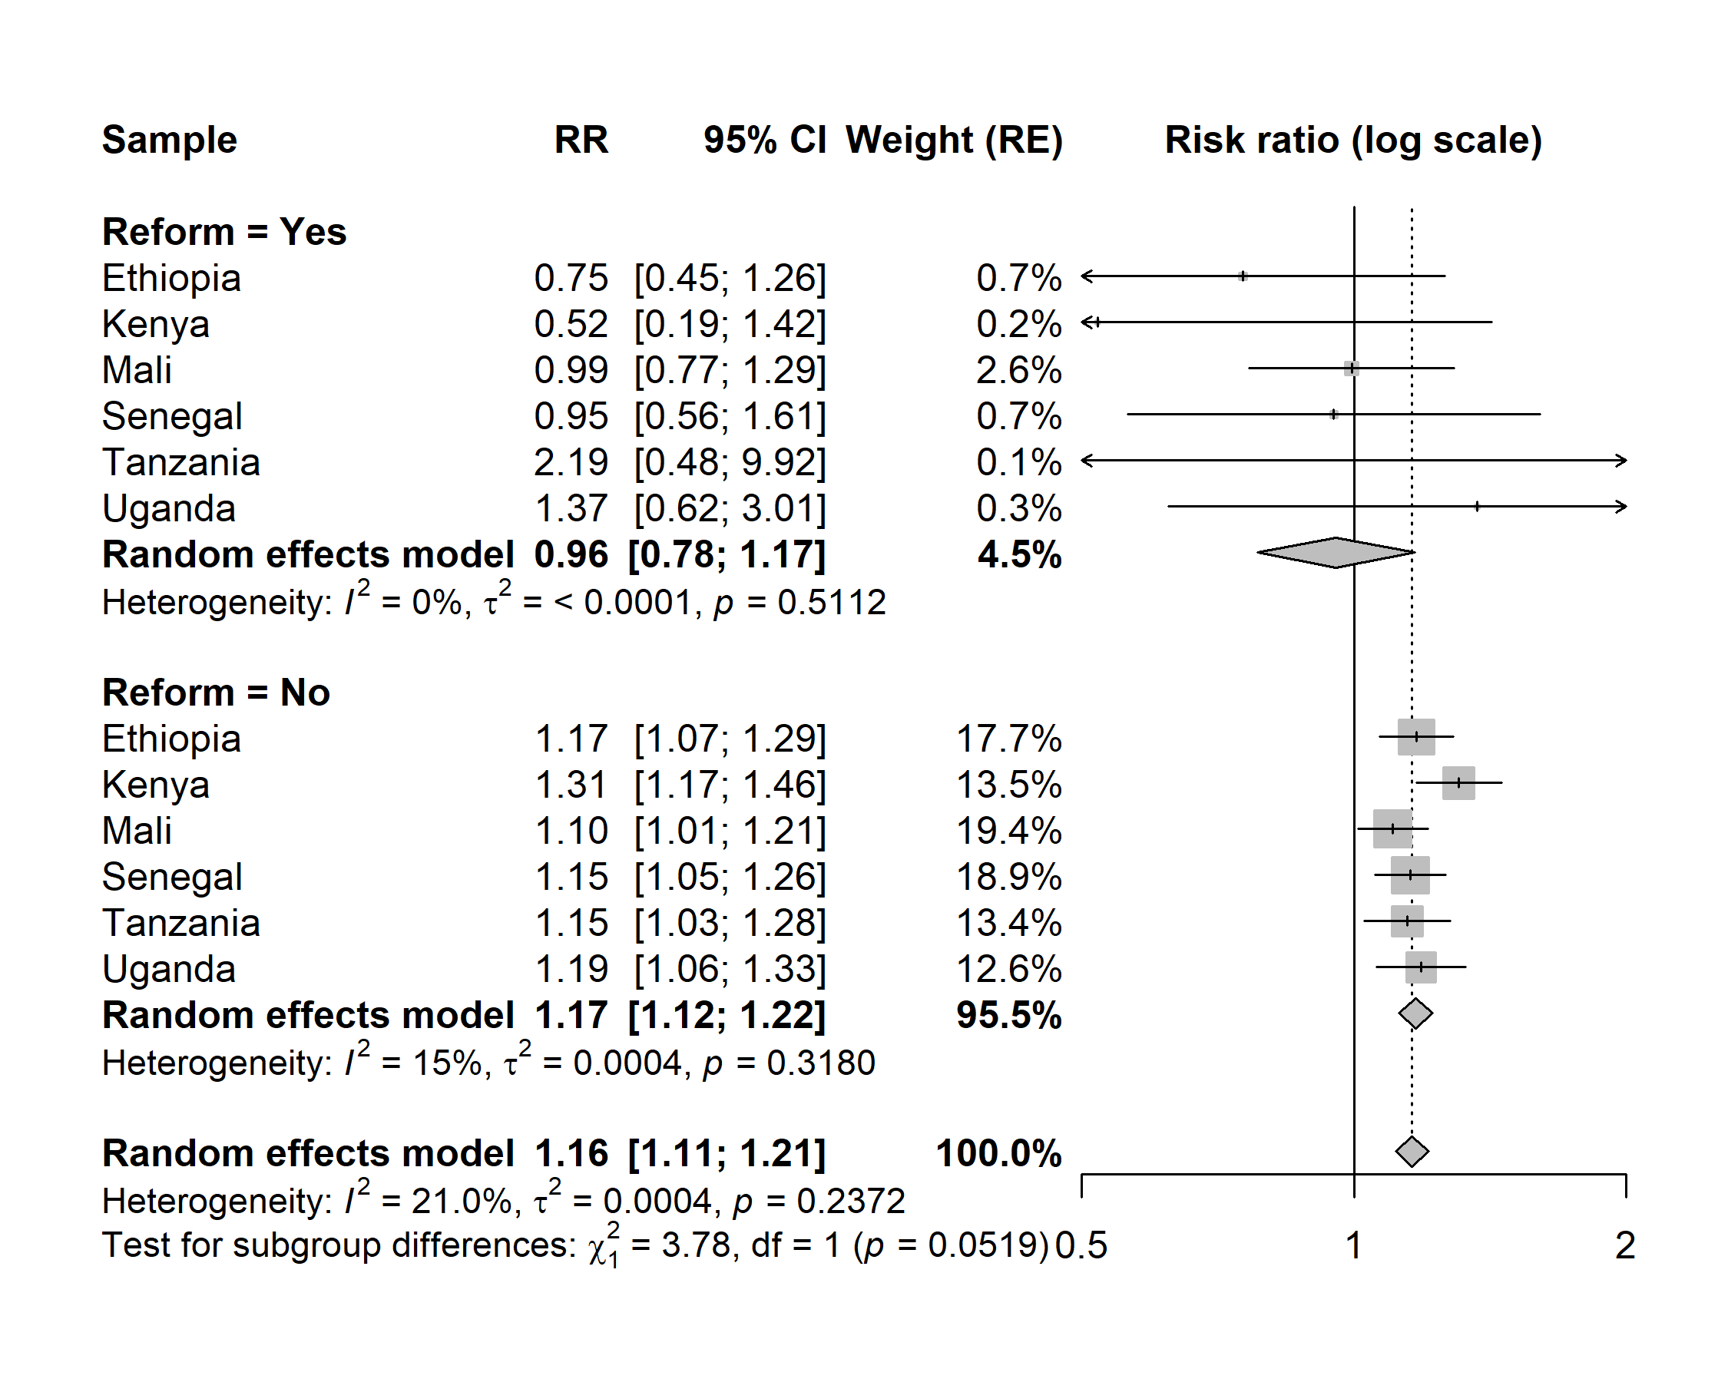
Figure S4. Country-specific and pooled estimates of the association between disaster exposure in the preceding 3 months and child wasting, stratified by maternal exposure to education reform.

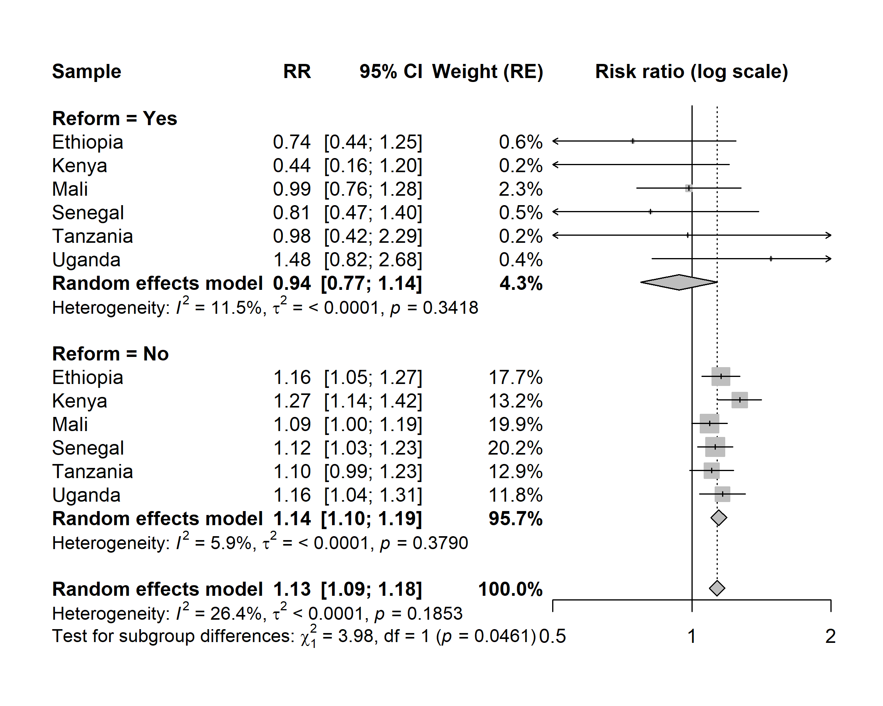Figure S5. Country-specific and pooled estimates of the association between disaster exposure in the preceding 6 months and child wasting, stratified by maternal exposure to education reform.

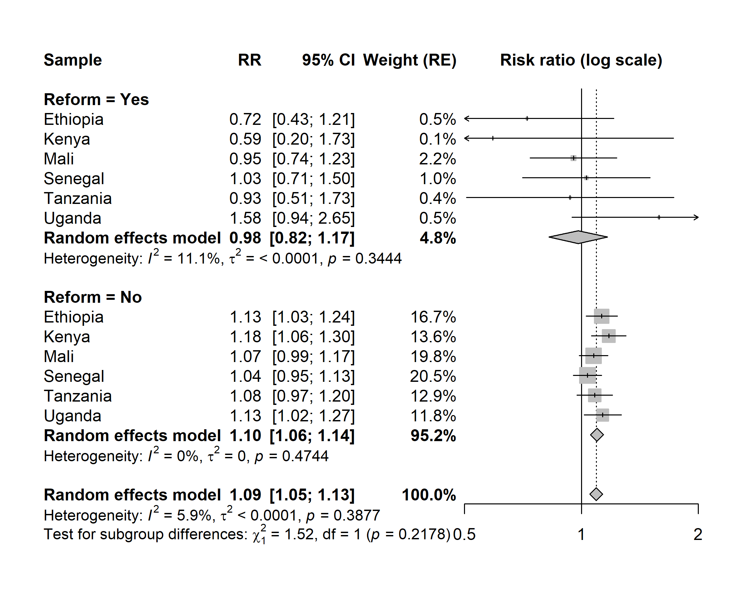
Figure S6. Country-specific and pooled estimates of the association between disaster exposure in the preceding 12 months and child wasting, stratified by maternal exposure to education reform.

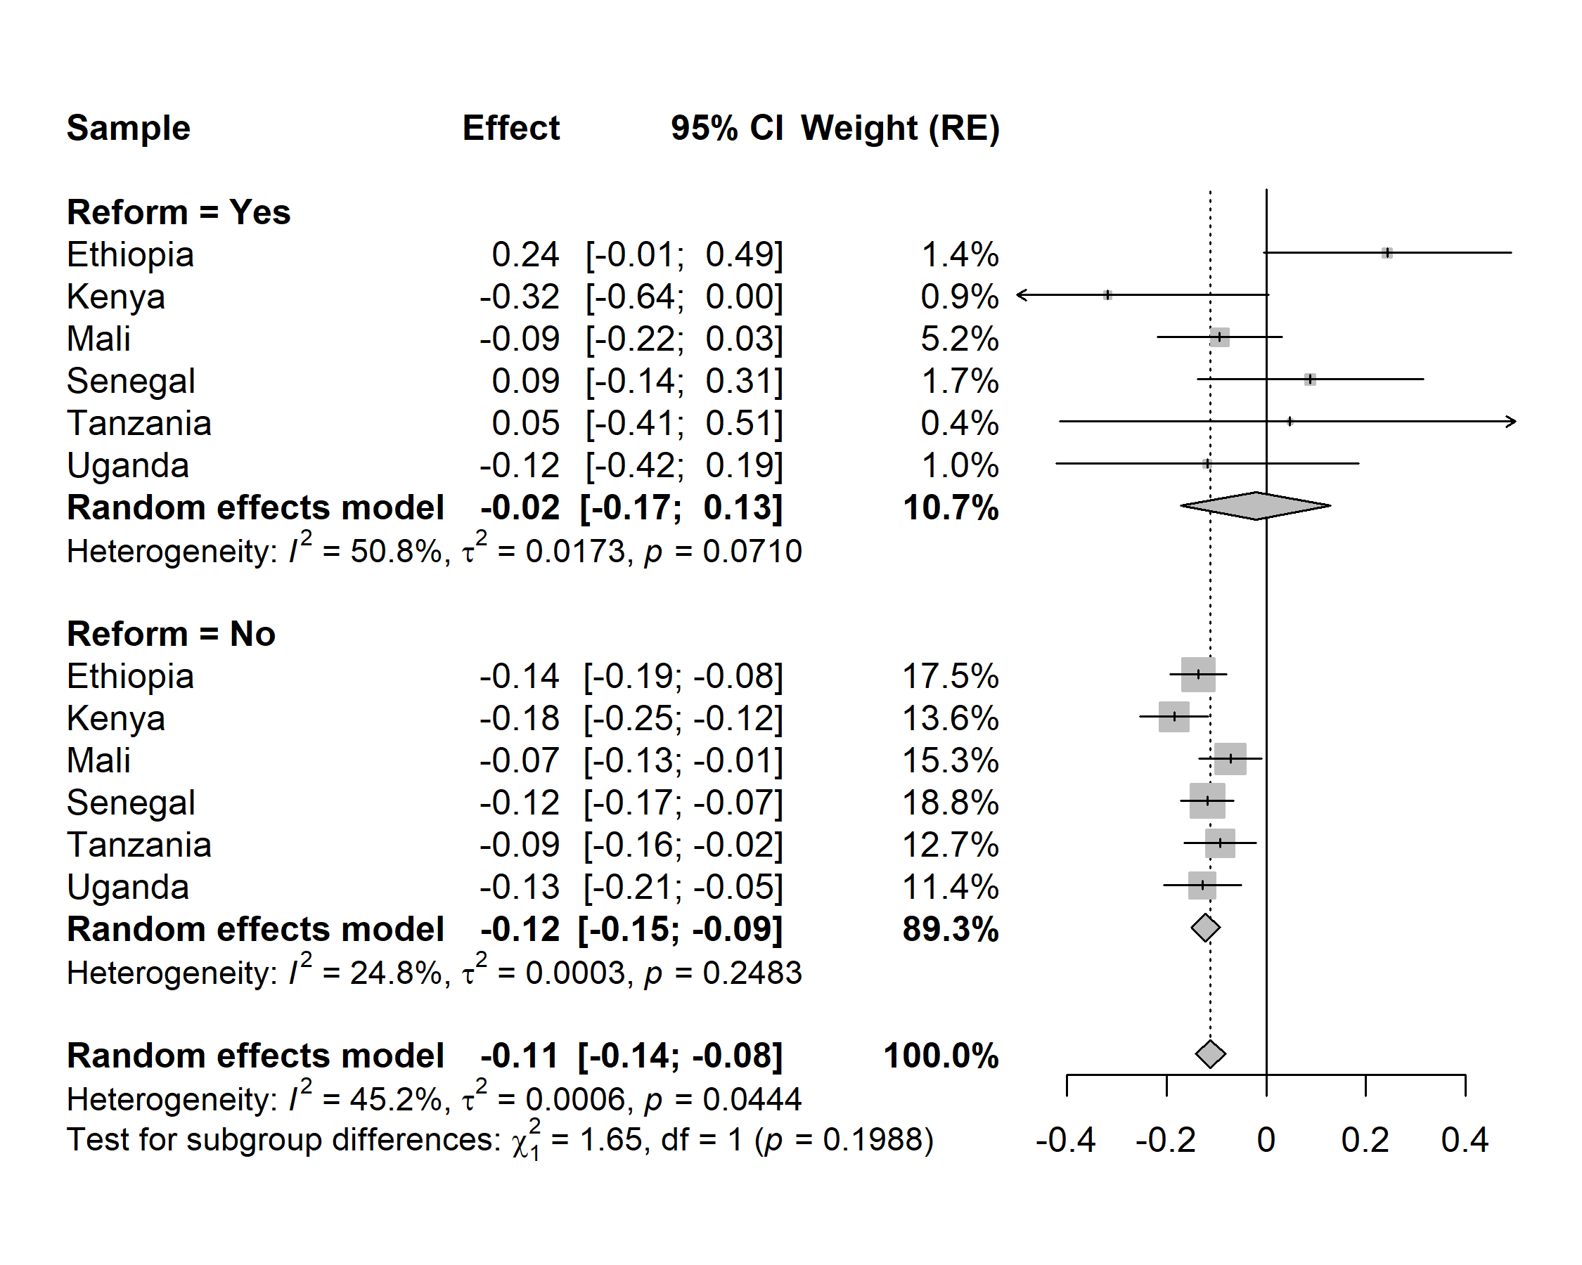Figure S7. Country-specific and pooled estimates of the association between disaster exposure in the preceding 3 months and child weight-for-height (WHZ) score, stratified by maternal exposure to education reform.

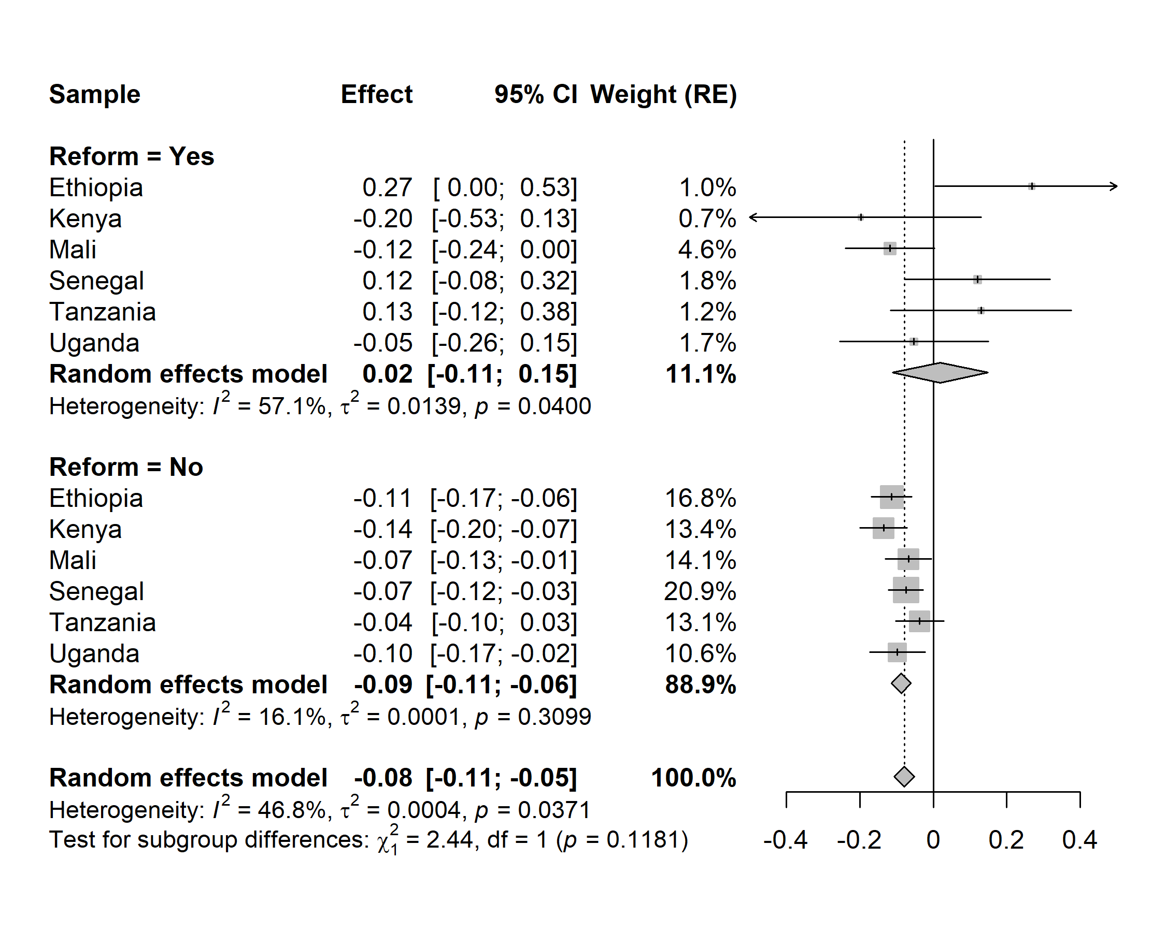Figure S8. Country-specific and pooled estimates of the association between disaster exposure in the preceding 6 months and child weight-for-height (WHZ) score, stratified by maternal exposure to education reform.

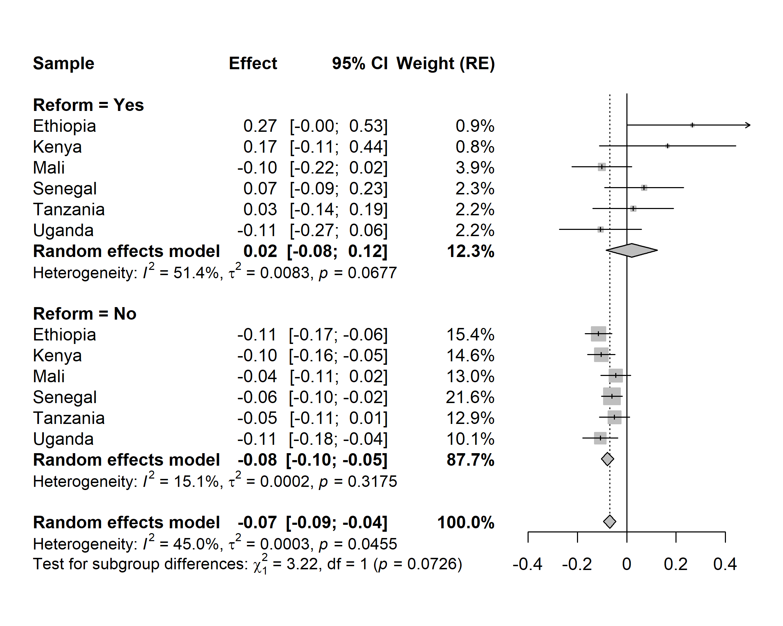Figure S9. Country-specific and pooled estimates of the association between disaster exposure in the preceding 12 months and child weight-for-height (WHZ) score, stratified by maternal exposure to education reform.

