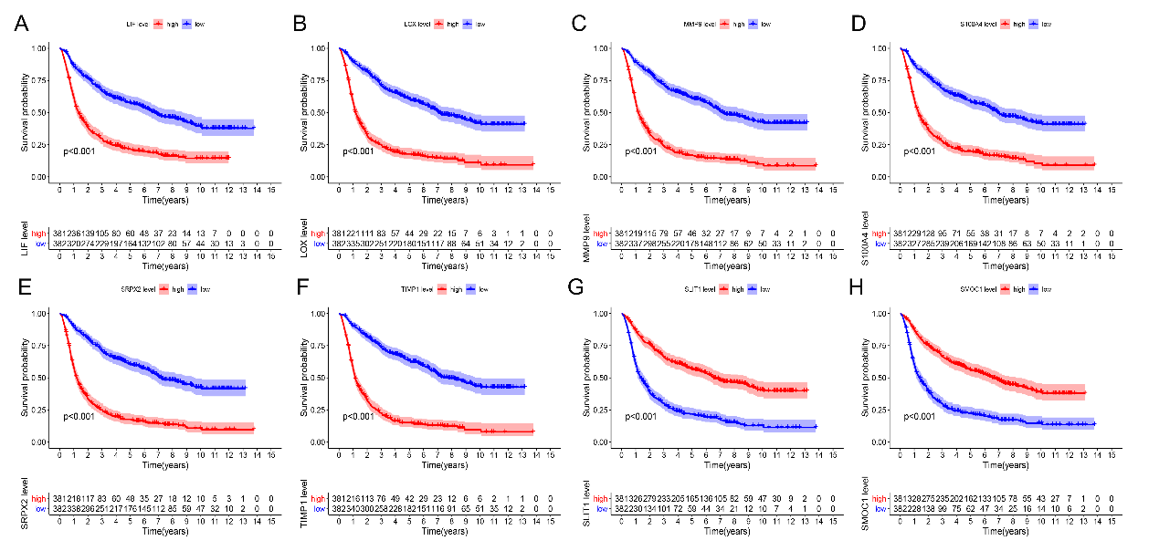
Supplementary Figure 1. The Kaplan Meier (KM) curve showed that the overall survival rate of the 8 immune-related matrisomes. (A) LIF (B) LOX (C) MMP9 (D) S100A4 (E) SRPX2 (F) TIMP1 (G) SLIT1 (H) SMOC1.

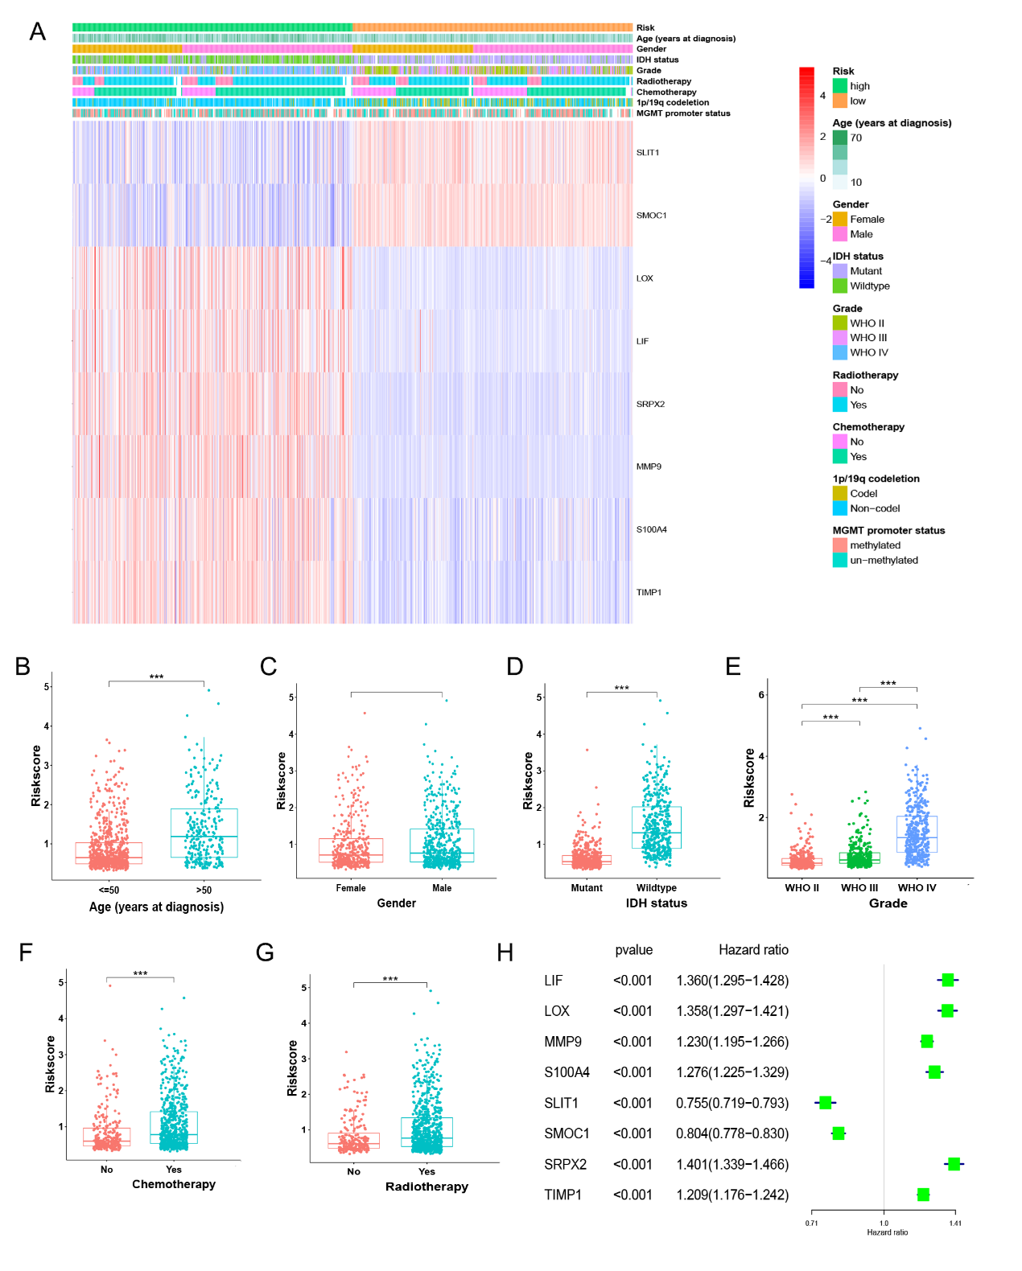
Supplementary Figure 2. Relationship between risk signature and clinical characteristics of glioma in CGGA database. (A) The heatmap showed the relationship between high and low risk groups and clinical features of glioma patients. Risk scores of high and low groups of (B) Age, (C) Gender, (D) IDH mutation status, (E) Grade, (F) Chemotherapy, and (G) Radiotherapy. (H) Univariable Cox regression of 8 immune-related matrisomes in CGGA database.

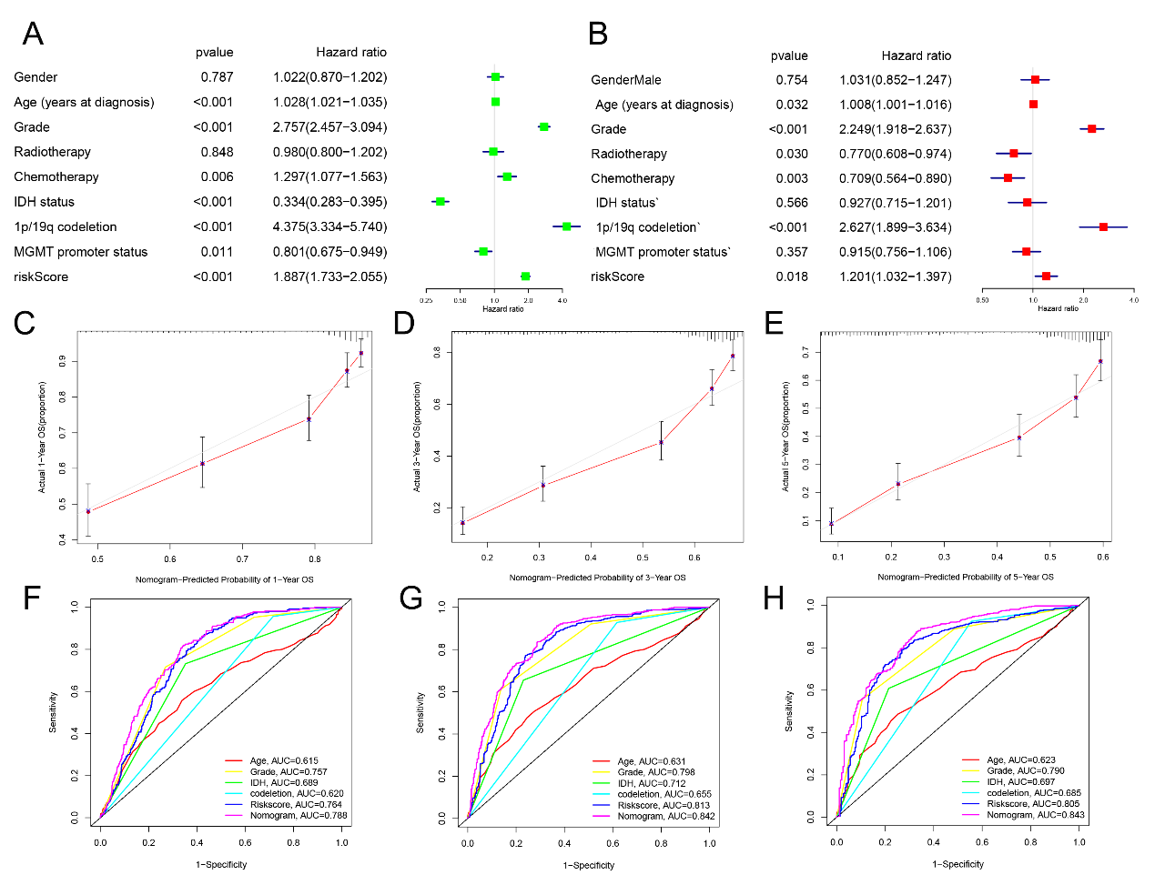
Supplementary Figure 3. Calibration plots were used to validate the efficacy in the CGGA cohort (C-E). ROC curves were used to evaluate the predictive ability of the nomogram and other predictors (F-H). Univariate Cox regression analysis (A) and Multivariate Cox regression analysis (B) in CGGA database.

