Supporting Information for
A Data-Driven High-Sensitivity Biomimetic Whisker Sensor
Yamin Hou¹, Qingpeng Chu¹, Jiahao Li¹, An Cao¹, Jian Wu⁴, Yongbo Deng³, Jian He^{2*}, Xiujian Chou¹
¹ Science and Technology on Electronic Test and Measurement Laboratory, North University of China, Taiyuan 030051, China
² School of Future Science and Engineering, Soochow University, Suzhou 215222, China
³ Institute of Microstructure Technology, Karlsruhe Institute of Technology, Hermann-von-Helmholtzplatz 1, Eggenstein-Leopoldshafen 76344, Germany
⁴ College of Materials Science and Engineering, Hohai University, Changzhou, 21200
*Corresponding author: Jian He; E-mail: drhejian@suda.edu.cn
Captions for Videos S1 to S5
Video S1. Real-time host-computer visualization of high-sensitivity whisker sensor (HSWS) responses under loading directions of 40°, 45°, 50°, 55°, and 90°.
Video S2. Demonstration of the HSWS-based virtual tactile feedback and VR interaction system.
Video S3. Demonstration of HSWS-enabled coordinated mobile robot teleoperation and robotic gripper manipulation.
Video S4. Demonstration of HSWS-enabled autonomous obstacle avoidance using a mobile robot.
Video S5. Demonstration of HSWS-enabled S-shaped wall-following autonomous exploration using a mobile robot.
Video S6. Demonstration of HSWS-enabled linear wall-following autonomous exploration using a mobile robot.
Table S1. Comparison of features between the HSWS and previously reported whisker sensors
Year | Sensor Type | Force  Resolution  (N) | Minimum  Angular  Resolution (°) | Number  of  Electrodes | References
2026 | capacitance | 0.006N | 5° | 4 | This Work
2025 | Triboelectric | 0.024N | 5° | 2 | S1
2024 | Triboelectric | 0.05N | 180° | 2 | S2
2024 | Resistive | 0.0024N | 45° | 4 | S3
2019 | Resistive | 0.002 | 15 | 4 | S4
2024 | Piezoelectric | 0.0013N | 180° | 1 | S5
2023 | Piezoelectric | 0.00007N | 180° | 1 | S6
2024 | Magnetic | 0.34N | 1.76° | 1 | S7
2024 | Magnetic | 0.005N | 180° | 1 | S8

Figure S1. Screen-printing fabrication process of the HSWS interdigitated electrodes.
Figure S2. SEM images of the conductive silver electrodes of the HSWS, including the surface morphology, printed line width, and cross-sectional morphology of the conductive layer.
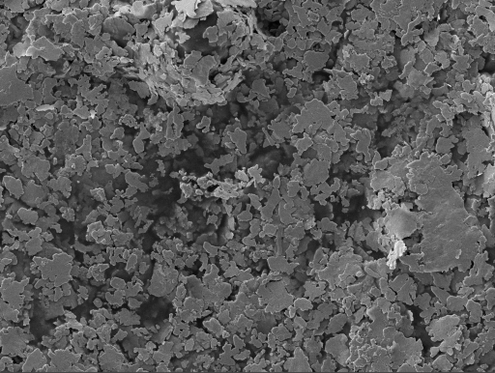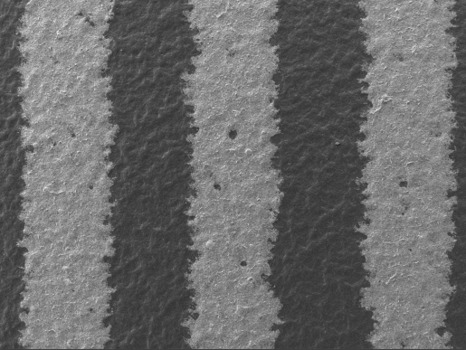
200 μm
5 μm
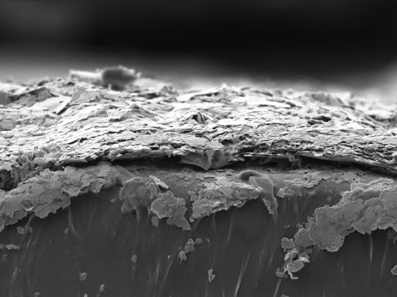
5 μm
250 μm
Figure S3. Complete confusion matrix for loading-direction classification at 5° angular intervals.
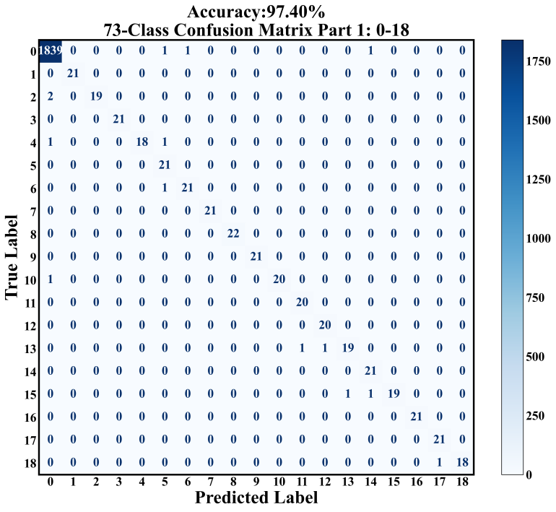
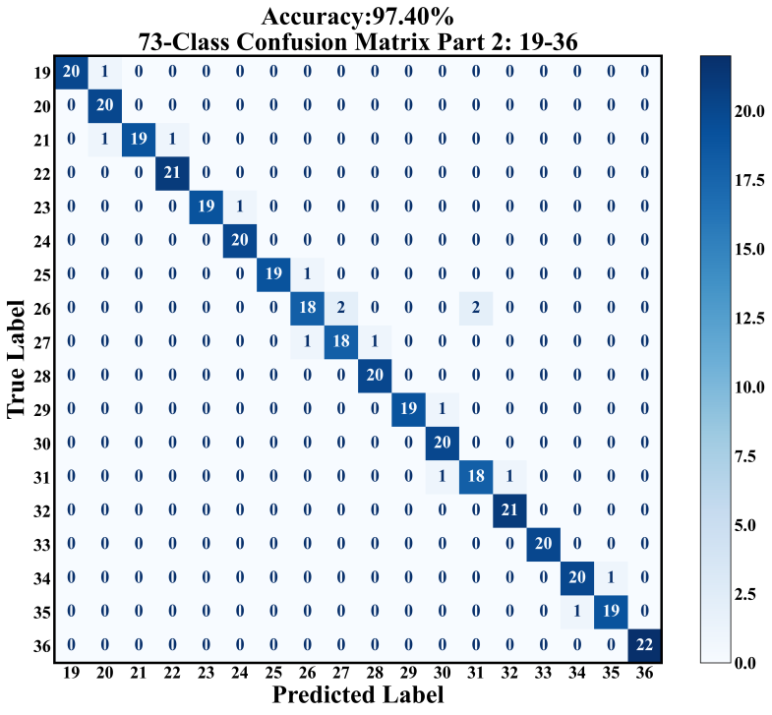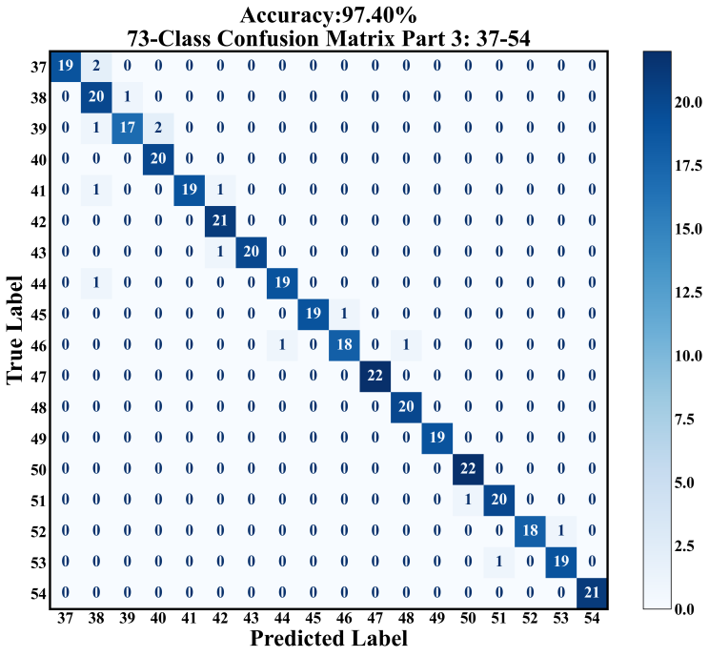
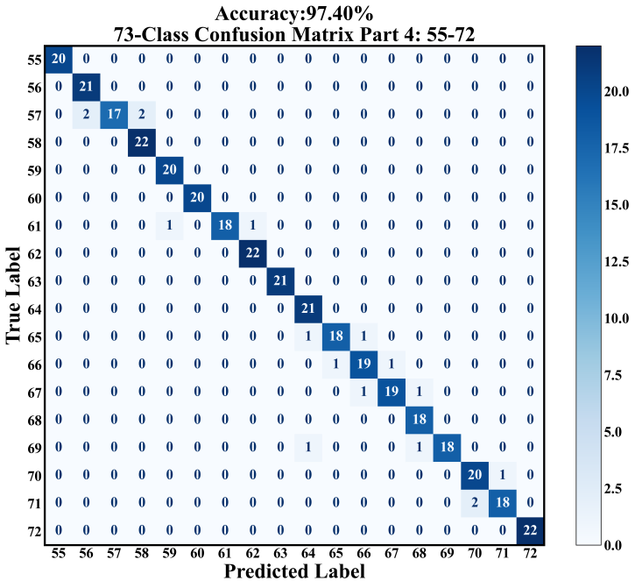
Figure S4. Training loss, training-set accuracy, and test-set accuracy as a function of training epoch for the loading-direction classification model.
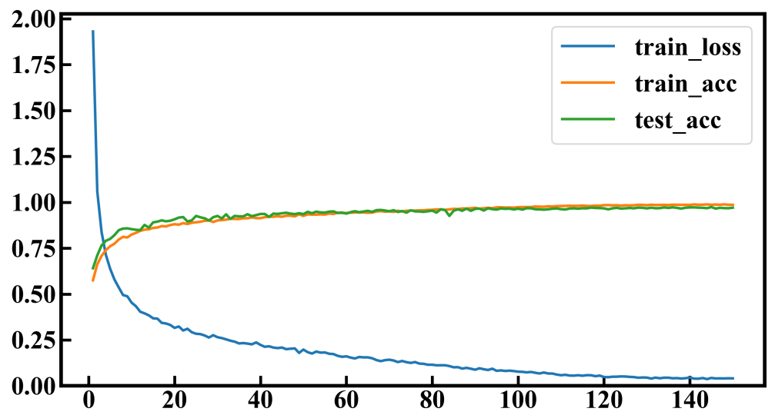
Supporting Notes
Note S1. Simplified Electromechanical Model of the HSWS
The HSWS consists of a boar-bristle whisker, a lower cross-shaped thermoplastic polyurethane (TPU) flexible membrane, upper and lower interdigitated electrodes, and upper and lower housings. When an external lateral force is applied to the whisker, the whisker bends and transfers the applied load to the central region of the lower cross-shaped TPU membrane. Because the whisker root is bonded to the center of the lower membrane, the bending moment generated at the whisker root drives the cross-shaped TPU membrane to undergo bending deformation. The lower interdigitated electrode is printed on the surface of the TPU membrane and therefore moves together with the membrane during deformation. In contrast, the upper electrode remains stationary within the cross-shaped groove of the upper housing. Consequently, deformation of the lower electrode changes both the local interelectrode spacing and the effective capacitive coupling area between the upper and lower electrodes, ultimately producing four-channel, direction-dependent differential capacitance signals.
Owing to its slender and flexible geometry, the boar-bristle whisker can be approximated as an Euler–Bernoulli beam. Similar to the treatment of whisker structures reported in previous studies, a slender whisker under small-deformation conditions can be described using a beam-bending model, while the flexible support at its base can be further represented by an equivalent elastic support.
The transverse bending behavior of the whisker under an external load can be expressed as
$E_{ω}I_{ω}\frac{∂^{4}ω(x,t)}{∂x^{4}}+ρ_{ω}A_{ω}\frac{∂^{2}ω(x,t)}{∂t^{2}}=q(x,t)$ $\text{(}{\text{S}}_{\text{1}}\text{)}$
Where $\text{ω(x,t)}$denotes the transverse displacement of the whisker at position $\text{x}$ and time t, x is the coordinate along the whisker length, ${\text{E}}_{\text{ω}}$ is the Young’s modulus of the boar-bristle whisker, ${\text{I}}_{\text{ω}}$ is the second moment of area of the whisker cross section, ${\text{ρ}}_{\text{ω}}$ is the whisker density, ${\text{A}}_{\text{ω}}$ is the cross-sectional area of the whisker, and $\text{q(x}\text{,}\text{t}\text{)}$ represents the distributed external load acting on the whisker.
In both the experiments and finite element simulations conducted in this work, the whisker was subjected primarily to slowly varying loads and can therefore be approximated as operating under quasi-static conditions. Accordingly, the inertial term associated with whisker acceleration can be neglected.
$${\text{ρ}}_{\text{ω}}{\text{A}}_{\text{ω}}\frac{{\text{∂}}^{\text{2}}\text{ω(x,t)}}{\text{∂}{\text{t}}^{\text{2}}}$$
Equation ${\text{S}}_{\text{1}}$ can therefore be simplified to
${\text{E}}_{\text{ω}}{\text{I}}_{\text{ω}}\frac{{\text{∂}}^{\text{4}}\text{ω(x,t)}}{\text{∂}{\text{x}}^{\text{4}}}\text{=q(x,t)}$ $\text{(}{\text{S}}_{\text{2}}\text{)}$
For a cylindrical whisker, the cross-sectional area and second moment of area are given by
${\text{A}}_{\text{ω}}\text{=π}{\text{r}}^{\text{2}}$ $\text{(}{\text{S}}_{\text{3}}\text{)}$
and
${\text{I}}_{\text{ω}}\text{=}\frac{\text{πr^4}}{\text{4}}$ $\text{(}{\text{S}}_{\text{4}}\text{)}$
respectively, where r is the whisker radius. In this work, the whisker radius was $\text{1.5mm}$
and the effective whisker height was $\text{26mm}$
When an external lateral force F is applied at or near the whisker tip, the force is transmitted along the whisker to its root, generating a bending moment given by
${\text{M}}_{\text{0}}\text{=Fd}$ $\text{(}{\text{S}}_{\text{5}}\text{)}$
where${\text{ M}}_{\text{0 }}$is the bending moment at the whisker root, $\text{F }$is the externally applied lateral force, and $\text{d }$is the effective whisker height. Equation ${\text{S}}_{\text{5}}$ indicates that, under the same applied force, a larger whisker height produces a greater bending moment at the root, thereby providing a stronger deformation-driving moment for the central region of the TPU membrane.
The lower cross-shaped TPU membrane can be regarded as a flexible elastic structure supporting the whisker root. For simplified analysis, the cross-shaped TPU membrane can be represented by a combination of an equivalent linear spring and an equivalent rotational spring. The linear spring describes the translational deformation of the membrane center, whereas the rotational spring represents the rotation or tilting of the membrane center under an applied bending moment. Accordingly, the elastic restoring force generated at the central region of the cross-shaped TPU membrane can be expressed as
${\text{F}}_{\text{m}}\text{=}{\text{k}}_{\text{m}}{\text{u}}_{\text{m}}$ $\text{(}{\text{S}}_{\text{6}}\text{)}$
Where ${\text{F}}_{\text{m}}$ is the elastic restoring force generated by the membrane, ${\text{k}}_{\text{m}}$ is the equivalent translational stiffness of the cross-shaped TPU membrane, and ${\text{u}}_{\text{m}}$ is the equivalent displacement of the membrane center.
Similarly, the elastic restoring moment associated with rotation of the membrane center can be expressed as
${\text{M}}_{\text{m}}\text{=}{\text{k}}_{\text{θ}}{\text{θ}}_{\text{m}}$ $\text{(}{\text{S}}_{\text{7}}\text{)}$
where ${\text{M}}_{\text{m}}$ is the restoring moment generated by the membrane, ${\text{k}}_{\text{θ}}$ is the equivalent rotational stiffness of the cross-shaped TPU membrane, and ${\text{θ}}_{\text{m}}$ is the rotation angle of the membrane center.
At the bonded interface between the whisker root and the central region of the TPU membrane, the force and bending moment transmitted by the whisker must be balanced by the elastic restoring force and restoring moment generated by the membrane. Therefore, the equilibrium relationships can be approximated as
$\text{F≈}{\text{k}}_{\text{m}}{\text{u}}_{\text{m}}$ $\text{(}{\text{S}}_{\text{8}}\text{)}$
and
$\text{Fd≈}{\text{k}}_{\text{θ}}{\text{θ}}_{\text{m}}$ $\text{(}{\text{S}}_{\text{9}}\text{)}$
Equations ${\text{S}}_{\text{8}}$ and ${\text{S}}_{\text{9}}$ show that a larger external force $\text{F}$ produces a greater displacement ${\text{u}}_{\text{m}}$ at the membrane center, whereas a larger effective whisker height d generates a greater bending moment at the whisker root and consequently a larger rotation angle ${\text{θ}}_{\text{m}}$ of the membrane center. In contrast, increasing either the translational stiffness ${\text{k}}_{\text{m}}$ or the rotational stiffness ${\text{k}}_{\text{θ}}$ of the cross-shaped TPU membrane suppresses membrane deformation. Therefore, the whisker height, whisker radius, TPU membrane thickness, and the width and length of the cross-shaped beams all influence the deformation of the membrane and, consequently, the sensing response of the HSWS.
Because the upper electrode is fixed within the cross-shaped groove of the upper housing, whereas the lower electrode is printed on the deformable TPU membrane, bending of the TPU membrane causes displacement of the lower electrode relative to the stationary upper electrode. The capacitance of the$\text{ i}$-th sensing channel can therefore be approximated as
$C_{i}=\frac{ε_{0}ε_{r}A_{eff,i}}{d_{i}}(i=1,2,3,4)$ $\text{(}{\text{S}}_{\text{10}}\text{)}$
Where ${\text{ε}}_{\text{0}}$ is the vacuum permittivity, ${\text{ε}}_{\text{r}}$ is the relative permittivity of the dielectric medium between the electrodes, ${\text{A}}_{\text{eff,i}}$ is the effective capacitive coupling area of the $\text{i}$-th channel, and${\text{ d}}_{\text{i}}$ is the local interelectrode spacing between the upper and lower electrodes of that channel. Therefore, deformation of the TPU membrane induced by whisker loading changes both ${\text{A}}_{\text{eff,i}}$ and ${\text{d}}_{\text{i}}$, giving rise to four-channel, direction-dependent differential capacitance signals.
When the whisker bends under an external load, the cross-shaped TPU membrane undergoes asymmetric deformation, resulting in different changes in the local interelectrode spacing ${\text{d}}_{\text{i}}$ and effective coupling area ${\text{A}}_{\text{eff,i}}$ among the four sensing channels. Accordingly, the capacitance variation of the i-th channel can be approximated as
$\text{∆}{\text{C}}_{\text{i}}\text{=}{\text{C}}_{\text{i0}}\text{(}\frac{{\text{∆A}}_{\text{eff,i}}}{{\text{A}}_{\text{eff,i}}}\text{-}\frac{\text{∆}{\text{d}}_{\text{i}}}{{\text{d}}_{\text{i}}}\text{)}$ $\text{(}{\text{S}}_{\text{11}}\text{)}$
Where ${\text{C}}_{\text{i0}}$ is the initial capacitance of the i-th channel, ${\text{∆A}}_{\text{eff,i}}$ is the variation in effective capacitive coupling area, and $\text{∆}{\text{d}}_{\text{i}}$ is the variation in local interelectrode spacing.
Equation ${\text{S}}_{\text{11}}$ indicates that the capacitance variation of the HSWS originates from two primary contributions: changes in the effective capacitive coupling area between the upper and lower electrodes and changes in the local interelectrode spacing. Because different loading directions produce different deformation regions and deformation amplitudes in the cross-shaped TPU membrane, the four capacitive channels exhibit distinct direction-dependent response patterns. Consequently, the loading direction and contact force magnitude applied to the whisker can be decoded from the four-channel capacitance variations.
Overall, the electromechanical transduction process of the HSWS can be summarized as
$\text{F→}{\text{M}}_{\text{0}}\text{=Fd→}{\text{u}}_{\text{m}}\text{,} {\text{θ}}_{\text{m}}\text{→∆}{\text{d}}_{\text{i}}\text{,}{\text{ ∆A}}_{\text{eff,i}}\text{→∆}{\text{C}}_{\text{i}}$ $\text{(}{\text{S}}_{\text{12}}\text{)}$
This simplified model illustrates that an external lateral force is first converted into a bending moment at the whisker root through the effective whisker height. The resulting bending moment then drives deformation of the cross-shaped TPU membrane, which changes the local interelectrode spacing and effective capacitive coupling area, ultimately producing four-channel, direction-dependent differential capacitance signals.
$$\text{M=Fd}$$
$${\text{C}}_{\text{i}}\text{=}\frac{{\text{ε}}_{\text{0}}{\text{ε}}_{\text{r}}{\text{A}}_{\text{eff,i}}}{{\text{d}}_{\text{i}}}\text{(i=1}\text{,}\text{2}\text{,}\text{3}\text{,}\text{4)}$$
Note S2. Material Parameters and Boundary Conditions for Finite Element Simulation
The whisker was modeled using the material properties of boar bristle, while the TPU membrane served as the primary flexible deformable component. The conductive silver-paste electrode layer was assumed to deform conformally with the TPU membrane.
Component | Material | Young’s  Modulus（E） | Poisson’sRatio（ν） | Density（ρ）
Whisker | Boar bristle | Experimentally calibrated value | 0.3-0.35 | 1200-1400${\text{kg/m}}^{\text{3}}$
Lower  membrane | TPU | 19.306MPa | 0.49 | 1100-1200${\text{kg/m}}^{\text{3}}$
Electrode layer | Conductive silver paste | Assumed to deform conformally with the TPU membrane | _____ | _____
Housing | PLA | 2-3GPa | 0.35 | 1200-1300${\text{kg/m}}^{\text{3}}$
Note S3. Confusion matrix for texture classification
The fully connected neural network MLP used in this work was implemented using the PyTorch framework in Python. Both model training and deployment were performed on a computing platform equipped with an NVIDIA GeForce RTX 3050 Laptop GPU. The architecture of the MLP model is described in detail as follows:

class MLP(nn.Module):
def__init__(self, in_features, num_classes=9):
super( ).__init__( )
self.feature_extractor=nn.Sequential(
nn.Linear(in_features, 256),
nn.BatchNorm1d(256),
nn.LeakyReLU(0.1, inplace=True),
nn.Dropout(0.2),
nn.Linear(256, 128),
nn.BatchNorm1d(128),
nn.LeakyReLU(0.1, inplace=True),
nn.Dropout(0.2),
nn.Linear(128, 64),
nn.BatchNorm1d(64),
nn.LeakyReLU(0.1, inplace=True),
)
self.classifier=nn.Sequential(
nn.Linear(64, 32),
nn.BatchNorm1d(32),
nn.LeakyReLU(0.1, inplace=True),
nn.Dropout(0.2),
nn.Linear(32, num_classes)
)
def forward(self, x):
features=self.feature_extractor(x)
logits=self.classifier(features)
return logits

Supplementary References
[S1] Wang, W. C et al. A Reconfigurable Omnidirectional Triboelectric Whisker Sensor Array for Versatile Human-Machine-Environment Interaction. Nano-Micro Lett. 18, 76 (2026). https://doi.org/10.1007/s40820-025-01930-x
[S2] Varghese, H., PriyaK, V., Hareesh, U. S., Chandran, A. Nano fibrous PAN-PDMS films based high-performance triboelectric artificial whisker for self-powered obstacle detection. Macromol. Rapid Commun. 45(2), 2300462 (2024). https://doi.org/10.1002/marc.202300462
[S3] Liu, X. Y. et al. A high-sensitivity flexible bionic tentacle sensor for multidimensional force sensing and autonomous obstacle avoidance applications. Micro syst. Nano Eng. 10(1), 149 (2024). https://doi.org/10.1038/s41378024-00749-7
[S4] Ahmad Ridzuan, N. A., Miki, N. Tooth-inspired tactile sensor for detection of multi-directional force. Micromachines 10(1), 18 (2018). https://doi.org/10.3390/mi10010018
[S5] Jiang, C. P. et al. Neuromorphic antennal sensory system. Nat. Commun. 15, 2109(2024). https://doi.org/10.1038/s41467-024-46393-7
[S6] Chen, C. et al A biomimetic ewhisker sensor with multimodal perception and stimuli discrimination. Device 1(5),100148(2023). https://doi.org/10.1016/j.device.2023.100148
[S7] Ren, H. et al. A robust and omnidirectional-sensitive electronic antenna for tactile-induced perception. Nat. Commun 16, 3135 (2025). https://doi.org/10.1038/s41467-025-58403-3
[S8] Zhang, H. et al. Development and application of magnetic tentacles array for sensing tiny forces. Measurement 240, 115533 (2025). https://doi.org/10.1016/j.measurement.2024.115533

