A Triphenylamine-Functionalized Silica Nanoparticle for Fluorescent Detection of Fe²⁺/Fe³⁺ Red Wine
Eda Erdemir*^{a,b}, Garen Suna*ª, Nisa Demirbilek^{c,} , Songül Eğlence-Bakırª, Musa Şahinª, Erman Karakuş*^{c}
ªDepartment of Chemistry, Faculty of Science, Istanbul University, 34134 Istanbul, Turkey
^{b}Institute of Graduate Studies in Science, Istanbul University, 34134 Istanbul, Turkey
^{c}Organic Chemistry Laboratory, Chemistry Group, National Metrology Institute, (TUBITAK UME), 41470 Gebze, Kocaeli, Turkey
Corresponding author: Erman Karakuş, Eda Erdemir, Garen Suna
CONTENTS PAGE
1. TGA Analysis of SNP–NH₂ and TPA–SNP.….……………………..….……………...…………..3

2. Time-Dependant Fluorescence Change of TPA–SNP with Fe^{2+/3+}………………………………....3

3. Determination of Detection Limit of Fe^{2+/3+}……………….…………………………………...…...5

4. Effect of pH …………………………………………………………..….………………………....5

5. UV-vis and fluorescence spectra illustrating the detection mechanism….………………………....5

6. DLS Analysis of SNP, SNP-NH₂ and TPA-SNP…………………………………………………..7

7. Comparison Chart of TPA-SNP with Other Reported Silica Nanoparticles Based Fe^{2+/3+} Selective

Probes…………………………………………………………………………………………………8

¹H and ¹³C NMR of T-T-AL……….…………………………………………………………..……..8

¹H and ¹³C NMR of Br-T-T-AL……….………………………………………………………….….8

¹H and ¹³C NMR of TPA-AL……….…………………………………………………………….….8

Mass spectrum of TPA-AL …………….….……………….………..……………………………….9

1. TGA Analysis

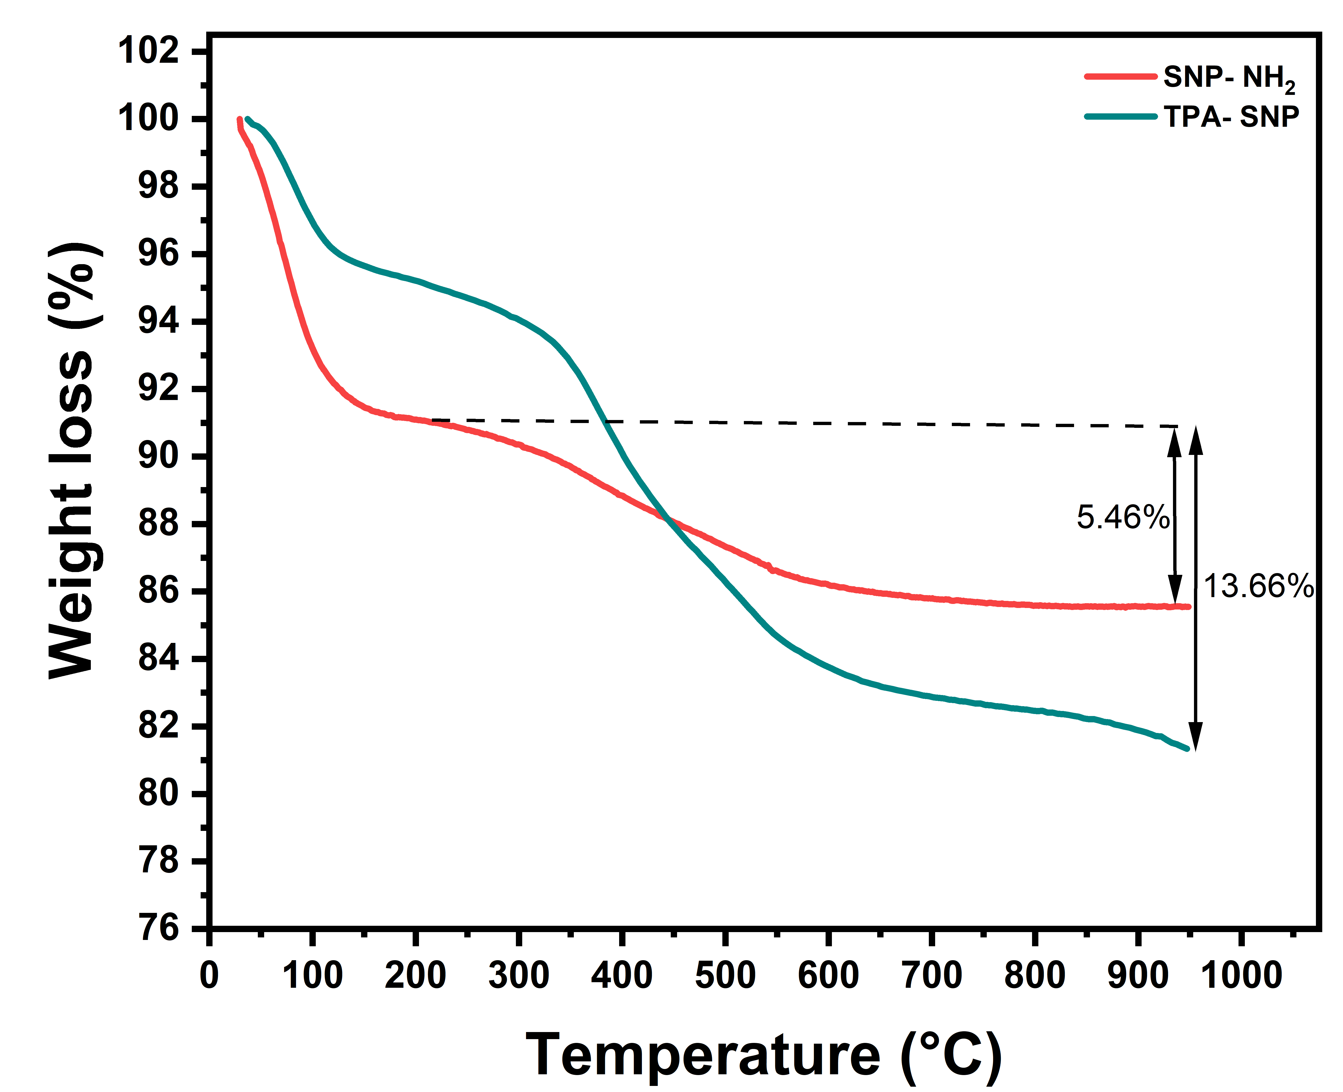
Figure S1. TGA curves of SNP–NH₂ and TPA–SNP at a heating rate of 10 °C min⁻¹.
2. Time-Dependent Fluorescence Change of TPA–SNP with Fe^{2+/3+}
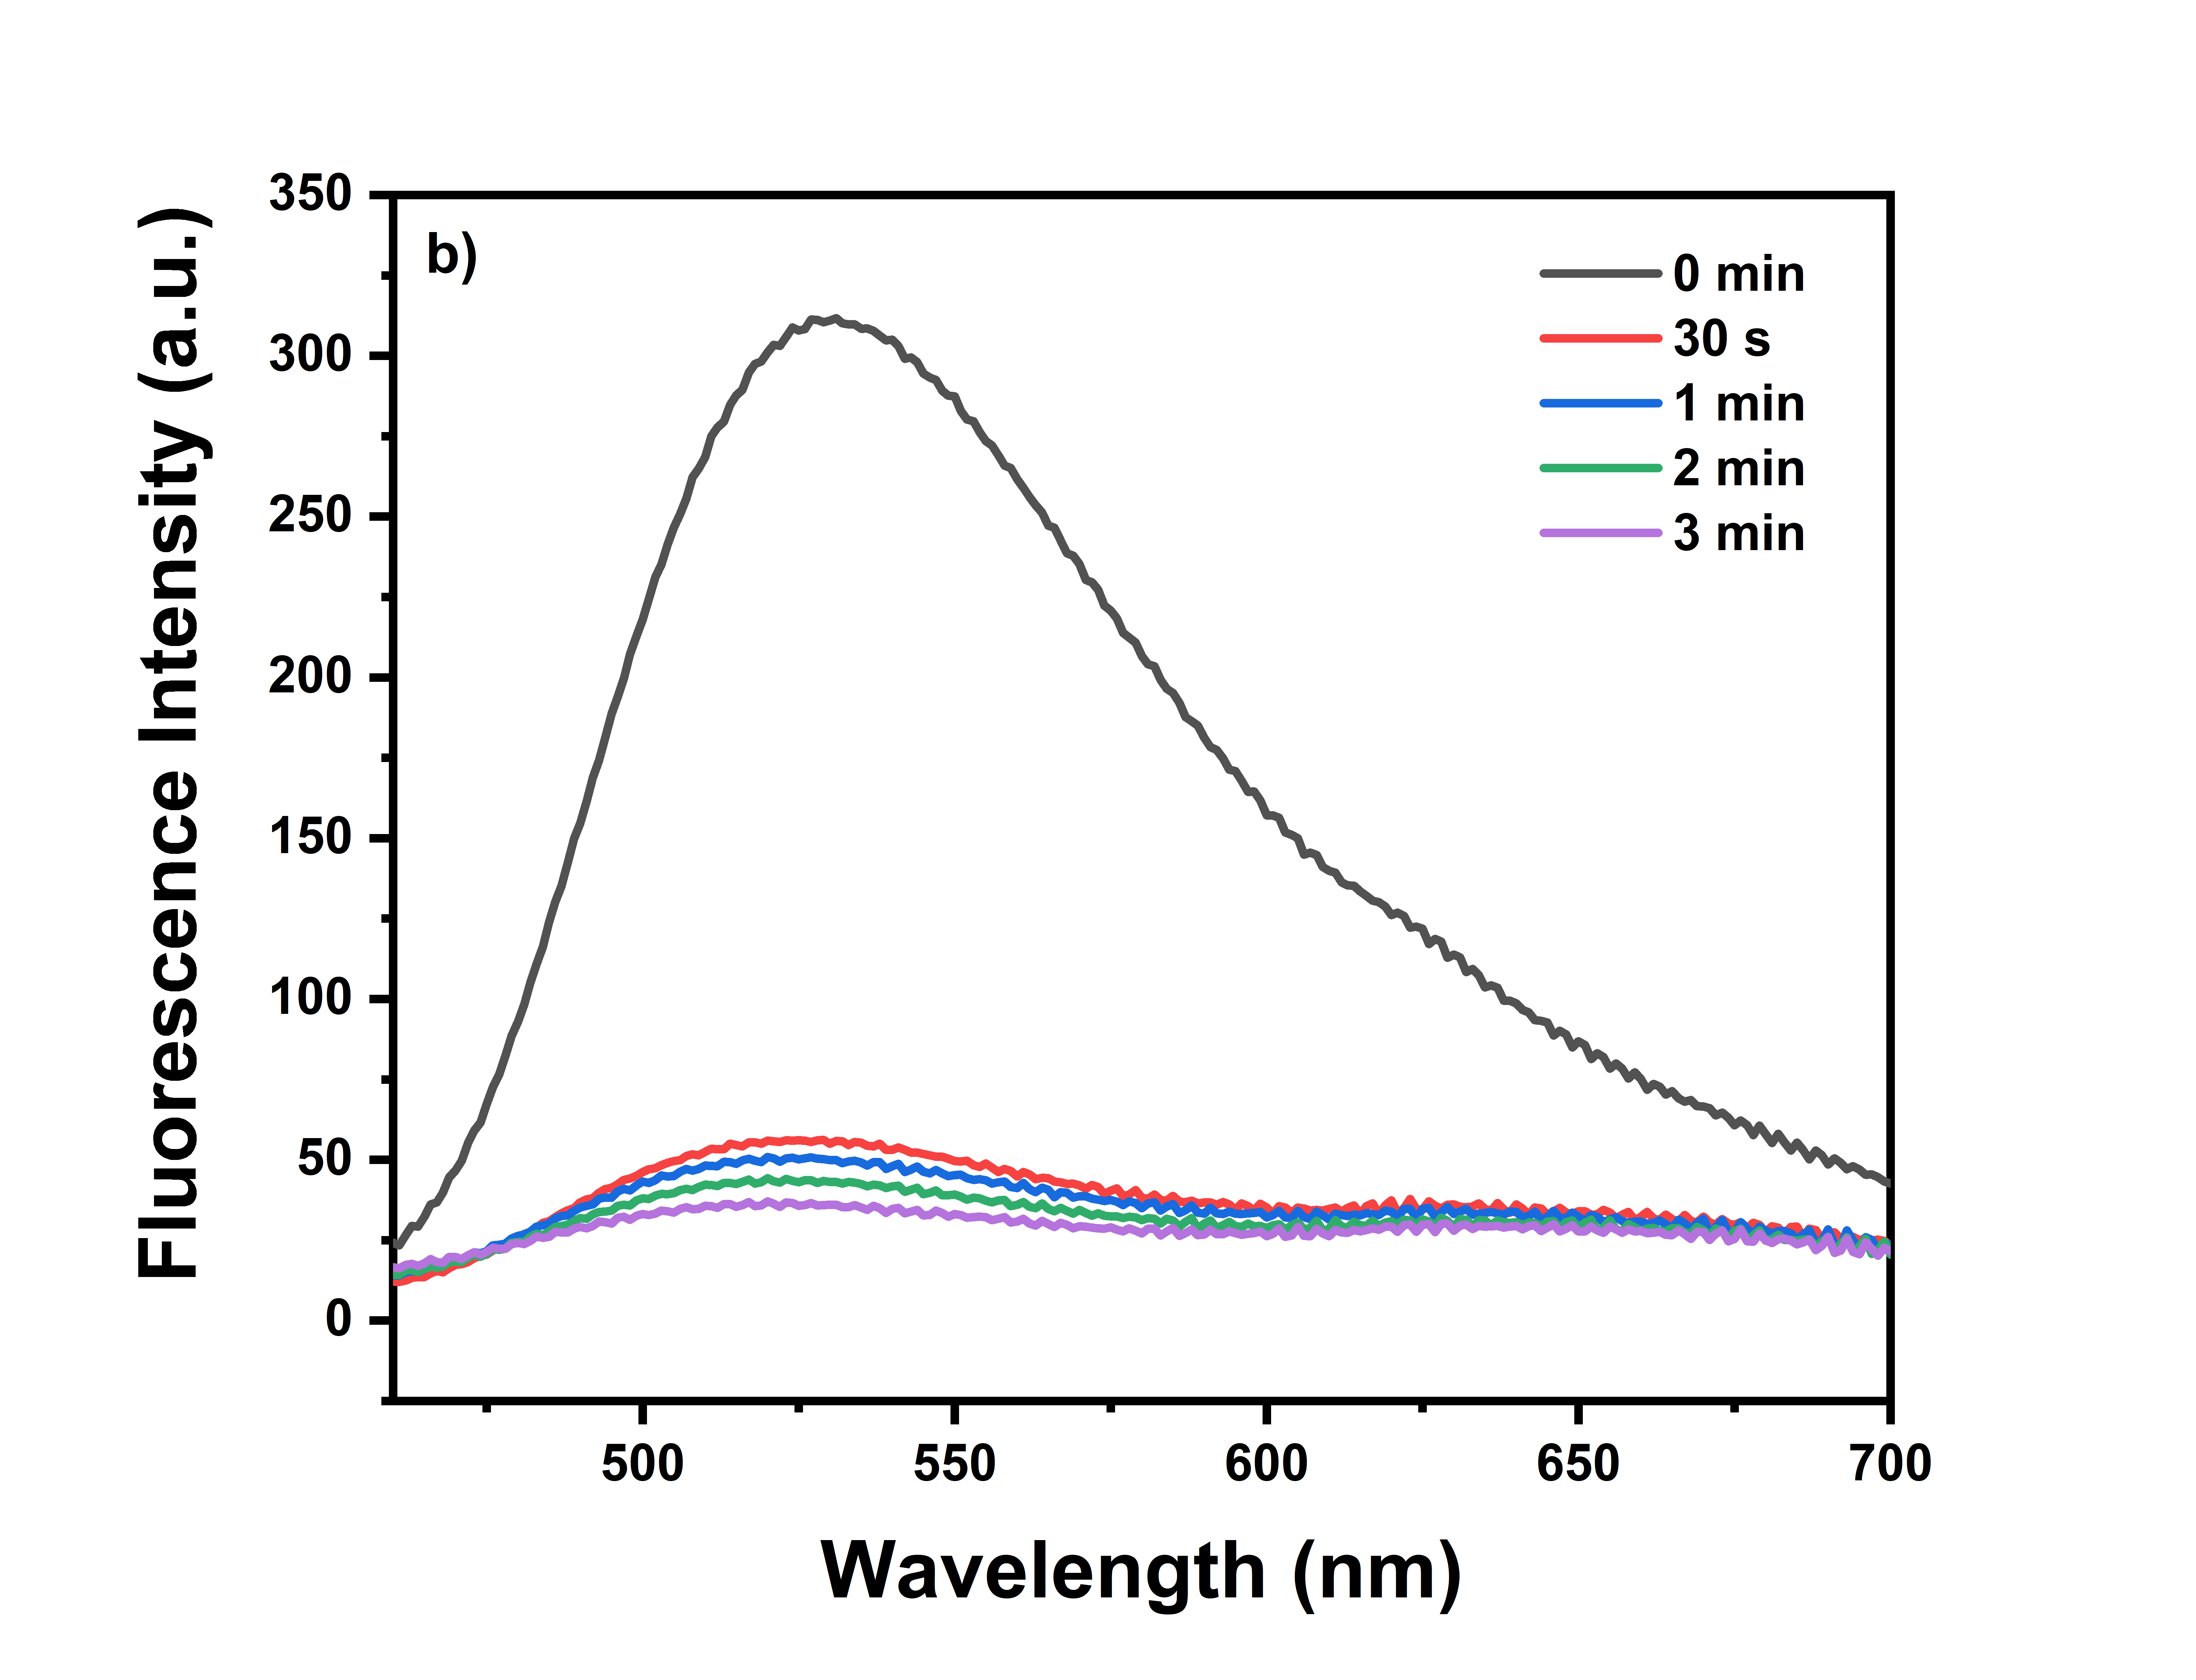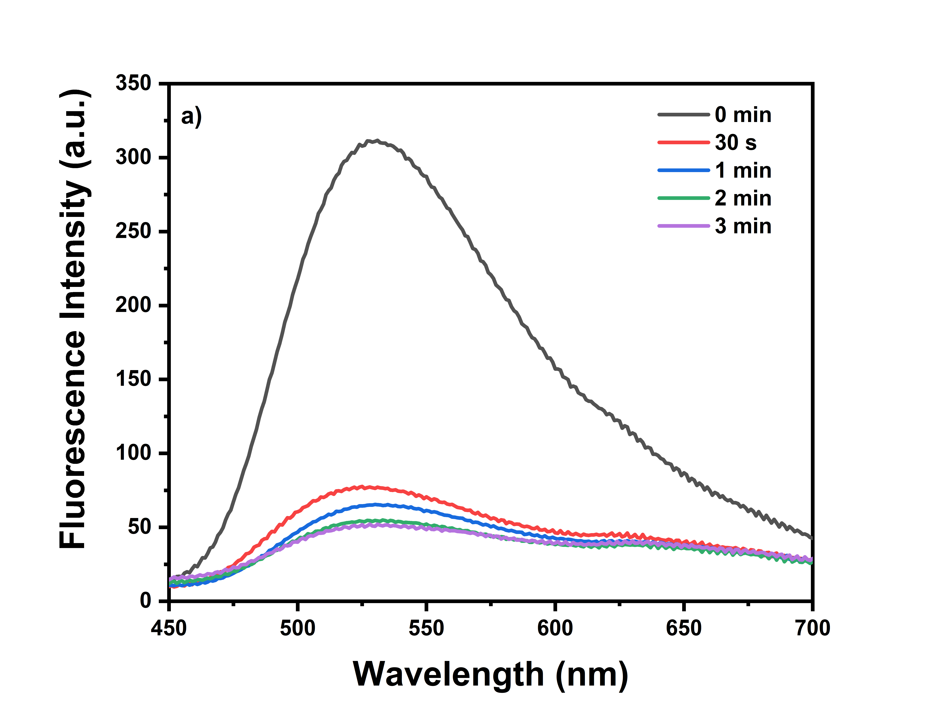
Figure S2. Time-Dependent Fluorescence Change of TPA–SNP with Fe^{2+/3+}
3. Determination of Detection Limit of Fe^{2+/3+}
The detection limit was calculated based on regression analysis. A highly precise calibration curve was established correlating fluorescence intensity with concentration within the range of 2.6 – 13.3 μM for Fe²⁺ and Fe³⁺ ions. LOD was determined using the formula LOD = 3.3σbi/m, where σbi denotes the standard deviation of all measurements based on linear regression, and m signifies the slope of the calibration curve. Linear regression analysis determined the LOD for Fe²⁺ and Fe³⁺ to be 1.24 and 0.97 μM, respectively.
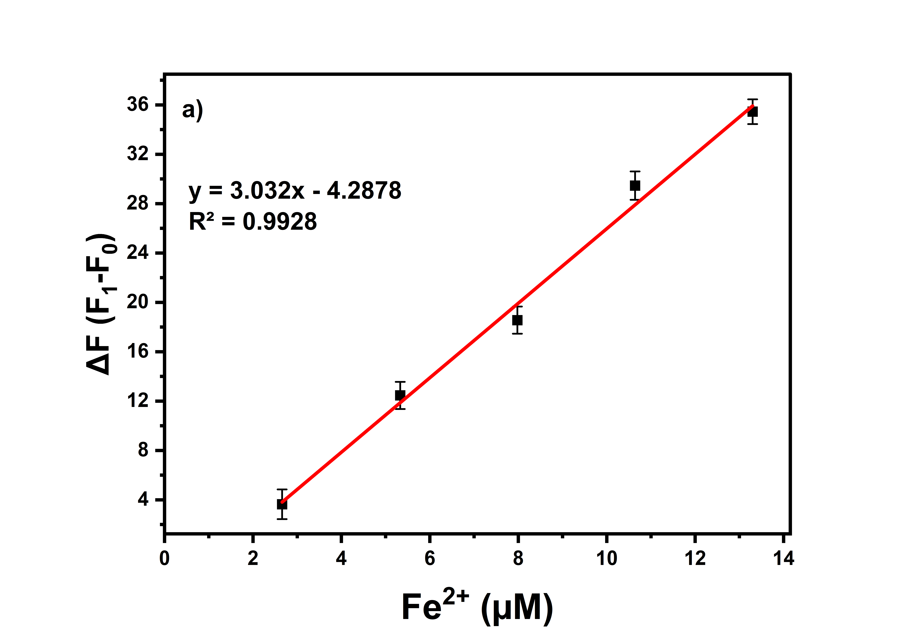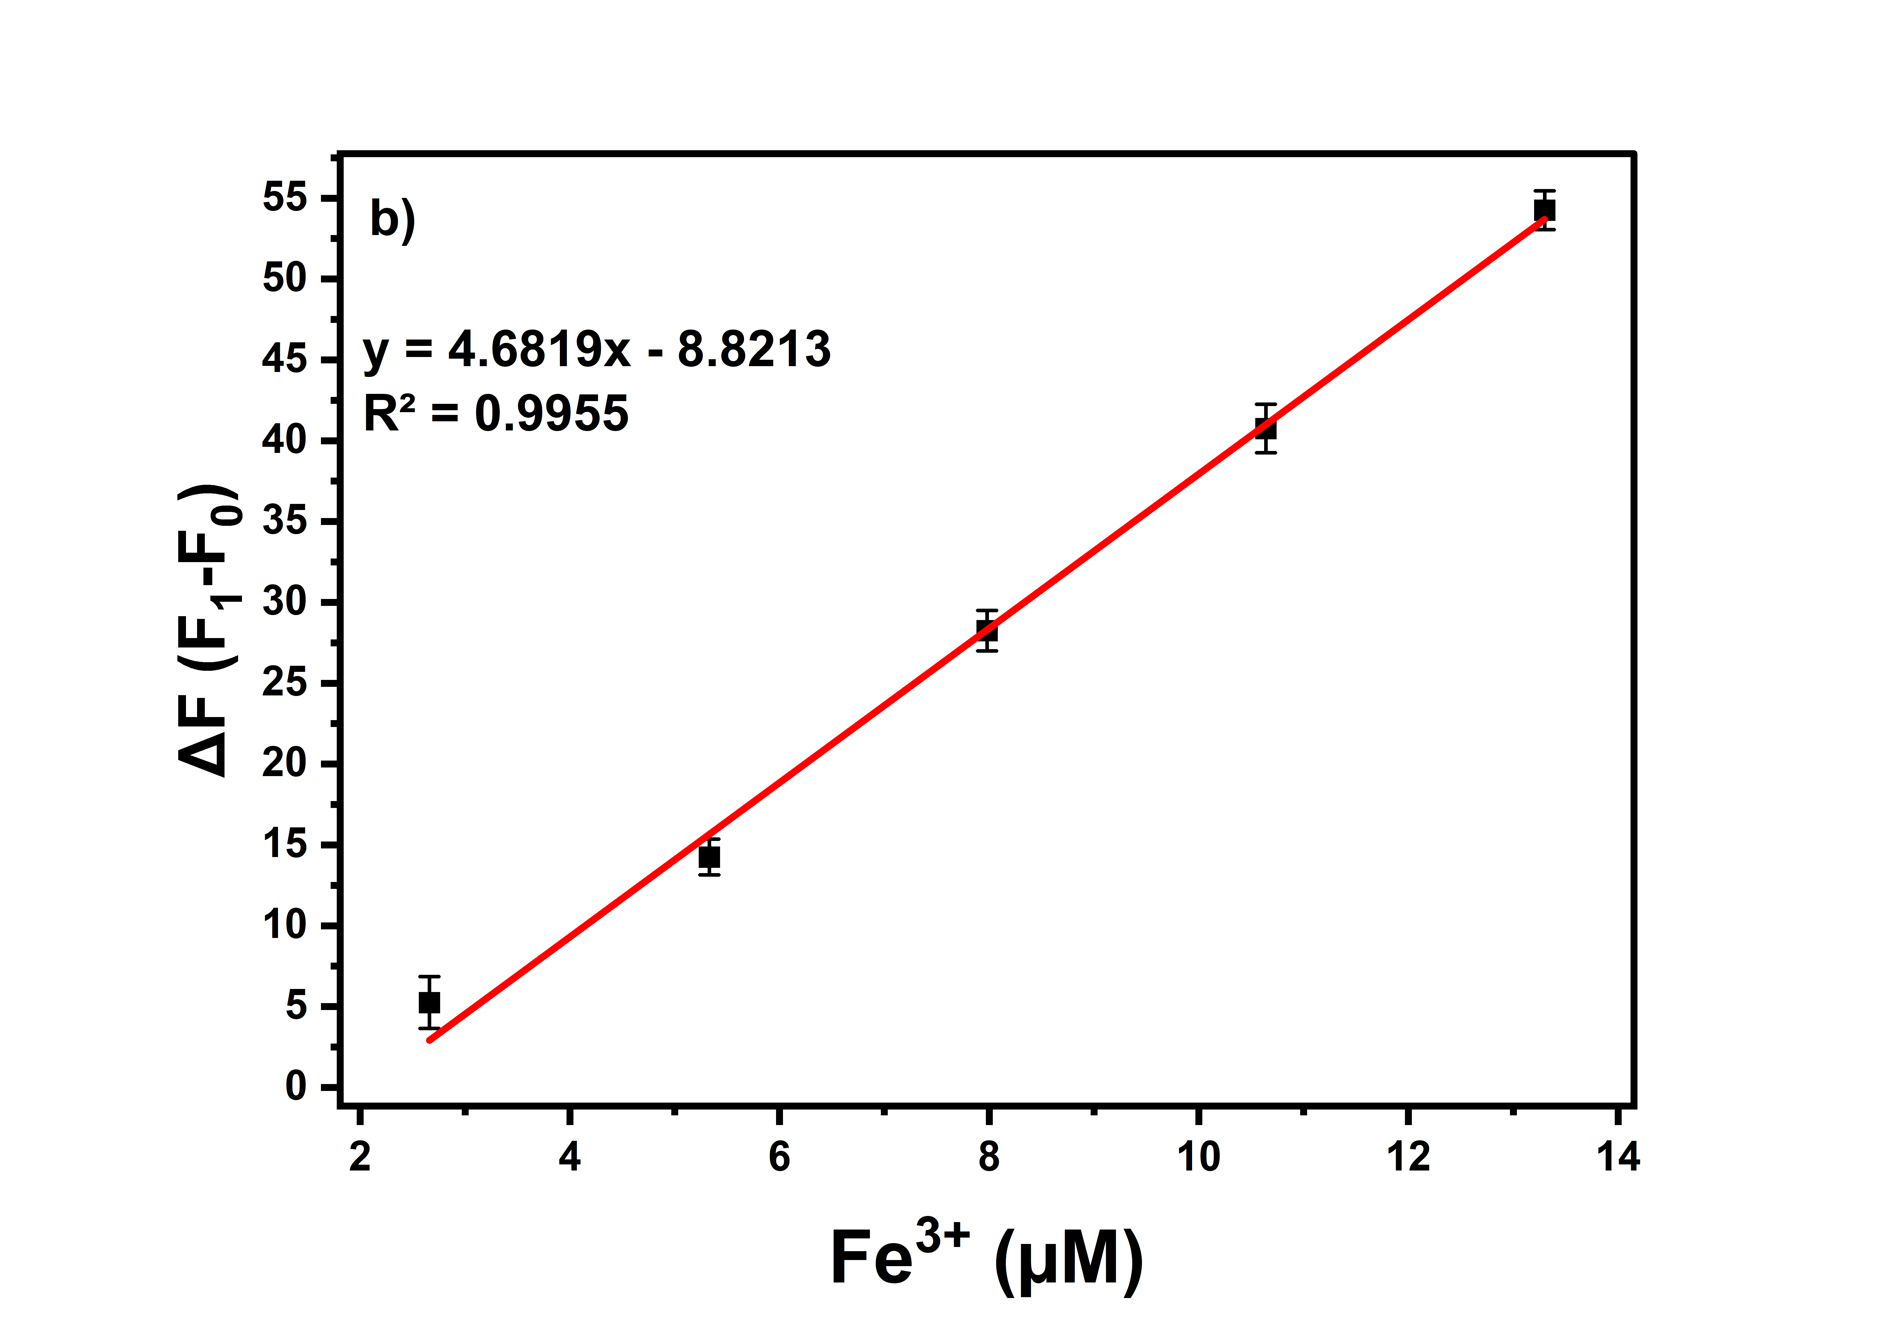
Figure S3. Fluorescence changes of TPA–SNP (25 ppm) upon addition of (a) Fe²⁺ (b) Fe³⁺ (2.6 to 13.3 μM).

4. Effect of pH
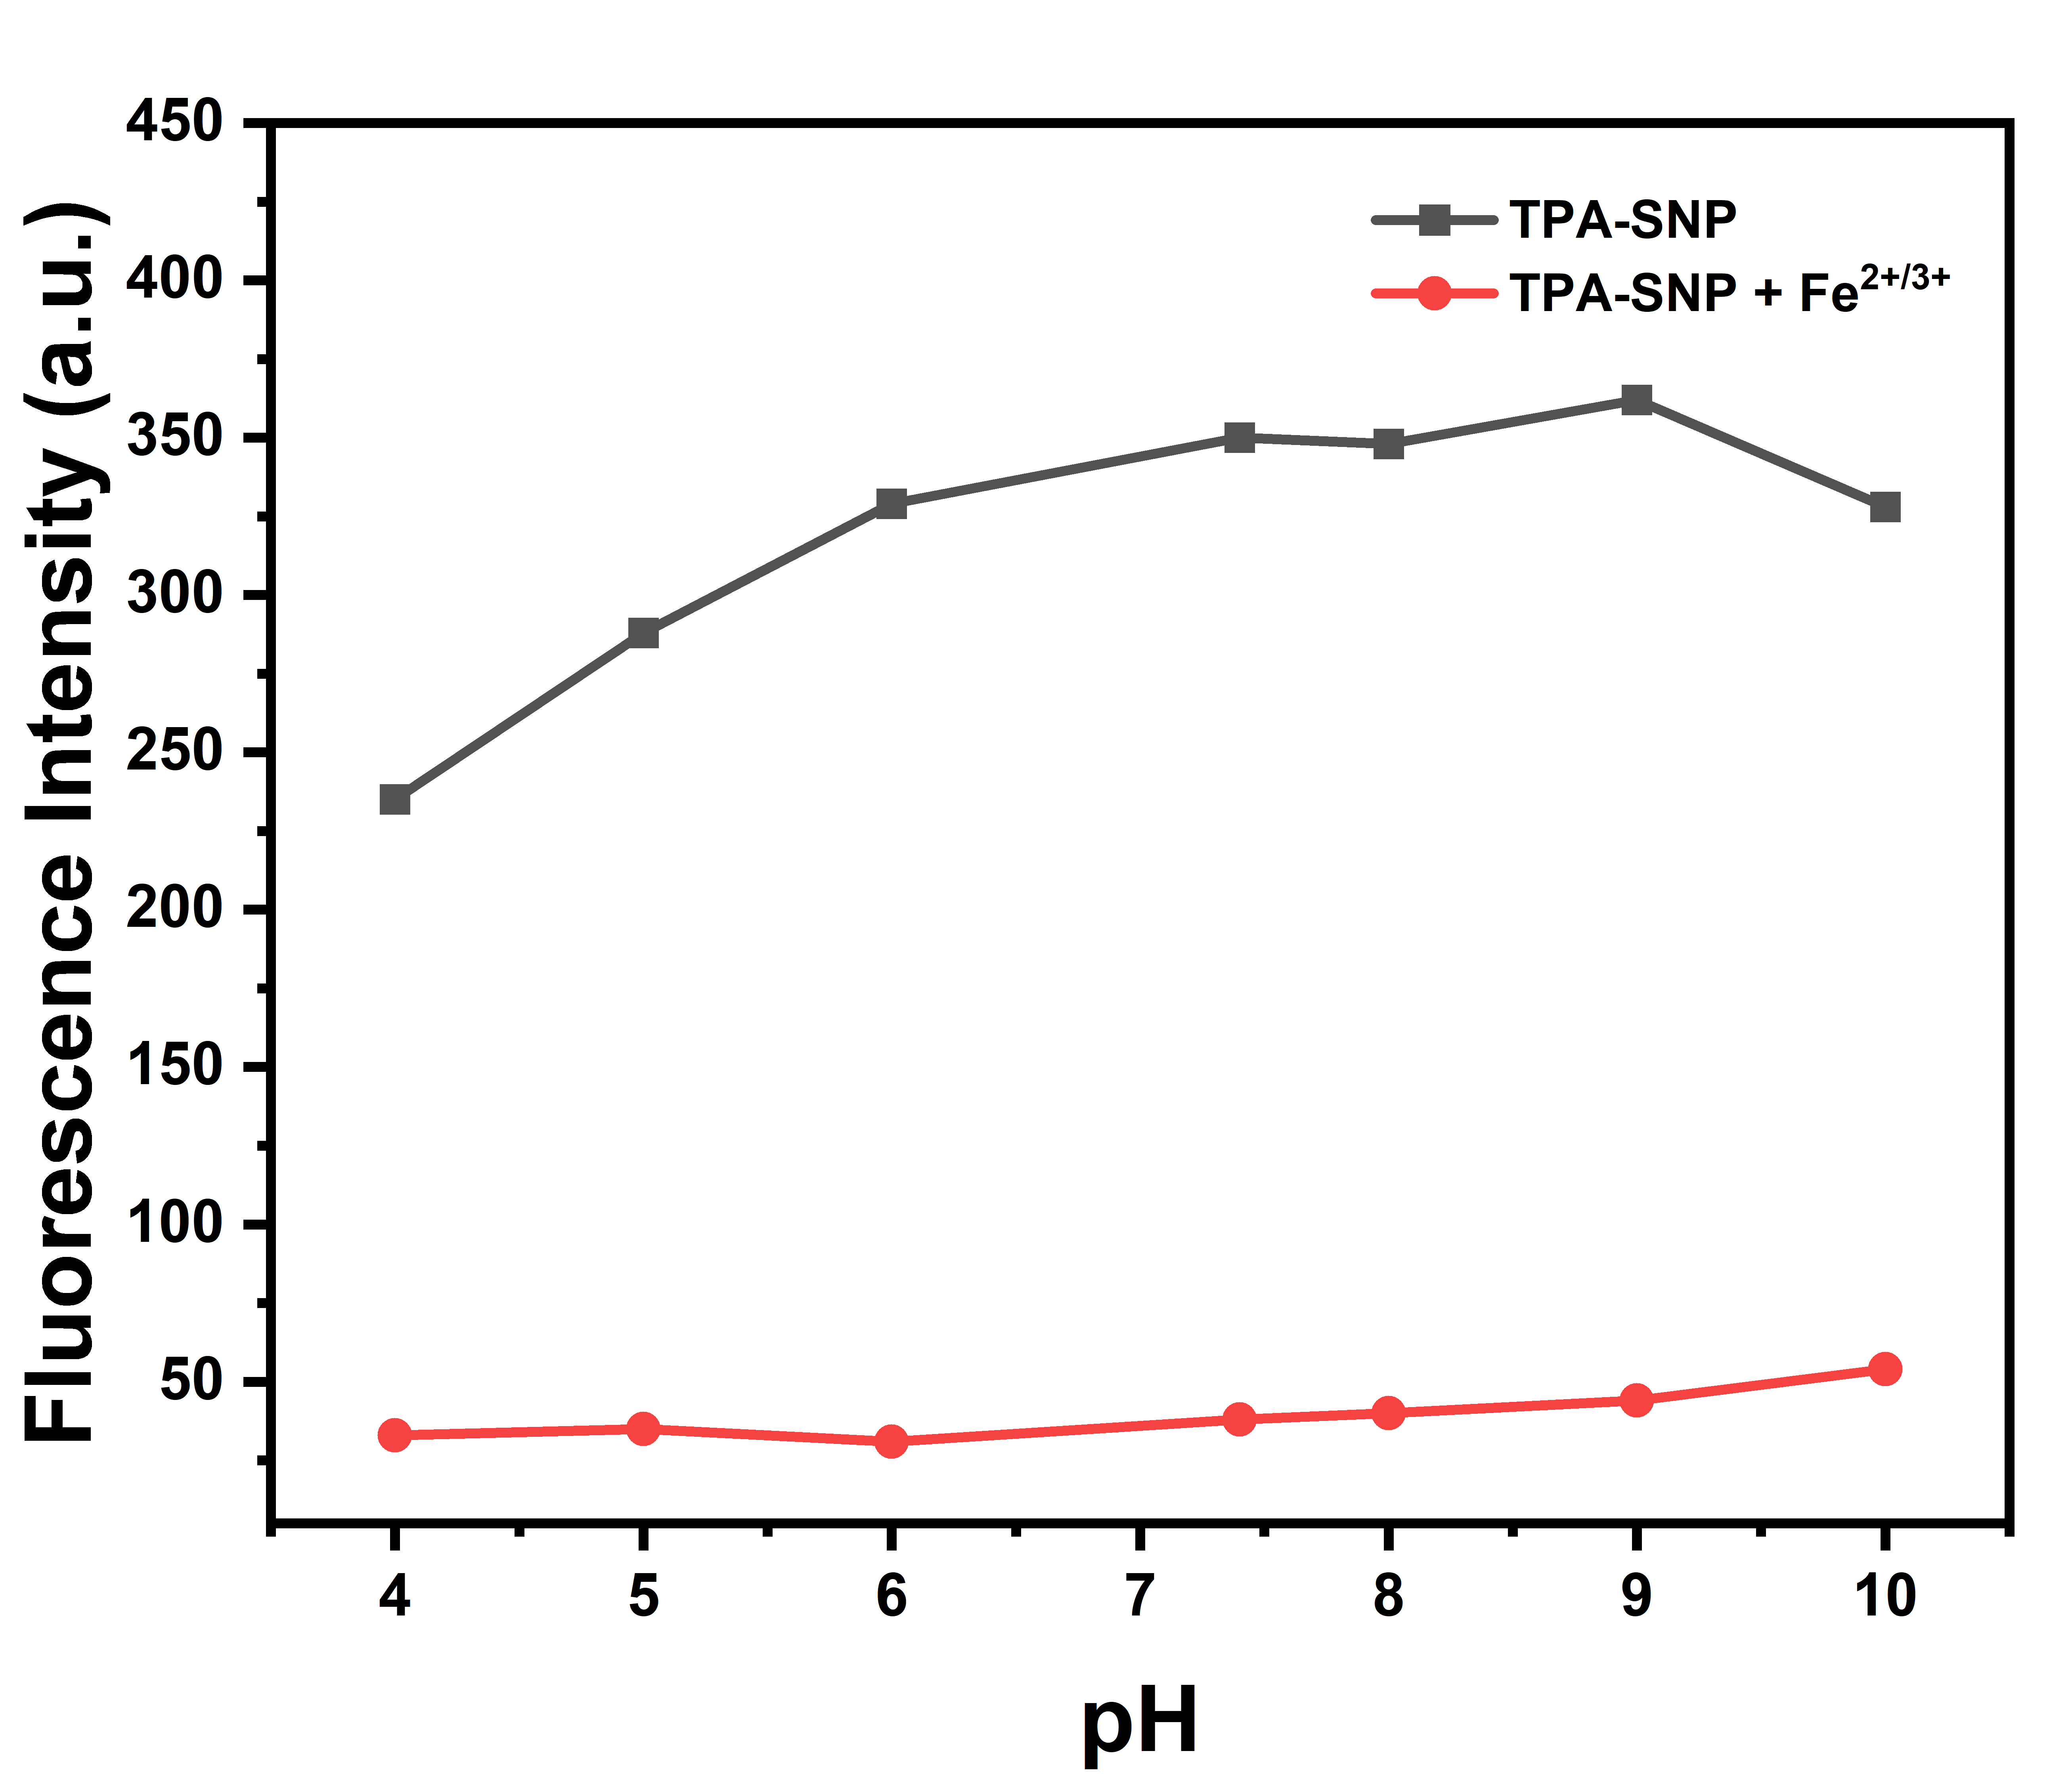
Figure S4. Effect of pH on the fluorescence intensity of TPA–SNP (25 ppm) in 1:1 THF/PBS in the absence (black line) and presence (red line) of Fe^{2+/3+} (100 µM).

5. Fluorescence and UV-Vis spectra illustrating the detection mechanism
Figure S5. (a) UV-Vis spectra and (b) fluorescence emission spectra illustrating the detection mechanism of TPA–SNP in the environment of Fe^{2+/3+}.

6. DLS Analysis of SNP, SNP-NH₂ and TPA-SNP

Figure S6. DLS Analysis of of SNP, SNP-NH₂ and TPA-SNP

Table S1. Comparison of silica nanoparticle-based fluorescent sensing systems reported for Fe³⁺ and Fe²⁺ detection

Material | Method | Mechanism | LOD | Reference
Sulfonamide-based nanocomposite (SAN) | Fluorometric analysis | Fluorescence enhancement (Fe³⁺) | 0.027 µM | 24
Salicylic acid-doped silica nanoparticles (SASP) | Fluorometric analysis | Fluorescence quenching | 0.025 µM | 23
EB-integrated mesoporous organosilica hybrids (EB–MOS) | Colorimetric and fluorometric analysis | Fluorescence quenching (Fe³⁺/Hg²⁺) | 0.448 µM | 22
Propidium iodide-integrated mesoporous silica nanoparticles (PIMSNs) | Colorimetric and fluorometric analysis | Fluorescence quenching (Fe³⁺) | 0.5 µM | 25
Rhodamine B-loaded silica nanoparticles (MRB@SiNPs) | Colorimetric and fluorometric analysis | Fluorescence enhancement (Fe³⁺) | 0.0496 µM | 26
BODIPY-modified silica nanoparticles (BOD–SNP) | Fluorometric analysis | Fluorescence enhancement (Fe³⁺) | 1.3 µM | 27
TPA-modified silica nanoparticles (TPA–SNP) | Fluorometric analysis | Fluorescence quenching (Fe³⁺/Fe²⁺) | 0.97 / 1.24 µM | This work

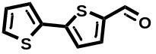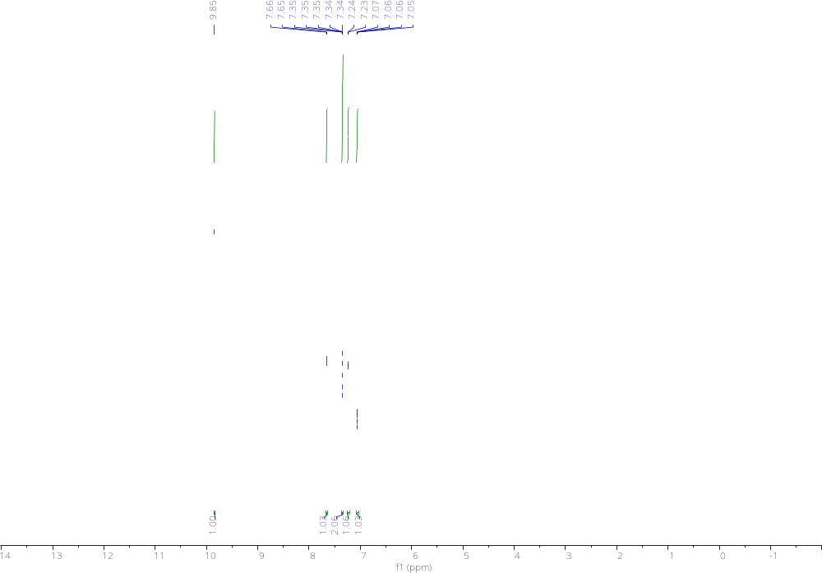
¹H NMR of T-T-AL

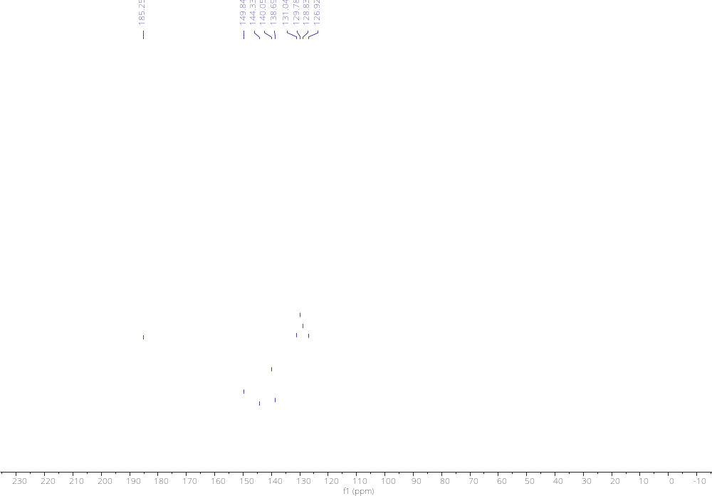
¹³C NMR of T-T-AL

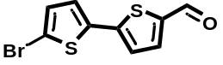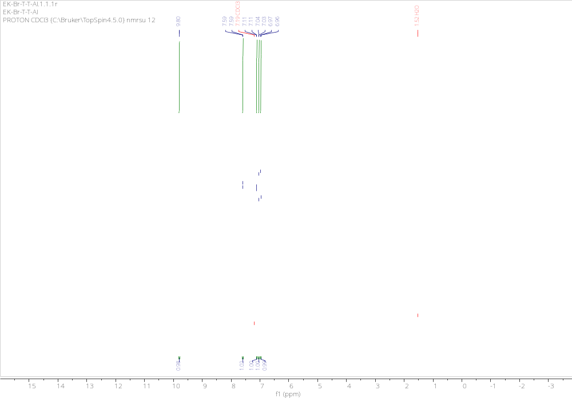
¹H NMR of Br-T-T-AL

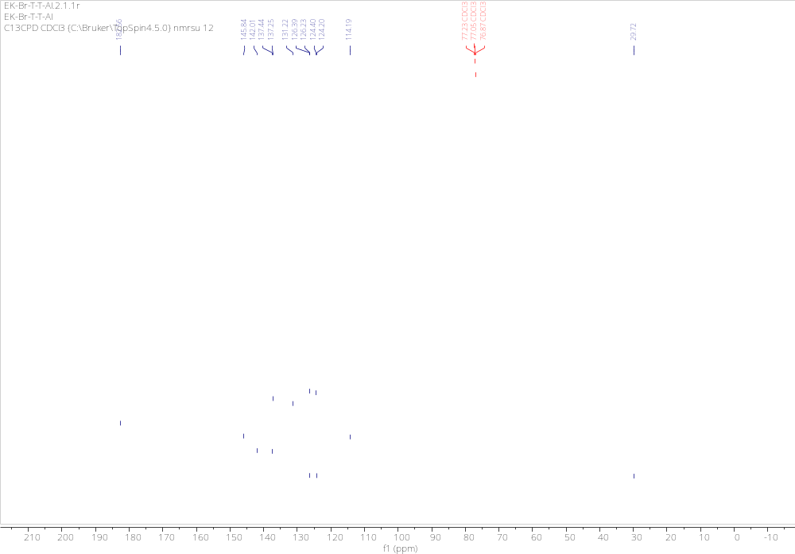
¹³C NMR of Br-T-T-AL

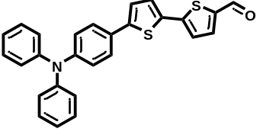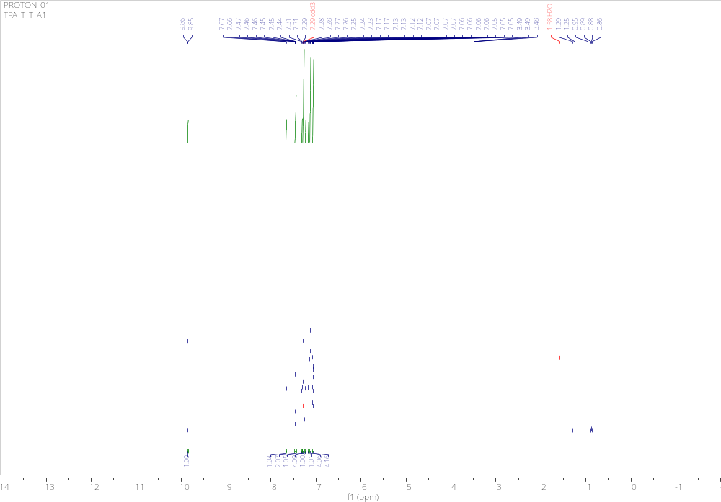
¹H NMR of TPA-AL

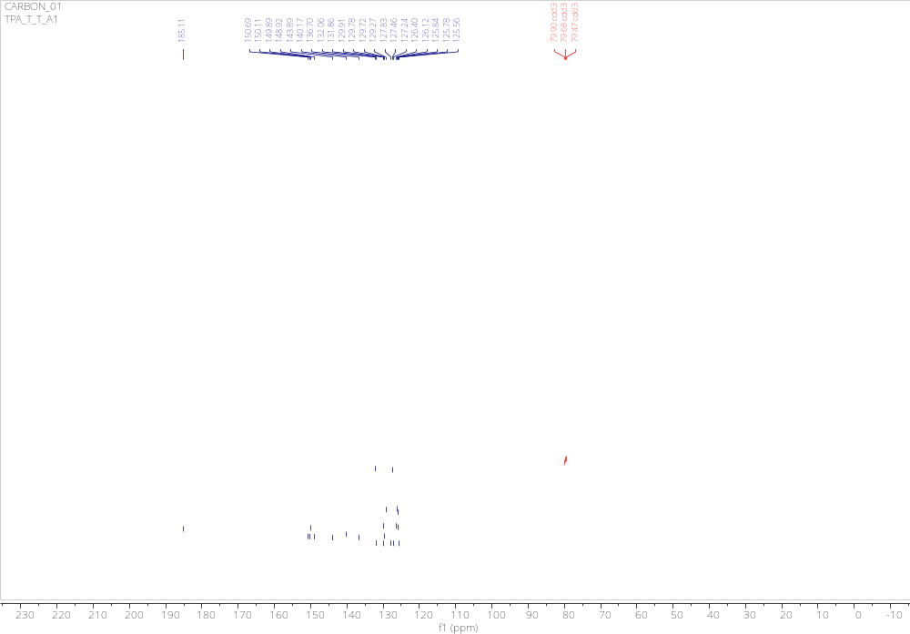
¹³C NMR of TPA-AL

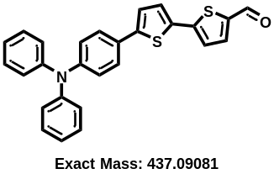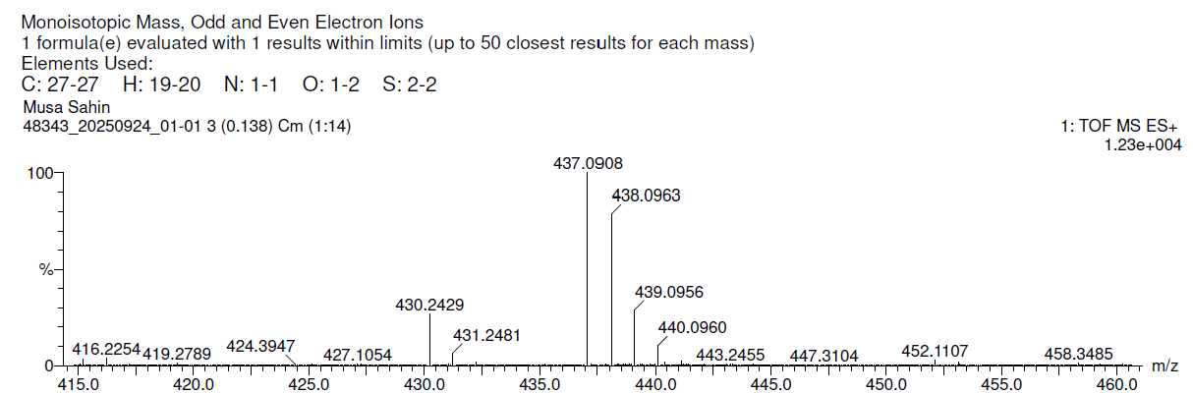
HRMS spectrum of TPA-AL

