Supplementary Information

Human encephalization accelerated late and linked to cultural complexity

Authors: Manuel Will, Jay T. Stock, Hannes Rathmann, Adam Gordon, Claudio Tennie

Supplementary Text 1
Uses and challenges of encephalization quotients in hominin brain size evolution
Since its inception as a scientific discipline, paleoanthropology has used the inferred absolute brain size of recovered fossil specimens to chart human cognitive evolution and consider whether there are specific, meaningful thresholds of brain size increase in the hominin lineage. The ‘cerebral rubicon’ for the separation of Homo from all other hominins has been a central element of this debate (Wood & Collard 1999), famously shifted down with the inclusion of Homo habilis to ~600 cm³ (Montagu 1961; Leakey et al. 1964) and potentially even further when later including Homo floresiensis (~400 cm³; Brown et al. 2004). The use of this measure faces methodological and theoretical challenges, most prominently the questionable value of an absolute value without a frame of reference. The brains of whales and elephants are much larger than those of current humans, but so are their bodies. Of course, a whale brain and a primate brain may not be comparable in terms of their internal structure, the number of neurons per volume, or neural connectivity. Yet, even among primates, brain (and body) size ranges several orders of magnitude (Boddy et al. 2012).
These issues have led some researchers to use measures of relative brain size, by ‘standardizing’ brain size with the help of some other relevant measure of body size, most often body mass (Brain-to-body mass ratio). This ratio has been further refined for comparative reasons by taking into account allometric effects of widely divergent body sizes across taxa, producing the so-called EQ (see Jerison 1973; Martin 1981). Following a widely used allometric formula for mammals and hominins by Martin (1981), EQ can be calculated as follows: (brain mass / 11.22) * body mass^0.76 (see also Ruff et al. 1997; deSousa & Cunha 2012; but see Grabowski et al. 2016 for a different formula). If the EQ is >1, brain mass is taken to be larger than expected for a species of that body size. The main advantage of using EQ is a higher comparability across species of widely different body and brain sizes (e.g., whales and mice, but also across all hominins) as both body and brain mass are relatively easily recorded in living species (Table S1).

Taxon | Order | Avg. Brain mass (g) | Avg. Body mass (g) | Taxon EQ
Homo sapiens | Primates | 1250 | 65143 | 5.72
Pan troglodytes | Primates | 355 | 60433 | 1.72
Pan paniscus | Primates | 330 | 39700 | 2.18
Pongo pygmaeus | Primates | 342 | 54229 | 1.80
Gorilla gorilla | Primates | 455 | 120975 | 1.31
Cebus capucinus | Primates | 70 | 2104 | 4.16
Delphinus delphis | Cetartiodactyla | 797 | 65087 | 3.65
Loxodonta africana | Proboscidea | 5436 | 4301340 | 1.09
Panthera leo | Carnivora | 260 | 84000 | 0.98
Table S1. Neontological data of average body mass, brain mass and taxon EQ in a selection of recent species with a focus on primates. Data from Boddy et al. 2012.
The main patterns of hominin brain evolution documented in previous studies, including those using EQ are as follows (based on Ruff et al. 1997; Rightmire 2004; deSousa & Cunha 2012; Shultz et al. 2012; Schoenemann 2013; Holloway 2015; Schrenk et al. 2015; Gingerich 2022): The late Miocene and early Pliocene are characterized by relatively small brain sizes (380 cm³) not unlike those of extant non-human apes. An early phase of slight increases in absolute and relative brain size characterizes the period ~4.5-2.5 Mya, including the genera of Ardipithecus and Australopithecus, with higher EQs compared to extant chimpanzees. In a second phase, a major evolutionary trend towards significantly larger absolute brains and EQ values occurred during ~2.5-1.5 Mya, associated with the origins of Homo and early Homo erectus in particular, also linked to a structural reorganization as inferred from endocasts (but see Ponce de Leon et al. 2021). Modest absolute brain size increases are observed within the genus Paranthropus. From ca. 1.5-0.8 Mya, a gradual increase in both brain and body size is observed within Homo (including anagenetic changes within Homo erectus). This is followed by a final phase of additional brain size gain and exponential increase in encephalization with the onset of the Middle Pleistocene and including Homo heidelbergensis, Neanderthals and Homo sapiens. Whether the overall trend of absolute and relative brain size increase within Homo is more gradual and constant (Schoenemann 2013; Du et al. 2018; Püschel et al. 2024) or step-like and punctuated (Ruff et al. 1997; Shultz et al. 2012; Gingerich 2022) remains a hotly debated topic.
Paleoanthropologists have been aware that using absolute brain size alone disregards any potential effects of changes in body size. The use of relative values, such as EQ, however, has not been without criticism. Key critiques of EQs have come from neontological studies, pointing out that there is no systematic relationship between cognitive abilities and body size and that the underlying regression formulae might not be uniformly applicable across mammals; suggesting that EQ may not be clear-cut predictor of cognitive capacities, particularly for comparisons across the entire mammalian class (e.g., Deacon 1990; Deaner et al. 2007; van Schaik et al. 2021; Smaers et al. 2021). In addition, uncertainties introduced due to associated body mass estimates may make EQ values less reliable in their estimation than absolute brain size (e.g., Shultz et al. 2012; Du et al. 2018).
A further methodical limitation for paleoanthropological interpretation stems from the fact that the calculation of EQs requires associated estimates of both brain and body size from the same individuals. The fragmentary nature of the fossil record poses a fundamental data-scarcity problem, and relatively few such EQ values predate the Late Pleistocene. A common attempt to circumvent this problem uses ‘mean EQ’ values for species by combining mean brain sizes and mean body sizes to generate what we shall call here an average ‘taxon EQ’ (see e.g., Ruff et al. 1997; deSousa & Cunha 2012; Püschel et al. 2021; Smaers et al. 2021). This approach remains problematic as it combines body and brain size estimates taken from different individuals, despite specimens within these groups potentially ranging widely in time, space and ecology. Intra-species variation, phenotypic plasticity, ecological influences and within-lineage evolutionary trends therefore add noise to the resulting averages and EQ values. Taxon EQs have low intrinsic meaning from a biological perspective, other than being united by a likely assignment to the same taxon. Moreover, taxon EQs are typically based on small sample sizes (n<5) of body and brain size, particularly before the Late Pleistocene, which means that their calculation is prone to the effects of outliers that can skew the means (Smith 2005; Schillaci & Schillaci 2009). Taxon EQ values also lack an expression of variability - the single values that result from their calculation may create a false impression of precision.
Notwithstanding these critiques - and without hope to access some of the alternative cognitive measures available to neontological studies - paleoanthropology has generally accepted EQ in its standard vocabulary, and its value is commonly included when describing key traits of hominin species or individual fossils (e.g., Rightmire 2004; Rosenberg et al. 2006; Falk et al. 2009). EQ values are also used for comparisons among taxa and across time (Ruff et al. 1997; deSousa & Cunha 2012; Schoenemann 2013; Holloway 2015; Grabowski et al. 2016). While acknowledging the limitations of the use of EQs, these studies present EQ as rough but useful proxies for cognitive abilities, particularly considering that comparisons are performed within one evolving lineage and not across the whole range of the animal kingdom or all mammals. Key advantages of using EQ then remain its comparability and allometric standardization, particularly within paleoanthropology, where other proposed measures of cognitive abilities, such as neuron counts/density, internal organization, or behavioral performance in cognitive tasks (e.g., Dunbar 1992; Healey & Krebs 1996; Stout et al. 2008; Smaers and Soligo 2013; Herculano-Houzel 2017; Smaers et al. 2021; van Schaik et al. 2021) are not available. Comparison of the relative size of specific parts of the brain, such as neocortex or prefrontal cortex size are of limited utility as these regions of the brain fossilize rarely. The current emphasis on taxon EQs in paleoanthropology continues to face challenges that may limit its potential for evaluating general cognitive change in human evolution at least when considered on its own. In summary, EQ in its current usage can be rightly criticized as an imperfect measurement of hominin cognitive abilities, but given broad correspondence between encephalization and cognition, and the lack of more nuanced methods of quantification, the approach remains useful and valuable overall. As argued in this contribution, further methodological and empirical advances are possible and, in doing so as by combining it with a paleodeme approach, EQ can re-emerge as a useful albeit still coarse measurement in fields such as paleoanthropology in which there are no or few higher-quality alternatives.
Supplementary Text 2
In this section we provide the results for the new calculations of taxon and individual EQs. First, a comparison of the current standard measure of taxon EQ derived from our database is presented below (Figure S1). The full data for the paleodeme EQs are provided in Table S2 and Figure S2 for comparison. Importantly, at the coarse - taxon averaging - standard resolution, the patterns of EQ that we observe within our dataset are similar to those noted in previous studies (Ruff et al. 1997; Rightmire 2004; deSousa & Cunha 2012; Shultz et al. 2012; Schoenemann 2013; Gingerich 2022), yet based on a larger dataset. Patterns that become evident at our more fine-grained types of EQ calculation (see below) are invisible as taxon EQs only provide a single mean value. Taxon EQ patterns found in this study for a total of 17 taxa are as follows. From oldest to youngest, Ar. ramidus, Au. Anamnesis, Au. prometheus and Au. afarensis show the lowest values of EQs, ranging between 1.54 (Ar. ramidus) up until 2.19 (Au. prometheus), most comparable to chimpanzees. These are followed by a slight increase in the younger Au. africanus (EQ=2.52) and Au. sediba (EQ=2.31). More notably, our expanded database finds that most Paranthropus species (EQ=2.57-2.84) show comparable taxon EQ values to Homo habilis (taxon EQ=2.70), Early Homo (taxon EQ=3.09), Homo naledi (taxon EQ=3.03) and Homo floresiensis (taxon EQ=2.52). Homo erectus s.l. sits slightly higher at taxon EQ=3.39. Only Mid-Pleistocene Homo, Neanderthals and Homo sapiens exhibit average taxon EQ values >4, with Homo sapiens topping the taxon chart at a value of 5.34 which doubles the figure of Homo habilis.
We calculated ‘individual EQs’ for n=66 hominin specimens (4.4 Mya - 11 ka; Figure S3). While this number of specimens illustrates how few fossils of sufficient completeness exist that provide both brain size and postcranial body mass estimates across over 4 million years of evolution, data for Late Pleistocene Homo sapiens (n=30; mean EQ=5.27) and to a lesser degree of Neanderthals (n=10; mean EQ=4.77) and Mid-Pleistocene Homo (n=8; mean EQ=4.21), give a sufficient approximation of actual individual EQs to make comparisons meaningful. Plotting these results across time and taxa (Figure S3) shows that >1.0 Mya, individual EQs are predominantly <3 and only later consistently >3, with a particular increase in the Middle Pleistocene. The results from two individuals representing early Homo erectus s.l., D2600 from Dmanisi at 1.8 Mya and an adult projection of KNM-WT 15000 at 1.47 Mya, fall within or only slightly above the EQ range of Au. garhi, Au. afarensis (Lucy) and H. floresiensis. The skewed distribution of individual EQs by time (89% of values <1.0 Mya) and taxa (e.g., Homo erectus s.l. n=2; mean individual EQ=2,63, most taxa n=1) prevents a detailed discussion of changes by taxon or through time using individual EQ.

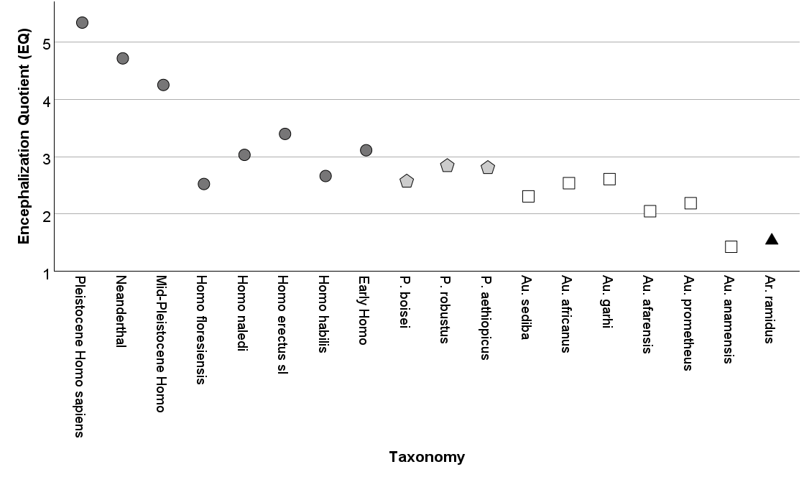
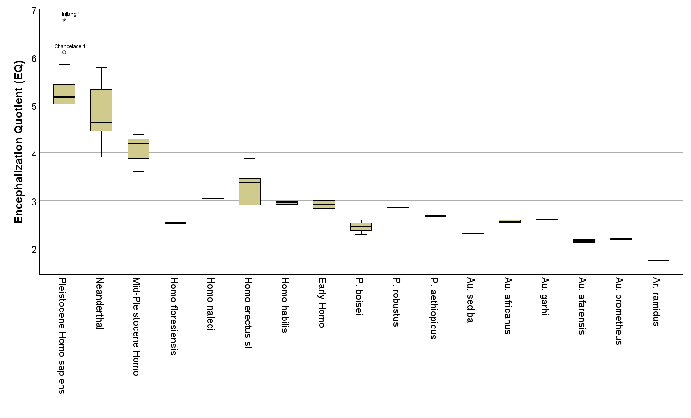
Figure S1. Top: Average taxon EQs by species ordered by genus and from older to younger. Bottom: Paleodeme EQ data grouped by the same taxa. Note the intra-specific variation (e.g., for Homo erectus s.l.) made visible for each taxon by using the paleodeme EQ approach.

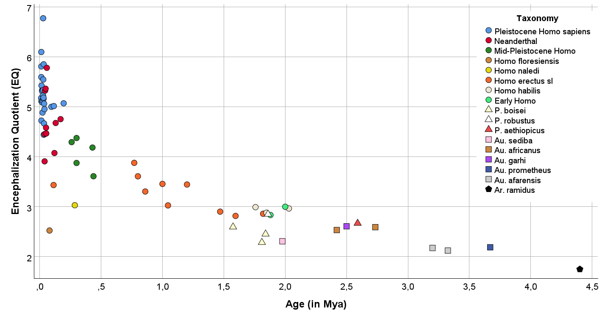
Figure S2. Scatterplot of Paleodeme EQs with taxonomic indication.

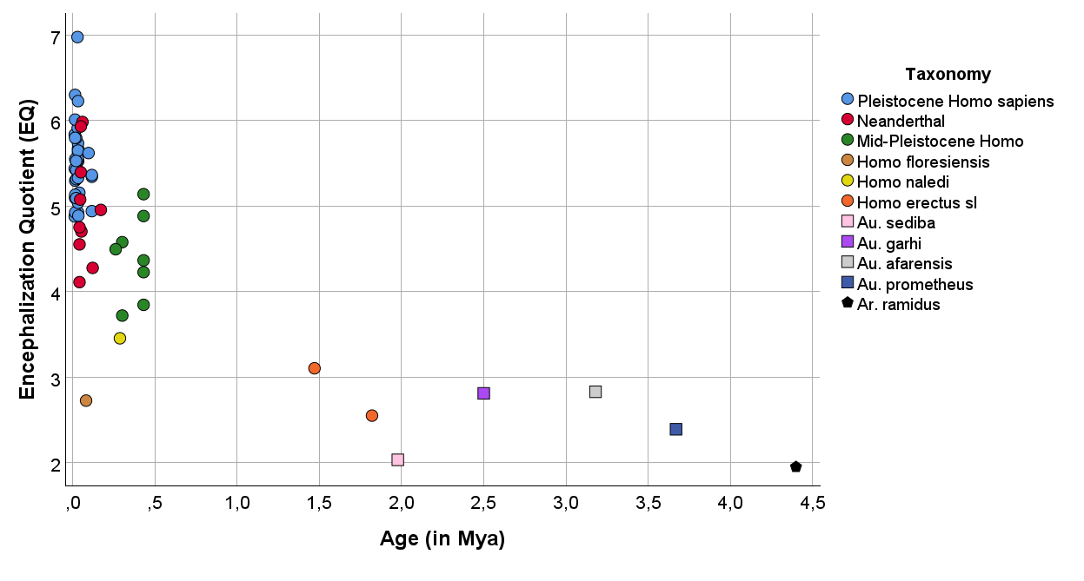
Figure S3: Scatterplot of individual EQ for fossil specimens with species designation.

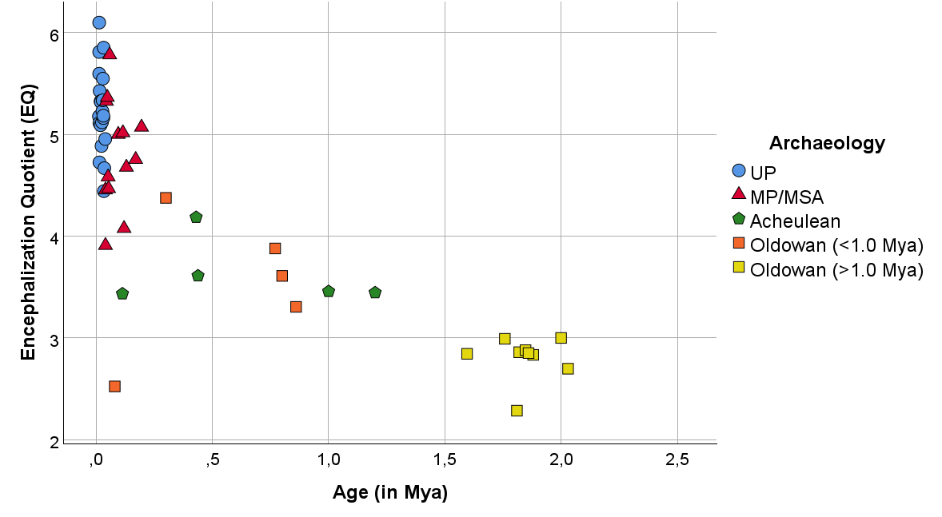
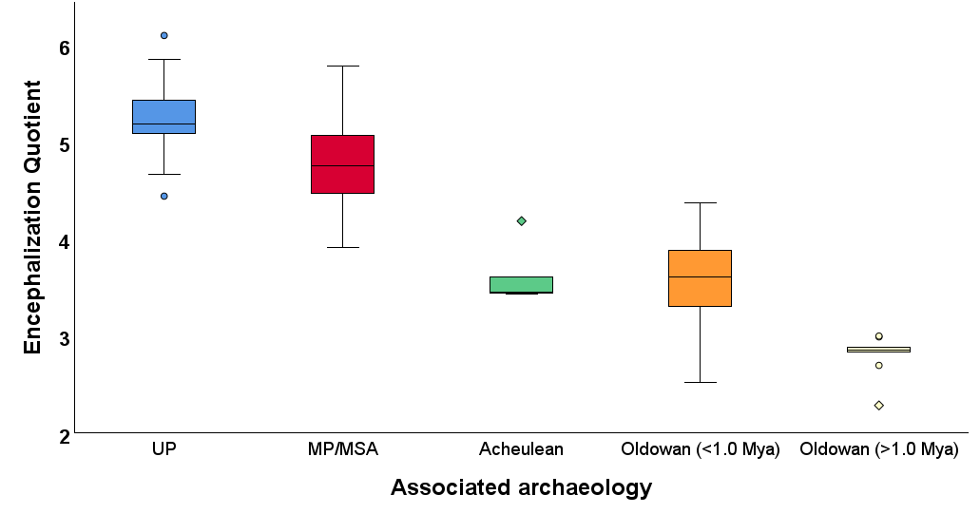
Figure S4. Paleodeme EQs with associated archaeology. Sample sizes (n): UP=21; MP/MSA=13; Acheulean=5; Oldowan(<1.0 Mya)=5; Oldowan (>1.0 Mya)=9.

Taxon | Paleodemes (n) | Body sizes (n) | Brain sizes (n) | Mean EQ | Range EQ
Pleistocene Homo sapiens | 26 | 66 | 61 | 5.29 | 4.44-6.77
Neanderthal | 10 | 23 | 15 | 4.74 | 3.91-5.78
Mid-Pleistocene Homo | 5 | 34 | 18 | 4.08 | 3.61-4.38
Homo floresiensis | 1 | 1 | 1 | 2.52 | -
Homo naledi | 1 | 9 | 3 | 3.03 | -
Homo erectus s.l. | 11 | 25 | 26 | 3.24 | 2.56-3.88
Homo habilis | 3 | 8 | 9 | 2.94 | 2.88-2.99
Early Homo | 2 | 9 | 3 | 2.92 | 2.83-3.00
Paranthropus boisei | 4 | 10 | 7 | 2.47 | 2.28-2.66
Paranthrobus robustus | 1 | 6 | 8 | 2.85 | -
Paranthropus aethiopicus | 1 | 1 | 1 | 2.67 | -
Australopithecus sediba | 1 | 3 | 1 | 2.31 | -
Australopithecus africanus | 2 | 24 | 7 | 2.55 | 2.51-2.59
Australopithecus garhi | 1 | 1 | 1 | 2.61 | -
Australopithecus afarensis | 2 | 16 | 5 | 2.03 | 1.94-2.12
Australopithecus prometheus | 1 | 1 | 1 | 2.19 | -
Ardipithecus ramidus | 1 | 1 | 1 | 1.75 | -
Table S2. Table of summary data for the calculation of Paleodeme EQs.

Supplementary Text 3
Phylogenetic piecewise regression analyses
Standard phylogenetic generalized least squares (PGLS) approaches cannot be used to fit linear models that incorporate phylogenetic information into the error structure of the model when multiple data points are present for any taxon present in the phylogenetic tree (as is the case for the paleodeme-level and individual-level datasets). In order to account for phylogeny and repeated measures within taxa, phylogenetic piecewise regression models with repeated measures were fit using Bayesian generalized linear models in the R package brms (Bürkner, 2017, 2018, 2021). A composite phylogeny for the taxa used in this study was compiled following Caparros & Prat (2021) and Ni et al. (2021) (Figure S5).
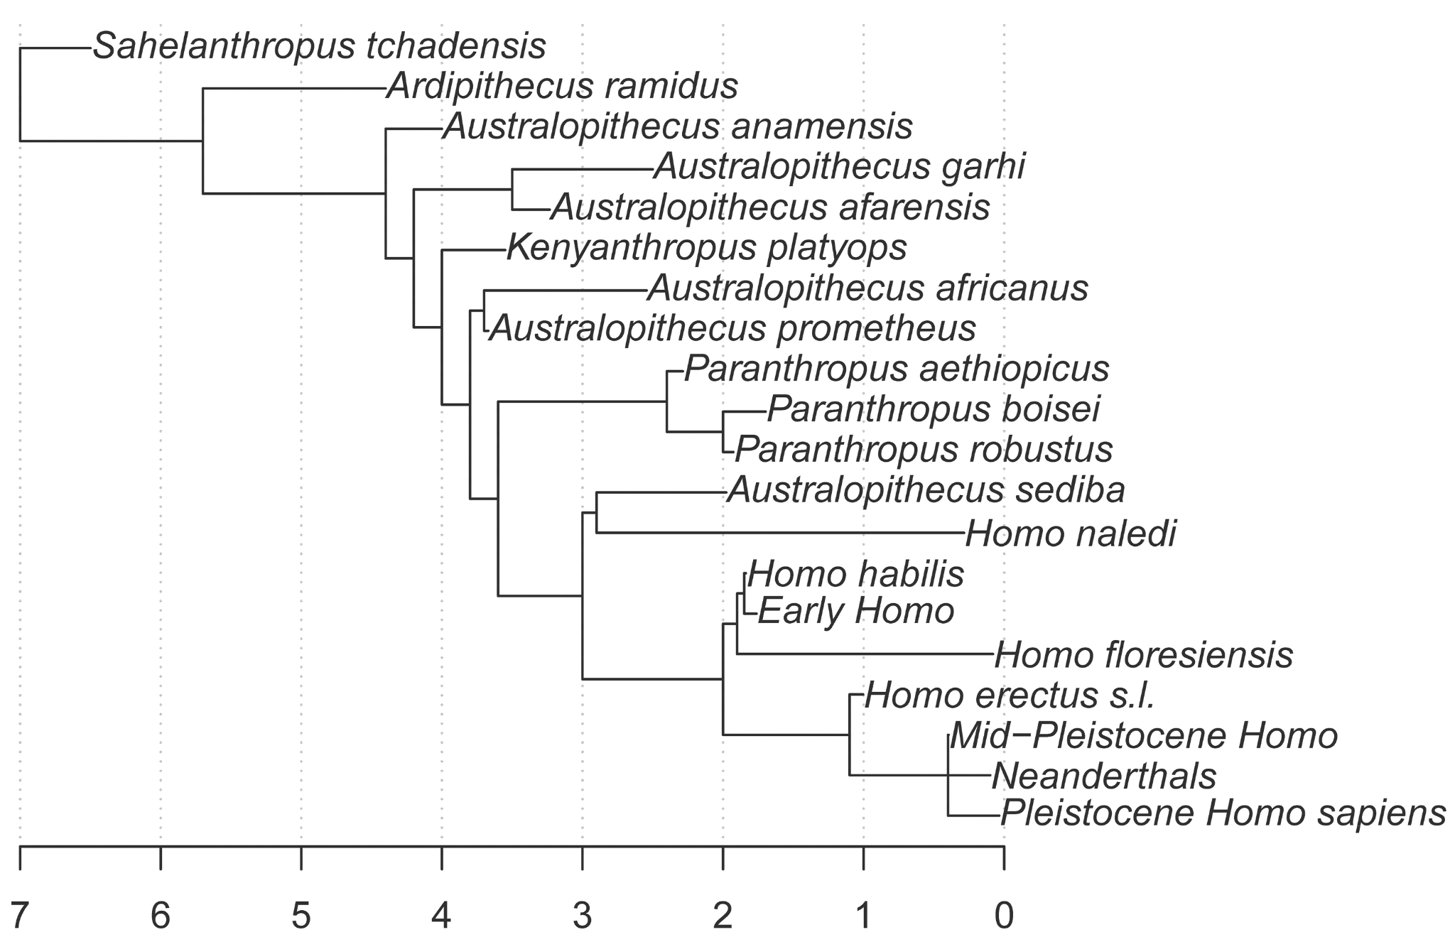
Figure S5. Phylogeny of taxa in these analyses, based on Caparros & Prat (2021) and Ni et al. (2021).
For the two independent variables of brain size and EQ, two-piece regression models with repeated measures and phylogeny treated as random effects were fit for each dataset (i.e., individuals, paleodemes, and taxa) both with and without including Homo floresiensis and H. naledi. In addition, each model was fit twice with two different prior distributions for the breakpoint: an inverse logit prior mapped to the time range of the sample (model 1), and a completely uninformative (uniform) prior spanning the sample time range (model 2). One-piece regression models were also run for comparison to determine whether two-piece models fit the data better. For each model, 4 chains were run for 1,000,000 iterations with a burn-in of 300,000 iterations and a thinning factor of 1,000.
Across both dependent variables (EQ and brain size) for all levels of analysis (data points corresponding to individual specimens, paleodeme means, or taxon means), and regardless of inclusion of the two small-brained recent taxa, a 2-piece model is always either the best model as indicated by WAIC or is effectively indistinguishable from the 1-piece model (ΔWAIC <= 2) (Table S3). However, in all cases the 95% credibility intervals for the piecewise regression breakpoints span either the entire time range of the sample (0 to 4.4 mya) or almost the entire time range (Table S3, Figures S6 & 7); in all cases the 95% credibility intervals include the breakpoint estimate for the corresponding two-piece model in the main text.

Level of analysis | With or without Homo naledi and H. floresiensis | Dependent variable | Number of pieces | Breakpoint prior | WAIC | ΔWAIC | Breakpoint estimate | Breakpoint 95% credibility interval
taxa | with | EQ | 1 | - | 9.26 | 0.00 | - | -
taxa | with | EQ | 2 | inv. logit | 10.80 | 1.54 | 3.79 | 0.00 - 4.40
taxa | with | EQ | 2 | uniform | 12.01 | 2.75 | 3.20 | 0.02 - 4.38
paleodemes | with | EQ | 1 | - | 91.07 | 0.00 | - | -
paleodemes | with | EQ | 2 | inv. logit | 92.57 | 1.49 | 3.69 | 0.00 - 4.40
paleodemes | with | EQ | 2 | uniform | 93.23 | 2.16 | 3.25 | 0.02 - 4.38
specimens | with | EQ | 1 | - | 99.69 | 0.00 | - | -
specimens | with | EQ | 2 | inv. logit | 101.03 | 1.34 | 3.26 | 0.00 - 4.40
specimens | with | EQ | 2 | uniform | 101.72 | 2.02 | 2.99 | 0.04 - 4.36
taxa | with | brain size | 2 | inv. logit | 170.48 | 0.00 | 2.18 | 0.01 - 4.39
taxa | with | brain size | 2 | uniform | 173.13 | 2.65 | 2.06 | 0.05 - 4.35
taxa | with | brain size | 1 | - | 183.04 | 12.56 | - | -
paleodemes | with | brain size | 2 | inv. logit | 905.70 | 0.00 | 2.17 | 0.01 - 4.39
paleodemes | with | brain size | 1 | - | 906.03 | 0.34 | - | -
paleodemes | with | brain size | 2 | uniform | 906.18 | 0.48 | 2.81 | 0.03 - 4.38
specimens | with | brain size | 2 | uniform | 866.24 | 0.00 | 2.48 | 0.06 - 4.34
specimens | with | brain size | 2 | inv. logit | 866.31 | 0.07 | 2.20 | 0.01 - 4.39
specimens | with | brain size | 1 | - | 866.39 | 0.15 | - | -
taxa | without | EQ | 2 | inv. logit | 7.59 | 0.00 | 3.64 | 0.00 - 4.40
taxa | without | EQ | 2 | uniform | 8.04 | 0.45 | 2.82 | 0.02 - 4.38
taxa | without | EQ | 1 | - | 10.69 | 3.10 | - | -
paleodemes | without | EQ | 1 | - | 87.71 | 0.00 | - | -
paleodemes | without | EQ | 2 | inv. logit | 89.53 | 1.82 | 3.63 | 0.00 - 4.40
paleodemes | without | EQ | 2 | uniform | 89.97 | 2.26 | 3.28 | 0.02 - 4.38
specimens | without | EQ | 1 | - | 96.61 | 0.00 | - | -
specimens | without | EQ | 2 | inv. logit | 97.39 | 0.78 | 3.25 | 0.01 - 4.40
specimens | without | EQ | 2 | uniform | 97.49 | 0.87 | 2.92 | 0.05 - 4.35
taxa | without | brain size | 2 | uniform | 151.02 | 0.00 | 1.85 | .078 - 3.10
taxa | without | brain size | 2 | inv. logit | 151.90 | 0.87 | 2.09 | 0.01 - 4.39
taxa | without | brain size | 1 | - | 170.05 | 19.03 | - | -
paleodemes | without | brain size | 2 | inv. logit | 878.74 | 0.00 | 2.68 | 0.02 - 4.39
paleodemes | without | brain size | 1 | - | 879.78 | 1.04 | - | -
paleodemes | without | brain size | 2 | uniform | 880.78 | 2.05 | 2.54 | 0.05 - 4.37
specimens | without | brain size | 2 | uniform | 836.54 | 0.00 | 2.45 | 0.12 - 4.31
specimens | without | brain size | 2 | inv. logit | 837.20 | 0.66 | 2.27 | 0.01 - 4.39
specimens | without | brain size | 1 | - | 844.29 | 7.75 | - | -
Table S3. WAIC comparisons and breakpoint estimates for 1- and 2-piece models fit using brms. Model with the lowest WAIC for each dataset shown in bold.

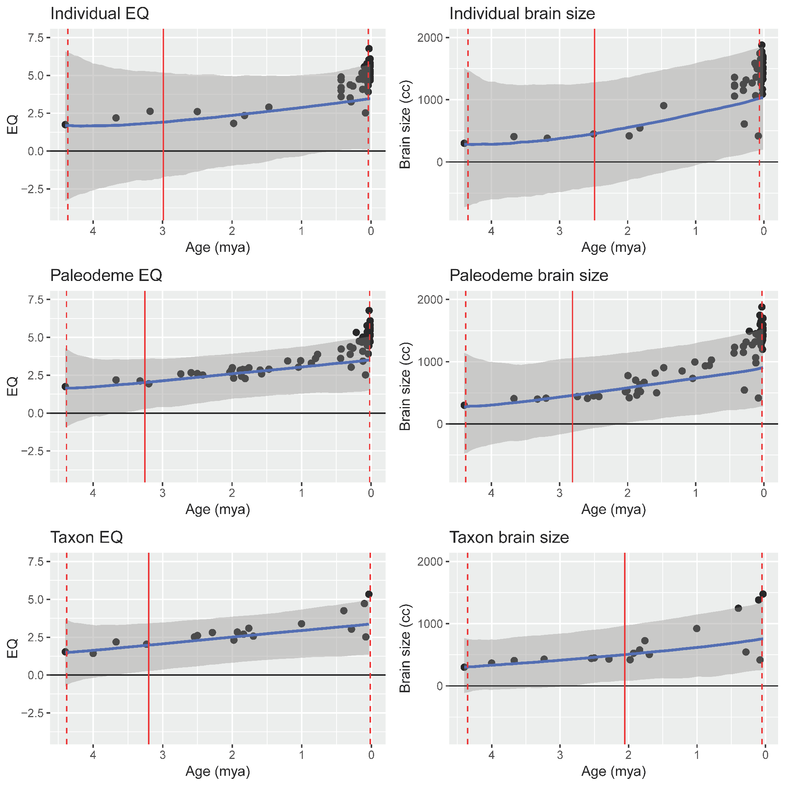
Figure S6. Phylogenetic, repeated-measure piecewise linear models with uniform priors for individual, paleodeme, and taxon full data sets. Vertical solid red lines indicate model-estimated breakpoint with endpoints of 95% credible intervals shown as vertical dashed lines. Note that the intervals span nearly the entire time range for all models.
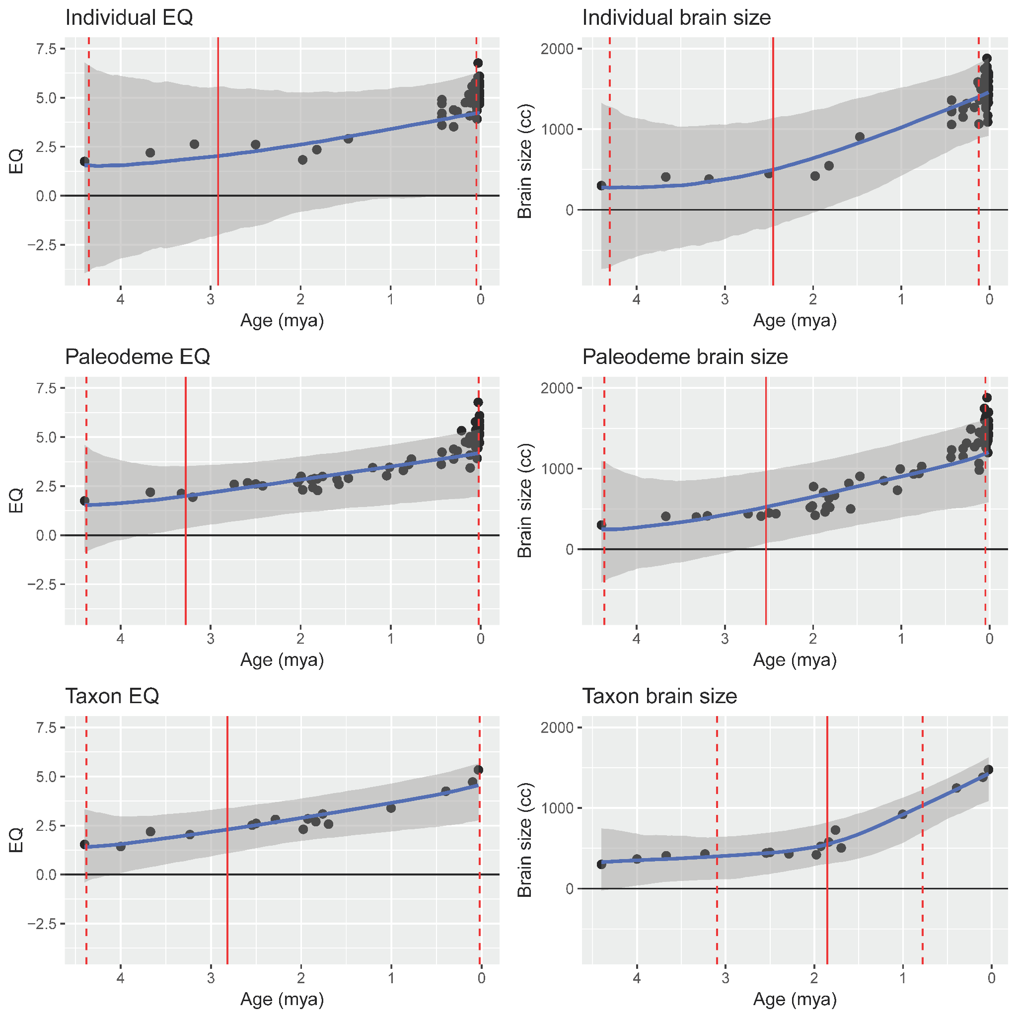
Figure S7. Phylogenetic, repeated measure piecewise linear models with uniform priors for individual, paleodeme, and taxon data sets (Homo floresiensis and H. naledi not included). Vertical solid red lines indicate model-estimated breakpoints with endpoints of 95% credible intervals shown as vertical dashed lines. Note that the intervals span nearly the entire time range for all but one model.
Supplementary Text 4
ANOVA of EQ and Brain Size by Tool Industry
Four ANOVA models were calculated: Paleodeme EQ, in which EQ was dependent on tool industry for the paleodeme data set; Paleodeme brain size, in which brain size was dependent on tool industry for the paleodeme data set; Individual EQ, in which EQ was dependent on tool industry for the individual data set; and Individual brain size, in which brain size was dependent on tool industry for the individual data set. All four models showed significant differences in means across tool industries (Table S4).
ANOVA model | F | df 1 | df 2 | p
Paleodeme EQ | 69.39 | 3 | 50 | < 0.001
Paleodeme brain size | 62.84 | 3 | 50 | < 0.001
Individual EQ | 21.61 | 3 | 52 | < 0.001
Individual brain size | 20.08 | 3 | 52 | < 0.001
Table S4. F-statistics and p-values for ANOVA models.
In addition, Tukey Honest Significant Differences tests were conducted for all four models to test for differences between all pairs of tool industries within each data set. In all cases, mean EQ and brain size increased monotonically as a function of increasingly complex tool industries (from least to most complex: Oldowan, Acheulean, MSA/Middle Paleolithic, Upper Paleolithic), but differences were not significant in all cases (Table S5).
ANOVA model | Comparison | Difference | 95% CI | p (adjusted)
Paleodeme EQ | Acheulean-Oldowan | 0.58 | -0.08 to 1.24 | 0.101
 | MSA/Middle Paleolithic-Oldowan | 1.77 | 1.29 to 2.26 | < 0.001
 | Upper Paleolithic-Oldowan | 2.20 | 1.77 to 2.63 | < 0.001
 | MSA/Middle Paleolithic-Acheulean | 1.19 | 0.52 to 1.86 | < 0.001
 | Upper Paleolithic-Acheulean | 1.62 | 0.99 to 2.25 | < 0.001
 | Upper Paleolithic-MSA/Middle Paleolithic | 0.43 | -0.02 to 0.88 | 0.067
Paleodeme brain size | Acheulean-Oldowan | 305.1 | 63.1 to 547.2 | 0.008
 | MSA/Middle Paleolithic-Oldowan | 691.1 | 513.5 to 868.7 | < 0.001
 | Upper Paleolithic-Oldowan | 763.0 | 604.6 to 921.5 | < 0.001
 | MSA/Middle Paleolithic-Acheulean | 386.0 | 139.4 to 632.6 | 0.001
 | Upper Paleolithic-Acheulean | 457.9 | 224.7 to 691.1 | < 0.001
 | Upper Paleolithic-MSA/Middle Paleolithic | 71.9 | -93.5 to 237.3 | 0.657
Individual EQ | Acheulean-Oldowan | 1.20 | 0.24 to 2.15 | 0.008
 | MSA/Middle Paleolithic-Oldowan | 1.80 | 0.97 to 2.63 | < 0.001
 | Upper Paleolithic-Oldowan | 2.16 | 1.37 to 2.95 | < 0.001
 | MSA/Middle Paleolithic-Acheulean | 0.61 | -0.07 to 1.29 | 0.097
 | Upper Paleolithic-Acheulean | 0.96 | 0.34 to 1.59 | 0.001
 | Upper Paleolithic-MSA/Middle Paleolithic | 0.36 | -0.06 to 0.77 | 0.113
Individual brain size | Acheulean-Oldowan | 515.5 | 171.3 to 859.8 | 0.001
 | MSA/Middle Paleolithic-Oldowan | 759.7 | 459.8 to 1059.5 | < 0.001
 | Upper Paleolithic-Oldowan | 779.4 | 495.5 to 1063.3 | < 0.001
 | MSA/Middle Paleolithic-Acheulean | 244.1 | -1.4 to 489.7 | 0.052
 | Upper Paleolithic-Acheulean | 263.9 | 38.1 to 489.7 | 0.016
 | Upper Paleolithic-MSA/Middle Paleolithic | 19.8 | -129.9 to 169.4 | 0.985
Table S5. Mean differences, their 95% confidence intervals, and multiple comparison adjusted p-values for all pairwise comparisons within the four ANOVA models using Tukey’s Honest Significant Differences test and a Family-wise Error Rate (FWER) of 0.05. Comparisons are the mean value of EQ or brain size for the more complex tool industry minus the mean value for the less complex tool industry. Differences significant at FWER α = 0.05 are highlighted in bold.
Supplementary Text 5
Resampling Analysis of Correlation Between EQ or Brain Size and Tool Industry Complexity
As described in the main text, for the correlation analysis we chose Procedural Units (PU) as a quantitative way to express technological complexity and assigned specific assemblages to one of four broad tool industries (Table S6).
Tool industry | Source | Site | PU
Upper Palaeolithic | Pasda 2017 | Munzingen | 13
Upper Palaeolithic | Aubrey et al. 2008 | Maitreaux | 14
Upper Palaeolithic | Chazan 2001b | Hayonim cave level D. | 8
Upper Palaeolithic | Chazan 2001a | La Farressie | 12
Upper Palaeolithic | Spinapolice et al. 2014 | Jebel Gharbi SJ-00-58A | 10
Upper Palaeolithic | Hahn and Owen 1985 | Geissenklosterle Cave Gravettian | 15
Upper Palaeolithic | Fernandez 2005 | Cueva Morin levels 9-10 | 13
Upper Palaeolithic | Hahn and Owen 1985 | Geissenklosterle Cave Aurignacian | 11
MSA/Middle Palaeolithic | Roussell et al. 2016 | Quincay cave | 12
MSA/Middle Palaeolithic | Villa et al. 2010 | Klasies cave MSA III deacon exc. | 13
MSA/Middle Palaeolithic | Groucutt 2014 | Tor Faraj | 10
MSA/Middle Palaeolithic | Otte 1990 and 1994 | Rocourt | 11
MSA/Middle Palaeolithic | Slimak 1999 | Champ Grande | 13
MSA/Middle Palaeolithic | Villa et al. 2010 | Klasies cave 1A lower HP | 16
MSA/Middle Palaeolithic | Malinsky-Buller et al. 2014 | Ein Qashish | 21
MSA/Middle Palaeolithic | Pleurdeau 2006 | Porc epic | 16
MSA/Middle Palaeolithic | Hogberg et al. 2011 | Hollow Rockshelter | 8
MSA/Middle Palaeolithic | Tryon et al. 2006 | Koilomot locus 2 | 8
MSA/Middle Palaeolithic | Shimelmitz and Kuhn 2013 | Tabun IX D | 10
MSA/Middle Palaeolithic | Villa et al. 2016 | Torre in Pietra level D | 12
MSA/Middle Palaeolithic | Schimelmitz et al. 2011 | Qesem Cave | 12
MSA/Middle Palaeolithic | Barkai et al. 2005 and Barzilai et al. 2011 | Qesem Cave | 16
MSA/Middle Palaeolithic | Hublin et al. 1987 and Richter et al. 2017 | Jebel Irhoud | 8
MSA/Middle Palaeolithic | Tryon et al. 2006 | Kapthurin LHA FS | 12
MSA/Middle Palaeolithic | Adler et al. 2014 | Nor Geghi 1 | 15
MSA/Middle Palaeolithic | Wilkins and Chazan 2012 | Kathu Pan 1 | 12
Acheulean | Villa et al. 2016 | Torre in Pietra level M | 8
Acheulean | Stout et al. 2014 | Boxgrove | 9
Acheulean | Isaac 1977 | Olorgesaillie | 5
Acheulean | Gilbert et al. 2016 | Hugub KK51 | 10
Acheulean | Goren-Inbar et al. 2008 | Gesher Benot Ya'aqov | 8
Acheulean | Li et al. 2017 | Canteen Koppie | 6
Acheulean | Torre et al. 2008 | RHS-Mugulud Peninj | 7
Acheulean | Gallotti 2013 | Garba Ivd | 10
Oldowan | Texier 1995 | NY 18 Nyabusosi | 10
Oldowan | Diez-Martin et al. 2009 | Olduvai Bed II BK | 6
Oldowan | Diez-Martin et al. 2009 | Olduvai Bed II BK | 7
Oldowan | Plummer and Bishop 2016 | Kanjera | 4
Oldowan | Delagnes and Roche 2005 | Lokalalei 2c | 4
Oldowan | Stout et al. 2010 | EG12 | 4
Oldowan | Braun et al. 2019 | Bokol Dora 1 | 3
Table S6. Procedural Unit (PU) data used to quantify tool industry complexity in the resampling analysis described in the main text. Data are from Paige & Perreault (2024) and are assigned to one of the four tool industries identified in this analysis.
We then performed iterative resampling procedures for paleodeme- and individual-level datasets as follows. In each iteration, every paleodeme (for paleodeme-level analyses) or individual specimen (for individual-level analyses) was paired with the PU value for a randomly-selected assemblage in the PU dataset corresponding to the same broad archaeological period (e.g., a paleodeme assigned to “MSA/Middle Paleolithic” would be paired with the PU value for one randomly selected assemblage from the 20 MSA/Middle Paleolithic assemblages in Appendix X, see Figures S8-11). The correlations between EQ and PU as well as brain size and PU were calculated for each iteration (note: for individual-level analysis, correlations between brain size and PU values were calculated for both the full data set and a reduced data set that only included those individuals that also had EQ data). 10,000 iterations were used for both sets of analyses, after which 95% confidence intervals for correlation coefficients were calculated by excluding the largest 2.5% and smallest 2.5% of resampled correlation coefficients in each analysis.
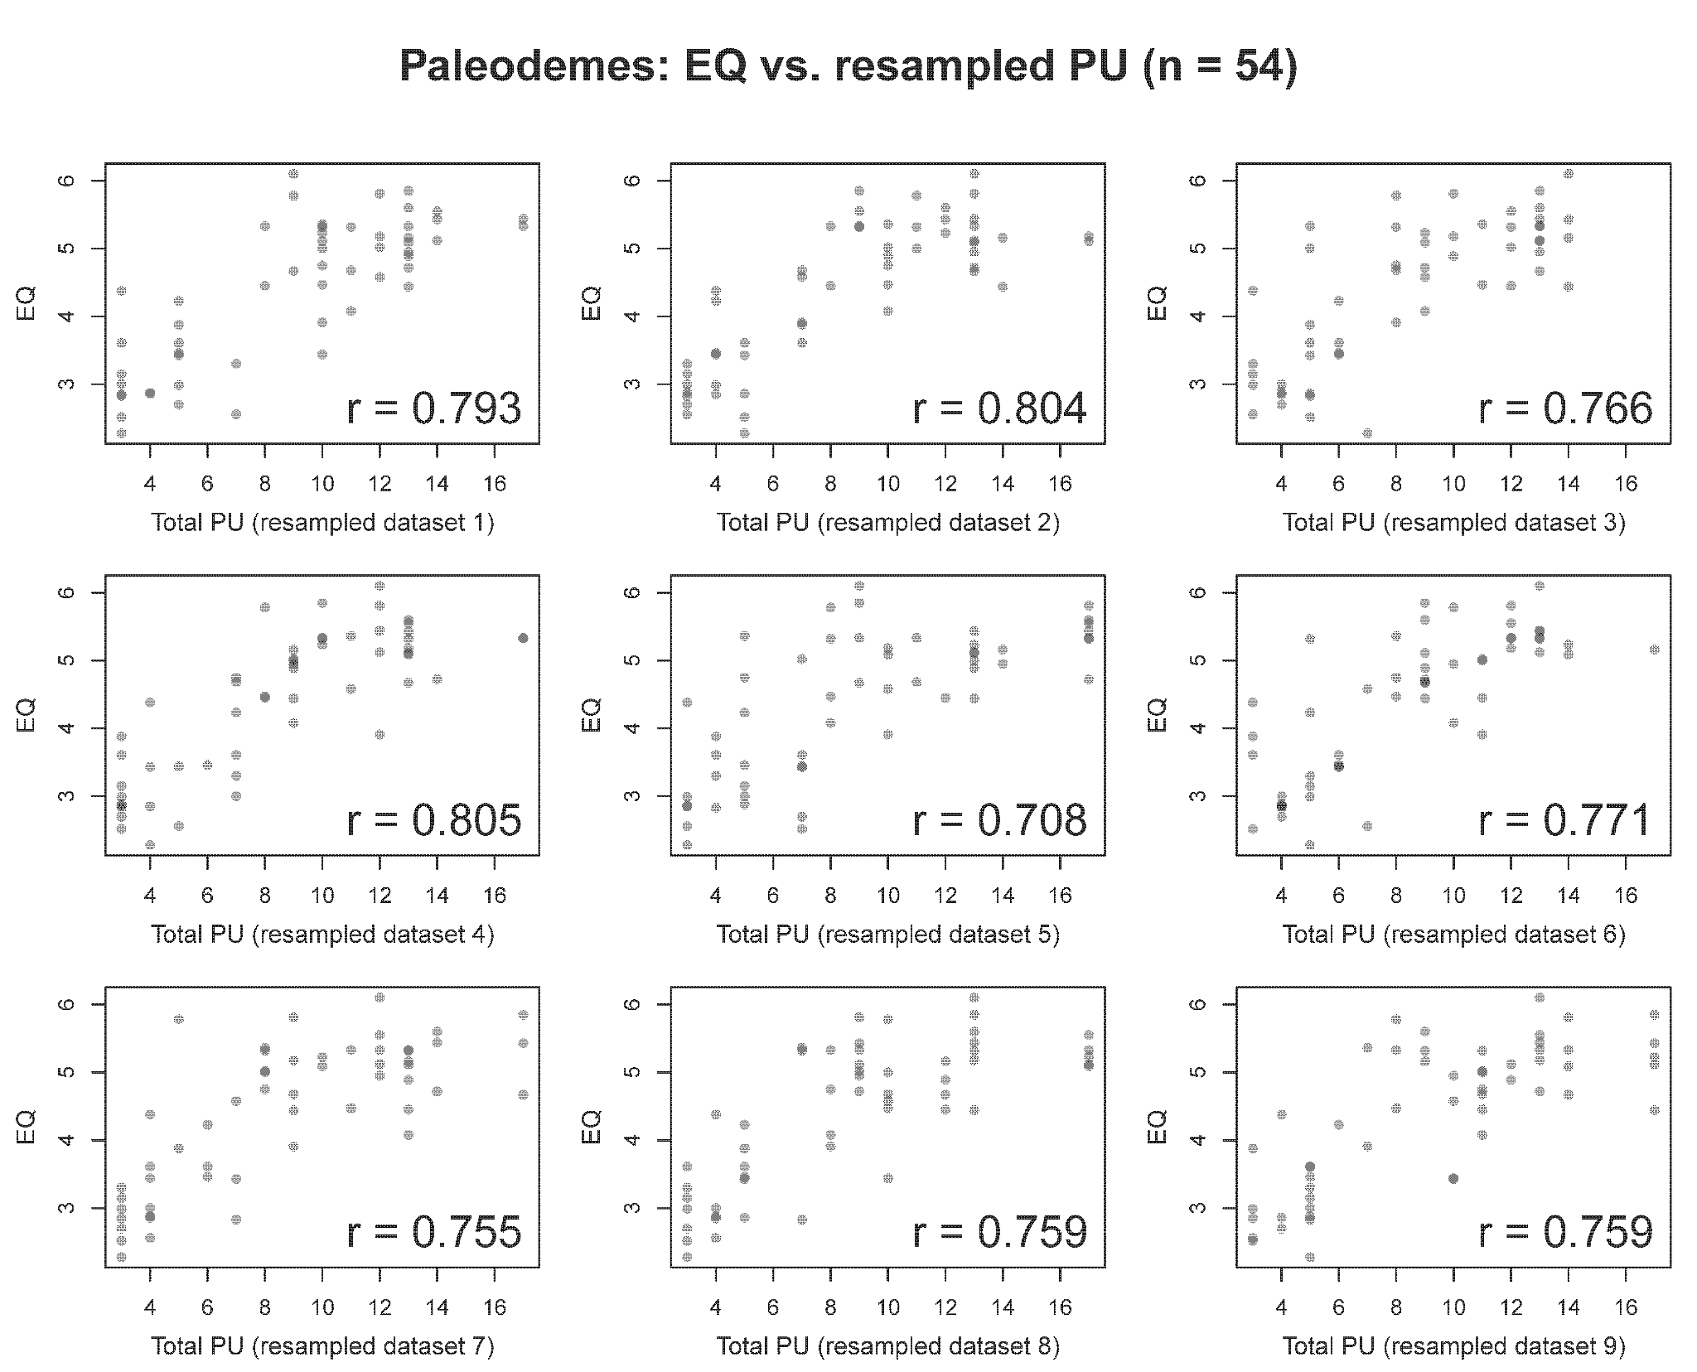
Figure S8. Nine resampled data sets for the correlation of EQ with PU in the paleodeme data set (10,000 resampled data sets were generated for this analysis). In each iteration of the resampling procedure, each paleodeme is randomly paired with a site from Table S6 that shares the same tool industry, and then correlation was calculated for EQ (from the paleodemes) and PU (from the archaeological assemblages).
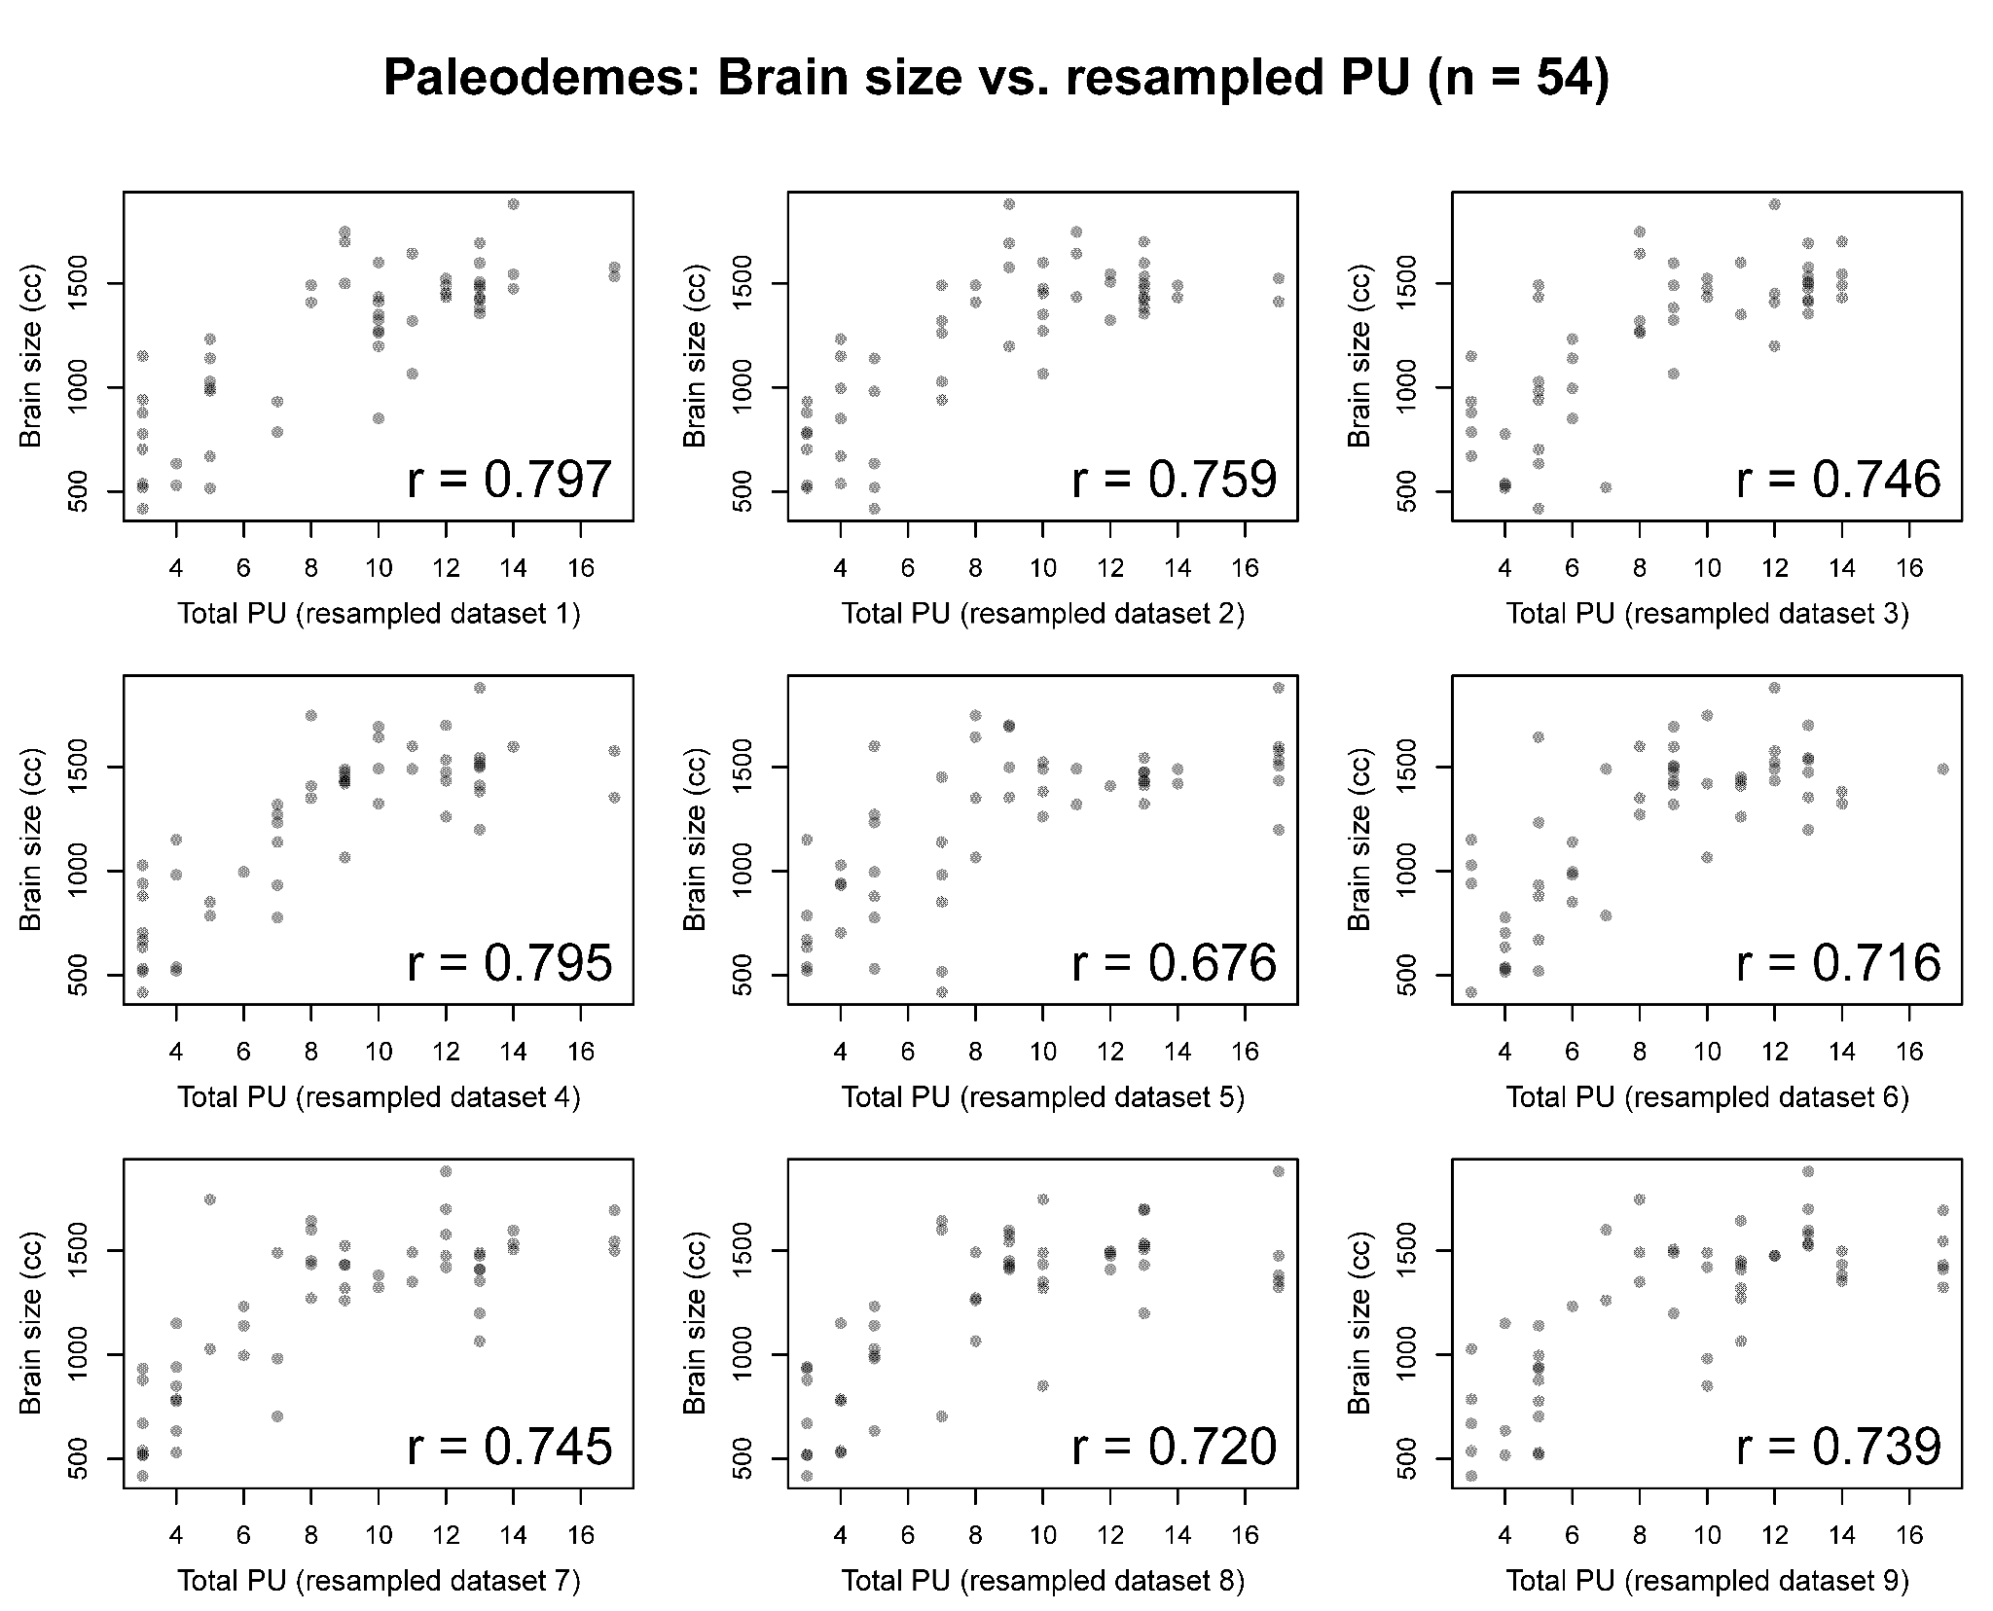
Figure S9. Nine resampled data sets for the correlation of brain size with PU in the paleodeme data set (10,000 resampled data sets were generated for this analysis). In each iteration of the resampling procedure, each paleodeme is randomly paired with a site from Table S6 that shares the same tool industry, and then correlation was calculated for brain size (from the paleodemes) and PU (from the archaeological assemblages).
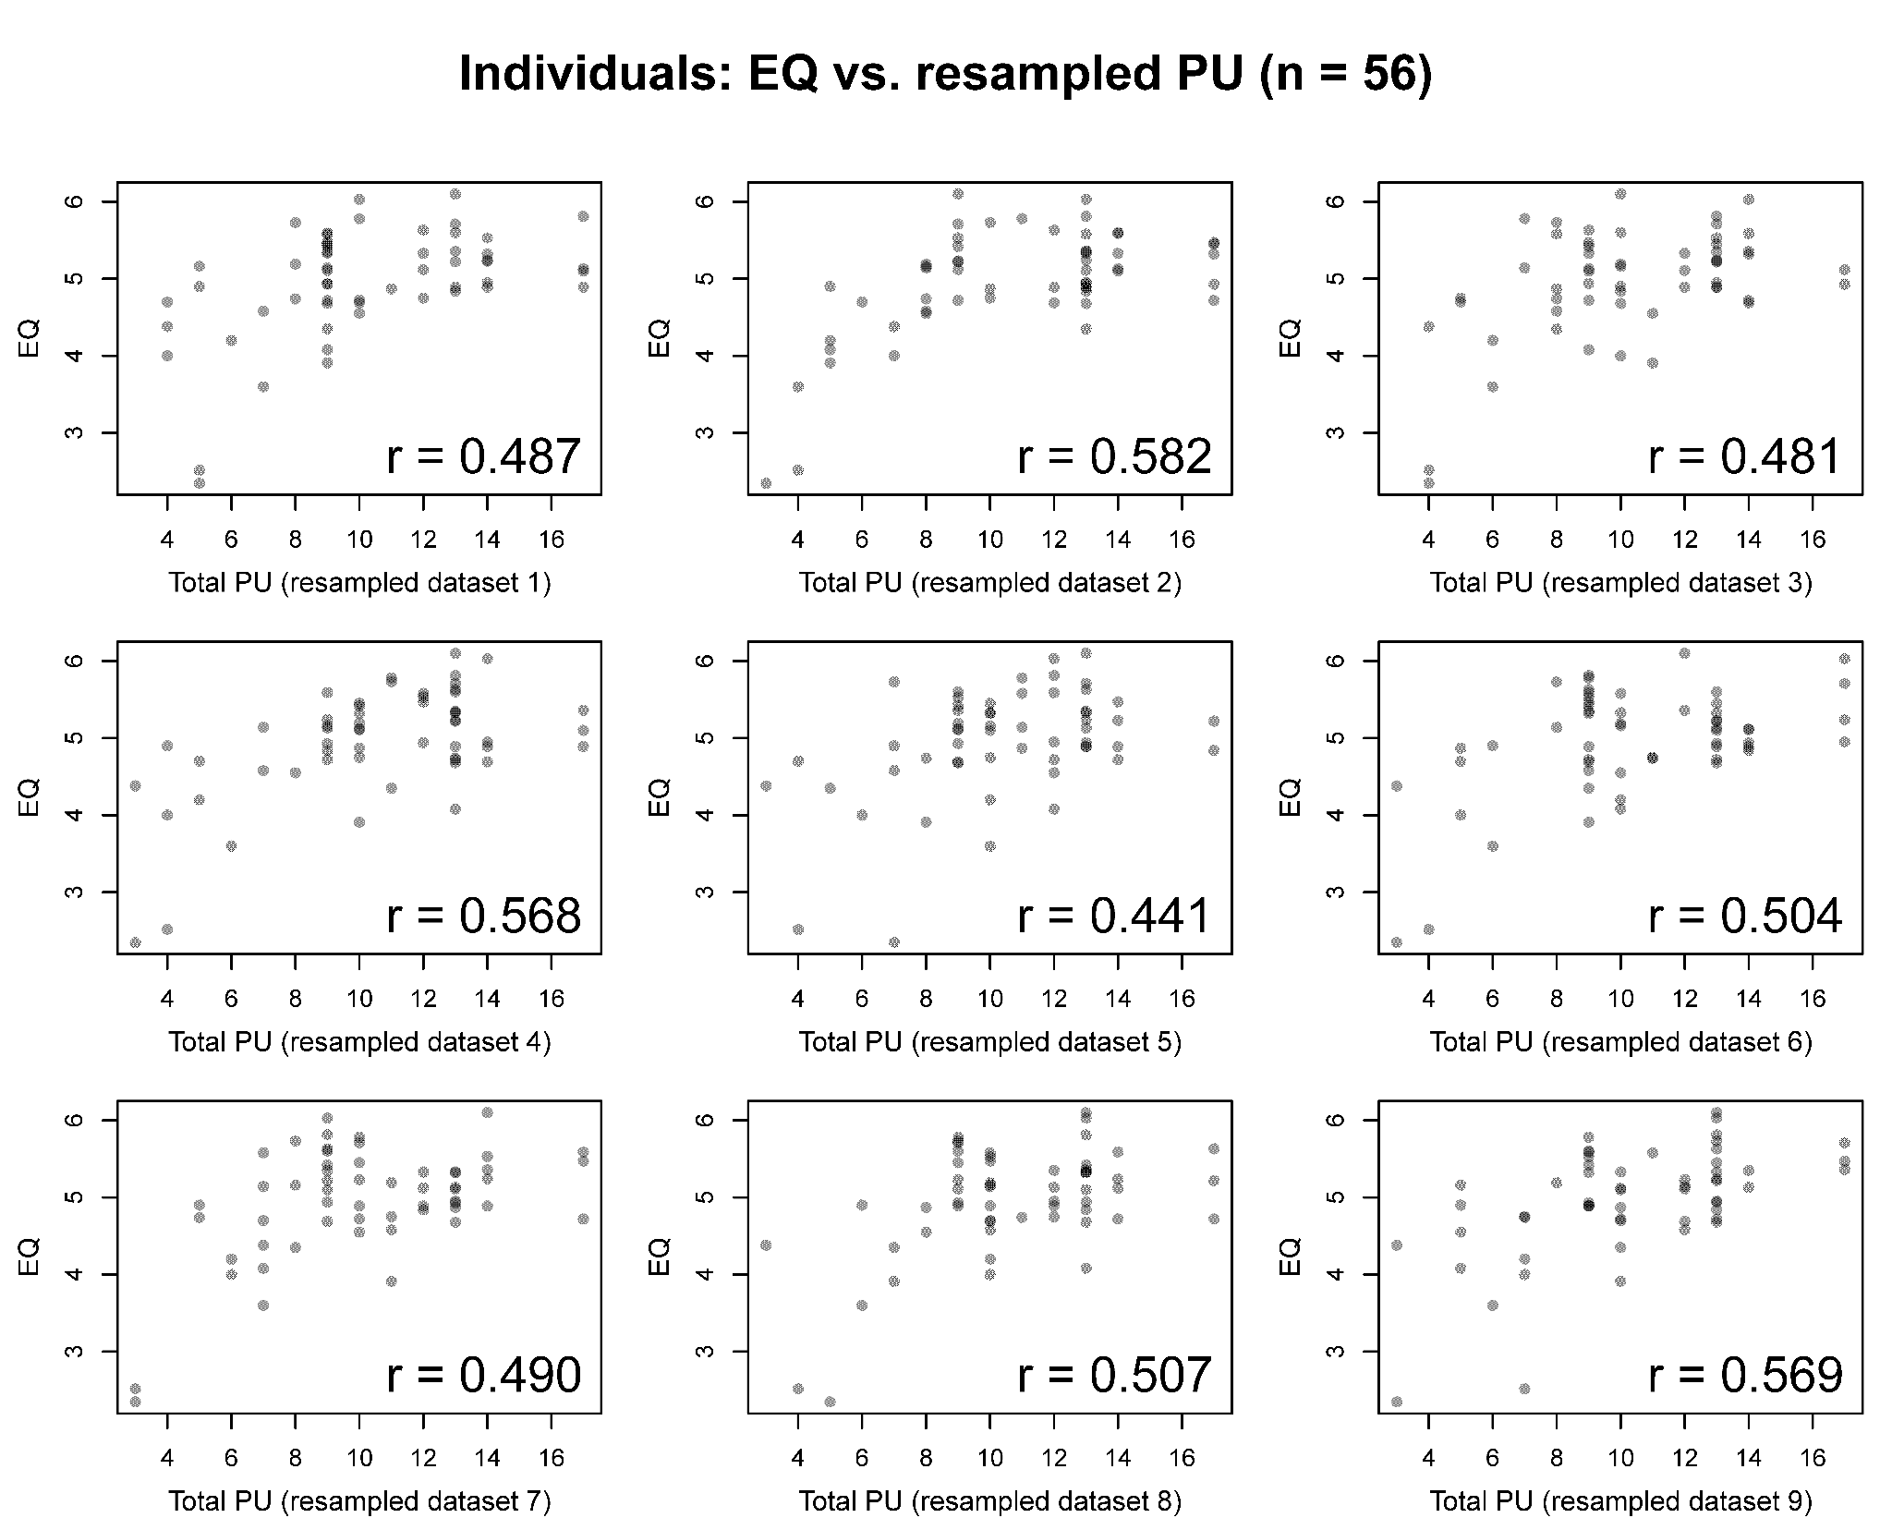
Figure S10. Nine resampled data sets for the correlation of EQ with PU in the individual data set (10,000 resampled data sets were generated for this analysis). In each iteration of the resampling procedure, each individual is randomly paired with a site from Table S6 that shares the same tool industry, and then correlation was calculated for EQ (from the individuals) and PU (from the archaeological assemblages).
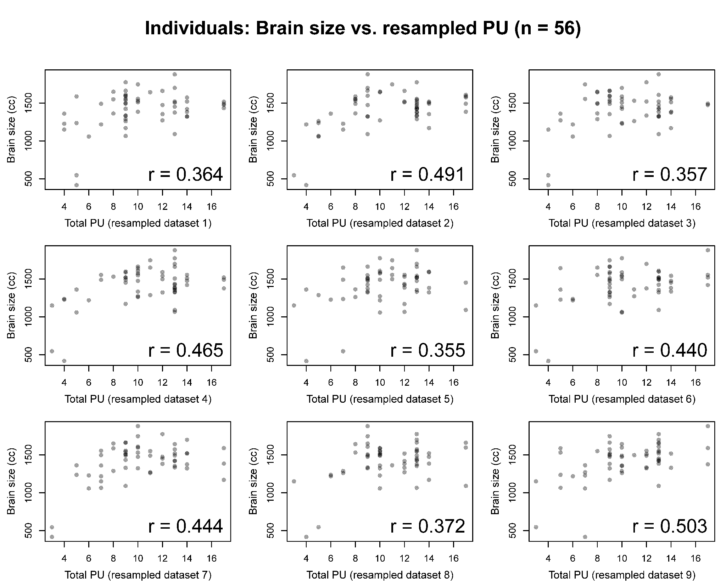
Figure S11. Nine resampled data sets for the correlation of brain size with PU in the individual data set (10,000 resampled data sets were generated for this analysis). In each iteration of the resampling procedure, each individual is randomly paired with a site from Table S6 that shares the same tool industry, and then correlation was calculated for brain size (from the individuals) and PU (from the archaeological assemblages).

