Supplements
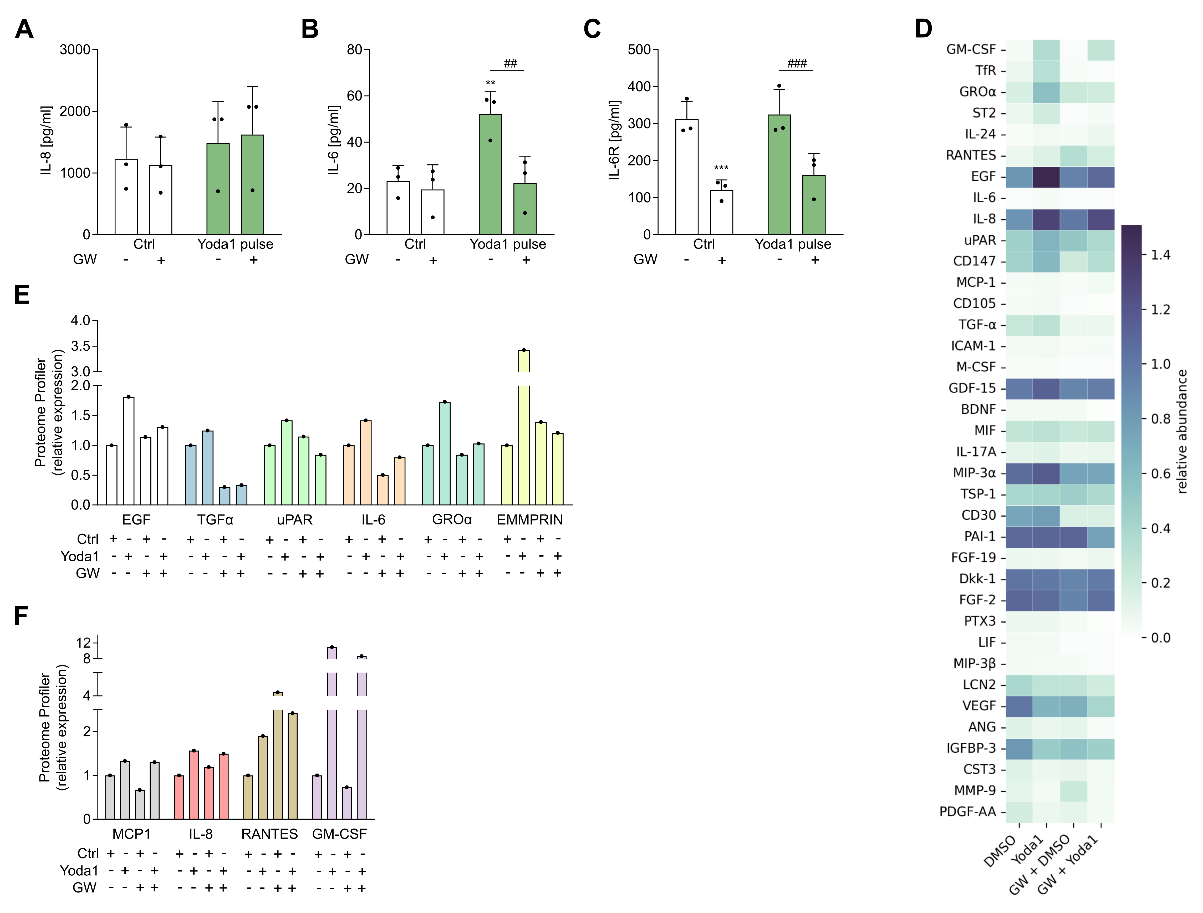
Suppl. Fig. 1: Role of ADAM10/17 in the Piezo1-induced pro-inflammatory mediator release from H441 and hAELVi cells
Supernatants from H441 cells pre-incubated with GW280264X (GW, 10 µM) or control reagent for 1 h, followed by a 5 min stimulation with Yoda1 (10 µM) or control reagent (Ctrl) were collected after a 24-h fresh medium incubation and analyzed for IL-8 (A), IL-6 (B) and sIL-6R (C) concentrations via ELISA. Supernatants as generated for A-C from hAELVi cells were analyzed using the human Cytokine XL Array Kit and raw values were visualized as a heatmap (D). Cytokines showing a Piezo1- and ADAM10/17-dependency are collected in E, whereas cytokines without ADAM10/17-dependency are shown in F. Quantitative data are shown as the means + SDs of at least three independent experiments. Statistical differences to the control are indicated by asterisks (* p≤0.05, ** p≤0.01, *** p≤0.001), whereas differences between the treatments are indicated by hashes (# p≤0.05, ## p≤0.01, ### p≤0.001).
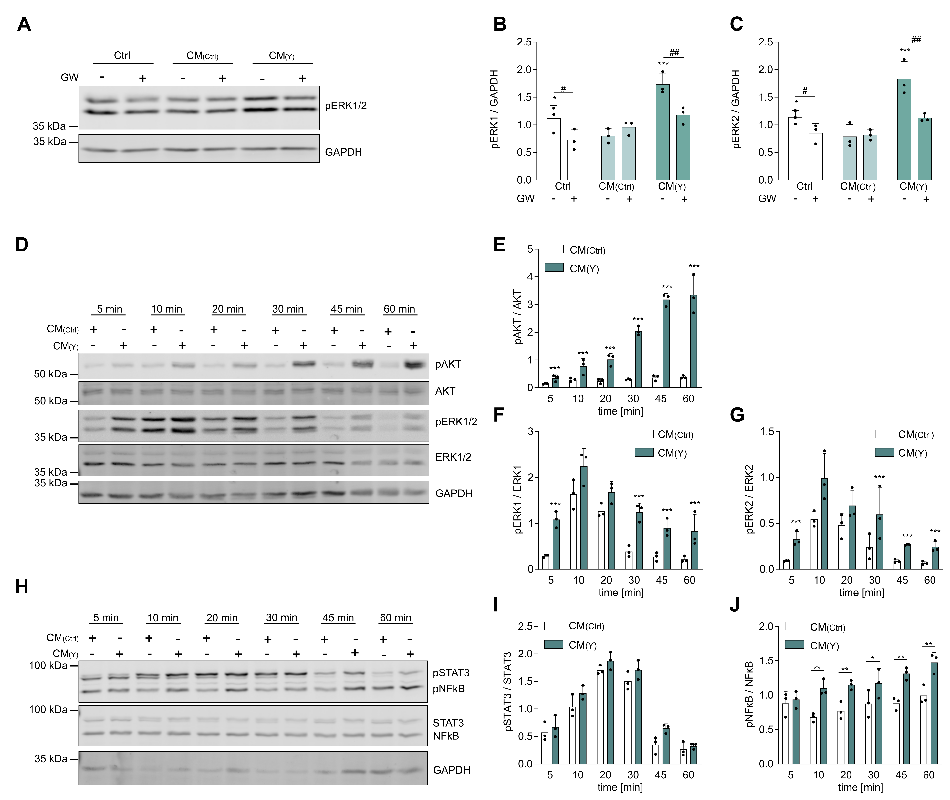

Suppl. Fig. 2: Endothelial signaling pathways induced by the crosstalk from Piezo1-activated epithelium
Supernatants from H441 cells pre-incubated with GW280264X (GW, 10 µM) or control reagent for 1 h, followed by a 5 min stimulation with Yoda1 (10 µM) (CM(Y)) or control reagent (CM(Ctrl)) were collected after a 24-h fresh medium incubation and transferred to HUVECs for 20 min. ERK1/2 phosphorylation changes were detected via Western blot (A-C). Conditioned media (CM) from hAELVi cells stimulated with Yoda1 (10 µM) (CM(Y)) or control reagent (CM(Ctrl)) were transferred to HUVECs for 5, 10, 20, 30, 45, 60 min and protein samples were analyzed for AKT (D, E), ERK1/2 (D, F, G), STAT3 (H, I) and NFκB (H, J) phosphorylation via Western blot. Quantitative data are shown as the means + SDs of at least three independent experiments. Statistical differences to the control are indicated by asterisks (* p≤0.05, ** p≤0.01, *** p≤0.001), whereas differences between the treatments are indicated by hashes (# p≤0.05, ## p≤0.01, ### p≤0.001).
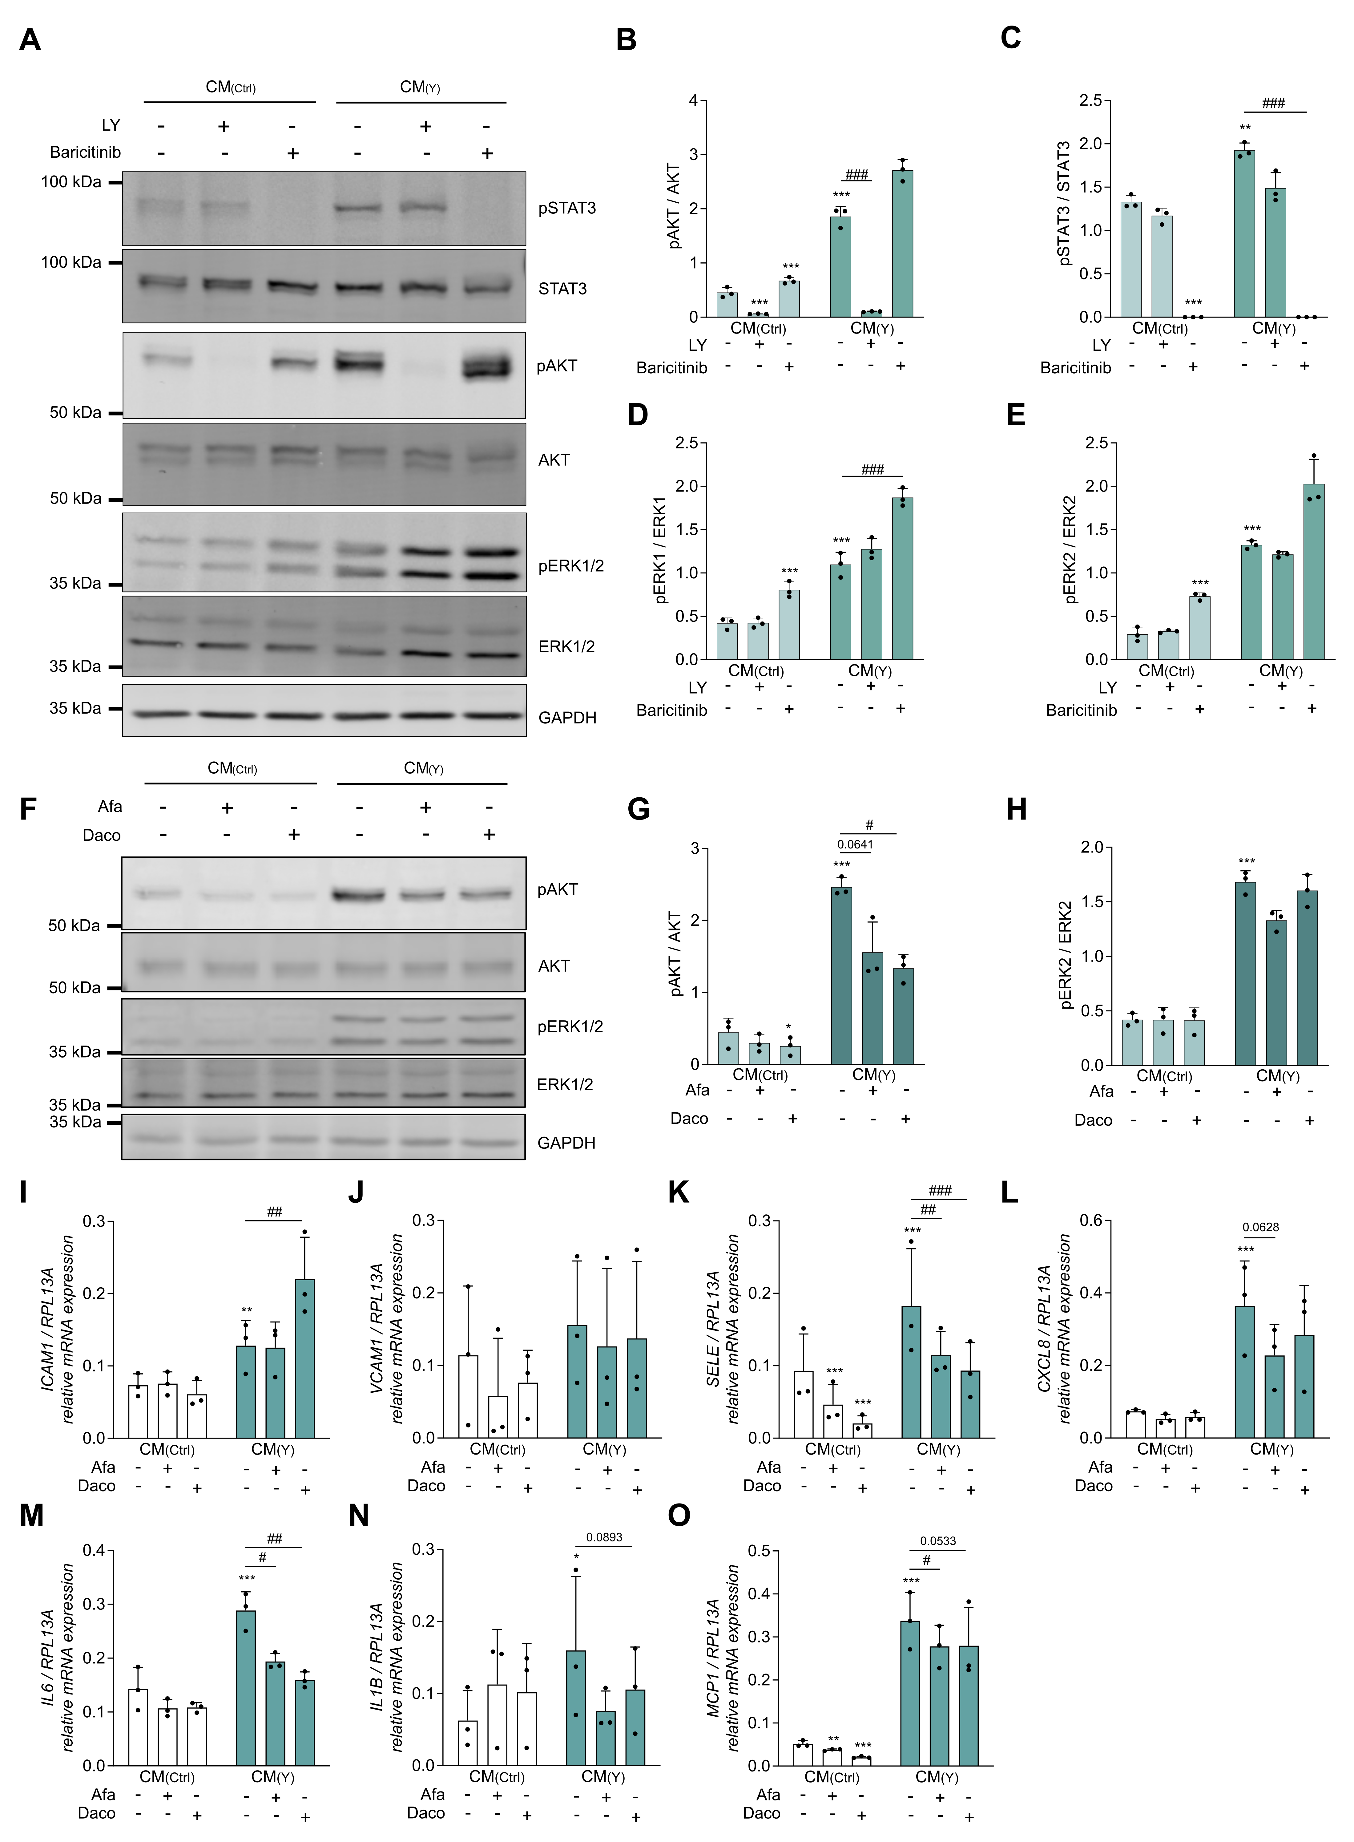

Suppl. Fig. 3: PI3K, JAK1/2 and ErbB inhibition effects on CM-induced phosphorylation changes and gene expression in HUVECs
HUVECs were stimulated for 20 min with control medium or conditioned medium (Ctrl / 10 µM Yoda1) from H441 cells in the presence or absence of PI3K inhibitor LY (10 µM) or JAK1/2 inhibitor Baricitinib (10 µM). AKT (A, B), STAT3 (A, C), and ERK1/2 (A, D, E) phosphorylation was subsequently analyzed by Western blot. Conditioned media (CM) from hAELVi cells stimulated with Yoda1 (10 µM) (CM(Y)) or control reagent (CM(Ctrl)) were transferred to HUVECs for 45 min (F-H) or 2 and 4 h (I-O) in the presence or absence of the pan-ErbB inhibitors Afatinib (Afa, 1 µM) and Dacomitinib (Daco, 3 µM). AKT (F, G) and ERK2 (F, H) phosphorylation was subsequently analyzed by Western blot. Changes in gene expression were analyzed by qPCR after 2 h (IL1B, MCP1, SELE) and 4 h (IL6, CXCL8, ICAM1, VCAM1) (I-O).

Target | Sequence (5'-3') | Temperature (°C)
hRPL13A_for | GCC CTA CGA CAA GAA AAG CG | 60
hRPL13A_rev | TAC TTC CAG CCA ACC TCG TGA | 60
hMCP1_for | ATG AAA GTC TCT GCC GCC | 57
hMCP1_rev | CTT CTT TGG GAC ACT TGC T | 57
hIL6_for | GTGTGAAAGCAGCAAAGAG | 57
hIL6_rev | AAGTCTCCTCATTGAATCCA | 57
hCXCL8_for | GAC ATA CTC CAA ACC TTT CC | 60
hCXCL8_rev | AAC TTC TCC ACA ACC CTC | 60
hIL1B_for | CAC CTG TAC GAT CAC TGA ACT G | 63
hIL1B_rev | CAC CAC TTG TTG CTC CAT ATC C | 63
hICAM1_for | GGA GCC CGC TGA GGT CAC GA | 66
hICAM1_rev | CGC TGG CAG GAC AAA GGT CTG G | 66
hVCAM1_for | GCA AGT CTA CAT ATC ACC C | 57
hVCAM1_rev | AAT CTT CCA TCC TCA TAG CA | 57
hSELE_for | TTG CCC TAT GCT ACA CAG | 56
hSELE_rev | TTG AGT CCA CTG AAG CCA | 56
Suppl. table 1: Used primers with corresponding sequences and annealing temperatures.

