Supplementary Information

Denary element synergy breaks stability–selectivity tradeoff in the oxidative dehydrogenation of propane using CO₂

Duanxing Li, Fang Zhang, Zhiheng Jia and Shinya Furukawa*

Division of Applied Chemistry, Graduate School of Engineering, The University of Osaka
2-1 Yamadaoka, Suita, Osaka, Japan 565-0871

E-mail: furukawa@chem.eng.osaka-u.ac.jp

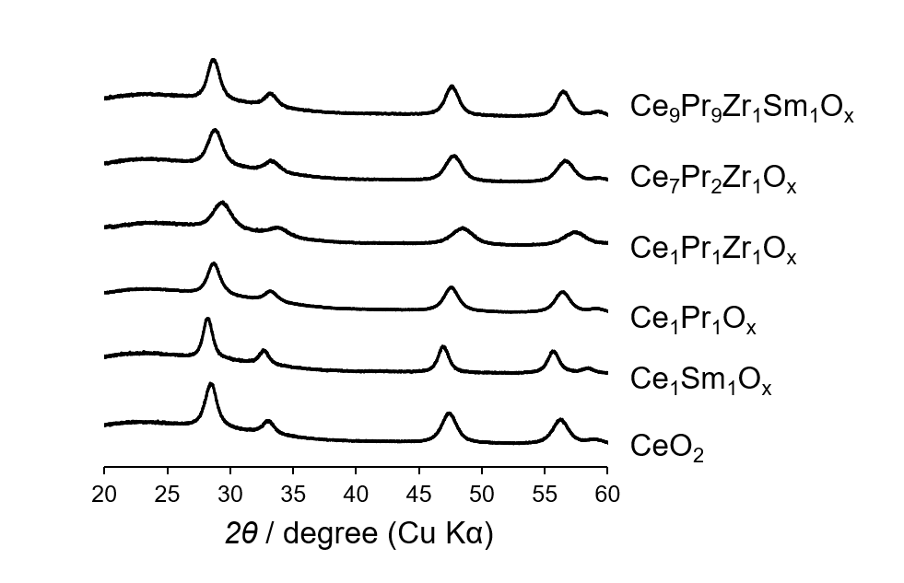
Supplementary Figure 1. X-ray diffraction patterns of various multicomponent oxide supports.

Supplementary Table 1. Molar ratio, crystal size and specific surface area of synthesized mixed oxides.
Oxide supports | molar ratioª |  |  |  | d space^{b} | crystal size^{c} | SSA^{d}
Oxide supports | Ce | Pr | Zr | Sm | nm | nm | m²/g
CeO₂ | 1  (1) | - | - | - | 0.1633 | 7.7 | 150
Ce₁Pr₁O_{x} | 0.45  (0.5) | 0.55  (0.5) | - | - | 0.1629 | 11.2 | 50
Ce₁Sm₁O_{x} | 0.52  (0.5) | - | - | 0.48  (0.5) | 0.1651 | 9.6 | 54
Ce₇Pr₂Zr₁O_{x} | 0.71  (0.7) | 0.21  (0.2) | 0.08  (0.1) | - | 0.1623 | 6.7 | 109
Ce₁Pr₁Zr₁O_{x} | 0.35 (0.34) | 0.34 (0.33) | 0.31 (0.33) | - | 0.1603 | 5.1 | 57
Ce₉Pr₉Zr₁Sm₁O_{x} | 0.45 (0.45) | 0.45 (0.45) | 0.05 (0.05) | 0.05 (0.05) | 0.1627 | 7.7 | 61
a. calculated by Vegard's law using (311) diffraction peak around 2θ 56° from Figure S1, values in parentheses indicate expected molar ratios;
b. calculated by Bragg's law using (311) diffraction peak around 2θ 56° from Figure S1;
c. calculated by Scherrer equation using (111) diffraction peak around 2θ 28° from Figure S1;
d. calculated from N₂ adsorption data by applying the Brunauer–Emmett–Teller method.
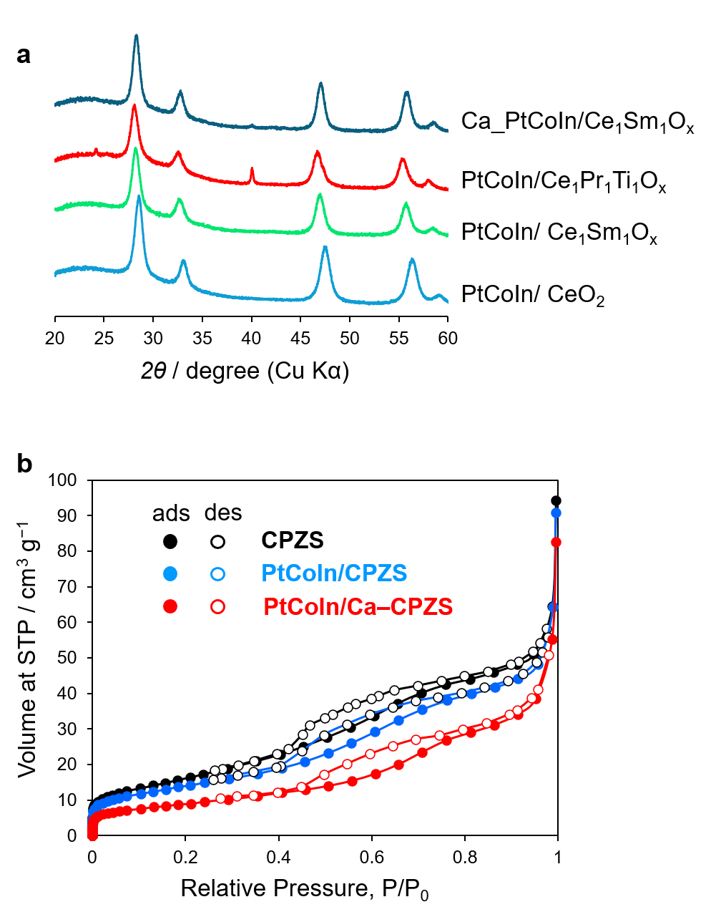
Supplementary Figure 2. a XRD patterns of the PtCoIn alloy catalysts supported on different multicomponent oxides, b N₂ adsorption–desorption isotherms of the CPZS support and the corresponding PtCoIn-loaded catalysts. Note: Owing to the strong X-ray scattering ability of Ce and Sm, the diffraction peaks of the supported alloy are obscured in the XRD patterns of catalysts containing high amounts of these elements.

Supplementary Table 2. Size of PtCoIn alloy nanoparticles measured by XRD and CO-pulse.
Samples | Size of alloy nanoparticles / nm
Samples | XRD | CO-Pulse
PtCoIn_Ce₁Pr₁O_{x} | 5.3 | 4.6
PtCoIn_Ce₁Pr₁Zr₁O_{x} | 5.4 | 5.2
PtCoIn_Ce₇Pr₂Zr₁O_{x} | 4.4 | 4.7
PtCoIn_Ca_{4.0}_Ce₇Pr₂Zr₁O_{x} | 3.7 | 3.8
PtCoIn_C₉P₉Z₁S₁O_{x} | 3.8 | 4.3
PtCoIn_Ca_{2.5}_C₉P₉Z₁S₁O_{x} | 3.6 | 3.5

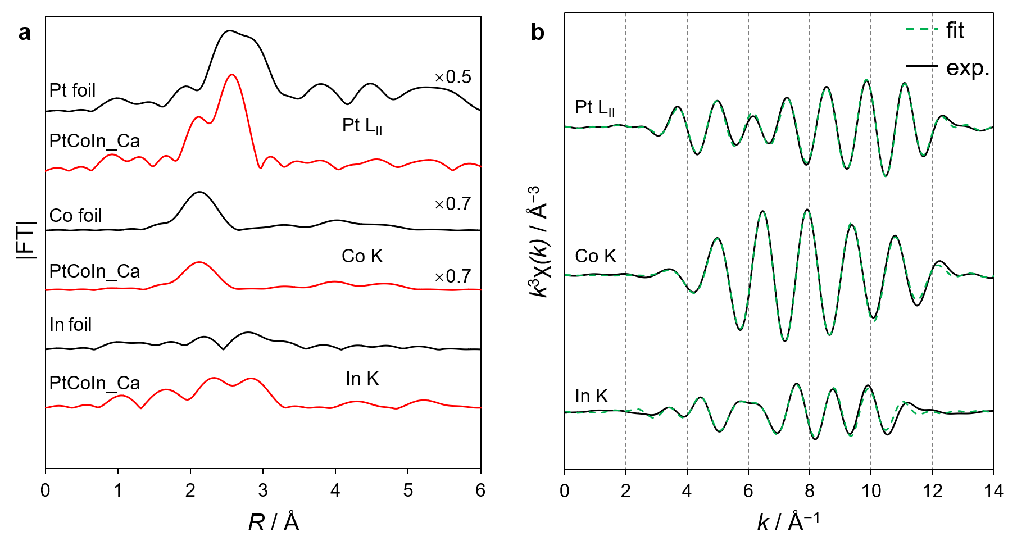
Supplementary Figure 3. a Fourier transforms of Pt L_{II}-, Co K- and In K-edge EXAFS of PtCoIn/Ca–C₉P₉Z₁S₁ catalysts and reference compounds. b Curve-fitting for the Pt L_{II}-, Co K-, and In K-edge k³-weighted EXAFS oscillations of PtCoIn/Ca–C₉P₉Z₁S₁. The k³-weighted EXAFS oscillation was Fourier-transformed in the k range of 3−14 Å⁻¹ for all edges. Curve-fitting was performed using the back Fourier-transforms of the coordination peaks ranging between 1.3−3.7 Å, 1.0−3.0 Å, and 1.2−4.0 Å for Pt LII-, Co K-, and In K-edge, respectively.

Supplementary Table 3. Results of EXAFS curve-fitting for PtCoIn/Ca–C₉P₉Z₁S₁ and the reference foils.

Sample | Edge | Shell | S_{o}^{2[a]} | CN^{[b]} | R^{[c]} (Å) | ∆E_{o}^{[d]} (eV) | σ^{2[e]} (Å²) | R-factor
Pt foil | Pt L_{II} | Pt–Pt | 0.80 | 12 (fix) | 2.78 ± 0.01 | 6.4 ± 1.9 | 0.000 | 0.020
Co foil | Co K | Co–Co | 0.79 | 12 (fix) | 2.49 ± 0.00 | 1.1 ± 0.3 | 0.006 | 0.001
In foil | In K | In–In | 0.76 | 4 (fix) | 3.13 ± 0.02 | 1.9 ± 1.5 | 0.014 | 0.024
In foil | In K | In–In | 0.76 | 8 (fix) | 3.31 ± 0.03 | 1.9 ± 1.5 | 0.021 | 0.024
PtCoIn/  Ca– C₉P₉Z₁S₁ | Pt L_{II} | Pt–In | 0.80  (fix) | 5.5 ± 0.7 | 2.71 ± 0.00 | 3.6 ± 0.9 | 0.008 | 0.009
PtCoIn/  Ca– C₉P₉Z₁S₁ | Pt L_{II} | Pt–Pt | 0.80  (fix) | 3.3 ± 0.7 | 2.86 ± 0.02 | 3.6 ± 0.9 | 0.013 | 0.009
PtCoIn/  Ca– C₉P₉Z₁S₁ | Co K | Co–Co | 0.79  (fix) | 9.0 ± 0.5 | 2.49 ± 0.00 | 0.49 ± 0.68 | 0.007 | 0.002
PtCoIn/  Ca– C₉P₉Z₁S₁ | Co K | Co–In | 0.79  (fix) | 1.5 ± 0.2 | 2.77 ± 0.05 | 0.49 ± 0.68 | 0.020 | 0.002
PtCoIn/  Ca– C₉P₉Z₁S₁ | In K | In–O | 0.76  (fix) | 3.6 ± 4.4 | 2.21 ± 0.05 | 7.56 ± 1.72 | 0.024 | 0.025
PtCoIn/  Ca– C₉P₉Z₁S₁ | In K | In–Pt | 0.76  (fix) | 7.3 ± 1.9 | 2.78 ± 0.01 | 7.56 ± 1.72 | 0.009 | 0.025
PtCoIn/  Ca– C₉P₉Z₁S₁ | In K | In–Co | 0.76  (fix) | 3.6 ± 1.9 | 2.91 ± 0.03 | 7.56 ± 1.72 | 0.020 | 0.025
[a]Amplitude factor. [b]Coordination number. [c]Distance between absorber and backscattering atoms. [d]Correction term in the absorption edge. [e]Disorder term (EXAFS Debye–Waller factor).

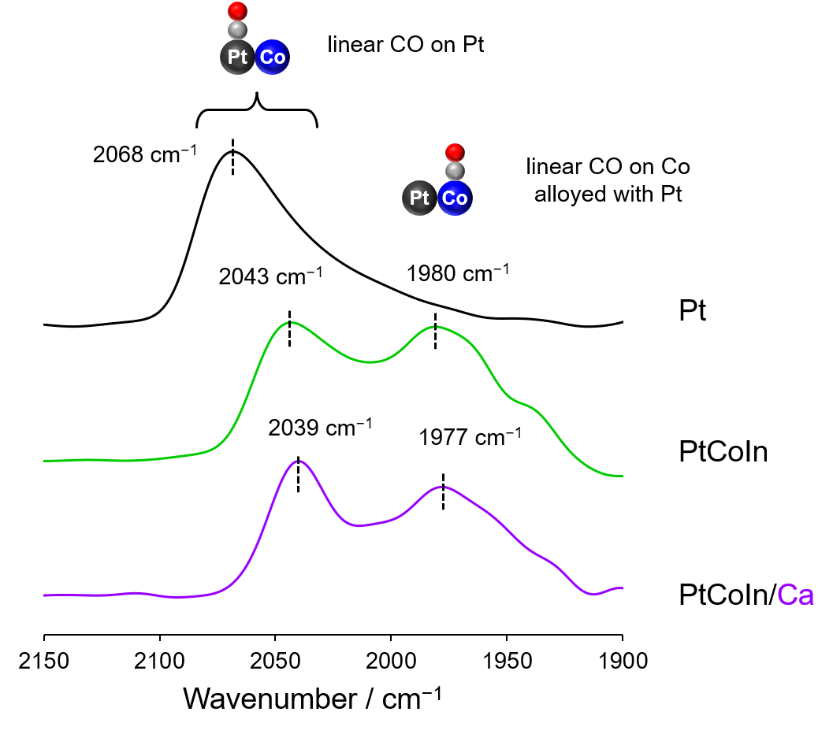

Supplementary Figure 4. FT-IR spectra of CO adsorbed on Pt/SiO₂, PtCoIn/SiO₂, and PtCoIn/Ca–SiO₂. For the FT-IR study, SiO₂-supported catalysts were used instead of the CeO₂-supported ones to avoid interference from the strong infrared absorption of CeO₂. The peak positions were consistent with those observed in literature of Pt/SiO₂ (2070 cm⁻¹),¹ Pt–In/SiO₂ (2042 cm⁻¹),² and Co in Pt–Co alloy surface (1988 cm⁻¹).³

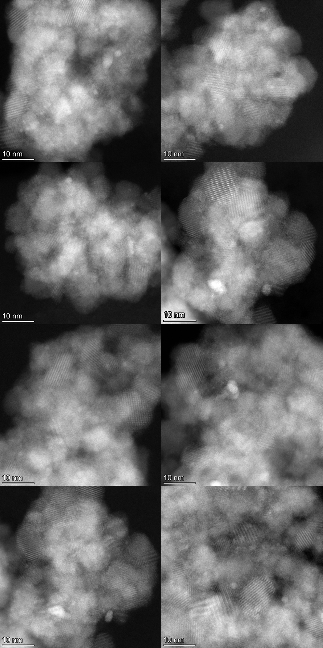
Supplementary Figure 5. HAADF-STEM images of PtCoIn/Ca–C₉P₉Z₁S₁ with several regions. More than 100 particles were counted using these images for size-distribution analysis.

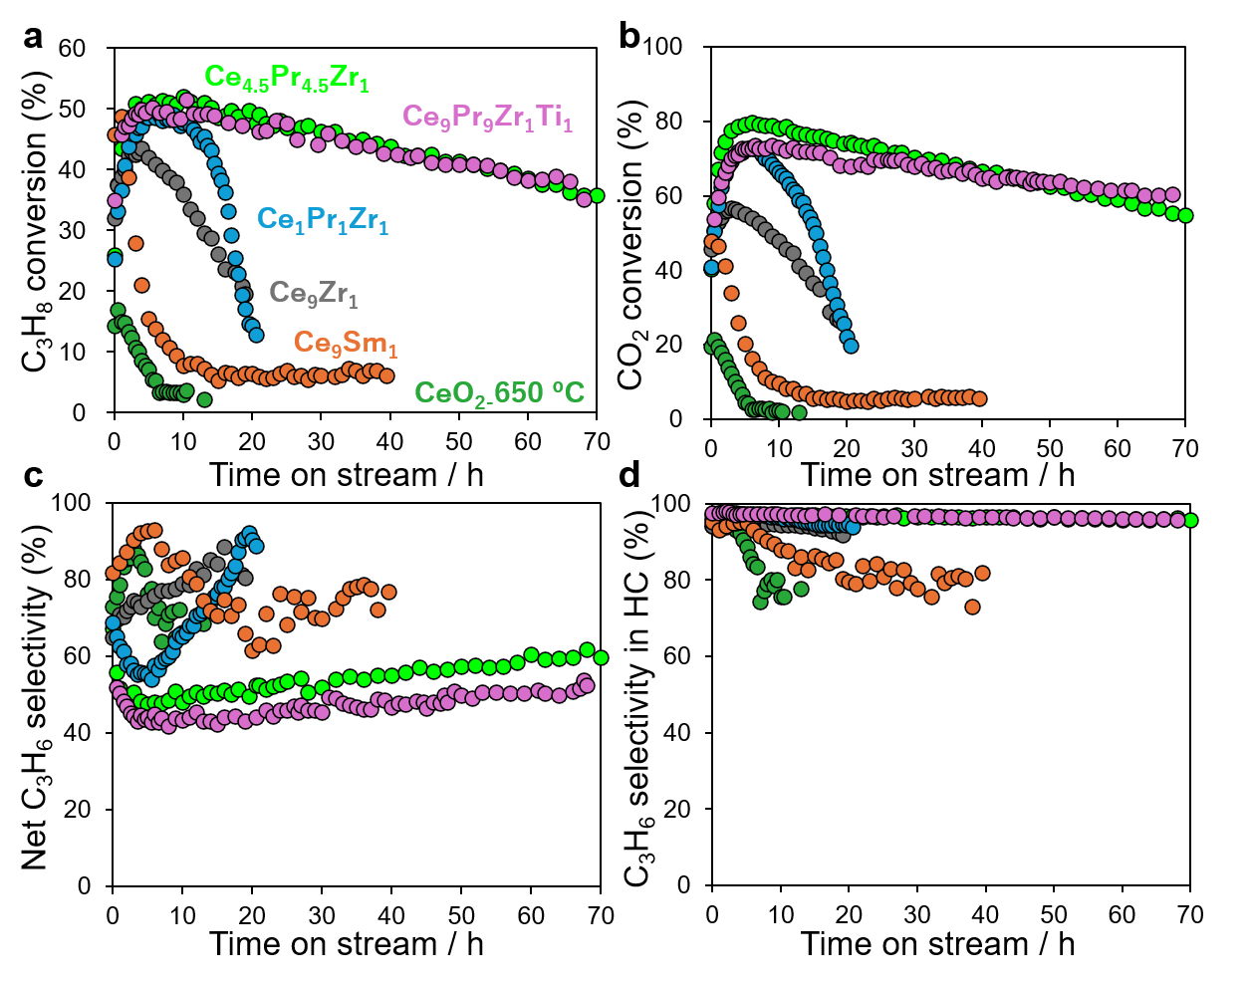

Supplementary Figure 6. Catalytic performance of PtCoIn loaded on Ce-based oxides in CO₂-ODP: a C₃H₈ conversion, b CO₂ conversion, c net C₃H₆ selectivity, and d C₃H₆ selectivity in HC.

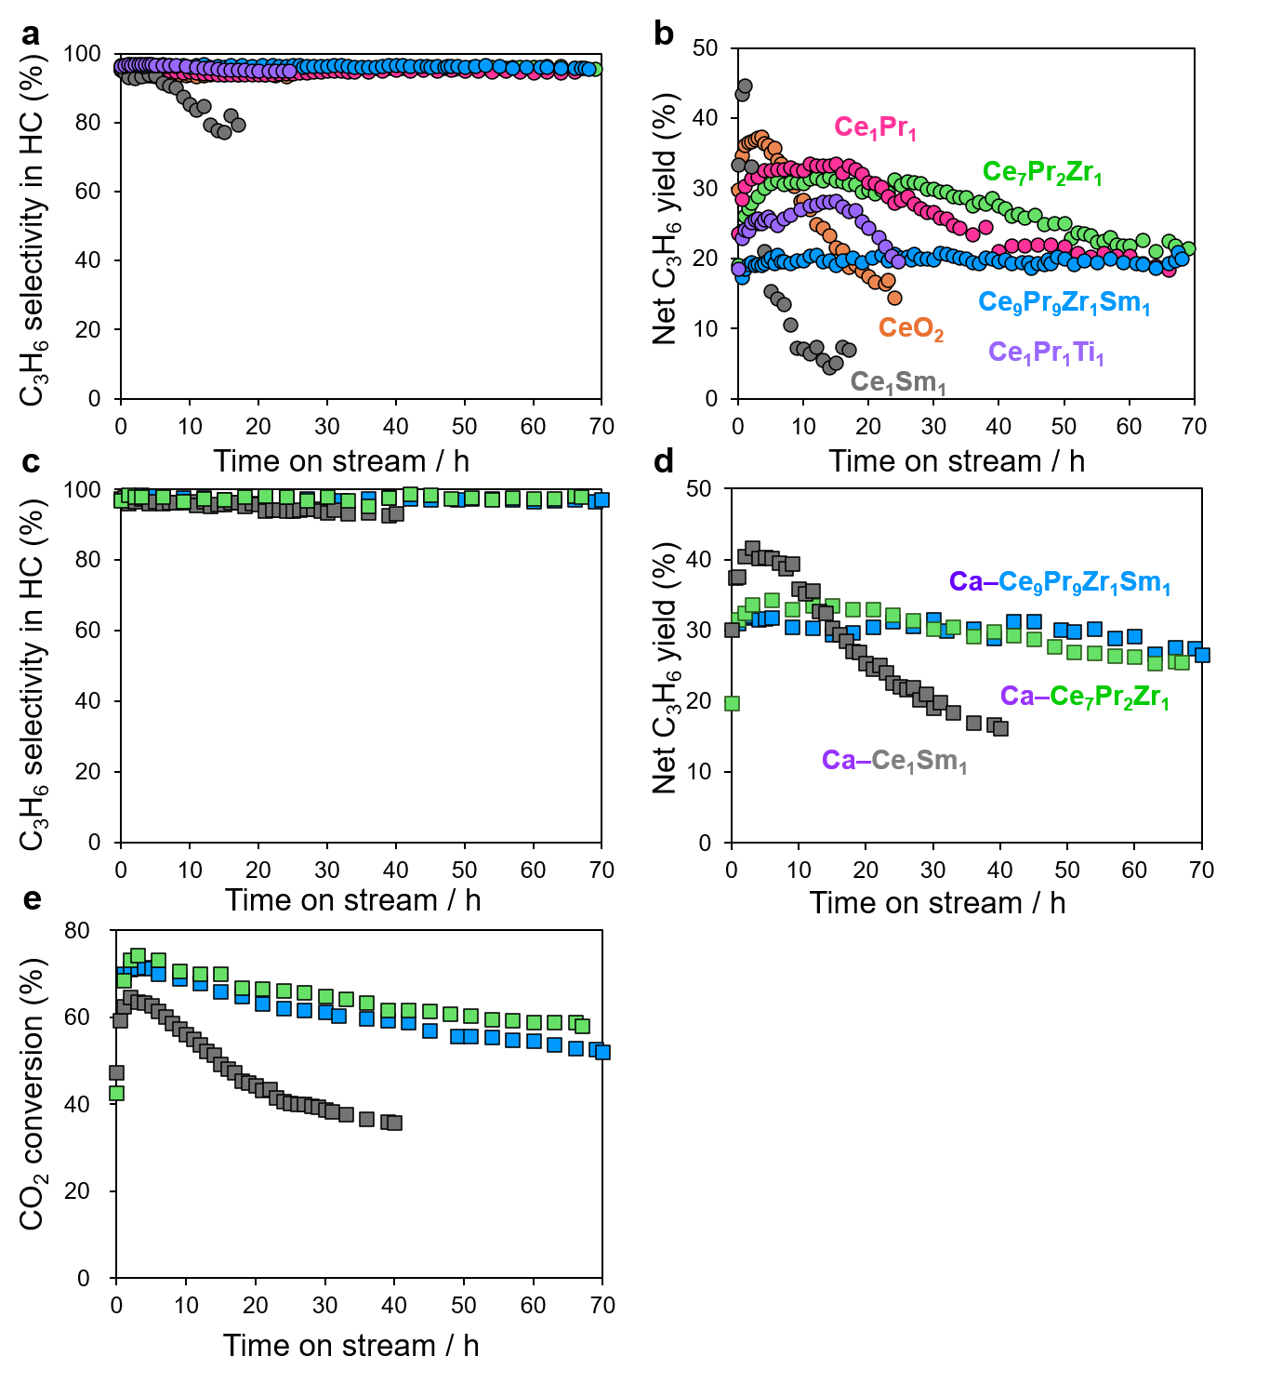
Supplementary Figure 7. a C₃H₆ selectivity in hydrocarbon and b net C₃H₆ yield of PtCoIn loaded on various oxide supports, c C₃H₆ selectivity in hydrocarbon, d net C₃H₆ yield and e CO₂ conversion for Ca decorated PtCoIn loaded on various oxide supports.

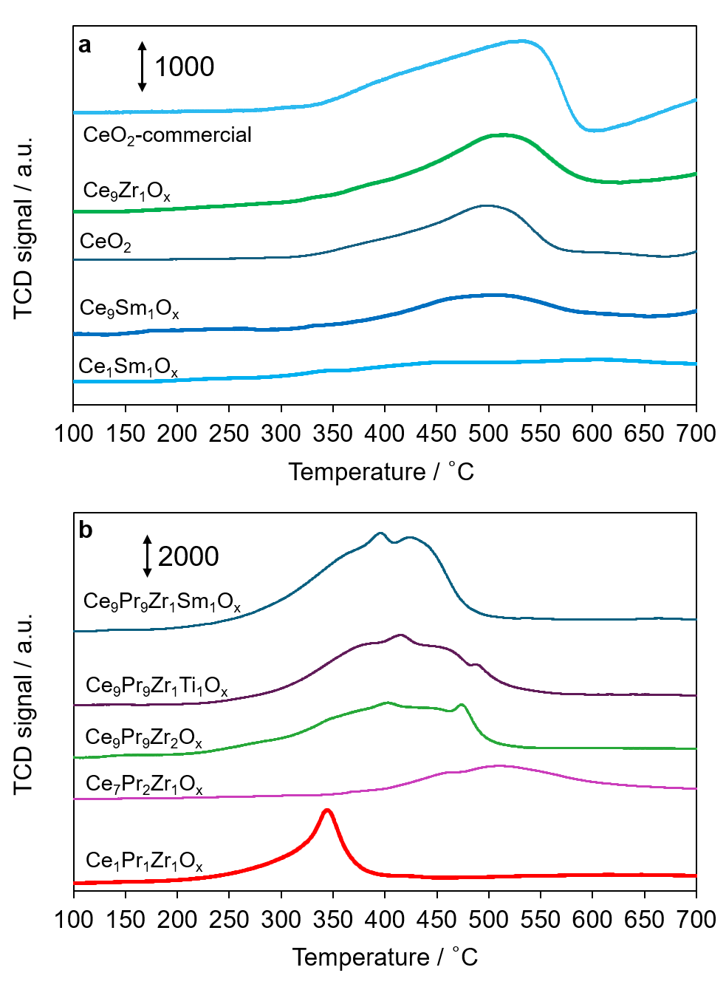
Supplementary Figure 8. TPR profiles of various multinary oxides used as catalyst supports.

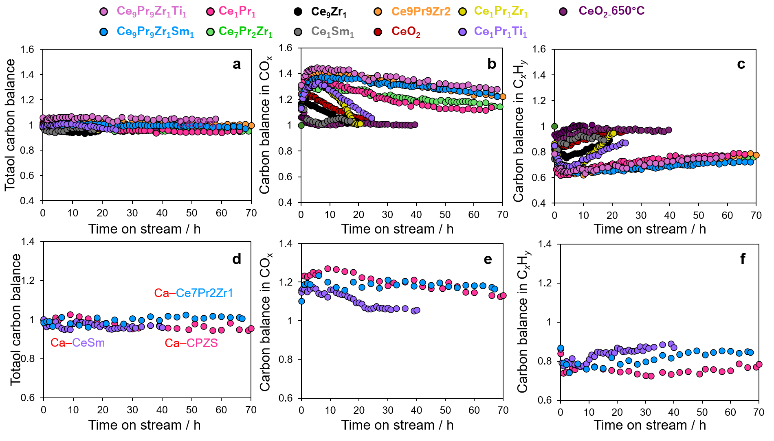

Supplementary Figure 9. a and d total carbon balance, b and e carbon balance in CO_{x}, c and f carbon balance in hydrocarbons of abc PtCoIn loaded on various oxides and def PtCoIn loaded on various oxides with Ca decoration.

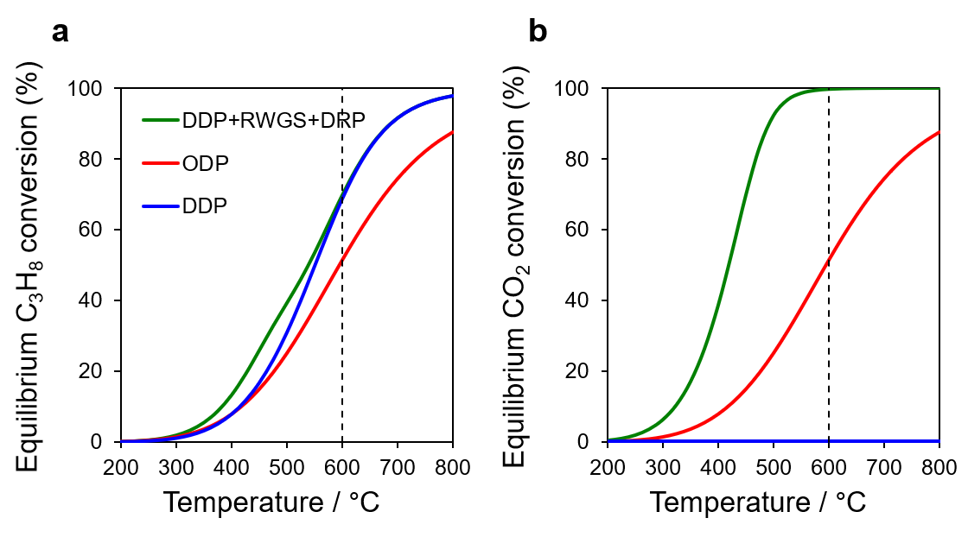
Supplementary Figure 10. Equilibrium conversions of a C₃H₈ and b CO₂ for DDP, ODP and ODP with DRP.

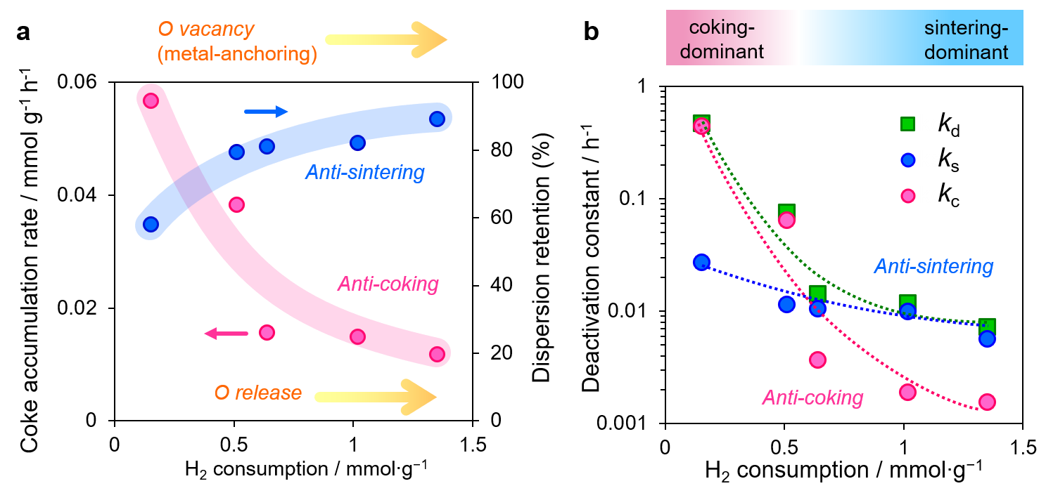
Supplementary Figure 11. a Dependence of coke accumulation rate and dispersion retention on H₂ consumption. b Dependence of overall deactivation constant (k_{d}), coking deactivation constant (k_{c}) and sintering deactivation constant (k_{s}) on H₂ consumption.

Supplementary Table 4. Dispersion, composition and surface area of prepared catalysts.

Alloy | Supportª | BET | Dispersion (%) |  | Dispersion retention |  | Composition ratio (%)^{b}
Alloy | Supportª | m² g⁻¹ | Fresh | Spent |  | (%) | Pt | Co | Ni | Sn | In |  | Ca
PtCoIn | CeO₂ | - | - | - |  |  | 1.0 | 0.7 | - | - | 2.2 | -
PtCoIn | CeSmO_{x} | - | 32 | 19 |  | 58 | - | - | - | - | - | -
PtCoIn | CePrO_{x} | - | 23 | 18 |  | 79 | - | - | - | - | - | -
PtCoIn | Ce₇Pr₂Zr₁O_{x} | 76 | 22 | 18 |  | 81 | 1.0 | 0.8 | - | - | 2.0 | -
PtCoIn | Ce₉Pr₉Zr₁Ti₁O_{x} | - | 16 | 13 |  | 82 | - | - | - | - | - | -
PtCoIn | Ce₉Pr₉Zr₁Sm₁O_{x} | 51 | 26 | 23 |  | 89 | 1.0 | 0.9 | - | - | 2.2 | -
PtCoIn | Ca_CeSmO_{x} | - | - | - |  | - | - | - | - | - | - | -
PtCoIn | Ca_Ce₇Pr₂Zr₁O_{x} | - | - | - |  | - | - | - | - | - | - | -
PtCoIn | Ca_Ce₉Pr₉Zr₁Sm₁O_{x} | 32 | 33 | 29 |  | 88 | 1.0 | 0.7 | - | - | 2.1 | 2.3
HEI | Ce₇Pr₂Zr₁O_{x} | 85 | 41 | 38 |  | 93 | 1.0 | 1.1 | 0.8 | 1.8 | 1.5 | -
HEI | Ce₉Pr₉Zr₁Sm₁O_{x} | 68 | 44 | 41 |  | 94 | - | - | - | - | - | -
HEI | Ca_Ce₇Pr₂Zr₁O_{x} | - | - | - |  | - | - | - | - | - | - | -
HEI | Ca_Ce₉Pr₉Zr₁Sm₁O_{x} | 70 | 34 | 34 |  | 99.5 | 1.0 | 1.2 | 0.8 | 1.6 | 1.4 | 1.7
a: Ca_oxide indicates that there is Ca decoration in this catalyst
b: tested by XRF.

Supplementary Text 1

The apparent deactivation constant, $k_{d}$, was assumed to consist of two independent contributions: catalyst deactivation caused by coke accumulation ($k_{c}$) and the reduction in the number of accessible surface metal sites caused by nanoparticle sintering ($k_{s}$). In the present treatment, these two deactivation processes were approximated as independent, considering that coke deposition and nanoparticle sintering originate from distinct chemical and physical phenomena, respectively. Because coking is commonly described by first-order deactivation kinetics and the gradual decrease in accessible surface metal sites caused by sintering can also be approximated as a first-order process for simplicity, the catalytic activity can be expressed as;
$$\begin{matrix} & r_{t}=r_{0}e^{-k_{d}t} & & \text{(6)}\end{matrix}$$
$$\begin{matrix} & =r_{0}e^{-k_{c}t}⋅e^{-k_{s}t} & & \text{(7)}\end{matrix}$$
$$\begin{matrix} & =r_{0}e^{-\left(k_{c}+k_{s}\right)t} & & \text{(8)}\end{matrix}$$
thus giving
$$\begin{matrix} & k_{d}=k_{c}+k_{s} & & \text{(9)}\end{matrix}$$
The sintering constant, $k_{s}$, was estimated from the change in metal dispersion before and after the reaction. Assuming that the number of accessible surface metal sites is proportional to metal dispersion, the decrease in dispersion due to sintering can likewise be approximated by a first-order decay:
$$\begin{matrix} & D_{t}=D_{0}e^{-k_{s}t} & & \text{(10)}\end{matrix}$$
$$\begin{matrix} & \ln{R_{D}}=-k_{s}t \left(R_{D}=D_{t}/D_{0}\right) & & \text{(11)}\end{matrix}$$
$$\begin{matrix} & k_{s}=-\frac{\ln{R_{D}}}{t} & & \text{(12)}\end{matrix}$$
where $D_{0}$, $D_{t}$, and $R_{D}$represent the metal dispersions before and after the reaction, and the dispersion retention, respectively. The coking constant was subsequently obtained from Eq. (9) as
$$\begin{matrix} & k_{c}=k_{d}-k_{s}. & & \text{(13)}\end{matrix}$$
Although this treatment relies on several simplifying assumptions, including independent first-order deactivation processes and proportionality between accessible surface metal sites and metal dispersion, it provides a useful semi-quantitative framework for evaluating the relative contributions of coking and sintering to the overall catalyst deactivation.

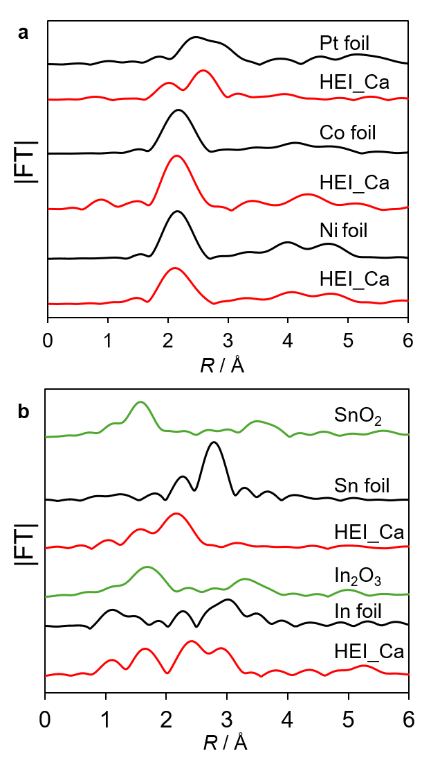

Supplementary Figure 12. Fourier transforms of a Pt L_{II}-, Co K- and Ni K-edge EXAFS, b In K- and Sn K-edge EXAFS of HEI/Ca–C₉P₉Z₁S₁ catalysts and reference compounds. The k³-weighted EXAFS oscillation was Fourier-transformed in the k range of 3−12 Å⁻¹ for all edges.

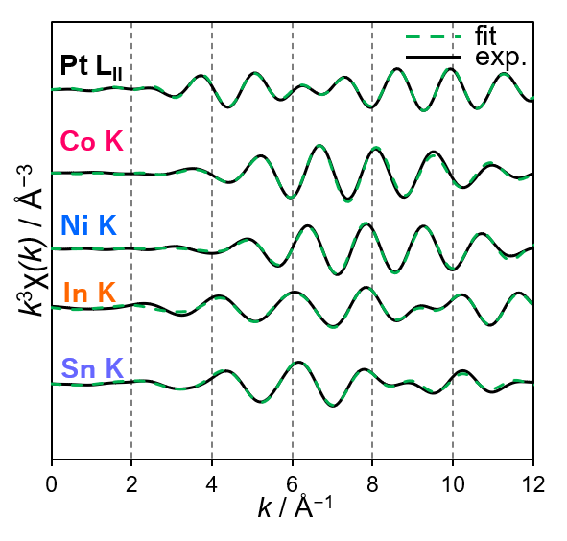
Supplementary Figure 13. Curve-fitting for the Pt L_{II}-, Co K-, Ni K-, In K- and Sn K-edge k³-weighted EXAFS oscillations of HEI/Ca–C₉P₉Z₁S₁. Curve-fitting was performed using the back Fourier-transforms of the coordination peaks ranging between 1.3−3.7 Å, 1.0−3.0 Å, 1.0−3.0 Å, 1.2−4.0 Å and 1.2−3.8 Å for Pt L_{II}-, Co K-, Ni K-, In K- and Sn K-edge, respectively.

Supplementary Table 5. Results of EXAFS curve-fitting for HEI/Ca–C₉P₉Z₁S₁ and the reference foils.
Sample | Edge | Shell | S_{o}^{2[a]} | CN^{[b]} | R^{[c]} (Å) | ∆E_{o}^{[d]} (eV) | σ^{2[e]} (Å²) | R-factor
Pt foil | Pt LII | Pt–Pt | 0.90 | 12 (fix) | 2.77 ± 0.01 | 6.3 ± 1.1 | 0.005 | 0.005
Co foil | Co K | Co–Co | 0.76 | 12 (fix) | 2.49 ± 0.00 | 7.3 ± 0.2 | 0.006 | 0.000
Ni foil | Ni K | Ni–Ni | 0.85 | 12 (fix) | 2.48 ± 0.00 | 2.8 ± 0.3 | 0.006 | 0.001
SnO₂ | Sn K | Sn–O | 0.99 | 6 (fix) | 2.06 ± 0.01 | 9.0 ± 1.8 | 0.002 | 0.007
In | In K | In–In | 0.88 | 4 (fix) | 3.14 ± 0.02 | 2.9 ± 1.5 | 0.016 | 0.027
In | In K | In–In | 0.90 | 8 (fix) | 3.32 ± 0.03 | 2.9 ± 1.5 | 0.021 | 0.027
HEI/Ca_9911 | Pt LII | Pt–Sn/In | 0.90 (fix) | 4.6 ± 0.7 | 2.70 ± 0.01 | 4.8 ± 1.0 | 0.007 | 0.009
HEI/Ca_9911 | Pt LII | Pt–Pt | 0.90 (fix) | 4.1 ± 5.9 | 2.84 ± 0.04 | 4.8 ± 1.0 | 0.020 | 0.009
HEI/Ca_9911 | Co K | Co–Co | 0.76 (fix) | 6.7 ± 0.9 | 2.48 ± 0.01 | 9.98± 2.4 | 0.009 | 0.008
HEI/Ca_9911 | Co K | Co–Sn/In | 0.76 (fix) | 5.1 ± 12.1 | 2.66 ± 0.07 | 9.98± 2.4 | 0.036 | 0.008
HEI/Ca_9911 | Ni K | Ni–Ni | 0.85 (fix) | 4.6 ± 0.3 | 2.47 ± 0.01 | −4.3 ± 2.5 | 0.005 | 0.010
HEI/Ca_9911 | Ni K | Ni–Sn/In | 0.85 (fix) | 1.4 ± 0.7 | 2.69 ± 0.01 | −4.3 ± 2.5 | 0.010 | 0.010
HEI/Ca_9911 | Sn K | Sn–O | 0.99 (fix) | 0.6 ± 0.7 | 2.02 ± 0.02 | −1.9 ± 4.1 | 0.003 | 0.022
HEI/Ca_9911 | Sn K | Sn–Co/Ni | 0.99 (fix) | 2.8 ± 0.8 | 2.62 ± 0.04 | −1.9 ± 4.1 | 0.016 | 0.022
HEI/Ca_9911 | Sn K | Sn–Pt | 0.99 (fix) | 1.4 ± 0.4 | 2.64 ± 0.02 | −1.9 ± 4.1 | 0.011 | 0.022
HEI/Ca_9911 | In K | In–O | 0.88 (fix) | 2.1 ± 0.3 | 2.06 ± 0.01 | −6.0 ± 2.29 | 0.004 | 0.015
HEI/Ca_9911 | In K | In–Co/Ni | 0.88 (fix) | 4.7 ± 0.8 | 2.62 ± 0.04 | −6.0 ± 2.29 | 0.032 | 0.015
HEI/Ca_9911 | In K | In–Pt | 0.88 (fix) | 2.3 ± 0.8 | 2.69 ± 0.01 | −6.0 ± 2.29 | 0.008 | 0.015
[a]Amplitude factor. [b]Coordination number. [c]Distance between absorber and backscattering atoms. [d]Correction term in the absorption edge. [e]Disorder term (EXAFS Debye–Waller factor).

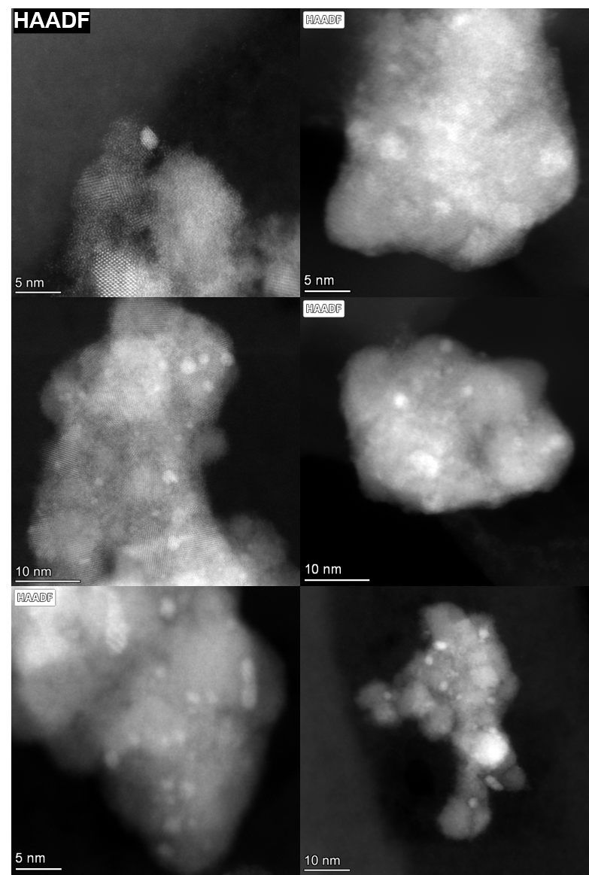
Supplementary Figure 14. HAADF-STEM images of HEI/Ca–C₉P₉Z₁S₁ catalyst. More than 100 particles were counted using these images for size-distribution analysis.
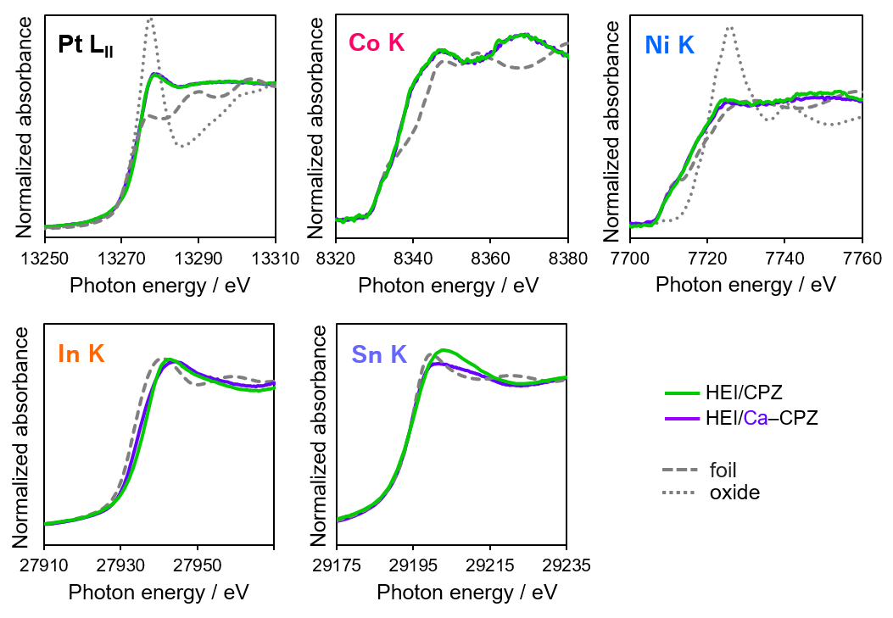
Supplementary Figure 15. XANES spectra of Pt L_{II}-, Co K-, Ni K-, Sn K- and In K-edge of HEI/(Ca–)C₇P₂Z₁ catalyst.

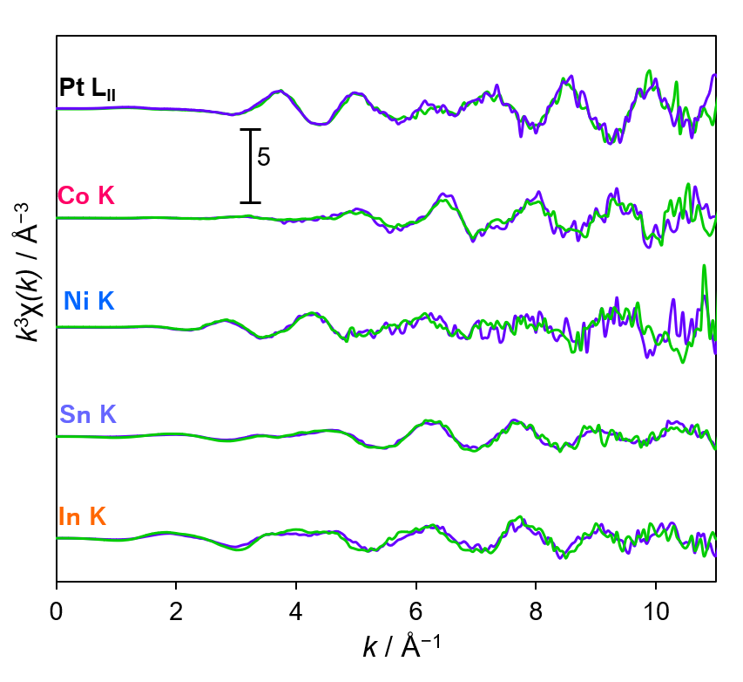
Supplementary Figure 16. k³-weighted EXAFS oscillation of Pt L_{II}-, Co K-, Ni K-, Sn K- and In K-edge of HEI/C₇P₂Z₁ catalyst (green) and HEI/Ca–C₇P₂Z₁ (purple).

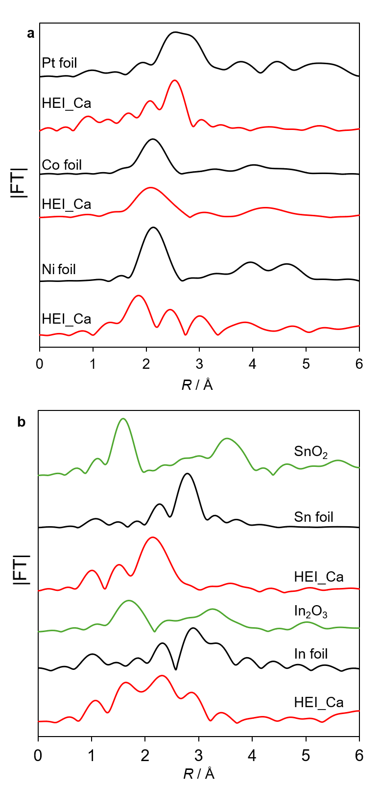
Supplementary Figure 17. Fourier transforms of a Pt L_{II}-, Co K-, Ni K-, b In K- and Sn K-edge EXAFS of HEI/Ca–C₇P₂Z₁ catalysts and reference compounds. The k³-weighted EXAFS oscillation was Fourier-transformed in the k range of 3−12 Å⁻¹ for all edges

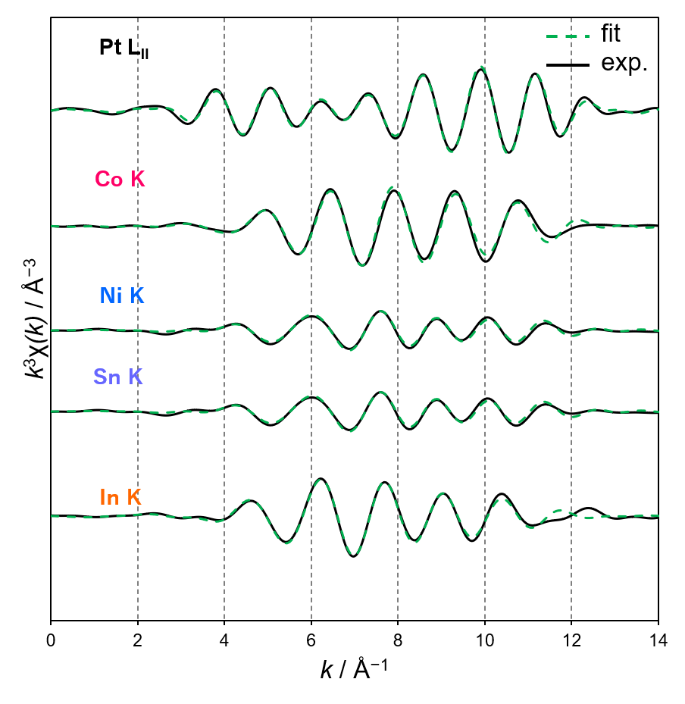
Supplementary Figure 18. Curve-fitting for the Pt LII-, Co K-, Ni K-, In K- and Sn K-edge k³-weighted EXAFS oscillations of HEI/Ca–C₇P₂Z₁. The k³-weighted EXAFS oscillation was Fourier-transformed in the k range of 3−12 Å⁻¹ for all edges. Curve-fitting was performed using the back Fourier-transforms of the coordination peaks ranging between 1.3−3.3 Å, 1.0−3.0 Å, 1.0−3.3 Å, 1.2−3.6 Å and 1.0−3.5 Å for Pt LII-, Co K-, Ni K-, In K- and Sn K-edge, respectively.

Supplementary Table 6. Results of EXAFS curve-fitting for HEI/Ca–C₇P₂Z₁ and the reference foils.

Sample | Edge | Shell | S_{o}^{2[a]} | CN^{[b]} | R^{[c]} (Å) | ∆E_{o}^{[d]} (eV) | σ^{2[e]} (Å²) | R-factor
Pt foil | Pt L_{II} | Pt–Pt | 0.80 | 12 (fix) | 2.78 ± 0.01 | 6.4 ± 1.9 | 0.000 | 0.020
Co foil | Co K | Co–Co | 0.79 | 12 (fix) | 2.49 ± 0.00 | 1.1 ± 0.3 | 0.006 | 0.001
Ni foil | Ni K | Ni–Ni | 0.80 | 12 (fix) | 2.48 ± 0.00 | 1.0 ± 0.5 | 0.006 | 0.001
Sn foil | Sn K | Sn–Sn | 0.75 | 8 (fix) | 3.01 ± 0.01 | 1.2 ± 1.1 | 0.013 | 0.015
In foil | In K | In–In | 0.76 | 4 (fix) | 3.13 ± 0.02 | 1.9 ± 1.5 | 0.014 | 0.024
In foil | In K | In–In | 0.76 | 8 (fix) | 3.31 ± 0.03 | 1.9 ± 1.5 | 0.021 | 0.024
HEI/Ca–C₇P₂Z₁ | Pt L_{II} | Pt–Sn | 0.80 (fix) | 3.3 ± 0.6 | 2.55 ± 0.04 | 4.9 ± 1.1 | 0.007 | 0.008
HEI/Ca–C₇P₂Z₁ | Pt L_{II} | Pt–Pt | 0.80 (fix) | 4.6 ± 4.0 | 2.60 ± 0.04 | 4.9 ± 1.1 | 0.017 | 0.008
HEI/Ca–C₇P₂Z₁ | Co K | Co–Co | 0.79 (fix) | 4.7 ± 0.4 | 2.65 ± 0.04 | −0.5 ± 3.0 | 0.006 | 0.016
HEI/Ca–C₇P₂Z₁ | Co K | Co–In | 0.79 (fix) | 2.3 ± 0.4 | 2.43 ± 0.02 | −0.5 ± 3.0 | 0.019 | 0.016
HEI/Ca–C₇P₂Z₁ | Ni K | Ni–Ni | 0.80 (fix) | 1.5 ± 0.4 | 2.80 ± 0.04 | −4.2 ± 1.5 | 0.004 | 0.009
HEI/Ca–C₇P₂Z₁ | Ni K | Ni–In | 0.80 (fix) | 4.4 ± 1.3 | 2.48 ± 0.02 | −4.2 ± 1.5 | 0.016 | 0.009
HEI/Ca–C₇P₂Z₁ | Sn K | Sn–O | 0.75 (fix) | 1.5 ± 0.7 | 2.60 ± 0.03 | 2.1 ± 3.6 | 0.010 | 0.019
HEI/Ca–C₇P₂Z₁ | Sn K | Sn–Co/Ni | 0.75 (fix) | 3.6 ± 1.0 | 2.11 ± 0.02 | 2.1 ± 3.6 | 0.002 | 0.019
HEI/Ca–C₇P₂Z₁ | Sn K | Sn–Pt | 0.75 (fix) | 3.6 ± 1.0 | 2.59 ± 0.02 | 2.1 ± 3.6 | 0.005 | 0.019
HEI/Ca–C₇P₂Z₁ | In K | In–O | 0.76 (fix) | 2.0 ± 1.8 | 2.71 ± 0.02 | −6.0 ± 4.48 | 0.013 | 0.018
HEI/Ca–C₇P₂Z₁ | In K | In–Co/Ni | 0.76 (fix) | 2.9 ± 1.3 | 2.17 ± 0.04 | −6.0 ± 4.48 | 0.025 | 0.018
HEI/Ca–C₇P₂Z₁ | In K | In–Pt | 0.76 (fix) | 2.9 ± 1.3 | 2.69 ± 0.03 | −6.0 ± 4.48 | 0.009 | 0.018
[a]Amplitude factor. [b]Coordination number. [c]Distance between absorber and backscattering atoms. [d]Correction term in the absorption edge. [e]Disorder term (EXAFS Debye–Waller factor).

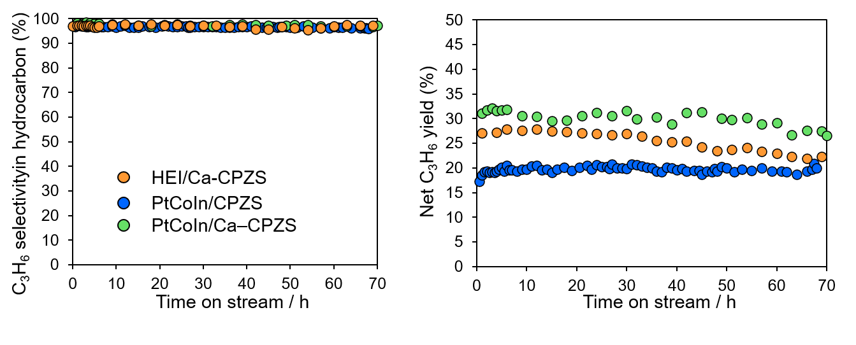
Supplementary Figure 19. Net C₃H₆ yield and C₃H₆ selectivity in hydrocarbon of PtCoIn/C₉P₉Z₁S₁, PtCoIn/Ca–C₉P₉Z₁S₁, and HEI/Ca–C₉P₉Z₁S₁ catalysts.

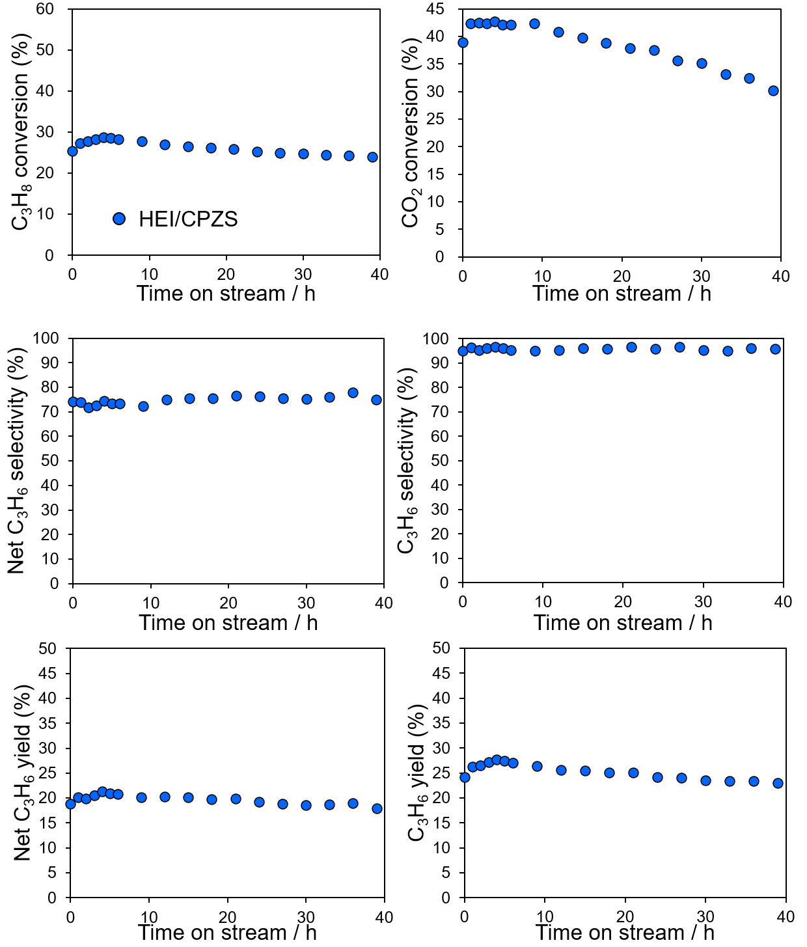
Supplementary Figure 20. CO₂-ODP performance of HEI/C₉P₉Z₁S₁ catalyst.

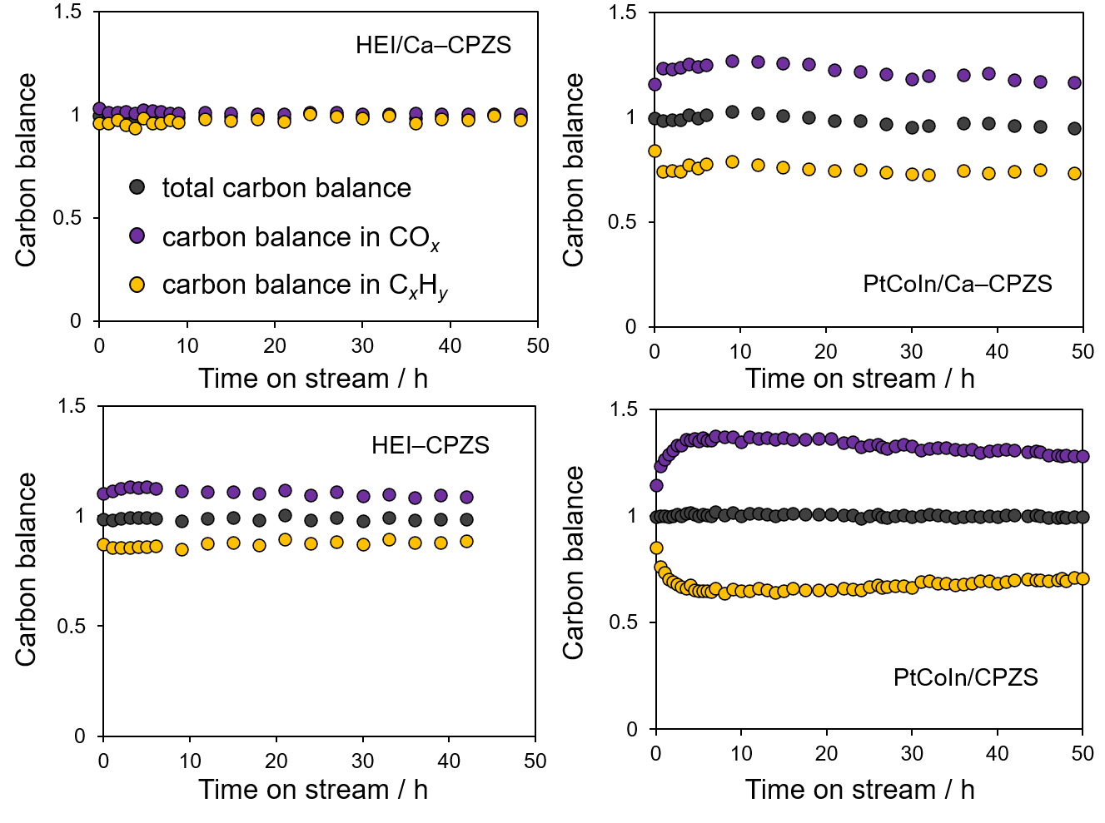
Supplementary Figure 21. Total carbon balance, carbon balance in C_{x}H_{y} and CO_{x} of various catalysts.

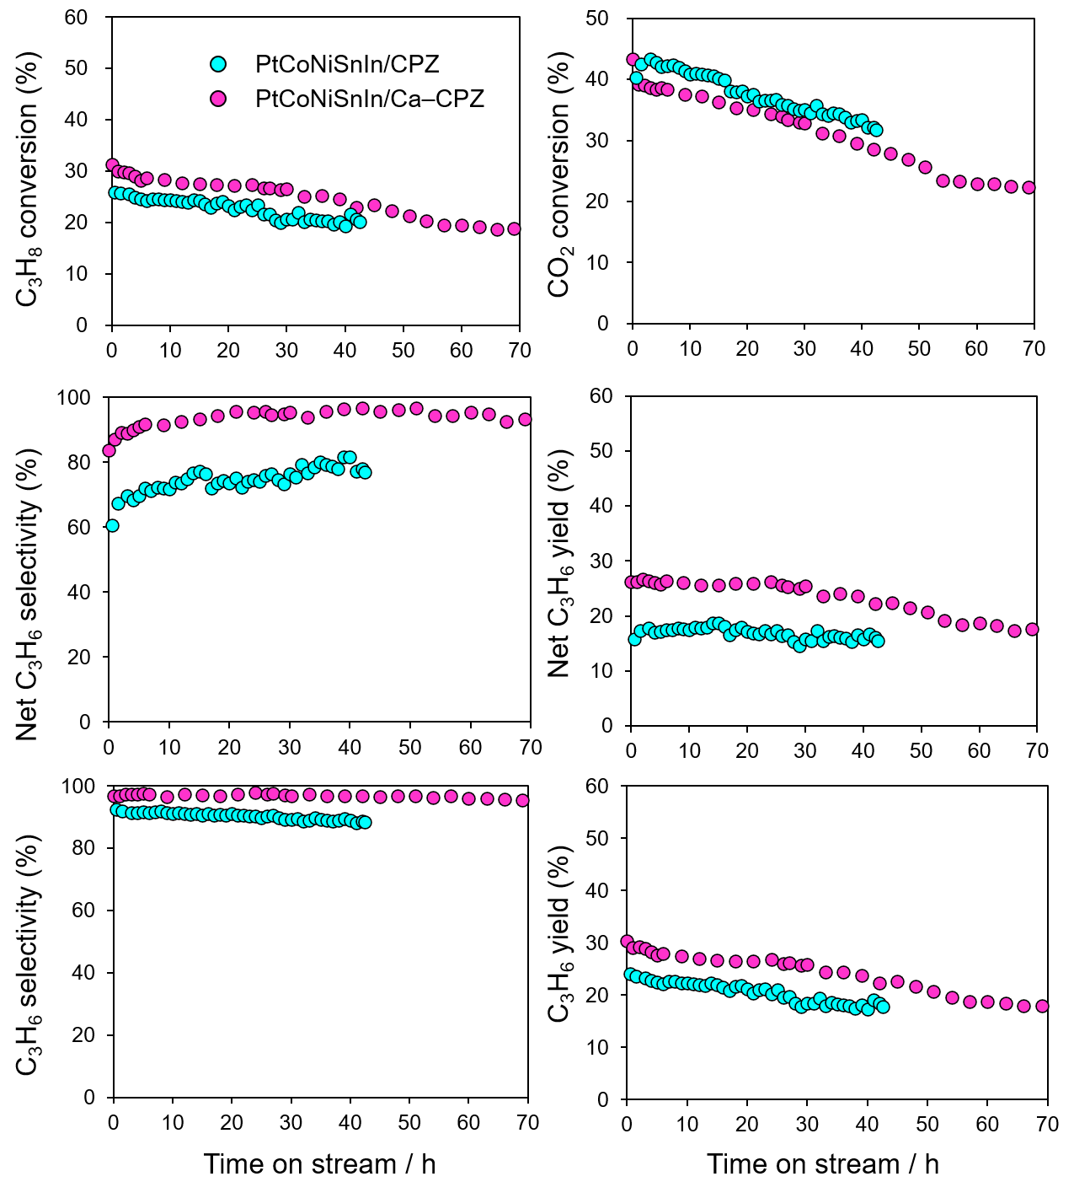
Supplementary Figure 22. CO₂-ODP performance of HEI/C₇P₂Z₁ and HEI/Ca–C₇P₂Z₁.

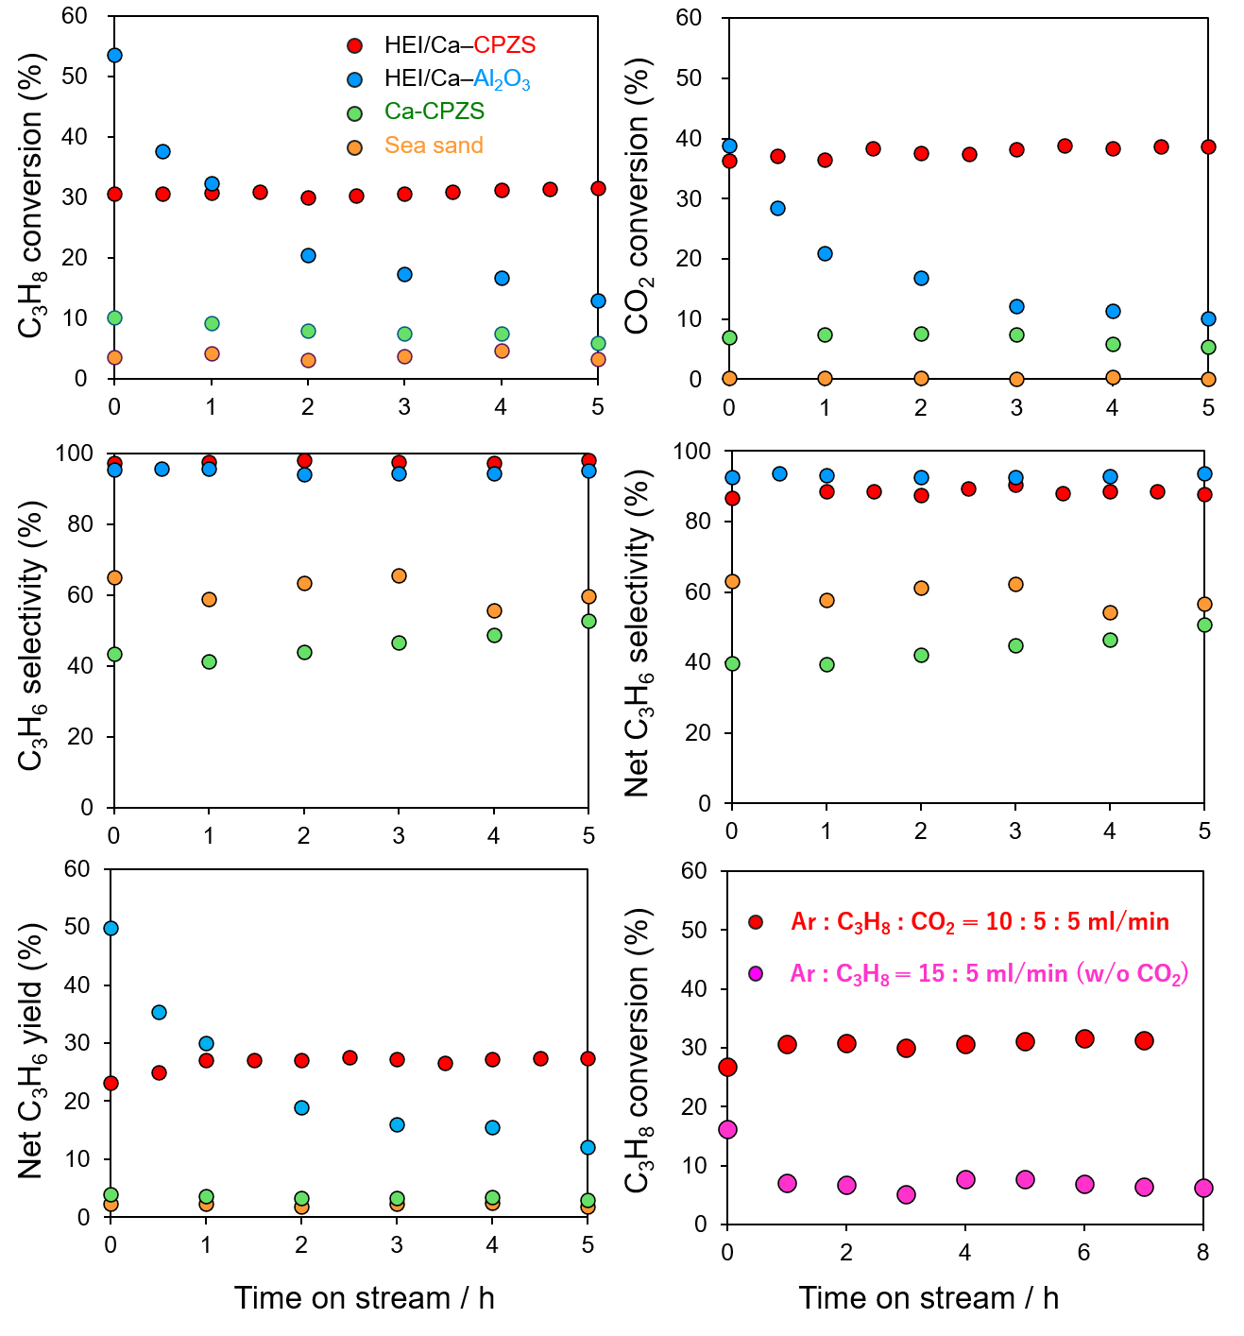
Supplementary Figure 23. Control experiments of CO₂-ODP with HEI/Ca–Al₂O₃, Ca–CPZS, sea sand. Direct propane dehydrogenation over HEI/Ca–CPZS.

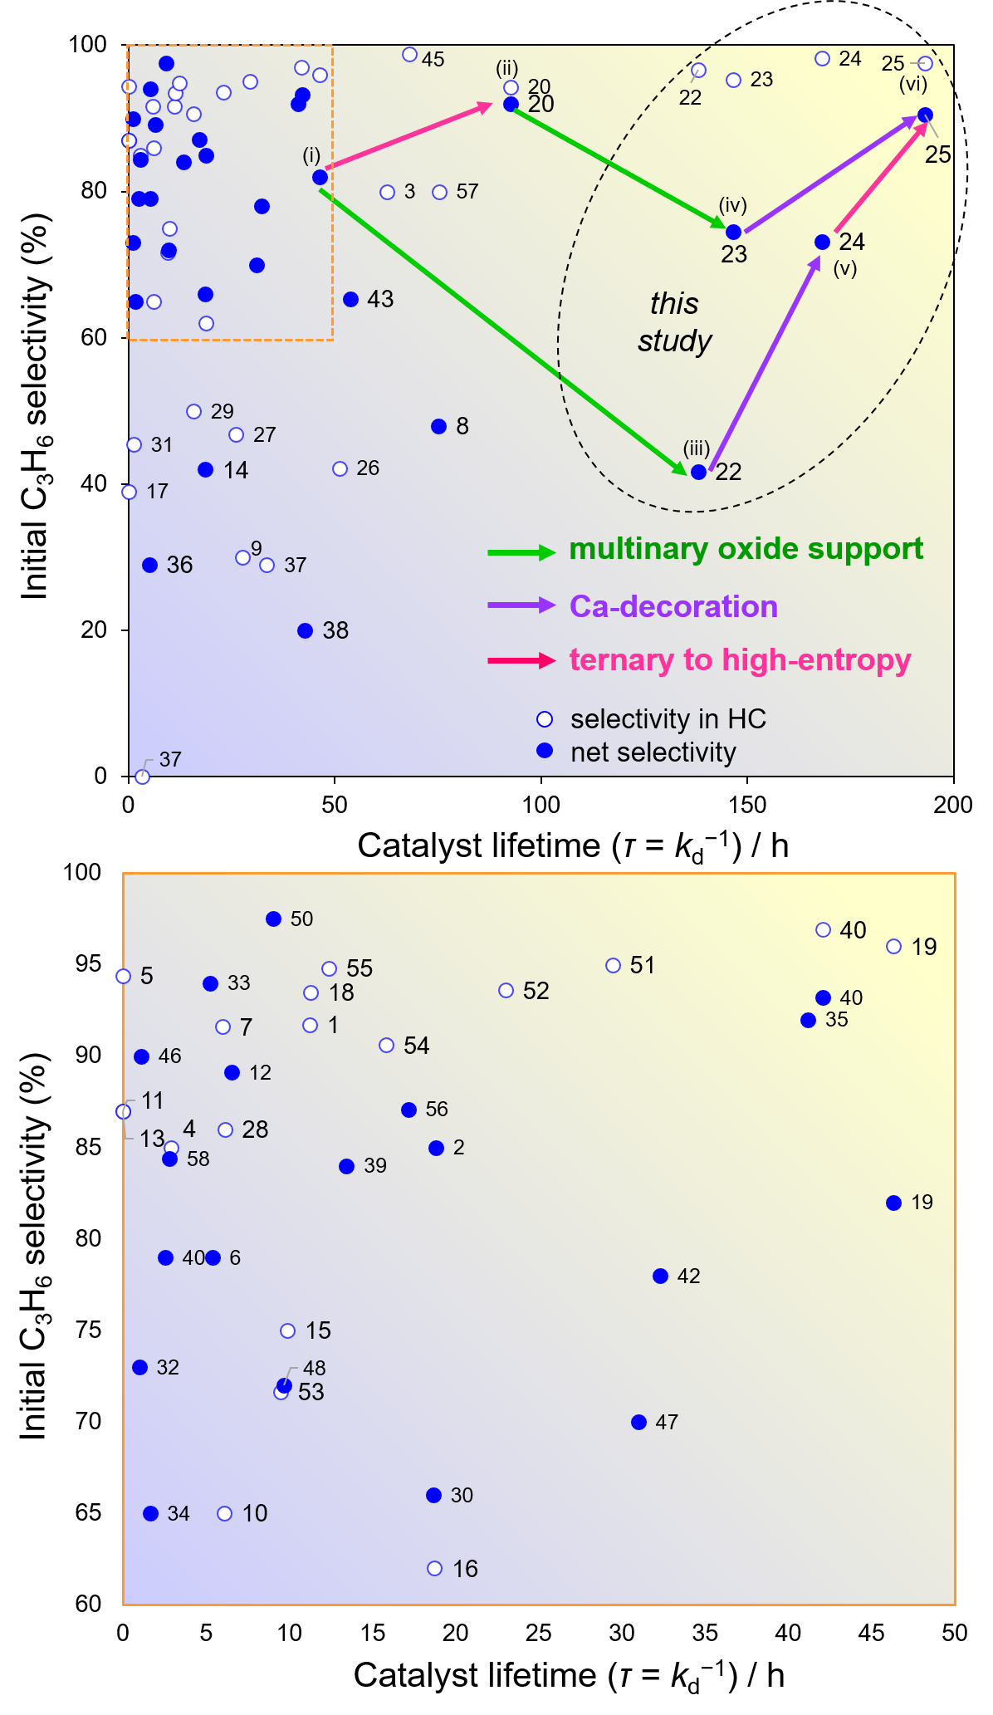
Supplementary Figure 24. Detailed number indication for Figure 5i. The numbers correspond to the entry numbers in supplementary Tables 7-9.

Supplementary Table 7. Catalytic conditions and performance of reported catalysts (No. 1-20 in Figure S24).

No. | Catalysts | Temp. | Gas feed ratio  C₃H₈:CO₂:Ar | Time (h) |  | C₃H₈ conv. (%) |  | C₃H₆ sel. (%) |  | kd (h⁻¹) | τ (h) | ref
 |  |  |  | i | f | i | f | i | f | kd (h⁻¹) | τ (h) | ref
1 | Ga₈Al₂O₁₅ | 500 | 2.5:5:92.5 | 0.25 | 8 | 49.7 | 33.1 | 91.7 | 98 | 0.089 | 11.2 | ⁴
2 | Ru₁Cr₁₀O_{x}/SiO₂ | 500 | 1:1:1 | 0.67 | 7 | 9 | 6.5 | (85) | (90) | 0.053 | 18.8 | ⁵
3 | Pd/CeZrAlO_{x} | 500 | 26:37:37 | 0.17 | 140 | 16 | 2 | 80 | 98 | 0.016 | 62.6 | ⁶
4 | 7%Cr/SBA-1 | 550 | 1:5:9 | 0.17 | 4 | 37.7 | 16 | 85 | 91 | 0.347 | 2.9 | ⁷
5 | Cr-O/SiO₂ | 550 | 1:5 | 0.17 | 0 | 17.2 | − | 94.4 | − | − | − | ⁸
6 | Cr₂O₃–ZrO₂ 180 | 550 | 2.5:5:92.5 | 0.17 | 6 | 53.3 | 27.8 | (79) | (90.8) | 0.186 | 5.4 | ⁹
7 | Ga₂O₃–M | 550 | 1:5:9 | 0.17 | 4 | 19 | 11 | 91.6 | 95 | 0.167 | 6.0 | ¹⁰
8 | FeCeO₂ | 550 | 1:1:2 | 0.10 | 20 | 17.5 | 14 | (48) | (53) | 0.013 | 75.2 | ¹¹
9 | Fe3Ni/CeO₂ | 550 | 1:1:2 | 0.10 | 10 | 4.8 | 3.4 | 30 | 58.2 | 0.036 | 27.5 | ¹²
10 | 20%ZnO-ZrO₂ | 550 | 1:4:20 | 0.08 | 2 | 24 | 20 | 65 | 70 | 0.165 | 6.1 | ¹³
11 | 15V-15Zr@ZSM-5 | 550 | 2.5:5:92.5 | 1.00 | 6 | 35 | 39 | 87 | 90 | 0.000 | 0.0 | ¹⁴
12 | 0.5%PtSnCe/SiO₂ | 550 | 1:1:5 | 0.08 | 6 | 55 | 33 | 89.1 | 93.4 | 0.154 | 6.5 | ¹⁵
13 | 2Ga₂O₃V₂O₅/ZSM-5 | 550 | − | 0.50 | 6 | 30 | 35 | 87 | 90 | 0.000 | 0.0 | ¹⁶
14 | FeNi/Ceria-Vo-R | 550 | 2.4:4.8:10 | 0.33 | 3 | 23 | 21 | 42 | 42 | 0.054 | 18.6 | ¹⁷
15 | 12% In/HZSM-5 | 580 | 1:4:5 | 1.00 | 6 | 25.2 | 17.6 | 75 | 70 | 0.101 | 9.9 | ¹⁸
16 | GaN/NaZSM-5(470) | 600 | 1:2:7 | 0.08 | 10 | 46 | 34 | 62 | 78 | 0.053 | 18.7 | ¹⁹
17 | CaO/ZSM-5 | 600 | 5 5 90 | 0.08 | − | 23.1 | − | 39 | − | 0.000 | 0.0 | ²⁰
18 | 2Cr-Ca/ZrO₂ | 600 | 1:3:6 | 0.08 | 10 | 20.2 | 9.5 | 93.5 | 94.6 | 0.089 | 11.3 | ²¹
19 | PtCoIn/CeO₂ | 600 | 1:1:2 | 0.08 | 50 | 61 | 35 | 96 (82) | 97.5 (87) | 0.022 | 46.3 | ²²
20 | HEI/CeO₂ | 600 | 1:1:2 | 0.08 | 50 | 30 | 20 | 94 (92) | 88 (86) | 0.008 | 92.6 | ²³

Supplementary Table 8. Catalytic conditions and performance of reported catalysts (No. 21-40 in Figure S24).

No. | Catalysts | Temp. | Gas feed ratio  C₃H₈:CO₂:Ar | Time (h) |  | C₃H₈ conv. (%) |  | C₃H₆ sel. (%) |  | kd (h⁻¹) | τ (h) | ref
 |  |  |  | i | f | i | f | i | f | kd (h⁻¹) | τ (h) | ref
21 | HEI/CeO₂ | 600 | 1:1:2 | 0.08 | 50 | 30 | 20 | 94 (92) | 88 (86) | 0.008 | 92.6 | ²³
22 | PtCoIn/CPZS | 600 | 1:1:2 | 8.00 | 68 | 47.1 | 36.5 | 97 (42) | 95.8 (53) | 0.007 | 138.0 | *
23 | HEI/CPZS | 600 | 1:1:2 | 4 | 40 | 28.7 | 24.0 | 95 (75) | 94.4 (75) | 0.007 | 146.5 | *
24 | PtCoIn/Ca–CPZS | 600 | 1:1:2 | 3 | 70 | 45.7 | 35.9 | 98 (73) | 97.2 (74) | 0.006 | 168.0 | *
25 | HEI/Ca–CPZS | 600 | 1:1:2 | 1 | 90 | 31 | 22 | 98  (91) | 96.9 (93) | 0.005 | 193 | *
26 | Ga₂O₃/HZSM-48 | 600 | 2.5:5:92.5 | 1.00 | 10 | 52.6 | 48.2 | 42.2 | 45.6 | 0.020 | 51.1 | ²⁴
27 | ZnO/HZSM-5 | 600 | 2.5:5:92.5 | 1.00 | 30 | 68.3 | 41.5 | 46.8 | 62.1 | 0.038 | 26.1 | ²⁵
28 | Cr-MSU-28 | 600 | 1:1:8 | 0.17 | 2 | 44 | 36.8 | 86 | 90.4 | 0.163 | 6.1 | ²⁶
29 | 5%Cr/SiO₂ | 600 | 15:30:55 | − | 20 | 80 | 53 | 50 | 90.6 | 0.063 | 15.8 | ²⁷
30 | 2%Cr₂O₃/SiO₂ | 600 | 15:30:55 | 0.30 | 17 | 71 | 50 | 66 | 90 | 0.055 | 18.3 | ²⁸
31 | 15%Ga/ZrO₂ | 600 | 2.5:5:92.5 | 0.17 | 3 | 38.6 | 6 | 45.4 | 77 | 0.807 | 1.2 | ²⁹
32 | Ga₂O₃/TiO₂ | 600 | 2.5:5:92.5 | 0.17 | 3 | 32 | 2.5 | (73) | − | 1.027 | 1.0 | ³⁰
33 | Ga₂O₃/Al₂O₃ | 600 | 2.5:5:92.5 | 0.17 | 3 | 26 | 17 | (94) | − | 0.190 | 5.2 | ³⁰
34 | Ga₂O₃/ZrO₂ | 600 | 2.5:5:92.5 | 0.17 | 3 | 30 | 7 | (65) | − | 0.614 | 1.6 | ³⁰
35 | Ga₂O₃/SiO₂ | 600 | 2.5:5:92.5 | 0.17 | 3 | 6.4 | 6 | (92) | − | 0.024 | 41.2 | ³⁰
36 | Ga₂O_{3/}MgO | 600 | 2.5:5:92.5 | 0.17 | 3 | 4.3 | 2.5 | (29) | − | 0.198 | 5.1 | ³⁰
37 | 10%In₂O₃/Al₂O₃ | 600 | 2.5:10:87.5 | 0.17 | 8 | 24 | 20 | 29 | 84 | 0.030 | 33.5 | ³¹
38 | In-Al-20 | 600 | 2.5:10:87.5 | 0.17 | 12 | 35 | 29 | (20) | (78) | 0.023 | 42.8 | ³²
39 | 5.2V-MSNS | 600 | 1:4:4 | 0.17 | 24 | 58 | 19 | (84) | (89) | 0.074 | 13.4 | ³³
40 | Cr/MSS-2 | 600 | 1:4:4 | 0.17 | 4 | 69 | 33 | (79) | (90) | 0.394 | 2.5 | ³⁴
*: data from this work

Supplementary Table 9. Catalytic conditions and performance of reported catalysts. No. 41-58 in Figure S24.

No. | Catalysts | Temp. | Gas feed ratio  C₃H₈:CO₂:Ar | Time (h) |  | C₃H₈ conv. (%) |  | C₃H₆ sel. (%) |  | kd (h⁻¹) | τ (h) | ref
 |  |  |  | i | f | i | f | i | f | kd (h⁻¹) | τ (h) | ref
41 | 0.5 Ni-Cr/Si | 600 | 1:1:8 | 0.17 | 12 | 90 | 19 | 0 | 90 | 0.308 | 3.2 | ³⁵
42 | 7 Ga/SiO₂-A | 650 | 1:2 | 0.08 | 20 | 33 | 21 | (78) | (77) | 0.031 | 32.3 | ³⁶
43 | 0.8GaN–Ga₂O₃/ZSM-5 | 600 | 1:2:7 | 1.00 | 55 | 55.1 | 31 | (65.3) | (80) | 0.019 | 53.7 | ³⁷
44 | PtSn/Ce-DMSN-0.5 | 550 | 8:8:8:1 | 0 | 33 | 40.9 | 24 | 96.9  (93.2) | 96.8 (92) | 0.024 | 42.1 | ³⁸
45 | Pt₁Sn₇/CeO_{x}–Al₂O₃ | 550 | 5:3:27 | 0.25 | 12 | 44.2 | 40 | 98.8 | 98 | 0.015 | 68.1 | ³⁹
46 | PtIn/Al₂O₃ | 550 | 8:8:34 | 0 | 1.5 | 32.5 | 11 | (90) | (80) | 0.907 | 1.1 | ⁴⁰
47 | KPt/Silicalite-1 | 500 | 1:1:4 | 0 | 10 | 50 | 42 | (70) | (90) | 0.032 | 31.0 | ⁴¹
48 | 5GaN/[Ga]MFI-100 | 600 | 1:2:7 | 0 | 6 | 65 | 50 | (72) | (76) | 0.103 | 9.7 | ⁴²
49 | Ni2.1%Cr3.6%Ox@S1-1.0 | 600 | 1:1:23 | 0 | 36 | 51.7 | 41 | 91.4 | − | 0.012 | 83.3 | ⁴³
50 | PtMn/SiO₂ | 500 | 10:10:5 | 0 | 2 | 31.8 | 27.2 | (97.5) | (97.8) | 0.111 | 9.0 | ⁴⁴
51 | 4 wt% Co@Z5–1000 | 600 | 1:2:7 | 3 | 38 | 45.1 | 20 | 95 | 95 | 0.034 | 29.4 | ⁴⁵
52 | MoCx/Si-1 | 550 | 1:1:2 | 0 | 24 | 13 | 5 | 93.6 | 95 | 0.043 | 23.0 | ⁴⁶
53 | 5Cr-Co/ZSM-5 (w) | 600 | 1:2:97 | 0 | 3 | 53.9 | 46 | 71.65 | 80 | 0.106 | 9.5 | ⁴⁷
54 | 10V-0.5Fe/S-1 | 600 | 1:1:3 | 0 | 8 | 52.5 | 40 | 90.6 | 90 | 0.063 | 15.8 | ⁴⁸
55 | Co/MgS-1 | 600 | 1:1 | 0 | 8 | 32.3 | 20 | 94.8 | 90 | 0.081 | 12.4 | ⁴⁹
56 | Si(5)PtSn/Al₂O₃ | 550 | 1:1:2 | 0.25 | 8 | 48 | 37 | (87.1) | (87.8) | 0.058 | 17.1 | ⁵⁰
57 | PtZn/Co@S-1 | 550 | 1:1:4 | 0 | 60 | 59.68 | 40 | (80) | (94.9) | 0.013 | 75.2 | ⁵¹
58 | 5Fe-5V-Al₂O₃ | 600 | 15:15:70 | 0.25 | 1 | 41.3 | 35 | 84.4 | − | 0.357 | 2.8 | ⁵²

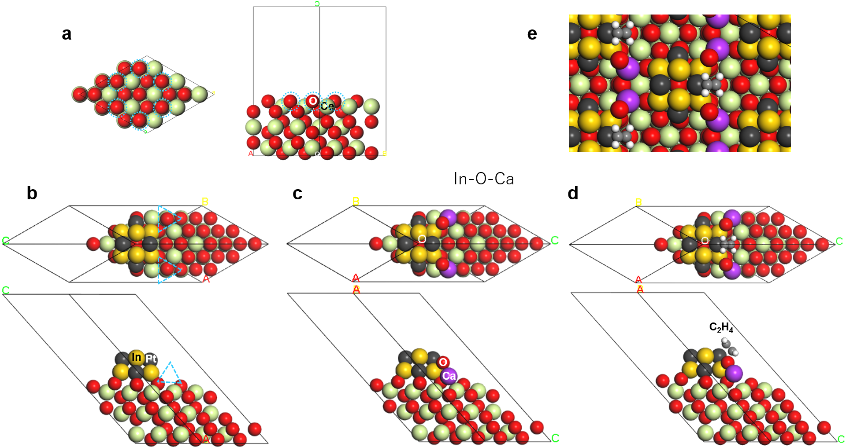

Supplementary Figure 25. Optimized structures of the slab models for (a) bare CeO₂(111) and (b) Pt–In/CeO₂(111), (c) Pt–In/CaO–CeO₂(111), (d) C₂H₄-adsorbed Pt–In/CaO–CeO₂(111). Dotted circle and triangle indicate the location of In–O linkage and the Ca cation on the surface, respectively. (e) Periodic view of the C₂H₄-adsorbed structure.

Supplementary Table 10. Structural and electronic state information on the π-adsorbed C₂H₄ on Pt.
structure | Pt–C1  / Å ª | Pt–C2  / Å ª | C1–C2  / Å ª | HCCH dihedral  angle / degree | Hirshfeld charge at Pt ^{b}
C₂H₄–Pt₄In₆/  CeO₂(111) | 2.184 | 2.204 | 1.413 | 161.38 | −0.01  (−0.13)
C₂H₄–Pt₄In₆/  CaO–CeO₂(111) | 2.202 | 2.236 | 1.406 | 164.40 | +0.05  (+0.02)
ª C2 atom is closer to the slab surface. ^{b} Values in parentheses indicate the charges before adsorption.

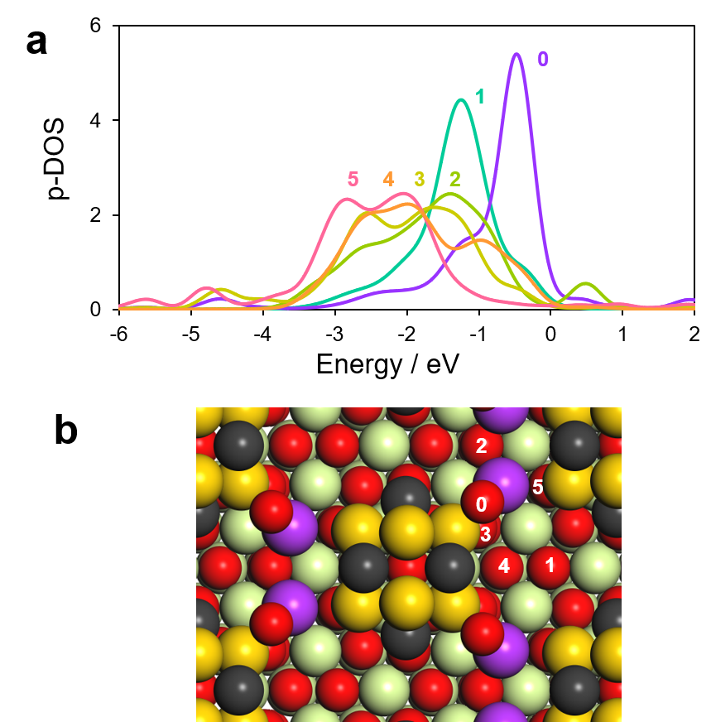

Supplementary Figure 26. a DOSs projected on the valence 2p states of single oxygen anions. Numbers indicate the oxygen anions designated in b. b The location of the selected oxygen anions on the slab model.

Supplementary References
- Hui Y., et al. Atomically precise design of PtSn catalyst for the understanding of the role of Sn in propane dehydrogenation. Precis. Chem. 2, 245−255 (2024).
- Zhou, T., et al. Reaction-induced dynamic evolution of PtIn/SiO₂ catalyst for propane dehydrogenation. Nat. Commun. 16, 5153 (2025).
- Yim, W.-L. & Klüner, T. Understanding of adsorption and catalytic properties of bimetallic Pt–Co alloy surfaces from first principles: insight from disordered alloy surfaces. J. Phys. Chem. C. 114, 7141−7152 (2010).
- Chen, M. et al. Dehydrogenation of propane over spinel-type gallia–alumina solid solution catalysts. J. Catal. 256, 293−300 (2008).
- Jin, R., Easa, J., Tran, D. T. & O’Brien, C. P. Ru-promoted CO₂ activation for oxidative dehydrogenation of propane over chromium oxide catalyst. Catal. Sci. Technol. 10, 1769−1777 (2020).
- Nowicka, E. et al. Elucidating the role of CO₂ in the soft oxidative dehydrogenation of propane over ceria-based catalysts. ACS Catal. 8, 3454−3468 (2018).
- Michorczyk, P., Pietrzyk, P. & Ogonowski, J. Preparation and characterization of SBA-1-supported chromium oxide catalysts for CO₂ assisted dehydrogenation of propane. Microporous Mesoporous Mater. 161, 56−66 (2012).
- Michorczyk, P., Zeńczak, K., Niekurzak, R. & Ogonowski, J. Dehydrogenation of propane with CO₂–a new green process for propene and synthesis gas production. Polish J. Chem. Technol. 14, 77−82 (2012).
- Wu, R. et al. Hydrothermally prepared Cr₂O₃–ZrO₂ as a novel efficient catalyst for dehydrogenation of propane with CO₂. Catal. Commun. 39, 20−23 (2013).
- Michorczyk, P., Kuśtrowski, P., Kolak, A. & Zimowska, M. Ordered mesoporous Ga₂O₃ and Ga₂O₃–Al₂O₃ prepared by nanocasting as effective catalysts for propane dehydrogenation in the presence of CO₂. Catal. Commun. 35, 95−100 (2013).
- Wang, H. & Tsilomelekis, G. Catalytic performance and stability of Fe-doped CeO₂ in propane oxidative dehydrogenation using carbon dioxide as an oxidant. Catal. Sci. Technol. 10, 4362−4372 (2020).
- Gomez, E. et al. Combining CO₂ reduction with propane oxidative dehydrogenation over bimetallic catalysts. Nat. Commun. 9, 1398 (2018).
- Yang, G. Q. et al. Oxidative dehydrogenation of propane with carbon dioxide catalyzed by Zn_{x}Zr_{1−x}O_{2−x} solid solutions. Ind. Eng. Chem. Res. 60, 17850−17861 (2021).
- Farsad, A., Lawson, S., Rezaei, F. & Rownaghi, A. A. Oxidative dehydrogenation of propane over 3D printed mixed metal oxides/H-ZSM-5 monolithic catalysts using CO₂ as an oxidant. Catal. Today 374, 173−184 (2021).
- Wang, L., Yang, G. Q., Ren, X. & Liu, Z. W. CeO₂-promoted PtSn/SiO₂ as a high-performance catalyst for the oxidative dehydrogenation of propane with carbon dioxide. Nanomaterials 12, 417 (2022).
- Lawson, S. et al. Structured bifunctional catalysts for CO₂ activation and oxidative dehydrogenation of propane. ACS Sustain. Chem. Eng. 9, 5716−5727 (2021).
- Wang, Y. et al. Defect-dependent selective C–H/C–C bond cleavage of propane in the presence of CO₂ over FeNi/ceria catalysts. ACS Sustain. Chem. Eng. 9, 17301−17309 (2021).
- Tian, H. et al. Catalytic performance of In/HZSM-5 for coupling propane with CO₂ to propylene. ChemistrySelect 5, 3626−3637 (2020).
- Wang, Z. Y. et al. Oxidative dehydrogenation of propane to propylene in the presence of CO₂ over S30 gallium nitride supported on NaZSM-5. Ind. Eng. Chem. Res. 60, 2807−2817 (2021).
- Lawson, S. et al. Integrated direct air capture and oxidative dehydrogenation of propane with CO₂ at isothermal conditions. Appl. Catal. B Environ. 303, 120907 (2022).
- Gao, Y. et al. One-pot synthesis of Ca oxide-promoted Cr catalysts for the dehydrogenation of propane using CO₂. Ind. Eng. Chem. Res. 59, 12645−12656 (2020).
- Xing, F., Nakaya, Y., Yasumura, S., Shimizu, K. & Furukawa, S. Ternary platinum–cobalt–indium nanoalloy on ceria as a highly efficient catalyst for the oxidative dehydrogenation of propane using CO₂. Nat. Catal. 5, 55−65 (2022).
- Xing, F., Ma, J., Shimizu, K. & Furukawa, S. High-entropy intermetallics on ceria as efficient catalysts for the oxidative dehydrogenation of propane using CO₂. Nat. Commun. 13, 5065 (2022).
- Ren, Y., Wang, J., Hua, W., Yue, Y. & Gao, Z. Ga₂O₃/HZSM-48 for dehydrogenation of propane: effect of acidity and pore geometry of support. J. Ind. Eng. Chem. 18, 731−736 (2012).
- Ren, Y., Zhang, F., Hua, W., Yue, Y. & Gao, Z. ZnO supported on high silica HZSM-5 as new catalysts for dehydrogenation of propane to propene in the presence of CO₂. Catal. Today 148, 316−322 (2009).
- Baek, J., Yun, H. J., Yun, D., Choi, Y. & Yi, J. Preparation of highly dispersed chromium oxide catalysts supported on mesoporous silica for the oxidative dehydrogenation of propane using CO₂: insight into the nature of catalytically active chromium sites. ACS Catal. 2, 1893−1903 (2012).
- Agafonov, Y. A., Gaidai, N. A., Lapidus, A. L. & Zelinsky, N. D. Influence of the preparation conditions for catalysts CrO_{x}/SiO₂ on their efficiency in propane dehydrogenation in the presence СО₂. Russ. Chem. Bull. 63, 381−388 (2014).
- Botavina, M. A. et al. Towards efficient catalysts for the oxidative dehydrogenation of propane in the presence of CO₂: Cr/SiO₂ systems prepared by direct hydrothermal synthesis. Catal. Sci. Technol. 6, 840−850 (2016).
- Li, H. et al. Dehydrogenation of ethylbenzene and propane over Ga₂O₃-ZrO₂ catalysts in the presence of CO₂. Catal. Commun. 8, 1317−1322 (2007).
- Xu, B., Zheng, B., Hua, W., Yue, Y. & Gao, Z. Support effect in dehydrogenation of propane in the presence of CO₂ over supported gallium oxide catalysts. J. Catal. 239, 470−477 (2006).
- Chen, M. et al. Study in support effect of In₂O₃/MO_{x} (M = Al, Si, Zr) catalysts for dehydrogenation of propane in the presence of CO₂. Appl. Catal. A Gen. 407, 20−28 (2011).
- Chen, M. et al. Dehydrogenation of propane over In₂O₃–Al₂O₃ mixed oxide in the presence of carbon dioxide. J. Catal. 272, 101−108 (2010).
- Xue, X. L., Lang, W. Z., Yan, X. & Guo, Y. J. Dispersed vanadium in three-dimensional dendritic mesoporous silica nanospheres: active and stable catalysts for the oxidative dehydrogenation of propane in the presence of CO₂. ACS Appl. Mater. Interfaces 9, 15408−15423 (2017).
- Wang, H. M., Chen, Y., Yan, X., Lang, W. Z. & Guo, Y. J. Cr doped mesoporous silica spheres for propane dehydrogenation in the presence of CO₂: effect of Cr adding time in sol-gel process. Microporous Mesoporous Mater. 284, 69−77 (2019).
- Yun, D. et al. Promotional effect of Ni on a CrO_{x} catalyst supported on silica in the oxidative dehydrogenation of propane with CO₂. ChemCatChem 4, 1952−1959 (2012).
- Tedeeva, M. A. et al. Dehydrogenation of propane in the presence of CO₂ on GaO_{x}/SiO₂ catalyst: influence of the texture characteristics of the support. Fuel 313, 122698 (2022).
- Wang, S.-W. et al. Metal nitride-terminated metal oxides efficiently catalyzing CO₂ oxidative dehydrogenation of propane. ACS Catal. 16, 2375−2385 (2026).
- Peng, C. et al. PtSn supported on CeO₂ modified dendritic mesoporous SiO₂ as an efficient catalyst for oxidative dehydrogenation of propane with CO₂. Appl. Catal. B Environ. 385, 126243 (2026).
- Tian, K. et al. Unraveling the hydrogen spillover in tandem propane dehydrogenation and reverse water gas shift reaction. Nat. Commun. 16, 10186 (2025).
- Lin, J. et al. Mechanistic insights into the rapid deactivation of PtIn/Al₂O₃ catalysts during CO₂-assisted propane dehydrogenation. J. Catal. 453, 116484 (2026).
- Li, W. et al. Engineering the electronic structure of Pt-KO_{x} cluster catalyst via alkali metal for efficient oxidative dehydrogenation of propane using CO₂. J. Energy Chem. 110, 301−310 (2025).
- Wang, Z. et al. CO₂ oxidative dehydrogenation of propane over a GaN supported on Ga-modified MFI zeolite catalyst. Mol. Catal. 585, 115373 (2025).
- Wu, R. et al. NiCrOx@silicalite-1 with advanced CO₂ utilization in oxidative dehydrogenation of propane: insights into bifunctional catalysis and reaction efficiency. ACS Sustain. Chem. Eng. 13, 8644−8659 (2025).
- Zhang, H. et al. Comparative study on transition metal promoted Pt/SiO₂ for oxidative dehydrogenation of propane with carbon dioxide. J. CO₂ Util. 97, 103116 (2025).
- Sun, Y. et al. Boosting CO₂ oxidative propane dehydrogenation via separate activation CO₂ and propane by in-framework and extra-framework Co species on ZSM-5 zeolite. Appl. Catal. B Environ. 373, 125324 (2025).
- Xu, B. et al. Molybdenum carbide nanoparticles in silicalite-1 zeolite for CO₂‑assisted propane dehydrogenation. ACS Catal. 15, 4089−4100 (2025).
- Otieno, H. N. et al. Attractive performance Cr–Co/ZSM-5 catalysts for the oxidative dehydrogenation of propane with carbon dioxide. J. Environ. Chem. Eng. 13, 115787 (2025).
- Wang, F. et al. CO₂-assisted oxidative dehydrogenation of propane catalyzed by Fe modified vanadium oxide/silicalite-1 catalysts. Chem. Eng. J. 505, 159104 (2025).
- Yang, L. et al. Alkaline-earth metals promote propane dehydrogenation with carbon dioxide through geometric effects: altering the reaction pathway. Appl. Catal. B Environ. 366, 124985 (2025).
- Kim, J. & Kim, D. H. Enhanced stability of silica-coated PtSn/Al₂O₃ catalyst for oxidative dehydrogenation of propane with CO₂. Fuel 384, 134003 (2025).
- Zhang, S. et al. Facilitating CO₂ dissociation via Fe doping on supported vanadium oxides for intensified oxidative dehydrogenation of propane. Chem. Eng. J. 481, 148231 (2024).
- Li, W. et al. Bifunctional catalysts with separated and tunable sites on zeolites for relay catalysis of the oxidative dehydrogenation of propane using CO₂. Adv. Funct. Mater. 35, 2414231 (2025).

