Supplementary file 2: Degree for all elements within the network

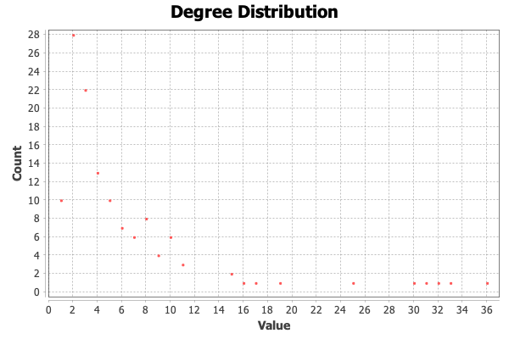

Value = number of links each element has to other elements in the network (degree)
Count = number of elements with specified number of links

Elements with high degree values:

Element label | Degree
Dysbiosis | 36
Diet | 33
Flat mood / depression | 32
Obesity | 31
Systemic inflammation | 30
Liver | 25

