Supplementary Materials for
From subsurface damage to surface instability: Integrating InSAR, UAV and microseismic observations of deep longwall mining beneath thick loess
Jiangtao Qiu¹*, Xinxin Yin², Lingyu Ji¹, Liangyu Zhu¹, Hongbin Cheng¹, Zongpan Bian¹, Haibo Wang³
1 The Second Monitoring and Application Center, China Earthquake Administration, Xi'an 710054, China;
2 Earthquake Administration of Gansu Province, Lanzhou 730000, China;
3 State Key Laboratory of Cryospheric Science and Frozen Soil Engineering, Northwest Institute of Eco-Environment and Resources, Chinese Academy of Sciences, Lanzhou 730000, China
*Corresponding author: qiujiangtao@smac.ac.cn
This file includes:
- Supplementary Text S1 to S3
- Figures S1 to S11
- Tables S1 to S4

Contents
Text S1. Choice of the Savitzky-Golay differentiation window
Text S2. Robustness of the 17-day lead-lag estimate
Text S3. NSGA-II configuration and solution degeneracy
Figure S1. Interferometric network of the 47 Sentinel-1 acquisitions
Figure S2. All 47 cumulative LOS displacement fields
Figure S3. All 47 LOS velocity fields
Figure S4. All 47 LOS acceleration fields
Figure S5. All 47 displacement-gradient magnitude fields
Figure S6. Original UAV photogrammetric products
Figure S7. Field photographs of surface fractures
Figure S8. Space-time evolution of the microseismic sequence
Figure S9. Savitzky-Golay window-length sensitivity
Figure S10. Cross-correlation sensitivity to the Benioff window
Figure S11. Complete NSGA-II solution set
Table S1. All 47 Sentinel-1 acquisitions
Table S2. Monthly statistics of the microseismic catalogue
Table S3. Savitzky-Golay processing parameters
Table S4. Cross-correlation analysis parameters and results

Supplementary Text
Text S1. Choice of the Savitzky-Golay differentiation window
The kinematic indicators used in Section 3.3 depend on the window length of the second-stage Savitzky-Golay (SG) filter that converts the daily-interpolated displacement series into velocity and acceleration. Windows of 7, 15, 31 and 45 days (second-order polynomial in all cases) were compared at the three monitoring points P1-P3 (Fig. S9). Short windows (7 and 15 d) track the raw epochs closely but amplify high-frequency atmospheric noise into spurious acceleration, with a standard deviation of the second derivative up to two orders of magnitude larger than for the 31-d window. The 45-d window suppresses noise further but visibly damps the transient acceleration episodes in October-December 2025 that carry the instability signal. In the fidelity-roughness trade-off (Fig. S9c) the 31-d window occupies the knee of the L-curve: residual RMS against the raw epochs remains close to the short-window level while acceleration roughness is already reduced to near the 45-d level. The 31-d window was therefore adopted for all velocity and acceleration fields in the main text.
Text S2. Robustness of the 17-day lead-lag estimate
The lead-lag relationship reported in Section 4.3 was derived from the cross-correlation of first-differenced series of windowed cumulative Benioff strain and daily maximum surface acceleration. Because the Benioff series requires a trailing accumulation window, the analysis was repeated for windows of 7, 14, 21 and 28 days (Fig. S10). The correlation peak occurs at a lag of +17 days (seismicity leading deformation) for every window, with peak coefficients R = 0.45-0.49, and exceeds the 95% confidence bounds in all cases. The lead time identified in the main text is therefore insensitive to the accumulation window and is not an artefact of the 14-d window chosen for temporal consistency with the Sentinel-1 revisit interval. Association between the raw (undifferenced) series is likewise significant (Pearson r = 0.39, p = 5.8×10⁻⁵; Spearman ρ = 0.43; Table S4).
Text S3. NSGA-II configuration and solution degeneracy
The early-warning rule of Section 3.6 was optimized with NSGA-II (population 40, 40 generations, fixed random seed) over the alarm threshold θ ∈ [0.01, 0.30] and the persistence window w ∈ [3, 30] d, with objectives POD (maximized) and FAR (minimized). The complete final population is shown in Fig. S11. Because the hazard series contains a small number of discrete acceleration episodes, the 40 non-dominated solutions collapse onto two objective vectors: 36 solutions achieve POD = 1.00 at FAR = 0.629 and four solutions achieve POD ≈ 0.60 at FAR ≈ 0.57. The knee solution (minimum Euclidean distance to the ideal point POD = 1, FAR = 0) corresponds to θ = 0.0396 and w = 19 d. The degeneracy of the front quantitatively supports the conclusion of Section 4.4 that Benioff strain alone detects all hazardous episodes only at the cost of a high false-alarm rate, and that operational warning requires multi-source indicators.

Supplementary Figures
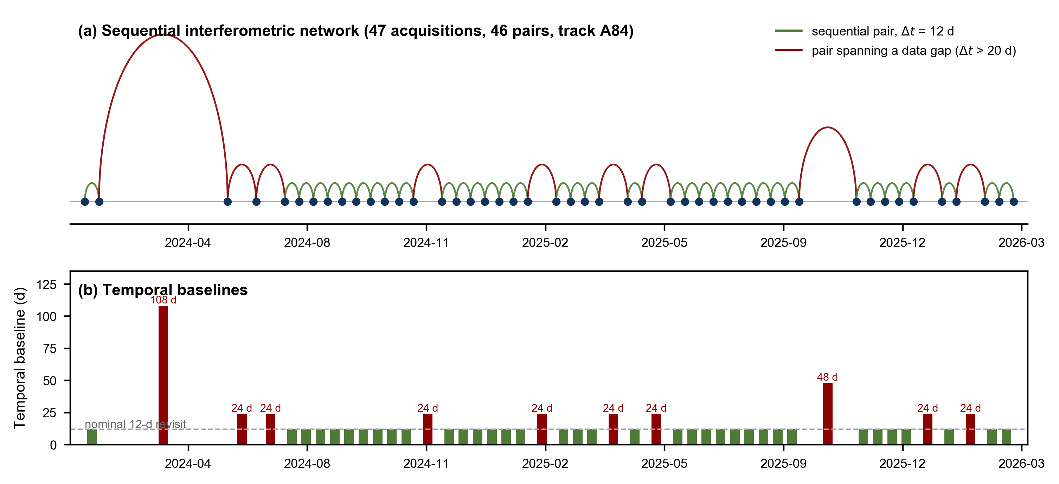
Figure S1. Temporal structure of the Sentinel-1 dataset (ascending Track 84, 47 acquisitions, January 2024 to March 2026). (a) Sequential interferometric chain connecting consecutive acquisitions; grey arcs denote nominal 12-day pairs and red arcs denote pairs bridging acquisition gaps (Δt > 20 d). (b) Temporal baselines between consecutive acquisitions; the two largest gaps (48 d and 108 d) are highlighted. The full SBAS network used for the inversion comprises 126 interferometric pairs with temporal and perpendicular baselines below 90 d and 90 m, respectively (Section 3.2).

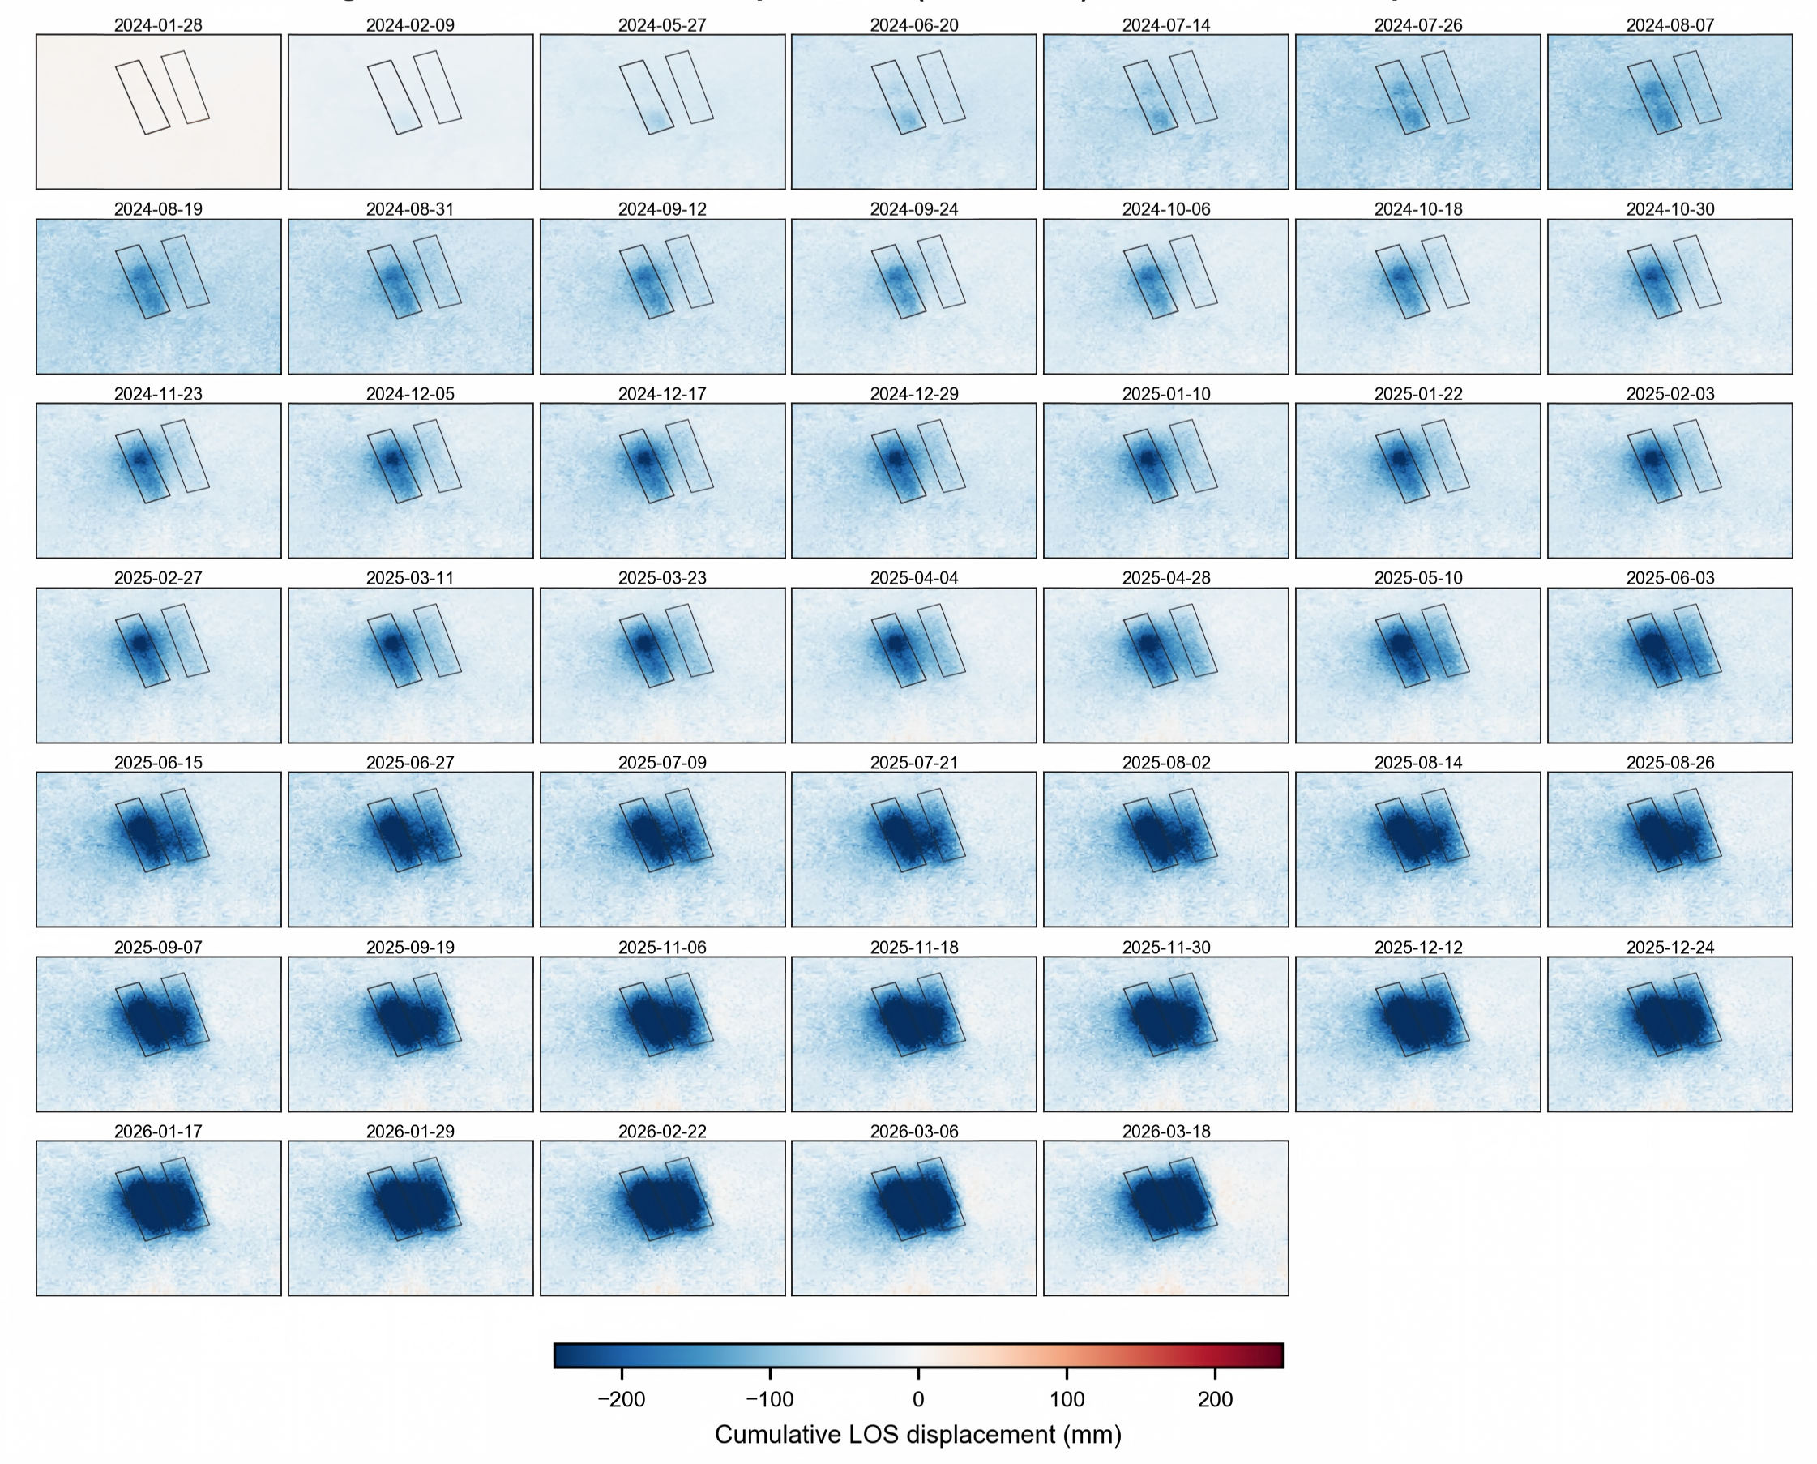
Figure S2. Complete set of 47 reference-corrected cumulative LOS displacement fields (mm) from 2024-01-28 to 2026-03-18, supplementing the six representative epochs of Fig. 2. Negative values indicate motion away from the satellite (subsidence). Black outlines mark the 1802-1803 and 2803-2804 longwall panels. The colour scale is symmetric and common to all panels.

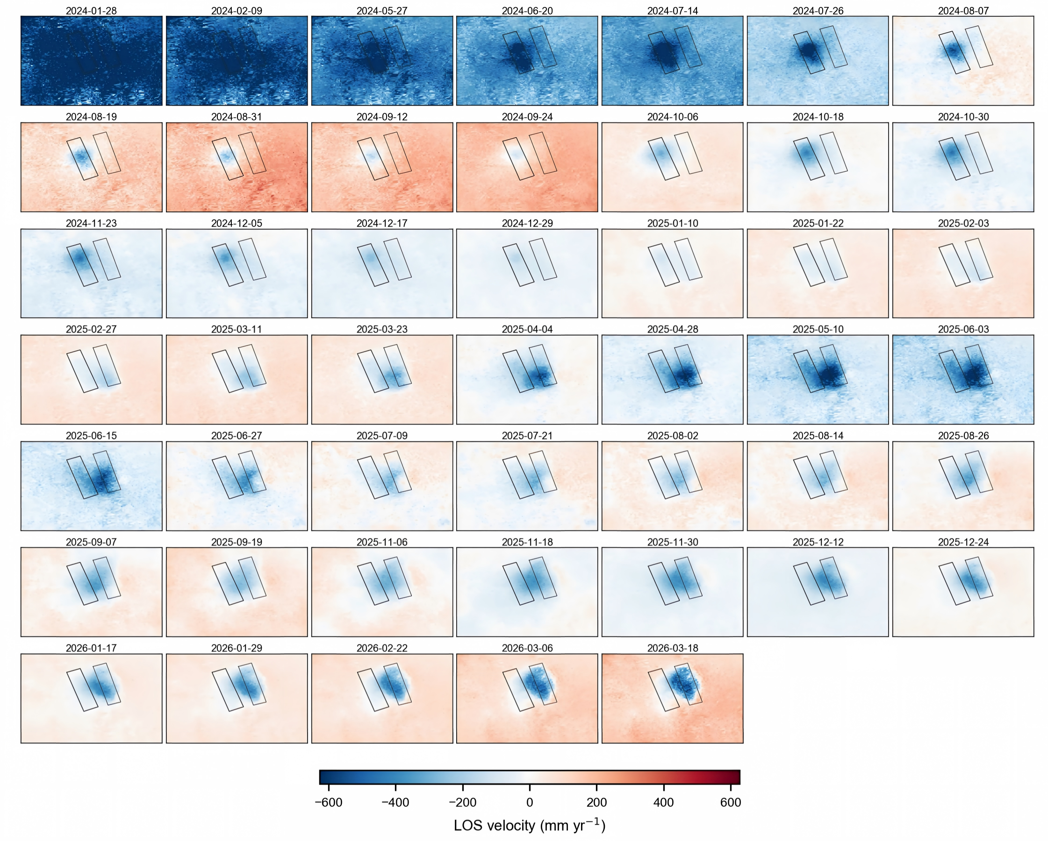
Figure S3. Complete set of 47 LOS velocity fields (mm yr⁻¹) derived with the two-stage Savitzky-Golay procedure of Section 3.3 (31-d differentiation window, second-order polynomial). The migration of the velocity maximum from the 1802-1803 panels (2024) to the 2803-2804 panels and finally into the inter-district interaction zone (2025) described in Section 4.2 can be followed epoch by epoch.

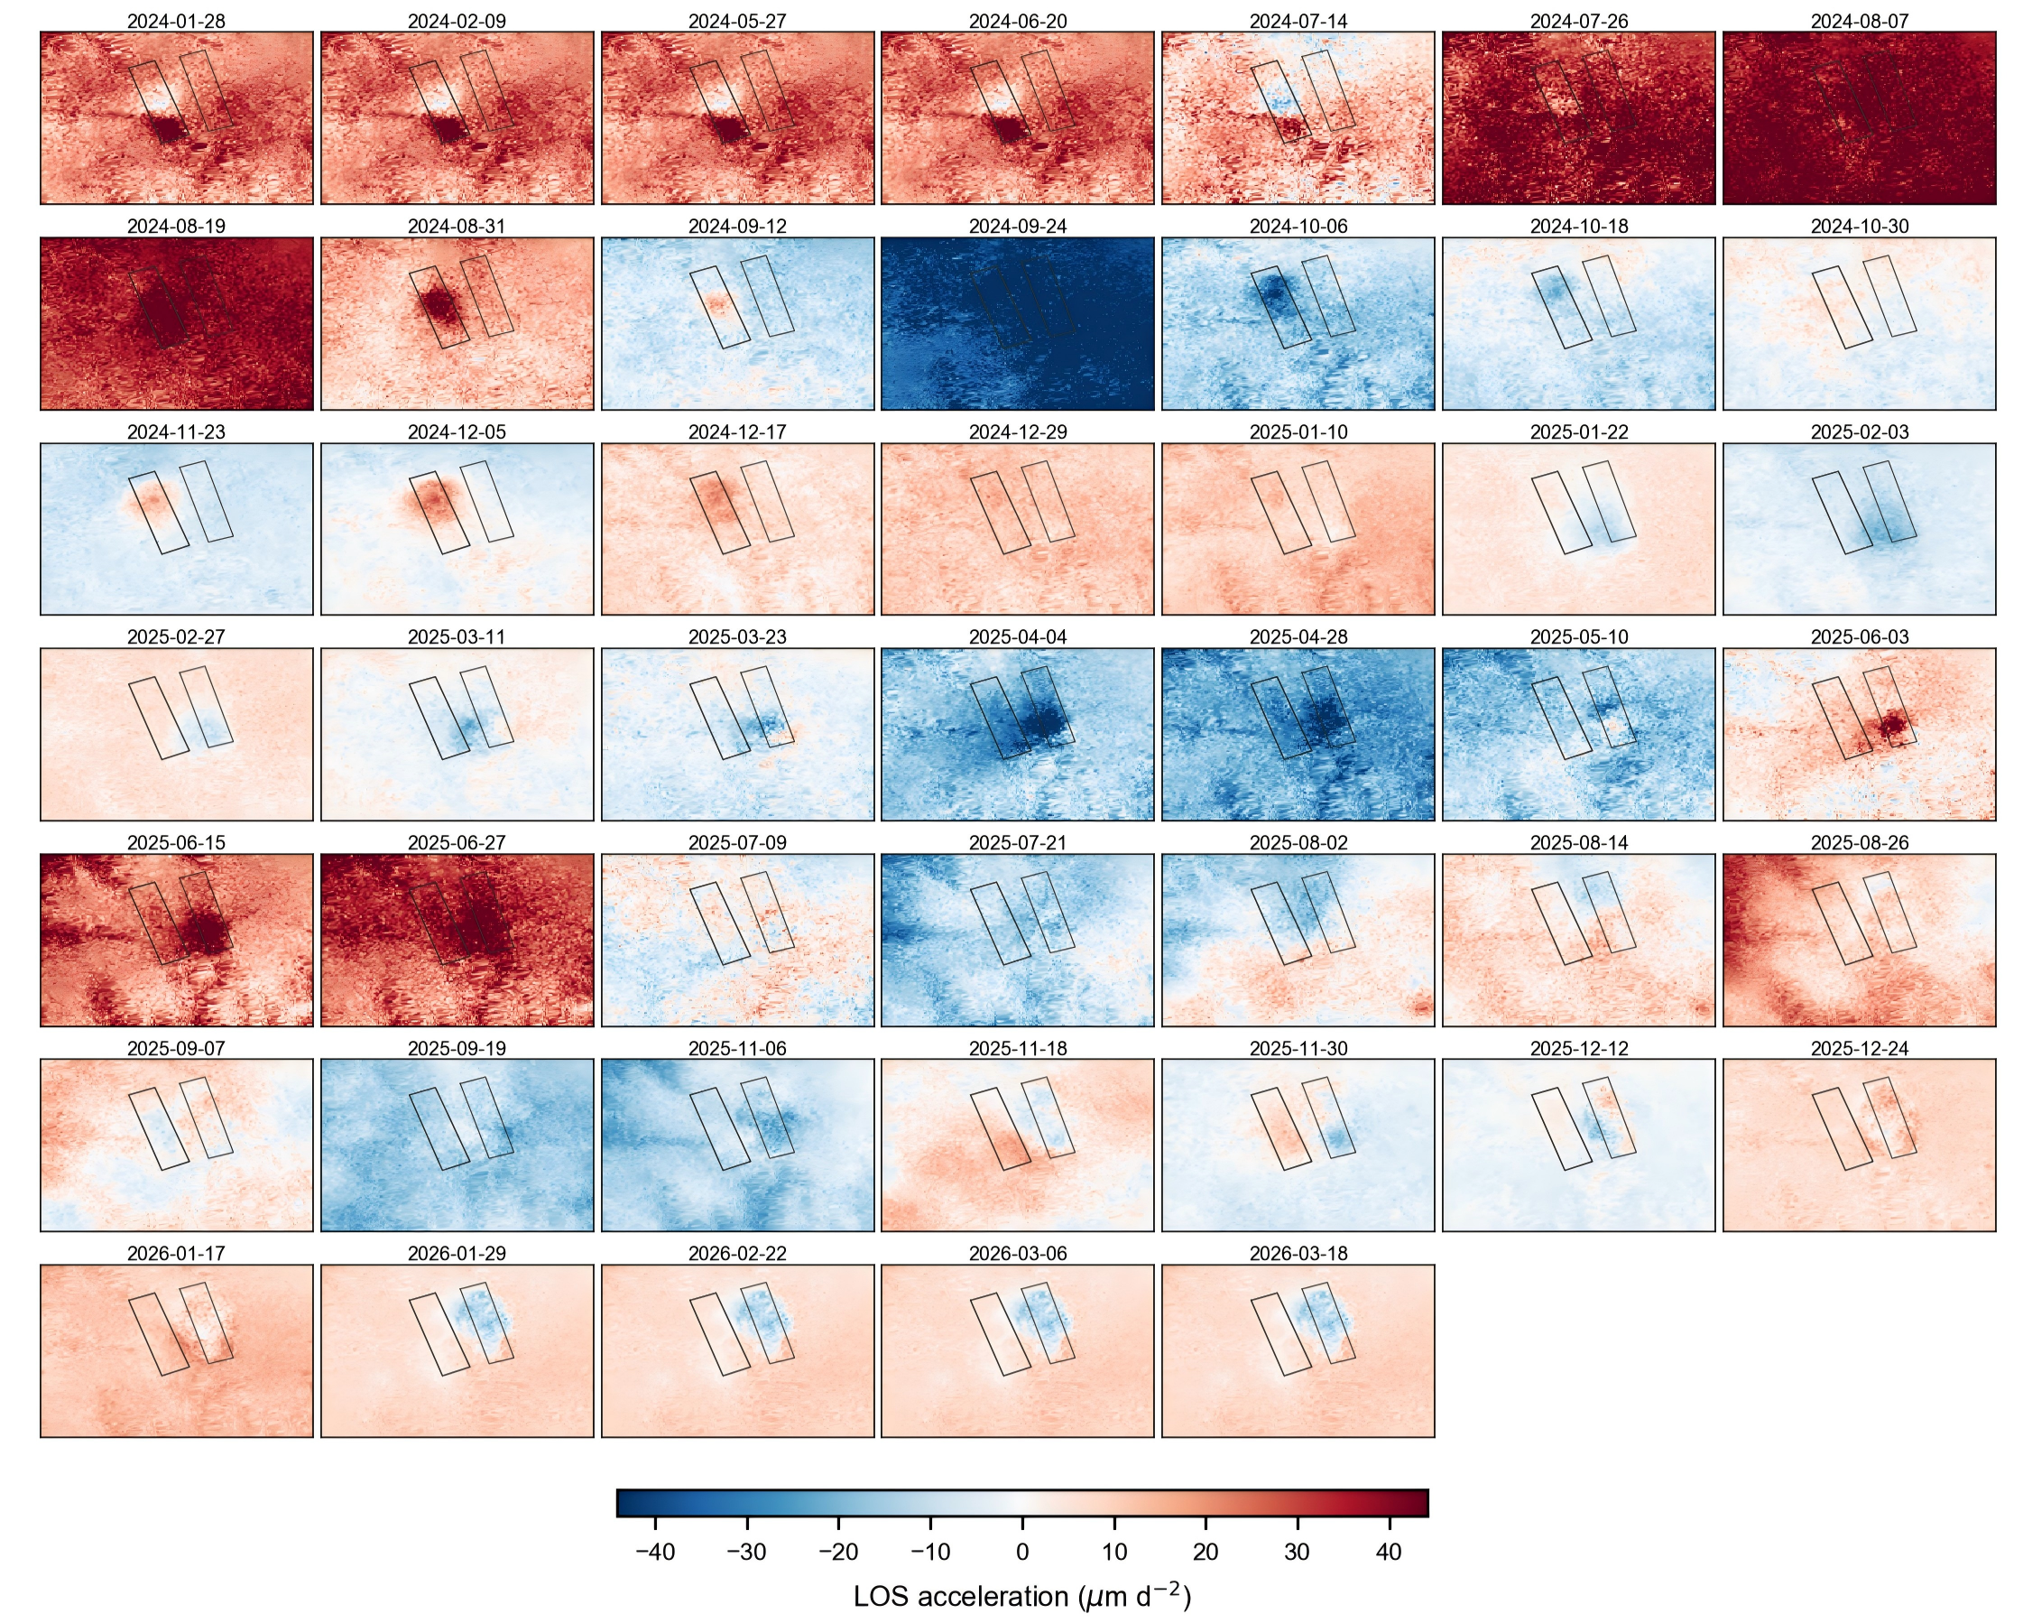
Figure S4. Complete set of 47 LOS acceleration fields (μm d⁻²) derived as the second SG derivative of the displacement series. Acceleration anomalies remain near the noise level during 2024, intensify from September 2025 and peak in October-December 2025, coincident with the microseismic activity maximum (Section 4.3).

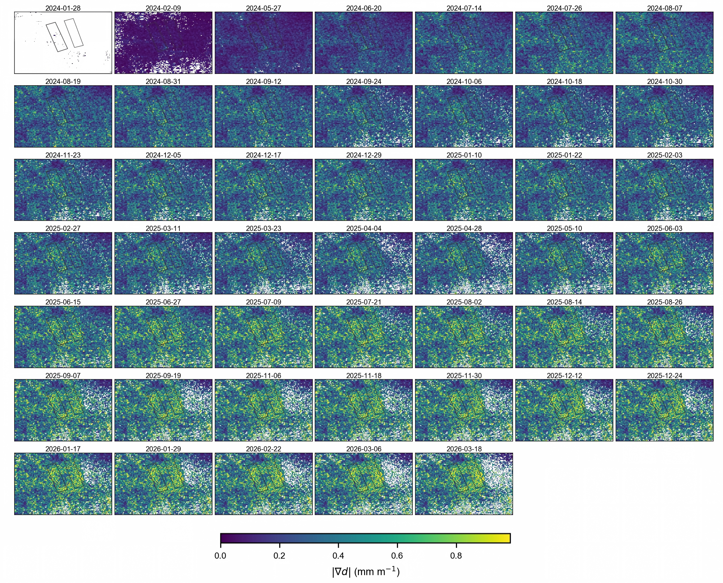
Figure S5. Complete set of 47 displacement-gradient magnitude fields |∇d| (mm m⁻¹) computed with finite-difference operators on the deformation grid (Section 3.3). High-gradient belts develop along the flanks of the two subsidence basins and, from mid-2025, along the coalescing composite basin; these belts spatially control the UAV-mapped surface ruptures (Fig. 4).

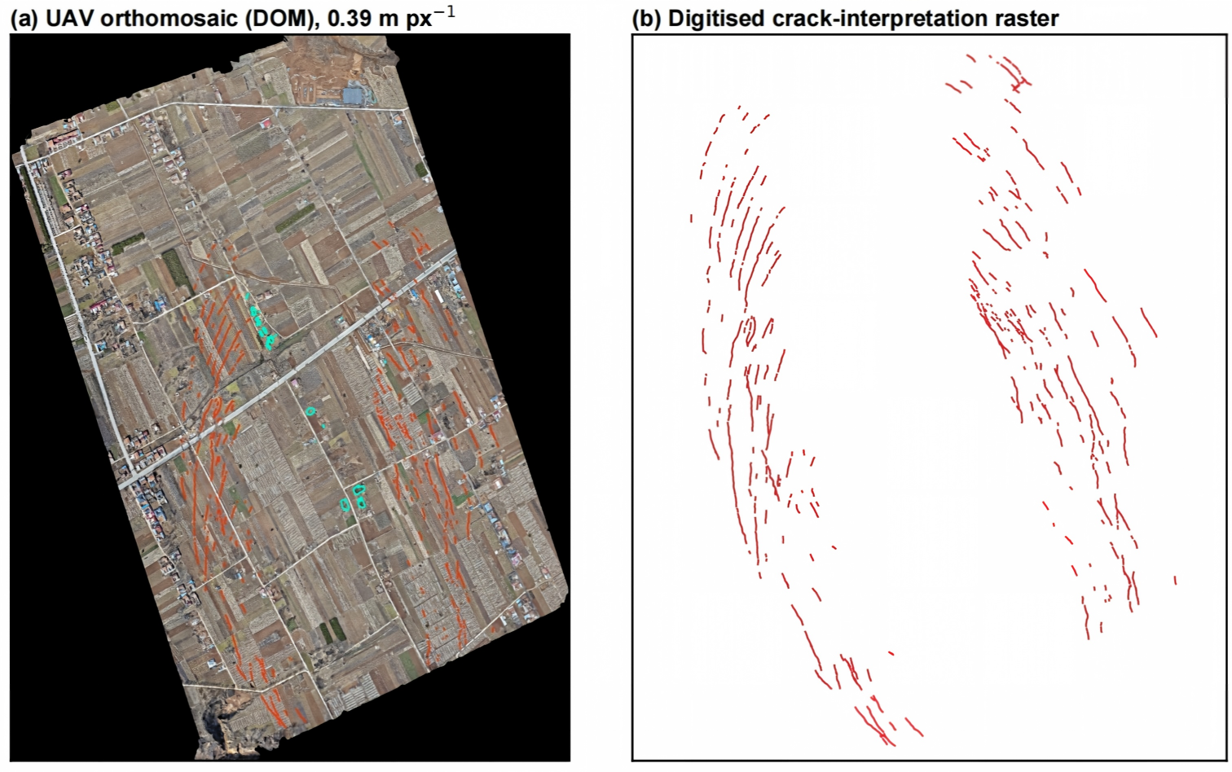
Figure S6. Original UAV photogrammetric products over the principal fracture zone (survey of 3,629 photographs, Section 3.4). (a) Digital orthophoto mosaic (DOM) resampled to 0.39 m px⁻¹ for co-registration with the InSAR grid (registration RMS ≈ 3.0 m), with interpreted crack traces overlaid in red. (b) Digitised crack-interpretation raster used for the statistical comparison with the displacement-gradient field in Fig. 4.

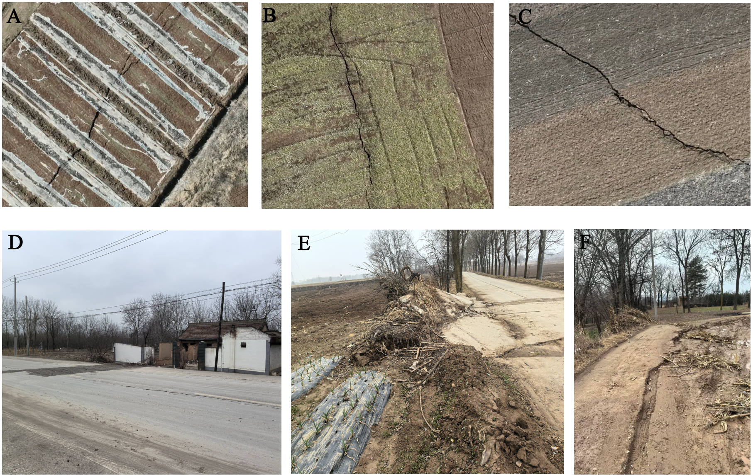
Figure S7. Field photographs of representative surface fractures.

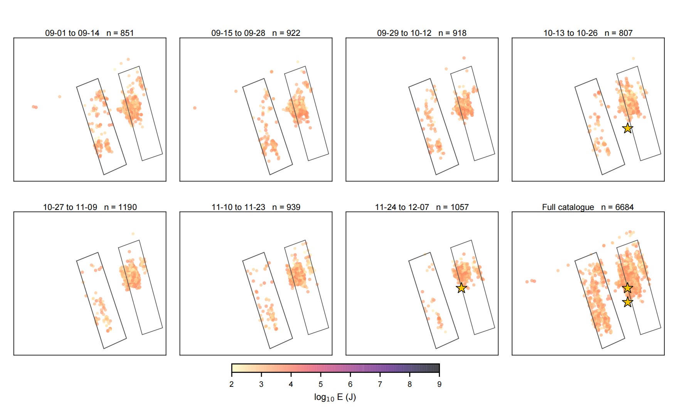
Figure S8. Space-time evolution of the underground microseismic sequence (6,684 events, 2025-09-01 to 2025-12-07), shown as seven consecutive 14-day windows plus the complete catalogue (bottom right). Symbol colour denotes log₁₀ of the radiated energy; gold stars mark high-energy events (E > 10⁸ J), including the 25 October and 6 December events discussed in Section 4.3. Black outlines: longwall panels; grey lines: roadways.

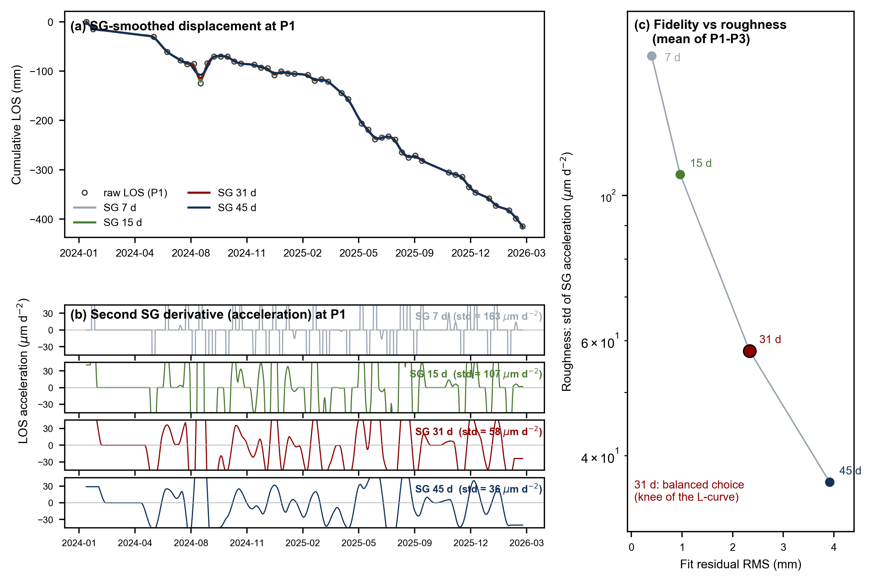
Figure S9. Sensitivity of the Savitzky-Golay differentiation to window length (7, 15, 31 and 45 d; second-order polynomial). (a) Smoothed displacement at P1 for the four windows compared with the raw LOS epochs. (b) Corresponding second-derivative (acceleration) series; the annotated standard deviation quantifies noise amplification for short windows. (c) Fidelity-roughness trade-off (mean of P1-P3): fit residual RMS versus acceleration roughness. The 31-d window (black-edged symbol) occupies the knee of the L-curve and is adopted in Section 3.3. See Text S1.

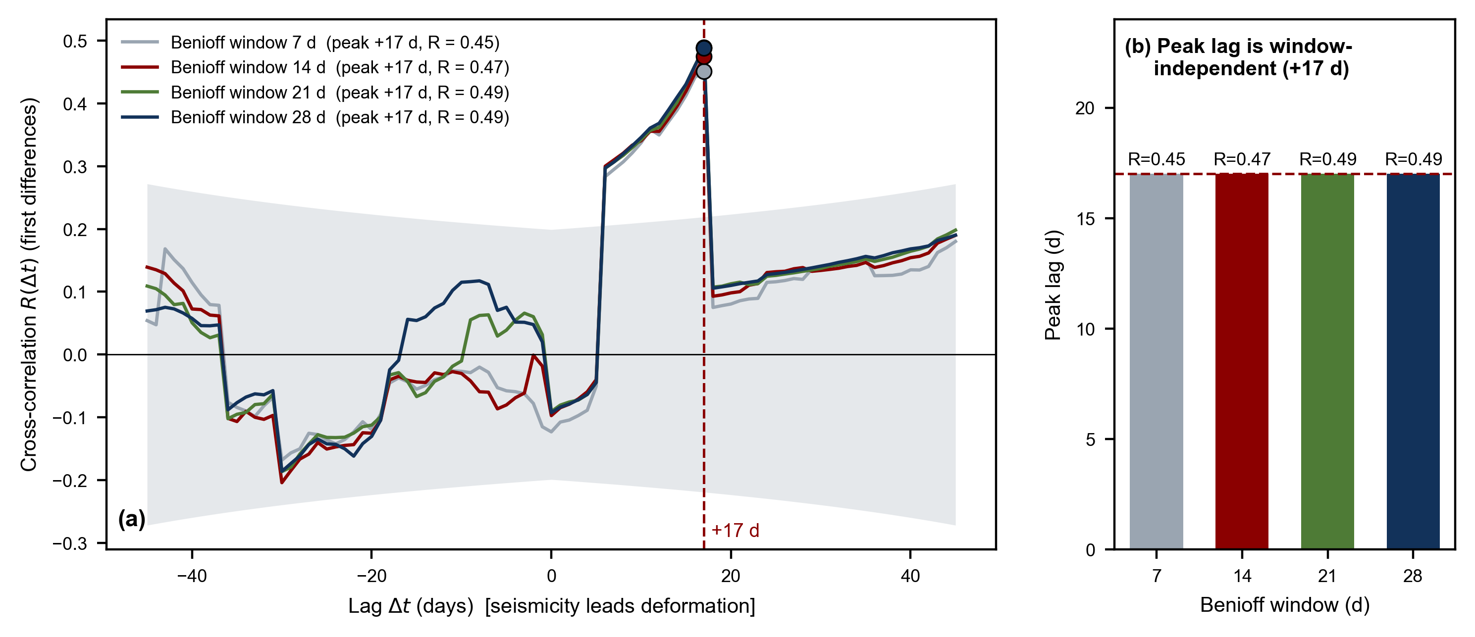
Figure S10. Sensitivity of the seismicity-deformation lead-lag estimate to the Benioff accumulation window. (a) Cross-correlation of first-differenced windowed Benioff strain and daily maximum surface acceleration for windows of 7, 14, 21 and 28 d; the shaded band shows the 95% confidence bounds (±1.96/√(n − |lag|)). (b) Peak lag per window: the maximum correlation occurs at +17 d (R = 0.45-0.49) for all four windows, demonstrating that the ≈17-day lead reported in Section 4.3 is window-independent. See Text S2.

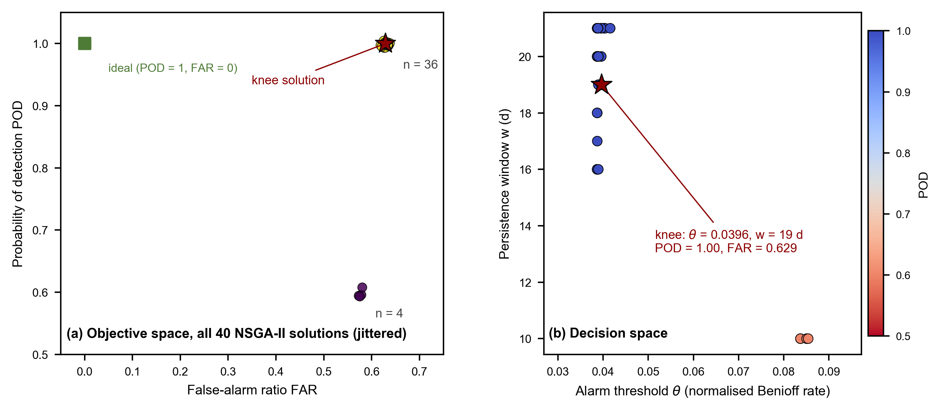
Figure S11. Complete final population of the NSGA-II early-warning optimization (40 non-dominated solutions; Section 3.6). (a) Objective space (small jitter added for visibility): the solutions collapse onto two objective vectors, n = 36 with POD = 1.00 / FAR = 0.629 and n = 4 with POD ≈ 0.60 / FAR ≈ 0.57; the red star marks the knee solution closest to the ideal point. (b) Decision space: alarm threshold θ versus persistence window w, coloured by POD; the knee solution corresponds to θ = 0.0396 and w = 19 d. See Text S3.

Supplementary Tables
Table S1. All 47 Sentinel-1 acquisitions used in this study (ascending Track 84, IW mode, VV polarization).
No. | Acquisition date | Interval to previous (d)
1 | 2024-01-28 | -
2 | 2024-02-09 | 12
3 | 2024-05-27 | 108
4 | 2024-06-20 | 24
5 | 2024-07-14 | 24
6 | 2024-07-26 | 12
7 | 2024-08-07 | 12
8 | 2024-08-19 | 12
9 | 2024-08-31 | 12
10 | 2024-09-12 | 12
11 | 2024-09-24 | 12
12 | 2024-10-06 | 12
13 | 2024-10-18 | 12
14 | 2024-10-30 | 12
15 | 2024-11-23 | 24
16 | 2024-12-05 | 12
17 | 2024-12-17 | 12
18 | 2024-12-29 | 12
19 | 2025-01-10 | 12
20 | 2025-01-22 | 12
21 | 2025-02-03 | 12
22 | 2025-02-27 | 24
23 | 2025-03-11 | 12
24 | 2025-03-23 | 12
25 | 2025-04-04 | 12
26 | 2025-04-28 | 24
27 | 2025-05-10 | 12
28 | 2025-06-03 | 24
29 | 2025-06-15 | 12
30 | 2025-06-27 | 12
31 | 2025-07-09 | 12
32 | 2025-07-21 | 12
33 | 2025-08-02 | 12
34 | 2025-08-14 | 12
35 | 2025-08-26 | 12
36 | 2025-09-07 | 12
37 | 2025-09-19 | 12
38 | 2025-11-06 | 48
39 | 2025-11-18 | 12
40 | 2025-11-30 | 12
41 | 2025-12-12 | 12
42 | 2025-12-24 | 12
43 | 2026-01-17 | 24
44 | 2026-01-29 | 12
45 | 2026-02-22 | 24
46 | 2026-03-06 | 12
47 | 2026-03-18 | 12

Table S2. Monthly statistics of the underground microseismic catalogue (2025-09-01 to 2025-12-07, 6,684 events).
Month | Events | Events/day | Total E (J) | Median E (J) | Max E (J) | Median depth (m)
2025-09 | 1909 | 63.6 | 3.41e+06 | 1194 | 6.5e+03 | 194
2025-10 | 1937 | 62.5 | 7.16e+08 | 1035 | 7.1e+08 | 194
2025-11 | 2363 | 78.8 | 4.24e+06 | 1174 | 6.5e+03 | 195
2025-12 | 475 | 67.9 | 3.70e+09 | 1394 | 3.7e+09 | 199
Total | 6684 | - | 4.42e+09 | 1149 | 3.7e+09 | 194

Table S3. Savitzky-Golay processing parameters (Section 3.3).
Processing step | Parameter | Value
Step 1: per-pixel time-series smoothing | Window length | 5 samples (~60 d)
 | Polynomial order | 2
 | Applied to | Reference-corrected LOS series of every pixel (47 epochs)
Step 2: kinematic differentiation | Resampling | Linear interpolation to a 1-d grid
 | Window length | 31 d (see Fig. S9 for 7/15/31/45-d sensitivity)
 | Polynomial order | 2
 | Derivatives | deriv = 1 (velocity, m d⁻¹); deriv = 2 (acceleration, m d⁻²)
 | Output sampling | Values extracted back at the 47 acquisition epochs

Table S4. Cross-correlation analysis parameters and results (Sections 3.5 and 4.3).
Item | Specification
Analysis window | 2025-09-01 to 2025-12-07 (98 d, daily sampling)
Seismic series | Benioff strain log₁₀(Σ√E + 1), 14-d trailing window (7/14/21/28-d sensitivity in Fig. S10)
Deformation series | P95 of |LOS acceleration| within the panel outlines, interpolated to daily values (μm d⁻²)
Detrending | First differences of both series
Lag range | -45 to +45 d (positive lag: seismicity leads deformation)
Significance | 95% bounds: ±1.96/√(n − |lag|)
Result | Peak at +17 d, R = 0.47; identical peak lag for all four Benioff windows
Raw-series association | Pearson r = 0.39 (p = 5.8×10⁻⁵); Spearman ρ = 0.43

