Supplementary Materials for

Direct Conversion of Plastic Waste to Graphite at Room Temperature under Air via Solvent-Free Mechanochemistry

Authors:
Bibhuti Kumar Jha¹, Jong-Chul Yoon¹, Cheng Qian², Seong-ji Ha¹, Feng Ding^{2*}, and Ji-Hyun Jang¹*

Affiliation:
- School of Energy and Chemical Engineering, Department of Energy Engineering, School of Carbon Neutrality, Graduate School of Semiconductor Materials and Device Engineering UNIST Ulsan 44919, Republic of Korea
- Suzhou Laboratory, Suzhou 215123, People’s Republic of China

Corresponding authors: Feng Ding (dingf@szlab.ac.cn)* and Ji-Hyun Jang (clau@unist.ac.kr)*

Table of contents Pages

- Materials and methods 4-12
- Graphitization and mechanochemical optimization for PE 13-21
- Quality of graphite 22-27
- Optimization of BM-Graphite 28
- Proposed mechanism for graphitization 28-33
- Properties of BM-Graphite 34-37
- Electrochemical test of BM-Graphite 38-40
- Applicability test of method 41-45
- Bibliography 45-48

List of figures
S1 | Impact of ball milling of PE with Mg | 12
S2 | Impact of ball milling and pretreatment on PE without catalyst | 13
S3 | Mechanochemical catalytic ability of elemental metals for the dissociation of C-C polymeric bond via Raman analysis | 14
S4 | Impact of graphitization reagents on PE via Raman analysis | 15
S5 | Impact of graphitization reagents on PS via Raman analysis | 16
S6 | Testing multiple combinations for graphitization. | 17
S7 | Impact of high and less reactive metal reagent while ball milling. | 18
S8 | Impact of pretreatment | 19
S9 | Temperature vs. time analysis of the reaction (PEMA) | 20
S10 | Lorentz fitting of the Raman 2D peak and mapping | 21
S11 | Functional group analysis by XPS | 22
S12 | Elemental analysis of BM-Graphite | 23
S13 | 1D and 2D XRD of BM-Graphite | 24
S14 | GC-MS/MS of PEM | 24
S15 | GC-MS of released gas from PEM | 25-26
S16a | Optimization of BM-Graphite, ball and time | 27
S16b | Optimization of BM-Graphite in Terms of Defect Densities and Crystallite Size Using Raman Spectra | 28
S17 | Feasibility of formation of carbide and impact of Al | 33
S18 | Morphology of graphite | 34
S19 | TEM and EDS analysis of BM-Graphite | 35
S20 | Functional group analysis of BM-Graphite | 36
S21 | Calculation of pore densities through Barrett-Joyner-Halenda (BJH) analysis | 36
S22 | Sheet resistance measurement through four probe resistivity meter | 37
S23 | Electrochemical performance of cathodes | 38
S24 | ZIB cathode dissolution after 500 cycling tests | 39
S25 | Characterization of synthesized cathodes | 40
S26 | Synthesis of graphene from BM-Graphite | 41
S27 | Crystallinity of polymers | 42
S28 | Relationship between degree of graphitization and crystallinity | 43
S29 | Verification of our method on different polymers and biowaste. | 44
3S30 | Individual components of lab wastes | 45

List of tables
ST - 1 | Optimization for 100mg PE | 11
ST -2 | Calculations for synthesized graphite | 12

UNITS

Instead of SI units, practical units have been used for convenience, such as temperature in ˚C and pressure in Torr. Conversions into SI units are as follows-

K = ˚C + 273

760 Torr = 1.01325 bar

Here, K is kelvin, the thermodynamic unit of temperature.

1. Materials and methods

- Materials-

Material | CAS number |  | Molecular weight (g/mol) | Company | Remark
Polyethylene (PE) | 9002884 | 4000 |  | Sigma-Aldrich | Density (d) = 0.92 g/ml
Poly(vinyl alcohol) (PVA) | 9002895 | 31,000-50,000 |  | Aldrich | Purity (p) =98-99%
Polyacrylonitrile (PAN) | 25014419 | 150,000 |  | Aldrich | d = 1.18g/ml
Polystyrene (PS) | 9003536 | 192,000 |  | Sigma-Aldrich | d = 1.069 g/ml
Toluene | 108-88-3 | 92.15 |  | Samchun | d = 0.864 g/ml, p = 99.5%
Ethyl alcohol | 64175 | 46.05 |  | Samchun | p = 99.9%
Hydrochloric acid (HCl) | 7647010 | 36.45 |  | Samchun | d = 1.18 g/ml, concentration = 35-37%
Hydrofluoric acid (HF) | 7664393 | 20.9 |  | Samchun | Concentration = 49%
Zinc (Zn) | 7440666 | 65.39 |  | Sigma | d = 7.133 g/ml
Nickel (Ni) | 7440020 | 58.69 |  | Aldrich | d = 8.9 g/ml, p = 99.7%
Manganese (Mn) | 7439965 | 54.94 |  | Aldrich | p = 99%
Chromium (Cr) | 7440473 | 51.99 |  | Alfa-Aesar | p = 99.2%, APS< 10 micron
Magnesium (Mg) | 7439954 | 24.31 |  | Aldrich | p = 99%
Aluminum (Al) | 7429905 | 26.98 |  | Acros Organic | p = 99%, 200-mesh
Calcium (Ca) | 7440702 | 40.08 |  | Aldrich | d = 1.54 g/ml, p = 99%
Iron (Fe) | 7439896 | 55.84 |  | Aldrich | p = 99.5%
Molybdenum (Mo) | 7439987 | 95.95 |  | Alfa-aesar | p = 99.9%, 250 mesh
Cobalt (Co) | 7440484 | 58.93 |  | Alfa-aesar | p = 99.8%, 325 mesh

- Methodology- Ball milling

Mechanochemistry, particularly through ball milling, has revolutionized chemical processes by using mechanical force to drive reactions that traditionally require high temperatures, solvents, or catalysts ^{1,2}. This method introduces stress and strain into materials, elevating reactants to higher energy states and effectively reducing the activation energy (EA) required for chemical transformations (schematic) ^{1,3,4}. As a result, reactions proceed more efficiently and sustainably under ambient conditions. The mechanical energy applied in ball milling enhances molecular reactivity by generating defects, macroradicals, and phonon excitations, which lead to improved catalysis, polymer degradation, and material synthesis without the need for harsh reagents ^{5–7}. This shift in energy levels enables more environmentally friendly reactions, aligning with green chemistry principles and supporting advancements in upcycling, catalyst formation, and functionalization.

BM-Graphite synthesis

Commercial graphite (HOPG, Bay Carbon, Inc.) was ball-milled for 8 minutes at 1060 rpm using a SPEX 8000D mixer. Milling was conducted in a stainless steel vial (internal diameter 40 mm, height 55 mm, wall thickness 5 mm, total volume 69.1 mL). The ball set comprised seven stainless steel balls (9 mm diameter) and three balls (6 mm diameter), with the polymer-to-ball mass ratio maintained at 1:190 throughout the grinding process. The vial is then cleaned with ethanol and tissue, followed by nitrogen purging at very high pressure to remove any residue (a process referred to as pretreatment of the vial). Noticeably, the pretreatment process can be performed multiple times with the same (used) graphite, eliminating the need for new graphite in each cycle.
After cleaning, 100 mg of plastic material, such as PE, 20 mg of Mg, and 20 mg of Al are added and ball-milled for 45 minutes. Complete conversion of the polymer to graphitic carbon was observed within 30 minutes (Fig. 12a). Following the subsequent purification steps, graphite was recovered from ten consecutive batches, with an average yield of approximately 18.1% by weight. This yield is comparable to the extraction efficiency of commercial natural graphite, when considering mass loss during processing ⁸. Notably, when only magnesium was utilized, theoretical calculations indicate that the conversion efficiency exceeded 80% (see Section 5). Purification is carried out as per a previously reported method for carbon and polymer separation ⁹, followed by etching using HCl or HF for more than 12 hours. The mixture is then filtered and washed with water and ethanol.
The alternative purification method involves heating the mixture to 350°C under an argon atmosphere (200 sccc) for 30 minutes, followed by an HCl wash. This method is relatively simple, making it an effective approach facilitates graphite purification and the recovery of magnesium, a reagent used in the process. In this study, this method is specifically employed for magnesium recovery.

The metal extraction process: The extraction of Mg, a used reagent, as Mg(OH)₂ was carried out through a systematic process illustrated in the schematic below (a). Initially (Step I), the mixture was heated to 350°C, followed by an HCl wash to convert Mg and MgO into MgCl₂. During this step, graphite settled at the bottom, enabling its separation from the acid solution (Step II). The resulting MgCl₂ solution was neutralized with NaOH at 70°C while maintaining a pH of ~10.5 (Step III). After 12 hours, a white precipitate of Mg(OH)₂ formed, confirmed through detailed characterization (Step IV).

HRTEM analysis (b) revealed lattice fringes with a d-spacing of 0.237 nm, corresponding to the (101) plane, consistent with literature values, and the FFT pattern confirmed its crystallinity ^{10,11}. The STEM image (c) highlighted the nanoparticle morphology, while EDS elemental mapping (d, e) demonstrated a uniform distribution of magnesium (Mg) and oxygen (O). The EDS spectrum (f) further confirmed the elemental composition, with carbon (C) peaks attributed to the TEM grid. Finally, the Raman spectrum (g) showed characteristic peaks at ~131, ~475, and ~666 cm⁻¹, corresponding to lattice vibrations, Mg–O stretching, and OH bending modes, respectively, verifying the successful conversion of Mg(OH)₂ ¹².

This Mg(OH)₂ has potential applications in various fields such as flame retardancy, wastewater acid-neutralization, and flue gas desulfurization, and can be further converted to MgO through a single heat treatment or to metallic Mg through oxidation followed by reduction ^{13–15}.

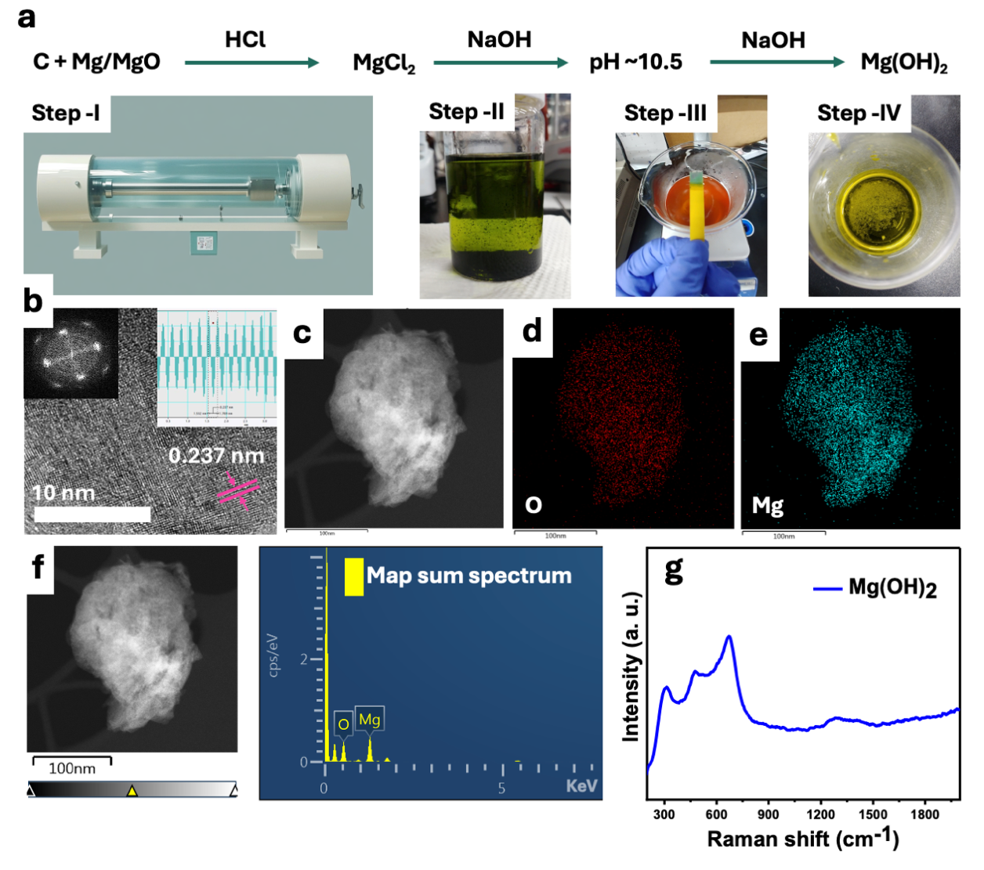

Making pencil from upcycled waste: A mixture of flour and ball-milled graphite is combined with water and a small amount (1 wt%) of polyvinylidene fluoride (PVDF) as a binding medium. This composite is then dried at 60°C for 12 hours. Notably, the fabrication of pencils is conducted, showcasing an efficient application of upcycled waste materials in stationery production.

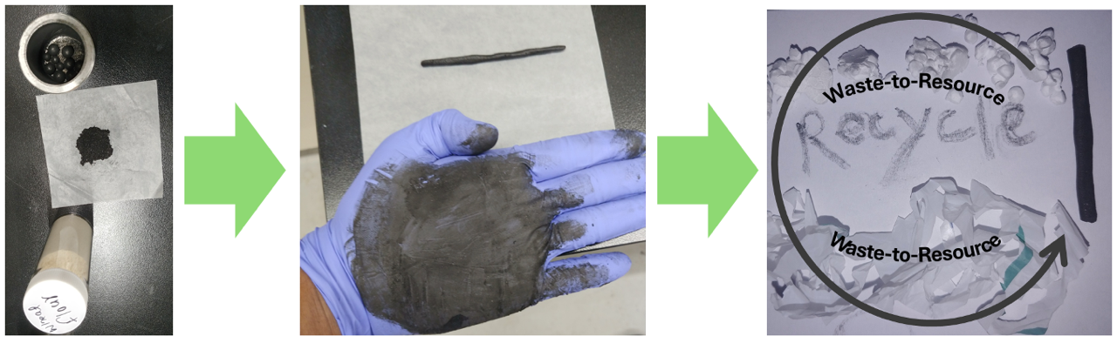

To examine the mechanism, reactions were performed in two steps: in the first step, PE is ball-milled with Mg and characterized; in the next step, Al is added to the vial and further ball-milled for 45 minutes before characterization.

Our method is applied to both plastic waste and organic waste, such as cabbage, potato, etc. While testing the applicability of our method, we evaluated each material under the optimized conditions for polyethylene. Additionally, when necessary, we chopped the plastic and organic waste before ball-milling them. We found that our method works for almost all polymers and bio-organic waste, including mixtures of different plastics, papers, gloves, and contaminated plastics (e.g., those containing biowaste or soil), indicating significant potential for commercial viability.

Synthesis of cathode materials (composites)

BM-Graphite and HOPG are sonicated for 30 minutes in 10 ml of water in 20 ml vials. 2 mmol of V₂O₅ (Sigma) in 21 ml of water is also stirred with 3 ml of H₂O₂ (thermo scientific). Then both the solutions were mixed and again stirred for 4 hours vigorously at 40 ˚C. Then the solutions of HOPG-V₂O₅ and BM-Graphite-V₂O₅ were kept in 100 ml of Teflon vials for hydrothermal reaction at 240 C for 48 hours with a 3 ˚C ramping rate. The product is washed with water and ethanol and dried in the oven at 70 ˚C for the whole night.

Electrochemical test

For the Zn-ion battery (ZIB) test, 2032 type coil cell (sinopro MRX) and 2M ZnSO4 (Sigma) electrolyte, Ti and Zn sheet (thermos scientific) with 0.25 mm thickness was used as the current collector, and anode, respectively. A full cell was also tested in a beaker cell to measure voltammograms of cathode material in EC-Lab (VMP3). WonATech cycler is used for coin cell testing at 0.1, 0.2, 0.5, 1, and 2A/g with a cut-off voltage of 0.2 to 1.6V.
Cathode materials were synthesized in a 7:2:1 ratio of active material: super-P and PVDF (beyond battery). And dried for 24h at 60 C in an oven.
- Abbreviations-

- PE – Polyethylene, PS – Polystyrene, M – Magnesium, C–Calcium, A – Aluminum

Ex. (i) PEMA stands for when polyethylene (PE) is ball milled with Mg and Al
(ii) PEC stands for when polyethylene is ball-milled with calcium

- Polymer + 1st reagent + 2nd reagent. Here, 1st reagent indicates a disruptor, and the second is a graphitization reagent.

Ex. PE + Mg + Al: Here, Mg is a disruptor and Al is a graphitization reagent.

- HOPG – Highly oriented pyrolytic graphite
- G – Gibbs free energy
- E_{A} – Activation energy
- KEPCO - Korea electric power corporation
- OECD - Organisation for economic co-operation and development
- Tom – Transport of material
- TPC – Total product cost
- TCI – Total capital investment
- FCI – Fixed capital investment

- Analytical characterization tools-

X-ray diffraction (XRD) using a Rigaku (D/MAX2500V/PC) system was employed for crystallographic studies. X-rays with a wavelength of 1.54 Å were used in high-resolution powder XRD, with a scan rate of 2 degrees per minute from 5 to 90 degrees, operating at 40 kV and 200 mA.

Raman spectroscopy, using a WITec (alpha300R) system, was performed with a 532 nm wavelength laser at 2 mW power, following calibration on a SiO₂/Si wafer with a peak at 520 cm⁻¹.

For morphological analysis, scanning electron microscopy (SEM) was conducted using a Hitachi High-Technologies (SU8220) system at 10 kV voltage and 7 μA current, while transmission electron microscopy (TEM) was performed using FEI (Titan G2(60-300)) and JEOL (JEM-2100F and JEM-2100) systems.

Time-of-flight secondary ion mass spectrometry (TOF-SIMS) using an ION TOF (TOF-SIMS 5) system and gas chromatography-mass spectrometry (GC-MS) using a Bruker (450-GC & 320-MS) system were employed for composition analysis of the sample in the solid and gaseous phases, respectively.

X-ray photoelectron spectroscopy (XPS) using a Thermo Fisher Scientific (ESCALAB 250XI) system with an Al Kα light source was used to analyze the chemical environment of the sample, with the C1s reference peak at 284.5 eV, and 2 scans at 1 eV resolution.

Solid-state C-13 nuclear magnetic resonance (¹³C NMR) spectra were collected on a Varian VNMRS600 spectrometer at a spinning rate of 40 kHz, with hexamethylbenzene (HMB) used as the reference (chemical shift = 17.3 ppm). Fourier-transform infrared (FTIR) spectra were obtained using a Varian 670/620 instrument over the 4000–600 cm⁻¹ range to identify the functional groups present in the samples.

The surface area, pore size, and pore volume were measured using the BET method (Brunauer-Emmett-Teller, Belsorp max, Bel Japan). The sheet resistance of the printable sample was measured using a four-point probe (Dasol Eng, FPP-RS8, with 1 mm pin spacing and 100 μm pin radius)."

Formulae for calculating crystallite size, number of layers, defect densities, and distance between defects, following previous paper from Science (2016) ¹⁶.

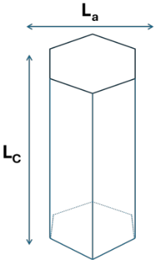
XRD

List of equations:
d $= λ/2sin(θ)$ (i) $L_{c}= {0.9λ}/{FWHM*cos⁡(θ)}$ (ii)
$N=({L_{c}}/d )+1$ (iii)
where d is an interlayer spacing, Lc is the crystallite size, N is the number of graphene sheets. $θ$ is the peak corresponding to a certain plane,$λ$ is the wavelength used for measuring XRD, and FWHM is the full width at half maxima using a Lorentz fit. Here the FWHM is 0.8156 for BM-Graphite with a $θ$ value of 13.28 degree, which is 0.23178 rad. From this, the calculated d value is 0.3354 nm. However, the Lorentz fit values for the peak position (2θ) is 26.4425 degrees, which corresponds to a d value of 0.33667 nm. Using this value, Lc (vertical crystallite size)​ was determined to be 100.1 Å, and based on this crystallite size, the calculated number of graphene layers is approximately 31 (Details – ST-2).

Raman –
$L_{D}^{2}{(nm)}^{2}=\left(1.8±0.5\right)×{10}^{-9}×ג^{4}×{({I_{D}}/{I_{G}})}^{-1}$ (iv)
$n_{D}{(cm}^{-2})= \frac{\left(1.8±0.5\right)×{10}^{22}×{({I_{D}}/{I_{G}})}^{1}}{ג^{4}}$ (v)
$L_{a}\left(nm\right)=2.4×{10}^{-10}×ג^{4}×{({I_{D}}/{I_{G}})}^{-1}$ (vi)

where I_{D} and I_{G} are the intensities of the D band and G band, respectively. λ is the wavelength used for measuring Raman (532 nm). L_{D}​ is the distance between defects, and $η_{D}$​ is the defect density. L_{a}​ is the crystallite size. Based on intensity ratios and formulae, all these parameters are used to optimize the graphite sample.

2. Graphitization and mechanochemical optimization for PE

It is hypothesized that mechanical collisions serve multiple purposes, such as enhancing electron wave function overlap across interfaces, inducing phonon excitation, and facilitating physical destruction. These processes supply the requisite energy for electron transitions and chemical reactions ¹⁷. We propose that the cumulative effect of repetitive collisions during grinding could initiate electron exchange between pristine polymer materials and surrounding substrates.

Conditions optimization – Material
Continuous ball milling after graphite formation could introduce defects in the graphite. Therefore, systematic optimization of the process was conducted (Fig. S16a, S16b). Among different ratios of PE:Mg:Al, the 100:20:20 ratio yielded good results in terms of graphite quality and low defect density (ND) when ball-milled for 1 hour (Fig. S16b). The suboptimal quality of graphite produced with a ratio of 100:10:10 may be attributed to insufficient Mg reagent, while the 100:30:30 ratio may result in an excessive reactive area, leading to fewer parallel-aligned, buckled ring-type alternating layers of carbon. Increasing the reactive area due to a high amount of reagent and prolonged ball milling could hinder the deposition of multiple or thick ring layers on Mg. A thin ring layer might be prone to breakage during carbide dissociation. In contrast, the 100:20:20 ratio likely ensures high-quality graphite by balancing the conditions for efficient reactions (ST-2b). After optimizing the number of balls and RPM (1060) for 1 h, further adjustments reduced the reaction time to 45 min using seven 9 mm balls and three 6 mm balls (Fig. S12b, referred to as BM-Graphite). However, this ratio may require further optimization depending on the type of plastic substrates, their amount, and their quality. The optimized graphite possesses a low defect density (ND) and a long crystallite size (La) (Fig. S16b). The long crystallite size and low defect density result in a greater distance between two defects (LD) (Fig. S16b).

Table – 1. Optimization for 100mg PE
Sample | Time | Balls | Remark
PEMA  (PE + Mg + Al) | 45 minutes | 7, 9 mm  & 3, 6 mm | Pretreatment is carried out before proceeding with the main experiment.

During the optimization process, the number of balls, time, substrate-to-catalyst ratio, and quantities were adjusted while maintaining a constant rotation speed of 1060 RPM.

Table – 2. Calculations for BM-Graphite (a) Calculation of the number of layers through XRD analysis. (b) Calculation of crystallite size and defect density by Raman analysis.

a
K = 0.9  Scherrer constant | Sample | Peak position (2θ) | FWHM (˚)  (Lorentz fit) | Crystallite size (Lc) (nm) | d = (nm) | Number of layers
λ = 0.154 | BM-G | 26.4425 | 0.8156 | 10.0016 | 0.336668 | 30.7076
 | HOPG | 26.4810 | 0.1826 | 44.67722 | 0.336187 | 133.8941
b
I_{D}/I_{G} | PEMA ratio | N_{D} | L_{a} | L_{D}
1.14 | 100:30:30 | 2.52355E+11 | 17.11872512 | 11.33095
1.37 | 100:30:30 | 3.03269E+11 | 14.24477857 | 10.33614
1.28 | 100:30:30 | 2.83346E+11 | 15.24636456 | 10.69335
0.77 | 100:10:10 | 1.7045E+11 | 25.34460603 | 13.78712
0.81 | 100:10:10 | 1.79305E+11 | 24.09302054 | 13.44238
0.80 | 100:10:10 | 1.77091E+11 | 24.3941833 | 13.52614
0.72 | 100:20:20 | 1.59382E+11 | 27.10464811 | 14.2578
0.5 | 100:20:20 | 1.10682E+11 | 39.03069328 | 17.10936
0.7 | 100:20:20 | 1.54955E+11 | 27.87906663 | 14.46005
0.595 | 100:20:20 | 1.31712E+11 | 32.79890192 | 15.68412
0.16 | 100:20:20 (opt) | 35418279405 | 121.9709165 | 30.24536
0.18 | 100:20:20 (opt) | 39845564330 | 108.4185924 | 28.5156

Conditions optimization – Ball milling
A systematic approach is employed to enhance the quality of graphite. Initially, the influence of varying the number of balls (energy) and the duration of milling (time) is optimized at 1060 rpm (Fig. S16). Findings reveal that using 7 balls of 9 mm and 3 balls of 6 mm for 1 hour yields high-quality graphite. While increasing milling time or the number of balls may boost yield, there is a point where further increase diminishes product quality. To evaluate the effects of ball milling and disruptive reagents, PE is milled for 1 hour with 7 balls of 9 mm and 3 balls of 6 mm (optimized conditions for balls), showing that milling without a disruptive reagent like Mg does not significantly impact PE (Fig. 1c, S-7). In contrast, ball milling in the presence of Mg led to the formation of graphite with high defect levels (Fig. 1f, S-1), as evidenced by the high intensity of the D band in the Raman spectra compared to the G and 2D bands. This understanding of Mg's role as a disruptor arises because, without Mg, PE does not undergo dissociation or depolymerization processes activated during ball milling due to stress or strain. Therefore, if the reagent efficiently breaks the C-C bonds and arranges them into high-quality graphene rings, the quality of graphite will increase. Following this, various graphitization reagents, including Fe, Ca, and Al (Fig. S6), were evaluated. The results showed that Al was superior to the other reagents, with the intensity of the G band significantly higher than that of the D band. Additionally, it was observed that employing the same disruptive reagent (Mg) could result in graphite of different qualities, highlighting the significant impact of the graphitization reagents (Fig. S4-6). Consequently, a combination of Mg and Al was considered a promising approach and optimized based on different durations of ball milling (Fig. S16). Moreover, Mg and Al are preferred in this study not only for their graphitization efficiency but also for their industrial viability. Both are earth-abundant, require less energy, have low demand, and generate fewer gas emissions compared to traditional reagents like Fe, making them well-suited for scalable applications ^{18,19}. Similar methods were also tested on polystyrene (PS), considering its aromatic and non-graphitizable nature, using different graphitization reagents (Al, Ca, and CuFeO₂), identifying Al as an excellent mechanochemical graphitization reagent (S-5).

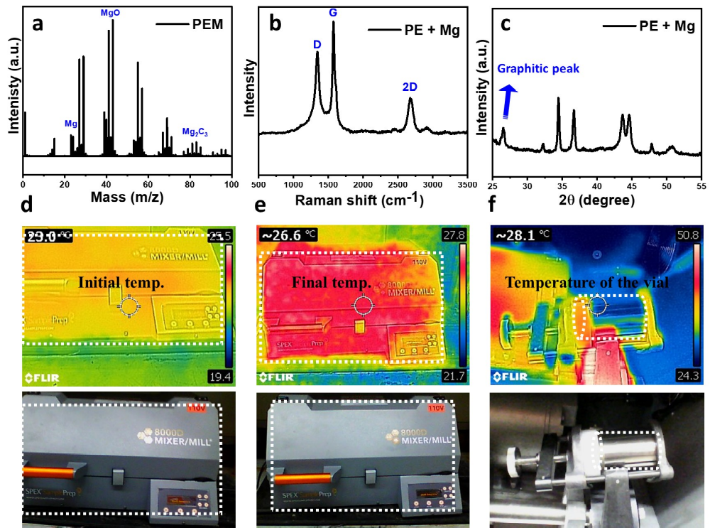

Figure S1. Impact of ball milling of PE with Mg. (a) TOF-SIM analysis confirmed the formation of carbide and MgO upon ball milling of PE+Mg. (b) Raman analysis confirms the formation of disordered graphite. (c) XRD pattern also aligned with Raman and TOF-SIM data. Presence of MgO (PDF card # - 010855620), Mg₂C₃ (PDF card # - 010810587), and graphite in XRD is also supported by TEM and aligning with TOF-SIM observation. (d) Thermal image analysis of the system at the start and (e) end of the experiment. (f) Temperature measurement of the reaction vial immediately after the ball milling process, illustrated by a white dotted line, reveals that the temperature was below 30°C at the time of completion.

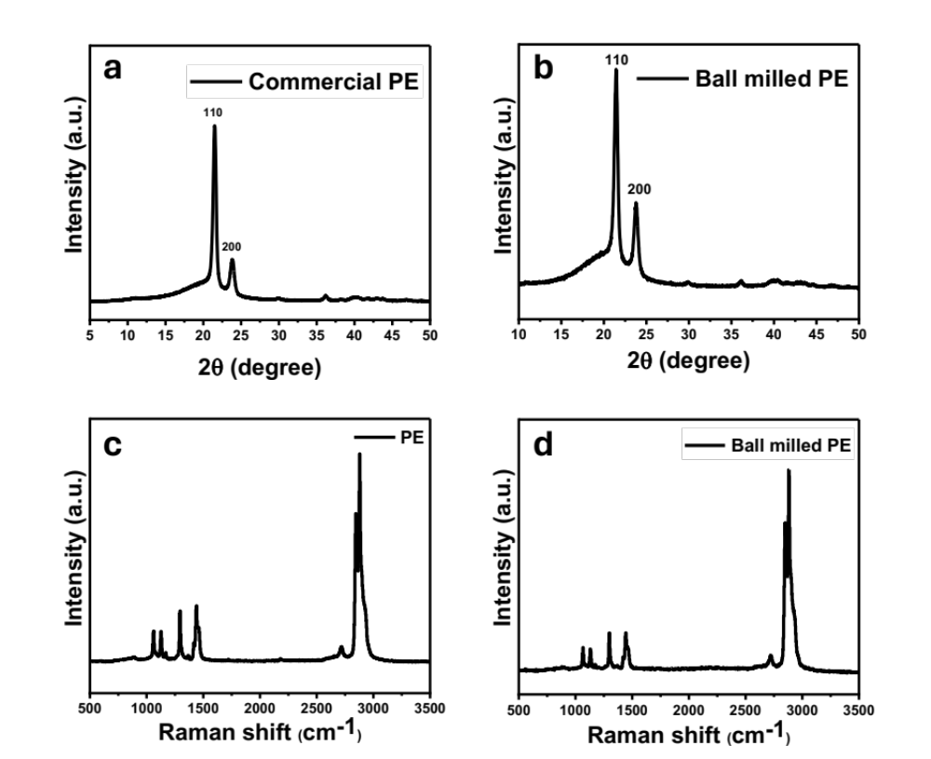

Figure S2. Impact of ball milling and pretreatment on PE without catalyst. (a) XRD of commercial PE. (b) XRD of ball milled PE. (c) Raman of commercial PE. (d) Raman of ball milled PE. Here, the vial is pretreated with graphite, as mentioned above, and then subjected to ball milling for one hour without a catalyst. Two points can be concluded from here: first, ball milling conditions are not sufficient to dissociate polymeric C-C bonds without catalysts, and second, pretreatment has no impact without catalysts.

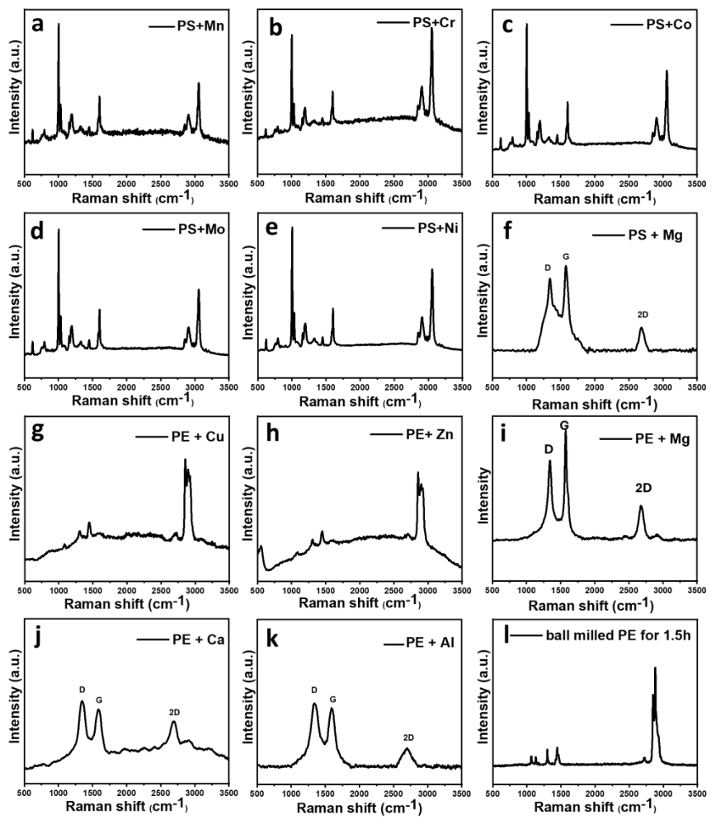

Figure S3. Mechanochemical catalytic ability of elemental metals for the dissociation of C-C polymeric bonds via Raman analysis. (a-k) Raman analysis of elementally catalyzed ball-milled products. Ball milling of polystyrene (PS) and polyethylene (PE) with Mn, Cr, Cu, Ni, Zn, Mo, Al, Mg, and Ca reveals that elements more reactive than carbon in the reactivity series of metals are capable of breaking polymeric bonds, thereby forming graphite. (l) Raman analysis of PE after ball milling for 90 minutes without a catalyst. Structure retention, even at high ball milling speeds (1060 rpm) and after prolonged ball milling (1.5 hours), indicates the influence of disruptors.

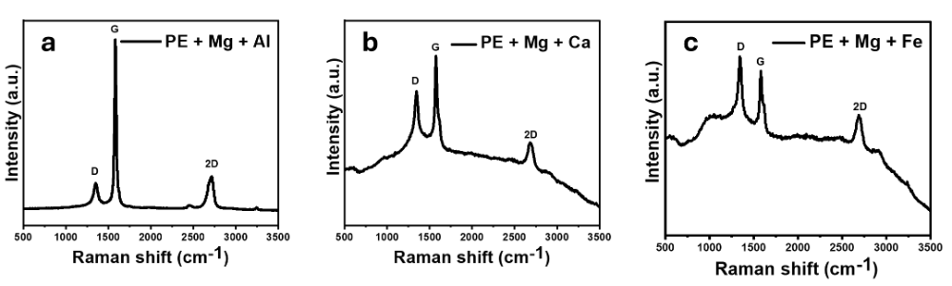

Figure S4. Impact of graphitization reagents on PE via Raman analysis (a) Impact of Al as a graphitization reagent, producing high-quality graphite. (b) Impact of Ca as a graphitization reagent, showing successful graphitization of PE. (c) The use of Fe as a graphitization reagent does not significantly impact the graphitization process. This indicates how the quality of graphite changes with different graphitization reagents while using the same disruptor. In these cases, PE is first ball-milled with Mg (called the disruptor), and then different graphitization reagents are used

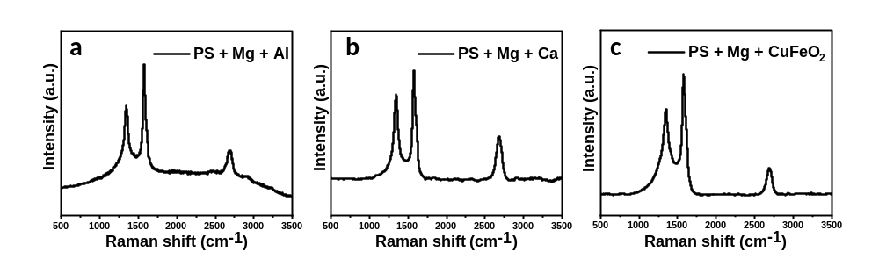

Figure S5. Impact of graphitization reagents on PS via Raman analysis (a) Impact of Al, as a graphitization reagent, shows successful graphitization of PS. (b) Impact of Ca, as graphitization reagent. (c) Delafossite (F-T catalyst), used as a graphitization reagent, reduces the quality of graphite, indicating that Al and Ca are better-graphitizing reagents than delafossite in mechanochemical processes. As we have previously reported, delafossite is a better reducing and graphitizing agent ²⁰. However, it appears that delafossite does not perform well under mechanochemical reactions due to its instability under milling conditions. Al and Ca are suitable graphitization reagents for the mechanochemical graphitization process.

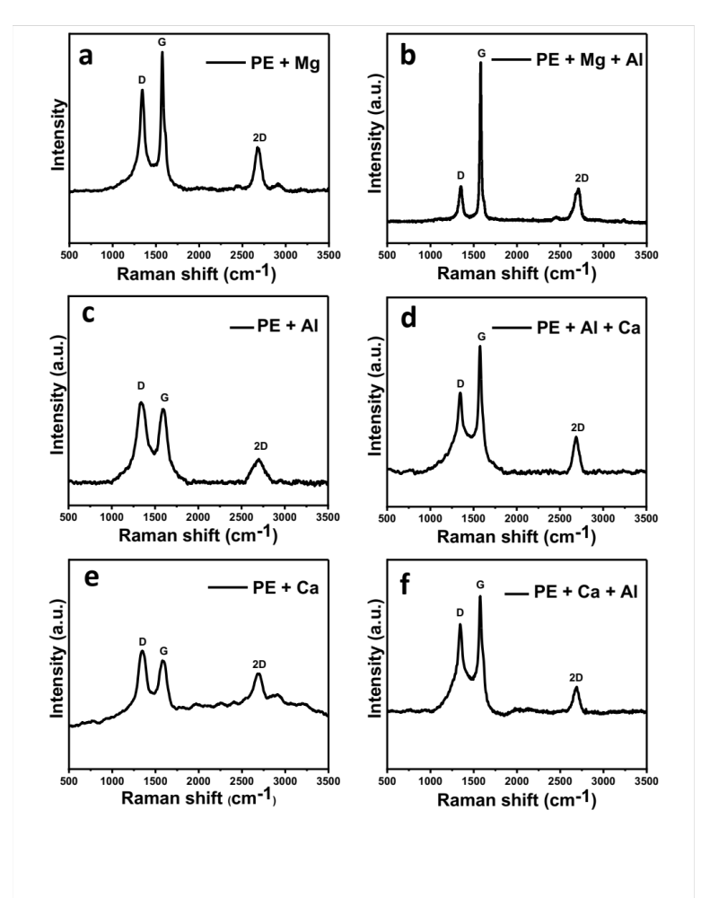

Figure S6. Testing multiple combinations for graphitization. (a, b) Observed Raman spectra of polyethylene with Mg (PEM) and polyethylene with Mg and Al (PEMA) in two consecutive processes. In the first step, PE is subjected to ball milling with the disruptive reagent Mg, and in the next step, Al is added for high-quality graphite. (c, d) A similar reaction is performed with Al as a disruptor and Ca as a graphitization reagent. (e, f) In this case, Ca acts as a disruptor while Al serves as a graphitization reagent. The results further confirm the aforementioned points: the quality of graphite is dominated by graphitization reagents; Al and Ca are excellent mechanochemical graphitization reagents, and elements that lie higher in the reactivity series can dismantle the polymeric C–C bonds mechanochemically near room temperature.

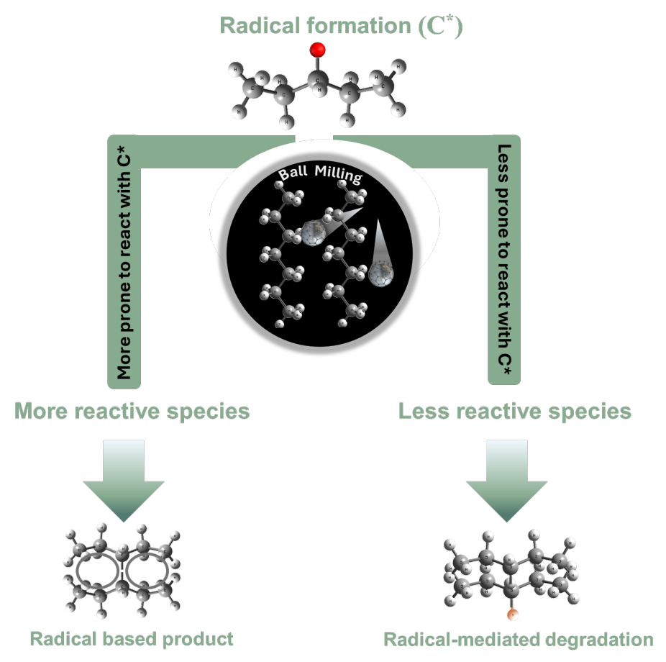

Figure S7. Impact of high and less reactive metal reagent while ball milling. We propose that when the polymer is activated by ball milling it forms reactive radical sites. If another reactive reagent comes into contact with these sites, they can react together to form radical-based products. However, if no suitable reactive reagent is present, the radicals may instead recombine with the polymer’s carbon chain, leading to radical-induced degradation of the polymer.

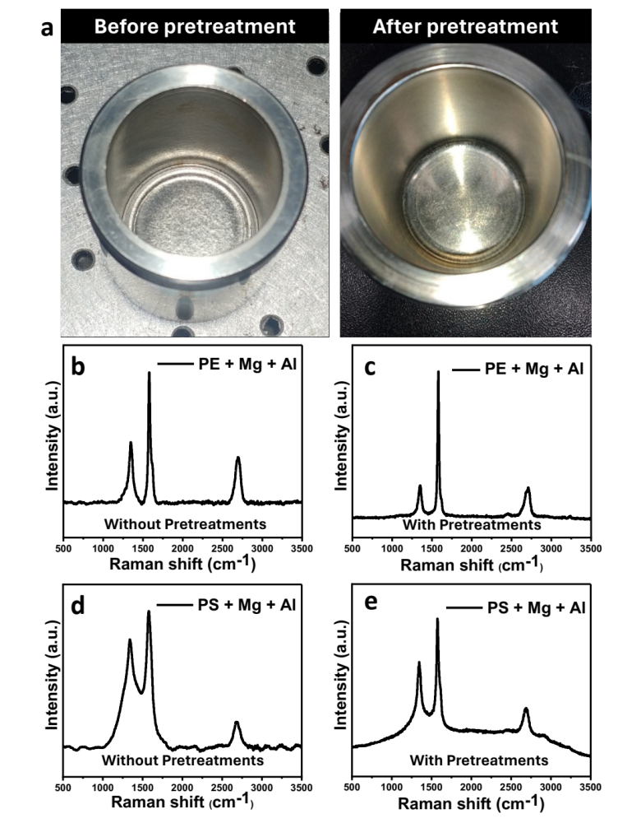
Figure S8. Impact of pretreatment by Raman analysis. (a) After soap cleaning the vial (left), it is subjected to ball milled with graphite for few minutes and then cleaned by tissue, ethanol, and high-pressure nitrogen purging (right). After this, vials are also wiped with wet tissue to remove any presence of graphite particles, this whole process is referred to as pretreatment. (b,c) Ball milling of PE with Mg and Al without and with pretreatments indicates that upon pretreating the quality of graphite increased. (d,e) Same result is observed when PS is subjected to ball milling, under same conditions. Hence, it can be concluded that pre-treating the reaction vial with graphite, followed by sequential washing with ethanol and tissue, and then nitrogen purging before the main reaction, enhances the quality of graphite. This can be attributed to the structure-directing effect of graphitic material on the graphitization of the polymer ²¹.

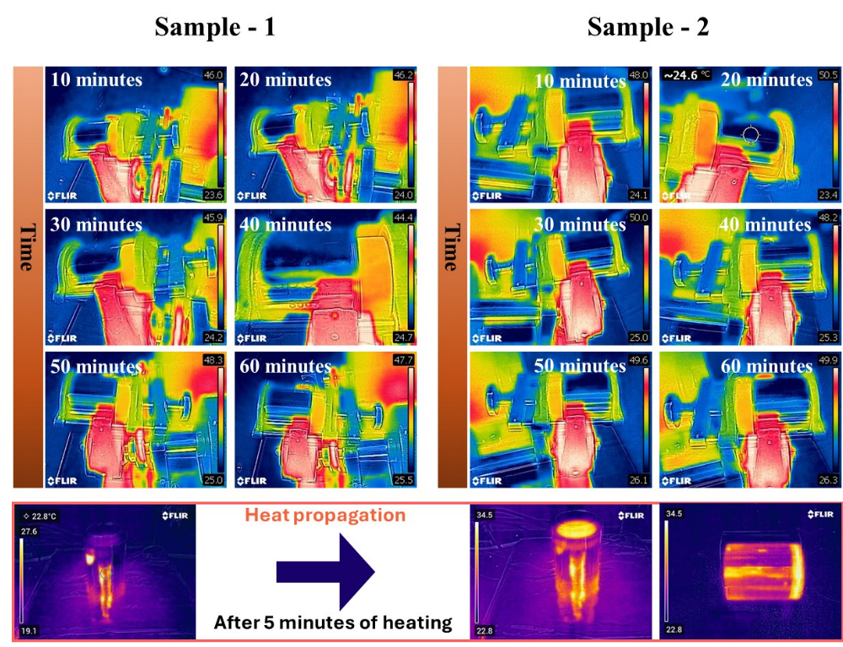

Figure S9. Temperature vs. time analysis of the reaction (PEMA) for two samples. This indicates that the temperature does not exceed 30°C throughout the mechanochemical process. To assess localized heat retention, we evaluated thermal propagation using a hot plate. Full temperature equilibration from the bottom to the top of the vial was reached within 5 minutes, indicating that any internal heat generation within the vial is minimal or is largely consumed during Mg₂C₃ formation.

Energy Calculation –

Rated power of 110V transformer = 2 kVA ~ 2 kW (Considering power factor is 100%, i.e. apparent power is equal to useful power)

Running time = 45 minutes = 0.75h

In 45 minutes, the amount of produced graphite is ca. 40mg (400mg in total in one batch)

Cost of graphite production from plastic = (2 kW * 0.75h)/0.04g ≈ 135,000 kJ/g

Traditionally, the energy required is – 7.62*10⁶ kJ/g

% difference = 98.2%

Even with a 60% drop in batch yield, the scaled system still slashes energy consumption by 95.57% per gram, requiring 22.58 times less energy than traditional methods.

3. Quality of graphite
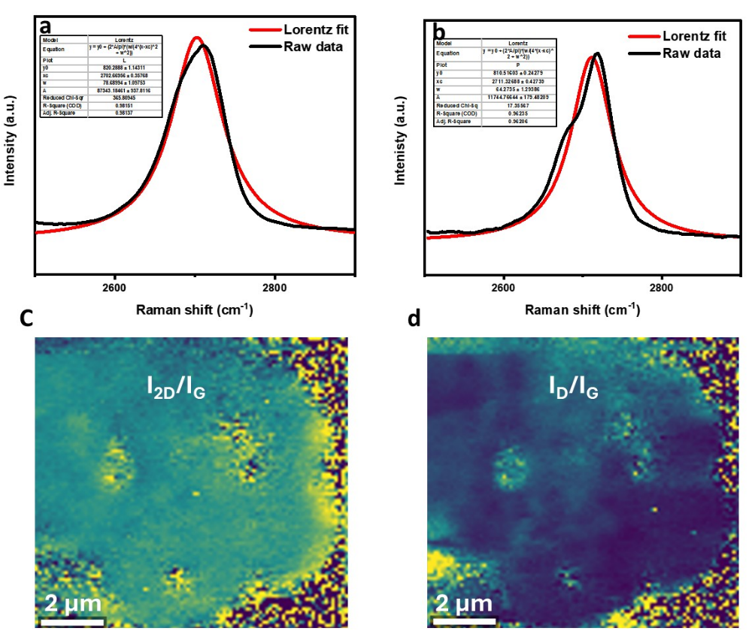

Figure S10. Lorentz fitting of the Raman 2D peak and mapping. (a) The 2D fitting gives a coefficient of determination of less than 0.985, indicating the formation of graphite ²². (b) HOPG 2D band fitting indicates the formation of similar types of graphite. (c,d) Raman mapping and corresponding intensity ratio analysis of ball‑milled graphite.

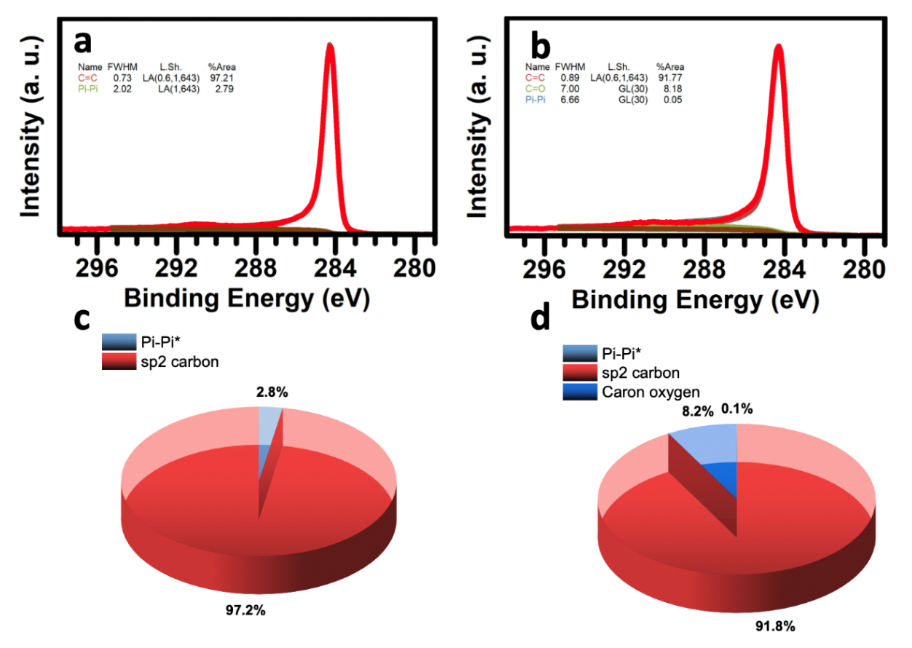

Figure S11. Functional group analysis by XPS – (a, c) HOPG shows a slightly higher content of sp² carbon compared to (b, d) BM-Graphite. Higher FWHM of BM-Graphite indicates the oxygen content is slightly higher in BM-Graphite than in HOPG; this could be a possible reason for the slightly lower sp² carbon content.

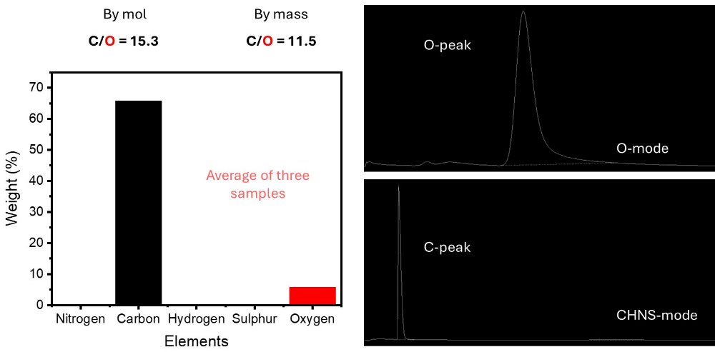
Figure S12. CHNSO analysis of BM-Graphite.

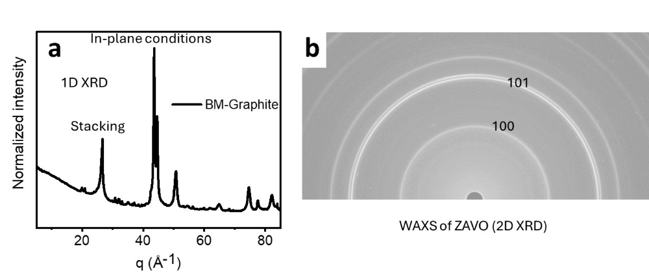
Figure S13. Wide-angle XRD analysis and corresponding one-dimensional profile transformation.

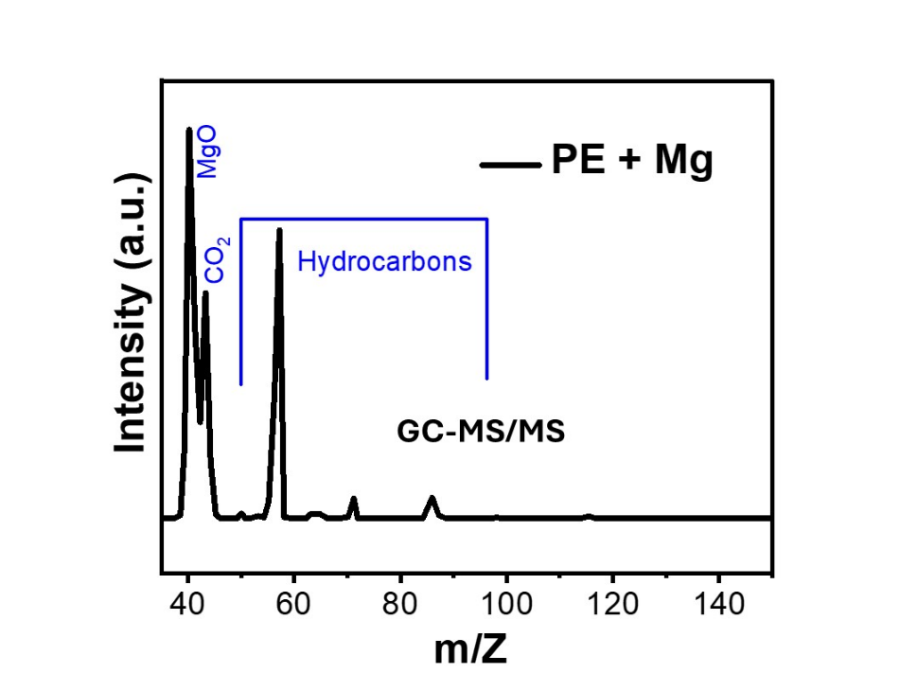
Figure S14. Gas chromatography-tandem mass spectrometry results of a gaseous sample.

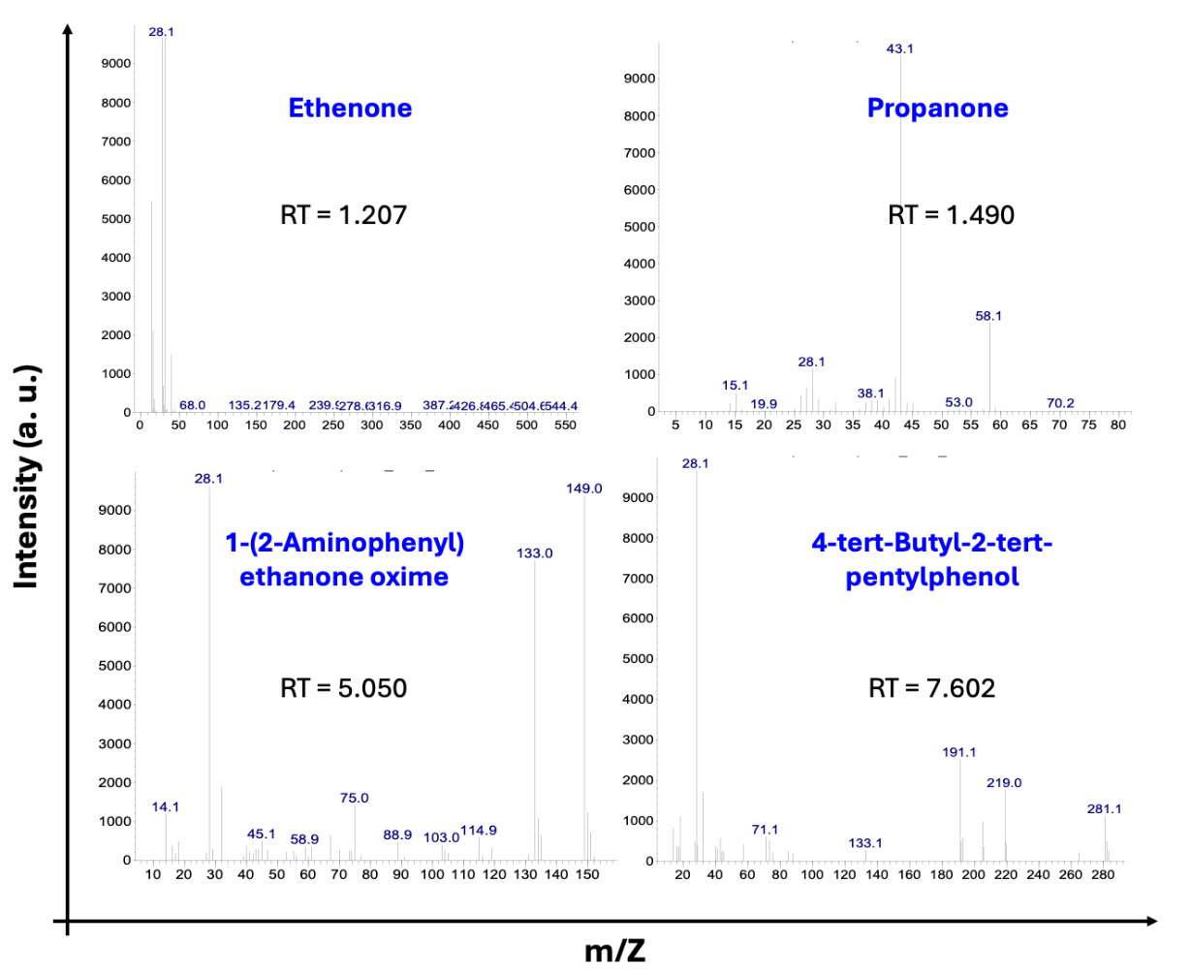

Figure S15a. GC–MS analysis was conducted on the gases released from the PE + Mg sample immediately after ball milling.

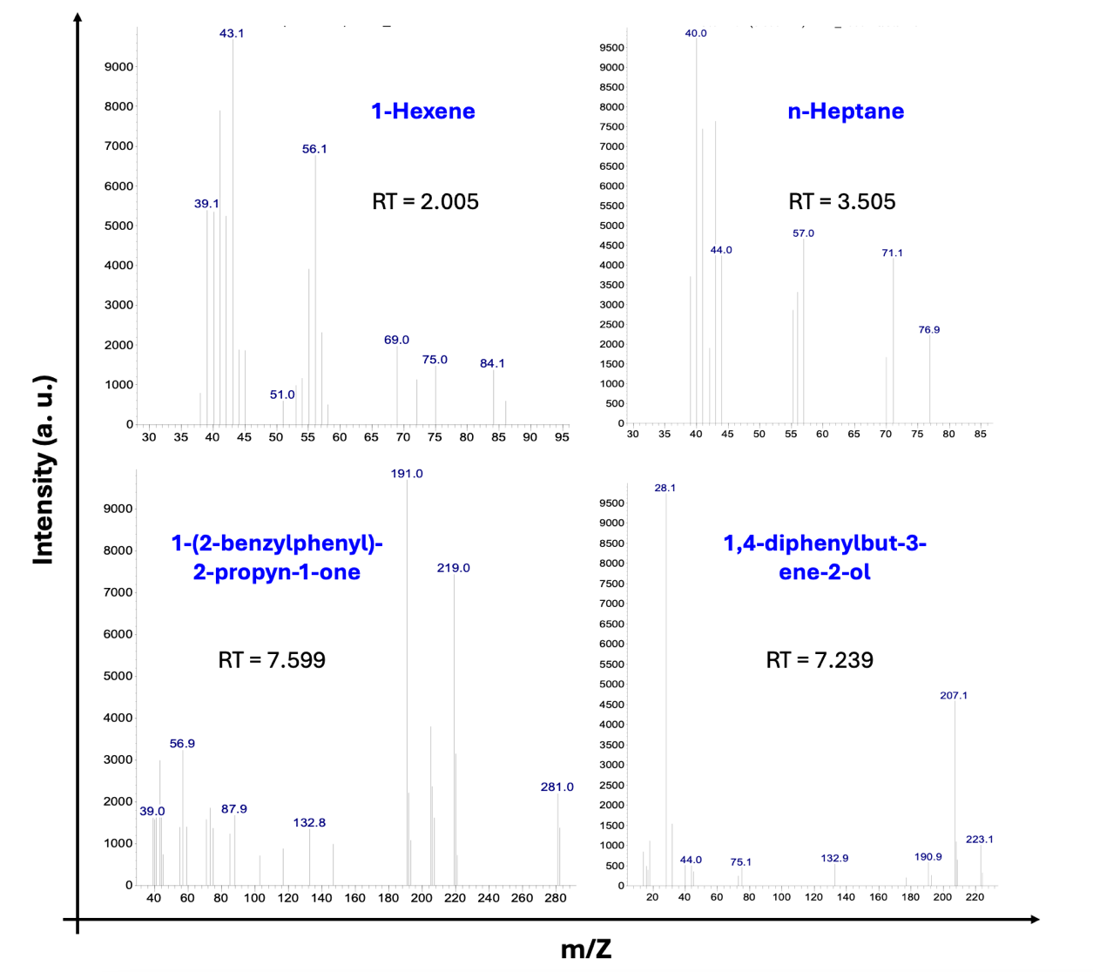

Figure S15b. GC–MS analysis of gases released from the PE + Mg sample immediately after ball milling.

4. Optimization of BM-Graphite using Raman spectroscopy.

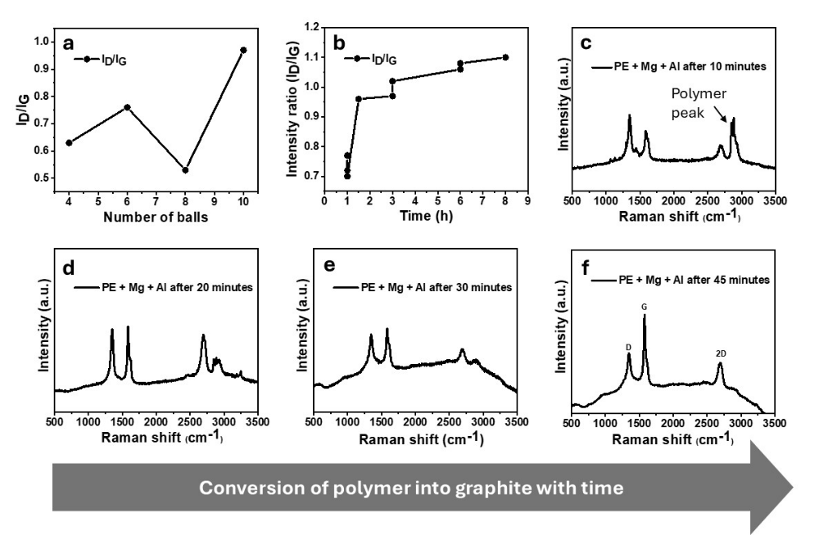

Figure S16a. Optimization of BM-Graphite: ball and time. (a) I_{D}/I_{G} ratio versus ball number; (b) I_{D}/I_{G} versus milling time. (c–f) Raman spectra tracking polymer-to-graphite conversion in the ball milling mixture: initial polymer peaks (c-f) diminish with time and disappear after 30 minutes (e), giving way to clear D, G, and 2D bands of graphitized carbon (f).

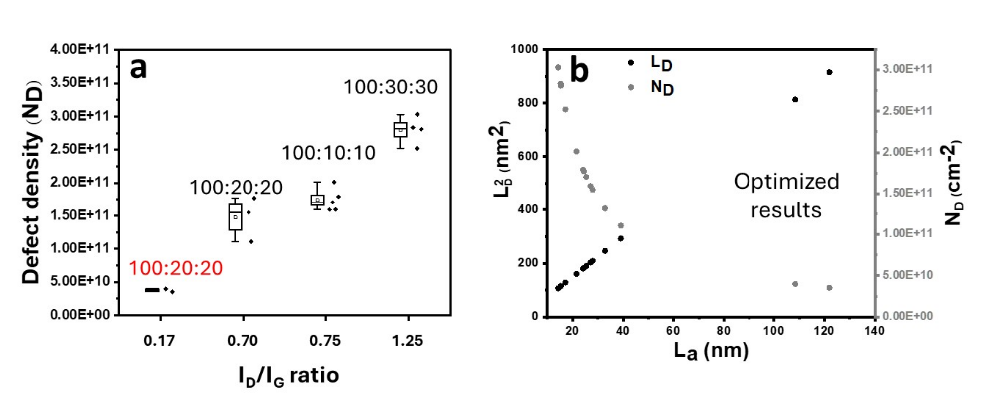
Figure S16b. Optimization of BM-Graphite in terms of defect densities and crystallite size using Raman spectra. Here, L_{a} denotes crystallite size, N_{D} represents defect density, and L_{D} signifies the distance between defects. (a) Different ratios of PE:Mg:Al are ball-milled for 1 hour, and it is found that the ratio 100:20:20 performs well. To further optimize the 100:20:20 ratio, ball milling is reduced to 45 minutes to achieve high-quality graphite, denoted in light blue color, labeled as the optimized result, where the average I_{D}/I_{G} ratio is 0.17. (b) The optimized results show low defect density and high crystallite size.

5. Proposed mechanism for graphitization:
- 3H₂
+ O₂
$$2Mg+{{3(CH}_{2})}_{n} { Mg}_{2}C_{3} 3C+2MgO$$
First critical point-
Despite considerable effort, direct detection of hydrogen released during the mechanochemical process was unsuccessful using Gas Chromatography–Mass Spectrometry (GC-MS), Gas Chromatography–Tandem Mass Spectrometry (GC-MS/MS), or Gas Chromatography–Multi-Angle Light Scattering (GC-MALS). To minimize hydrogen leakage during sampling, we drilled a hole in the vial cap and sealed it with polymer resin, allowing a needle to be inserted directly into the sealed vial post-reaction for gas analysis without opening the system. Despite this precaution, no hydrogen was detected, likely due to rapid leakage, reaction with oxygen or carbon to form water or hydrocarbons, or inadequate instrument sensitivity for hydrogen’s low mass. Additionally, ToF-SIMS analysis did not reveal hydride or hydroxide products, suggesting hydrogen either escapes or participates in side reactions without affecting the primary limiting reagent (Mg). Hence, it did not affect the main Mg-limited mechanochemical conversion. Therefore, stoichiometric and yield calculations were based on the limiting reagent and corroborated by GC-MS, ToF-SIMS, and yield analysis.

Second critical point-
In a purely mechanical context, repetitive high-energy collisions elevate the starting materials into a high-energy, vibrationally excited, and radically fractured ground state (mechanoradicals), effectively shifting the initial energy baseline upward (E_{reactant} E*_{reactant}). The introduction of Mg structurally stabilizes the intermediate state through the low-barrier formation of the metastable carbide Mg₂C₃, fundamentally altering the chemical reaction pathway. Therefore, the drastic reduction in the apparent activation energy originates from a combination of mechanical ground-state destabilization and chemical transition-state stabilization via the carbide pathway.

Third critical point-
Our density functional theory (DFT) calculations confirm that a direct pathway where Mg oxidizes to MgO without carbide intermediates cannot facilitate the high chemical potential required to reconstruct sp³ C–C bonds into ordered sp² aromatic rings under ambient conditions. Instead, the continuous generation of carbon-centered mechanoradicals (confirmed by EPR, Fig. 3c) enables the direct capture of fragments into Mg₂C₃. The exothermic transformation of this metastable carbide into MgO and graphite under air (Path 2, ΔE = -1.986 eV/atom) provides a highly localized, downward thermodynamic driving force that reconstructs the carbon backbone, bypassing conventional high-temperature melting or pyrolysis boundaries. Experimental and theoretical data indicate that MgO does not drive mechanochemical graphitization. Specifically, polyethylene (PE) retains its structure after ball milling with MgO rather than converting into graphite, aligning with thermodynamic and density functional theory (DFT) predictions.

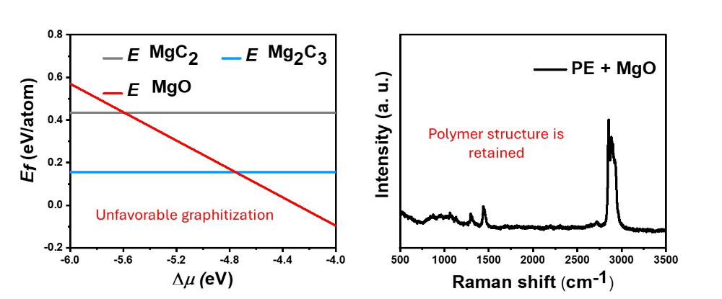

Fourth critical point-
We believe that the transformation is governed by the structural instability of metastable magnesium carbide (pp. 17, 19). Under continuous shear and compressive strain during mechanical milling, the ionic bonds between Mg²⁺ ions and the linear C₃⁻² polyallene units are continuously deformed. As magnesium is stripped away by oxygen, the newly liberated, highly reactive carbon radicals undergo immediate planar sp² condensation to minimize their surface free energy. The repetitive mechanical impacts supply the continuous activation energy required for these adjacent hexagonal rings to align and stack into long-range graphitic domains.

Mechanochemical Conversion of Polyethylene to Graphite
Materials and Experimental Inputs
- Polyethylene (PE): 100 mg sample with an average molecular weight (Mw) of 4000 g/mol.
- Magnesium (Mg) Powder: 20 mg per batch.
- Ball Milling Vial: Cylindrical, diameter = 40 mm; height = 55 mm; calculated volume = 69.12 cm³ (using $V=πr^{2}h$).
- Atmospheric Oxygen: 20.95% of vial volume.
Step 1: Calculation of Carbon Content in Polymer
- The number of moles of PE is:
$$n_{\text{PE}}=\frac{0.1\text{ g}}{4000\text{ g/mol}}=2.5×{10}^{-5}\text{ mol}$$
- Each PE macromolecule contains approximately $\frac{4000\text{ g/mol}}{28\text{ g/mol}}≈143$ ethylene repeat units.
- Therefore, total moles of ethylene units:
$$n_{\text{ethylene}}=n_{\text{PE}}×143=0.00357\text{ mol}$$
- Since each ethylene unit contains 2 carbon atoms:
$$n_{\text{C}}=0.00357\text{ mol}×2=0.00714\text{ mol}$$
Step 2: Calculation for Available Mg
- Number of moles of Mg:
$$n_{\text{Mg}}=\frac{0.02\text{ g}}{24.305\text{ g/mol}}=0.000823\text{ mol}$$
Step 3: Stoichiometry of Mg-Carbide Formation
- Reaction equation:
$$2\text{ Mg}+3\text{ C}⟶{\text{Mg}}_{2}{\text{C}}_{3}$$
- For every 2 moles Mg, 3 moles C are required ($\text{Mg}:\text{C}=2:3$)
- For the available Mg:
$$\text{C required}=\frac{3}{2}×0.000823=0.001235\text{ mol}$$
(Since available C $(0.00714\text{ mol})$ exceeds this, Mg is limiting reagent.)
- Moles of Mg₂C₃ formed:
$$n_{{\text{Mg}}_{2}{\text{C}}_{3}}=\frac{0.000823}{2}=0.000411\text{ mol}$$
Step 4: Oxygen Supply in the Reaction Vial
- Vial volume: 69.12 cm³ $=69.12\text{ mL}$
- Oxygen partial volume: $0.2095×69.12=14.49\text{ mL}$
- Moles of O₂ (at STP): $n_{{\text{O}}_{2}}=\frac{14.49\text{ mL}}{22400\text{ mL/mol}}=6.47×{10}^{-4}\text{ mol}$ (Using ideal gas, or as your provided value, $8.93×{10}^{-4}$ mol)
Step 5: Carbon Yield Calculation
- Subsequent reaction:
$${\text{Mg}}_{2}{\text{C}}_{3}+{\text{O}}_{2}⟶2\text{ MgO}+3\text{ C}$$
- Since Mg₂C₃ is limiting, moles of C produced:
$$n_{\text{C,prod}}=3×0.000411=0.00123\text{ mol}$$
- Mass of graphite expected:
$$m_{\text{C,prod}}=0.00123\text{ mol}×12.01\text{ g/mol}=0.0148\text{ g}=14.8\text{ mg}$$
Step 6: Experimental Yield and Conversion Efficiency
- Observed yield: Average ~11.9 mg graphite per batch
- Conversion efficiency:
$$\%\text{ Yield}=\frac{11.9\text{ mg}}{14.8\text{ mg}}×100=80.4\%$$
Step 7: Analytical Verification
- ToF-SIMS data support the reaction pathway along with observed experimental values and confirm graphite formation consistent with stoichiometric expectations.

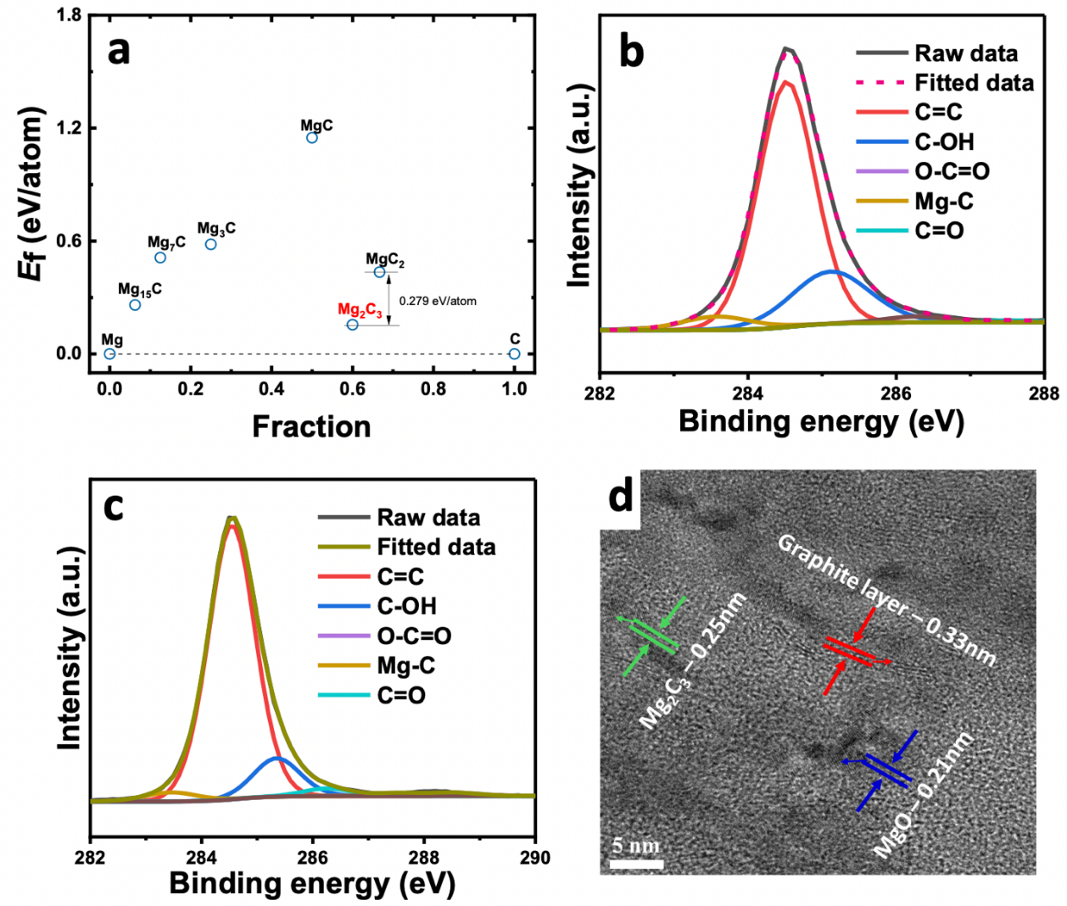

Figure S17. Feasibility of carbide formation and impact of Al. (a) Formation energy of different carbides of Mg through DFT calculations. This indicates the feasibility of synthesizing Mg₂C₃ among other carbides of Mg. (b) The C 1s XPS spectrum of the ball-milled product of PE + Mg shows the presence of carbide with a high content of sp² carbon, as well as Mg–C bonds. (c) High-resolution C 1s spectra of PEMA indicate that the intensity of sp² carbon further increases upon the addition of Al. (d) TEM images indicate the presence of graphite along with MgO and Mg₂C₃. This result further supports XPS, TOF-SIM, and other characterizations. Characterizations are performed immediately after ball milling.

6. Properties of BM-Graphite

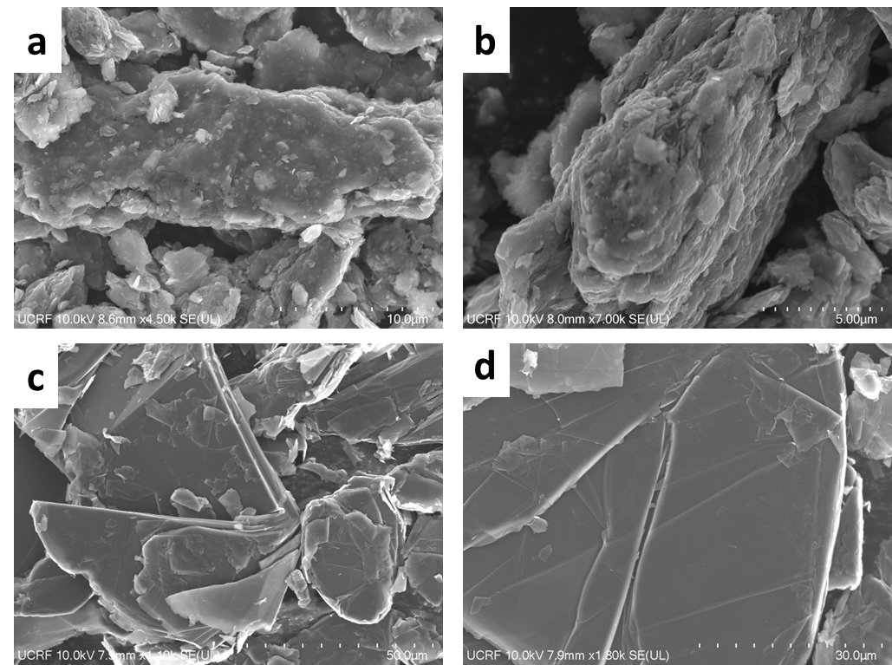

Figure S18. Morphology of (a,b) BM-Graphite and (c,d) HOPG using SEM.

TEM analysis

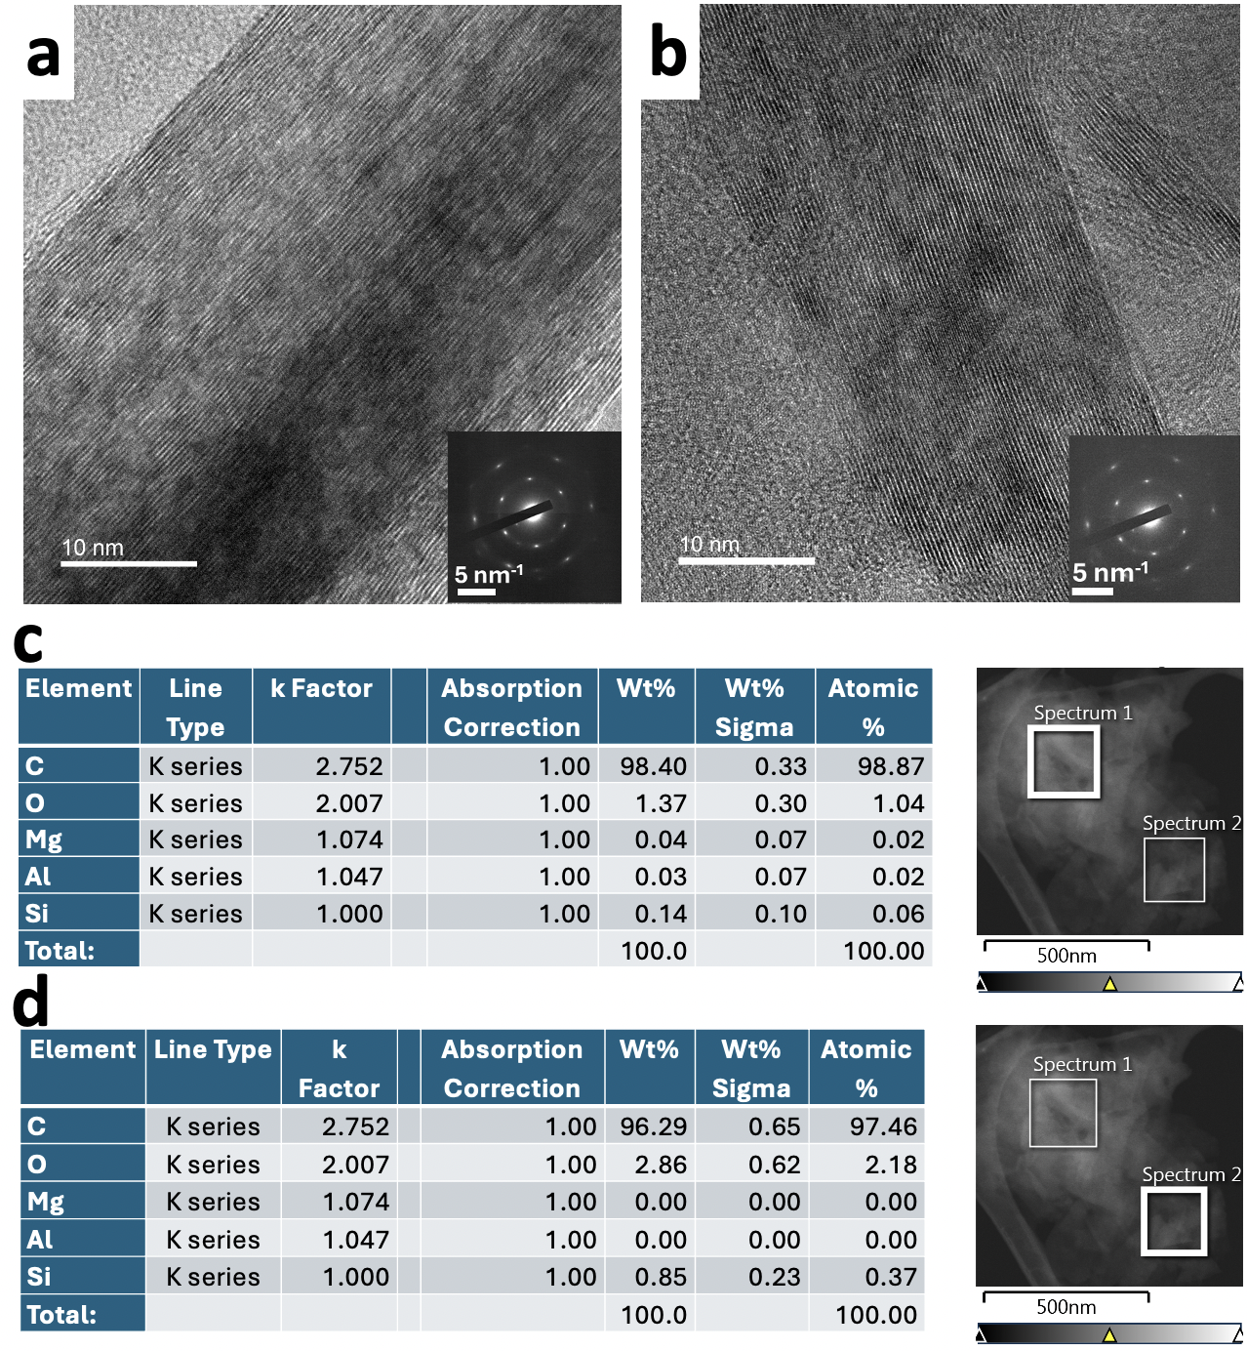

Figure S19. TEM and EDS analysis of BM-Graphite (a, b) HRTEM images of BM-Graphite indicate a highly ordered structure, supporting the SAED patterns. (c, d) EDS analysis of BM-Graphite at two different spots reveals a high content of carbon (~98%) and a low content of oxygen or functional groups (~2%).

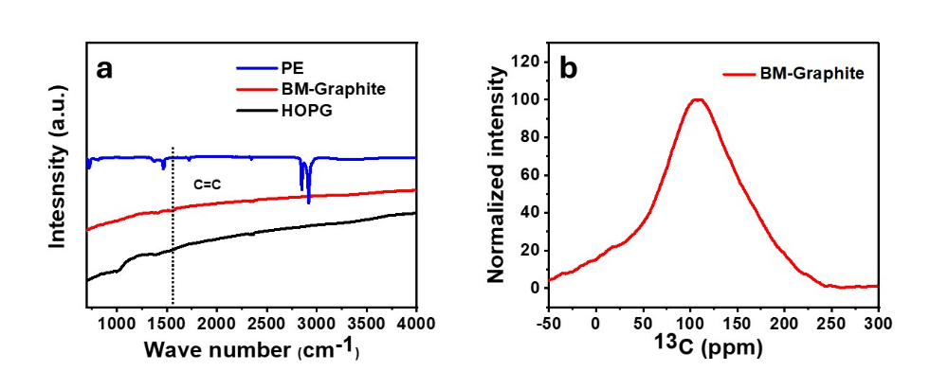
Figure S20. Functional group analysis of BM-Graphite via (a) FTIR and (b) ¹³C NMR analysis. FTIR and NMR strongly align with the TEM-EDS analysis, both, indicating a low content of functional groups.

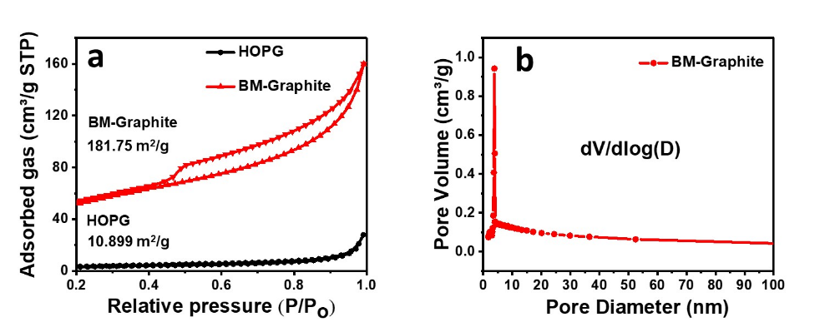

Figure S21. Calculation of pore densities through Barrett-Joyner-Halenda (BJH) analysis. (a) BET analysis confirms a higher surface area for BM-Graphite than HOPG. (b) Most of the pores are less than 50 nm in diameter, confirming the mesoporous nature of the sample, which aligns with the BET isotherm and SEM. This porous characteristic could be a possible reason for the high surface area of BM-Graphite.

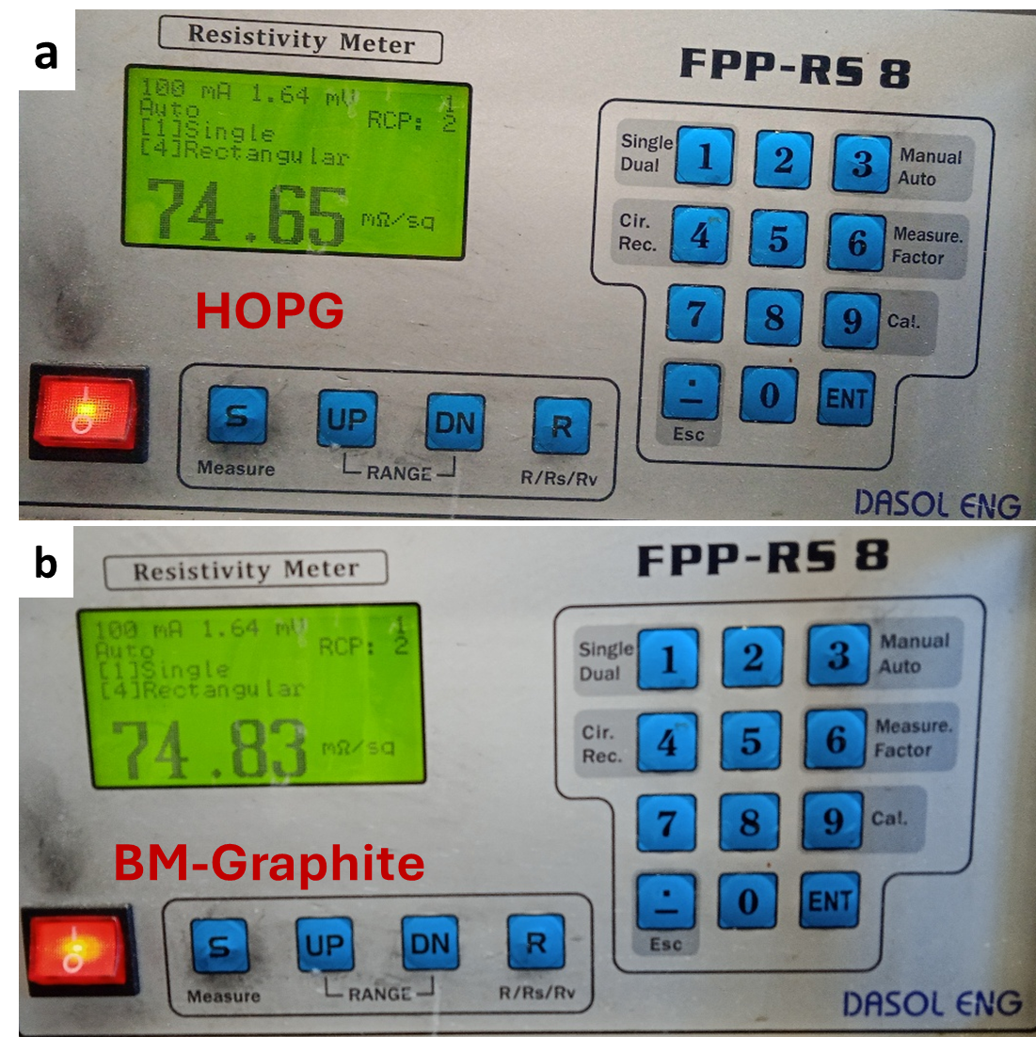

Figure S22. Sheet resistance measurement through four probe resistivity meter (a) commercial graphite (HOPG) (b) BM-Graphite. Pallets are prepared using a compression machine and the sample is compressed at 25 tons for 1 minute.

7. Electrochemical test of BM-Graphite
The incorporation of BM-graphite into VO to form the BMG-VO composite reduces activation time and significantly enhances capacity retention.

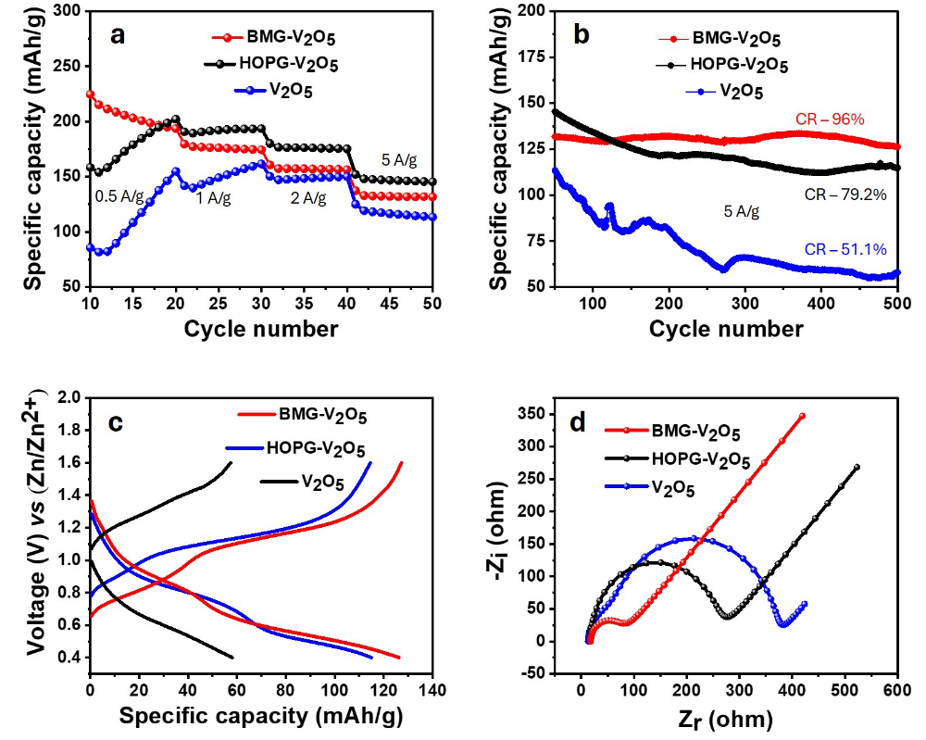
Figure S23. Electrochemical performance of cathodes. (a) Zinc-ion battery (ZIB) performance of BM-Graphite composited with V₂O₅ (BMG–V₂O₅) and HOPG composited with V₂O₅ (HOPG–V₂O₅), alongside commercial V₂O₅, at various current densities. (b) Stability test of the composite cathodes and commercial V₂O₅ at 5 A/g. CR represents capacity retention after 500 cycles for each cathode. (c) Galvanostatic charge-discharge tests reveal significant capacity retention improvements for VO composites with BM-Graphite and HOPG after 500 cycles compared to pure VO. Ball-milled graphite composite demonstrates superior capacity retention, confirming enhanced cathode stability within the electrolyte environment. The graphite composites effectively improve the electrochemical performance and long-term cycling stability of the vanadium oxide material. (d) Electrochemical impedance spectroscopy of the cathodes indicates that BM-Graphite exhibits lower charge transfer resistance, contributing to enhanced stability and kinetics during cycling ²³.

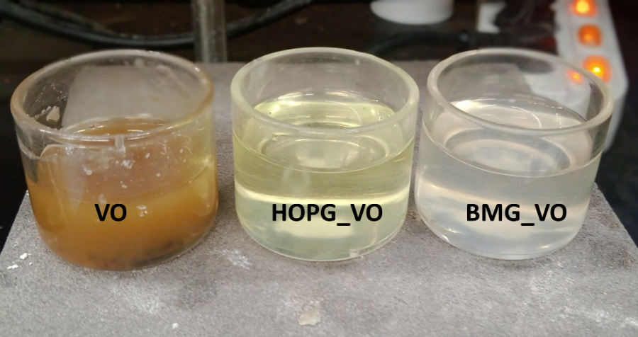
Figure S24. ZIB cathode dissolution after 500 cycling tests. VO gets dissolved a lot, and this is the reason for low-capacity retention (~51% after 500 cycles). Upon compositing with HOPG, the dissolution rate decreases, while upon compositing with BM-Graphite the dissolution of the cathode material is negligible. The extent of cathode dissolution is indicated by the darkness of yellowish color, which is the color of V₂O₅.

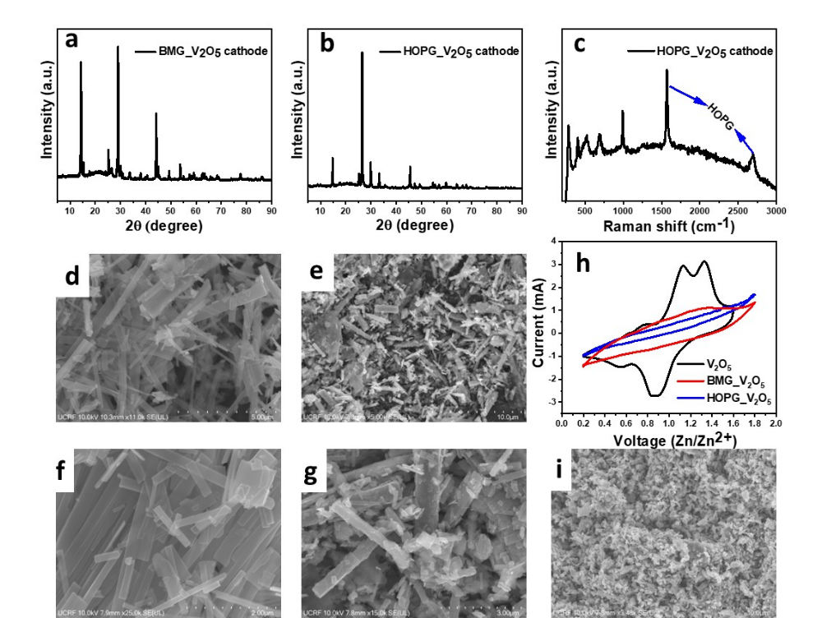
Figure S25. Characterization of synthesized cathodes. (a,b) XRD analysis of BM-Graphite (BMG) and HOPG composite with V₂O₅. Graphite peak is observed at 26.5 degree, same as HOPG. (c) Raman analysis of the HOPG-V₂O₅ composite indicates clear 2D and G bands. The strong HOPG signals in both Raman and XRD confirm its predominant presence in the sample. (d,f) Morphology via SEM analysis of BMG-V₂O₅ composite. (e,g) Morphology via SEM analysis of HOPG-V₂O₅ composite. (h,i) Morphology of commercial V₂O₅.

8. Applicability test of method

To assess the applicability of our method, we conducted ball milling experiments using plastic bags (from the convenience store), and Styrofoam obtained from garbage, all without prior optimization. Raman's analysis revealed that all the commercial plastic products underwent graphitization, regardless of whether they were subjected to pretreatments, sorting, and cleaning. Not only this, graphene is also synthesized from BM-Graphite using scotch tape.

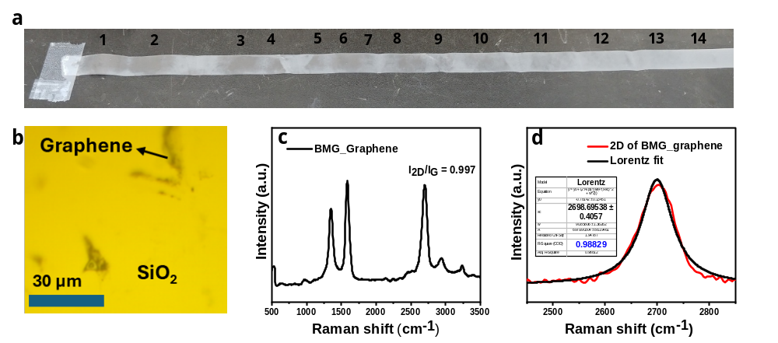

Figure S26. Synthesis of graphene from BM-Graphite (a) Scotch tape method used to exfoliate BM-Graphite until it becomes transparent. (b) Optical microscopic view of graphene on a SiO₂ substrate. After mechanical exfoliation, graphene is transferred to the Si/SiO₂ substrate for characterization. (c) Raman analysis of synthesized graphene from BM-Graphite. (d) Lorentz fit of the 2D band of graphene exfoliated from BM-Graphite (BMG_Graphene). The lower shift of the 2D band compared to BM-Graphite and the R² value (coefficient of determination) indicate the formation of few-layer graphene (less than 10 layers) ²².

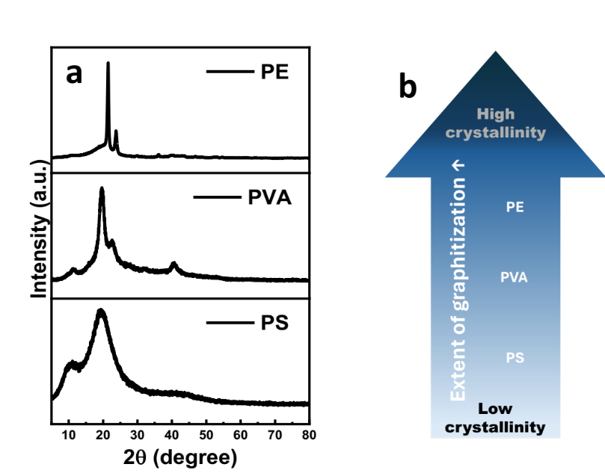

Figure S27. Crystallinity of polymers. (a) XRD of polystyrene (PS), Polyvinyl alcohol (PVA), and polyethylene (PE). XRD reveals that PS possesses the lowest crystallinity or amorphous nature while PE possesses the highest crystallinity, aligning with previously reported classification ^{24–26}. (b) Schematics of the impact of crystallinity on mechanochemical graphitization.

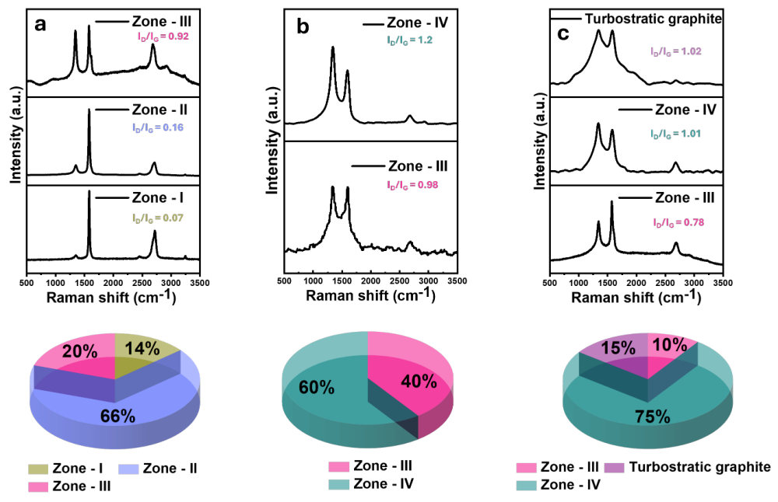

Figure S28. Relationship between degree of graphitization and crystallinity (Zone I: 0 ≤ I_{D}/I_{G} < 0.10, Zone II: 0.1 ≤ I_{D}/I_{G} < 0.5, Zone III: 0.5 ≤ I_{D}/I_{G} < 1, Zone IV: I_{D}/I_{G} ≥ 1) (a) PE + Mg + Al exhibits three graphitic quality zones based on Raman intensity ratios. Zone I represents the highest-quality graphite, while Zone III indicates poor-quality graphite. Zone II, which contains the highest proportion, is identified as the main phase. (b) PVA + Mg + Al displays only two zones. (c) PS + Mg + Al shows three zones, including an additional turbostratic zone. The turbostratic zone is characterized by a broad D band and a negligible 2D band, signifying turbostratic graphitization or amorphous graphite. The spectral variation in PS suggests a combination of ordered and disordered carbon arrangements within its composition, differing from PE and PVA. The pie chart below, derived from 50 Raman signals, illustrates the differences in graphitic quality among the samples.

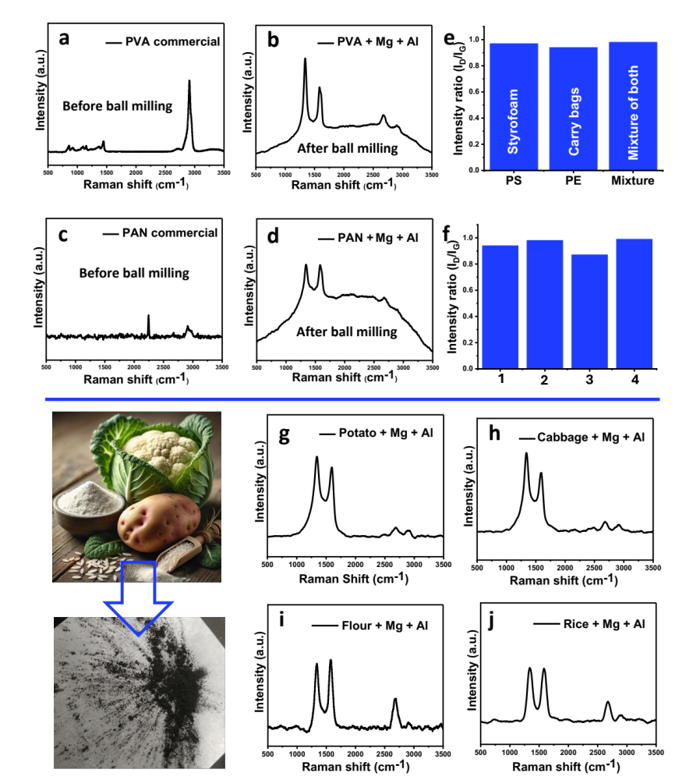

Figure S29. Verification of our method on different polymers and biowaste. (a, b) PVA before and after ball milling with Mg + Al. (c, d) Raman analysis of PAN before and after ball milling with Mg + Al. (e) Applicability of our method on commercial products such as carry bags and Styrofoam, as well as on their mixture via Raman analysis. (f) Here, (1) indicates the quality of graphite (intensities ratio) when a mixture of plastics from our lab is ball milled; (2) indicates the mixture of commercially available plastic from a bin; (3) indicates the mixture of different types of paper, from coffee cups to printing paper; and (4) indicates the dirty plastic mixture from the soil. These results demonstrate the practical utility range of this method. (g-j) Conversion of biomass waste products: Potato skin, cabbage, flour, and rice were converted into valuable graphite, as confirmed by Raman analysis.

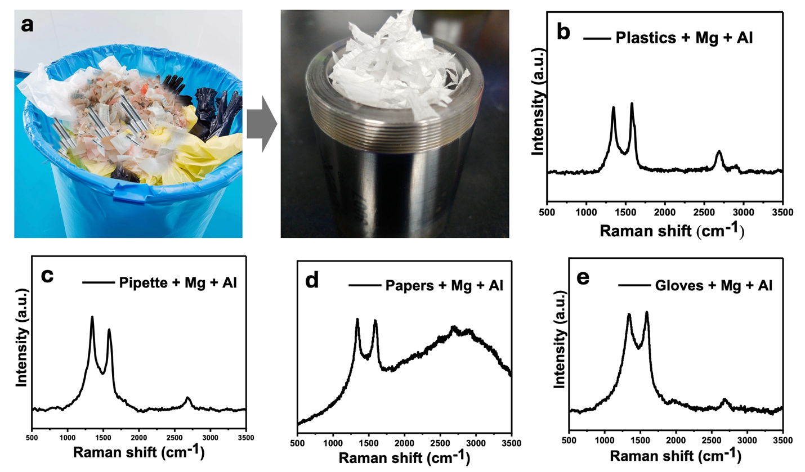
Figure S30. Individual components of lab waste. (a) Various components of lab waste including papers, gloves, pipettes, and plastics—are shown alongside their chopped mixture placed in a vial for ball milling. (b-e) Raman analysis confirms the successful graphitization of the individual components.

References
1. Han, G. F. et al. Mechanochemistry for ammonia synthesis under mild conditions. Nat Nanotechnol 16, 325–330 (2021).
2. Ramirez, A. L. B. et al. Mechanochemical strengthening of a synthetic polymer in response to typically destructive shear forces. Nat Chem 5, 757–761 (2013).
3. Lee, J. S., Han, G. F. & Baek, J. B. Mechanochemical Ammonia Synthesis: Old is New Again. ChemSusChem 16, (2023).
4. Chang, Y. et al. Kinetic Phenomena in Mechanochemical Depolymerization of Poly(styrene). ACS Sustain Chem Eng 12, 178–191 (2024).
5. Balema, V. P. et al. Depolymerization of polystyrene under ambient conditions. New Journal of Chemistry 45, 2935–2938 (2021).
6. O’Neill, R. T. & Boulatov, R. The many flavours of mechanochemistry and its plausible conceptual underpinnings. Nature Reviews Chemistry vol. 5 148–167 Preprint at https://doi.org/10.1038/s41570-020-00249-y (2021).
7. Peterson, G. I., Ko, W., Hwang, Y. J. & Choi, T. L. Mechanochemical Degradation of Amorphous Polymers with Ball-Mill Grinding: Influence of the Glass Transition Temperature. Macromolecules 53, 7795–7802 (2020).
8. Liang, C. et al. Green synthesis of graphite from CO2 without graphitization process of amorphous carbon. Nat Commun 12, (2021).
9. George L. Bata, M. Q. United States Patent Office. 3,232,891 (1996).
10. Chen, Y., Yang, X., Wu, L., Tong, L. & Zhu, J. Recovery of Mg from H2SO4 Leaching Solution of Serpentine to Precipitation of High-Purity Mg(OH)2 and 4MgCO3·Mg(OH)2·4H2O. Minerals 13, (2023).
11. Kumari, L., Li, W. Z., Vannoy, C. H., Leblanc, R. M. & Wang, D. Z. Synthesis, characterization and optical properties of Mg(OH)2 micro-/nanostructure and its conversion to MgO. Ceram Int 35, 3355–3364 (2009).
12. Li, T. & Ichimura, M. Fabrication of transparent mg(Oh)2 thin films by drop-dry deposition. Materials 14, 1–9 (2021).
13. Ochonma, P., Gao, X. & Gadikota, G. Tuning Reactive Crystallization Pathways for Integrated CO2 Capture, Conversion, and Storage via Mineralization. Acc Chem Res 57, 267–274 (2024).
14. Guo, M. et al. Regulation of collagen-derived carbon material structures through in-situ precipitation templating for fast sodium storage. Carbon N Y 217, (2024).
15. Yi, L. et al. Solidophobic Surface for Electrochemical Extraction of High-Valued Mg(OH)2 Coupled with H2 Production from Seawater. Nano Lett 24, 5920–5928 (2024).
16. Damien Voiry et al. High-quality graphene via microwave reduction of solution-exfoliated graphene oxide. Science (1979) 353, 1409–1413 (2016).
17. Wang, Z. et al. A contact-electro-catalysis process for producing reactive oxygen species by ball milling of triboelectric materials. Nat Commun 15, (2024).
18. Rahimpour Golroudbary, S., Makarava, I. & Kraslawski, A. Environmental Assessment of Global Magnesium Production. Mineral Processing and Extractive Metallurgy Review 44, 389–406 (2023).
19. Watari, T., Nansai, K. & Nakajima, K. Major metals demand, supply, and environmental impacts to 2100: A critical review. Resources, Conservation and Recycling vol. 164 Preprint at https://doi.org/10.1016/j.resconrec.2020.105107 (2021).
20. Yoon, J. C. et al. Graphitization with Suppressed Carbon Loss for High-Quality Reduced Graphene Oxide. ACS Nano 15, 11655–11666 (2021).
21. Cunning, B. V., Wang, B., Shin, T. J. & Ruoff, R. S. Structure-directing effect of single crystal graphene film on polymer carbonization and graphitization. Mater Horiz 6, 796–801 (2019).
22. Roscher, S., Hoffmann, R. & Ambacher, O. Determination of the graphene-graphite ratio of graphene powder by Raman 2D band symmetry analysis. Analytical Methods 11, 1180–1191 (2019).
23. Zhang, Y. et al. Orbital and Electrical Dual Function of Polymer Intercalant for Promoting NH4+ Storage in Vanadium Oxide Anode. Adv Energy Mater 15, (2025).
24. Kar, K. K. & Zhu Christopher Li Editors, L. Y. Gas Permeation and Barrier Properties of Liquid Crystalline Polymers. (Springer, Cham, 2020). doi:https://doi.org/10.1007/978-3-030-43350-5_67.
25. Peng, Z., Ye, L. & Ade, H. Understanding, quantifying, and controlling the molecular ordering of semiconducting polymers: From novices to experts and amorphous to perfect crystals. Materials Horizons vol. 9 577–606 Preprint at https://doi.org/10.1039/d0mh00837k (2022).
26. Galeski, A. Strength and toughness of crystalline polymer systems. Progress in Polymer Science (Oxford) vol. 28 1643–1699 Preprint at https://doi.org/10.1016/j.progpolymsci.2003.09.003 (2003).
27. Yadav, G. et al. Techno-economic analysis and life cycle assessment for catalytic fast pyrolysis of mixed plastic waste. Energy Environ Sci 16, 3638–3653 (2023).
28. Xu, Z. et al. Chemical upcycling of polyethylene, polypropylene, and mixtures to high-value surfactants. Science (1979) 381, 666–671 (2023).
29. OECD POLICY HIGHLIGHTS Monitoring Trade in Plastic Waste and Scrap. (2024).

