Supporting Information
Activation of cadmium under simulated solar illumination and its impact on the mobility of Cd in flooded soils
Bihao Luo, Chenfeng Xiao, Yuling Liu, Li Li, Liang Peng, Qingru Zeng, Si Luo*
College of Resources and Environment, Hunan Agricultural University, Changsha 410128, PR China

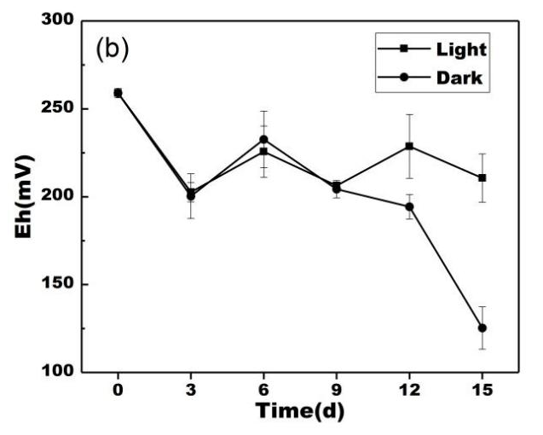
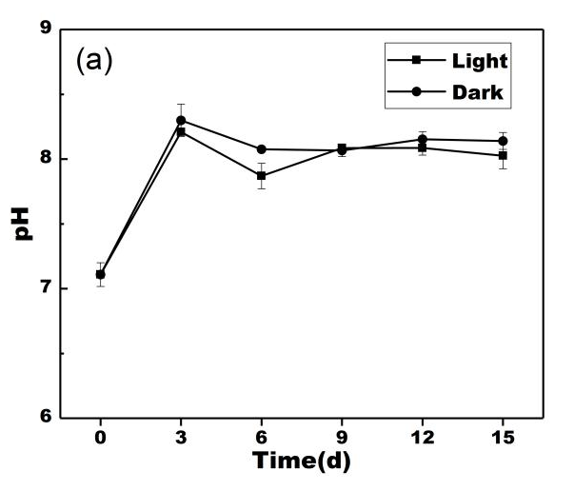

Fig. S1. The variation of soil (a) pH and (b) Eh within 15 days

These authors contributed equally to this work.
∗ Tel: +86-0731-84618166, Fax: +86-0731-4611473. E-mail: Rose850101@163.com (S. Luo).

