SUPPLEMENTARY MATERLIAL
Title:
Passive Biaxial Ankle Movement Training with Electrical Stimulation
for Ankle Sensorimotor Function in Chronic Stroke

Running title: Biaxial Ankle Training in Chronic Stroke

Authors
Ji-Eun Cho, Joon-Ho Shin, Hogene Kim

Correspondence and reprint request to:
Hogene Kim, PhD
Department of Clinical Rehabilitation Research
National Rehabilitation Center, Seoul, Korea
Research Institute 407-ho, 58 Samgaksan-ro, Gangbuk-gu, Seoul, 01022, South Korea
Tel: +82-2-901-1905
Fax: +82-2-901-1918
E-mail: hogenekim@korea.kr

Online Supplement I
Ankle Movement Training System
We have developed the Ankle Movement Training (AMT) device for quantitative measurement of ankle function and provision of rehabilitation to improve paretic ankle function in hemiparetic stroke patients. Supplement I contains a description of the features and detailed composition of the AMT system and the ankle-training protocol used in this study.

- Ankle Movement Training (AMT) device

The AMT device consists of the force plate, foot cradle, and supporting frames (Figure I). ¹ The ankle dorsiflexion (DF) and plantarflexion (PF) were implemented using a seesaw-type foot cradle that pivoted along the transverse ankle axis, with the height of the malleoli determined from the surface of the footplate in the sagittal plane between two supporting side frames. For ankle inversion (INV) and eversion (EV), the rear part of the foot force plate was attached to the rear supporting beam of the foot cradle and rotated along a 42°-tilted subtalar axis relative to the foot cradle.¹ The custom foot force plate consisted of two sandwich-paneled aluminum plates with four bar-type load cells (RS-34, Shezhen Hongrui Sensors Instrument Co., Ltd.) collinearly located between four diagonal corners, which were respectively fastened to the plate inside each side.¹

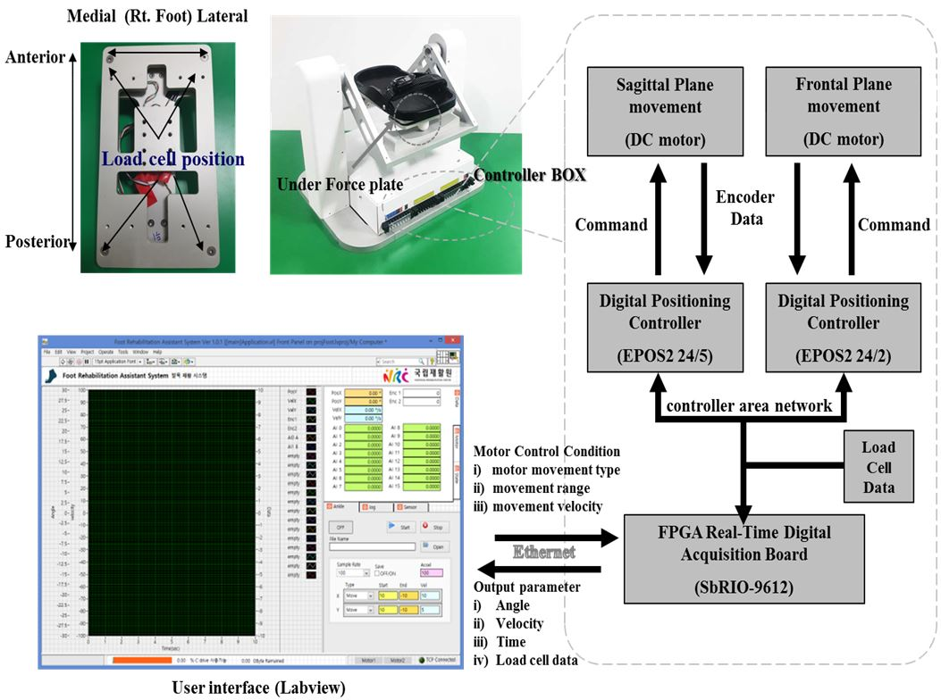
Figure Ⅰ. Ankle Movement Training hardware and software system
The AMT device has an interface of a control program that includes a passive/active ankle range of motion evaluation mode and a personalized passive training mode according to the joint range setting. During training and evaluations, the foot force plate in the AMT device measured the four-quadrant (anterior, posterior, medial, and lateral) ground-reaction forces sampled at 1 kHz. The first motor (Model: EC-i40, Maxon Motor Inc., Sachseln, Switzerland) for the DF/PF was located around the lower supporting column, and the motor torque was transmitted via a precise timing belt and high-torque timing pulleys that rotated the foot cradle along the transverse ankle axis. The second motor for the ankle INV/EV was attached to the rear center of the foot cradle, and it transmitted the rotational torque for ankle INV and EV via a beveled gear to a 90°-flexed axis along a 42°-tilted subtalar axis in the sagittal plane. The movement speed along the ankle (talocrural) and subtalar (talocalcaneal) axes was 2.14°/s after 14:1 high-powered planetary gearheads (GP32HP, Maxon Motor Inc., Switzerland).¹

Online Supplement Ⅱ

Assessed for eligibility (n=40)

Enrollment

Excluded (n=5)
♦ Not meeting inclusion criteria (n=3)
♦ Other reasons (n=2)

Randomized (n=35)

Allocation
Allocated to intervention
Experimental group (n=17)

♦ Received allocated intervention (n=17)

Allocated to intervention
Experimental group (n=18)

♦ Received allocated intervention (n=18)

Follow-Up
Lost to follow-up (n=0)
♦ Discontinued intervention (n= 0)
Lost to follow-up (n=5)
♦ Discontinued intervention: discharge (n=5)

Analysis
Analysed experimental group (n=18)
♦ Excluded from analysis (n=0)
Analysed experimental group (n=12)
♦ Excluded from analysis (n=0)

Figure Ⅱ. Consolidated standards of reporting trials (CONSORT) diagram.

Online Supplement III

This study studied the clinical effects of the passive bi-axial ankle movements that were synchronized with electrical stimulus to corresponding ankle muscles(AMT-EST). Especially the difference between pre- and post-training effects was properly shown by comparing the number of participants who had no proprioception at the trial when moving up to 100% more of the target angle, i.e. a dorsiflexion-10º trial was moving up to 20º dorsiflexion etc (Figure III). In the experimental group, bi-axial AMT-EST therapy group, the number of participants who had no proprioception dramatically reduced after the AMT-EST bi-axial ankle therapy. In control group, there was less changes in the number of participants with no proprioception in corresponding trials due to group participants with better proprioception. Thus it may show that the proposed AMT-EST therapy would be effective in chronic stroke patients with more severely impaired proprioception.
A
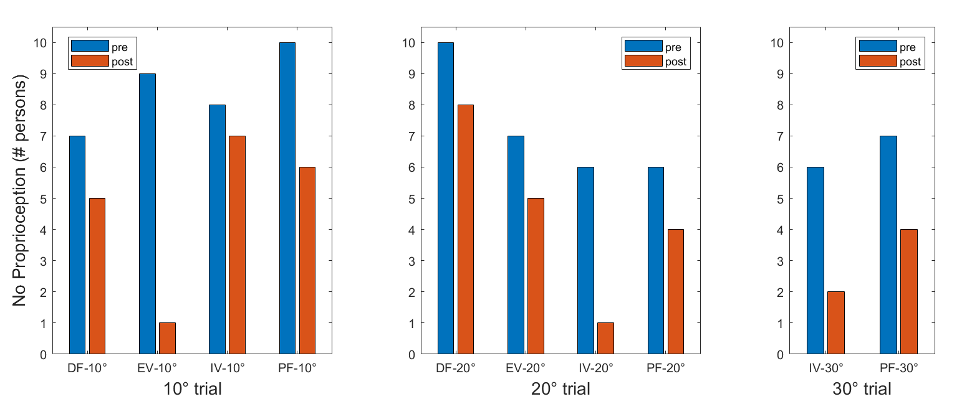
B
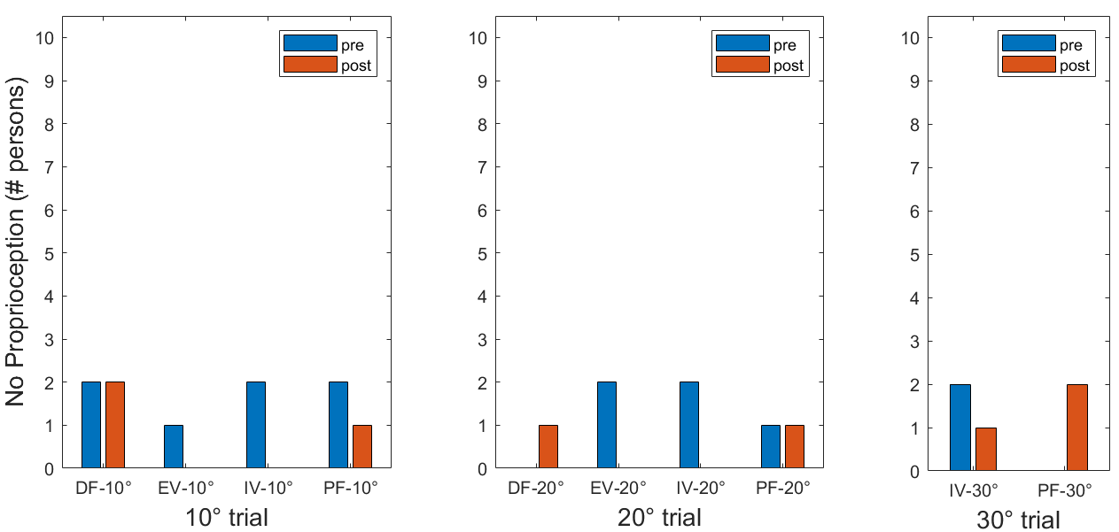
Figure III. Pre- and post-training comparison on the number of participants with no proprioception during trials DF denotes dorsiflexion, PF denotes plantar flexion, IV denotes inversion and EV denotes eversion(A: Experimental Group; B: Control Group).
Online Supplement IV

This study showed that the AMT-EST was effective ankle therapy for chronic stroke patients with more impaired ankle proprioception. The ankle proprioception was appropriately defined to show such effectiveness. To be more clear explanations about the measurements, Figure IV showed boxplots and scatter plots of each ankle proprioception ratio, defined as shown below, and its corresponding values. To show more intuitively in the figure, the range of y-axis was extended to 300% for 10º trials, 150% for 20º trials and 100% for 30º trials so that each y-axis scale in the figures was matched angles in corresponding trials.
$$Proprioception ratio=\left|\frac{Target angle-Actual angle}{Target angle}\right|$$
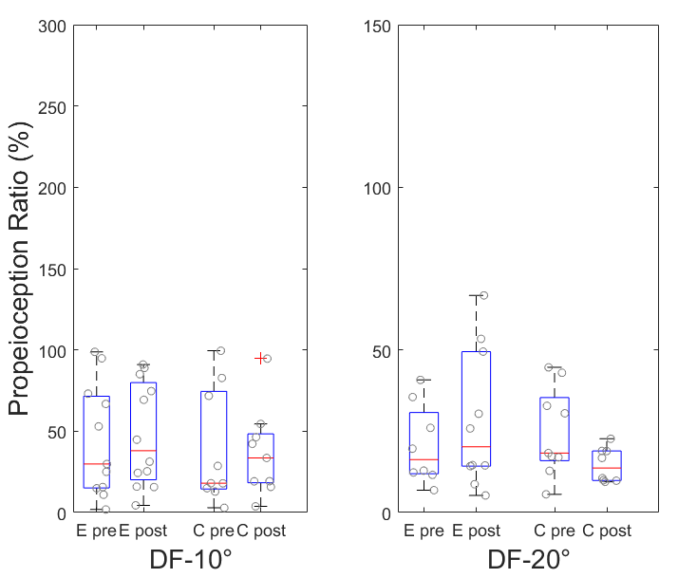
B
A
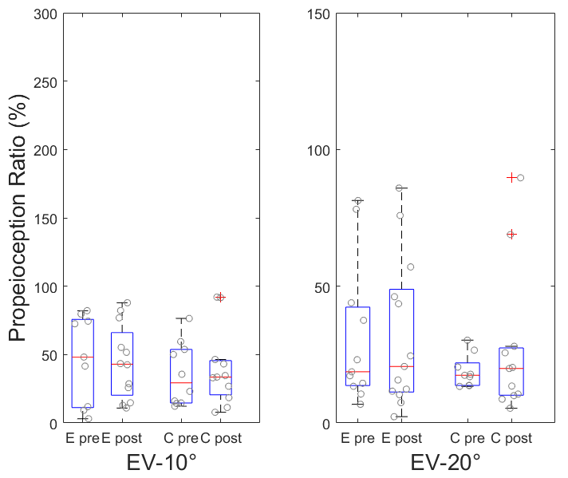
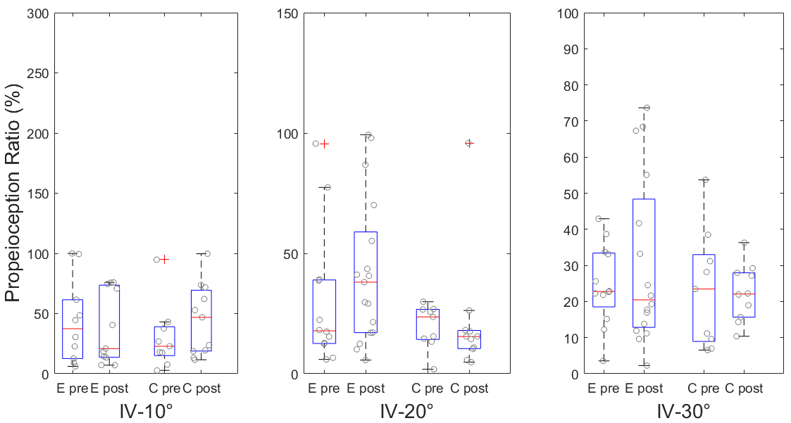
C

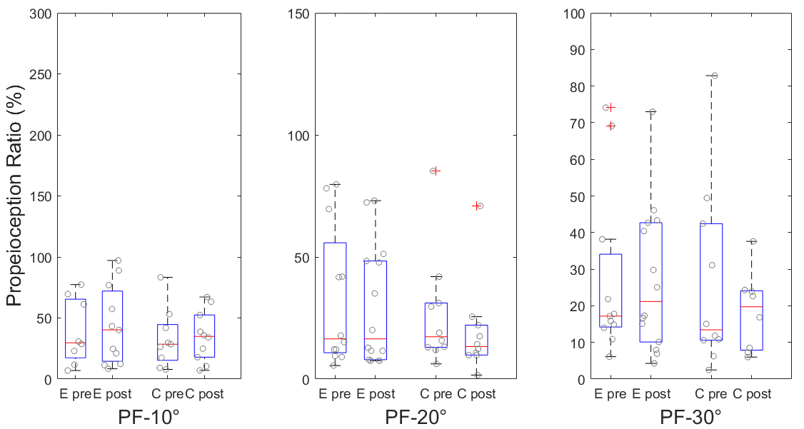
D

Figure IV. Boxplots and scatter plots of pre-/post-training proprioception ratio both for experimental(denoted as ‘E’) and control(denoted as ‘C’) groups. A: Dorsiflexion(denoted as ‘DF’), B: Eversion(denoted as ‘IV’), C:Eversion(denoted as ‘EV’), D:Plantarflexion(denoted as ‘PF’)

Online Supplement V
Outcome measures: Motor, Balance, and Gait
This study assessed the functional ability measured by motor function (the motor domain of Fugl–Meyer Lower Extremity Assessment [FM-L]), balance (Berg Balance Scale [BBS], Timed Up and Go test [TUG], and Korean Version of Fall Efficacy Scale [K-FES]), and walking speed (10-meter walking test [10MWT]).
For the measurement of motor functions, we used the motor domain of the FM-L.² The motor domain includes measurements of movement, coordination, and reflex action about the hip, knee, and ankle. The domain is rated on a 3-point ordinal scale (0 = cannot be performed, 1 = partially performed, 2 = fully performed). The maximum possible score of the motor domain of FM-L is 34, corresponding to full sensorimotor recovery.
For the balance measurement, BBS was used as a clinical test of a subject’s static and dynamic balance.³ The test comprised a set of 14 simple balance-related tasks, ranging from standing up from a sitting position to standing on one foot. TUG was used to assess a subject’s mobility and both static and dynamic balance.⁴ The test consists of the participant getting up from the chair, walking 3 m, turning at a designated spot, returning to the seat, and sitting down. The time taken to perform the test is recorded using a stopwatch. Less time on the test means good mobility and balance ability. The K-FES was applied to ascertain a person’s level of confidence in performing activities of daily living.⁵ It is a self-report questionnaire and contains 10 items, with each scored on a scale of 0–10, and the total summed scores range from 0 to 100. A high score indicates high confidence in performing activities of daily living without falling.
To measure walking speed, the 10MWT was measured.⁶ The time in seconds to walk the middle 10-m section of a 14-m walkway was used. The timing starts when the participant’s first foot crosses the 2-m mark and stops when the first foot crosses the 12-m mark, through the course of the participant’s continued progress to the 14-m mark. An average value of the three trials was used for the analysis.

References
1. Kim H, Cho S, Lee H. Effects of passive Bi-axial ankle stretching while walking on uneven terrains in older adults with chronic stroke. Journal of biomechanics. 2019;89:57-64.
2. Beckerman H, Vogelaar T, Lankhorst G, Verbeek A. A criterion for stability of the motor function of the lower extremity in stroke patients using the Fugl-Meyer assessment scale. 1996.
3. Blum L, Korner-Bitensky N. Usefulness of the Berg Balance Scale in stroke rehabilitation: a systematic review. Physical therapy. 2008;88(5):559-566.
4. Ng SS, Hui-Chan CW. The timed up & go test: its reliability and association with lower-limb impairments and locomotor capacities in people with chronic stroke. Archives of physical medicine and rehabilitation. 2005;86(8):1641-1647.
5. Tinetti ME, Richman D, Powell L. Falls efficacy as a measure of fear of falling. Journal of gerontology. 1990;45(6):P239-P243.
6. Peters DM, Fritz SL, Krotish DE. Assessing the reliability and validity of a shorter walk test compared with the 10-Meter Walk Test for measurements of gait speed in healthy, older adults. Journal of geriatric physical therapy. 2013;36(1):24-30.

