Supplementary Table S1(a). Item-level distribution of Likert responses.
Domain | Item | Strongly disagree n (%) | Disagree n (%) | Neutral n (%) | Agree n (%) | Strongly agree n (%) | Mean ± SD
Core empathy | E1 | 12 (2.5%) | 1 (0.2%) | 38 (8.0%) | 267 (56.0%) | 159 (33.3%) | 4.17 ± 0.79
Core empathy | E2 | 13 (2.7%) | 5 (1.0%) | 58 (12.2%) | 279 (58.5%) | 122 (25.6%) | 4.03 ± 0.82
Core empathy | E3 | 10 (2.1%) | 5 (1.0%) | 41 (8.6%) | 251 (52.6%) | 170 (35.6%) | 4.19 ± 0.80
Core empathy | E4 | 11 (2.3%) | 3 (0.6%) | 33 (6.9%) | 256 (53.7%) | 174 (36.5%) | 4.21 ± 0.79
Core empathy | E5 | 12 (2.5%) | 6 (1.3%) | 36 (7.5%) | 269 (56.4%) | 154 (32.3%) | 4.15 ± 0.81
Core empathy | E6 | 11 (2.3%) | 5 (1.0%) | 46 (9.6%) | 279 (58.5%) | 136 (28.5%) | 4.10 ± 0.79
Core empathy | E7 | 11 (2.3%) | 9 (1.9%) | 68 (14.3%) | 278 (58.3%) | 111 (23.3%) | 3.98 ± 0.81
Core empathy | E8 | 12 (2.5%) | 13 (2.7%) | 77 (16.1%) | 253 (53.0%) | 122 (25.6%) | 3.96 ± 0.87
Core empathy | E9 | 9 (1.9%) | 3 (0.6%) | 29 (6.1%) | 250 (52.4%) | 186 (39.0%) | 4.26 ± 0.76
Core empathy | E10 | 11 (2.3%) | 3 (0.6%) | 29 (6.1%) | 227 (47.6%) | 207 (43.4%) | 4.29 ± 0.80
Techno-clinical empathy | TC1 | 10 (2.1%) | 10 (2.1%) | 149 (31.2%) | 222 (46.5%) | 86 (18.0%) | 3.76 ± 0.84
Techno-clinical empathy | TC2 | 12 (2.5%) | 3 (0.6%) | 54 (11.3%) | 279 (58.5%) | 129 (27.0%) | 4.07 ± 0.79
Techno-clinical empathy | TC3 | 18 (3.8%) | 56 (11.7%) | 154 (32.3%) | 201 (42.1%) | 48 (10.1%) | 3.43 ± 0.95
Techno-clinical empathy | TC4 | 9 (1.9%) | 2 (0.4%) | 54 (11.3%) | 288 (60.4%) | 124 (26.0%) | 4.08 ± 0.74
Techno-clinical empathy | TC5 | 10 (2.1%) | 5 (1.0%) | 72 (15.1%) | 290 (60.8%) | 100 (21.0%) | 3.97 ± 0.77
Techno-clinical empathy | TC6 | 8 (1.7%) | 8 (1.7%) | 54 (11.3%) | 254 (53.2%) | 153 (32.1%) | 4.12 ± 0.80
Digital health readiness | DH1 | 10 (2.1%) | 28 (5.9%) | 172 (36.1%) | 212 (44.4%) | 55 (11.5%) | 3.57 ± 0.85
Digital health readiness | DH2 | 9 (1.9%) | 21 (4.4%) | 105 (22.0%) | 259 (54.3%) | 83 (17.4%) | 3.81 ± 0.84
Digital health readiness | DH3 | 8 (1.7%) | 38 (8.0%) | 168 (35.2%) | 209 (43.8%) | 54 (11.3%) | 3.55 ± 0.86
Digital health readiness | DH4 | 10 (2.1%) | 8 (1.7%) | 80 (16.8%) | 281 (58.9%) | 98 (20.5%) | 3.94 ± 0.79
Digital health readiness | DH5 | 9 (1.9%) | 8 (1.7%) | 63 (13.2%) | 256 (53.7%) | 141 (29.6%) | 4.07 ± 0.81
Communication skill | CS1 | 10 (2.1%) | 18 (3.8%) | 103 (21.6%) | 261 (54.7%) | 85 (17.8%) | 3.82 ± 0.84
Communication skill | CS2 | 8 (1.7%) | 4 (0.8%) | 47 (9.9%) | 272 (57.0%) | 146 (30.6%) | 4.14 ± 0.76
Communication skill | CS3 | 8 (1.7%) | 2 (0.4%) | 70 (14.7%) | 280 (58.7%) | 117 (24.5%) | 4.04 ± 0.75
Communication skill | CS4 | 10 (2.1%) | 7 (1.5%) | 80 (16.8%) | 266 (55.8%) | 114 (23.9%) | 3.98 ± 0.81
Communication skill | CS5 | 8 (1.7%) | 2 (0.4%) | 55 (11.5%) | 276 (57.9%) | 136 (28.5%) | 4.11 ± 0.75
Technology-assisted care attitude | AT1 | 14 (2.9%) | 14 (2.9%) | 92 (19.3%) | 239 (50.1%) | 118 (24.7%) | 3.91 ± 0.90
Technology-assisted care attitude | AT2 | 9 (1.9%) | 18 (3.8%) | 87 (18.2%) | 271 (56.8%) | 92 (19.3%) | 3.88 ± 0.83
Technology-assisted care attitude | AT3 | 14 (2.9%) | 27 (5.7%) | 135 (28.3%) | 238 (49.9%) | 63 (13.2%) | 3.65 ± 0.89
Technology-assisted care attitude | AT4 | 7 (1.5%) | 9 (1.9%) | 59 (12.4%) | 295 (61.8%) | 107 (22.4%) | 4.02 ± 0.75
Technology-assisted care attitude | AT5 | 8 (1.7%) | 4 (0.8%) | 60 (12.6%) | 267 (56.0%) | 138 (28.9%) | 4.10 ± 0.77
Note. Responses are shown separately for strongly disagree, disagree, neutral, agree, and strongly agree. Mean ± SD is also presented for each item.

Supplementary Table S1(b). Crude logistic regression for high techno-clinical empathy.
Predictor | COR (95% CI) | p-value
Age group
≤24 years | Ref
25–29 years | 0.83 (0.52–1.33) | 0.446
30–34 years | 1.09 (0.64–1.87) | 0.755
≥35 years | 0.92 (0.53–1.62) | 0.785
Gender
Male | Ref
Female | 0.69 (0.48–0.99) | 0.046*
Professional status
Medical student | Ref
MBBS/BDS graduate | 1.13 (0.73–1.75) | 0.577
Postgraduate trainee | 0.92 (0.52–1.62) | 0.768
Postgraduate degree completed | 0.96 (0.50–1.86) | 0.908
Communication-skill training
No | Ref
Yes | 0.84 (0.56–1.26) | 0.397
Telemedicine experience
No | Ref
Yes | 2.06 (1.39–3.06) | <0.001***
Digital-health training
No | Ref
Yes | 2.05 (1.21–3.46) | 0.007**
Digital tool-use frequency
Never | Ref
Sometimes | 1.47 (0.98–2.19) | 0.061
Regularly | 1.83 (1.02–3.29) | 0.043*
Primary digital tool
Telemedicine | Ref
EHR | 0.56 (0.23–1.34) | 0.189
AI-based clinical support | 0.58 (0.31–1.09) | 0.091
Remote monitoring | 0.48 (0.11–2.08) | 0.327
None | 0.52 (0.31–0.90) | 0.018*
Multiple digital tools | 1.87 (0.75–4.62) | 0.178
Other | 0.34 (0.12–0.99) | 0.047*
Core empathy level
Lower/moderate core empathy | Ref
High core empathy | 7.53 (4.65–12.22) | <0.001***
Digital health readiness
Not digitally ready | Ref
High digital readiness | 7.40 (4.89–11.19) | <0.001***
Communication skill level
Lower/moderate communication skill | Ref
Strong communication skill | 4.21 (2.79–6.34) | <0.001***
Technology-assisted care attitude
Less positive attitude | Ref
Positive attitude | 9.23 (6.03–14.15) | <0.001***
Note. Values are crude odds ratios with 95% confidence intervals. Ref indicates the reference category. Significance: *p<0.05; **p<0.01; ***p<0.001.

Supplementary Table S1(c). Preliminary keyword-assisted summary of open-ended responses.
Question | Theme | n (%)
challenge_digital_empathy | Non-empty responses | 200 (41.9%)
challenge_digital_empathy | Communication or non-verbal cue gap | 40 (20.0%)
challenge_digital_empathy | Technical/infrastructure barriers | 29 (14.5%)
challenge_digital_empathy | Trust, privacy, or confidence concern | 6 (3.0%)
challenge_digital_empathy | Time pressure or workload | 22 (11.0%)
challenge_digital_empathy | Patient literacy/access barrier | 11 (5.5%)
technology_enhance_empathy | Non-empty responses | 183 (38.4%)
technology_enhance_empathy | Better communication and access | 39 (21.3%)
technology_enhance_empathy | Efficiency and follow-up | 16 (8.7%)
technology_enhance_empathy | AI or decision-support tools | 13 (7.1%)
technology_enhance_empathy | Training or patient education | 5 (2.7%)
technology_enhance_empathy | Personalized or patient-centered support | 32 (17.5%)
training_needed | Non-empty responses | 190 (39.8%)
training_needed | Digital communication/empathy training | 35 (18.4%)
training_needed | Telemedicine platform and technical training | 21 (11.1%)
training_needed | Ethics, privacy, and confidentiality | 8 (4.2%)
training_needed | AI/digital health literacy | 54 (28.4%)
training_needed | Practical simulation or role-play | 5 (2.6%)
Note. Percentages reflect the proportion of respondents providing each thematic response among non-empty responses to the corresponding open-ended question.

Supplementary Table S1(d). Logistic regression diagnostics and sensitivity analysis.
Model | Outcome | N | Hosmer–Lemeshow χ² (df) | HL p-value | AUC | McFadden’s pseudo R² | Maximum VIF
Model 1 | High techno-clinical empathy | 477 | 2.65 (8) | 0.955 | 0.652 | 0.049 | 10.05
Model 2 | High techno-clinical empathy | 477 | 3.61 (8) | 0.890 | 0.850 | 0.305 | 10.10
Sensitivity model | TCE total ≥ median (24) | 477 | 3.61 (8) | 0.890 | 0.850 | 0.305 | Same covariate set
Note. Hosmer–Lemeshow p-values greater than 0.05 indicate no statistical evidence of poor calibration. AUC indicates model discrimination; VIF indicates multicollinearity diagnostics.

Supplementary Table S1(e). Spearman correlation among continuous construct mean scores.
Variable 1 | Variable 2 | Spearman’s rho | p-value
Core empathy | Techno-clinical empathy | 0.656 | <0.001***
Core empathy | Digital readiness | 0.483 | <0.001***
Core empathy | Communication skill | 0.599 | <0.001***
Core empathy | Tech-assisted attitude | 0.590 | <0.001***
Techno-clinical empathy | Digital readiness | 0.629 | <0.001***
Techno-clinical empathy | Communication skill | 0.568 | <0.001***
Techno-clinical empathy | Tech-assisted attitude | 0.680 | <0.001***
Digital readiness | Communication skill | 0.509 | <0.001***
Digital readiness | Tech-assisted attitude | 0.629 | <0.001***
Communication skill | Tech-assisted attitude | 0.557 | <0.001***
Note. Spearman’s rank correlation was used to assess monotonic association among continuous domain mean scores.

Supplementary Figure S1. Spearman correlation matrix of construct mean scores.
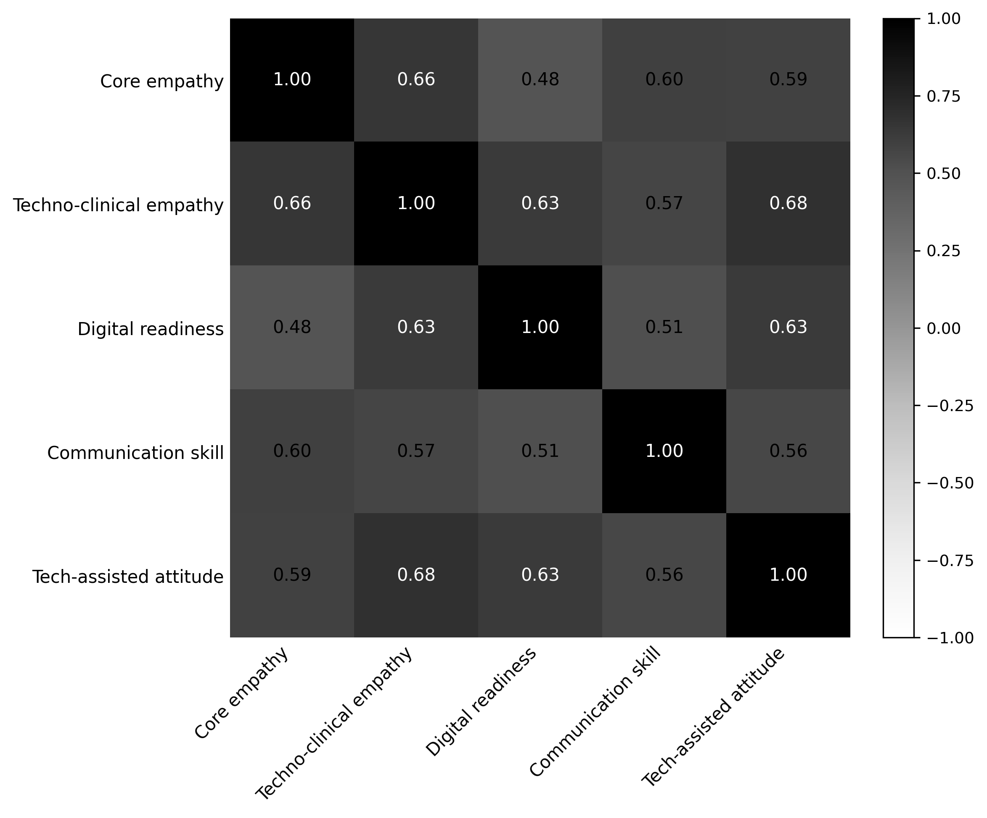
Note. Color intensity and cell values indicate the direction and magnitude of Spearman’s rho between domain mean scores.

