Religious communities as custodians of geoheritage: towards a culturally grounded approach to geotourism in Dogu’a Tembien (Tigray, Ethiopia)

Jan Nyssen^{1,2,*}, Tesfaalem Ghebreyohannes², Yonas Meheretu ^{4,5}, Wolbert Smidt^{6,7}, Seifu Gebreslassie⁸, Michael Gervers⁹, Sofie Annys¹, Frances Williams¹⁰, Miruts Hagos¹¹
¹Department of Geography, Ghent University, Ghent, Belgium (jan.nyssen@ugent.be)
²Department of Geography, Environment and Population Studies, Mekelle University, Mekelle, Tigray, Ethiopia
⁴Department of Biology, Mekelle University, Mekelle, Ethiopia
⁵Department of Wildlife, Fish and Environmental Studies, Swedish University of Agricultural Sciences, Uppsala, Sweden
⁶Faculty of History and Cultural Studies, Mekelle University, Mekelle, Tigray, Ethiopia
⁷Research Centre Ancient South Arabia and Northeast Africa, Friedrich Schiller Universität Jena, Germany
⁸EthioTrees project, Mekelle, Tigray, Ethiopia
⁹Department of Historical and Cultural Studies, University of Toronto, Scarborough, Canada
¹⁰Department of Earth Sciences, University of Adelaide, Adelaide, Australia
¹¹Faculty of Mining and Geosciences, Mekelle University, Mekelle, Tigray, Ethiopia

ONLINE SUPPLEMENTARY DATA
S1. Geological Setting of Dogu’a Tembien’s rock churches and other caves
The geological setting of Tigray comprises, from oldest to youngest, the Neoproterozoic basement complex, Paleozoic sedimentary rocks, the Mesozoic fluvio-marine succession, and Cenozoic volcanic rocks with associated sedimentary deposits (Figure S1). The Neoproterozoic basement of Tigray represents the southern extension of the juvenile crust of the Arabian-Nubian Shield. It comprises two major lithostratigraphic groups: the older Tsaliet Group, consisting mainly of metavolcanic and volcaniclastic rocks, and the younger Tambien Group, composed predominantly of sedimentary rocks that underwent low-grade metamorphism (Alene et al. 2006; Beyth 1972; Miller et al. 2009). Both groups are intruded by syn- to post-tectonic magmatic bodies, ranging from granitic to dioritic compositions.
Following a major erosional unconformity and peneplanation, the Neoproterozoic basement rocks are overlain by Paleozoic fluvio-glacial deposits characteristic of Tigray (Figure S1). These siliciclastic deposits, traditionally referred to as the Enticho Sandstone and Edaga Arbi Glacials, form the basal part of the Paleozoic–Mesozoic sedimentary succession. Their lithology and thickness vary both laterally and vertically, reflecting local depositional conditions. The Enticho Sandstone comprises predominantly siliciclastic rocks and displays sedimentary structures including cross-stratification and conglomeratic facies, with features in its upper part indicating glacial influence. Several rock-hewn churches are excavated in this formation, although none occur within the present study area. The overlying Edaga Arbi Glacials consist predominantly of dark-brown to light-red laminated shale and siltstone, commonly containing dispersed granitic pebbles and boulders, together with minor diamictites (Bussert 2010).
After a prolonged period of erosion and depositional hiatus, the Paleozoic-Mesozoic succession was established, beginning with the Adigrat Sandstone and continuing upward through the Antalo Limestone, Agula Shale and Amba Aradam Formation. This succession records a major phase of sedimentation associated with the development of the regional sedimentary basin.
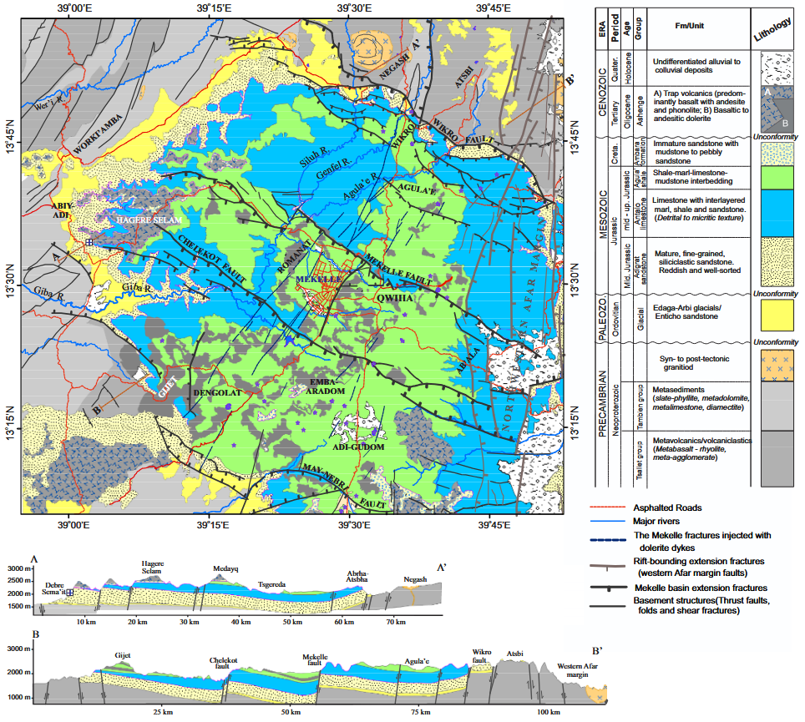
Figure S1. Simplified geological map of the Mekelle sedimentary basin and surrounding areas. Lithological contacts and major structural elements were interpreted from high-resolution satellite imagery, including Sentinel-2, SPOT and Landsat 8 data. The names of formal lithostratigraphic units preserve their established historical geographic references in accordance with international stratigraphic practice (Salvador 1994). Accordingly, the Antalo Limestone and Enticho Sandstone retain the historical spellings introduced in nineteenth-century geological literature (Blanford 1870), although the corresponding localities are now generally written Hintalo and Intich'o.
The Adigrat Sandstone, which hosts many of the renowned rock-hewn churches of northern Ethiopia, consists predominantly of grey to reddish, fine-grained, well-sorted and texturally mature quartz arenite. It forms a prominent cliff-forming unit throughout much of Tigray and reaches its greatest known thickness, of approximately 700 m, in the vicinity of Debre Semaʿit Yohannis (Figure S1, section AA’) (Bosellini et al. 1997). Its pronounced resistance to erosion and the resulting cliffs and sandstone pinnacles have strongly influenced the geomorphology of Dogu’a Tembien and provided the geological setting for numerous rock-hewn churches and other human excavations.
The Adigrat Sandstone is conformably overlain by the Antalo Limestone, also referred to as the Antalo Supersequence, which constitutes a major sedimentary succession within the Mekelle Basin. It comprises several lithological units, including limestone, marl, shale and evaporitic or lagoonal deposits. Natural caves in the Antalo Limestone have locally been transformed into churches, or other sacred spaces such as the Zeyi cave (Causer 1962; Dramis and Fubelli 2019; Nyssen et al. 2020b). The upper part of the Mesozoic succession consists of the Amba Aradam Formation, composed predominantly of detrital, commonly mottled sandstone (Hagos et al. 2020), which hosts a few rock-hewn churches and, particularly, human-made caves (Bussert and Nyssen 2019).
The Mesozoic sedimentary succession is separated from the overlying Cenozoic volcanic rocks by a major unconformity. The Cenozoic succession consists mainly of a thick pile, locally reaching approximately 2000 m, of flood basalts interlayered with pyroclastic fall deposits and flows, together with associated hypabyssal intrusions, including the Mekelle dolerites (Ukstins et al. 2002). The volcanic rocks are interbedded with silicified lacustrine deposits in which a few rock-hewn churches have been excavated, with the overlying basalt locally forming their roofs (Hagos et al. 2019).
The Quaternary comprises alluvium, colluvium and freshwater tufa, some of whose caves have locally been enlarged for use as churches (Dramis and Fubelli 2019).

S2. Debre Semaʿit Yohannis: architectural description
The interior of the approximately 46 m² rock-hewn church (Figs. S1, S2) is organised around columns with bracket-type capitals. Decorative elements such as friezes, cornices, and beam imitations with square cassette motifs appear to have been carved as part of the original excavation phase (Donald Phillipson, University of Cambridge, pers. comm.; Ewa Balicka-Witakowska, Uppsala University, pers. comm.). A large cross engraved in the ceiling forms part of this integrated architectural design. Based on architectural comparisons with other northern Ethiopian churches, the structure can broadly be placed between the late medieval and early modern periods (Lepage and Mercier 2005; Phillipson 2009). The beam imitations resemble features found in early built churches of Tigray, including Debre Dammo (13th-14th centuries), as well as in rock-hewn churches such as ʿAddi Qesho (Phillipson 2009) (Donald Phillipson; Habtamu Mekonnen, Debre Berhan University, pers. comm.). The dome-like ceiling feature has tentatively been interpreted as possibly reflecting Gondarine-period (16th-17th century) architectural influence (Hailay Teklay, Tourism and Culture Commission of Tigrai Regional State, pers. comm.)
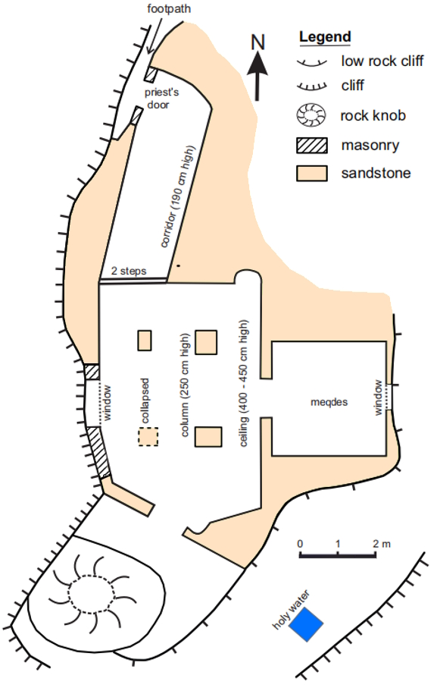
Figure S2. Ground plan of Debre Semaʿit Yohannis rock-hewn church. The eastern chamber (meqdes), the innermost and holiest part of an Ethiopian Orthodox church, accessible only to ordained clergy (Chaillot 2002), was not visited by the authors. Its dimensions are reconstructed from descriptions provided by the priests and constrained by the remaining rock mass, consistent with the position of the window in the wall.
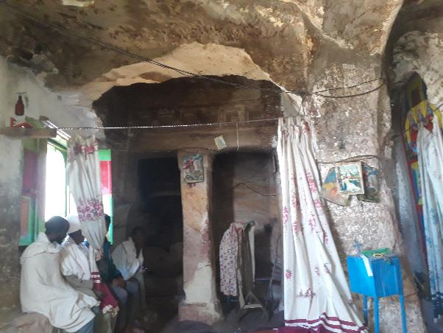
Figure S3. Interior of Debre Semaʿit Yohannis church, showing columns with bracket capitals and carved decorative elements. The central part of the ceiling shows evidence of a later modification, with fresher rock surfaces contrasting with the older carved surfaces. The western end of the church (left) differs structurally from the remainder of the interior, with a masonry wall containing a window replacing the otherwise rock-hewn structure. Local tradition attributes this modification to a catastrophic event during the period of Gragn Ahmed, whereas a geomorphological interpretation suggests partial toppling of the sandstone pinnacle in which the church was excavated. Photograph by Jan Nyssen, 2019.

The wall paintings are likely later additions. Their age cannot be established without sampling and analytical methods such as pigment characterisation. Studies of Tigrayan rock-hewn churches indicate that mural decoration often represents later phases of ecclesiastical use and embellishment (Lepage and Mercier 2005; Phillipson 2009). The paintings include a schematic equestrian figure and a roughly executed horse (Figure S4). Although the equestrian figure is locally identified as Saint George, this identification cannot be confirmed on iconographic grounds (E. Balicka-Witakowska, pers. comm.). Experts consider the painting relatively recent and note affinities with local rock-art traditions (Negash, 2001) rather than canonical church painting (A.C. D’Andrea; Hailay Teklay, pers. comm.).
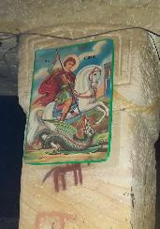
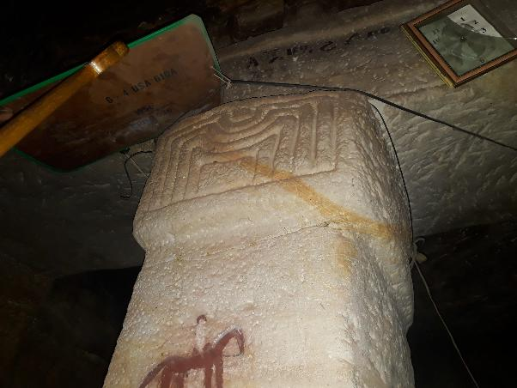
Figure S4. Detail of columns with bracket capitals and carved decorative elements at Debre Semaʿit Yohannis rock-hewn church; painting of equestrian figure and modern Saint George image attached to the column (inset). Photographs by Jan Nyssen, 2019.

S3. Debre Sema’it Yohannis: a hidden church, a contested memory, and a changing rock pinnacle
According to local tradition, Debre Sema’it Yohannis was originally a hidden monastery, known only to its religious community and concealed within the rugged sandstone landscape of Dogu’a Tembien. The church is traditionally associated with Yohannis Welde Negodguad (John the Apostle, “Son of Thunder”, the nickname reportedly given by Jesus to John in the Gospel of Mark [Mark 3:17].
The church is said to have been discovered during the reign of Emperor Libne Dingil (r. 1508–1540), when two local nobles from the area of Abiy ʿAddi, ʿInqomika'el and Tesfamika'el, were hunting wild animals, including antelopes and game birds, on mountain slopes that were still covered by dense forest. According to the oral tradition, their hunting dog disappeared towards the cliff face, and while searching for it, the hunters came upon large pots of honey and butter, interpreted as provisions left by the resident monks. Continuing their search, they reached the summit, where they discovered the previously hidden rock-hewn church and its monastic community.
Local tradition associates the subsequent exposure of the church with the turbulent period of the campaigns of imam Ahmad ibn Ibrahim al-Ghazi (popularly called "Gragn Ahmed", c. 1506–1543), leader of the Muslim state of Adal, whose armies devastated many Christian sites in the Ethiopian highlands during the sixteenth century. According to oral accounts, imam Ahmed occupied Debre Sema’it for approximately six months, using the church as a temporary residence and killing monks, priests, guards, and other religious figures associated with the site. More than half of the approximately 44 monks are said to have been killed, while survivors fled to Waldibba Monastery. In this tradition, imam Ahmed’s presence at the site is remembered as an act of desecration, reflecting his broader campaign of church destruction and persecution of Christian communities. The destruction of one pillar and the western opening of the church is attributed locally to divine anger against the desecration and killings, expressed through a lightning strike.
The same oral tradition further relates that, after Emperor Gelawdewos (r. 1540–1559) defeated imam Ahmed and expelled his forces from Tigray, it was discovered that Debre Sema’it had lost a manuscript recording the history of the church. During his occupation, imam Ahmed is said to have removed this manuscript and attempted to carry it eastwards through Irob while retreating from Tigray. According to the tradition, Emperor Gelawdewos recovered the manuscript before it left the region and deposited it at Gunde Gunde Monastery, where it is believed to remain today. No documentary evidence has yet been identified to corroborate this tradition. Co-author Michael Gervers, who coordinated the 2006 digitisation of the 219 manuscripts in the Gunde Gunde collection (U T Scarborough Library n.d.), is unaware of any manuscript referring to Debre Sema’it Yohannis. However, he notes that such a text could still exist among the recently digitised manuscripts from the nearby nunnery of Asira Met’ira or among material that has not yet been fully catalogued.
Local accounts also provide explanations for the present architectural configuration of the church. Informants consistently stated that the church has retained its present shape for as long as living memory extends, with the exception of the loss of one pillar and the western opening. Four local informants interviewed in 2026 - Priest Haylejiwergis Berhe (75 years), Priest Aregawi Welu (72 years), ayte Gebrekidan Getsu (68 years), and ayte Gebru Beyene (64 years) - reported no inherited memory or oral account of a larger collapse of the rock pinnacle or a major modification of the church layout. They attributed the destruction of the pillar and the western opening to the lightning event associated with imam Ahmed’s occupation.
The western masonry wall and window (Figure S5) are interpreted locally as a reconstruction following this event. According to informants, churches require openings to provide light to the interior, and the western window was therefore incorporated into the repaired wall. A competing explanation previously circulated locally attributes the loss of the pillar to Italian military action during the 1935–1936 invasion, when Ethiopian forces were reportedly sheltering inside the church and were fired upon. However, the oral accounts collected in 2026 consistently place the damage much earlier, associating it with the sixteenth-century period of imam Ahmed.
From a geomorphological perspective, the present configuration suggests an additional hypothesis. Rather than representing only the collapse of a carved architectural element, the western end of the church may reflect partial toppling of the rock pinnacle itself. A substantial part of the western side of the sandstone pinnacle may have toppled away, removing part of the original rock-hewn space, after which the remaining opening was closed by a masonry wall containing a window. Such a process would explain why the western end differs structurally from the remainder of the church, which is entirely excavated into the bedrock. Comparable failures of the host rock are known elsewhere in Tigray. For example, the rock-hewn church of Abba Yohanni near Abiy ʿAddi has similarly lost its western end, while at Maryam Dingelat, north of the Hawzen Plain, collapse removed part of the southern side of the church (M. Gervers, pers. comm., 2026). These examples demonstrate that large-scale failure of sandstone cliffs surrounding rock-hewn churches is not exceptional.
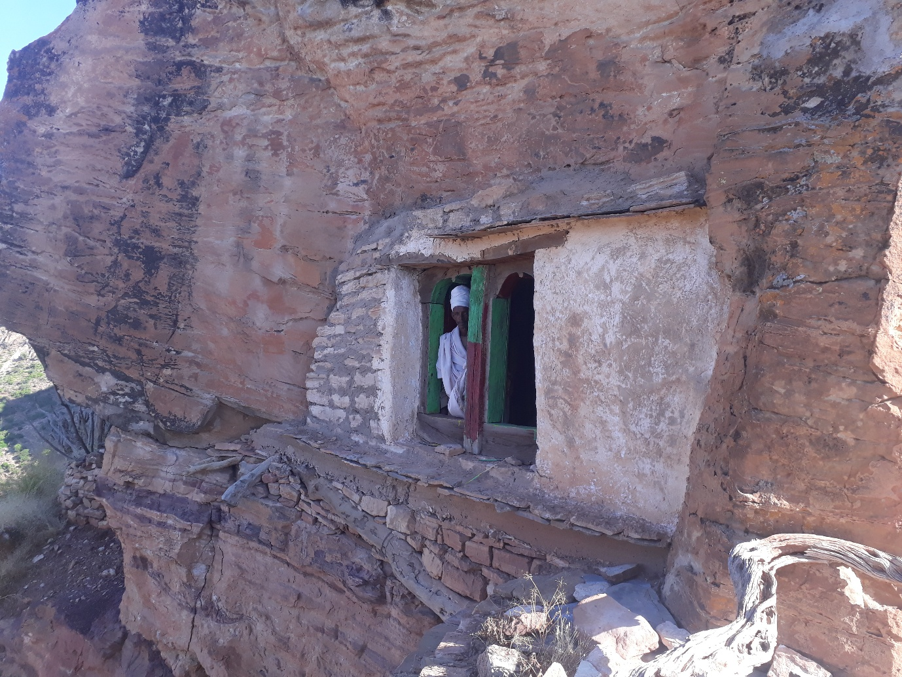
Figure S5. Masonry wall and window at the western side of the rock church. The exposed sandstone around the window and wall is visibly fresher and lighter in colour than the adjacent weathered rock to the left, indicating more recent exposure of this surface. Photograph by Jan Nyssen, 2019.
If such a collapse occurred, its sudden and visually striking nature may have contributed to its attribution to lightning, a common explanation in oral traditions for abrupt landscape changes and unusual geomorphic features. At present, however, no independent dating evidence exists to determine when this modification occurred. Although the oral tradition attributes the destruction to divine lightning during the occupation of imam Ahmed, the architectural evidence is compatible with a natural collapse of the sandstone pinnacle, possibly influenced by stress redistribution following excavation of the church itself, after which the damaged western end was repaired by constructing the present masonry wall. The case illustrates how architectural remains, geomorphological processes, and religious narratives interact in shaping the historical memory of sacred landscapes.

S4. Caves, tunnels, and caverns
Natural and artificial underground spaces, including caves, tunnels, and rock caverns, illustrate particularly well the interaction between geology, religion, and human ingenuity in Tigray. From a geotourism perspective, they are prime attractions due to their geomorphology, historical significance, and evidence of long-term human adaptation. Sites such as the Zeyi cave, extending 364 m, have long served as centres of spiritual practice, and are believed to reflect the Christian appropriation of earlier sacred spaces (Kaplan 1984; Phillipson 2009). Other examples, such as the 60 m Siqurto foot tunnel, illustrate remarkable engineering skills: local artisans excavated the tunnel simultaneously from opposite ends, missing each other by only 3 m, despite the absence of modern surveying equipment (Figure S6). The tunnel gives access to farmland and formerly shortened the walking distance between Adigrat and Nebelet by 8.8 km (Nyssen et al. 2020a).
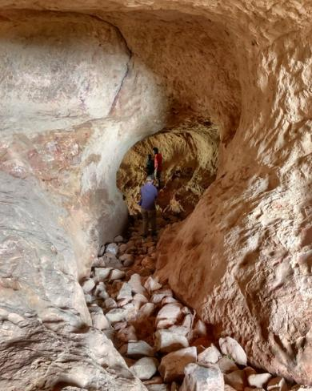
Figure S6. Siqurto foot tunnel through a ridge at Gobo Doguʿat, showing chisel marks and internal structure. The bottom of the tunnel, hewn in relatively soft Adigrat Sandstone, has been deeply incised by the steps of generations of people and livestock; after which the incision was filled up with large stones to make walking easier. Photograph © Greg & Mandy Chase (Explorer Genes), reproduced with permission.

These sites are particularly attractive to geotourists because they reveal both the geological history of the landscape (through exposed rock types, stratigraphy, and structural features) and centuries of human interaction with it. They demonstrate how natural landforms have been adapted for religious, domestic, and agricultural purposes, creating landscapes in which geological and cultural heritage are closely intertwined. Their continued excavation and use (Figure S7) indicate that rock-hewing remains a living tradition in Tigray (Gervers and Philipp 2015-2026; Lamesa et al. 2022).

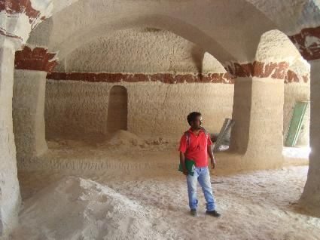
Figure S7. Newly excavated rock-hewn church (Medhane ʿAlem) in a pinnacle of Mt. Werqamba (Philipp 2017). The excavation highlights contrasts in rock colour reflecting the local stratigraphy, particularly visible at the level of the column capitals with bracket-type forms. Similar recent excavation activities are reported elsewhere in the region; in some cases, parts of smaller, older rock-hewn churches are removed or modified during the process. A major factor driving such excavations is economic: carving a church into suitable rock is often significantly less costly than constructing a building of comparable size using modern materials (Gervers and Philipp 2015-2026). Photograph by Jan Nyssen, 2016.

S5. Landscape features in local oral traditions
The natural environment provides many elements of local myths and oral traditions in Doguʿa Tembien. Rocks, landforms, water, vegetation, animals and agricultural practices feature prominently in stories transmitted between generations (Figure S8). Here we present several examples in which natural features are associated with narratives of religious events, extraordinary people, weather phenomena, or other events in local history (after Gebreselassie and Lanckriet 2019).
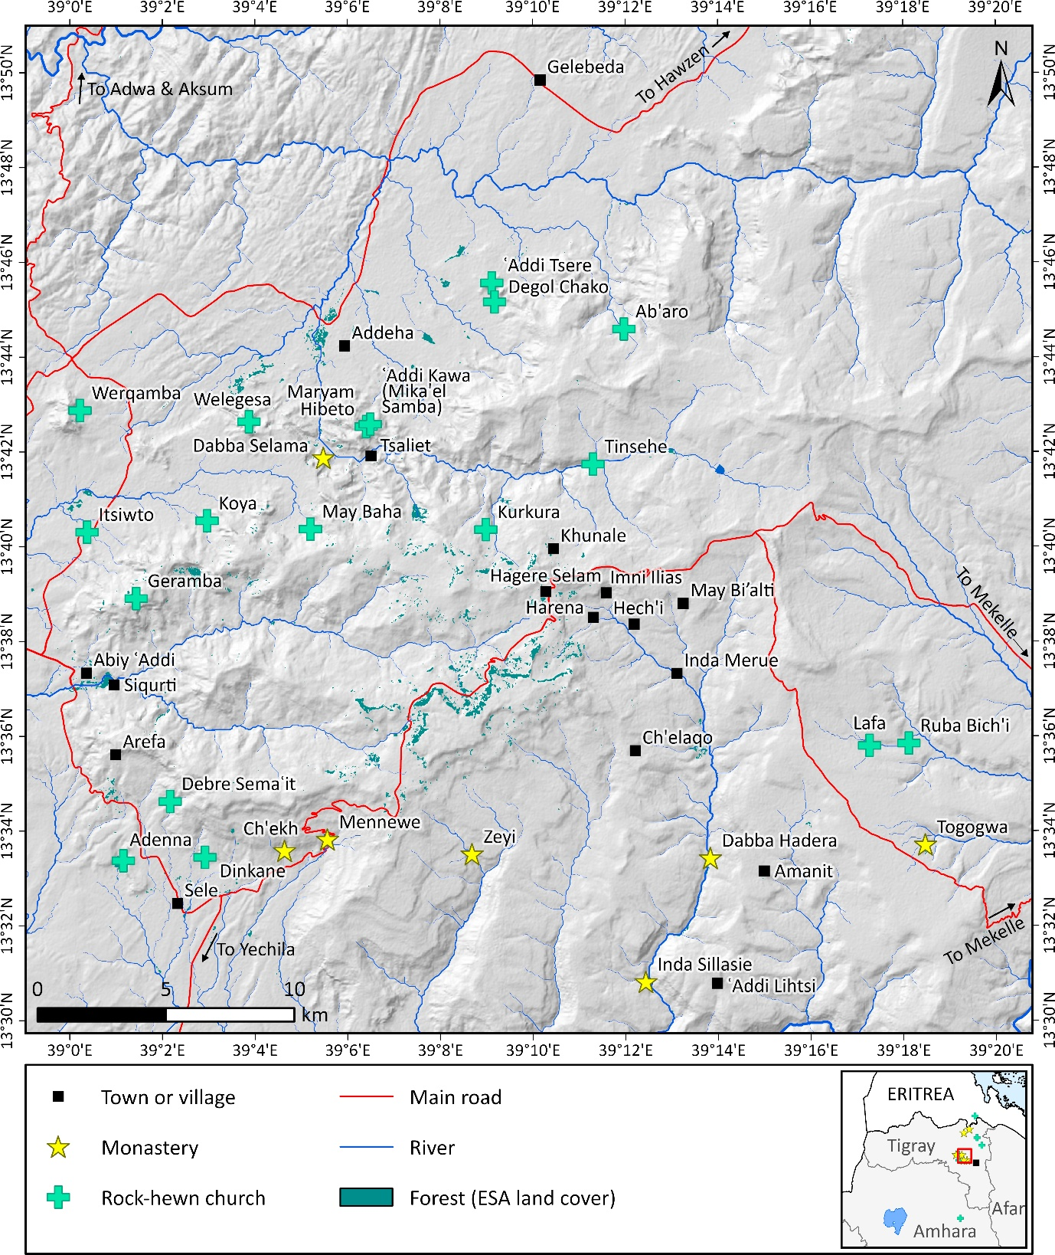
Figure S8. Map of the memory landscape of Dogu’a Tembien, showing rock churches, monasteries, and locations mentioned in local oral traditions. Topography is represented by shaded relief.
S5.1. The wedding procession turned to stone
According to local tradition, a wedding procession once travelled from the village of Amanit Gudeli to Khunale, passing through the village of Hech’i on its return journey. A church, Inda-Zegelil Mika’el Gonad, stood near the route. The wedding party passed the church without praying or paying respect to Saint Mika’el Gonad, continuing to dance and play music.
Saint Mika’el Gonad became angry and, according to the story, instantly turned the entire procession to stone. The people, the bride and her horse, their ornaments, and the equipment they carried were all petrified. The place is still called Inda Merue, meaning “marriage ceremony” (Figs. S8, S9).
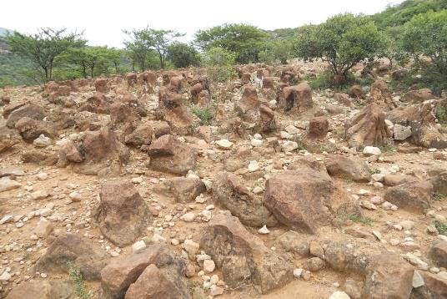
Figure S9. Inda Merue, locally associated with the petrified wedding procession. Photograph by Seifu Gebreselassie, September 2017.
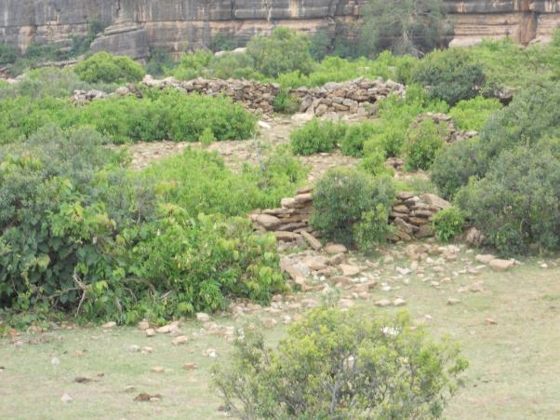
Figure S10. The location of the former church of Mika’el Gonad near Hech’i. Photograph by Seifu Gebreselassie, September 2017.
One elderly man who had followed the procession was praying as he entered Hech’i and was therefore spared. Because he was too old to walk, he was riding a horse. His presence is said to be commemorated by a horse-foot-shaped imprint in the landscape, known as Mergatsi Feres, meaning “horse stepping” (Figure S11).
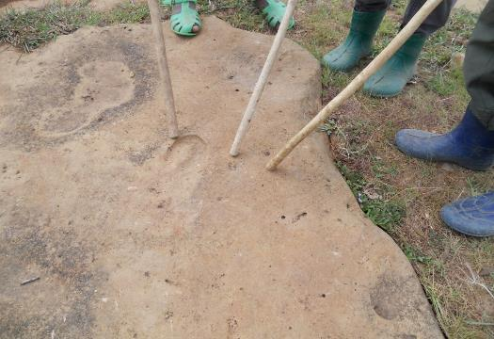
Figure S11. Mergatsi Feres (“horse stepping”), the horse-foot-shaped feature associated with the wedding procession story. Photograph by Seifu Gebreselassie, September 2017.
When the old man reached Hech’i, he told the villagers what had happened. The inhabitants became concerned and asked the church leaders to bring the Tabot Mika’el, the Ark of Saint Michael, to appease Mika’el Gonad. The Ark was subsequently sent to Dabba Hadera, further down the valley, where the site became associated with holy water. The holy water continues to be used in religious and healing ceremonies.
The rock formations at Inda Merue are developed in limestone and are interpreted geomorphologically as lapiez, a karst landform produced by the dissolution of limestone by rainwater along joints and other fractures (Dramis and Fubelli 2019). The resulting fissures isolate slabs of limestone, producing forms that are locally interpreted through the story of the petrified wedding procession.

S5.2. Lightning and thunder
According to local traditions, lightning and thunder occur when God is disappointed or angry with human behaviour. If God is merely disappointed because people have committed too many mistakes or errors, lightning may occur. The fire associated with lightning is believed to produce large gullies. In this interpretation, the effects of lightning are restricted to the Earth's surface and do not penetrate the underlying rocks.
Thunder indicates a greater degree of divine anger. It may occur when people work on religious holidays, act jealously, steal, or otherwise seriously transgress accepted behaviour. The trembling associated with God's anger is believed to enter the Earth, causing rocks to burst and potentially triggering landslides.

S5.3. Gemsa or miguemas: an agricultural story
According to local tradition, a farmer in May Bi’alti once cultivated sorghum. One year, the crop developed poorly and the farmer expected no harvest. He therefore brought his oxen to plough across the wilting crop in preparation for planting another crop. When he returned several days later to sow the new crop, he was surprised to find that the sorghum had recovered and was growing well. After he told his neighbours what had happened, the practice was adopted more widely, both in the village and well beyond.
The resulting tillage technique is known locally as gemsa or miguemas. It involves ploughing across standing crop during the azmera rainy season, creating broad, shallow furrows (Figure S12). The technique is used particularly for maize, sorghum and finger millet and, according to local farmers, the technique helps conserve soil moisture, suppress weeds and thin the crop (Nyssen et al. 2011). The ploughing also cuts part of the existing root system; root pruning is known from agronomic studies to modify subsequent root and shoot growth in sorghum and other crops (Blum et al. 1977; Geisler and Ferree 1984).
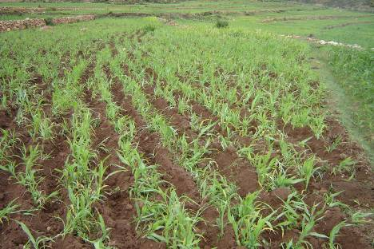
Figure S12. Miguemas ploughing technique for sorghum in Harena, showing the broad, shallow furrows left after ploughing (after Nyssen et al. 2011).

S5.4. The rock of Imni Ilias
Imni Ilias, situated between the villages of Harena and Hech’i, is a large isolated rock associated with the story of a man named Ilias. According to local tradition, Ilias possessed extraordinary strength and could move enormous stones without assistance.
Ilias selected a large stone in the lowlands of Kolla Tembien, near Tsaliet village close to Addeha, and carried it towards Hech’i, where he intended to use it in constructing a church. When he reached the vicinity of Harena, local farmers told him that his effort was unnecessary because the church there had already been completed. Angry that his efforts had been in vain, Ilias threw down the stone and died. The rock subsequently became known as Imni Ilias, in recognition of his exceptional strength. It remains at the site today (Figure S13).
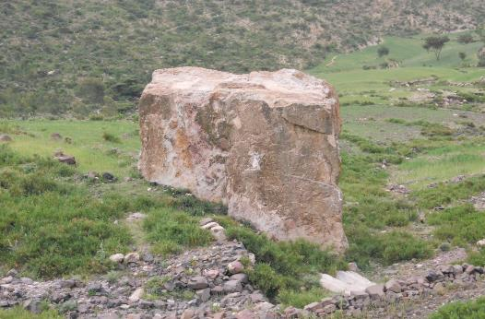
Figure S13. The large rock of Imni Ilias between Harena and Hech’i. Photograph by Seifu Gebreselassie, September 2017.
The rock belongs geologically to the Amba Aradam Sandstone formation and is located below the sandstone cliff, approximately 100 m higher up. Its present position in the Antalo Limestone terrain of Harena is interpreted as the result of rockfall from the overlying sandstone cliff. Rockfall is a widespread geomorphological process along the steep Amba Aradam Sandstone escarpment, although most individual blocks are considerably smaller than Imni Ilias (Nyssen et al. 2006).

S5.5. The serpent and the linear vegetation feature near Ch’elaqo
According to local tradition, a large snake was born at Siqurti near Abiy ʿAddi. The snake developed a language through which she could communicate with her human twin sister, Nigste Saba. Initially the snake lived on milk, but as she grew she began to eat meat and cattle. Each day she consumed an ox, which the local community was required to provide as a form of tribute. Failure to provide the required cattle was believed to put the entire village at risk.
The community appealed to the snake's sister, but Nigste Saba protected her because the snake had given her power as deputy chief of the village. Eventually the people could no longer provide enough cattle and asked Nigste Saba to kill her sister. In return, they promised to make her queen. Nigste Saba eventually agreed. She ordered the snake to leave the village and seek another place to live, and the two sisters travelled together through the Mika’el Abiy area, including Ch’elaqo. According to the story, wherever the snake passed or rested, vegetation grew, and local farmers continue to avoid cutting these shrubs. A remarkably straight line of shrubs is particularly conspicuous near Ch’elaqo (Figure S14).
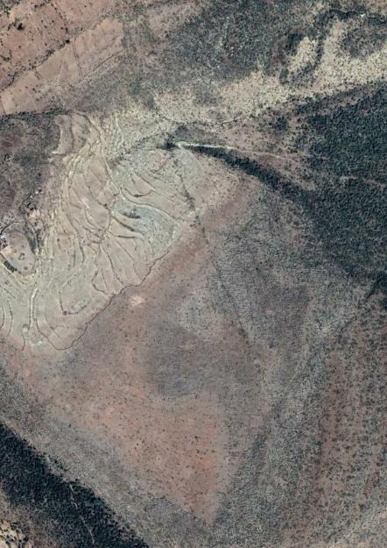
Figure S14. The kilometre-long linear vegetation pattern associated with the serpent myth near Ch’elaqo (Google Earth Imagery, 2018)
The snake and her sister eventually reached Kolla Tembien, where local people had prepared a large fire near Gelebeda. Nigste Saba lured the snake towards the fire, and the people burned her to death. Sparks from the burning snake fell on Nigste Saba's foot, transforming it into a donkey hoof. The people subsequently failed to honour their promise to make Nigste Saba queen. She began constructing a grave monument over the body of her sister. According to the story, the weight of the stones caused a sudden movement of the ground, frightening the people, who finally accepted her as their Queen of Sheba. Later, a merchant persuaded Nigste Saba to travel to Israel to seek medical treatment from King Solomon for her damaged foot. Guards initially refused her entry because they had never seen a woman with a donkey's foot. As she approached the entrance to the throne hall, however, her foot suddenly returned to normal. King Solomon was astonished by her beauty, and she became pregnant during her stay. On returning to Tigray, she consolidated her position as queen.
Traditions concerning the Queen of Sheba occur at several locations in Ethiopia. One tradition places her birthplace at Arefa, south of Siqurti, a remote berekha area on steep slopes overlooking Abiy ʿAddi near the boundary between Doguʿa Tembien and Kolla Tembien. A tourist signboard in Abiy ʿAddi also identifies Arefa with the Queen of Sheba tradition.
Variants of this narrative, generally interpreted as reflecting the cult of Arwe, the pre-Christian Serpent King (Manzo 2014; Smidt 2025) appear throughout Tigray and other parts of Ethiopia, such as near Aksum and near Wuqro, where large rock outcrops are perceived as remnants from the time of the Serpent King. These traditions suggest pre-Christian beliefs later incorporated into Christian tradition (Finneran 2012; Smidt 2025). Comparable associations between geological features and serpent deities occur outside the Ethiopian Orthodox cultural sphere. Among the Gumuz of Western Ethiopia, for example, a mafic dyke is associated with the “Serpent-God” (Mège and Korme 2004).
The linear feature near Ch’elaqo follows a structural lineament and extends for approximately one kilometre. Its conspicuous vegetation alignment is visible in satellite imagery and remains associated locally with the route taken by the snake.

S5.6. May Hib’o: a place named for water
May Hib’o, near ʿAddi Lihtsi, lies in a catchment whose upper part is relatively level and largely cultivated. From the surrounding slopes, distinctively green vegetation follows the drainage lines, suggesting groundwater emergence. A community pond stores surface water, while the geological structure and regional dip appear to favour groundwater concentration in the area. Further downslope, a cattle track leads through bushland towards a gorge. A dusty open area serves as a standing place for cattle waiting to drink. Water-loving grasses and lime concretions occur on the surrounding cliffs.
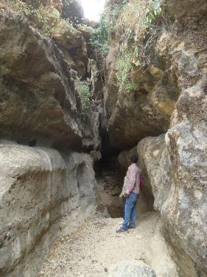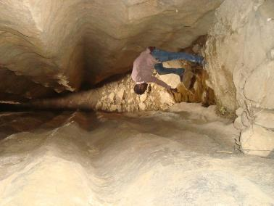
Figure S15. May Hib’o cave: cattle drinking place at the entrance (left) and clear water in the cave (right). Photographs by Jan Nyssen, 8 November 2016.
Beyond the cattle pond lies a cave following a joint or fracture in the bedrock (Figure S15). The cave is approximately 35 m long, 3 m wide and 8 m high. Clear standing water occurs at its far end. Part of the water derives from rainfall infiltrating through wide openings in the rock, while its persistence suggests a connection with groundwater and springs. Cattle drink at the pond near the cave entrance, whereas people use the clearer water inside the cave. When the cattle pond contains abundant water, however, it can block access to the cave.

S6. Inda Abba Selama pilgrimage of 2021
Inda Abba Selama, commonly shortened locally to Dabba Selama, is a remote monastery in Doguʿa Tembien traditionally associated with Saint Frumentius (Abba Selama), who is regarded in Ethiopian tradition as the first bishop of Ethiopia. The monastery occupies an isolated flat-topped mesa of Adigrat Sandstone, a prominent residual landform rising above the deeply dissected surrounding landscape. Steep sandstone cliffs and rugged terrain extend around and below the mesa. Its exceptional physical isolation has long attracted the attention of researchers and visitors. Ruth Plant and David Buxton documented the rock-hewn churches of Tigray in the early 1970s, while later surveys described Dabba Selama as one of the most difficult religious sites in the region to access (Nyssen 2019; Plant 1985; Plant and Buxton 1970). The monastery itself incorporates a rock-hewn church carved into the Adigrat Sandstone. The church has an approximately basilical arrangement, with four bays, a recess, unusually rounded pillars that expand towards their ends, and distinctive arches (Gerster 1972).
The monastery is also a major pilgrimage destination. The annual pilgrimage takes place on Hamle 26 and attracts large numbers of worshippers from the surrounding area and beyond (Nyssen et al. 2016). The final approach is made on foot across rugged terrain, followed by a descent and traverse over narrow ledges and a steep ascent to the monastery. The physical difficulty of the route is therefore an integral part of the experience of visiting the monastery. Women are traditionally not permitted to make the final ascent or enter the monastery and church; consequently, many pilgrims remain on the adjacent sandstone plateau while a smaller proportion continue towards the monastery itself (Nyssen 2019).
The photographs in Figures S16-S22 document the pilgrimage of Hamle 26, 2013 Ethiopian Calendar (2 August 2021), showing both the scale of the gathering and the extraordinary topographic setting of the monastery. They also illustrate the way in which religious practice is spatially organised by the geology and geomorphology of the site. Pilgrims gather and pray on the larger sandstone plateau, while access to the monastery is concentrated along a narrow ledge and a steep ascent to the smaller mesa. Gifts and animals brought for the monks form part of the pilgrimage activities. The absence of roads or vehicle access means that pilgrims approach the site on foot over the final dozen kilometres.
Dabba Selama's isolation has also been important in more recent history. The surrounding community was able to maintain a relatively strong degree of social cohesion and, during the Tigray War (2020–2022), its difficult access and rugged terrain contributed to the community's relative protection from some of the destruction experienced elsewhere in Tigray (Nyssen et al. 2023a, b). The monastery and its surrounding landscape thus combine geological, religious, historical and social values, making Dabba Selama a particularly striking example of the memory landscape discussed in this paper.
Photos: courtesy of Tigray Culture and Tourism Bureau, reproduced with permission.
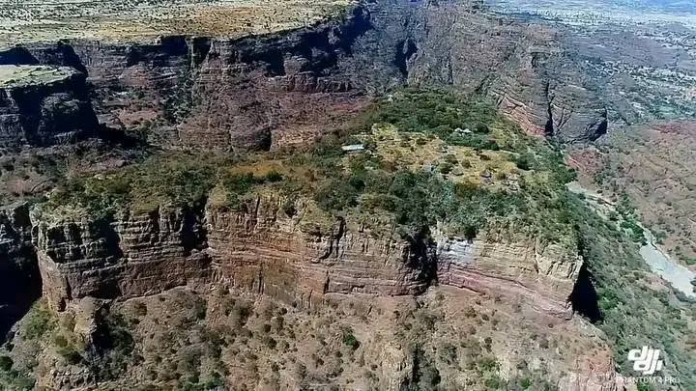
Figure S16. Drone view of the mesa occupied by Dabba Selama monastery, showing its isolated position within the rugged sandstone landscape of Doguʿa Tembien. The smaller mesa at left is inoccupied and not commonly accessed. At right, the Tsaliet River in its deep gorge. The difficult access to the monastery is a defining characteristic of the site (Nyssen 2019; Nyssen et al. 2023a). Photograph courtesy of the Tigray Culture and Tourism Bureau. Reproduced with permission.

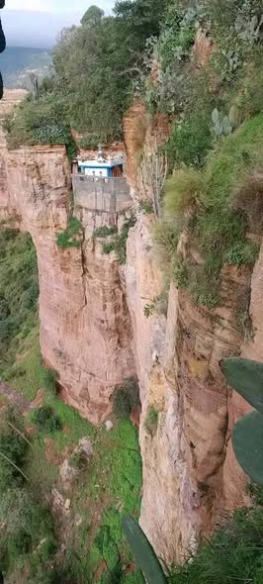

Figure S17. Partial view of the Dabba Selama mesa, showing the steep sandstone cliffs and the isolated position of the monastery. The rugged geomorphology of the Adigrat Sandstone contributes strongly to the site's physical inaccessibility and its distinctive sacred character. Photograph courtesy of the Tigray Culture and Tourism Bureau. Reproduced with permission.
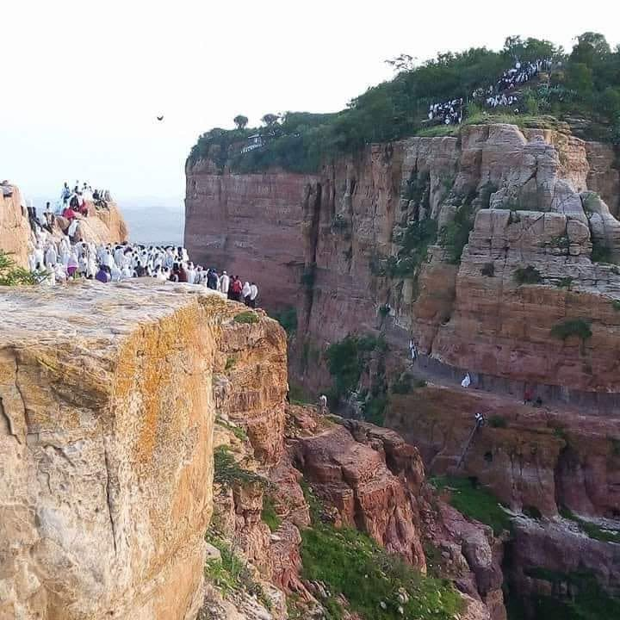
Figure S18. Pilgrims praying during the 2021 pilgrimage. One group is gathered on the main sandstone plateau, while another is on the smaller mesa occupied by the monastery. The narrow access ledge connecting the two parts of the site is visible. The spatial distribution of the pilgrims reflects both the religious organisation of the site and its exceptionally difficult topography. Photograph courtesy of the Tigray Culture and Tourism Bureau. Reproduced with permission.
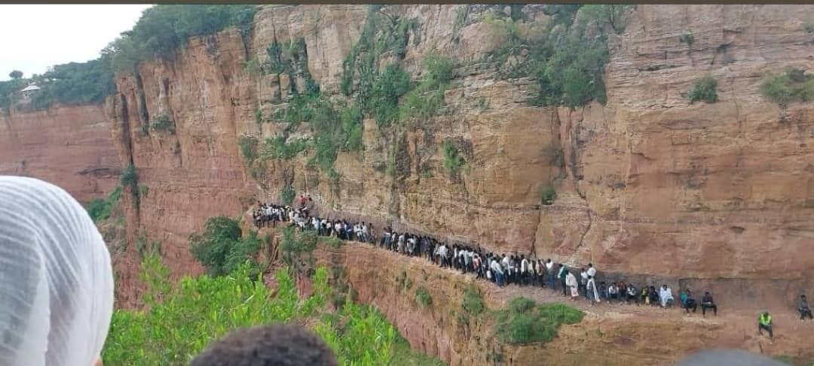
Figure S19. Pilgrims queuing for the ascent to Dabba Selama monastery. The climb is physically demanding, and goats and other offerings brought for the monks are carried upwards alongside the pilgrims. The steep and exposed ascent has long contributed to the reputation of Dabba Selama as one of Ethiopia's most difficult-to-access monasteries. Photograph courtesy of the Tigray Culture and Tourism Bureau. Reproduced with permission.
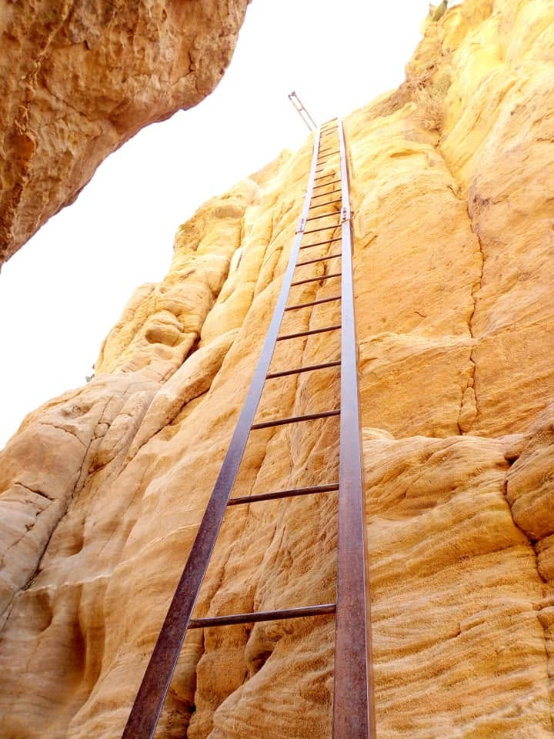
Figure S20. Section of the ascent to Dabba Selama monastery using a metal ladder. The ladder provides access across one of the steepest sections of the route. Local accounts associate its installation with the period of Italian occupation in the 1930s. Photograph courtesy of the Tigray Culture and Tourism Bureau. Reproduced with permission.
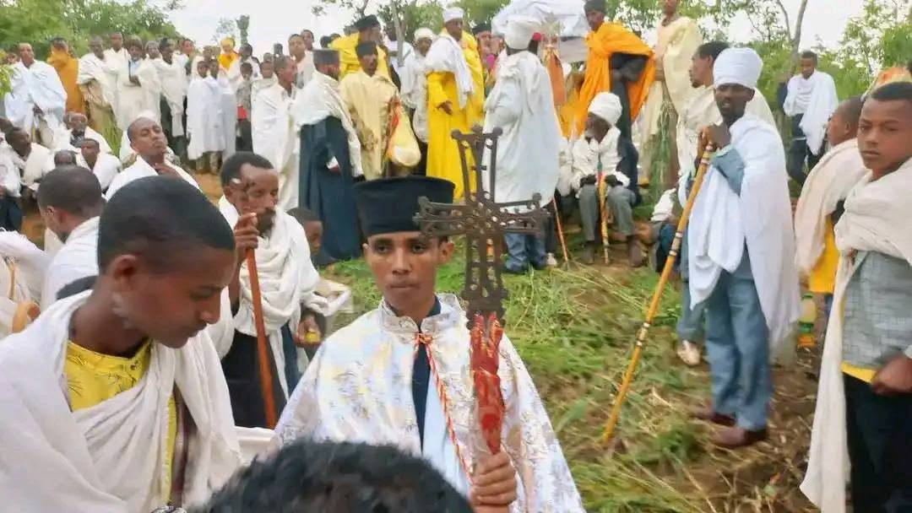
Figure S21. Pilgrims arriving at Dabba Selama monastery and gathering with monks, priests and deacons. Women are traditionally not permitted to make the final ascent or visit the monastery and church; many therefore remain on the adjacent plateau. Photograph courtesy of the Tigray Culture and Tourism Bureau. Reproduced with permission.
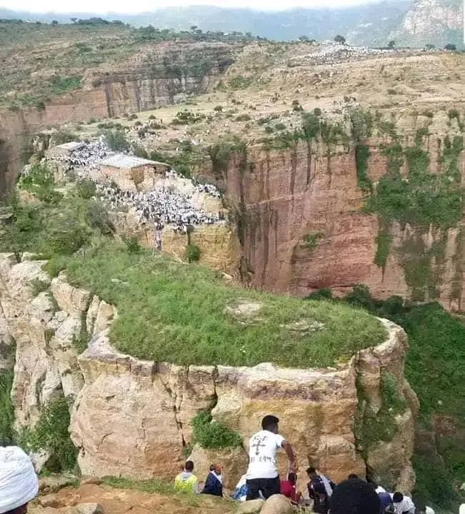
Figure S22. View back from the edge of the monastery mesa towards the intermediate sandstone mesa and the larger plateau where many pilgrims remain during the pilgrimage. The narrow access ledge continues around the rear of the intermediate mesa. The absence of roads or vehicles illustrates the remoteness of the monastery; pilgrims reach the site on foot over rugged terrain, walking the final several kilometres. The photograph also illustrates the spatial separation between those who ascend to the monastery and the much larger number of pilgrims who remain on the accessible plateau. Photograph courtesy of the Tigray Culture and Tourism Bureau. Reproduced with permission.

S7. Culturally appropriate iconography for interpretation at sacred geosites
The discussions at Debre Semaʿit Yohannis indicated that local expectations for future signage include a representation of the site's patron saint, John the Apostle. No representation of Saint John is currently known at Debre Semaʿit itself. Authentic examples of Tigrayan Orthodox iconography are, however, preserved in historic church manuscripts. Figure S23 shows a representation of Saint John the Apostle in a manuscript preserved at Abune Abiyegzi monastery at Debre Medhanit. Such imagery could provide a culturally appropriate reference for future interpretive material at Debre Semaʿit, rather than relying on generic religious illustrations.
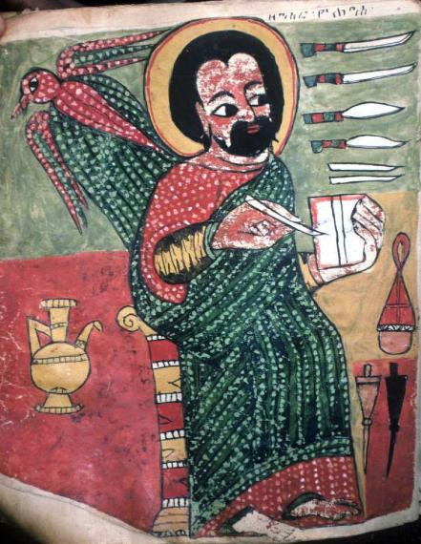
Figure S23. Saint John the Apostle in a manuscript preserved at Abune Abiyegzi monastery, Debre Medhanit. Example of authentic Tigrayan Orthodox iconography that could inform interpretive material at Debre Semaʿit Yohannis. Photograph: Michael Gervers, 2006.

References
Alene M, Jenkin G, Leng M, Darbyshire DP (2006) The Tambien Group, Ethiopia: An early Cryogenian (ca. 800–735Ma) Neoproterozoic sequence in the Arabian–Nubian Shield. Precambrian Research 147:79-99. doi:10.1016/j.precamres.2006.02.002
Beyth M (1972) Paleozoic–Mesozoic sedimentary basin of Makalle outlier. Am Assoc Pet Geol Bull 56:2426-2439
Blanford WT (1870) Observations on the Geology and Zoology of Abyssinia Made during the Progress of the British Expedition to that Country in 1867-68. Macmillan and Company,
Blum A, Arkin GF, Jordan WR (1977) Sorghum root morphogenesis and growth. I. Effect of maturity genes. Crop Science 17:149-153. doi:10.2135/cropsci1977.0011183X001700010039x
Bosellini A, Russo A, Fantozzi PL, Getaneh A, Solomon T (1997) The Mesozoic succession of the Mekele outlier (Tigre Province, Ethiopia). Memorie di Scienze Geologiche 49:95-116
Bussert R (2010) Exhumed erosional landforms of the Late Palaeozoic glaciation in northern Ethiopia: Indicators of ice-flow direction, palaeolandscape and regional ice dynamics. Gondwana Research 18 (2-3):356-369. doi:10.1016/j.gr.2009.10.009
Bussert R, Nyssen J (2019) Rock-Hewn Sandstone Churches and Man-Made Caves in and Around Dogu’a Tembien. In: Nyssen J, Jacob M, Frankl A (eds) Geo-trekking in Ethiopia’s Tropical Mountains. GeoGuide. Springer, Cham (CH), pp 121-137. doi:10.1007/978-3-030-04955-3_8
Causer D (1962) A cave in Ethiopia. Wessex Cave Club Journal 7 (86):91-94
Chaillot C (2002) The Ethiopian Orthodox Tewahedo Church tradition: a brief introduction to its life and spirituality. Inter-Orthodox Dialogue,
Dramis F, Fubelli G (2019) Limestone, karst and tufa dams in the western part of the Mekelle Outlier. In: Nyssen J, Jacob M, Frankl A (eds) Geo-Trekking in Ethiopia’s Tropical Mountains, the Dogu’a Tembien District, vol 1. Springer GeoGuides. Springer Nature, Heidelberg, Germany, pp 107-119. doi:10.1007/978-3-030-04955-3_7
Finneran N (2012) Hermits, saints, and snakes: the archaeology of the early Ethiopian monastery in wider context. The International Journal of African Historical Studies 45 (2):247-271
Gebreselassie S, Lanckriet S (2019) Local myths in relation to the natural environment of Dogu’a Tembien. In: Nyssen J, Jacob M, Frankl A (eds) Geo-Trekking in Ethiopia’s Tropical Mountains, the Dogu’a Tembien District, vol 1. Springer GeoGuides. Springer Nature, Heidelberg (Germany), pp 519-528. doi:10.1007/978-3-030-04955-3_35
Geisler D, Ferree DC (1984) Response of Plants to Root Pruning. In: Horticultural Reviews. pp 155-188. doi:https://doi.org/10.1002/9781118060797.ch5
Gerster G (1972) Kirchen im Fels; Entdeckungen in Äthiopien. 2nd edn. Atlantis Verlag, Zürich & Freibug im Breisgau
Gervers M, Philipp T (2015-2026) New Rock-Hewn Churches of Ethiopia. Digital research project. Available at: https://www.utsc.utoronto.ca/projects/ethiopic-churches/. University of Toronto. https://www.utsc.utoronto.ca/projects/ethiopic-churches/. Accessed 1/4/2026 2026
Hagos M, Amare K, Koeberl C, Nyssen J (2019) The Volcanic Rock Cover of the Dogu’a Tembien Massif. In: Nyssen J, Jacob M, Frankl A (eds) Geo-trekking in Ethiopia’s Tropical Mountains. GeoGuide. Springer Nature, Cham (CH), pp 139-151. doi:10.1007/978-3-030-04955-3_9
Hagos M, Gebreyohannes T, Amare K, Bushra A, Berhane G, Walraevens K, Koeberl C, van Wyk de Vries B, Cavalazzi B (2020) Tectonic link between the Neoproterozoic dextral shear fabrics and Cenozoic extension structures of the Mekelle basin, Northern Ethiopia. International Journal of Earth Sciences 109:1957-1974. doi:10.1007/s00531-020-01882-0
Kaplan S (1984) The monastic holy man and the Christianization of early Solomonic Ethiopia, vol 73. Studien zur Kulturkunde. Steiner, Wiesbaden
Lamesa A, Atsba H, Saint-Bézar B (2022) Églises rupestres du Tәgray oriental et central. Résultats de prospections et hypothèses techniques et socio-économiques Annales d'Ethiopie 34:245-296. doi:10.3406/ethio.2022.1720
Lepage C, Mercier J (2005) Art éthiopien. Les églises historiques du Tigray. Etudes et Recherche sur les Civilisations, Paris
Manzo A (2014) Snakes and Sacrifices: Tentative Insights into the Pre-Christian Ethiopian Religion. Aethiopica 17:7-24. doi:10.15460/aethiopica.17.1.737
Mège D, Korme T (2004) Dyke swarm emplacement in the Ethiopian Large Igneous Province: not only a matter of stress. Journal of Volcanology and Geothermal Research 132 (4):283-310. doi:10.1016/S0377-0273(03)00318-4
Miller N, Stern B, Avigad D, Beyth M, Schilman B (2009) Cryogenian slate-carbonate sequences of the Tambien Group, Northern Ethiopia (I): Pre-“Sturtian” chemostratigraphy and regional correlations. Precambrian Research 170:129-156. doi:10.1016/j.precamres.2008.12.004
Nyssen J (2019) Description of trekking routes in Dogu’a Tembien. In: Nyssen J, Jacob M, Frankl A (eds) Geo-Trekking in Ethiopia’s Tropical Mountains, the Dogu’a Tembien District, vol 2. Springer GeoGuides. SpringerNature, Cham (CH), pp 557-675. doi:10.1007/978-3-030-04955-3_38
Nyssen J, Gebreslassie S, Assefa R (2016) ካብ ሐረስቶት ደጉዓ ተምቤን እንታይ ንስምዕ? (What do we hear from the farmers in Dogu’a Tembien?) [in Tigrinya]. Hagere Selam, Central Tigray, Ethiopia
Nyssen J, Ghebreyohannes T, Meaza H, Dondeyne S (2020a) Exploration of a medieval African map (Aksum, Ethiopia) – How do historical maps fit with topography? In: De Ryck M, Nyssen J, Van Acker K, Van Roy W (eds) Liber Amicorum: Philippe De Maeyer In Kaart. University Press, Wachtebeke (Belgium), pp 165-178
Nyssen J, Govaerts B, Tesfay Araya, Cornelis WM, Bauer H, Mitiku Haile, Sayre K, Deckers J (2011) The use of the marasha ard plough for conservation agriculture in Northern Ethiopia. Agron Sustain Dev 31 (2):287-297. doi:10.1051/agro/2010014
Nyssen J, Hailemariam Meaza, Annys S, Emnet Negash, Biadgilgn Demissie, Zbelo Tesfamariam, Tesfaalem Ghebreyohannes (2023a) Ethiopia: how a lucky village in Tigray survived the devastating war. The Conversation. doi:10.64628/AAJ.ape57cm6e
Nyssen J, Hailemariam Meaza, Annys S, Emnet Negash, Biadgilgn Demissie, Zbelo Tesfamariam, Tesfaalem Ghebreyohannes (2023b) How did the community surrounding the Horn’s oldest monastery survive the Tigray War? - Dabba Selama revisited. Reinventing Peace. World Peace Foundation (Tufts University), Somerville, MA, USA
Nyssen J, Poesen J, Moeyersons J, Deckers J, Mitiku Haile (2006) Processes and rates of rock fragment displacement on cliffs and scree slopes in an amba landscape, Ethiopia. Geomorphology 81 (3-4):265-275. doi:10.1016/j.geomorph.2006.04.021
Nyssen J, Yonas M, Annys S, Ghebreyohannes T, Smidt W, Welegerima K, Gebreselassie S, Sembroni A, Dramis F, Ek C (2020b) The Zeyi cave geosite in northern Ethiopia. Geoheritage 12:1-15. doi:10.1007/s12371-020-00446-7
Philipp T (2017) Medhane Alem Warq Amba (Tämben Region). https://www.utsc.utoronto.ca/projects/ethiopic-churches/medhane-alem-warq/. Accessed 1/4/2026 2026
Phillipson DW (2009) Ancient churches of Ethiopia: Fourth-fourteenth centuries. Yale University Press,
Plant R (1985) Architecture of the Tigre, Ethiopia. Ravens Educational and Development Services,
Plant R, Buxton D (1970) Rock-hewn churches of the Tigre province. Ethiopia Observer 13 (3):159-267
Salvador A (1994) International stratigraphic guide-a guide to stratigraphic classification, terminology, and procedure, vol 214. Geological Society of America Special Paper. International Union of Geological Sciences and Geological Society of America, Boulder, USA
Smidt W (2025) Local traditions and practices in Tigray related to spirits and snakes – Steps towards a reconstruction of pre-Christian belief systems in Aksumite times and before. In: Stein P, Jeschke J, Gerbothe T (eds) Tempel - Ritus - Kult im Antiken Orient. Forschungssymposion zu Ehren von Norbert Nebes. Sabaica et Æthiopica, vol 2. Harrassowitz Wiesbaden, pp 247-280
U T Scarborough Library (n.d.) Gunda Gunde Manuscript Collection. https://gundagunde.digital.utsc.utoronto.ca/. Digital Scholarship Unit, University of Toronto Scarborough,
Ukstins IA, Renne PR, Wolfenden E, Baker J, Ayalew D, Menzies M (2002) Matching conjugate volcanic rifted margins: 40Ar/39Ar chrono-stratigraphy of pre- and syn-rift bimodal flood volcanism in Ethiopia and Yemen. Earth and Planetary Science Letters 198 (3):289-306. doi:10.1016/S0012-821X(02)00525-3

