Appendix
Supplementary Figs. S1–S9
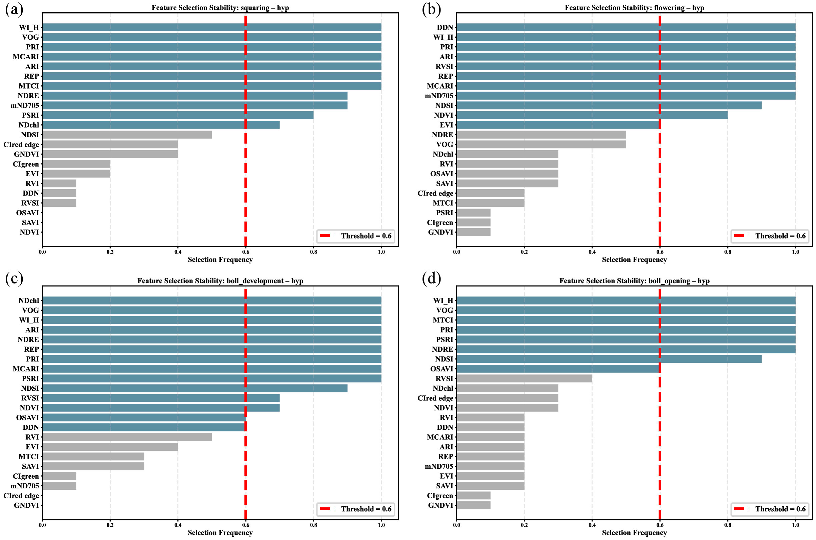
Fig. S1. RFECV-based robust feature-selection results. (a–d) Feature-selection stability for hyperspectral features at squaring, flowering, boll development, and boll opening, respectively. Blue bars indicate features with selection frequencies above the stability threshold of 0.6; grey bars indicate features below the threshold.
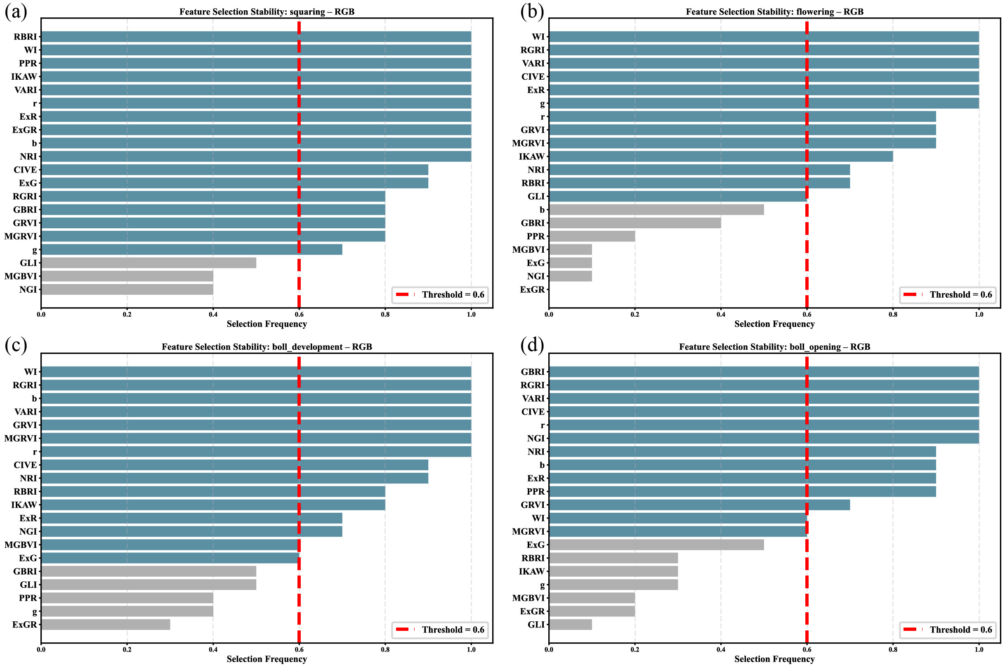
Fig. S2. RFECV-based robust feature-selection results. (a–d) Feature-selection stability for RGB features at squaring, flowering, boll development, and boll opening, respectively. Blue bars indicate features with selection frequencies above the stability threshold of 0.6; grey bars indicate features below the threshold.
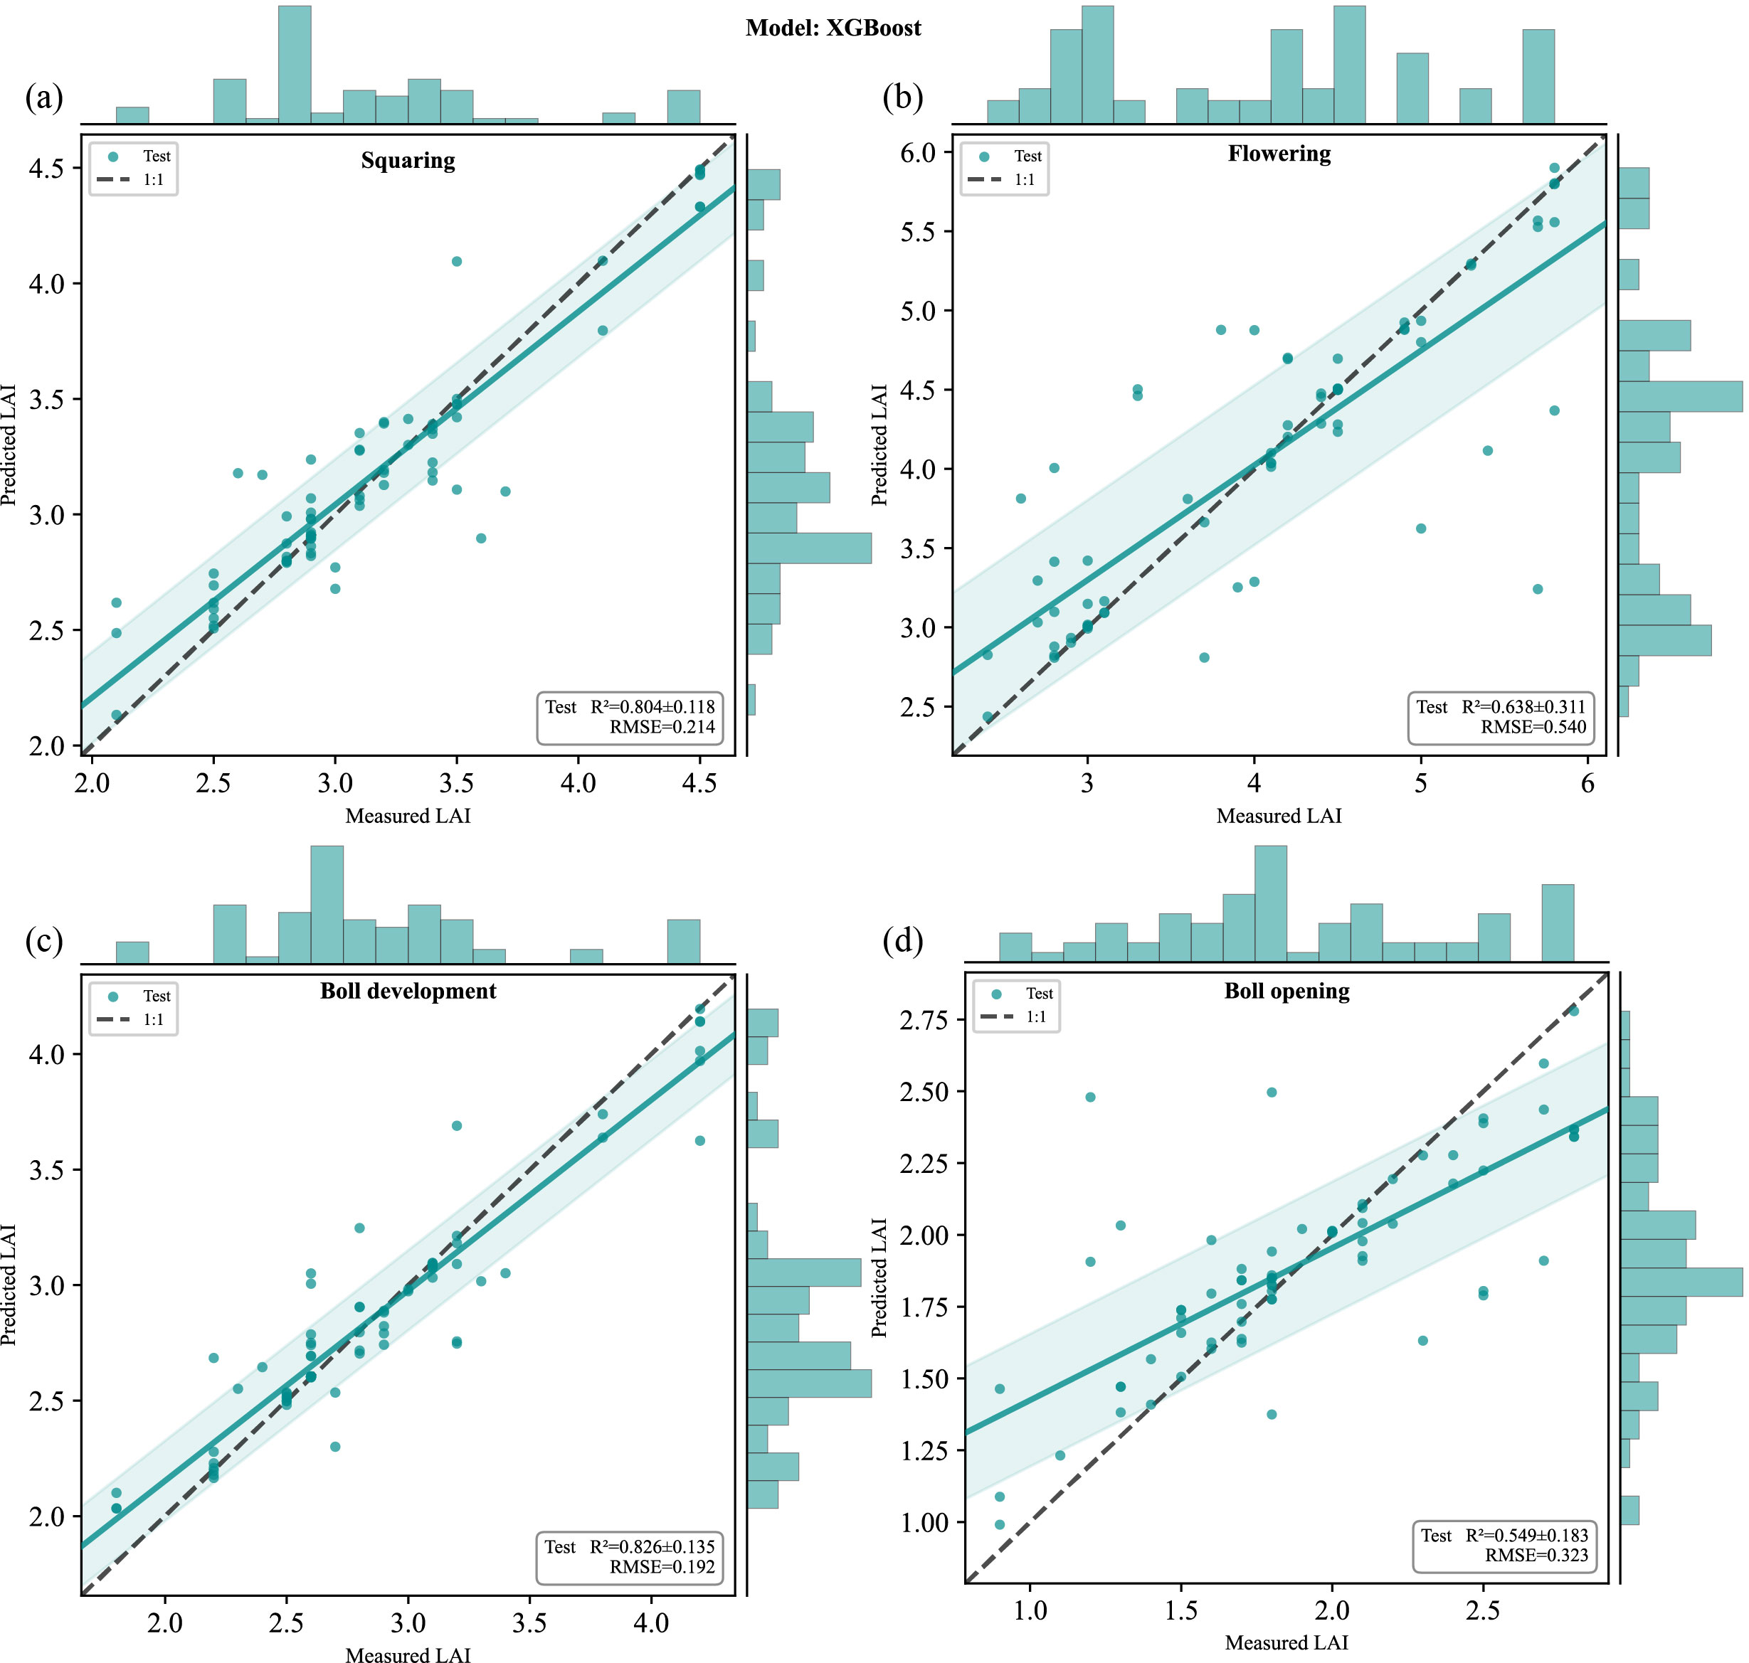
Fig. S3. Predicted-versus-observed 1:1 scatterplots for XGBoost using fused features: (a) squaring, (b) flowering, (c) boll development, and (d) boll opening. Each panel pools test-set predictions from all five folds, with marginal histograms along the top and right axes. The dashed black line is the 1:1 reference. Insets report the mean ± SD of fold-specific R² values and the mean RMSE.
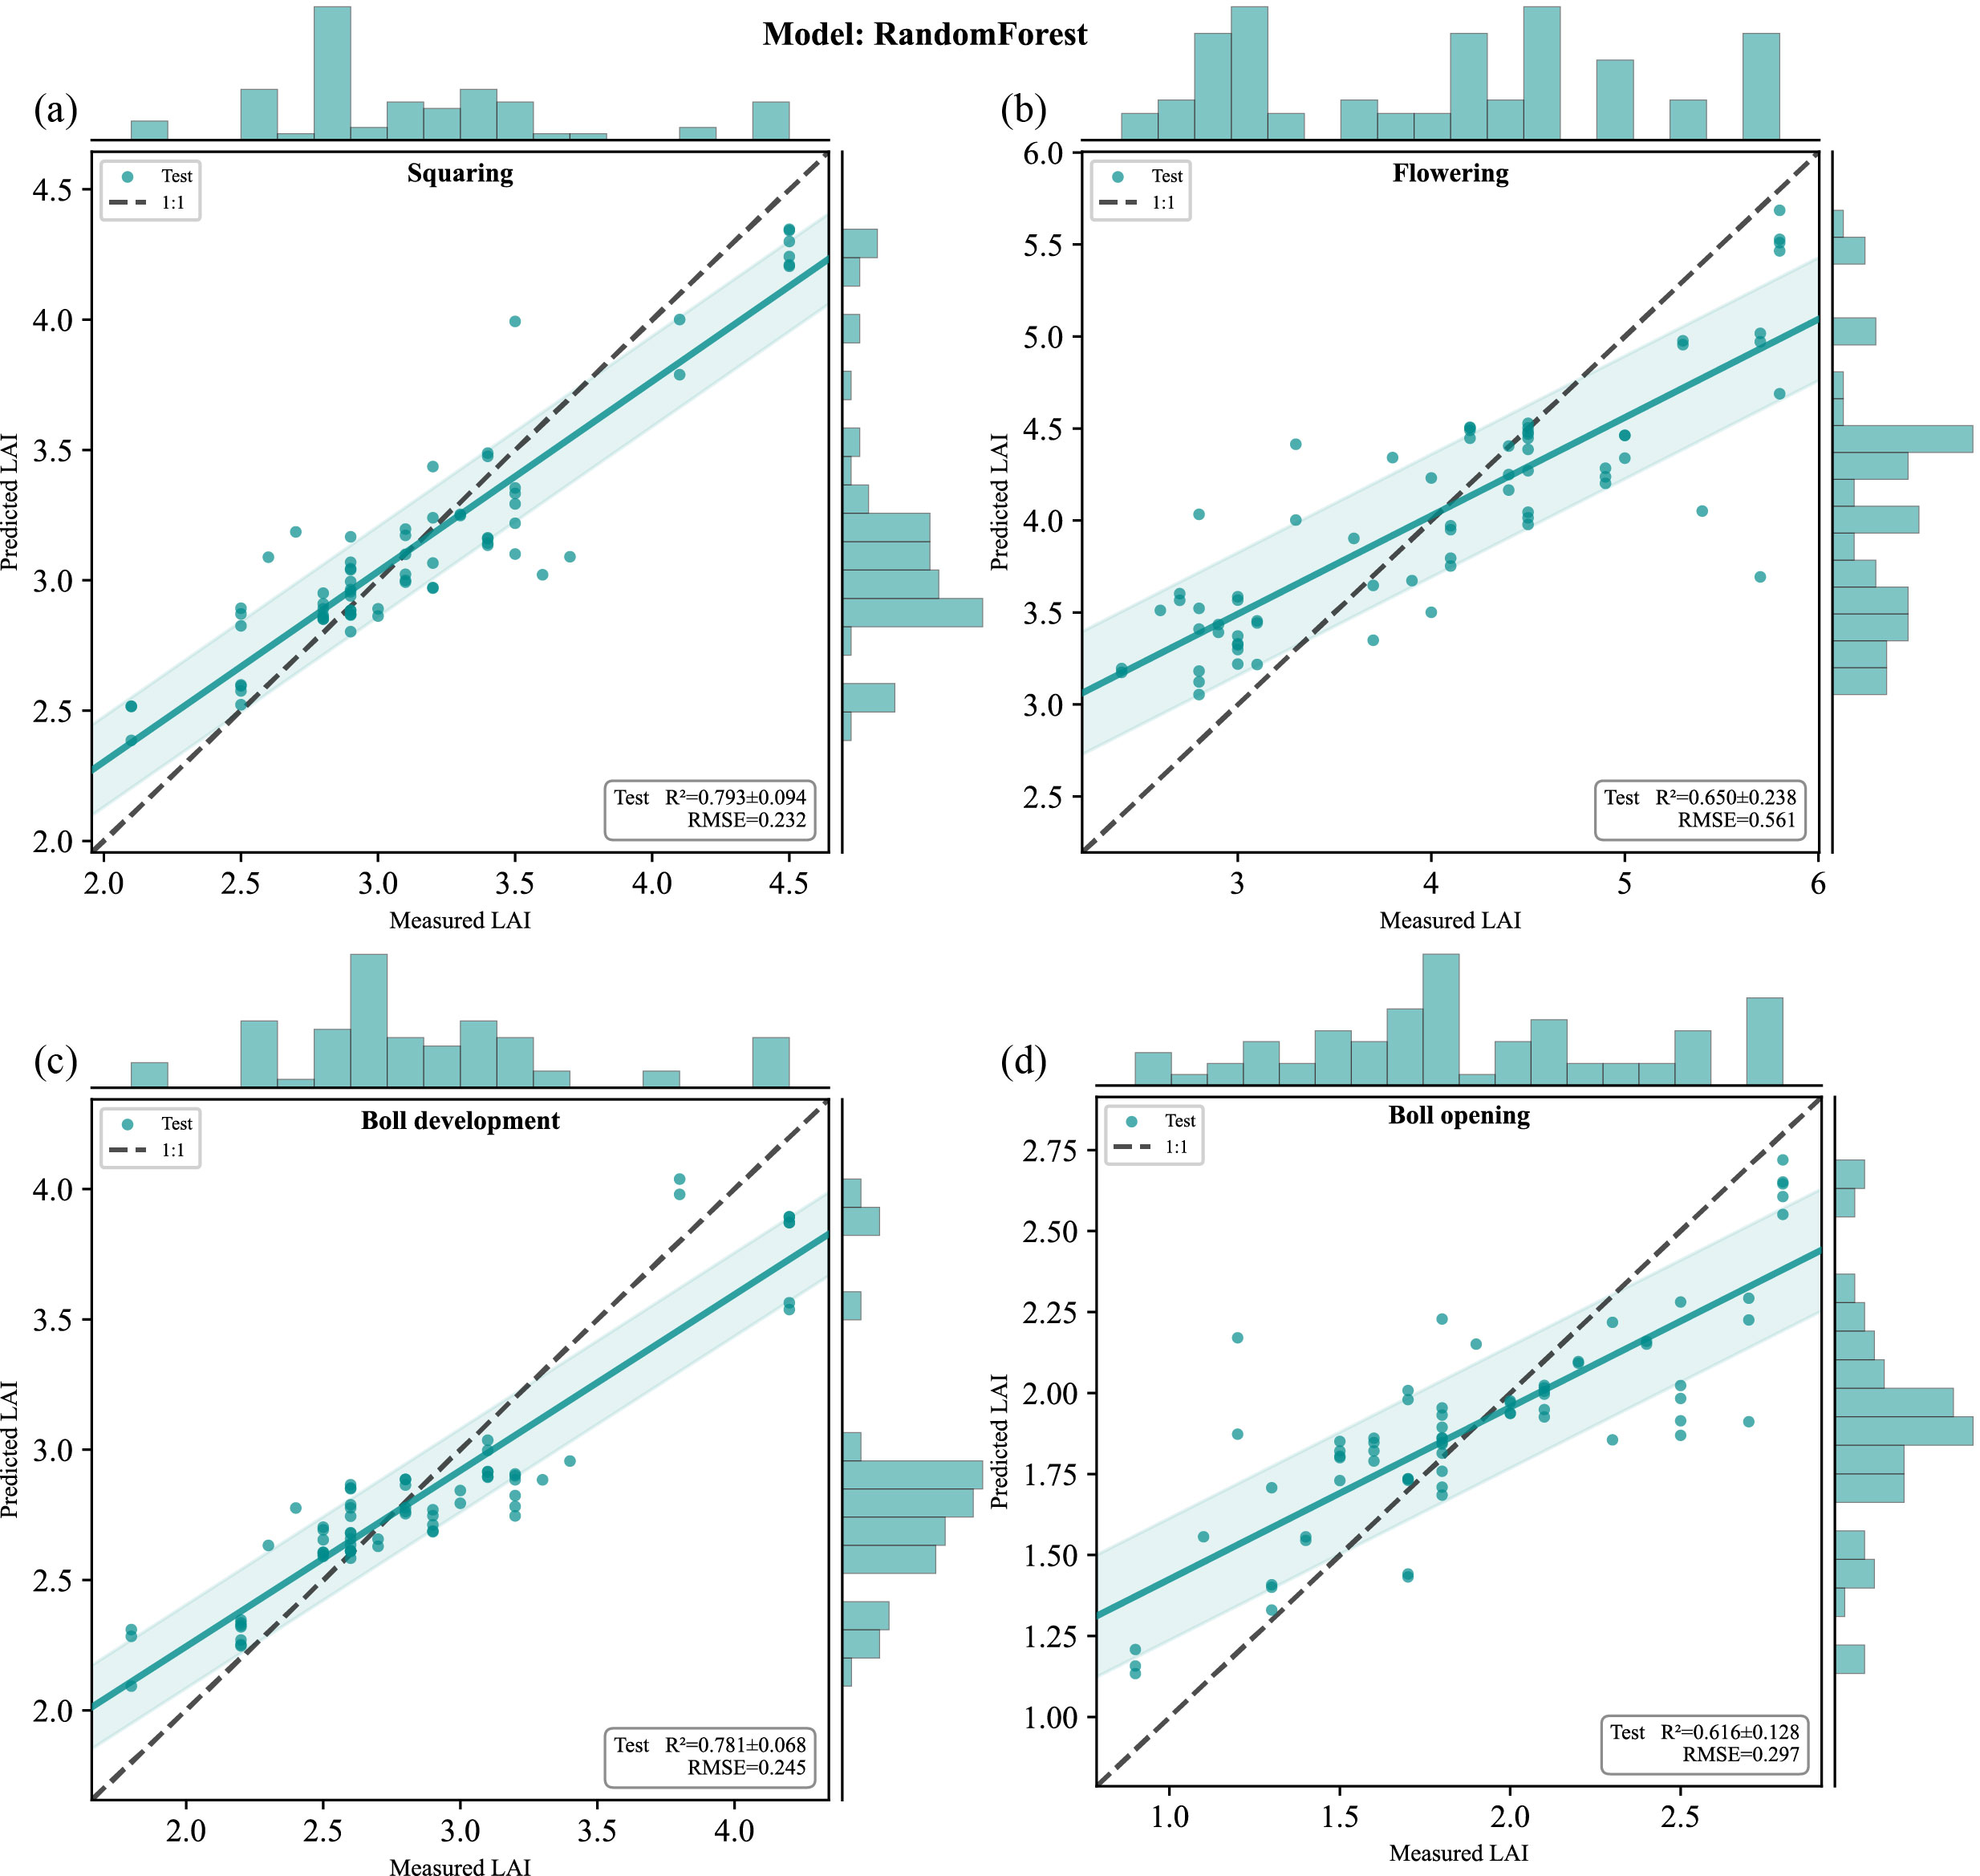
Fig. S4. Predicted-versus-observed 1:1 scatterplots for random forest using fused features: (a) squaring, (b) flowering, (c) boll development, and (d) boll opening. Each panel pools test-set predictions from all five folds, with marginal histograms along the top and right axes. The dashed black line is the 1:1 reference. Insets report the mean ± SD of fold-specific R² values and the mean RMSE.
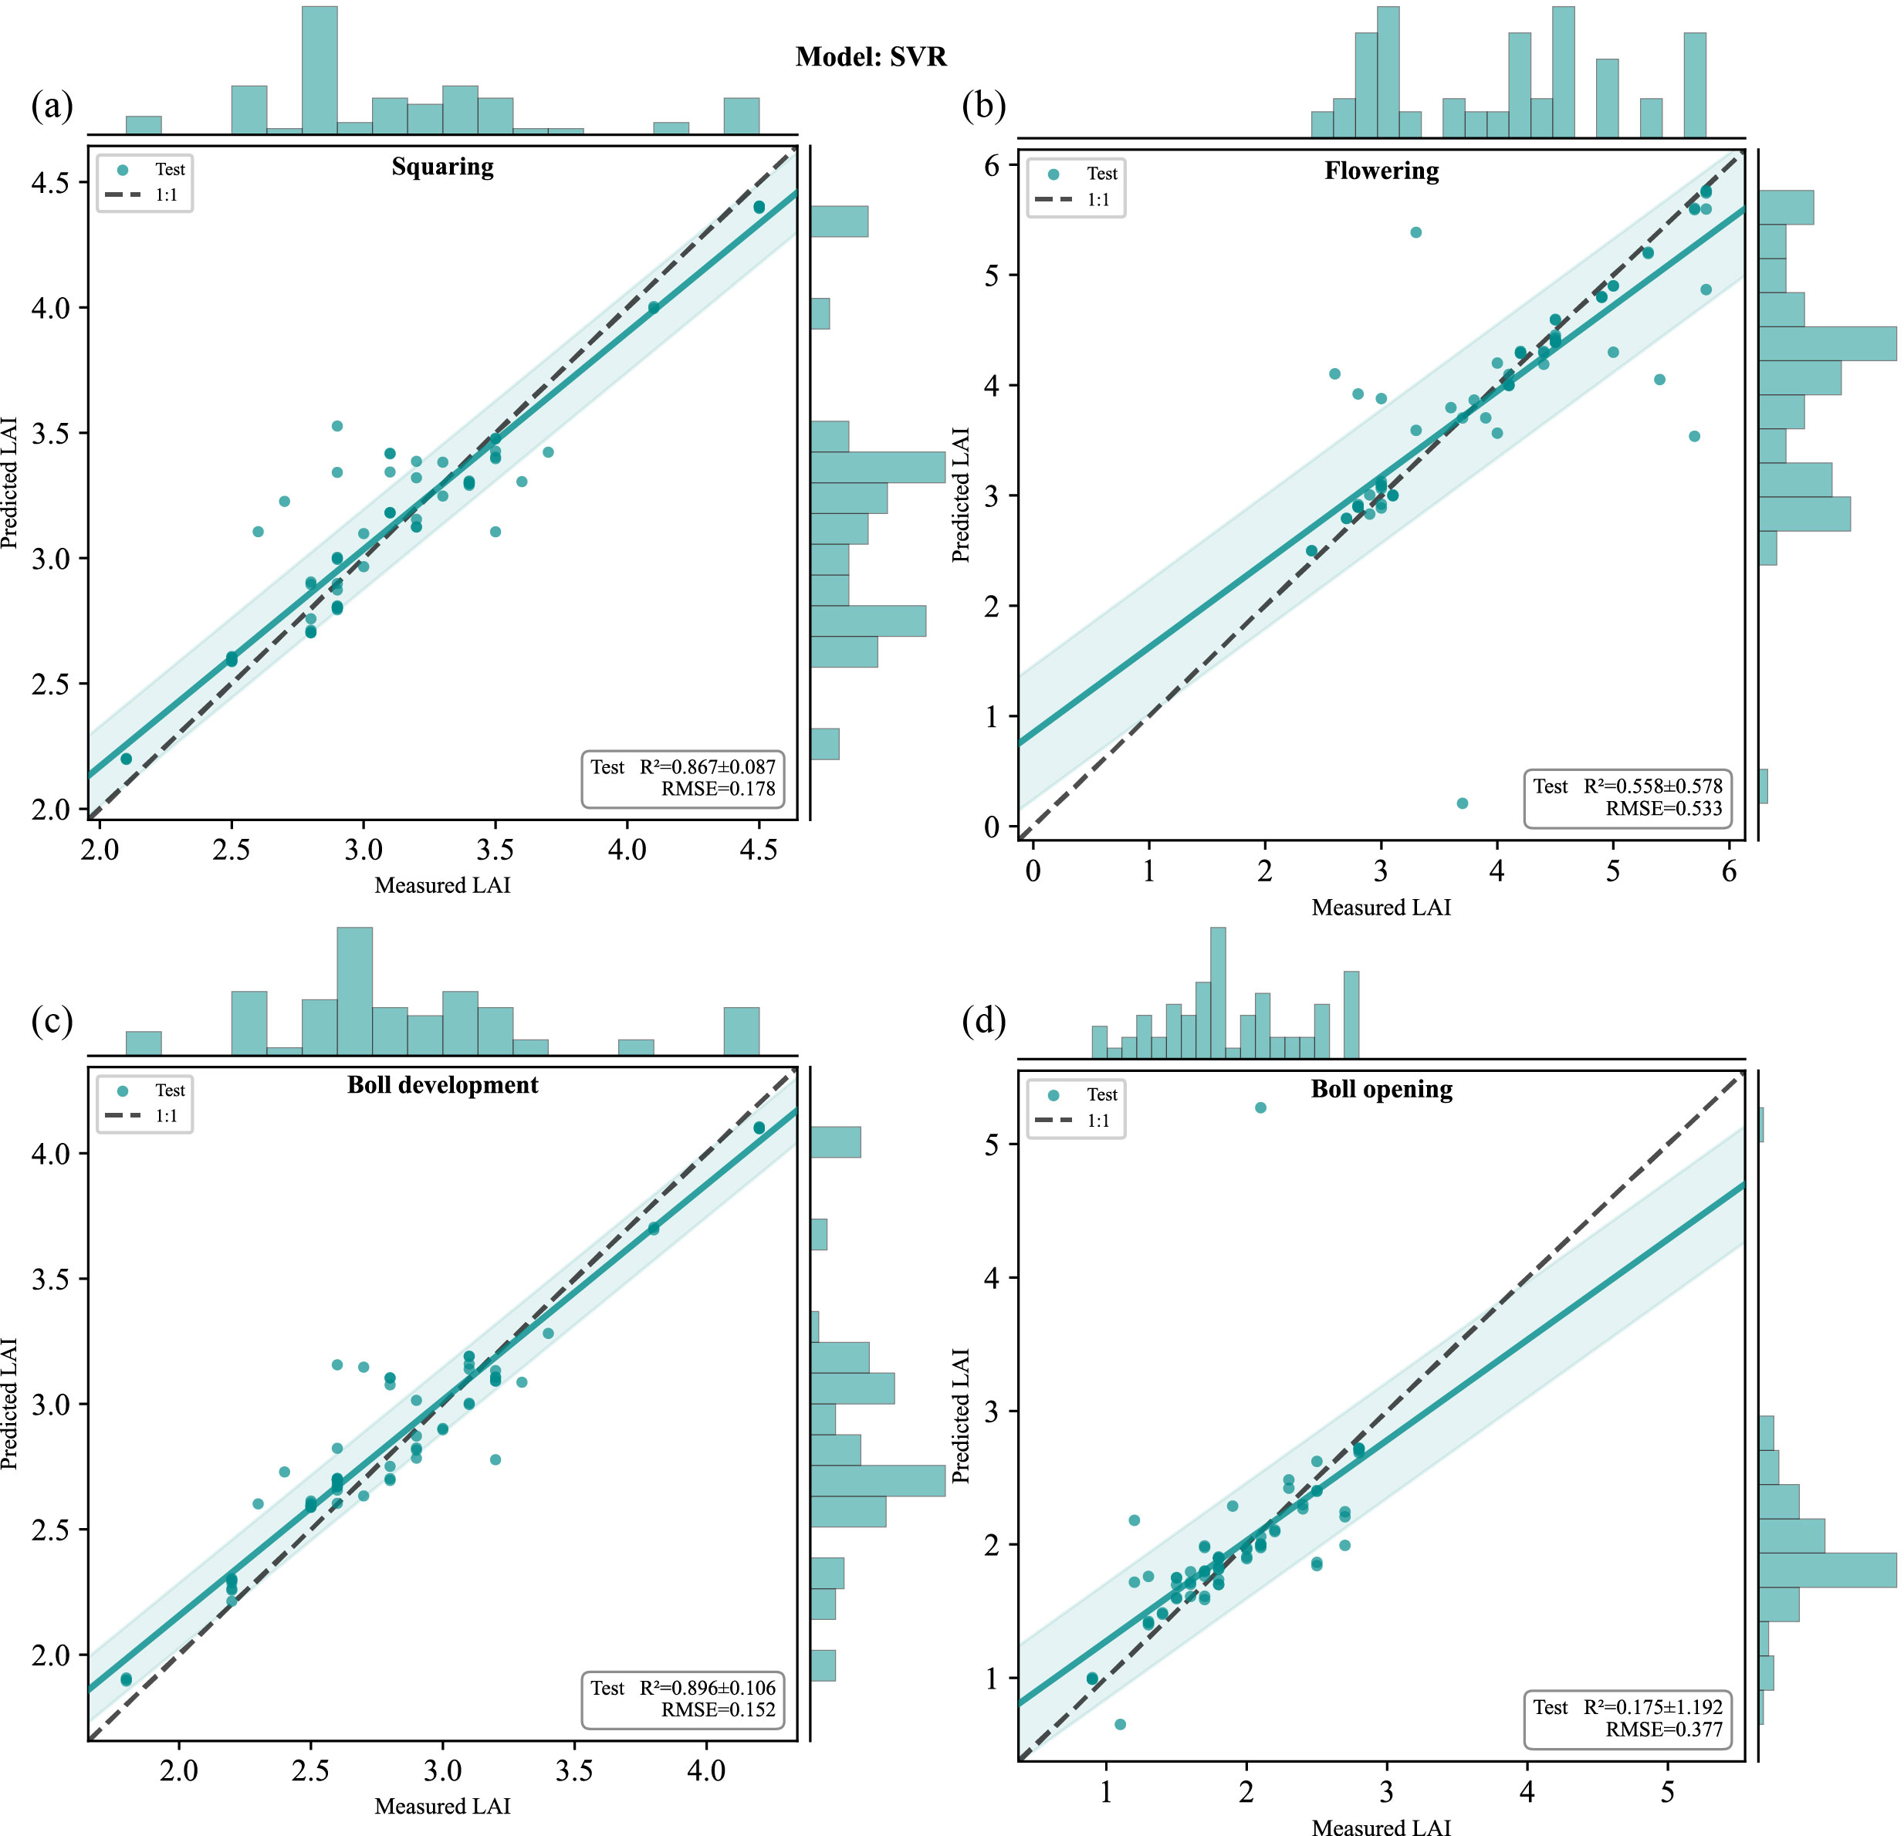
Fig. S5. Predicted-versus-observed 1:1 scatterplots for SVR using fused features: (a) squaring, (b) flowering, (c) boll development, and (d) boll opening. Each panel pools test-set predictions from all five folds, with marginal histograms along the top and right axes. The dashed black line is the 1:1 reference. Insets report the mean ± SD of fold-specific R² values and the mean RMSE.
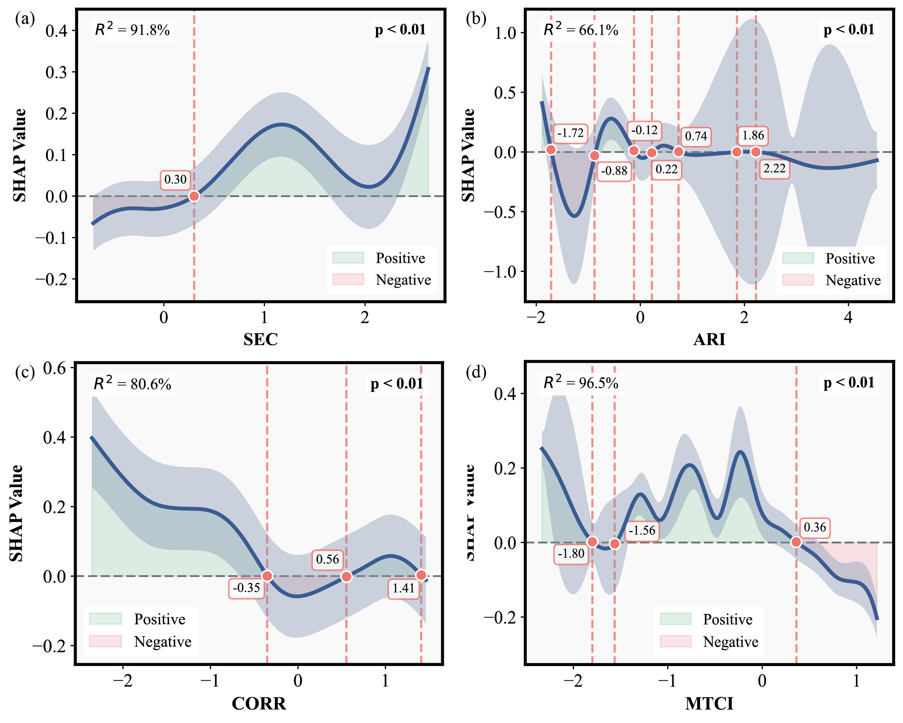
Fig. S6. SHAP dependence plots for the second-ranked feature at each stage: (a) SEC at squaring, (b) ARI at flowering, (c) CORR at boll development, and (d) MTCI at boll opening. The blue curve shows the LOESS-smoothed trend, and the shaded band indicates the 95% confidence interval.
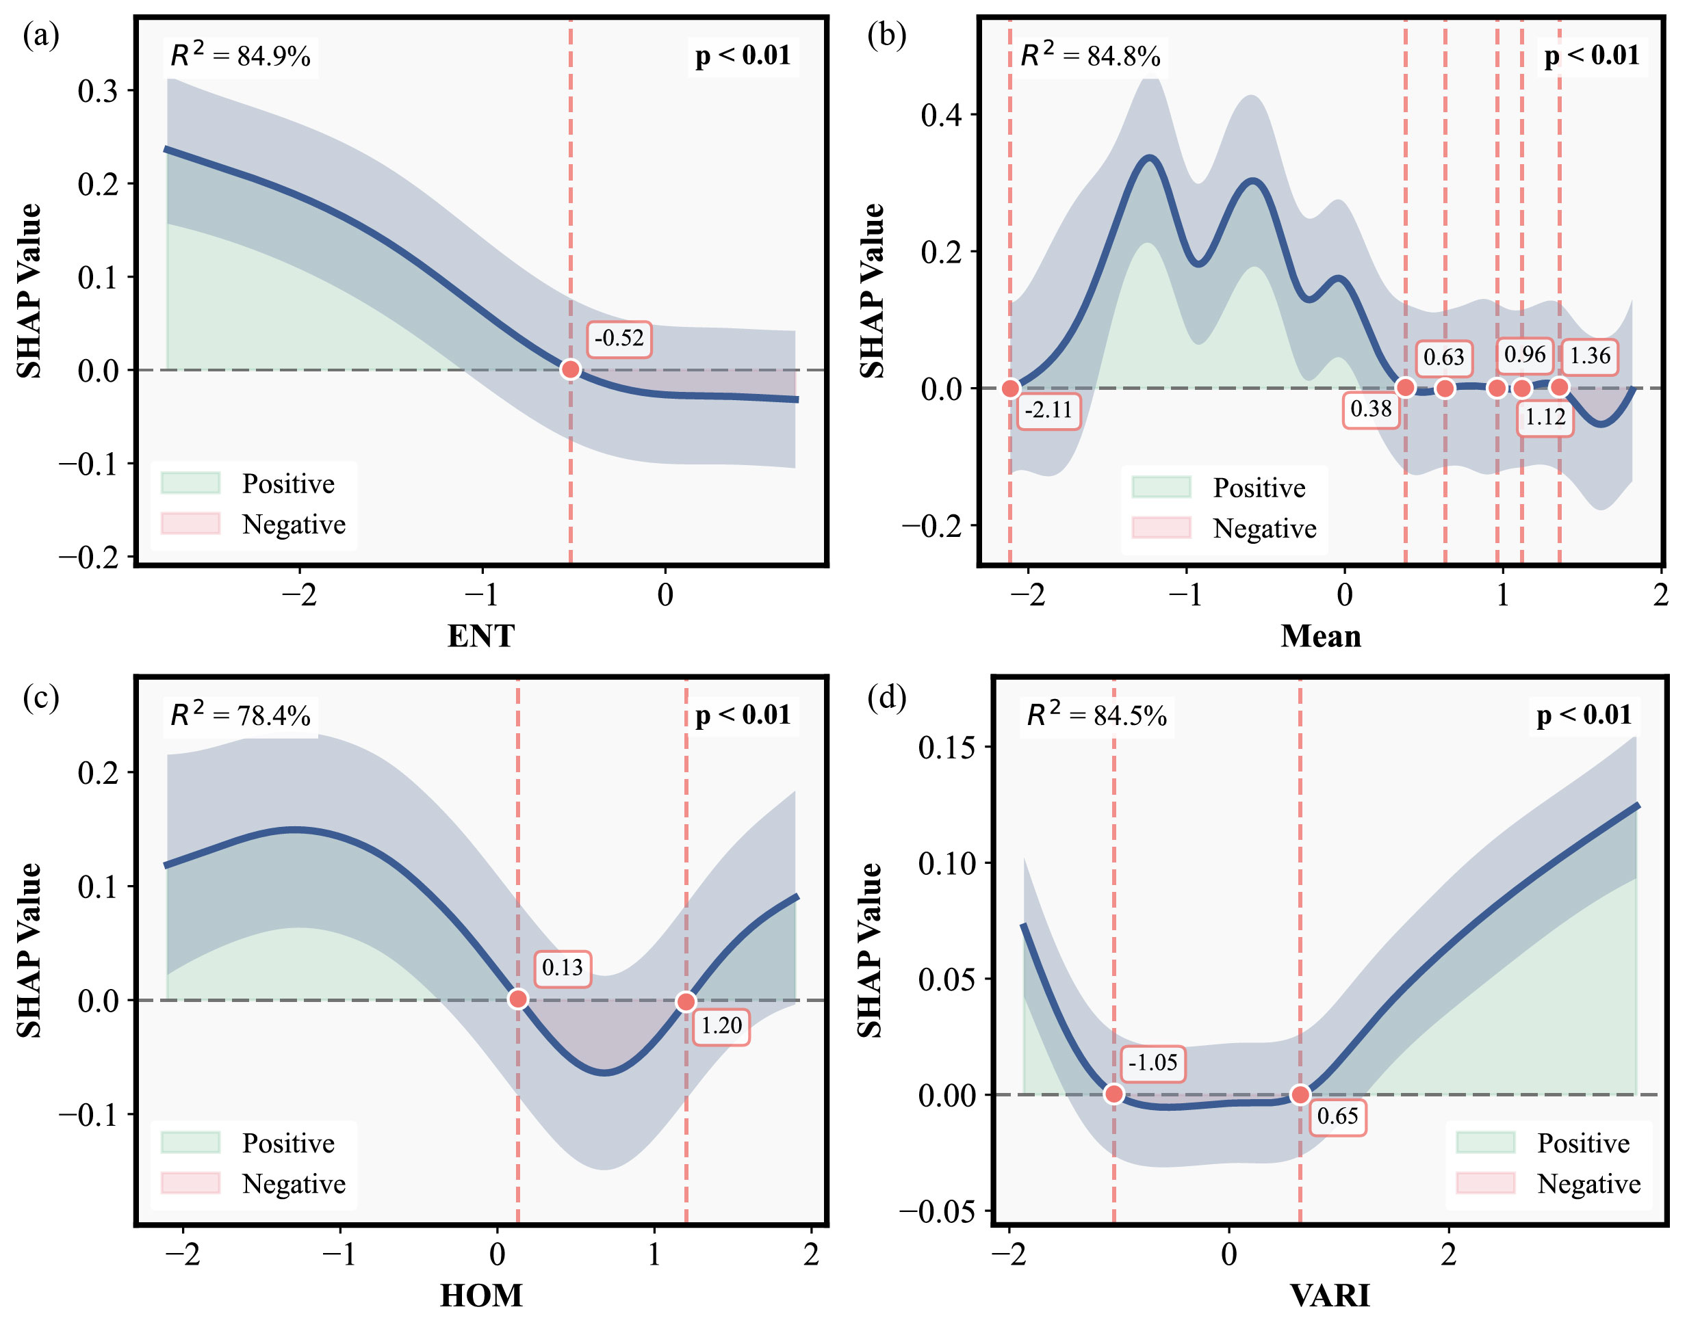
Fig. S7. SHAP dependence plots for the third-ranked feature at each stage: (a) ENT at squaring, (b) Mean at flowering, (c) HOM at boll development, and (d) VARI at boll opening. The blue curve shows the LOESS-smoothed trend, and the shaded band indicates the 95% confidence interval.
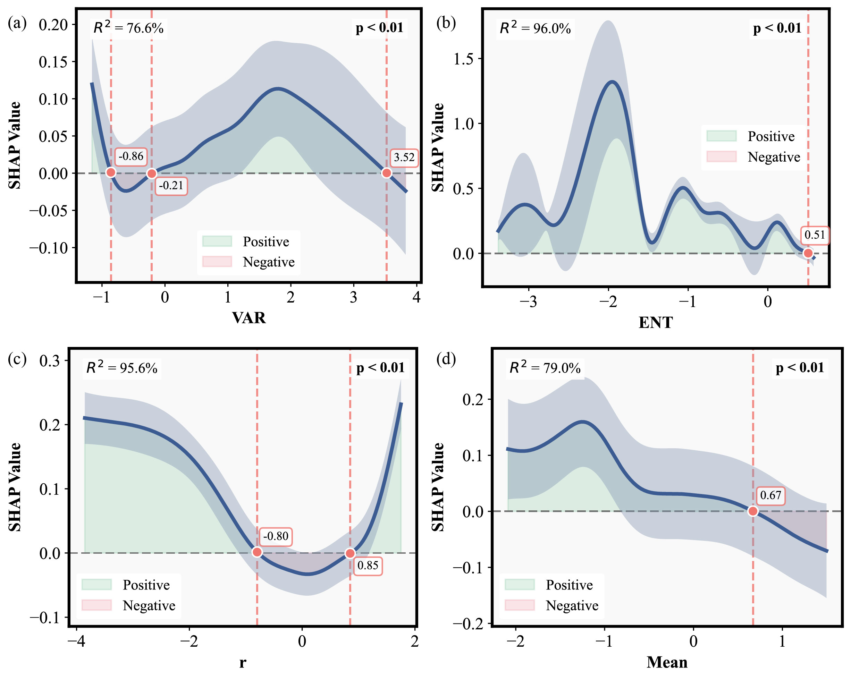
Fig. S8. SHAP dependence plots for the fourth-ranked feature at each stage: (a) VAR at squaring, (b) ENT at flowering, (c) r at boll development, and (d) Mean at boll opening. The blue curve shows the LOESS-smoothed trend, and the shaded band indicates the 95% confidence interval.
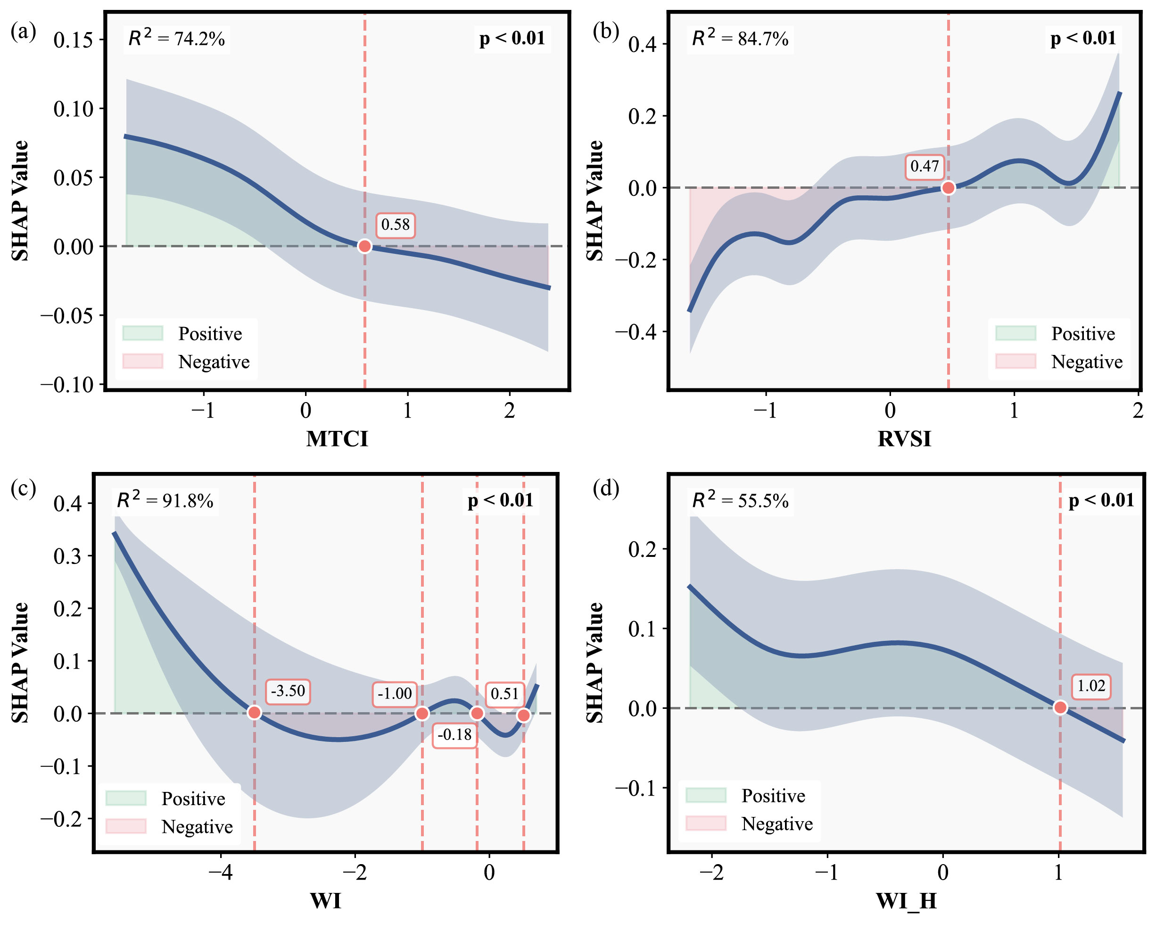
Fig. S9. SHAP dependence plots for the fifth-ranked feature at each stage: (a) MTCI at squaring, (b) RVSI at flowering, (c) WI at boll development, and (d) WI_H at boll opening. The blue curve shows the LOESS-smoothed trend, and the shaded band indicates the 95% confidence interval.

