Supplementary Information
This supplementary material documents the setup, parameter calibration, and independent-validation results supporting the Geosciences Journal submission.
Supplementary Note S1. Ablation analysis setup
The ablation analysis was designed to evaluate whether the main components of the FLC framework contribute to the real-case prediction performance. The same 131 parameter-calibration points were used to select the correction intensity parameter beta for each FLC variant. The final accuracy was evaluated using 40 independent validation points that were not involved in beta calibration.
The no-decay variant sets the correction weight to 1 inside the local correction zone and 0 outside. Therefore, it tests whether a hard in-zone correction can fit the validation points better than the distance-decay weighting. The symmetric variant fixes lambda at 0.5, representing equal displacement partitioning between the two sides of the fault.
Table S1 Definition of model variants used in the ablation analysis
Variant | λ | Decay | β | Purpose
Z₁ baseline | - | - | - | Universal-kriging reference surface without fault-aware correction.
FLC full | 1.0 | Yes | Recal. | Full FLC variant with asymmetric displacement partitioning and distance-decay weighting.
FLC no-decay | 1.0 | No | Recal. | Hard in-zone correction with uniform correction weight inside the local correction zone.
FLC symmetric | 0.5 | Yes | Recal. | Symmetric hanging-wall/footwall displacement partitioning with distance-decay weighting.
FLC symmetric no-decay | 0.5 | No | Recal. | Additional supplementary variant combining symmetric partitioning and no distance decay.

Supplementary Note S2. Beta calibration
For each FLC variant, beta was searched from 0.00 to 1.50 with an interval of 0.01. The best beta was selected by minimizing RMSE at the 131 parameter-calibration points. The resulting beta values were then fixed for the independent validation.
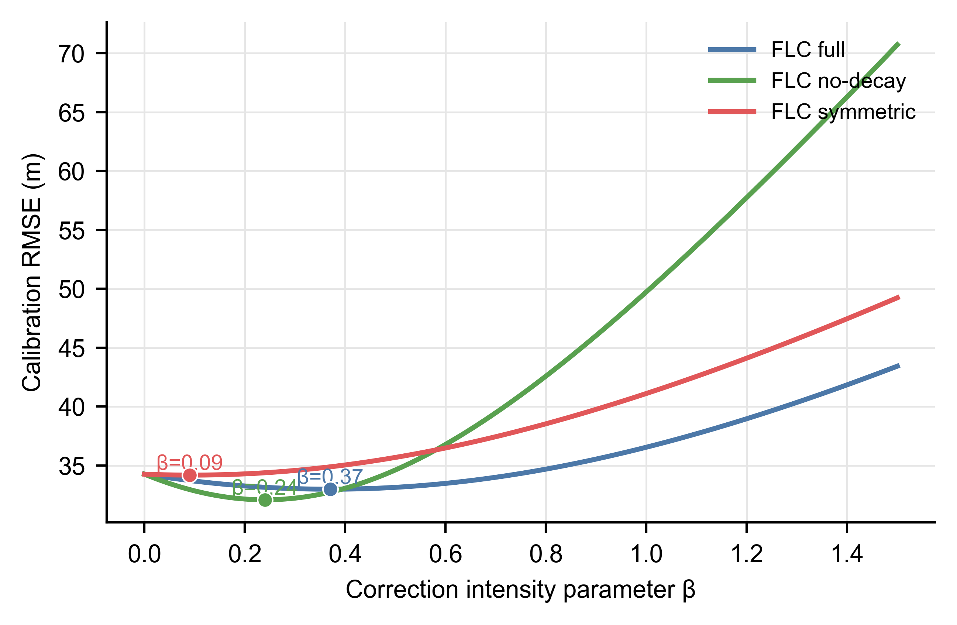
Fig. S1 Beta-calibration curves for the FLC ablation variants. The marked points indicate the beta value that minimizes the calibration RMSE for each variant
Table S2 Calibrated beta values and calibration-point accuracy
Variant | Best β | Cal. RMSE (m) | Cal. MAE (m)
FLC full | 0.37 | 32.99 | 21.17
FLC no-decay | 0.24 | 32.09 | 21.20
FLC symmetric | 0.09 | 34.18 | 21.26
FLC symmetric no-decay | 0.19 | 33.62 | 21.06

Supplementary Note S3. Independent validation results
The calibrated variants were evaluated at 40 independent validation points. The results show that asymmetric displacement partitioning is essential: forcing lambda to 0.5 weakened the improvement over Z1. The no-decay variant produced the lowest point-based error, suggesting that a hard in-zone correction can fit sparse validation points more aggressively. In contrast, the full FLC model keeps distance-decay weighting as a geological regularization term that supports smoother transition within the correction zone.
Table S3 Independent-validation accuracy of the ablation variants
Variant | β | RMSE (m) | MAE (m) | ME (m) | R²
Z₁ baseline | - | 41.33 | 23.75 | -18.82 | 0.767
FLC full | 0.37 | 36.60 | 18.69 | -11.48 | 0.817
FLC no-decay | 0.24 | 34.07 | 18.19 | -8.98 | 0.842
FLC symmetric | 0.09 | 40.65 | 22.96 | -18.64 | 0.774
FLC symmetric no-decay | 0.19 | 38.13 | 20.28 | -16.84 | 0.802

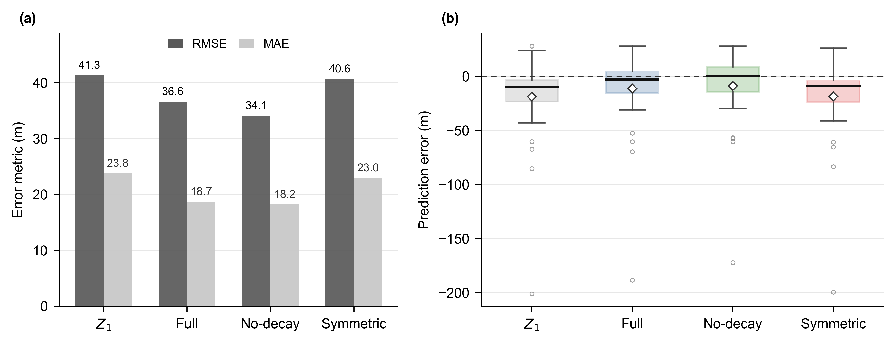
Fig. S2 Ablation comparison of the key FLC components. (a) RMSE and MAE of different model variants. (b) Prediction-error distributions at independent validation points
Supplementary Note S4. Output files
The following machine-readable files were generated for reproducibility and can be submitted as supplementary data if required:
- real_case_flc_ablation_metrics.csv
- real_case_flc_ablation_validation_predictions.csv
- flc_full_beta_sweep.csv
- flc_no-decay_beta_sweep.csv
- flc_symmetric_beta_sweep.csv
- real_case_flc_ablation_metadata.json
These files are generated by the scripts described in the Code availability statement and may be submitted as separate supplementary data files.
Supplementary Note S5. Universal kriging interpolation parameters for Z₁
The Z₁ reference surface was generated by universal kriging before applying fault-aware local correction. Table S4 summarizes the reproducible interpolation settings used in the Z₁-generation script. These settings document the baseline surface used by the subsequent FLC correction.
Table S4 Universal kriging settings used to generate the Z1 reference surface
Item | Setting
Source code | uk.py
Input table | train_unfold.csv; coordinate and elevation fields: X, Y, Z
Output raster | Z_unfold_new.tif / Z₁ reference raster
Interpolation domain | X: 422590-427646; Y: 3639058-3642824
Grid spacing | 1 m
Kriging model | UniversalKriging from PyKrige
Variogram model | Spherical
Variogram nugget | 0.0
Variogram sill | Variance of input Z values
Variogram range | 75th percentile of pairwise sample distances
Drift term | regional_linear
Raster CRS and format | EPSG:32633; GeoTIFF compressed with LZW

Supplementary Note S6. Synthetic experiment parameters and outputs
The synthetic experiment was used as a controlled test in which the true stratigraphic surface and the imposed fault-related displacement were known. Two discontinuity scenarios were generated on the same regular grid, and the Z₁, FLC, UR, and UR+ surfaces were compared against the true surface.
Table S5 Main synthetic-experiment parameters
Item | Setting
Source code | synthetic.py
Output directory | synthetic_final_clean/
Grid | 300 x 300 cells; dx = dy = 10 m; x0 = y0 = 0
Fault position | Central vertical fault line at x = xs[nx // 2]
Damage-zone radii | Rdn = 250 m; Rup = 500 m; gamma = 2.0
True displacement | H_true = 40 m
True partitioning and decay | lambda_true = 0.6; kappa_true = 1.0; p_true = 2.0
UR settings | lambda_ur_fixed = 0.5; feather = 120 m; horizontal scale = 0.35
Sampling | 55 borehole points; 131 calibration points; 40 validation points
FLC search grid | lambda = 0.0-1.0 at 0.1 interval; beta = 0.10-1.00 at 0.03 interval
Synthetic UK model | UniversalKriging with linear variogram and regional_linear drift

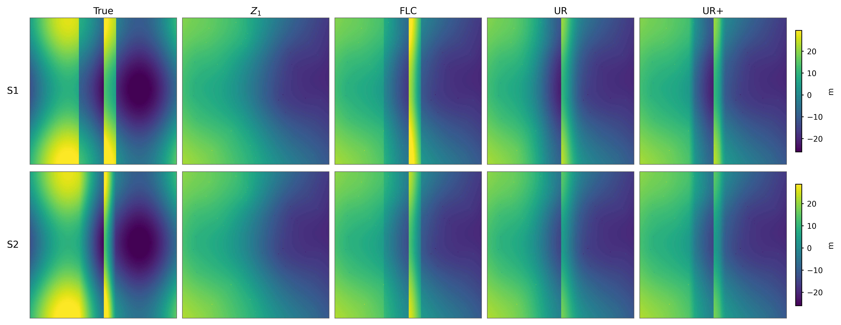
Fig. S3 Synthetic true surfaces and reconstructed surfaces for scenarios S1 and S2. Z1 is the universal-kriging reference surface; FLC is the proposed fault-aware local correction; UR and UR+ are unfolding/refolding-based comparison surfaces

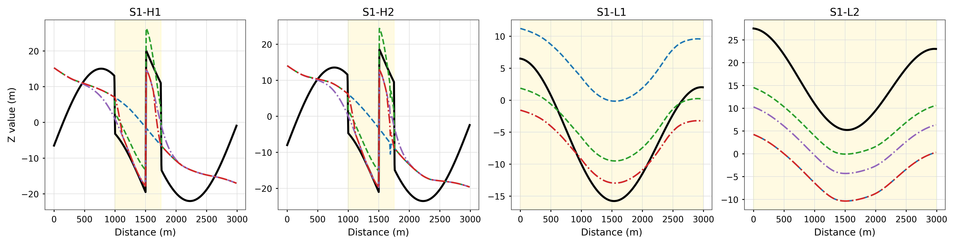
Fig. S4 Synthetic profile comparison for scenario S1. The shaded zones indicate the local correction zones; solid black, blue dashed, green dashed, purple dash-dotted, and red dash-dotted lines denote the true surface, Z1, FLC, UR, and UR+, respectively
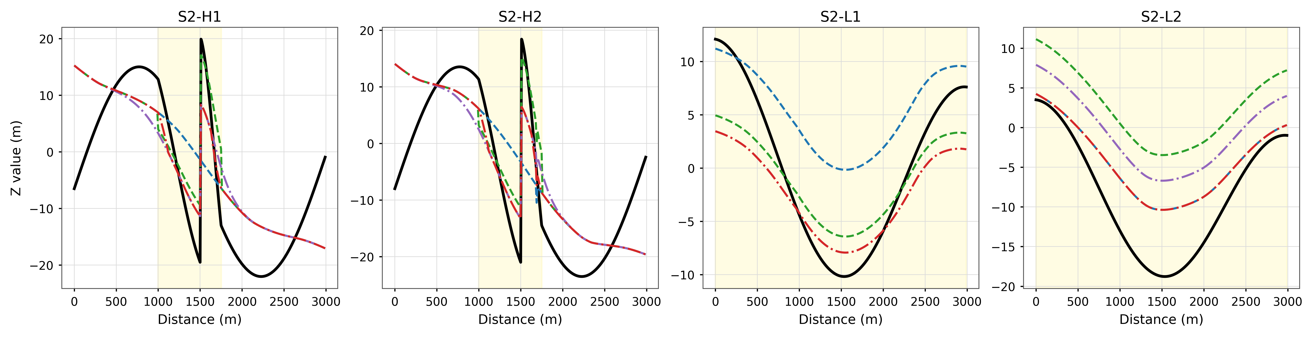
Fig. S5 Synthetic profile comparison for scenario S2. The same profile locations and line styles as Fig. S4 are used

Table S6 Calibrated parameters in the synthetic experiment
S | Best λ | Best β | UR λ | UR H (m) | FLC RMSE (m)
S1 | 0.70 | 1.00 | 0.50 | 32.68 | 6.46
S2 | 0.70 | 0.67 | 0.50 | 19.83 | 7.46

Table S7 Grid-based synthetic accuracy metrics
ID | Method | RMSE, m | MAE, m | In-zone RMSE, m | In-zone MAE, m
S1 | Z₁ | 11.28 | 9.27 | 16.04 | 14.77
S1 | FLC | 8.22 | 6.50 | 4.66 | 3.84
S1 | UR | 9.10 | 7.39 | 6.64 | 5.26
S1 | UR+ | 8.91 | 7.11 | 8.24 | 6.25
S2 | Z₁ | 9.84 | 7.96 | 11.70 | 9.61
S2 | FLC | 8.58 | 6.93 | 6.75 | 5.57
S2 | UR | 9.06 | 7.43 | 7.60 | 6.22
S2 | UR+ | 8.64 | 6.97 | 7.03 | 5.71

