Bimetallic cobalt-nickel phosphide composite biomass carbon materials as efficient electrocatalysts for zinc-air batteries
Hanshuang Wangª, Min Taoª, Hengyu Lin^{c}, Chuanling Zhuª, Chang Zouª, Qingye Liuª, Jiangtao Li ª, Xueyan Sun^{b}*, Wei Zhaoª*, Yilun Liu^{c}

ª School of Chemical Engineering, Northwest University, Xi’an 710127, China
^{b} Luoyang Institute of Science and Technology, Luoyang 471023, China
^{c} School of Aerospace Xi'an Jiaotong University, Xi’an 710049, China
*Corresponding Author, E-mail: zhaowei3313@nwu.edu.cn
sunxueyan@lit.edu.cn

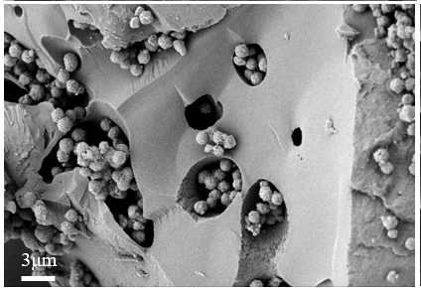
Fig. S1. SEM plot of CoNi@NC

Table S1. Specific surface area and pore volume of CoP@NC, CoMnP@NC, CoFeP@NC and CoNiP@NC
Sample | Specific surface area (m² g⁻¹) | Pore volume (cm³ g⁻¹)
CoP@NC | 19.4875 | 0.0779
CoMnP@NC | 16.9112 | 0.0630
CoFeP@NC | 24.4811 | 0.0399
CoNiP@NC | 17.5437 | 0.0889

Table S2. ORR onset potentials, half-wave potentials, limiting current values, and Tafel slopes for CoP@NC, CoMnP@NC, CoFeP@NC, CoNiP@NC, and Pt/C
 | E_{onset} (V) | E_{1/2}(V) | J_{0.2V}(mA cm⁻²) | Tafel Slope (mV dec⁻¹)
CoP@NC | 0.813 | 0.658 | -4.17 | 102.94
CoMnP@NC | 0.841 | 0.666 | -4.27 | 94.18
CoFeP@NC | 0.821 | 0.661 | -4.03 | 93.44
CoNiP@NC | 0.876 | 0.670 | -4.64 | 87.42
Pt/C | 0.892 | 0.828 | -5.43 | 78.12
Table S3. OER starting potentials, overpotentials, and tafel slopes for CoP@NC, CoMnP@NC, CoFeP@NC, CoNiP@NC, and RuO₂
 | E_{onset} (V) | overpotential (V) | Tafel Slope (mV dec⁻¹)
CoP@NC | 1.566 | 0.539 | 128.41
CoMnP@NC | 1.541 | 0.527 | 126.54
CoFeP@NC | 1.510 | 0.508 | 117.32
CoNiP@NC | 1.501 | 0.503 | 116.26
RuO₂ | 1.533 | 0.597 | 133.32
Table S4. ORR and OER potential differences for CoP@NC, CoMnP@NC, CoFeP@NC, CoNiP@NC and Pt/C-RuO₂ catalysts
 | E_{ORR} (V) | E_{OER} (V) | ∆E (V)
CoP@NC | 0.658 | 1.769 | 1.111
CoMnP@NC | 0.666 | 1.757 | 1.091
CoFeP@NC | 0.661 | 1.738 | 1.077
CoNiP@NC | 0.670 | 1.733 | 1.063
Pt/C-RuO₂ | 0.828 | 1.827 | 0.999

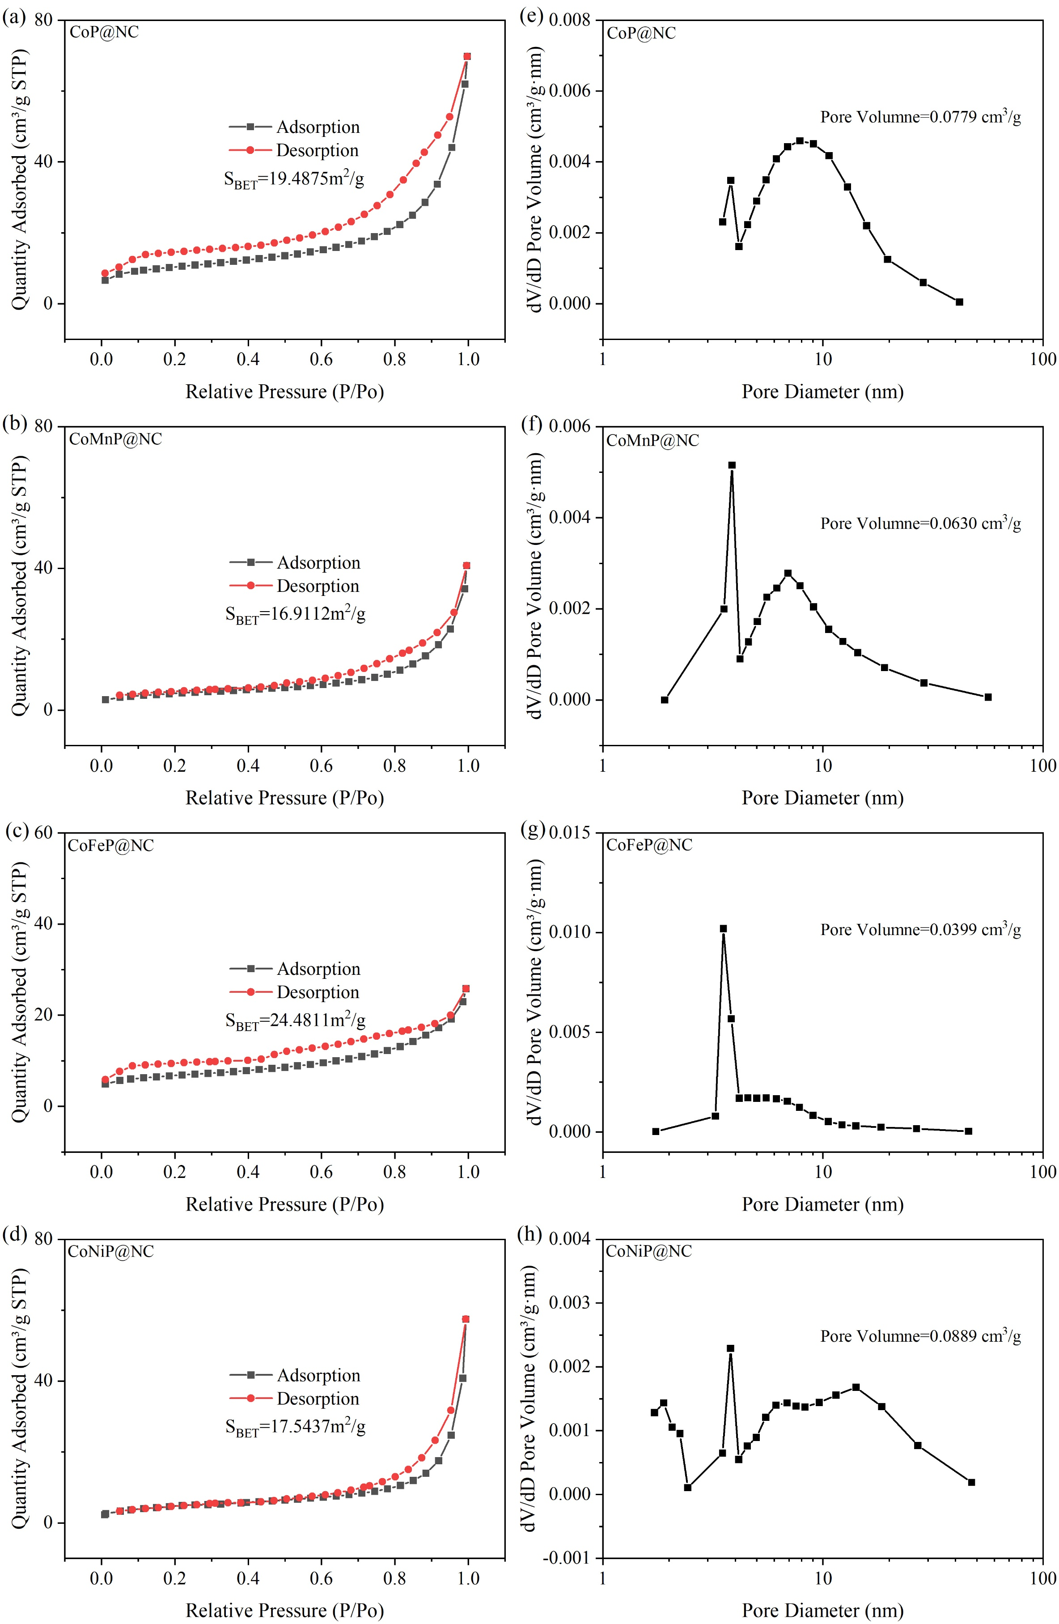
Fig. S2. Nitrogen adsorption-desorption hysteresis curves and corresponding pore size distributions for (a, e) CoP@NC, (b, f) CoMnP@NC, (c, g) CoFeP@NC, and (d, h) CoNiP@NC.

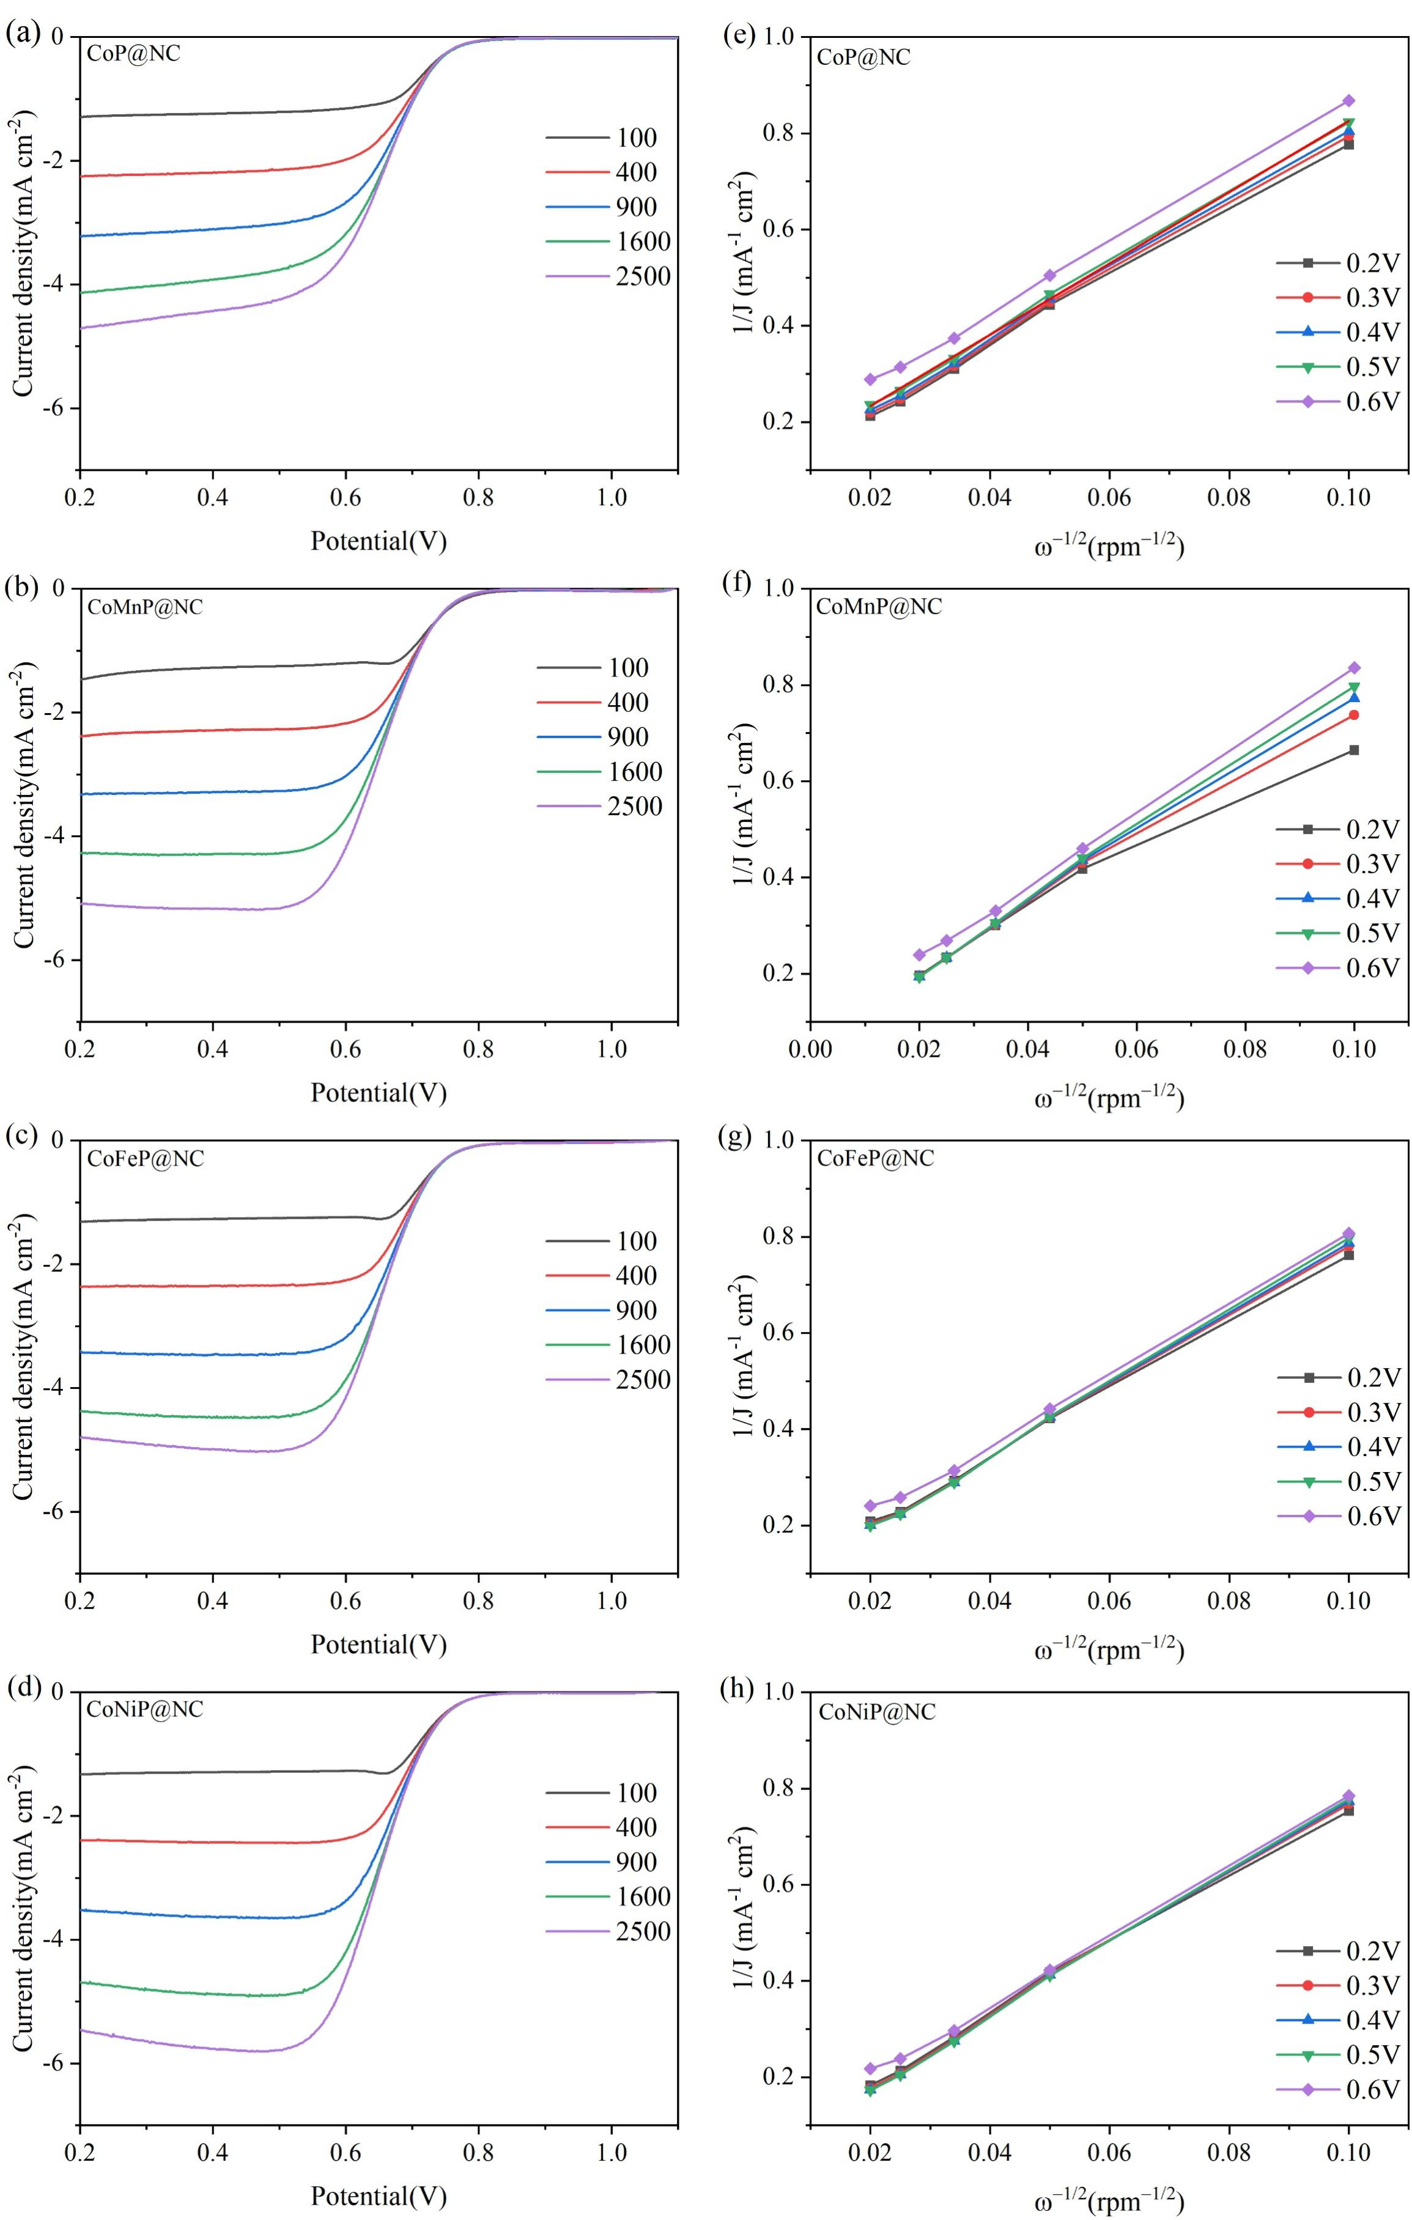
Fig. S3. LSV curves of CoP@NC, CoMnP@NC, CoFeP@NC and CoNiP@NC catalysts (a-d) at different rotational speeds and the corresponding Koutecky-Levich plots (e-h).

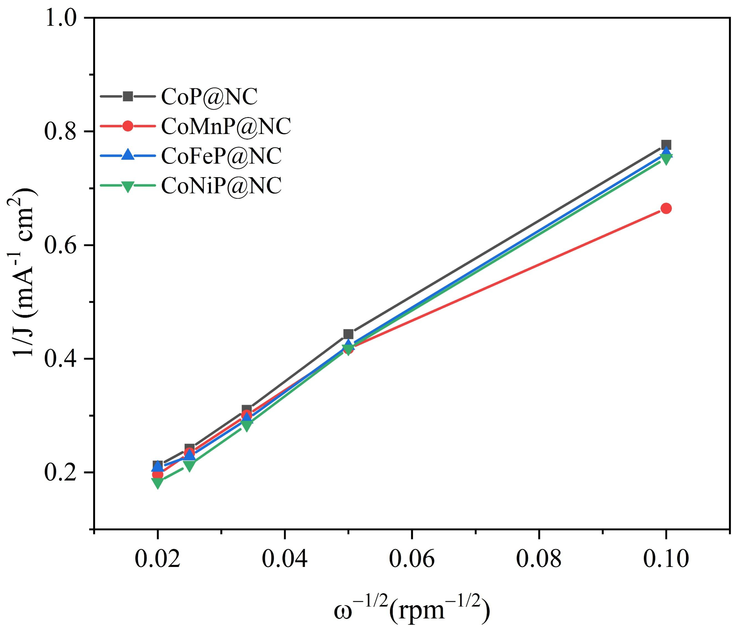
Fig. S4. K-L plot of CoMP@NC catalyst at 0.2 V.

Table S5. Bifunctional catalytic activity of other catalysts in the literature
Catalysts | E_{ORR}(V)(E_{1/2}) | E_{OER}(V)  @j=10 mA cm⁻² | ∆E=E_{OER}-E_{ORR}
Mn-CoFeP-2 | 0.670 vs. RHE | 1.733 vs. RHE | 1.063 This work
Pt/C¹ | 0.97 vs. RHE | 2.19 vs. RHE | 1.22
IrO₂¹ | 0.38 vs. RHE | 1.70 vs. RHE | 1.32
RuO₂¹ | 0.54 vs. RHE | 1.64 vs. RHE | 1.10
Mn-Co₃O₄² | 0.69 vs. RHE | 1.80 vs. RHE | 1.11
BSCF/g–C₃N₄VC³ | -0.324 vs. Ag/AgCl | 0.796 vs. Ag/AgCl | 1.12
Co-AQ⁴ | 0.86 vs. RHE | 1.95 vs. RHE | 1.09
Mn-Ni/RGO⁵ | 0.750 vs. RHE | 1.929 vs. RHE | 1.191
GCN/CNT⁶ | 0.71 vs. RHE | 1.78 vs. RHE | 1.07

Table S6. The Comparison of liquid Zn-air batteries performance of this work with other non-noble metal-based catalysts recently reported.
Catalysts | Cycling current density (mA cm⁻² ) | Stability
Mn-CoFeP-2 | 2 | 240 h This work
Co/N-CP⁷ | 5 | 30 h
VSMO⁸ | 5 | 20 h
Co-AQ⁴ | 2 | 100 h
Mn-Co₃O₄⁹ | 2 | 90 h
C@CNT[Ni]¹⁰ | 5 | 120 h
Mo/NiCo₂O₄¹¹ | 5 | 96 h
References
(1) Rincon, R. A.; Masa, J.; Mehrpour, S.; Tietz, F.; Schuhmann, W. Activation of oxygen evolving perovskites for oxygen reduction by functionalization with Fe-Nx/C groups. Chemical Communications 2014, 50 (94), 14760-14762.
(2) Shui, Z.; Yu, S.; Lu, W.; Xu, L.; Liu, Q.; Zhao, W.; Liu, Y. Bifunctional Electrocatalysts of Mn-doped Co₃O₄ for Oxygen Reduction and Oxygen Evolution Reactions in Alkaline Medium. Acta Chim. Sinica 2024, 82 (10), 1039-1049.
(3) Chen, F.; Xue, L.; Shang, Z.; Zhang, Z.; Chen, D. An enhanced non-noble perovskite-based oxygen electrocatalyst for efficient oxygen reduction and evolution reactions. Journal of Solid State Chemistry 2020, 282,
(4) Chai, R.-L.; Han, S.-B.; Wang, L.W.; Li, S.-H.; Pan, H.; Zhang, H.B.; Tu, X.Y.; Wang, Z.Y.; Wang, X.; Li, G.-Y.; et al. Electronic Structure Tunable Metallosupramolecular Polymers as Bifunctional Electrocatalysts for Rechargeable Zn-Air Battery. Small 2025, 21 (12),
(5) Xue, Y.; Wang, Y.; Zheng, Z.; Lu, Q.; Chen, W.; Yan, S.; Sun, S.; Zhang, H.; Shao, G. Nickel-hydroxide decorated trimanganese-tetroxide nanorods supported on graphene as bifunctional electrocatalyst for metal-air batteries. J. Electroanal. Chem. 2024, 963,
(6) Divinagracia-Luzadas, M.; Kaneko, K.; Hori, K.; Paraggua, J. A.; Noda, S.; Ocon, J. Synthesis and Evaluation of Self-Supporting Graphitic Carbon Nitride/ Carbon Nanotube (GCN/CNT) ORR/OER Electrodes in Aqueous and Non-Aqueous Media. Curr. Appl Phys. 2025, 71, 14-26.
(7) Li, H.; Qiu, H.; Aliyeva, A.; Wang, J.; Muller, M.; Hansen, L.; Tjardts, T.; Aktas, C.; Benedikt, J. Cobalt-decorated defective carbon paper as a self-supported catalyst for oxygen electrocatalysis and rechargeable zinc-air battery. Journal of colloid and interface science 2025, 689, 137230-137230.
(8) Riquelme-Garcia, P.; Garcia-Rodriguez, M.; Flores-Lasluisa, J. X.; Cazorla-Amoros, D.; Morallon, E. Enhanced electrocatalytic performance of SrMn1-xCoxO3 perovskite metal oxides for oxygen reactions in Zn-air batteries: Influence of Mn/Co ratio. Appl. Surf. Sci. Adv. 2025, 27,
(9) Shui, Z.; Tian, H.; Mu, H.; Xu, L.; Gao, X.; Chen, X. Mn doping for regulating the electronic structure of Co₃O₄ to construct dual active sites for oxygen electrocatalysis. Inorganic Chemistry Frontiers 2025, 12 (7), 2783-2791.
(10) Modak, A.; Phutela, A.; Kundu, A.; Das, S.; Bhasin, V.; Bhattacharyya, D.; Bhattacharya, S. Hyper-Cross-Linked Polymer-Derived Carbon-Coated Fe-Ni Alloy/CNT as a Bifunctional Electrocatalyst for Rechargeable Zinc-Air Batteries. Journal of Physical Chemistry Letters 2025, 16 (4), 1051-1065.
(11) Sharma, R.; Singh, A.; Halder, A. Synergistic effect of lattice strain, oxygen vacancy and morphology in Mo doped NiCo2O4 for high-performance zinc air batteries. Journal of Energy Storage 2025, 107, 114918.

