Supplementary Table 1: List of antibodies

Antibody | Source | Cat. number
E-Cadherin | Cell Signaling Technology | 3195
N-Cadherin | Cell Signaling Technology | 13116
Vimentin | Cell Signaling Technology | 5741
FAP | Cell Signaling Technology | 66562
Fibronectin | Cell Signaling Technology | 26836
α - SMA | Affinity Biosciences | AF1032
β - Actin | Cell Signaling Technology | 3700
Anti-Rabbit IgG, HRP-linked | Cell Signaling Technology | 7074
Anti-Mouse IgG, HRP-linked | Cell Signaling Technology | 7076

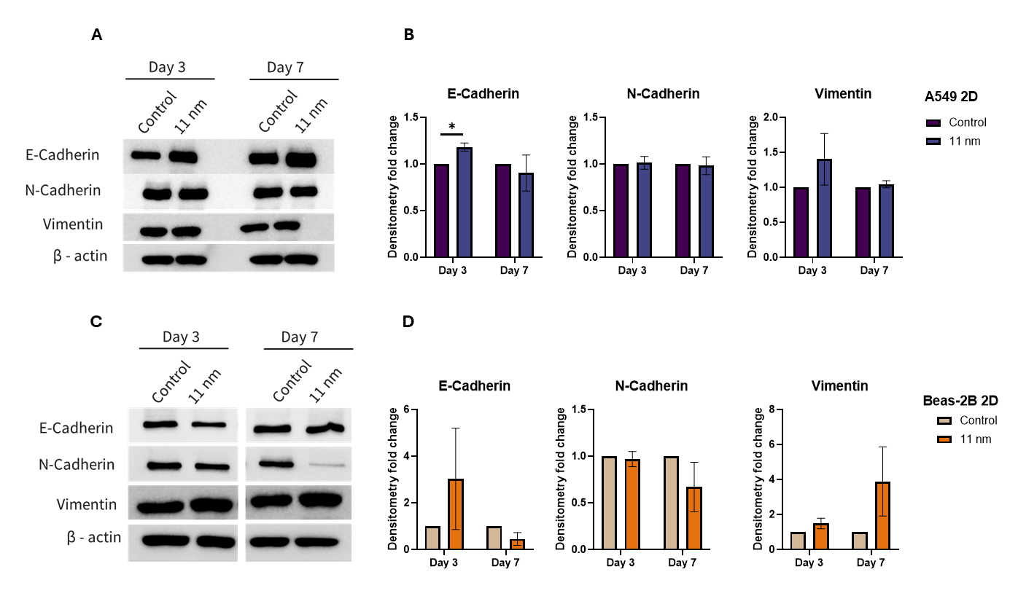
Supplementary Figure 1. Protein profile of EMT in 2D models of A549 and BEAS-2B exposed to silica CM
Western blot of EMT markers in (A) A549 and (C) BEAS-2B cultured in 2D models and (B, D) their respective densitometry analysis. Data are presented as mean ± SEM (n=3). *p < 0.05.

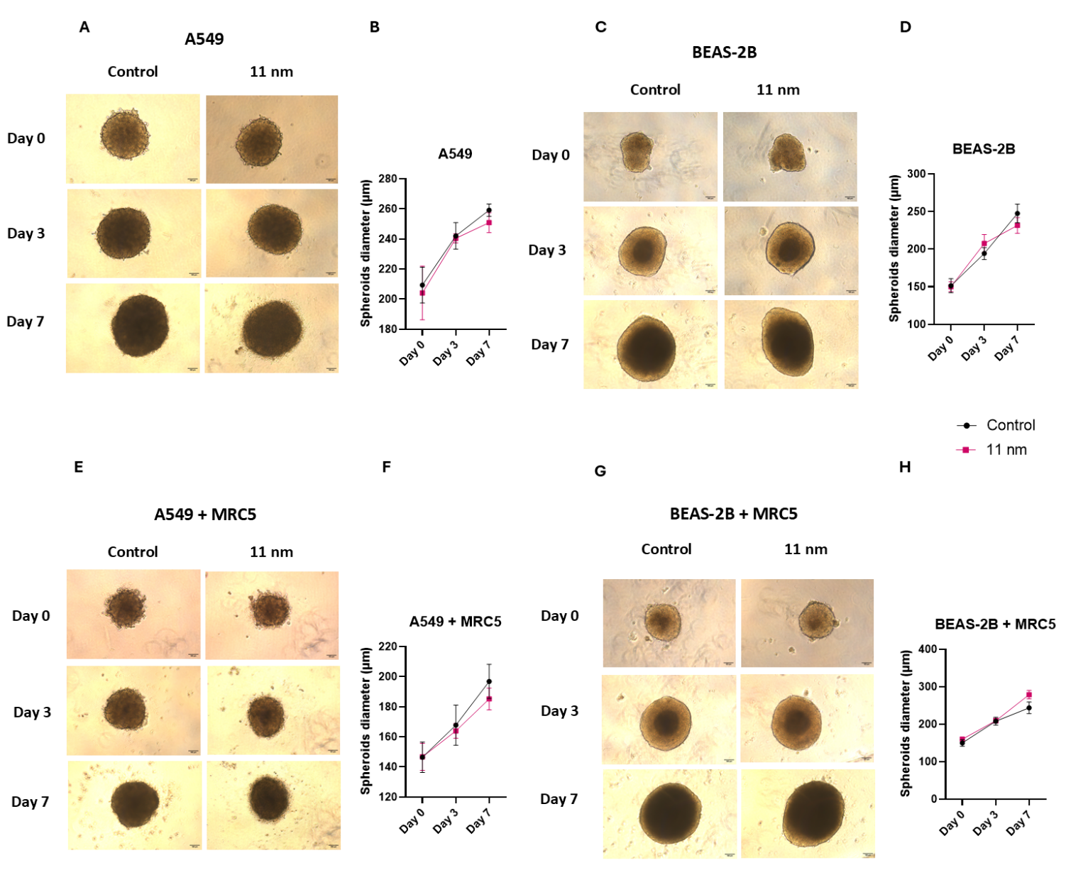

Supplementary Figure 2. Images of A549 and BEAS-2B 3D mono- and co-culture spheroids
Images of 3D monoculture spheroids of (A) A549, (C) BEAS-2B and co-cultures (E) A549 + MRC5 and (G) BEAS-2B + MRC5. Graphs of spheroid diameter (µm) for the corresponding culture model (B, D, F, and H) measured by ImageJ software. Scale bar is 100 µm.

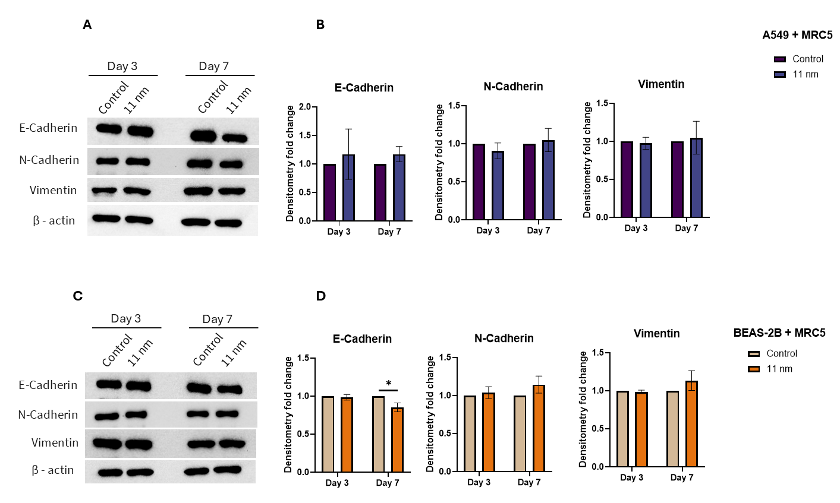

Supplementary Figure 3. Protein expression of EMT markers in 3D spheroid co-cultures of A549 and BEAS-2B with MRC5 during exposure to silica
Protein expression of EMT markers in (A) A549 and (C) BEAS-2B co-cultured with MRC5 in 3D models determined by western blot and (B, D) their respective densitometry analysis. Data are presented as mean ± SEM (n=3). *p < 0.05.

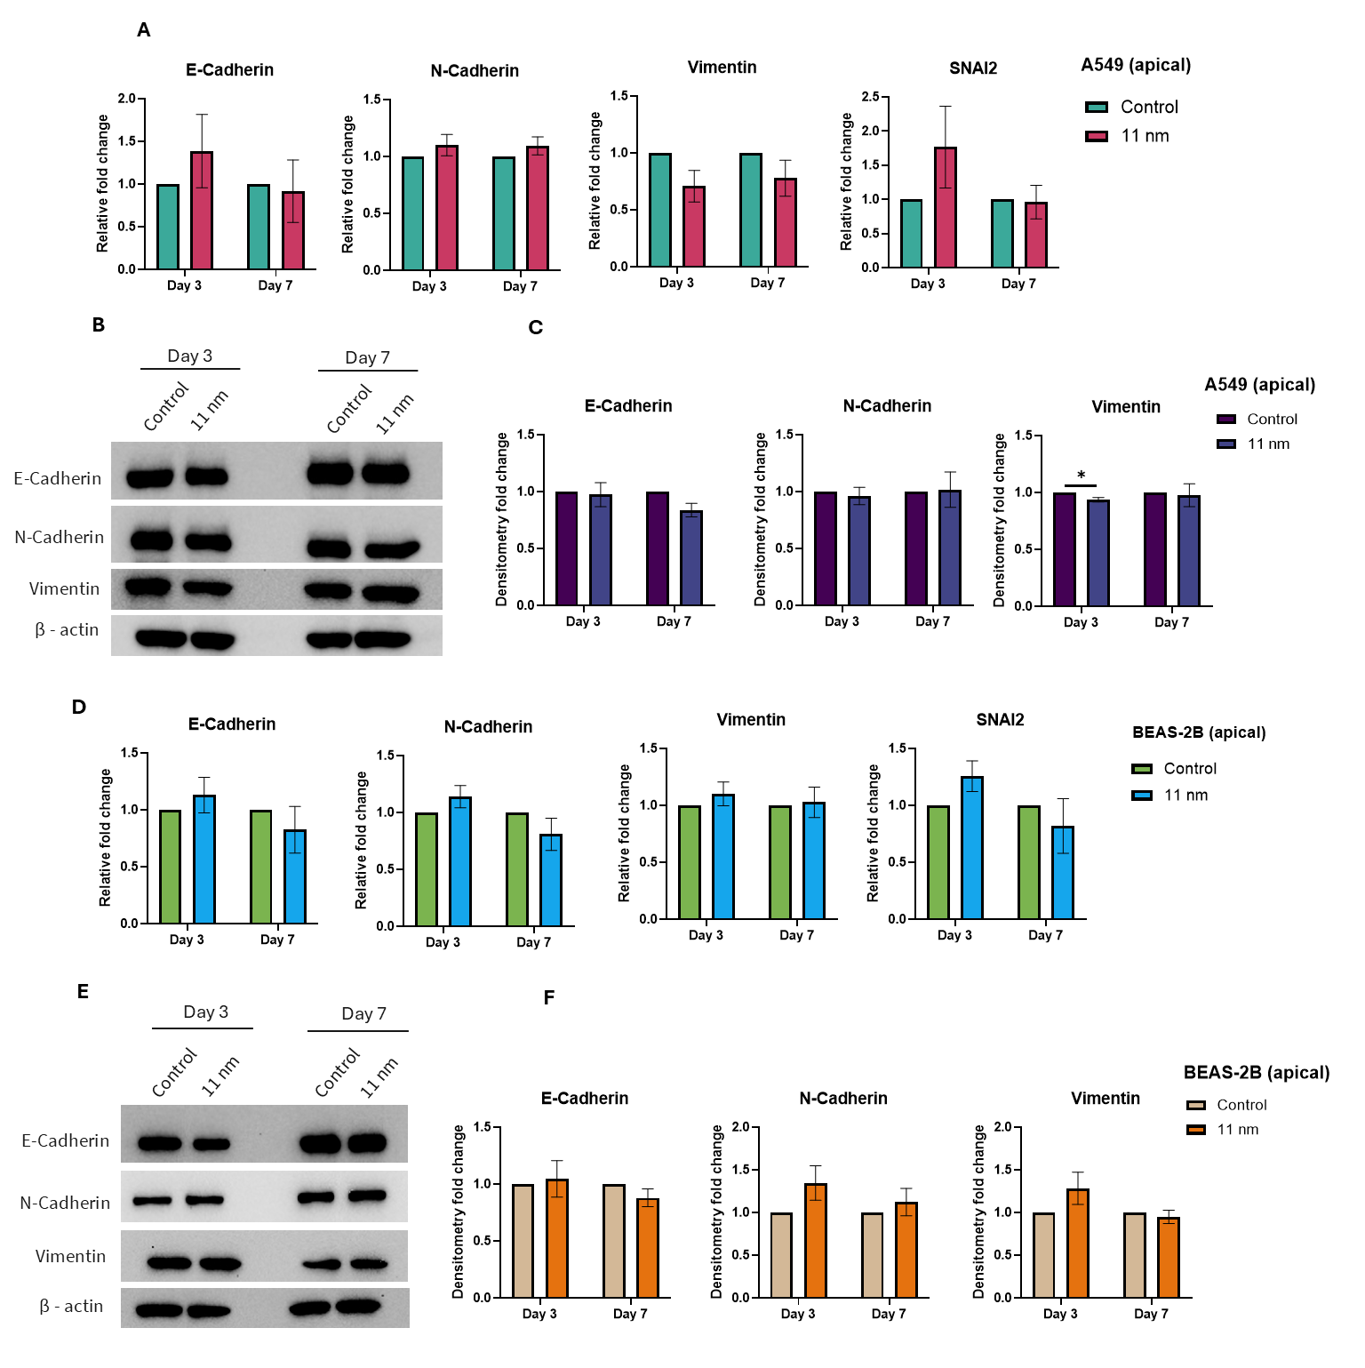

Supplementary Figure 4. EMT expression profile in A549 and BEAS-2B cells co-cultured with MRC5 in transwell models
mRNA levels of EMT markers in (A) A549 and (D) BEAS-2B transwell co-cultures with MRC5. Protein expression levels in (B) A549 and (E) BEAS-2B transwell models and (C, F) their respective densitometry analysis. Data presented as ± SEM (n=3). *p < 0.05.
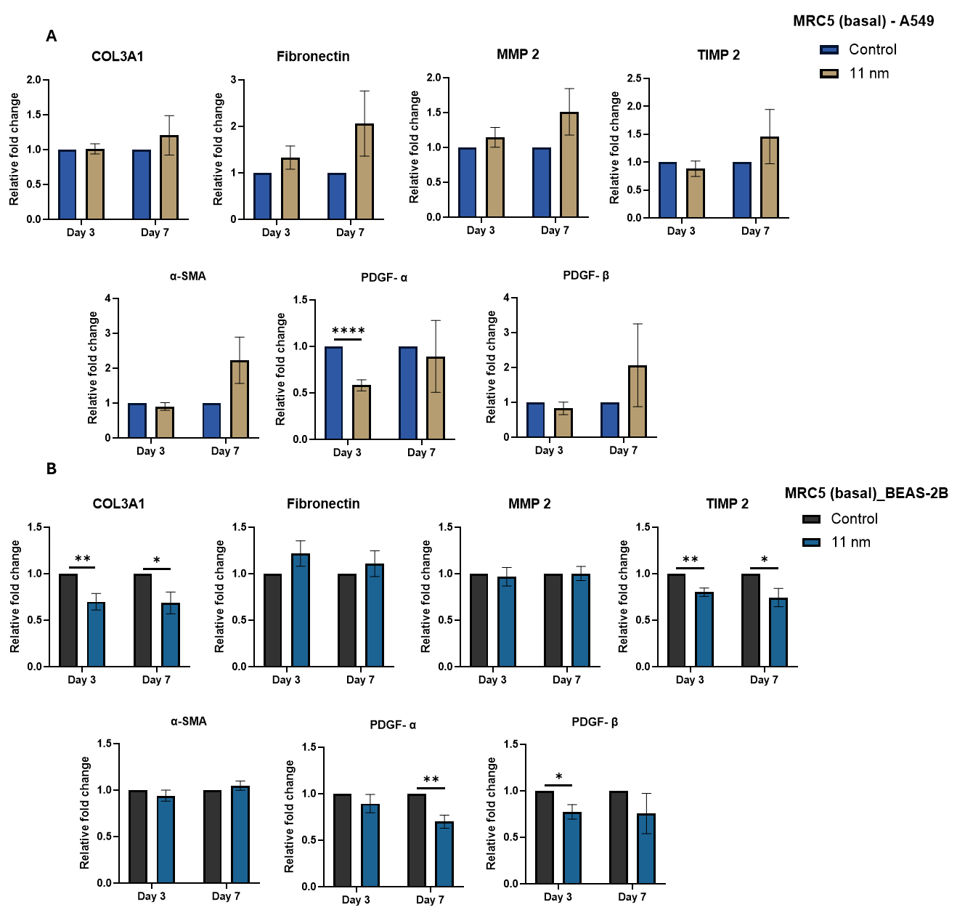

Supplementary Figure 5. Fibrogenesis and tissue remodeling in MRC5 co-cultured with A549 or BEAS-2B in transwell models
mRNA levels of matrix remodeling markers in MRC5 (basal) co-cultures with (A) A549 and (B) BEAS-2B on the apical side of a transwell model. Data presented as ± SEM (n=3). *p < 0.05, **p < 0.01.

