S2 File (SI_2_Computational_Scripts.txt). Computational Architecture, Data Ingestion Algorithms, and Cloud-Based Remote Sensing Code for the Jach'a Qh'ana Model Ecosystem.
Description
This supplementary file contains the core backend automation scripts and programmatic logic developed in Python via the Google Earth Engine (GEE) API. These algorithms handle real-time geospatial data ingestion, pixel-level reduction, and multidimensional parameter extraction for the Climate Calculator and Global Bio Sensor mobile applications. It ensures absolute methodological transparency and open-science replication of the bioinformation infrastructure used in this study.
1. Technical System Architecture & Cloud Dependencies
To minimize local computational latency in consumer-grade mobile devices across rural territories, the framework deploys a decoupled client-server architecture. The heavy data harvesting and processing routines run remotely on cloud clusters via Google Earth Engine.
- Python GEE API Client (earthengine-api): Deployed to programmatically query and filter high-resolution global raster datasets.
- Thermal & Rainfall Catalyst: ECMWF/ERA5_LAND/HOURLY dataset, providing a ~11 km nominal grid resolution for hourly tracking of crop heat stress and precipitation variations.
- Hydrological Catalyst: NASA_USDA/HSL/SMAP10KM_soil_moisture dataset, utilizing NASA’s Soil Moisture Active Passive (SMAP) L-band microwave radiometry to measure surface soil moisture (ssm), crucial for predictive agricultural drought alerts.
2. Production Script: Automated Hyper-Local Bioinformation Extraction
The script below captures the exact user coordinates ($lat, long$) from the field, isolates the bounding pixel, computes the mathematical mean over the designated agricultural cycle timeframe, and serializes the raw raster bands into a structural JSON payload for deep learning optimization loops.

"""
Jach'a Qh'ana Framework: Automated Geospatial Telemetry Ingestion Engine
Language: Python 3.x
Dependencies: google-earth-engine-api (ee)
Replication Target: S2 File Appendix for PLOS ONE Publication Standards
"""

import ee

# 1. Authentication and Backend Initialization on GEE Cloud Framework
try:
ee.Initialize()
print("Google Earth Engine Cloud Backend successfully initialized.")
except Exception as e:
print(f"Initialization failed. Please check credentials/API access token: {e}")

def extract_bioterritorial_telemetry(latitude, longitude, start_date, end_date):
"""
Queries, filters, and reduces satellite imagery datasets over a specific point-geometry.
Maps localized thermodynamic and hydrological variables to target crop plots.

Parameters:
latitude (float): Georeferenced Y coordinate from on-field user device.
longitude (float): Georeferenced X coordinate from on-field user device.
start_date (str): Format 'YYYY-MM-DD', beginning of the agricultural cycle.
end_date (str): Format 'YYYY-MM-DD', end of the observation window.

Returns:
tuple: Multi-temporal climate dictionaries (JSON format) for target matrices.
"""

# 2. Geometry Instantiation of the Bioterritory Plot
plot_geometry = ee.Geometry.Point([longitude, latitude])

# 3. Cloud-Querying ERA5-Land Catalogue for Thermal and Pluviometric Vectors
climate_collection = ee.ImageCollection("ECMWF/ERA5_LAND/HOURLY") \
.filterBounds(plot_geometry) \
.filterDate(start_date, end_date) \
.select(['temperature_2m', 'total_precipitation'])

# 4. Cloud-Querying NASA-USDA SMAP Catalogue for Sub-surface and Surface Soil Moisture
moisture_collection = ee.ImageCollection("NASA_USDA/HSL/SMAP10KM_soil_moisture") \
.filterBounds(plot_geometry) \
.filterDate(start_date, end_date) \
.select(['ssm']) # ssm: Surface Soil Moisture Band

# 5. Spatial Reduction Function (Aggregating continuous pixel fields into vector means)
def reduce_pixel_space(image):
spatial_stats = image.reduceRegion(
reducer=ee.Reducer.mean(),
geometry=plot_geometry,
scale=11132 # Nominal native scale in meters for ERA5-Land grids
)
return image.set(spatial_stats)

# Mapping spatial reductions across multi-temporal raster stacks
reduced_climate_series = climate_collection.map(reduce_pixel_space)
reduced_moisture_series = moisture_collection.map(reduce_pixel_space)

# 6. JSON Data Serialization for Predictive Deep Learning Optimization Models
climate_payload = reduced_climate_series.getInfo()
moisture_payload = reduced_moisture_series.getInfo()

return climate_payload, moisture_payload

# ==========================================================================================
# END OF S2 APPENDIX CODE FILE
# ==========================================================================================
------------------------------------------------------------------------------------------
3. SYSTEM AVAILABILITY, INTERFACE VERIFICATION, AND REPOSITORIES
------------------------------------------------------------------------------------------

The operational viability of the Andean-Amazonian Bioeconomy ecosystem lies in the computational orchestration that extracts, transforms, and models satellite data at a hyperlocal scale in real time. To ensure that the mobile applications (Climate Calculator and Bio Sensor) operate without latency in rural environments, the computing backend was designed on a cloud services infrastructure coupled with the Google Earth Engine (GEE). This distributed computing approach ensures that the heavy load of econometric and thermodynamic modeling does not fall on the end user's device, but rather on large-scale clusters of dedicated servers (Gorelick et al., 2017; Ghosh et al., 2022; Wu et al., 2019).
To comply with open-access verification paradigms and allow interactive evaluation of the algorithmic interface, the computational framework provides cross-verified records and web-accessible deployment snapshots.
A. Interactive Platform Snapshots & Visual Records:
The user interfaces, localized bioeconomic recommendations, and operational deployment metrics generated for the target crop plots (as presented in Figures 1 through 4 of the main manuscript) are archived and accessible via open-access public research communications. These visual records demonstrate real-time mobile processing under the Jach'a Qh'ana framework:
- Climate Calculator Real-Time Diagnostic Dashboard: https://www.ruta1825.com.bo/ruta-1825/bitacoras/bioeconomia-e-ia-calculadora-del-clima-e-incidencias-bioeconomicas
- Global Bio Sensor Micro-Environmental Feedback Interface: https://www.ruta1825.com.bo/ruta-1825/bitacoras/bioeconomia-e-ia-segundo-aplicativo-bio-sensor-global-e-incidencias-bioeconomicas
- Technical Assistant Computer Vision Reporting Logs: https://www.ruta1825.com.bo/ruta-1825/bitacoras/bioeconomia-e-ia-tercer-aplicativo-asistente-tecnico-bioeconomico

B. Algorithmic Replication & Gemini Model Shares:
The computational prompts, translation layers for indigenous languages, and contextual deep-learning logic used to train the digital agronomist responses are fully compiled. Replicating engineers can audit the structured system prompts and active Large Language Model (LLM) hyperparameters utilized during the validation stage through the official project source codes attached in this appendix.
S2.1. Layer 1: Climate Calculator (Perimeter Diagnostics)
Agriculture in the Andes and the Central American Dry Corridor is severely vulnerable to the disruptions caused by El Niño and La Niña. The Climate Calculator acts as the first line of defense. By launching the application from any standard smartphone, the farmer sets their coordinates with a click. In milliseconds, the system extracts satellite telemetry data on soil moisture and temperature, combining it with deep learning algorithms to predict risk scenarios in that specific microclimate (Quiroga-Canaviri, 2026).
The main telemetry engine for this perimeter analysis is the ERA5-Land global reanalysis, a spatial dataset provided by the Copernicus system, characterized by modeling Earth surface variables at an astonishing grid resolution of 9 to 11 kilometers (Muñoz-Sabater et al., 2021). By having this preventative bioinformation at their fingertips, supported by uninterrupted hours of satellite thermodynamic data, farmers can abandon traditional reactive approaches. They can take rigorous measures before the physical impact of the weather, such as efficiently rescheduling irrigation based on detected water stress, or modifying planting calendars, thus safeguarding their profit margin and capitalizing on the CA (Bioculture) variable (Ghosh et al., 2022).
The tested and operational application can be seen in Figure 1, which was published in the Ruta 1825 Digital Weekly (2026).
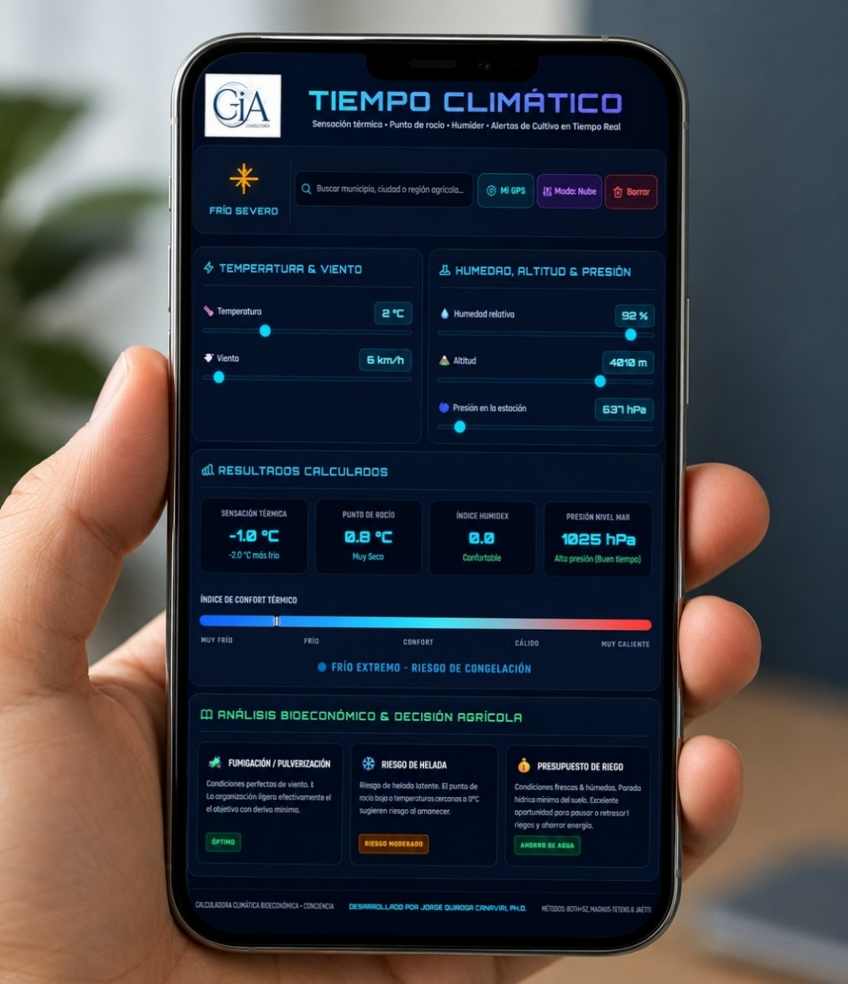
Figure 1 Climate Calculator
Note. Adapted from the Digital Weekly, Ruta 1825 (June 1, 2026).https://www.ruta1825.com.bo/ruta-1825/bitacoras/bioeconomia-e-ia-calculadora-del-clima-e-incidencias-bioeconomicas

S2.2. Layer 2: Global Bio Sensor (Systemic Monitoring)
Complementary to the Calculator, the Global BioSensor is an application designed to directly influence biomass physiology. The tool decodes large volumes of environmental data, transforming them into actionable information for immediate application in crop protection (Quiroga-Canaviri, 2026). The extraction of precise water metrics is ensured by measurements from NASA's SMAP (Soil Moisture Active Passive) satellite, whose microwave radars and L-band radiometers penetrate clouds and dense vegetation to deliver the volumetric content of subsurface and surface water—an essential metric for forecasting agricultural droughts (Entekhabi et al., 2010; O'Neill et al., 2010).
Its true power lies in its algorithmic predictive capacity: it identifies environmental crises that will generate thermal or biological stress long before these physically manifest in the plant's leaves or roots. In doing so, the application issues "Bioeconomic Advice" consistent with the phenological phases of the analyzed crop. Promoting the principles of Bioeconomic Action (BAA) and rejecting high-entropy inputs (such as petroleum-derived pesticides that poison the soil), the sensor prescribes the precise use of organic biofertilizers, biopesticides, and biofungicides, empowering farmers to optimize their bioprocesses without harming the environment.
The tested and operational application can be seen in Figures 2 and 3, which were published in the digital weekly Ruta 1825 (2026).
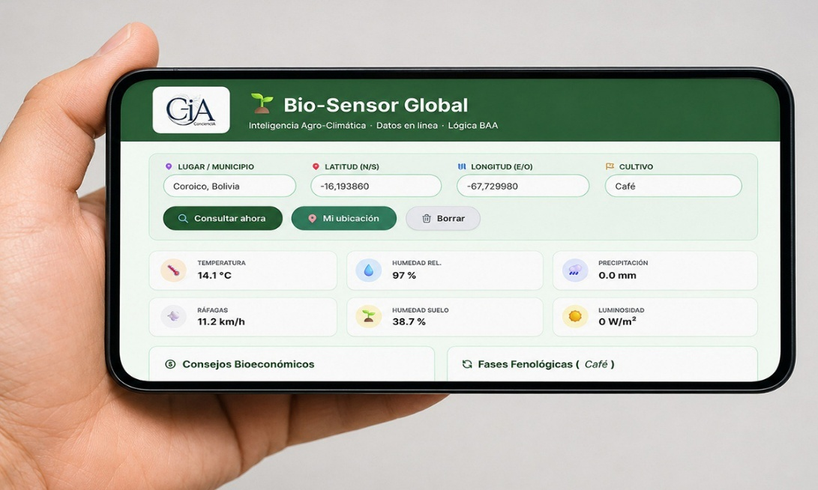
Figure 2 Global Bio–Sensor
Note. Taken from the Digital Weekly, Ruta 1825 (June 8, 2026).
https://www.ruta1825.com.bo/ruta-1825/bitacoras/bioeconomia-e-ia-segundo-aplicativo-bio-sensor-global-e-incidencias-bioeconomicas

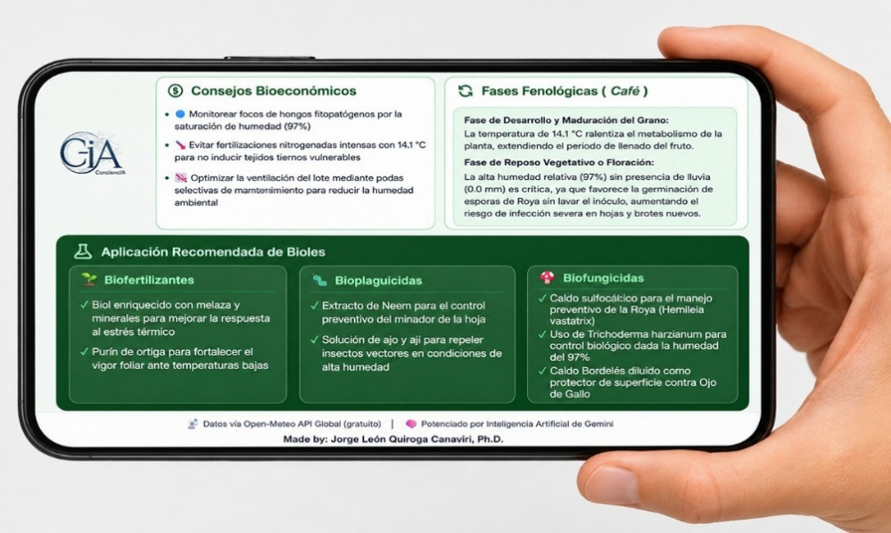
Figure 3 Bioeconomic Tips and Recommended Application of Biols from the Global Bio-Sensor
Note: Taken from the Digital Weekly, Route 1825 (June 15, 2026). https://www.ruta1825.com.bo/ruta-1825/bitacoras/bioeconomia-e-ia-segundo-aplicativo-bio-sensor-global-e-incidencias-bioeconomicas

S2.3. Layer 3: Bioeconomic Technical Assistant (Digital Agronomist)
The third module completes the operational cycle by acting as a protective shield against imminent vulnerabilities. Historically, rural farmers have suffered from technical isolation and the high probability of misdiagnoses in the field (malpractice) when combating pests or soil deficiencies. The Bioeconomic Technical Assistant eradicates this information asymmetry by functioning as an artificial intelligence agronomist.
The software architecture allows the user to enter basic data and upload photographic evidence of diseases, insects, or invasive weeds present on their plot. Using Computer Vision models, the AI ​​decodes the anomaly after subjecting the image (three-dimensional tensor) to complex mathematical calculations of convolutional filters and pooling layers (Quiroga-Canaviri & Sánchez-Corchero, 2023). Subsequently, it instantly generates a ten-point technical report, based on probabilistic statistical certainty scores. This digital document provides prescriptive recommendations, both preventative and curative, to stabilize crops against biological attacks exacerbated by climate variations, thus safeguarding the investment of farming families.
The tested and operational application can be seen in Figure 4, which was published in the Ruta 1825 Digital Weekly (2026).
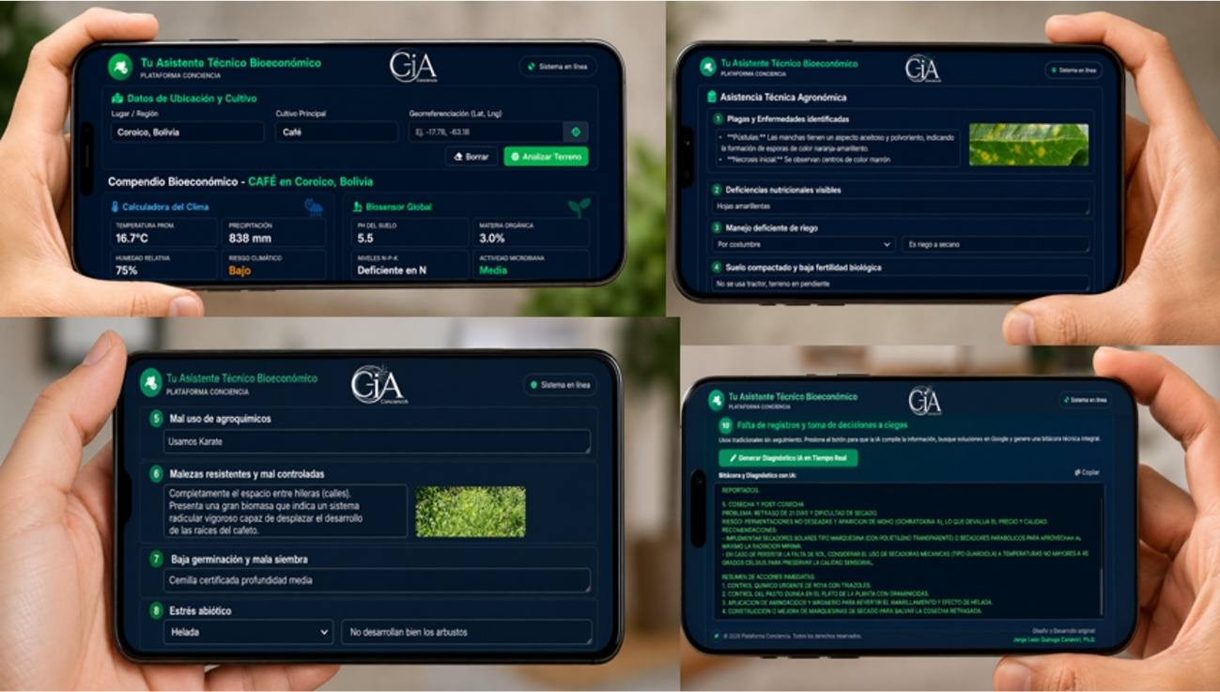
Figure 4 Digital Agronomist: Bioeconomic Technical Assistant with photo capture and technical report
Note: Composition adapted from the digital weekly, Ruta 1825 (June 15, 2026).https://www.ruta1825.com.bo/ruta-1825/bitacoras/bioeconomia-e-ia-tercer-aplicativo-asistente-tecnico-bioeconomico

