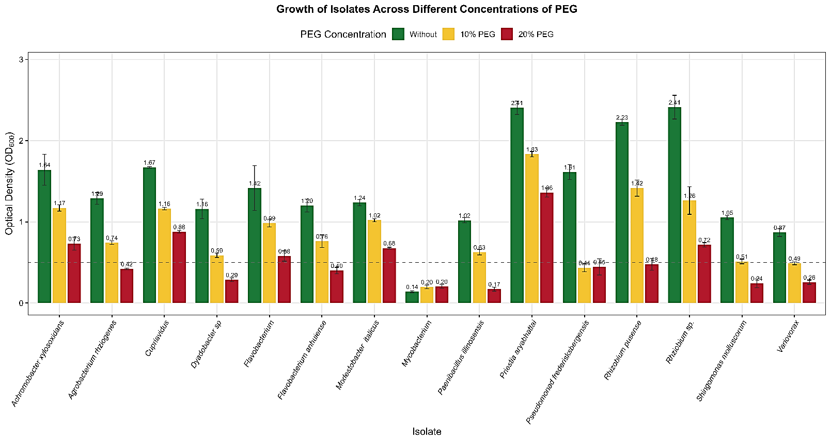Fig. S1 Growth of tested isolates (OD₆₀₀ measurements) in the presence of various concentrations of PEG₆₀₀₀ (0 %, 10%, 20 %). The majority of such isolates belonged to Pseudomonadota followed by Bacteroidota, Bacillota and Actinomycetota, respectively.

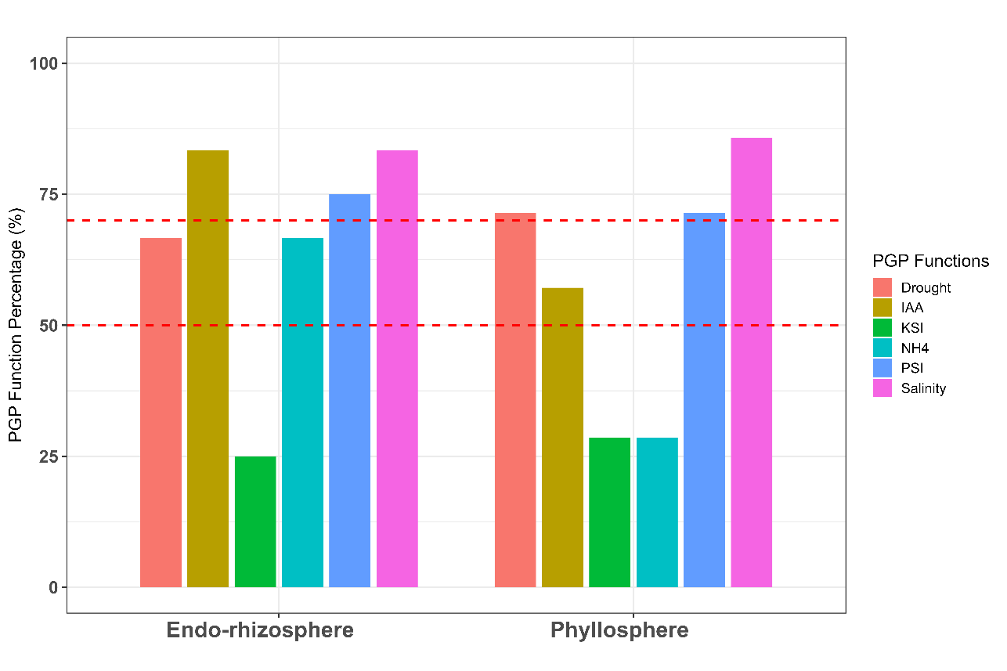
A

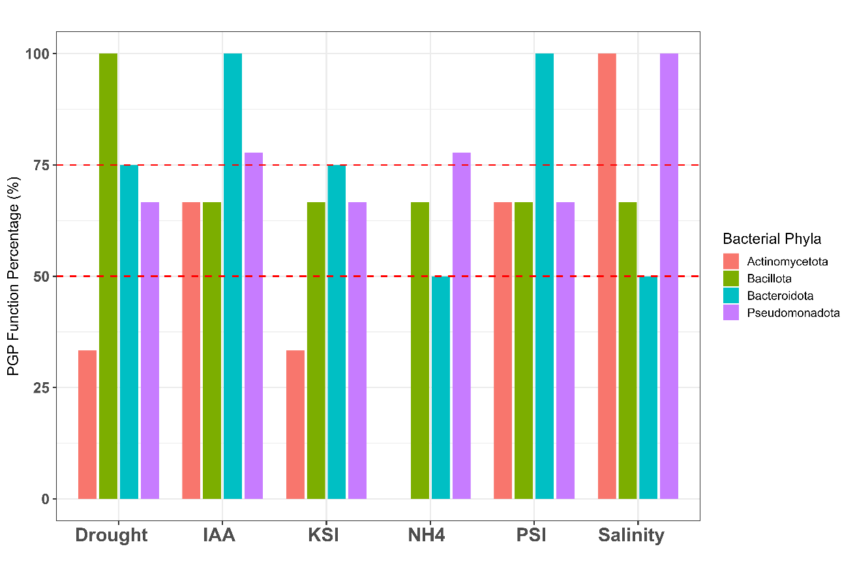
B

Fig. S2 Relative in vitro expressed PGP functions of representative tested isolates as affected by plant compartment (A) and microbiota phyla (B)

