Supporting Information
Post-print gold nanometallization tunes the architecture-dependent chemomechanics of 4D protein microstructures
Myrto Charitaki^{1,2 ᵼ} , Savvas Papamakarios^{1,3 ᵼ}, Maria Farsari^{1 *}
1: Institute of Electronic Structure and Laser, Foundation for Research and Technology-Hellas (FORTH/IESL), Heraklion, Crete, Greece
2: Department of Materials Science and Engineering, University of Crete, Heraklion, Crete, Greece
3: Department of Physics, National and Kapodistrian University of Athens, Athens, Greece
^{ᵼ}: These authors contributed equally.
*: Correspondence: Maria Farsari (mfarsari@iesl.forth.gr).

Contents
Spectroscopic characterization and optimization of the nanometallization process 3
Architectural compatibility of post-print nanometallization 5
Au-rich architecture-associated residues following calcination 7
Direction-dependent and cyclic pH response 8
Morphological verification of the response architectures 10
Short-term cyclic response and first-cycle recovery 11
References 13

Spectroscopic characterization and optimization of the nanometallization process
Representative ATR-FTIR spectra were acquired from air-dried, two-photon-polymerized BSA/CUR and BSA/CUR-Au films on glass. The BSA/CUR-Au films were prepared using two immersion–precipitation cycles, corresponding to the condition used in the subsequent experiments. Both spectra retained the principal protein-associated amide-I region at approximately 1641 cm⁻¹, attributed predominantly to peptide C=O stretching, and the amide-II region at approximately 1516–1529 cm⁻¹, associated mainly with N–H bending and C–N stretching vibrations (Supplementary Fig. 1a). These observations demonstrate persistence of the proteinaceous chemical environment following nanometallization. However, quantitative assessment of protein secondary structure requires resolution and deconvolution of the overlapping contributions within the amide-I region; retention of the principal amide bands alone cannot establish the absence of conformational changes or protein denaturation.^{1,2}
Representative Raman spectra of corresponding air-dried films also showed substantial differences following nanometallization (Supplementary Fig. 1b). In addition to changes in the relative intensities and profiles of the protein-associated bands, the BSA/CUR-Au spectrum contained a low-frequency feature near 254 cm⁻¹. This feature falls within the spectral range in which Au-S-associated vibrations have been reported for thiolate-protected gold systems. Nevertheless, Au-S vibrational frequencies depend strongly on the gold structure, coordination environment and ligand identity, and the present representative spectrum cannot independently establish a specific Au-S bonding configuration.^{3,4} The FTIR and Raman measurements are therefore treated as qualitative chemical fingerprints rather than quantitative measurements of protein conformation or interfacial bonding.
The evolution of the deposited phase was investigated after one, two and three immersion–precipitation cycles. SEM revealed nanoparticle-decorated struts under all three conditions, while the corresponding EDS maps and spectra confirmed Au signals after each cycle (Supplementary Fig. 1c). Analysis of 200 segmented nanoparticles per condition produced mean Feret diameters of 37.6 ± 10.3 nm after one cycle, 34.5 ± 8.9 nm after two cycles and 33.5 ± 7.3 nm after three cycles (Supplementary Fig. 1d). The distributions overlapped substantially and the mean Feret diameter did not increase monotonically with cycle number, indicating that additional immersion–precipitation cycles did not predominantly enlarge the individually resolved nanoparticles.
By contrast, the measured strut width increased progressively from 3.40 ± 0.34 μm after one cycle to 3.60 ± 0.15 μm after two cycles and 4.49 ± 0.42 μm after three cycles, based on three width measurements per condition (Supplementary Fig. 1e). The increase in strut width, despite the similar particle-size distributions, is consistent with cumulative deposition, increasing surface coverage and outward accumulation of the inorganic phase. Two immersion–precipitation cycles were therefore selected for the subsequent structural, pH-response, mechanical and spectroscopic experiments to balance extensive nanometallization with retention of geometric fidelity.
Local EDS composition was further evaluated using seven acquisitions obtained from different structures and experimental preparations after the two-cycle protocol. Using the original instrument-reported mass fractions without renormalization, the measurements produced average compositions of 44.08 ± 14.40 wt% C, 15.62 ± 7.40 wt% O and 37.78 ± 21.36 wt% Au (mean ± s.d.; Supplementary Fig. 1f). Nitrogen was quantified in one of the seven acquisitions at 17.72 wt% and was not reported in the remaining acquisitions; it was therefore retained as a detected value and was not imputed as zero or removed by renormalization. The variability in the Au fraction reflects the local, surface-sensitive character of EDS, differences in the selected acquisition regions and heterogeneity in the nanoparticle coverage. These measurements demonstrate reproducible local detection of Au but should not be interpreted as a measurement of the bulk gold content of the structures or as evidence of Au distribution throughout the interior of the struts.
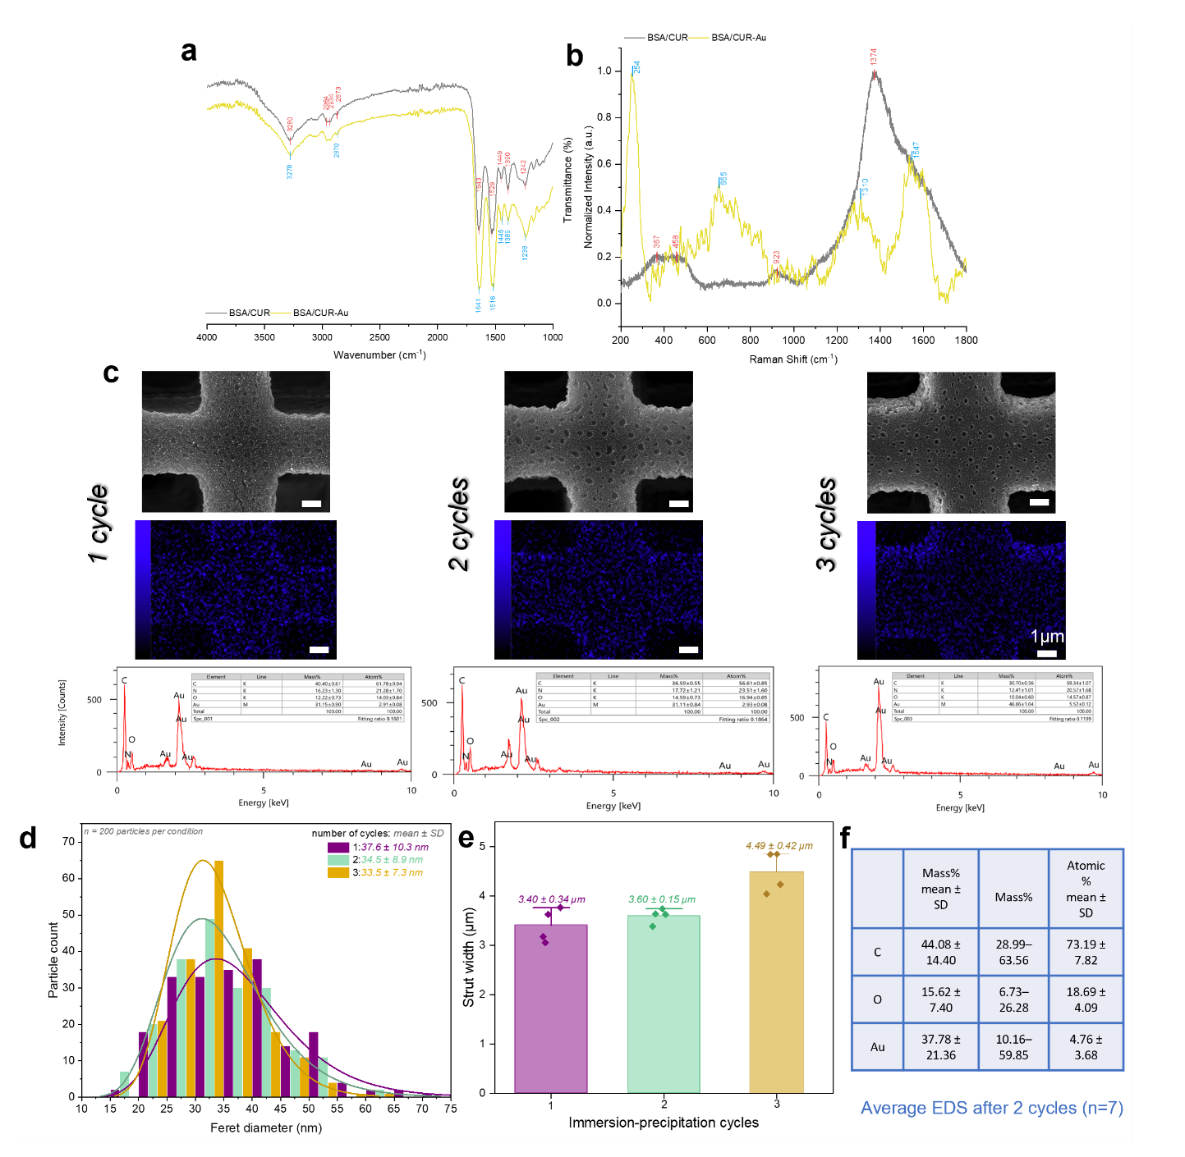
Supplementary Fig. 1: Spectroscopic characterization and cycle-dependent evolution of BSA/CUR-Au nanometallization. a, Representative ATR-FTIR spectra of air-dried, two-photon-polymerized BSA/CUR and BSA/CUR-Au films on glass. The BSA/CUR-Au film was subjected to two immersion-precipitation cycles. b, Representative baseline-corrected, smoothed and intensity-normalized Raman spectra of corresponding air-dried films. c, SEM images, corresponding Au EDS maps shown in blue and representative EDS spectra after one, two and three immersion-precipitation cycles. d, Feret-diameter distributions of 200 segmented nanoparticles per cycle condition. Reported values are mean ± s.d. e, Strut widths after one, two and three immersion-precipitation cycles. Bars show mean ± s.d. from three width measurements per condition; individual measurements are overlaid. f, Summary of the original instrument-reported mass fractions obtained from seven local EDS acquisitions on structures subjected to the two-cycle protocol. Nitrogen was quantified at one acquisition site and was not imputed for sites at which it was not reported. Scale bars are shown in the respective panels.

Architectural compatibility of post-print nanometallization
To assess whether the sequential fabrication process could be applied beyond the lattice used for material characterization, multiple three-dimensional architectures were fabricated from the same BSA/CUR photoresist and subsequently subjected to two immersion-precipitation cycles. SEM showed recognizable geometry after nanometallization across two gyroid variants, a volumetric mesh containing fine suspended connections, arrays of hollow microtowers, a flower-like structure and a three-dimensional chiral architecture designed for potential metamaterial applications (Supplementary Fig. 2).
The volumetric mesh retained interconnected features with dimensions extending to the micrometre and submicrometre scale, while higher-magnification imaging showed nanoparticle decoration across the exposed junctions. Similarly, the gyroids and hollow microtowers retained their characteristic internal openings and external architecture following the aqueous treatment, repeated reduction and washing steps. These structures demonstrate that defining the geometry before introducing the inorganic phase enables the same nanometallization protocol to be applied to topologically distinct architectures. The images were not used to quantitatively compare coating thickness or nanoparticle uniformity between designs.
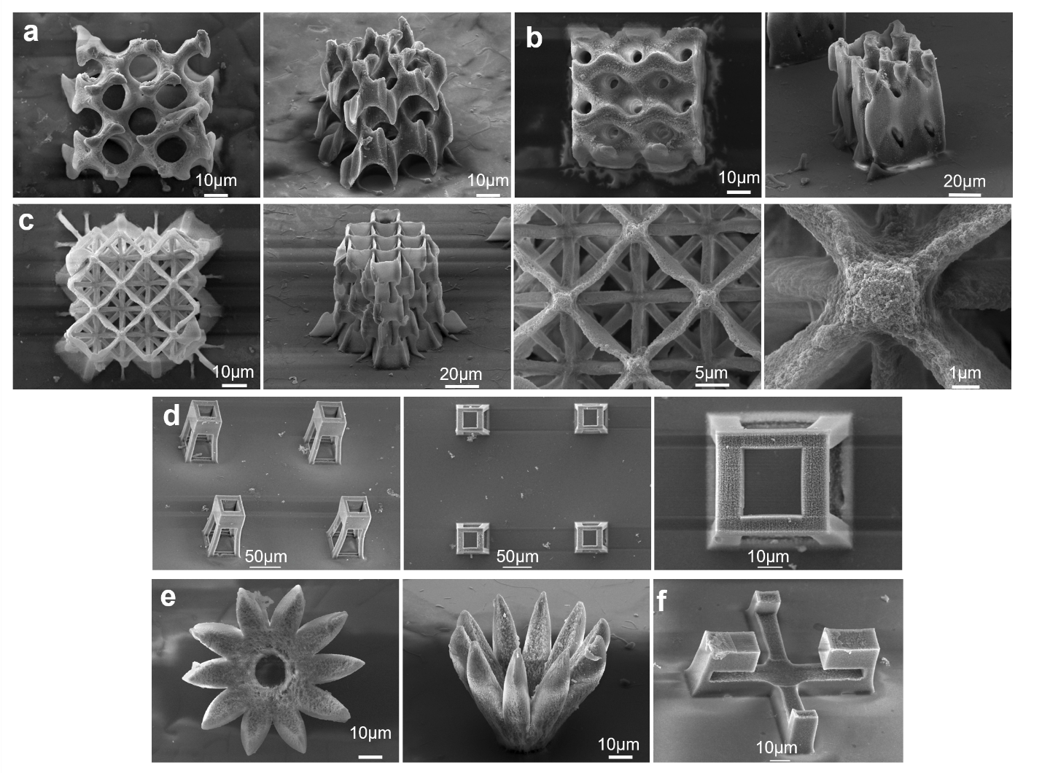
Supplementary Fig. 2: Architectural compatibility of the sequential fabrication and nanometallization process. SEM images of representative BSA/CUR-Au microarchitectures following two immersion–precipitation cycles. a,b, Two variants of gyroid architectures shown from different viewing directions. c, Volumetric mesh containing fine suspended and interconnected struts, together with progressively higher magnifications of representative connections and junctions. d, Arrays of hollow microtowers shown at different magnifications. e, Flower-like architecture shown from top and oblique viewing directions. f, Three-dimensional chiral architecture designed for potential metamaterial applications. These examples demonstrate retention of recognizable architecture-specific features after post-print nanometallization. Scale bars are shown in the respective panels.

Au-rich architecture-associated residues following calcination
Post-calcination characterization was performed as an exploratory proof-of-concept experiment to examine whether the deposited gold extended across the printed architectures sufficiently to leave an architecture-associated inorganic residue after removal of most of the organic matrix. BSA/CUR-Au square lattices and flower-like structures were fabricated on quartz substrates, subjected to two immersion-precipitation cycles and calcined in a TL 1100-8 furnace (Thermolab/Borel) in ambient air. The temperature was increased to 900 °C at 1 °C min⁻¹, maintained at 900 °C for 1 h and subsequently decreased at 1 °C min⁻¹. Calcination was used only as an analytical proof of concept and not as the intended endpoint of the BSA/CUR–Au hybrid platform. Related hydrogel-infusion approaches instead use thermal removal of the organic template as a primary manufacturing step for producing metal or ceramic replicas.^{5,6}
Following calcination, porous residues remained attached to the quartz substrate at the positions of both printed architectures (Supplementary Fig. 3a,b). The square-lattice residue retained a recognizable overall outline and pore arrangement, although substantial surface coarsening, porosity and local deformation were evident. The calcined flower-like residue underwent more pronounced geometric transformation, including inward movement and closure of its petal-like elements. These observations demonstrate that the final morphology is strongly affected by the starting architecture and thermal treatment, and that the furnace conditions and design would require further optimization if shape-preserving metallic replicas were desired.
Local EDS was acquired from the calcined residue without sputter coating. The measured composition was 91.43 wt% Au, 3.15 wt% C and 5.41 wt% O, corresponding to 43.58 at% Au, 24.65 at% C and 31.77 at% O (Supplementary Fig. 3c). The high local Au fraction demonstrates that the immersion-precipitation process deposited sufficient inorganic material across the printed architecture to leave an Au-rich residue after calcination. However, because the measurement was local and the experiment was exploratory, it does not quantify the bulk composition, calcination yield or shrinkage of the complete structure. Similarly, retention of an Au-rich residue after thermal treatment does not independently establish that a continuous, load-bearing gold network existed before calcination or that nanoparticles were distributed throughout the interior of the protein struts.

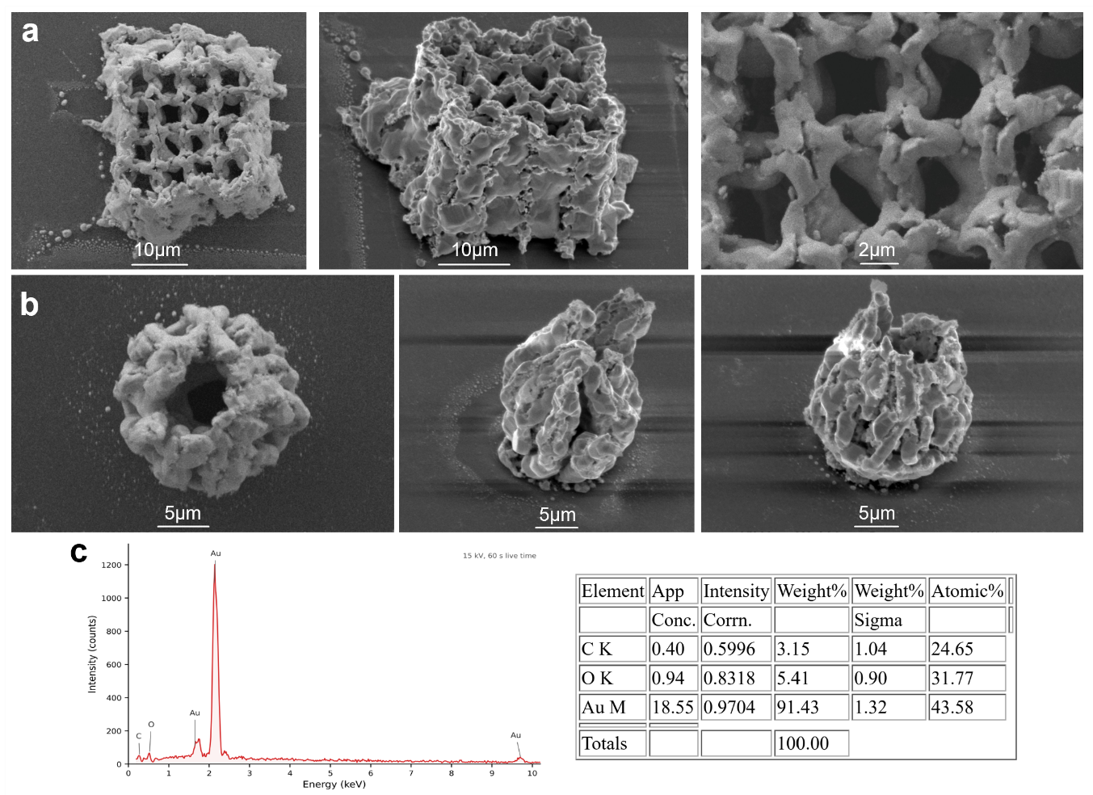
Supplementary Fig. 3: Au-rich architecture-associated residues remaining after calcination of BSA/CUR–Au structures. All SEM images show structures after calcination in ambient air at 900 °C. a, SEM images of a calcined square-lattice residue remaining attached to a quartz substrate, shown from different viewing directions and at progressively higher magnifications. The recognizable lattice outline is retained despite substantial coarsening and porosity. b, SEM images of a calcined flower-like residue remaining attached to quartz, showing deformation and closure of its petal-like elements. c, Representative local EDS spectrum and instrument-reported composition acquired from an unsputtered calcined residue. The measured composition was 91.43 wt% Au, 3.15 wt% C and 5.41 wt% O. Scale bars are shown in the respective panels.

Direction-dependent and cyclic pH response
To provide the complete dimensional datasets underlying Figs. 2 and 3, absolute and normalized measurements were examined throughout five consecutive pH cycles (Supplementary Fig. 4). For every cycle, the hydrated structures were sequentially exposed to pH 7.4, 4.7, 2.5, 7.4, 9.0, 11.5 and 7.4. Normalized dimensional change was calculated relative to the intermediate pH 7.4 measurement within the same cycle:
$$ΔD\left(\%\right)=\frac{D_{pH}-D_{7.4}}{D_{7.4}}×100$$
The absolute lateral dimensions reproduced the contraction–expansion sequence during each cycle, with substantially larger dimensional excursions in BSA/CUR cubes and tori than in their BSA/CUR-Au counterparts (Supplementary Fig. 4a). Normalization to the intermediate pH 7.4 state enabled comparison between independently fabricated structures of different initial sizes and showed that the difference between the two compositions persisted throughout all five cycles (Supplementary Fig. 4b). Reversible pH-dependent dimensional changes have previously been reported in multiphoton-fabricated BSA hydrogels, although their magnitude depends on photoresist composition, architecture, constraint and the surrounding ionic environment.^{7–9}
The absolute and normalized height measurements similarly showed that the out-of-plane response depended strongly on architecture (Supplementary Fig. 4c,d). Non-metallized roofed tubular lattices exhibited the largest alkaline expansion but also the most pronounced reduction in actuation range over repeated cycles. The corresponding BSA/CUR-Au lattices displayed a substantially smaller deformation amplitude and a shallower cycle-dependent decline. The cubes exhibited smaller vertical changes, emphasizing that network swelling was translated differently by solid and open-lattice architectures.
Analysis of torus wall thickness separated local strut swelling from the overall change in torus diameter. The BSA/CUR wall thickness increased from approximately 27 µm at pH 7.4 to 49 µm at pH 11.5, whereas the BSA/CUR-Au wall thickness increased only from approximately 25 to 27 µm (Supplementary Fig. 4e). The corresponding pH 11.5-to-pH 7.4 ratios remained distinct across the five cycles, with no clear monotonic cycle-dependent trend in either composition (Supplementary Fig. 4f). The regression lines are therefore presented as descriptive fits and were not subjected to inferential statistical testing.
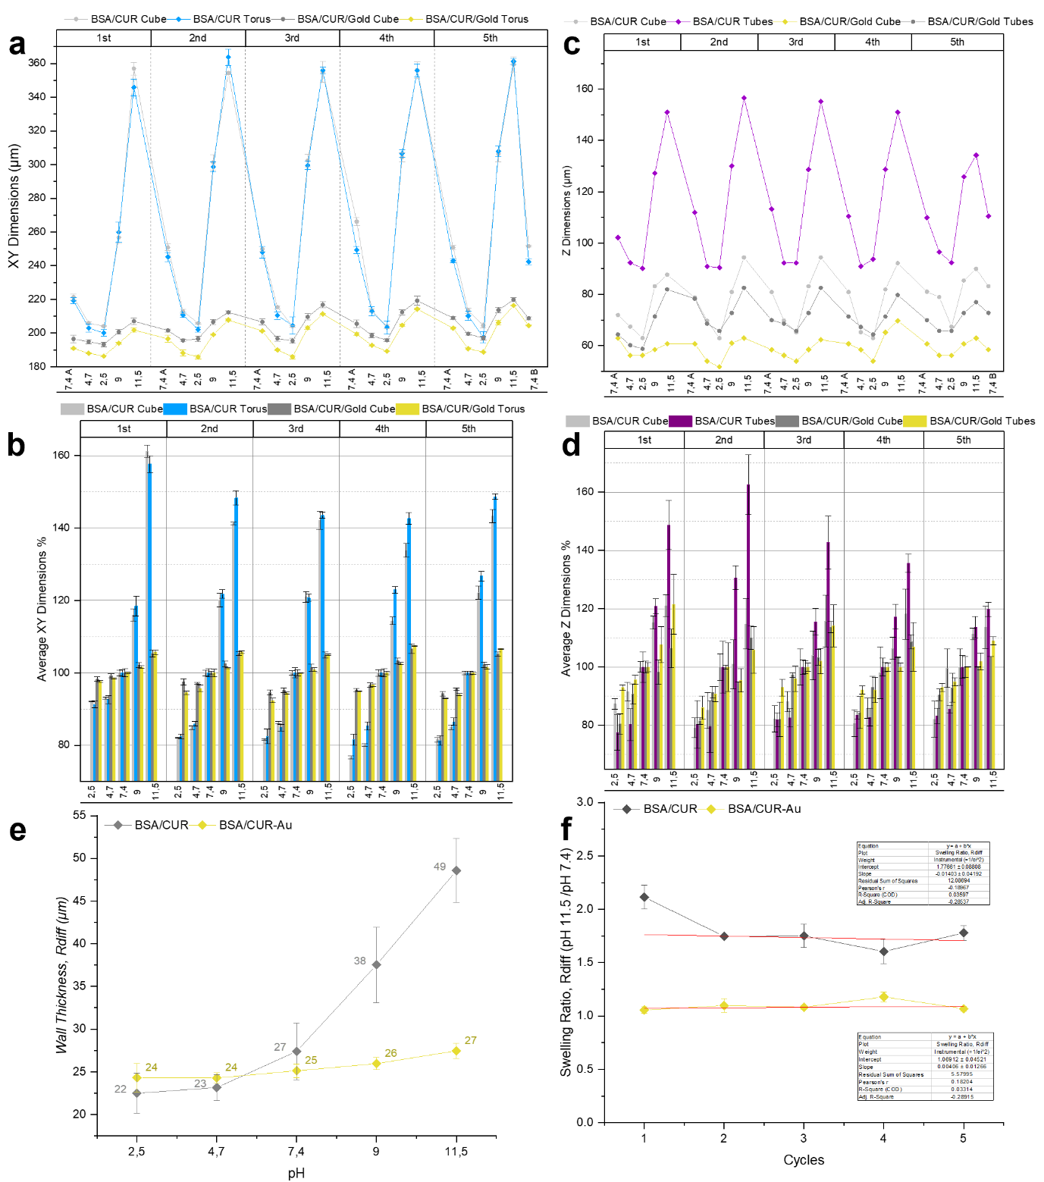
Supplementary Fig. 4: Complete lateral and vertical pH-response datasets. a, Absolute XY dimensions of BSA/CUR and BSA/CUR–Au cubes and tori throughout five pH cycles. b, Corresponding normalized lateral dimensions, expressed relative to the intermediate pH 7.4 measurement within each cycle. c, Absolute Z dimensions of BSA/CUR and BSA/CUR–Au cubes and roofed tubular lattices throughout five cycles. d, Corresponding normalized vertical dimensions. e, Torus wall thickness, $t_{wall}=(D_{out}$- $D_{in}$)/2, as a function of pH. f, Wall-thickness ratio $t_{wall}\left(pH 11.5\right)/t_{wall}\left(pH 7.4\right)$over five cycles; red lines are descriptive linear fits. Data are mean ± s.d. from (n=3) independently fabricated structures per material and geometry; the same structures were followed throughout all five cycles.

Morphological verification of the response architectures
SEM imaging confirmed the dry-state morphology of the BSA/CUR-Au architectures used for the vertical-response and compression experiments (Supplementary Fig. 5a). The roofed tubular lattice contained diagonally interconnected walls supporting a continuous upper plate, which provided a defined surface for optical height measurements and subsequent contact with the compression platen. SEM images of the spiral architecture used for qualitative visualization of pH-driven deformation are shown in Supplementary Fig. 5b. All structures received two immersion-precipitation cycles and were additionally sputter-coated with gold for SEM imaging; these micrographs are therefore used only to document architecture and not to determine elemental composition.
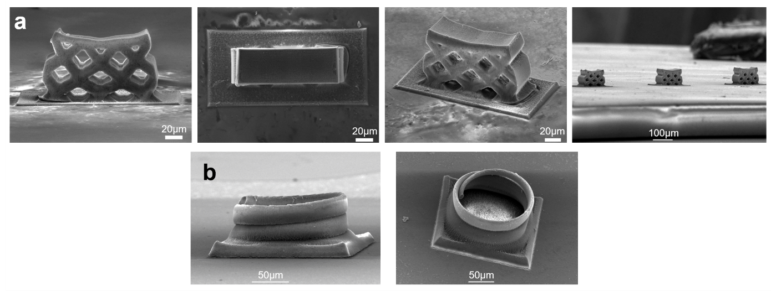
Supplementary Fig. 5: Architectures used for vertical-response measurements, compression and qualitative pH actuation. a, SEM images of BSA/CUR-Au roofed tubular lattices shown from different orientations and magnifications. The continuous upper plate provided a defined surface for height measurement and compression-platen contact. b, SEM images of BSA/CUR-Au spiral architecture. All structures underwent two immersion-precipitation cycles and were subsequently sputter-coated with gold for SEM imaging. Scale bars are shown in the panels.

Short-term cyclic response and first-cycle recovery
Short-term mechanical repeatability was evaluated by comparing the maximum nominal compressive stress measured during the third and first loading cycles. The third-to-first-cycle maximum-stress retention was calculated separately for each structure as $σ_{\max{,}3}/σ_{\max{,}1}×100$ and then averaged across three independently fabricated structures. Mean retention was 102% for BSA/CUR cubes, 87% for BSA/CUR–Au cubes, 84% for BSA/CUR roofed tubular lattices and 94% for BSA/CUR-Au roofed tubular lattices (Supplementary Fig. 6a).
First-cycle residual strain was read at the end of the first unloading step. Mean residual strains were approximately 0.4%, 0.7%, 0.3% and 0.5% for BSA/CUR cubes, BSA/CUR-Au cubes, BSA/CUR roofed tubular lattices and BSA/CUR-Au roofed tubular lattices, respectively (Supplementary Fig. 6b). These descriptive measurements indicate limited residual deformation following the initial compression and maximum-stress retention of 84-102% by the third cycle. No inferential statistical comparisons were performed for these metrics, and the three-cycle experiment is not interpreted as a long-term fatigue assessment.
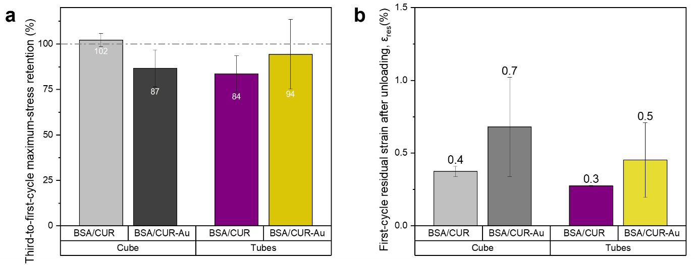
Supplementary Fig. 6: Short-term cyclic response and residual deformation of compressed microstructures. a, Third-to-first-cycle maximum-stress retention, calculated separately for each structure. The dashed horizontal line denotes 100% retention. b, First-cycle residual strain read at the end of the first unloading step. Bars represent mean ± s.d. for (n=3) independently fabricated structures. The data are presented descriptively; no inferential statistical comparisons were performed.

References
1. Usoltsev, D., Sitnikova, V., Kajava, A. & Uspenskaya, M. Systematic FTIR spectroscopy study of the secondary structure changes in human serum albumin under various denaturation conditions. Biomolecules 9, (2019).
2. Bhattacharjee, T. T. et al. FTIR study of secondary structure changes in Epidermal Growth Factor by gold nanoparticle conjugation. Biochim. Biophys. Acta Gen. Subj. 1862, 495–500 (2018).
3. Rashid, U. et al. Chemistry of the Au-Thiol Interface through the Lens of Single-Molecule Flicker Noise Measurements. J. Am. Chem. Soc. 146, 9063–9073 (2024).
4. Varnholt, B. et al. Structural Information on the Au–S Interface of Thiolate-Protected Gold Clusters: A Raman Spectroscopy Study. The Journal of Physical Chemistry C 118, 9604–9611 (2014).
5. Saccone, M. A., Gallivan, R. A., Narita, K., Yee, D. W. & Greer, J. R. Additive manufacturing of micro-architected metals via hydrogel infusion. Nature 612, 685–690 (2022).
6. Ji, Y., Hong, Y., Bhandari, D. R. & Yee, D. W. Hydrogel-Based Vat Photopolymerization of Ceramics and Metals with Low Shrinkages via Repeated Infusion Precipitation. Advanced Materials 38, (2026).
7. Kaehr, B. & Shear, J. B. Multiphoton fabrication of chemically responsive protein hydrogels for microactuation. Proceedings of the National Academy of Sciences 105, 8850–8854 (2008).
8. Lay, C. L., Lee, Y. H., Lee, M. R., Phang, I. Y. & Ling, X. Y. Formulating an Ideal Protein Photoresist for Fabricating Dynamic Microstructures with High Aspect Ratios and Uniform Responsiveness. ACS Appl. Mater. Interfaces 8, 8145–8153 (2016).
9. Wei, S. et al. Protein-Based 3D Microstructures with Controllable Morphology and pH-Responsive Properties. ACS Appl. Mater. Interfaces 9, 42247–42257 (2017).

