Supplementary
A Miniaturized Mid-Infrared Spectrometer Enabled by Hybrid Encoding of q-BIC Thermal Emitters with Uncooled Imaging
Long Wen#, Qinke Liu#, Yuyang Wang, Zikun Xia, Yiyao Lu, Yucong Huang, Yang Zhang*, Qin Chen* and Baojun Li*
Jinan University, College of Physics & Optoelectronic Engineering, Institute of Nanophotonics, Guangdong Provincial Key Laboratory of Nanophotonic Manipulation, Guangzhou, China

S1. Material parameters for the simulations
S2. Device fabrication
S3. Optical measurements
S4. Further numerical calculation results
S5. q-BIC source encoding and background suppression
S6. Spectral reconstruction
S7. Quantitative evaluation of spectral reconstruction quality
S8. Polymer classification and PMMA concentration analysis
S9. PAA-PI thermal imidization process

S1. Optical measurements
All experiments were conducted at an ambient temperature of 25 °C and a relative humidity of approximately 40% to ensure consistent environmental conditions across FTIR calibration and thermal-camera measurements. The thermal emission spectra of the fabricated q-BIC metasurface emitters were measured using a Fourier-transform infrared (FTIR) spectrometer (VERTEX 70V, Bruker) equipped with a liquid-nitrogen-cooled mercury cadmium telluride (MCT) detector. As illustrated in Supplementary Fig. S1, the metasurface sample was mounted on a miniature heater and heated to the target temperatures to generate thermal emission. The heater incorporated real-time temperature monitoring and proportional-integral-derivative (PID) feedback control, maintaining the temperature fluctuation within ±1 °C of the set point. Spectra were recorded only after the sample temperature had stabilized at each set point. For spectral normalization, a high-emissivity graphite reference was used as the blackbody standard. The metasurface sample and the graphite reference were mounted at the same position on the heater and measured separately under identical temperature and optical-collection conditions. The blackbody-reference spectrum measured by the FTIR is related to the theoretical blackbody spectral exitance through the common instrumental throughput and collection geometry, yielding the absolute emissivity as the ratio of the sample emission to the blackbody reference:
$ε_{i }\left(T_{n},λ\right)= \frac{L_{CH_{i}} \left(T_{n},λ\right)}{L_{\begin{aligned}BB \\ \end{aligned}} \left(T_{n},λ\right)}$ (Eq. S1)
In Eq. (S2), the numerator and denominator represent the background-subtracted FTIR spectra of the i-th q-BIC channel and the blackbody reference, respectively, both measured at the same temperature. The resulting quantity is the absolute emissivity of the corresponding channel. To eliminate the instrumental response and facilitate comparison across different channels, we further define the relative emissivity of each channel as:
$ε_{i}^{'}\left(T_{n}, λ\right) = \frac{L_{CH_{i}} \left(T_{n},λ\right)-L_{CH_{r}} \left(T_{n},λ\right)}{L_{\begin{aligned}BB \\ \end{aligned}} \left(T_{n},λ\right)-L_{CH_{r}} \left(T_{n},λ\right)}$ (Eq. S2)
The reference term is the background-subtracted spectrum of the non-resonant on-chip region. The prime denotes reference correction and is not a derivative. The numerator isolates the q-BIC-associated contribution relative to the reference region, whereas the denominator normalizes it to the available radiative contrast between the equivalent blackbody and the reference region. This definition was used to construct the resonance-dominated response library employed in the subsequent camera model and spectral reconstruction.
To suppress out-of-field thermal radiation and restrict the angular acceptance of the measurement, two apertures with a fixed separation were positioned between the thermal emitter and the FTIR interferometer. The first aperture primarily served as a field stop to reduce environmental and adapter-generated thermal backgrounds, whereas the second aperture defined the collection cone of the emitted radiation. The transmitted emission subsequently passed through a long-pass filter before entering the interferometer, where it was divided by the beam splitter, reflected by the fixed and moving mirrors, recombined and detected by the MCT detector.
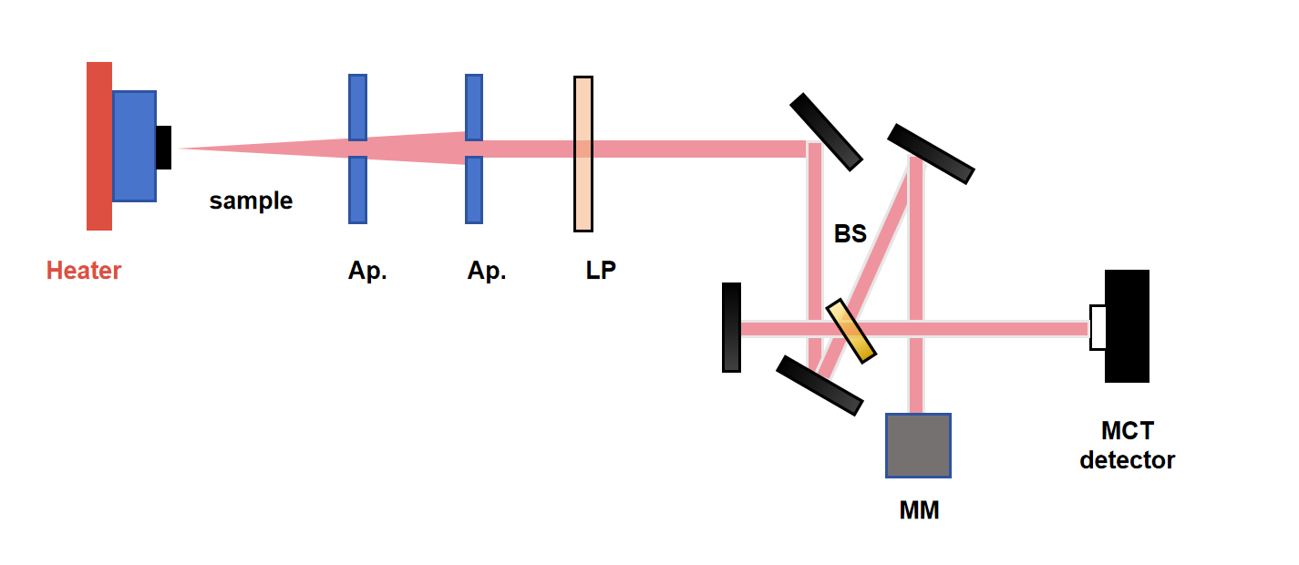
Figure S1. FTIR-based thermal-emission measurement configuration. The q-BIC metasurface emitter was mounted on a PID-controlled miniature heater. Its thermal emission sequentially passed through two apertures used for background suppression and angular-aperture control, followed by a long-pass filter, before entering the FTIR interferometer. The beam was divided and recombined by the beam splitter after reflection from the fixed and moving mirrors, and the resulting interferogram was recorded using a liquid-nitrogen-cooled MCT detector.

S2. Device fabrication
The complete sample-fabrication process is illustrated in Supplementary Fig. S2. A 5 nm thick titanium adhesion layer and a 120 nm thick gold back reflector were sequentially deposited onto a silicon substrate by electron-beam evaporation (EBE) at a base pressure of 3.75×10⁻⁷ Torr and a deposition rate of 0.6 Å/s. Using the same deposition system, a 500 nm thick ZnS spacer layer and a 700 nm thick Ge layer were subsequently deposited at rates of 2 and 1.5 Å/s respectively. PMMA 950 A4 resist (Kayaku Advanced Materials) was spin-coated onto the Ge surface at 4000 rpm for 60 s and baked at 180 ℃ for 90 s, yielding a resist thickness of approximately 180 nm. The inverse designed metasurface patterns were exposed using a 100-kV electron-beam lithography system (EBPG5150, Raith B.V.). The exposed resist was developed in a 1:3 mixture of methyl isobutyl ketone and isopropyl alcohol (MIBK: IPA) for 120 s, followed by rinsing in IPA for 30 s. After that, 30 nm thick Al₂O₃ layer was then deposited by electron-beam evaporation at 1.5Å/s. After lift-off, the patterned Al₂O₃ layer served as a hard mask for transferring the metasurface pattern into the underlying Ge layer by inductively coupled plasma reactive-ion etching (ICP-RIE; PlasmaPro 100 Cobra, Oxford Instruments). The remaining Al₂O₃ mask was removed by immersion in a 2.38% aqueous tetramethylammonium hydroxide (TMAH) solution for 60 s, followed by thorough rinsing with deionized water.
To assess compatibility with scalable fabrication, the metasurface patterns were additionally defined using a UV photolithography process. S1805 positive photoresist (Shipley) was spin-coated onto the sample at 4000 rpm for 60 s and soft-baked at 100 ℃ for 60 s. The metasurface patterns were subsequently exposed using a DWL66+ direct laser writing system (Heidelberg Instruments Mikrotechnik GmbH, Heidelberg, Germany) and developed to form the patterned resist mask. The resulting pattern was transferred into the Ge layer using the same hard-mask deposition and ICP-RIE procedure described above.
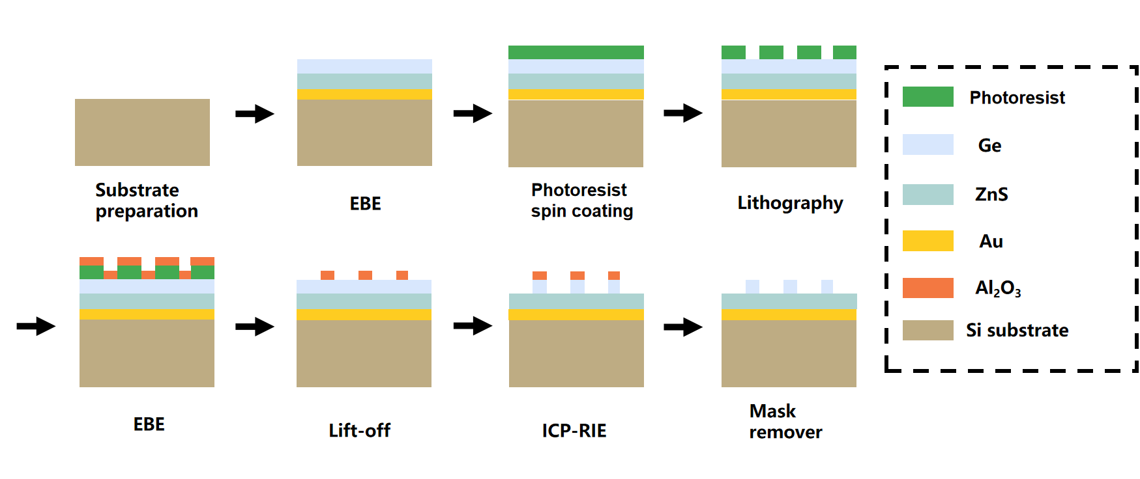
Figure S2. Process flow of the q-BIC sample fabrication.

S3. Material parameters for the simulations
The wavelength-dependent optical constants of the e-beam-evaporated ZnS and Ge films were taken from Amotchkina et al., who experimentally characterized the refractive indices and extinction coefficients of these materials over 0.4–12 μm. The reported optical constants were imported into the numerical solver as wavelength-dependent material functions. The optical response of the Au back-reflector was described using a Drude dispersion model.
To incorporate the thermo-optic response of Ge, the room-temperature refractive index reported by Amotchkina et al. was used as the baseline, while its temperature-dependent variation was determined from the wavelength- and temperature-dependent dispersion relation reported by Li, following the temperature-mapping treatment used for thermally tunable Ge metasurfaces. The same linear relation was used to calculate the Ge refractive indices at 473, 523, 573, 623, and 673 K. Because the recommended temperature range of Li’s Ge model extends to 550 K, the refractive indices at 573, 623, and 673 K were obtained by linearly extrapolating the temperature–refractive-index relationship. These extrapolated values were used only to describe the temperature-induced resonance shift in the numerical model. The extinction coefficient of Ge was retained at its room-temperature value because a validated temperature-dependent loss dataset was not included in the model.

S4. Further numerical calculation results
The far-field radiation of the q-BIC mode is governed by the in-plane asymmetry angle α. In the symmetry-preserving configuration, the ideal BIC remains decoupled from the free-space radiation continuum despite its strong field confinement. Introducing a finite $\text{α}$ breaks the in-plane symmetry and opens a radiative leakage channel, converting the ideal BIC into a far-field-accessible q-BIC. The resulting response is determined by the competition between radiative and absorptive losses, with the total quality factor satisfying:
$\frac{1}{Q_{tot}}=\frac{1}{Q_{rad}}+\frac{1}{Q_{abs}}$ (Eq. S3)
A small asymmetry maintains a high Q-factor but produces weak far-field emission, resulting in a low camera signal. Increasing $\text{α}$ strengthens the radiative coupling and raises the peak emissivity until the radiative and absorptive loss rates become approximately balanced. This critical-coupling condition produces the maximum thermal-emission intensity. A further increase in $\text{α }$drives the system into the over-coupled regime, where excessive radiative leakage broadens the resonance, reduces the Q-factor and lowers the peak emissivity. The calculated spectra show that 10°, 15°, 25° correspond approximately to the under-coupled, critically coupled and over-coupled regimes, respectively. Among these conditions, $\text{α}$=15° provides the most favourable compromise between peak emissivity, linewidth, off-resonant background and far-field signal strength, and was therefore selected for the hybrid encoding emitters.
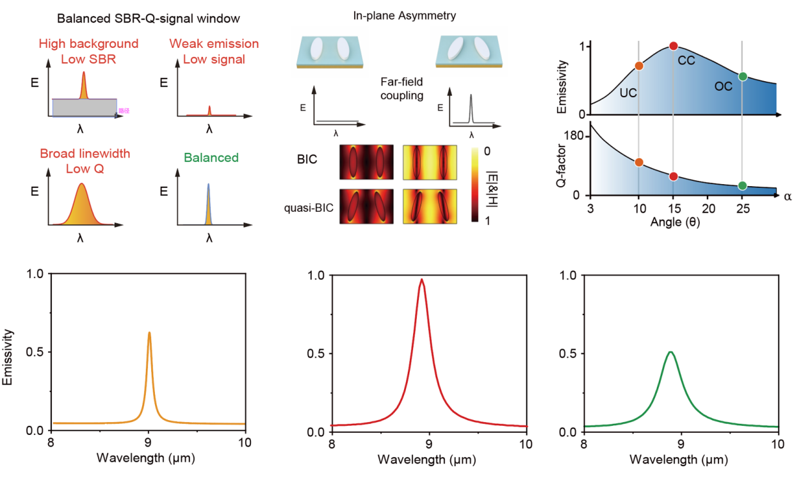
Figure S3. Selection of the in-plane asymmetry angle for balanced q-BIC thermal emission. The upper-left schematics illustrate the competing requirements of low off-resonant background, sufficient far-field signal and narrow linewidth. The upper-middle panel shows the transition from an ideal BIC to a radiative q-BIC through in-plane symmetry breaking, together with the corresponding magnetic-field distributions. The upper-right panel presents the calculated peak emissivity and Q-factor as functions of the asymmetry angle $\text{α}$, identifying the under-coupled (UC), critically coupled (CC) and over-coupled (OC) regimes. The lower panels show representative emission spectra at 10°, 15° and 25°, respectively.

S5. q-BIC source encoding and background suppression
Definition of the encoding states and measurement conditions
Let $g$=1,…,M index the geometric channels, where M=8, and let n=1,…,N index the temperature states, where N=5. Each combination of geometry and temperature defines one hybrid encoding state:
$i = (g-1) N+n, i = 1 ,…, I, I = M×N =40$ (Eq. S4)
here, M and N denote the total numbers of geometric and temperature states, respectively, whereas g and n identify a particular state. The emitter temperature associated with state $i$ is denoted by Tₙ.
The measurement condition is indexed by u∈{0,m}, where u=0 denotes the blank measurement and u=m denotes measurement with material m. Their corresponding transmittance spectra are defined as:
$τ_{0}\left(λ\right)= 1, τₘ\left(λ\right)= xₘ\left(λ\right) , u∈\{0,m\}$ (Eq. S5)
The region index p∈{q,r} identifies either the q-BIC emitter region p=q or its paired non-resonant reference region p=r. These regions correspond to CHᵢ and CHᵣ, respectively, in Fig. 4.

Source-encoded radiative signal formation
At encoding state $i$, the emitter is maintained at $T_{n}$, whereas the material and surrounding environment are assumed to remain at $T_{a}$. The spectral radiative contribution leaving the material towards the camera is written as:
$$L_{p,i}^{\left(u\right)}\left(λ\right)=τ_{u }{\left(λ\right)ε}_{p,i }{\left(λ\right)M}_{\left(bb\right)}\left(λ,T_{n}\right)+τ_{u }\left(λ\right)\left[1-ε_{p,i }\left(λ\right)\right]M_{\left(bb\right)}\left(λ,T_{a}\right)+$$
$\left[1-τ_{u}\left(λ\right)\right]M_{\left(bb\right)}\left(λ,T_{a}\right)$(Eq. S6)
where $ε_{p,i }\left(λ\right)$ is the emissivity of region p at encoding state $i$, and $M_{\left(bb\right)}\left(λ,T\right)$ is the Planck blackbody spectral exitance at temperature $T$. The three terms represent, respectively: (i) thermal emission from the heated chip transmitted through the material; (ii) ambient radiation reflected by the opaque chip and subsequently transmitted through the material; and (iii) the combined contribution of material thermal emission and front-side reflected ambient radiation. This form separates the spatially common ambient contribution from the temperature-dependent signal encoded by the emitter emissivity. The wavelength-dependent response of the collection optics and camera is expressed as:
$H\left(λ\right)=G\left(λ\right)D_{cam}\left(λ\right)$ (Eq. S7)
Where $G\left(λ\right)$ is the calibrated optical collection factor, including the wavelength-dependent throughput of the collection path, and $D_{cam}\left(λ\right)$is the spectral responsivity of the mid-infrared camera. The raw camera count $V_{i}$ is then defined as:
$V_{i}=\int_{Λ}{H\left(λ\right)}L_{i}\left(λ\right)dλ+B_{i}$ (Eq. S8)
where $Λ$ denotes the calibrated detection band, $B_{i}$ is the additive background shared by the paired regions, including stray radiation and camera offset.

On-chip differential referencing
For each hybrid-encoded state (i.e., each combination of the eight geometric channels and five temperature settings), raw camera counts were extracted from a q-BIC emitter region and its on-chip non-resonant reference region. The two regions were measured in the same thermal frame and therefore experienced nominally identical heating, environmental radiation, optical throughput and camera offset. For material m and the corresponding blank condition, the differential counts are described to:
$ΔV_{i}^{\left(m\right)}=V_{CH_{i},m}-V_{CH_{r},m}, ΔV_{i}^{\left(0\right)}=V_{CH_{i}}-V_{CH_{r}}$ (Eq. S9)
The validity of the on-chip differential reference was examined by measuring the radiation spectra of CH₅ and CH_{r} at 623 K under identical acquisition conditions (Supplementary Fig. S4). The q-BIC channel exhibits a pronounced narrowband emission peak near 8.96 μm superimposed on a broadband thermal background, whereas the non-resonant reference region shows only a weak and spectrally smooth contribution. Subtracting the reference signal from the q-BIC channel therefore suppresses the common non-resonant background and isolates the resonance-dominated contribution used for source encoding. This spectral comparison provides the experimental basis for Eq. (S10), while residual spatial mismatch and detector noise remain included in $e_{i}$.
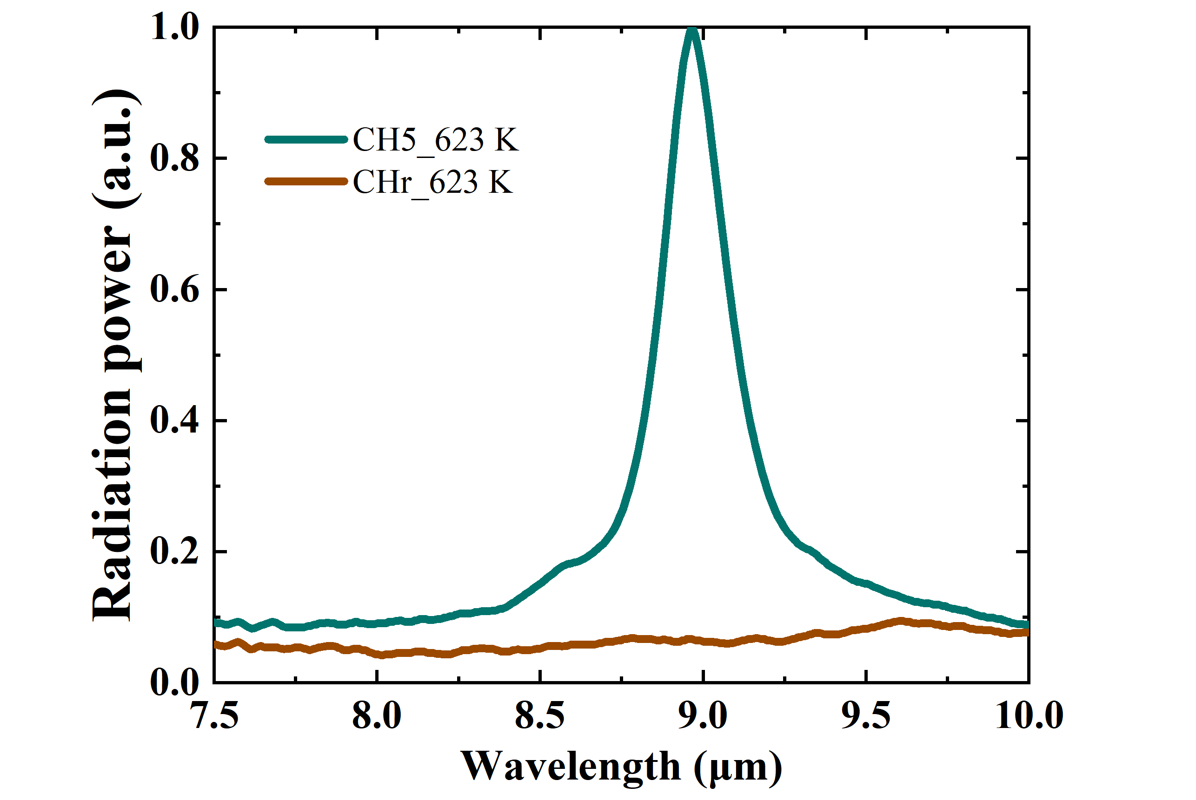
Supplementary Fig. S4 | Experimental validation of on-chip differential referencing. Radiation spectra measured from the q-BIC encoding channel CH₅ and its paired non-resonant reference region CH_{r} at 623 K under identical acquisition conditions. CH₅ exhibits a narrowband emission peak near 8.96 μm superimposed on a broadband thermal background, whereas CH_{r} shows only a weak and slowly varying background contribution. Their spatial difference suppresses the common non-resonant background and retains the resonance-dominated signal used for source encoding. Radiation power is presented in arbitrary units.
The blank and material measurements were acquired separately using the same encoding state and acquisition settings. The material-loaded differential count was normalized by the corresponding blank differential count:
$y_{i}=\frac{ΔV_{i}^{\left(m\right)}}{ΔV_{i}^{\left(0\right)}} =\frac{V_{CH_{i},m}-V_{CH_{r},m}}{V_{CH_{i}}-V_{CH_{r}}}$ (Eq. S10)
Neglecting the residual error terms, this ratio can be expressed as a normalized spectrally weighted measurement of the material transmittance:
$y_{i}≈\frac{\int_{Λ}{w_{i}}(λ)x_{m}(λ) dλ}{\int_{Λ}{w_{i}}(λ) dλ}+e_{i}$ (Eq. S11)
where $e_{i}$ is the residual error after blank normalization, and the term $w_{i}$:
$w_{i}(λ)=H(λ)\left[ε_{q,i}(λ)-ε_{r,i}(λ)\right]\left[M_{bb}(λ,T_{n})-M_{bb}(λ,T_{a})\right]$ (Eq. S12)
is the effective spectral weighting function of encoding state $i$. It includes the differential emitter response, the temperature-dependent radiative contrast, the collection optics and the camera responsivity. Combining the 40 normalized measurements gives:
$Y={\left[y_{1},y_{2},…,y_{40}\right]}^{T}∈R^{40×1}$ (Eq. S13)

S6. Spectral reconstruction
The effective response of each spatial–thermal state was sampled at 401 wavelengths on a common grid (7.8 μm-9.8 μm). These grid points define the discretization of the recovered spectrum and do not create additional independent measurements. After row normalization, the response-matrix elements were defined as:
$Φ_{ij}=\frac{\left[w_{i\left(λ_{j}\right)Δλ}\right]}{\left[\sum_{r=1}^{J}{w_{i\left(λ_{r}\right)Δλ}}\right]}, Φ∈R^{40×401}, J=401$(Eq. S14)
where the wavelength increment is the grid interval and the response matrix has 40 rows and 401 columns. The measurement vector contains the 40 normalized camera readings, while the unknown vector contains the transmittance values at the 401 wavelength samples. Their forward relationship is given by:
$Y=Φx+e (Eq. S15)$
Because the system contains fewer independent measurements than wavelength samples, recovery of x requires an explicit prior. The spectrum was represented in the fixed sparse basis Ψ used by the reconstruction implementation:
$x=Ψs, Y=ΦΨs+e (Eq. S16)$
where s is the sparse coefficient vector. The coefficients were estimated by L1-regularized data fitting:
$$\hat{s}=\arg{\min_{s}\left\{\frac{1}{2}{\left\|Y-ΦΨs\right\|}_{2}^{2}+α{\left\|s\right\|}_{1}\right\}} (Eq. S17)$$
and the reconstructed spectrum was obtained as:
$$\hat{x}=Ψ\hat{s} (Eq. S18)$$
Specifically, the Gaussian basis was used to reconstruct the narrowband filter spectra, whereas the DCT basis was used for the broadband polymer spectra.

S7. Quantitative evaluation of spectral reconstruction quality
Fidelity definition
The reconstruction performance was evaluated by comparing the reconstructed spectra with their FTIR-measured counterparts in terms of spectral-shape fidelity. Let $S_{i}$ and ${\hat{S}}_{i}$ denote the reference and reconstructed transmittance values, respectively, at the $i$-th wavelength point on the common reconstruction grid, where $i$ = 1,...,$J$ and $J$ = 401 in this work. To evaluate spectral-shape similarity independently of the overall intensity scale, the two non-negative spectra were first normalized as:
$p_{i}=\frac{S_{i}}{\sum_{j=1}^{J}{S_{j}}}, q_{i}=\frac{{\hat{S}}_{i}}{\sum_{j=1}^{J}{{\hat{S}}_{j}}}$ $(Eq. S19)$
The spectral fidelity was then calculated as:
$\text{F}\text{ = }{\left(\sum_{i}{\sqrt{p_{i}q_{i}}}\right)}^{2}, Fidelity (\%)=100F$ $(Eq. S20)$
The fidelity ranges from 0 to 100%, with a higher value indicating greater similarity between the normalized spectral shapes.

Double-peak reconstruction success criterion
To evaluate the spectral resolution, synthetic double-peak spectra with peak-to-peak spacings ranging from 20 to 200 nm were constructed. For each spacing, ±2% random readout noise was added to the camera measurement vector, and 50 independent reconstructions were performed.
A reconstruction was considered successful when all three of the following conditions were satisfied:
1. The spectral fidelity between the reconstructed and reference spectra was at least 95%;
2. The reconstructed peak-position error was less than 20% of the true peak-to-peak spacing;
3. The relative error in the reconstructed peak-intensity ratio was less than 30%.
The success rate for each peak spacing was defined as the percentage of successful reconstructions among the 50 trials. The spectral resolution was defined as the minimum peak-to-peak spacing at which the reconstruction success rate reached 90%.

S8. Polymer classification and PMMA concentration analysis
To evaluate the material identification capability of the system, seven common polymers—PP, PTFE, PVC, EVA, PI, PPS, and HDPE—were examined, with five samples of each polymer and 35 samples in total. The transmission spectrum of each sample was first reconstructed using the 40 hybrid encoding states. The reconstructed spectrum was then compared with the FTIR reference spectra of the seven polymers, and the material showing the highest spectral fidelity was assigned as the predicted class. Before comparison, all reconstructed and FTIR reference spectra were interpolated onto the same wavelength grid and processed using identical baseline-correction and normalization procedures.
All 35 polymer samples were correctly identified, corresponding to an identification accuracy of 100%. These results demonstrate that the reconstructed spectra retain sufficient mid-infrared fingerprint information for material identification.

PMMA Concentration Prediction
PMMA films prepared from precursor solutions with concentrations ranging from 2 to 10 wt% were used to construct the quantitative model, with five film samples measured at each concentration. Their reconstructed spectra and nominal concentrations were used to train a partial least-squares (PLS) regression model. The trained model was subsequently applied to predict the concentrations of the test samples, yielding the results shown in Fig. 5b with an RMSE of 0.086%. The prediction error was evaluated using the root-mean-square error (RMSE):
$$RMSE=\sqrt{\frac{1}{n}\sum_{k=1}^{n}{(}c_{k}-{\hat{c}}_{k})^{2}} (Eq. S21)$$
where $c_{k}$ and ${\hat{c}}_{k}$ denote the nominal and predicted PMMA concentrations of the $k$ held-out film, respectively, and $n$ is the number of held-out films.

S9. PAA-PI thermal imidization process
Preparation of the PAA/ZnS Sample
The PAA sample was prepared by spin-coating a 15% PAA solution directly onto a ZnS substrate at 4000 rpm for 40 s. The resulting PAA coating remained supported by the ZnS substrate throughout thermal treatment and spectral characterization.
In-Situ Thermal-Imidization Tracking
The PAA/ZnS sample was heated at 180$^{∘}C$, and its transmission spectra were recorded at heating times of 5, 40, 80, 120, 160, and 200s using the same optical configuration and data-processing procedure. Further heating beyond 200s produced no measurable change in the characteristic transmission spectrum, indicating that the conversion had reached a stable state.
The imidization process was evaluated from the relative transmittance change at 1242 cm⁻¹ using 1262 cm⁻¹ as the local baseline, following the definition provided in the main text.

References
- H. Li. Refractive index of silicon and germanium and its wavelength and temperature derivatives. J. Phys. Chem. Ref. Data 9, 561-658 (1993).
- T. Amotchkina, M. Trubetskov, D. Hahner, V. Pervak. Characterization of e-beam evaporated Ge, YbF3, ZnS, and LaF3 thin films for laser-oriented coatings. Appl. Opt. 59, A40-A47 (2020).

