Supplementary Materials
Appendix A: Latent class growth modelling methodology
Class assignment based on posterior probabilities in latent class growth models
The posterior probability that an individual $i$belongs to the latent class$k$:
$γ_{ik}=P(C_{i}=k|y,θ)$ (1)
Is estimated using Bayes’ theorem, once the model parameters $θ$ are estimated from the data.
We consider the following steps to estimate class membership:
Step 1: Estimate model parameters
- Fit LCGM, this gives estimates of:
  - The mixing proportions (prior class probabilities) ${\hat{π}}_{k}$
  - The class-specific parameters (regression coefficients, variance) ${\hat{θ}}_{k}$
Step 2: Compute the individual likelihood under each class
$f_{k}(y_{i}|{\hat{θ}}_{k})$ (2)
- This is the probability of the observed data $y_{i}$ for individual $i,$Under class $k$using the estimated parameters.
Step 3: Apply Bayes’ theorem
${\hat{γ}}_{ik}=\frac{{\hat{π}}_{k}f_{k}(y_{i}|{\hat{θ}}_{k})}{\sum_{c=1}^{K}{{\hat{π}}_{c}}f_{i}(y_{i}|{\hat{θ}}_{i})}$ (3)
- These probabilities sum to one across classes for each individual
$\sum_{k=1}^{K}{{\hat{γ}}_{ik}=1}$ (4)

Latent class growth model (LCGM)
The Latent Class Growth Model (LCGM) assumes that the population comprises $G$unobserved (latent) subgroups, each with its own distinct growth trajectory. For individual $i (i = 1, …, N)$ measured at time $j (j = 1, …, T),$the model can be expressed as a finite mixture of class-specific growth functions:
$p\left(y_{i} | θ\right)=\sum_{g=1}^{G}{π_{ig}p(y_{i}|θ_{g})}$ (5)
where:
- $y_{i}={\left(y_{i1},y_{i2},…,y_{iT}\right)}^{T}$ is the vector of repeated measurements for the individual $i$;
- $π_{ig}=P(k_{i}=g)$ is the probability that the individual $i$ belongs to class g;
- $θ_{g}$ represents the set of parameters for class g;
- $p(y_{i}|θ_{g})$ is the class-specific likelihood contribution.
Within-class growth model
Conditional on class membership ($kᵢ = g$), the repeated outcome (e.g., HAZ or WAZ) follows:
$y_{ij,g}=f_{g}\left(a_{ij}\right)+μ_{0i,g}+ϵ_{ij,g}$ (6)
Where:
- $y_{ij,g}$ is the outcome for the individual $i$ at time $j$ in latent class $g$.
- $μ_{0i,g}\sim N\left(0,τ_{g}^{2}\right)$ is a random intercept for the individual $i$ at time$j$ in latent class $g$
- $∈_{ij,g}\sim N(0, σ_{g}^{2})$ is a residual error for the individual $i$ at time$j$ in latent class $g$
$f_{g}(a_{ij})$ is the class-specific function of age, which may take several forms:
Functional Form | Expression
Linear | $f_{g}(a_{ij})=β_{0}+β_{1}age$ (7)
Quadratic | $f_{g}(a_{ij})=β_{0}+β_{1}age+β_{2}age^{2}$ (8)
Cubic | $f_{g}(a_{ij})= β_{0}+β_{1}age+β_{2}age^{2}+β_{3}age^{3}$ (9)
Spline | $f_{g}(a_{ij})=β_{0}+\sum_{k=1}^{4}{β_{k}Β_{k}(age)}$(Natural cubic spline with 4 degrees of freedom) (10)
Fractional polynomial (1) | $f_{g}(a_{ij})=β_{0}+β_{1}age+β_{2}\log\left(age+1\right)$ (11)
Fractional polynomial (2) | $f_{g}\left(a_{ij}\right)=β_{0}+β_{1}age+β_{2}\log\left(age+1\right)+\frac{β_{3}}{age+1}$ (12)
Fractional polynomial (3) | $f_{g}\left(a_{ij}\right)=β_{0}+β_{1}age+β_{2}\log\left(age+1\right)+\frac{β_{3}}{age+1}+β_{4}age^{2}$ (13)
This formulation is equivalent to a linear mixed-effects model with a class-specific random intercept.
Class membership model
The probability that an individual $i$ belongs to class g (for $g ∈ \{1, …, G\})$ is modelled as:
$P\left(k_{i}=g | c_{i}\right)=\frac{exp⁡(δ_{0g}+δ_{g}^{T}c_{i})}{\sum_{h=1}^{G}{exp⁡(δ_{0h}+δ_{h}^{T}c_{i})}}$ (14)
Where:
$c_{i}=$ a vector of dummy variables for the country from which child i comes from
The reference class is typically $g=1 (δ_{0,1}=0)$
Exponentiated coefficients give $exp⁡(δ_{g})$ gives odds ratios for the country predicting class membership.
Weighted logistic regression for latent class membership
After fitting the Latent Class Growth Model (LCGM), each subject $i$ has a posterior probability of belonging to each latent class $k$, denoted as ${\hat{p}}_{ik}$. To account for the uncertainty in class assignment, we used these posterior probabilities as weights in the regression analyses. Specifically, we applied weighted multinomial logistic regression (wMLR) for outcomes with more than two classes and weighted binary logistic regression for outcomes with two classes, allowing each subject to contribute proportionally to their likelihood of class membership rather than being deterministically assigned to a single class.
Model specification
Suppose there are $K$ latent classes. For each subject $i,$let:
- $C_{i}∈\left\{1,…,K\right\}=$latent class assignment,
- $X_{i}=\left(X_{i1},…,X_{ip}\right)=$ vector of predictors (Viral load, educational level, water availability, Types of toilets in the premises, distance to clinic, marital status, BMI, etc.),
- ${\hat{p}}_{i}=\left({\hat{p}}_{i1},…,{\hat{p}}_{iK}\right)=$ posterior probabilities from the LCGM
To account for uncertainty in class assignment, we weighted each subject in the regression by its posterior probability of belonging to each class.
For multinomial logistic regression (K > 2), the weighted model for the probability of class membership is:
$P\left(C_{i}=k | X_{i}\right)=\frac{exp⁡(β_{k0}+β_{k}^{T}X_{i})}{\sum_{l=1}^{K}{exp⁡(β_{k0}+β_{k}^{T}X_{i})}}, k=1,…,K$ (15)
A reference class (say $K$) is chosen, so $β_{K0}=0$ and $β_{K}=0$.
where:
- $β_{k0}$ is the intercept for the class $k$, representing the baseline log-odds of being in class k when all predictors are zero.
- $β_{k}=(β_{k1}​,…,β_{kp}​)$ is the vector of regression coefficients for predictors in class $k$.
- $β_{k}^{T}​X_{i}​=β_{k1}​X_{i1}​+⋯+β_{kp}​X_{ip}$​ is the total contribution of all predictors for the subject $i$ to the log-odds of being in class $k$ relative to the reference class.
Thus, the log-odds of being in class $k$ relative to the reference class are:
$log\frac{P(C_{i}=k|X_{i})}{P(C_{i}=K|X_{i})}=β_{k0}+β_{k}^{T}X_{i}, k=1,…, K-1$ (16)
For binary outcomes (K = 2), this simplifies to standard weighted logistic regression:
$logit\left(P\left(C_{i}=1 ∣ X_{i}\right)\right)=β_{0}+β^{T}X_{i}​$ (17)
where $β_{0}$​ is the intercept and $β^{T}X_{i}​$ is the weighted sum of predictor effects.
This approach ensures that the regression estimates reflect the uncertainty in class membership while incorporating the effects of all predictors.
Weighted likelihood
In a regression, each subject contributes equally. Here, each subject’s likelihood contribution is weighted by their posterior probability of belonging to the assigned class.
The weighted likelihood is:
$l\left(β\right)=\sum_{i=1}^{n}{\sum_{k=1}^{K}{{\hat{p}}_{ik}×log⁡P(C_{i}=k|X_{i};β)}}$ (18)
Where:
- ${\hat{p}}_{ik}$ are the posterior probabilities from the LCGM.
- $P(C_{i}|X_{i};β)$ is the multinomial probability defined above.
Maximising this weighted likelihood yields the estimates $β_{k}$
Use of the three-step (Bolck- Croon-Hagenaars/ BCH Method)
The Bolck-Croon-Hagenaars (BCH) three-step method was employed to investigate the associations between latent growth trajectories and maternal characteristics. First, a latent class model was fitted to repeated anthropometric measures to identify distinct growth trajectories and to estimate posterior probabilities of class membership. Country was included as the only predictor of class membership using a standard multinomial regression estimated alongside the trajectory model. Second, individuals were assigned to classes with a classification error matrix derived to quantify uncertainty. Third, these weights were incorporated into a weighted multinomial regression model to examine associations between latent class membership and covariates (e.g., maternal education, viral load, and household characteristics). This approach accounts for classification uncertainty and minimizes bias arising from class misclassification (Bolck et al., 2004).
Estimation
Latent Class Growth Models (LCGMs) are estimated using the maximum-likelihood Expectation-Maximization (EM) algorithm, which provides a stable, interpretable, and computationally efficient framework for parameter estimation. The EM algorithm explicitly accounts for unobserved class memberships rather than optimizing them directly, allowing simultaneous estimation of class membership probabilities and individual growth parameters. EM, when compared to other optimization methods (such as the Newton-Raphson method), offers greater numerical stability, clearer interpretability, and more reliable convergence in the presence of latent classes or incomplete data. LCGMs can be implemented in software such as Mplus or R (e.g., the LCMM package), which allows flexible specification of the number of classes, trajectory shapes, and random effects.
Model fit evaluation
Model fit was assessed using deviance, Akaike Information Criterion (AIC), and Bayesian Information Criterion (BIC), with lower values indicating better fit. Entropy was used to evaluate classification accuracy, with values greater than 0.8 suggesting clear assignment to latent classes. BIC is particularly beneficial for determining the optimal number of latent classes when within-class variability in growth trajectories is allowed, unlike models that assume homogeneity within classes. However, in large samples, criteria less sensitive to sample size, such as entropy, may be preferred over sample-dependent measures like AIC and BIC ²⁸ Because each criterion has inherent limitations, model selection in this study considered multiple indices in conjunction with the substantive context of the growth mixture model (GMM) to determine the most appropriate number of classes ^{19-20, 28}.
Appendix B: Growth trajectories in HIV-exposed children: Growth mixture model analysis
Table S1.
Posterior classification diagnostics for three-class growth mixture models
 | Height for age z-score (HAZ) |  |  | Weight for age z-score (WAZ)
Metric | Mid-to-moderate stunting | Severe stunting | Adequate growth | Severe underweight | Recovery | Stable mild underweight
Posterior Classification
Number of Individuals (N) | 294 | 323 | 119 | 174 | 60 | 502
Percentage (%) | 39.91% | 43.90% | 16.19% | 23.64% | 8.14% | 68.23%
Mean Posterior Probability
Assigned to Class 1 | 0.6922 | 0.1564 | 0.1514 | 0.7099 | 0.1930 | 0.0972
Assigned to Class 2 | 0.2034 | 0.6298 | 0.1668 | 0.1776 | 0.8108 | 0.0116
Assigned to Class 3 | 0.1099 | 0.1514 | 0.7387 | 0.1389 | 0.0040 | 0.8571
Proportion with Posterior Probability Above Threshold (%)
> 0.7 | 49.02% | 34.52% | 57.75% | 38.86% | 69.74% | 77.45%
> 0.8 | 42.52% | 25.64% | 45.45% | 32.53% | 59.04% | 68.63%
> 0.9 | 31.89% | 15.38% | 32.09% | 26.33% | 46.13% | 57.84%

Table S1 shows acceptable class separation for both the HAZ and WAZ three-class growth mixture models. For HAZ, the largest trajectory classes were severe stunting (43.9%) and mid-to-moderate stunting (39.9%), while adequate growth comprised 16.2% of children. The mean posterior probabilities for class assignment ranged from 0.63 to 0.74, with the highest certainty observed for the adequate growth trajectory (0.74). Approximately 35–58% of participants had posterior probabilities >0.70, indicating moderate classification precision. For WAZ, the stable mild underweight trajectory was the largest class (68.2%), followed by severe underweight (23.6%) and recovery (8.1%). Classification accuracy was stronger for WAZ than HAZ, with mean posterior probabilities ranging from 0.71 to 0.86. The recovery (0.81) and stable mild underweight (0.86) trajectories demonstrated particularly good class separation. Furthermore, 70–77% of participants in these classes had posterior probabilities >0.70, and 46–58% exceeded 0.90, indicating high assignment certainty.
The LMR test supported the 3-class over the 2-class solution for both HAZ (p = 0.042) and WAZ (p = 0.038), while the BLRT was significant for both outcomes (p < 0.001), providing additional statistical support for the 3-class solution.
Posterior classification diagnostics (Table S1) revealed substantial variation across classes. For HAZ, the adequate growth class showed the highest mean posterior probability (0.74), with 57.8% of participants having probabilities >0.70. By contrast, the severe stunting class showed modest separation (mean posterior probability: 0.63), with only 34.5% of participants having probabilities >0.70 and just 25.6% exceeding 0.80. This indicates that children in the severe stunting class are less clearly distinguished from other classes, particularly from the mid-to-moderate stunting group. For WAZ, classification was stronger: the recovery (0.81) and stable mild underweight (0.86) classes showed good separation, with 69.7% and 77.5% of participants, respectively, having posterior probabilities >0.70. However, the severe underweight class showed more modest separation (mean probability: 0.71; 38.9% with probability >0.70). The LMR test supported the 3-class over the 2-class solution for both HAZ (p=0.042) and WAZ (p=0.038), and BLRT was significant for both (p<0.001). Despite the marginal p-values, the 3-class solution was retained due to its substantive interpretability and consistency with prior literature showing three growth patterns (Le Roux et al., 2019; Fowler et al., 2022).
Table S2. Table S-2. Maternal, household, and HIV-related clinical characteristics according to height-for-age (HAZ) and weight-for-age (WAZ) trajectory class membership among HIV-exposed uninfected children.
 |  | Height for age z-score |  |  |  | Weight for age z-score
Variable | Category | Mid-to-moderate stunting (n=294) | Severe stunting (n=323) | Adequate growth (n=119) | p-value | Severe underweight (n=174) | Recovery trajectories (n=60) | Stable mild underweight (n=502) | p-value
Mother’s age-years, n (%) | <25 | 10  (3.3%) | 14  (4.2%) | 3  (2.5%) | 0.134 | 7  (4.0%) | 2  (3.2%) | 25  (4.9%) | 0.049**
 | ≥35 | 96  (32.7%) | 105 (32.5%) | 39  (32.5%) |  | 61  (34.8%) | 23  (38.3%) | 136  (27.0%)
 | 25–34 | 190 (64.0%) | 205 (63.3%) | 78  (64.9%) |  | 107  (61.2%) | 35  (58.5%) | 341  (68.0%)
Mother’s level of education, n (%) | Basic education | 91 (31.1%) | 93  (28.7%) | 35  (29.5%) | 0.214 | 52  (30.0%) | 10  (15.9) | 168  (33.4%) | 0.002
 | Higher education | 203 (68.9%) | 230 (71.3%) | 84  (70.5%) |  | 122  (70.0) | 50  (84.1) | 334  (66.6%)
Employment status, n (%) | Formal employment | 56  (19.2%) | 43  (13.4%) | 29  (24.6%) | <0.001 | 24  (13.9%) | 16  (26.6%) | 79  (15.7%) | 0.027
 | Not employed | 144 (48.9%) | 167 (51.8%) | 55  (46.2%) |  | 85  (48.7%) | 25  (41.5%) | 261  (52.0%)
 | Self-employed | 94  (31.9%) | 113 (34.8%) | 35  (29.2%) |  | 65  (37.4%) | 19  (31.9%) | 162  (32.2%)
Marital status, n (%) | Has partner | 68  (23.1%) | 51 (15.7%) | 39  (32.5%) | <0.001 | 30  (17.2%) | 14  (23.4%) | 105  (20.9%) | 0.587
 | Married | 189 (64.3%) | 238 (73.7%) | 67  (56.0%) |  | 119  (68.5%) | 38  (62.8%) | 334  (66.6%)
 | No partner | 37  (12.5%) | 34  (10.6%) | 13  (11.5%) |  | 25  (14.3%) | 8  (13.8%) | 62  (12.4%)
Electricity in the premises, n (%) | No | 101 (34.2%) | 141 (43.7%) | 36 (30.6%) | <0.001 | 77 (44.0%) | 15 (24.5%) | 185 (36.9%) | 0.003
 | Yes | 193 (65.8%) | 182 (56.3%) | 83  (69.4%) |  | 97  (56.0%) | 45  (75.5%) | 317  (63.1%)
Tap water in the premises, n (%) | No | 120 (40.7%) | 150 (46.5%) | 44  (37.1%) | <0.001 | 85  (49.1%) | 19  (30.9%) | 197  (39.3%) | 0.002
 | Yes | 174 (59.3%) | 173 (53.5%) | 75  (62.9%) |  | 89  (50.9%) | 41  (69.1%) | 305  (60.7%)
Types of toilets in the premises, n (%) | Other | 180 (61.1%) | 177 (54.9%) | 66  (55.8%) | <0.001 | 97  (56.0%) | 26  (42.6%) | 315  (62.8%) | <0.001
 | Private flushed toilet | 55  (18.7%) | 54 (16.8%) | 28  (23.3%) |  | 27  (15.8%) | 15  (24.5%) | 86  (17.1%)
 | Shared flushed toilet | 59  (20.2%) | 91  (28.3%) | 25  (20.9%) |  | 49  (28.2%) | 20  (33.0%) | 101  (20.1%)
Travel time from home to clinic, n (%) | <1 hour | 189 (64.3%) | 212 (65.6%) | 75  (63.2%) | 0.356 | 108  (62.3%) | 43  (71.3%) | 329  (65.5%) | 0.274
 | >1 hour | 105 (35.7%) | 111 (34.4%) | 44  (36.8%) |  | 66  (37.7%) | 17  (28.7%) | 173  (34.5%)
Own or family own a house | No | 160 (54.5%) | 185 (57.3%) | 64  (54.0%) | 0.079 | 104  (59.7%) | 28  (46.8%) | 277  (55.1%) | 0.087
 | Yes | 134 (45.5%) | 138 (42.7%) | 55  (46.0%) |  | 70  (40.3%) | 32  (53.2%) | 225  (44.9%)
Viral load at delivery or at 10-day window period, copies/mL, n (%) | Detected | 39  (13.3%) | 59  (18.3%) | 16  (13.3%) | <0.001 ª | 30  (17.2%) | 6  (9.6%) | 81  (16.1%) | 0.202 ª
 | Undetected | 255 (86.7%) | 264 (81.7%) | 103 (86.7%) |  | 144  (82.8%) | 54  (90.4%) | 421  (83.9%)
CD4 count at delivery or at 10-day window period, cells/µL, n (%) | <500 | 193 (65.8%) | 182 (56.3%) | 83  (69.4%) | 0.012 ª | 18  (10.3%) | 3  (5.3%) | 46  (9.1%) | 0.122 ª
 | ≥500 | 120 (40.7%) | 150 (46.5%) | 44  (37.1%) |  | 156  (89.7%) | 57  (94.7%) | 456  (90.9%)
ART regimen at delivery or at 10-day window period, n (%) | EFV/NVP-based | 174 (59.3%) | 173 (53.5%) | 75  (62.9%) | <0.001 ª | 34  (19.5%) | 22  (35.9%) | 143  (28.4%) | 0.006 ª
 | DTG-based | 180 (61.1%) | 177 (54.9%) | 66  (55.8%) |  | 129  (73.9%) | 36  (59.8%) | 338  (67.3%)
 | LPV/r, ATV/r, RTV based | 55  (18.7%) | 54  (16.8%) | 28  (23.3%) |  | 11  (6.6%) | 2  (4.3%) | 21  (4.2%)
BMI at delivery or at 10-day window period, kg/m² n (%) | <18.5 | 59  (20.2%) | 91  (28.3%) | 25  (20.9%) | <0.001 ª | 41  (23.3%) | 16  (25.9%) | 104  (20.8%) | 0.101 ª
 | 18.5–24.9 | 189 (64.3%) | 212 (65.6%) | 75  (63.2%) |  | 84  (48.2%) | 32  (52.9%) | 269  (53.5%)
 | 25–29.9 | 105 (35.7%) | 111 (34.4%) | 44 (36.8%) |  | 49  (28.5%) | 12 (21.2%) | 129 (25.7%)
Duration of last ARTs used from pregnancy to delivery, months, n (%) | 1 - 6 | 31  (10.7%) | 26  (7.9%) | 18  (14.7%) | 0.253 ª | 34  (19.7%) | 11  (18.5%) | 73  (14.5%) | 0.131 ª
 | 6 – 9 | 262 (89.3%) | 298 (92.1%) | 102 (85.3%) |  | 140  (80.3%) | 49  (81.5%) | 429  (85.5%)
HAZ = Height-for-Age Z-score; WAZ = Weight-for-Age Z-score. p-values from Pearson's chi-squared test unless otherwise indicated. ** Fisher-Freeman-Halton exact test (Monte Carlo simulation, B = 10 000 replicates). ª p- value < 0.05 calculated from Cochran’s Q test.

Maternal, household, and HIV-related clinical characteristics differed across HAZ and WAZ trajectory classes (Table S-2). For HAZ trajectories, children in the adequate growth class were more likely to have mothers in formal employment (29/119, 24.6%) than those in the mid-to-moderate stunting (56/294, 19.2%) or severe stunting (43/323, 13.4%) classes (p < 0.001). They were also more likely to live in households with electricity (83/119, 69.4% vs. 193/294, 65.8% and 182/323, 56.3%), access to tap water (75/119, 62.9% vs. 174/294, 59.3% and 173/323, 53.5%), and private flushed toilets (28/119, 23.3% vs. 55/294, 18.7% and 54/323, 16.8%) (p < 0.001 for all). Maternal marital status also varied across HAZ classes, with a higher proportion of mothers in the adequate growth class reporting a partner (39/119, 32.5%) than in the mid-to-moderate stunting (68/294, 23.1%) and severe stunting (51/323, 15.7%) classes (p < 0.001). Differences were also observed in maternal viral load suppression, CD4 count, ART regimen, and BMI at delivery (p < 0.05), whereas maternal age, education, travel time to the clinic, and home ownership did not differ significantly.
For WAZ trajectories, children in the recovery trajectory class were more likely to have mothers with higher education (50/60, 84.1%) than those in the severe underweight (122/174, 70.0%) or stable mild underweight (334/502, 66.6%) classes (p = 0.002). Formal employment was also more common among mothers of children in the recovery class (16/60, 26.6%) than among those in the severe underweight (24/174, 13.9%) and stable mild underweight (79/502, 15.7%) classes (p = 0.027). Children in the recovery class were more likely to reside in households with electricity (45/60, 75.5% vs. 97/174, 56.0% and 317/502, 63.1%) and tap water (41/60, 69.1% vs. 89/174, 50.9% and 305/502, 60.7%) and were less likely to use unimproved sanitation facilities (26/60, 42.6% vs. 97/174, 56.0% and 315/502, 62.8%) (p ≤ 0.003 for all). Maternal age differed across WAZ classes, with mothers aged ≥35 years comprising 38.3% (23/60) of the recovery class compared with 34.8% (61/174) and 27.0% (136/502) of the severe and stable mild underweight classes, respectively (p = 0.049). ART regimen at delivery was also associated with WAZ trajectory membership (p = 0.006), whereas marital status, travel time to clinic, home ownership, viral load status, CD4 count, and maternal BMI were not.

Table S3. Random and fixed effects estimate for height-for-age z-score (HAZ) and weight-for-age z-score (WAZ) growth trajectories from growth mixture modelling (Reference Class: Class 3)
 |  | Height-for-age z-score |  | Weight-for-age z-score
Parameter | Notes | Estimate | Standard Error | Estimate | Standard Error
Random-effects variance-covariance
Variance (intercept) | Between-subject variance | 1.16453 | — | 1.07930 | —
Variance (age) | Slope variance for age (months) | 0.00074 | — | 0.00031 | —
Covariance (intercept × age) | Correlation slightly negative | -0.01701 | — | -0.01168 | —
Proportional coefficients
Severe stunting/underweight (Class1) | Proportional odds / latent class coefficient | 1.05472 | 0.09331 | — | —
Mid-to-moderate stunting \s table mild underweight (Class 2) | Proportional odds / latent class coefficient | 0.78754 | 0.07464 | — | —
Residual standard error | Within-subject variability | 0.67522 | 0.00844 | 0.50578 | 0.00601
Table S3 presents the fixed- and random-effects estimates from the growth mixture models for height-for-age z-scores (HAZ) and weight-for-age z-scores (WAZ), with recovery to non-stunted/ recovery to non-underweight (Class 3) as the reference trajectory. The random-effects variances indicate substantial between-subject variability in baseline growth status for both HAZ (variance = 1.1645) and WAZ (variance = 1.0793), suggesting considerable heterogeneity in children’s initial nutritional status. The variance associated with age was relatively small for both outcomes, indicating limited variability in growth rates over time across individuals. The negative covariance between the intercept and age for both HAZ (-0.0170) and WAZ (- 0.0117) suggests that children with poorer baseline growth tended to experience slightly greater improvements over time, although the relationship was weak. For HAZ, the proportional coefficients for Class 1 (1.0547 ± 0.0933) and Class 2 (0.7875 ± 0.0746) indicate meaningful separation between the latent trajectory classes relative to the reference class, supporting the identification of distinct stunting trajectories. The residual standard errors were 0.6752 for HAZ and 0.5058 for WAZ, reflecting moderate within-subject variability around the predicted growth curves. Overall, the model estimates suggest that the growth mixture models captured both substantial individual-level heterogeneity and distinct latent growth patterns in child nutritional outcomes over time.
Table S4. Model Fit Statistics for Latent Class Growth Models of Height-for-Age and Weight-for-Age Z-Scores Across Functional Forms and Class Solutions
 |  | Height for age z-score |  |  | Weight for age z-score
No. of Classes | Functional Form | AIC | BIC | Entropy | AIC | BIC | Entropy
 | Linear | 14034.49 | 14054.70 | — | 14393.19 | 14413.42 | —
 | Quadratic | 13637.73 | 13662.99 | — | 14376.23 | 14401.53 | —
 | Cubic | 13546.51 | 13576.83 | — | 14376.58 | 14406.93 | —
1 | Spline | 13552.60 | 13587.96 | — | 14378.19 | 14413.60 | —
 | FP (1) | 13449.89 | 13475.15 | — | 14368.57 | 14393.86 | —
 | FP (2) | 13417.24 | 13447.55 | — | 14360.72 | 14391.07 | —
 | FP (3) | 13362.10 | 13397.47 | — | 14347.78 | 14383.19 | —
 | Linear | 13743.38 | 13793.90 | 0.448 | 14063.78 | 14114.36 | 0.349
 | Quadratic | 13149.33 | 13209.95 | 0.476 | 13735.25 | 13795.95 | 0.425
2 | Cubic | 12992.13 | 13062.85 | 0.495 | 13587.93 | 13658.75 | 0.473
 | Spline | 12970.45 | 13051.27 | 0.520 | 13462.97 | 13543.91 | 0.507
 | FP (1) | 12959.41 | 13020.03 | 0.516 | 13548.54 | 13609.25 | 0.513
 | FP (2) | 12905.51 | 12976.24 | 0.453 | 13506.83 | 13577.65 | 0.486
 | FP (3) | 12840.76 | 12921.59 | 0.476 | 13449.37 | 13530.31 | 0.484
 | Linear | 13676.96 | 13757.79 | 0.518 | — | — | —
 | Quadratic | 13021.29 | 13117.27 | 0.535 | 13574.40 | 13670.52 | 0.584
3 | Cubic | 12836.12 | 12947.26 | 0.540 | 13363.72 | 13475.01 | 0.506
 | Spline | 12818.90 | 12945.19 | 0.551 | 13167.64 | 13294.11 | 0.521
 | FP (1) | 12805.57 | 12901.55 | 0.531 | 13278.57 | 13374.68 | 0.520
 | FP (2) | 12748.10 | 12859.24 | 0.528 | 13247.33 | 13358.63 | 0.512
 | FP (3) | 12693.16 | 12819.46 | 0.545 | 13178.35 | 13304.81 | 0.515
Table S-4 shows that model fit improved as the number of latent classes increased from one to three, with lower AIC and BIC values indicating better fit. Non-linear models, particularly fractional polynomial [FP(3)] and spline models, consistently outperformed linear, quadratic, and cubic specifications for both HAZ and WAZ trajectories. The three-class FP(3) model provided the best overall fit for HAZ (AIC = 12693.16; BIC = 12819.46), while the three-class spline and FP(3) models showed the best fit for WAZ. Entropy values were moderate (approximately 0.5), suggesting acceptable but not perfect class separation. Overall, the findings support the use of three-class non-linear growth mixture models to capture heterogeneity in child growth trajectories. The LMR test supported the 3-class over the 2-class solution for both HAZ (p = 0.042) and WAZ (p = 0.038), while the BLRT was significant for both outcomes (p < 0.001). Entropy values were moderate (HAZ = 0.555; WAZ = 0.538), indicating acceptable but not perfect class separation.
Table S5. Model fit statistics for growth mixture models
 |  | HAZ |  |  | WAZ
Model | Description | AIC | BIC | Entropy | AIC | BIC | Entropy
1 | Homogeneous diagonal; common variance | 15608.79 | 15740.14 | 0.572 | 13092.04 | 13223.57 | 0.580
2 | Homogeneous diagonal; class-specific variance | 15598.98 | 15740.43 | 0.583 | 13094.5 | 13236.15 | 0.579
3 | Unstructured; common variance | 15524.96 | 15661.36 | 0.540 | 12935.41 | 13071.99 | 0.538
4 | Unstructured; class-specific variance | 15514.23 | 15660.74 | 0.555 | 12936.43 | 13083.13 | 0.574

Table S-5 compares the fit statistics of alternative growth mixture models for HAZ and WAZ trajectories. Model fit improved when unstructured covariance matrices were used, as reflected by lower AIC and BIC values compared with homogeneous diagonal structures. Model 4 provided the best overall fit for HAZ, while Model 3 provided the best fit for WAZ; these were therefore selected as the final models. Entropy values were moderate, indicating some classification uncertainty; however, this was addressed using the BCH three-step approach in covariate analyses. Residual diagnostics further supported adequate model performance, with only minor systematic bias observed in the smallest trajectory class.
Entropy values in the 0.5-0.6 range are common in applied growth mixture modelling of child anthropometry (Toledo et al., 2022; Fowler et al., 2022). They indicate that while classes are statistically distinguishable, there is substantial overlap between adjacent classes. We addressed this using the BCH three-step method in all covariate analyses. Readers should interpret class labels as reflecting probabilistic groupings rather than discrete categories.

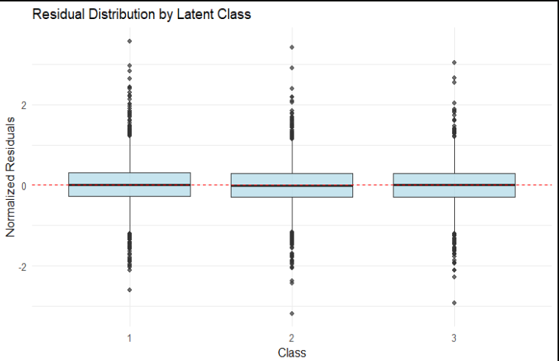
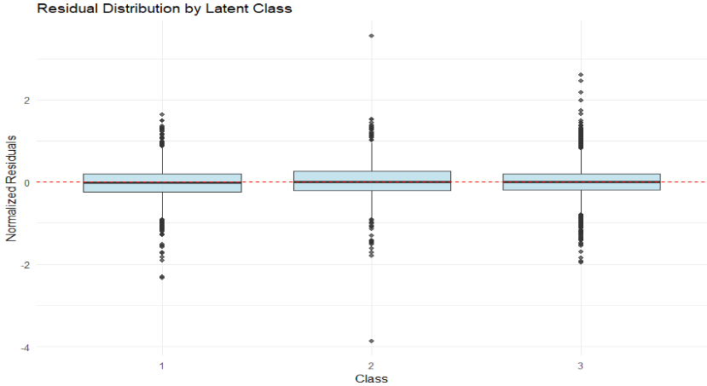
Fig. S1. Residual distributions by latent class and outcome. The top panel displays the distribution of residuals for the height-for-age z-score (HAZ), while the bottom panel shows the corresponding distribution for the weight-for-age z-score (WAZ).
Residuals are centered at zero across all three classes with similar interquartile ranges (±0.2 SD), indicating unbiased estimates and consistent model fit. Symmetric distributions with most values within ±2 SD support normality assumptions. Outliers are symmetrically distributed, reflecting natural variation rather than systematic misspecification. The uniform performance across classes supports the three-class solution. Comparing outcomes, HAZ residuals span a wider range (±3 SD) than WAZ residuals (±2.5 SD), with HAZ showing slightly more extreme outliers. Both outcomes demonstrate comparable model adequacy, though WAZ exhibits tighter residual distributions, suggesting marginally superior predictive precision for weight relative to height trajectories.
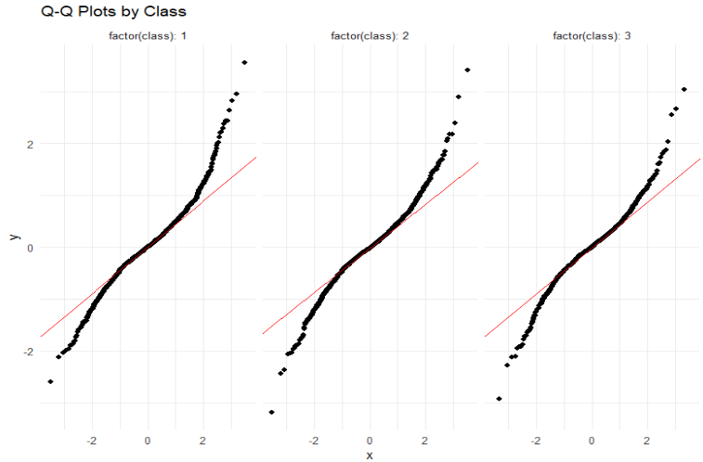
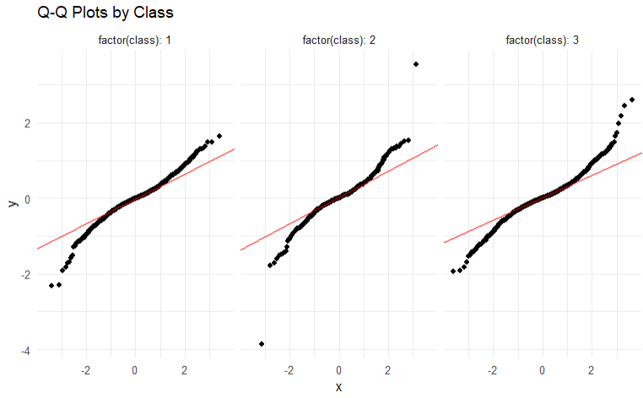
Fig. S2. Q–Q plots of residuals by latent class and outcome. The top panel displays the residual distribution for the height-for-age z-score (HAZ), while the bottom panel shows the corresponding residual distribution for the weight-for-age z-score (WAZ).
Residuals closely follow the theoretical normal distribution in the central range (±2 SD) across all classes, validating maximum likelihood assumptions. Systematic deviations in the extreme tails produce characteristic S-shaped curves indicative of leptokurtosis-excess kurtosis common in applied settings. This pattern is consistent across classes, indicating a data-wide feature rather than class-specific misspecification. Symmetric tail behaviour mitigates bias concerns. While tails deviate from strict normality, the strong central alignment supports valid inference. Future extensions could employ robust standard errors or Student’s t-distribution mixtures to accommodate heavy tails. Cross-outcome comparison reveals similar leptokurtic patterns for both HAZ and WAZ, with slightly more pronounced S-curves in HAZ, particularly
for Class 2. The consistency of heavy-tail behaviour across outcomes reinforces this as a genuine data characteristic rather than outcome-specific model inadequacy.
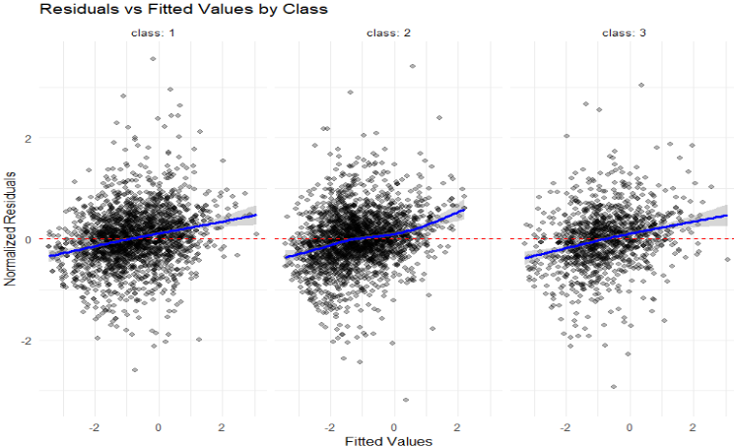
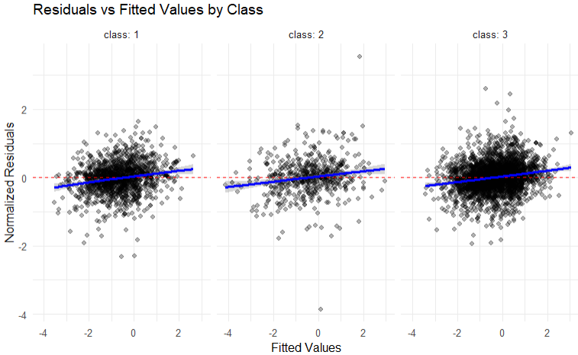
Fig. S3. Residuals versus fitted values by latent class and outcome. The top panel displays the residuals for the height-for-age z-score (HAZ), while the bottom panel shows the corresponding residuals for the weight-for-age z-score (WAZ).
Residuals show uniform vertical dispersion across fitted values with no funnel patterns, confirming homoscedasticity. LOESS curves reveal modest deviations in Classes 1 and 3 (<0.5 SD) and more pronounced curvature in Class 2, suggesting potential functional form inadequacy. While the homoscedastic variance assumption is supported, the systematic patterns, particularly in Class 2, indicate opportunities for model refinement. Class 2’s smaller sample size and complex residual pattern warrant investigation of alternative trajectory specifications. Comparing outcomes, HAZ shows more pronounced LOESS curvature in Class 2 than WAZ, suggesting height trajectories may be more challenging to model for this subpopulation. WAZ displays flatter LOESS curves across all classes, indicating better functional form adequacy for weight modelling.
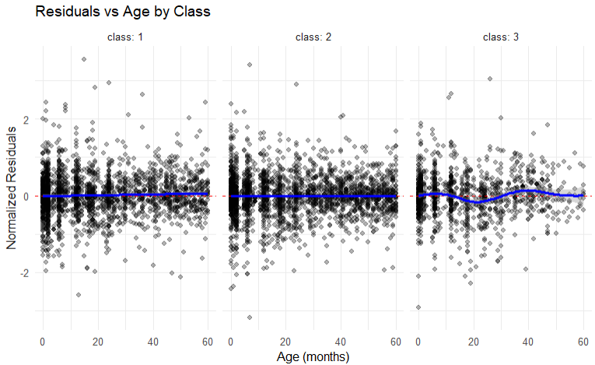
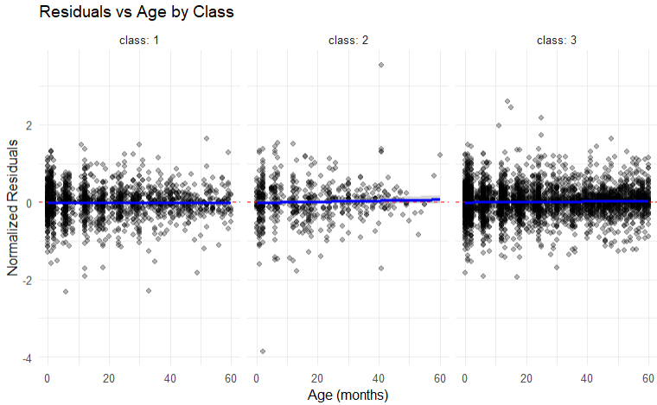
Fig. S4. Residuals versus age by latent class and outcome. The top panel displays the residuals for the height-for-age z-score (HAZ), while the bottom panel shows the corresponding residuals for the weight-for-age z-score (WAZ).
LOESS curves reveal distinct temporal patterns across classes. Class 1 shows a flat LOESS curve centered at zero across all ages, indicating excellent trajectory specification. Class 2 exhibits pronounced curvature with systematic age-related bias (underprediction in early ages, overprediction later), suggesting the current functional form inadequately captures this subpopulation’s nonlinear growth dynamics. Class 3 displays minor LOESS fluctuations. Residual variance remains constant across age in all classes, supporting the time-invariant error specification. These class-specific temporal patterns substantiate the mixture modelling framework and indicate qualitatively different developmental trajectories. Priority extensions include class-specific functional forms (particularly for Class 2) and time-varying covariates. Outcome comparison shows more dramatic age-related curvature in HAZ than in WAZ, with temporal patterns substantially flatter. This suggests height growth in Class 2 follows a more complex nonlinear trajectory than weight gain, requiring outcome-specific functional forms.
Table S6. Residual descriptive statistics by outcome. The top table summarizes the distribution of residuals for the height-for-age z-score (HAZ), while the bottom table presents the corresponding residual distribution for the weight-for-age z-score (WAZ).
Class | Number of observations | Mean Residual | SD Residual | Min Residual | Max Residual
Height-for-age z-score (HAZ)
1 | 2145 | 0.0131 | 0.5648 | -2.599 | 3.557
2 | 2279 | -0.0114 | 0.5530 | -3.180 | 3.414
3 | 1205 | -0.0017 | 0.5653 | -2.921 | 3.036
Weight-for-age z-score (WAZ)
1 | 1511 | -0.0195 | 0.4295 | -2.329 | 1.637
2 | 599 | 0.0064 | 0.5254 | -3.860 | 3.545
3 | 3519 | 0.0073 | 0.3981 | -1.948 | 2.607
Across all latent classes, residuals are centered near zero for both outcomes, indicating minimal systematic bias. For HAZ, mean residuals were 0.0131 (Class 1), -0.0114 (Class 2), and -0.0017 (Class 3), with standard deviations ranging from 0.42 to 0.53, reflecting moderate and comparable dispersion across classes. Residuals were largely contained within ±3 z-score units (min −2.599, max 3.036), with extreme values being rare. For WAZ, mean residuals were similarly small (-0.0195 in Class 1, 0.0064 in Class 2, and 0.0073 in Class 3), and variability was lower than for HAZ (SD 0.4–0.53), indicating a tighter model fit. Although Class 2 exhibited a wider range due to a small number of extreme negative residuals (min -4.), these 599 did not materially affect overall fit.
Table S7: Comparison of 2-class and 3-class solutions for HAZ and WAZ
Outcome | Model | AIC | BIC | Entropy | Smallest class | LMR p-value
HAZ | 2-class | 12,750 | 12840 | 0.582 | 22.3% | —
HAZ | 3-class | 12693 | 12819 | 0.555 | 16.2% | 0.042
WAZ | 2-class | 1380 | 13270 | 0.565 | 18.7% | —
WAZ | 3-class | 12935 | 13072 | 0.538 | 8.1% | 0.038
Note: 3-class model selected as final based on BIC and interpretability; 2-class model shown for comparison
Sensitivity analyses using a 2-class solution for HAZ and WAZ (Supplementary Table S7) produced similar substantive conclusions regarding the association between country and growth patterns, suggesting that the 3-class findings were robust to alternative class enumeration.
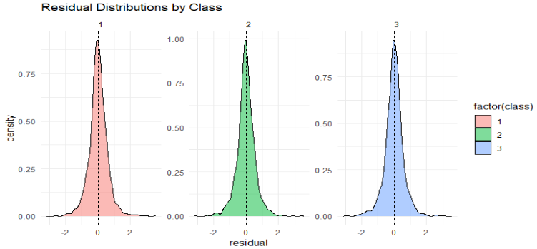
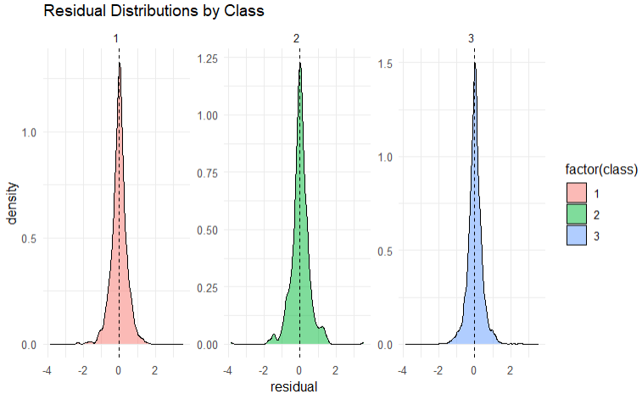
Fig. S5. Density distributions by latent class for anthropometric outcomes. The top panel displays the distribution of residuals for the height-for-age z-score (HAZ), while the bottom panel shows the corresponding distribution for the weight-for-age z-score (WAZ).
The distributions reveal differential model performance across the three latent classes. Class 1 demonstrates superior predictive accuracy with highly concentrated residuals around zero (peak ~1.0), suggesting this class captures a well-defined growth pattern with minimal prediction error. Class 3 shows similarly strong performance with the sharpest peak (~1.0 for HAZ, ~1.5 for WAZ), indicating precise model specification for this subgroup. Class 2, however, exhibits notably different characteristics, lower peak density (~0.75 for HAZ, ~1.5 for WAZ), greater dispersion, and evidence of systematic bias (slight rightward shift). This pattern suggests either greater heterogeneity within Class 2 or model misspecification for this growth trajectory, warranting further investigation into whether additional covariates or nonlinear terms might improve fit.
Appendix C: Residual diagnostics summary
Comprehensive diagnostics support the three-class growth mixture model with fractional polynomial trajectories. All classes show near-zero bias, symmetric distributions, and appropriate variance structures. Class 1 demonstrates exemplary fit across all diagnostics. Class 3 exhibits generally adequate fit with minor temporal fluctuations. Class 2 consistently shows elevated variance, systematic bias, and temporal curvature, indicating the fractional polynomial specification may inadequately capture this subpopulation's developmental dynamics. This is acknowledged as a limitation in the main discussion.
While diagnostics identify opportunities for refinement, particularly for Class 2, overall patterns support valid inference. The model successfully captures developmental heterogeneity, with class-specific patterns confirming genuine population subgroups rather than statistical artifacts
Table S8: GRoLTS checklist
GRoLTS item | Description | Reported in
1 | Research questions/objectives | Introduction
2 | Study design | Methods, Section 2.1
3 | Sample size justification | Methods, Section 2.1 (N = 736)
4 | Statistical model | Methods, Section 2.3
5 | Number of classes | Results, Table S1
6a | Model selection | Methods, Section 2.3.1; Table S4
6b | Entropy interpretation | Table S1; Results paragraph
7 | Class labels | Results, Table S1
8a | Posterior probability thresholds | Table S1
8b | Classification error matrix | Methods Section 2.3 (BCH approach)
9 | Predictors of class membership | Results, Tables 2–3
10 | Outcome analysis | Results, Tables 2–3
11a | Software version | Methods, Section 2.3
11b | Code availability | Methods, Section 2.3

