Supplementary Table S1. Landcover type and ROW/roadside area within the study region.
Study area | 6,140 ha
Rangeland area | 3,347 ha
Forest area | 417 ha
Total road length | 111,965 m/112 km
Average ROW width | 5.8 m
ROW area (per road-side) | 653,875.7 m²/65.4 ha
Total ROW area | 130.8 ha

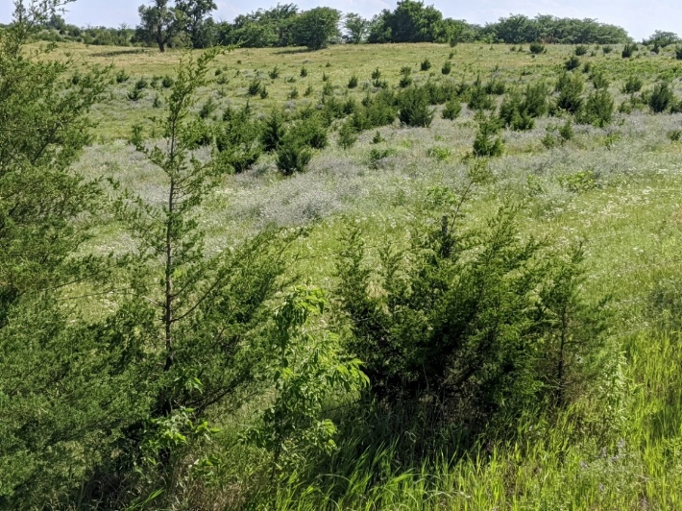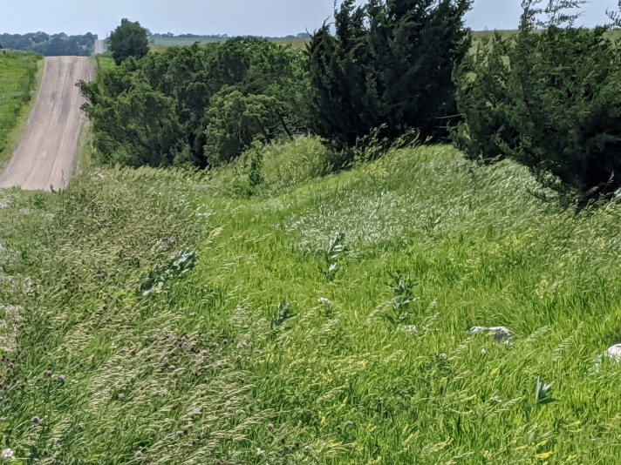
Supplementary Figure F1. Photographs depicting current tree invasion along roadsides in the Denton Hills study area.
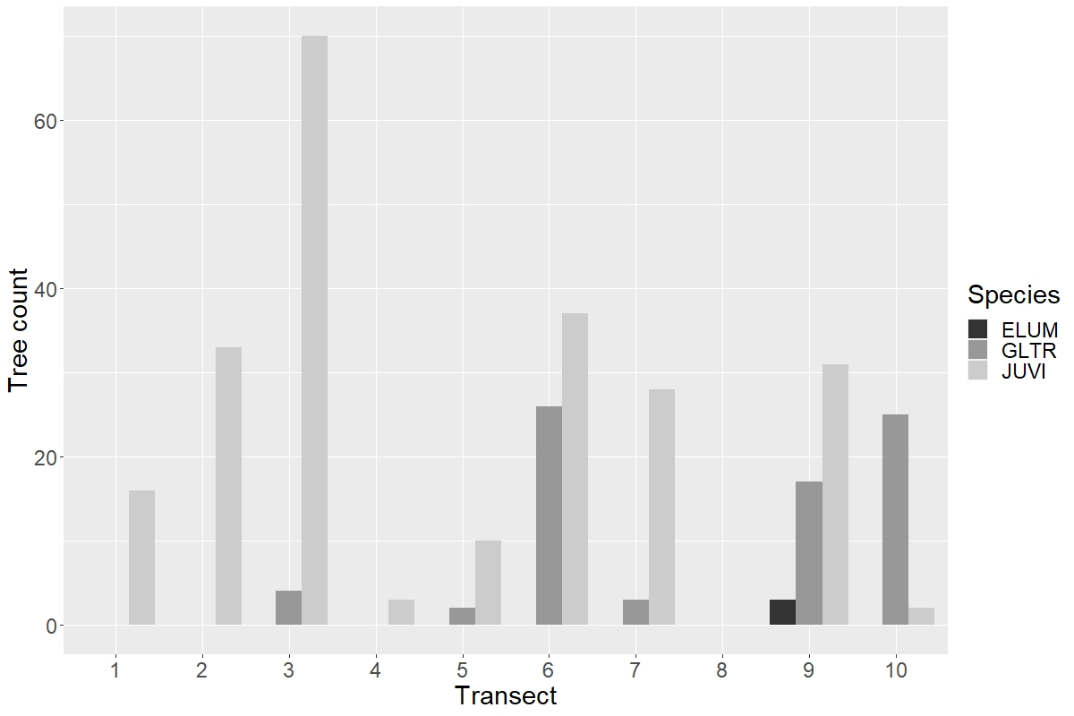
Supplementary Figure F2. Tree species counts across transects (n = 10). JUVI = Juniperus virginiana, GLTR = Gleditsia tricanthos. ELUM = Elaeagnus umbellata.

