Supplementary material for:

Root architectural plasticity and rhizosphere phosphatase hotspots jointly enhance phosphorus acquisition in Camellia oleifera on amendment-treated acidic red soils

Huimin Yinª, Yuhua Li^{b}, Xinyi Zhangª, Shanshan Suª, Yuhong Liª, Lichao Wuª, * Xiaojun Jiang^{c}, * Jun Yuan^{a*}

ªKey Laboratory of Soil and Water Conservation and Desertification Combating of Hunan Province, School of Forestry, School of Soil and Water Conservation, Central South University of Forestry and Technology, Changsha, 410004, China;
^{b} Liangfengjiang National Forest Park, Nanning, Guangxi, 530000, China;
^{c} YongZhou Vocational Technical College, Hunan, 425100, China.

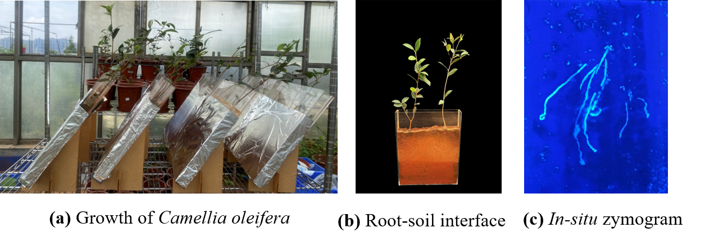
Fig. S1 Growth status, root-soil interface, and in situ zymogram of Camellia oleifera seedlings. (a) Growth status of seedlings in rhizoboxes (tilted at 45°); (b) visual observation of the root-soil interface; (c) original in situ zymogram showing enzyme activity.

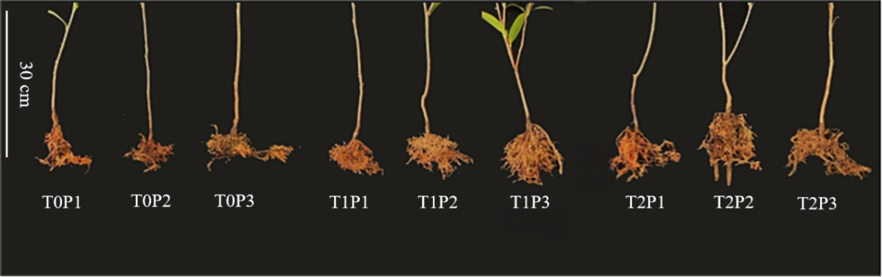
Fig. S2 Changes in root morphology of Camellia oleifera seedlings under combined application of different levels of soil amendments and phosphorus.

Fig. S3 Root growth status of C. oleifera after 60 days of growth. T0P1, no amendment + 5 μmol L⁻¹ KH₂PO₄; T0P2, no amendment + 0.5 mmol L⁻¹ KH₂PO₄; T0P3, no amendment + 1 mmol L⁻¹ KH₂PO₄; T1P1, 60 g amendments + 5 μmol L⁻¹ KH₂PO₄; T1P2, 60 g amendments + 0.5 mmol L⁻¹ KH₂PO₄, T1P3, 60 g amendments + 1 mmol L⁻¹ KH₂PO₄; T2P1, 120 g amendments + 5 μmol L⁻¹ KH₂PO₄; T2P2, 120 g amendments + 0.5 mmol L⁻¹ KH₂PO₄; T2P3, 120 g amendments + 1 mmol L⁻¹ KH₂PO₄.

Table. S1 Effects of combined application of different levels of soil amendments and phosphorus on root architecture of C. oleifera seedlings. T0P1, no amendment + 5 umol L⁻¹ KH₂PO₄; T0P2, no amendment + 0.5 mmol L⁻¹ KH₂PO₄; T0P3, no amendment + 1 mmol L⁻¹ KH₂PO₄; T1P1, 60 g amendments + 5 umol L⁻¹ KH₂PO₄; T1P2, 60 g amendments + 0.5 mmol L⁻¹ KH₂PO₄, T1P3, 60 g amendments + 1 mmol L⁻¹ KH₂PO₄; T2P1, 120 g amendments + 5 μmol L⁻¹ KH₂PO₄; T2P2, 120 g amendments + 0.5 mmol L⁻¹ KH₂PO₄; T2P3, 120 g amendments + 1 mmol L⁻¹ KH₂PO₄;The mean value of the data in the table is ± standard deviation. Different lowercase letters indicate that different treatments have significant differences at the p < 0.05 level，same below.
Treatments | Length (cm) | Surface area(cm²) | Tips | Forks | Crossings
T0P1 | 135.15±1.71c | 11.02±0.13b | 202.67±5.78c | 465.00±51.50c | 41.67±6.01c
T0P2 | 161.98±3.80b | 13.94±0.18b | 273.33±17.63b | 890.67 ± 11.72b | 78.33±0.88b
T0P3 | 267.87±3.70a | 17.18±0.30a | 448.00±18.33a | 1081.67 ± 21.62a | 121.33±6.12a
T1P1 | 144.85±2.01c | 12.37±0.60c | 227.33±2.40c | 620.00 ± 36.37c | 68.33±5.70b
T1P2 | 199.64±5.33b | 15.00±0.49b | 336.00±4.04b | 1001.33 ± 13.25b | 84.33±0.88b
T1P3 | 370.96±16.24a | 31.22±3.85a | 448.33±56.44a | 1135.67 ± 64.09a | 133.67±6.96a
T2P1 | 193.10±14.19c | 15.95±1.67bc | 462.00±2.52c | 497.00 ± 117.24b | 85.00±11.14b
T2P2 | 428.40±12.50a | 27.12±1.61a | 590.33±8.67a | 832.67 ± 76.80a | 85.00±11.14b
T2P3 | 334.26±10.12b | 19.17±3.40b | 498.33±14.50b | 799.67 ± 32.10a | 114.67±4.48a

Table. S2 Soil physicochemical properties under different treatments.
 | pH | CEC  (cmol kg⁻¹) | SOM  (g kg⁻¹) | TP  (g kg⁻¹) | TN  (g kg⁻¹) | TK  (g kg⁻¹) | NH₄⁺-N  (mg kg⁻¹) | NO₃⁻-N  (mg kg⁻¹)
T0P1 | 4.25±0.08a | 8.98±0.04a | 3.81±0.54a | 0.42±0.05a | 1.40±0.13a | 18.08±1.50a | 12.34±1.20b | 14.43±0.91a
T0P2 | 4.20±0.04a | 9.00±0.11b | 4.00±0.20a | 0.54±0.02b | 1.57±0.08a | 18.43±0.86a | 15.80±0.86a | 11.39±1.06b
T0P3 | 4.09±0.12a | 8.99±0.27a | 4.15±0.14a | 0.61±0.01c | 1.48±0.14a | 18.23±1.03a | 14.46±0.81a | 12.34±1.20ab
T1P1 | 6.46±0.10b | 13.34±0.04b | 8.12±0.6b | 0.56±0.04a | 1.96±0.13b | 20.95±1.17a | 17.89±0.30b | 14.86±1.17a
T1P2 | 6.75±0.11a | 14.473±0.40a | 8.25±0.34b | 0.63±0.01b | 2.18±0.03a | 21.09±0.46a | 19.25±0.46a | 15.25±0.55a
T1P3 | 6.76±0.16a | 14.23±0.06a | 10.04±0.83a | 0.69±0.02c | 2.3±0.01a | 20.80±0.67a | 19.12±0.66a | 14.73±0.50a
T2P1 | 6.95±0.03a | 15.256±0.18a | 9.81±0.87b | 0.6±00.05a | 2.37±0.08b | 21.86±0.04b | 21.83±0.59b | 18.85±1.13a
T2P2 | 7.05±0.03a | 15.485±0.06a | 11.08±0.67ab | 0.70±0.01b | 2.43±0.01b | 22.38±0.98ab | 22.71±0.28b | 18.64±1.02a
T2P3 | 7.09±0.09a | 15.746±0.06a | 12.38±0.5a | 0.77±0.02c | 2.61±0.11a | 23.27±0.65a | 24.36±0.83a | 19.22±0.71a

