Carrier-Free Supramolecular Co-Assembly Enables Oxygen-Economizing Photodynamic Therapy via Mitochondrial Respiration Suppression
Xin Xie^{1†}, Tao Quan^{1†}, Haiqian Zhang¹, Rui Liang¹, Yong Huang¹, Lihe Sun¹, Fengmin Xiu¹, Biao Zheng¹, Shangjun Zhou ^{3*}, Chaohui Zhen^{1*}, Xinsheng Peng^{1*}, and Bowen Li ^{2*}

¹The First Dongguan Affiliated Hospital, School of Pharmacy, Guangdong Medical University, Dongguan, Guangdong, 523710, China
²School of Pharmacy, Anhui Medical University, Hefei, Anhui, 230032, China
³Department of Surgery, Dongguan Hospital of Guangzhou University of Chinese Medicine, Dongguan, Guangdong, 523220, China

*Corresponding authors.
E-mail addresses: zhoushangjun@163.com (S. Zhou), figozhen@gdmu.edu.cn (C. Zhen), xspeng@gdmu.edu.cn (X. Peng), bowen_li@ahmu.edu.cn (B. Li).

†The authors contributed equally to this work.

Supplementary Methods
Materials
Chlorin e6 (Ce6, 94%) was purchased from Adamas Reagent Co., Ltd (Shanghai, China). Berberine (BBR, 99%) was obtained from Aladdin Biochemical Technology Co., Ltd (Shanghai, China). The CCK-8 assay kit was purchased from KeyGEN Biotechnology Co., Ltd (Jiangsu, China). The reactive oxygen species assay kit (DCFH-DA) and live/dead double staining kit (Calcein-AM/PI) were acquired from Servicebio Technology Co., Ltd (Wuhan, China). The mitochondrial membrane potential kit (JC-1) and mitochondrial complex I activity assay kit were provided by Baisha Biotechnology Co., Ltd (Guangzhou, China). The Annexin V-FITC/PI apoptosis detection kit was purchased from GlpBio Tecchnology Inc (California, USA). The singlet oxygen assay kit with SOSG, Mito-Tracker™ Red CMXRos, and DAPI staining solution were obtained from Beyotime Biotechnology (Shanghai, China).
Instrumentation
The size distribution and zeta potential analysis were measured on a Zetasizer Nano ZS system (Malvern, UK). The transmission electronic microscopy (TEM) images were obtained using TECNAI G2F30 with acceleration voltage of 200 kV (FEI, USA). The absorption spectrum was recorded with a UV-2600i spectrophotometer (Shimadzu, Japan). The drug release profile was tested using Nexera XR (Shimadzu, Japan) high-performance liquid chromatography (HPLC). The fluorescence spectrum was measured on FS5 Spectrofluorometer-R11 (Edinburgh, UK). Confocal laser scanning microscope (CLSM) images were taken on LSM 980 with Airyscan 2 (ZEISS, Germany). Oxygen consumption rate (OCR) was determined by using a Seahorse XFe96 Analyzer (Agilent, USA). Flow cytometry analysis was performed on a FongCyte™ flow cytometer (Challenbio, China). The in vivo and ex vivo fluorescence images were obtained by IVIS Spectrum imaging system AniView100 (BioLight, China). Hypoxic conditions (O₂ <1%) were established using a 2.5L anaerobic jar (Mitsubishi, Japan) equipped with a gas-generating pouch (D-09) and a CO₂ adsorbent (C-500).

Cell culture
HepG2 cells were maintained in Dulbecco’s modified eagle medium (DMEM) media supplemented with 10% FBS and 1% penicillin and streptomycin. The cells were incubated at 37°C in a humidified atmosphere containing 5% CO₂.
Animal Model Establishment
The BALB/c nude mice aged 4-6 weeks were acclimated for one week in an SPF environment. HepG2 cells in the logarithmic phase were harvested and resuspended in PBS to a concentration of 1×10⁷ cells/mL. Each mouse received a subcutaneous injection of 200 μL of cell suspension (containing 2×10⁶ cells) into the right flank. Mice were monitored daily. Starting from day 7, tumor length (L) and width (W) were measured every two days, and tumor volume was calculated using the formula V = (L × W²) / 2. All procedures followed the guidelines of the Guizhou University Animal Ethics Committee.
Statistical analysis
All data are presented as mean ± standard deviation. Statistical analyses were performed using GraphPad Prism 10 software. Differences between two groups were assessed using a two-tailed Student’s t-test, and survival curves were compared by the log-rank test. A P value of < 0.05 was considered statistically significant, with greater significance levels denoted as **P < 0.01 and ***P < 0.001.

Table S1. The Size and PDI values of various formulations with different feed ratios of BBR and Ce6.
Formulation  Size/PDI | BBR:Ce6  (3:1) | BBR:Ce6  (2:1) | BBR:Ce6  (1:1) | BBR:Ce6  (1:2) | BBR:Ce6  (1:3)
Size (nm) | 261.0±4.5 | 254.9±3.5 | 116.2±0.3 | 416±6.2 | 225.4±6.5
PDI | 0.48±0.09 | 0.47±0.04 | 0.153±0.08 | 0.58±0.06 | 0.39±0.05

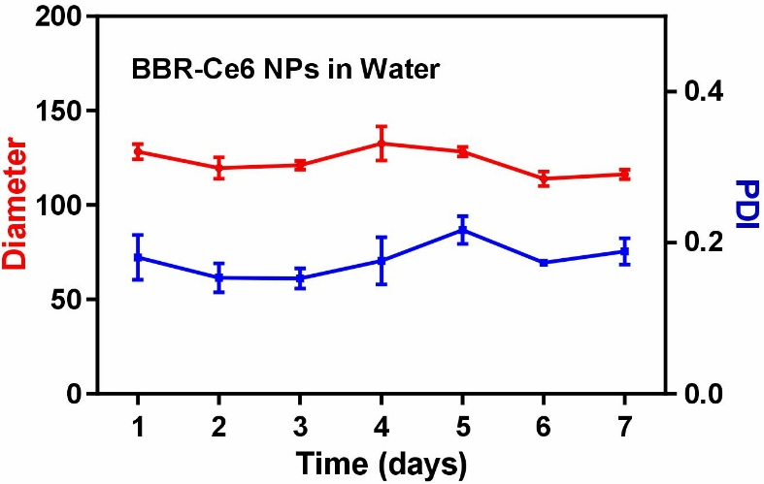
Fig. S1. The change in average diameter and PDI of BBR-Ce6 NPs in water over time.

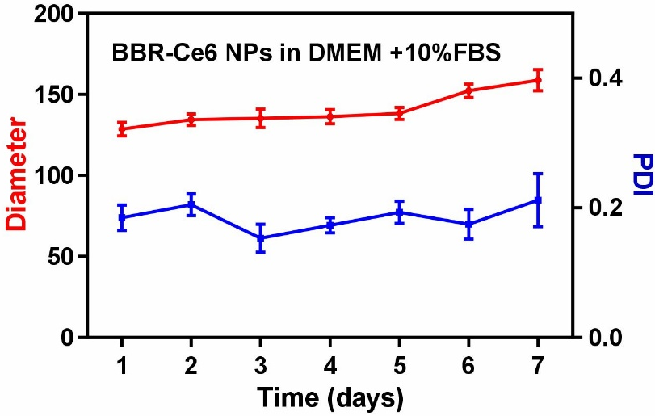
Fig. S2. The change in average diameter and PDI of BBR-Ce6 NPs in DMEM+10% FBS over time.

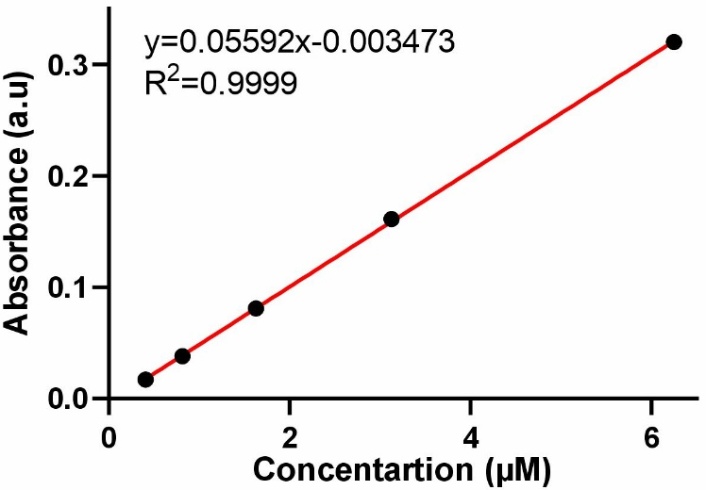
Fig. S3. Standard curve of Ce6 measured by UV-vis (absorbance at 665 nm).
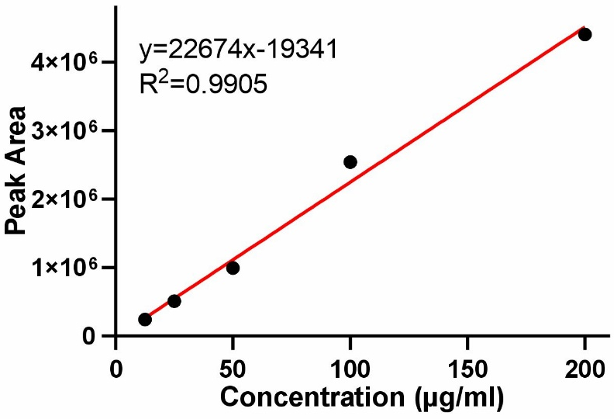
Fig. S4. Standard curve of BBR measured by HPLC. The conditions were as follows: stationary phase, Symmetry C18 column (250 mm x 4.6 mm, 5 um), temperature, 25°C, elution flowrate, 0.8 mL/min; detection wavelength, 265 nm, mobile phase, HPLC grade Acetonitrile/0.033 M PBS (65/35, v/v).

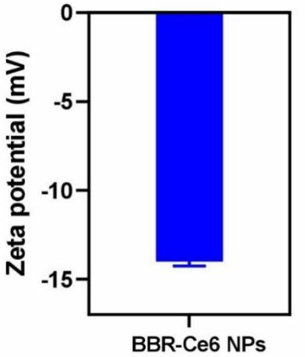
Fig. S5. The zeta potential of BBR-Ce6 NPs.
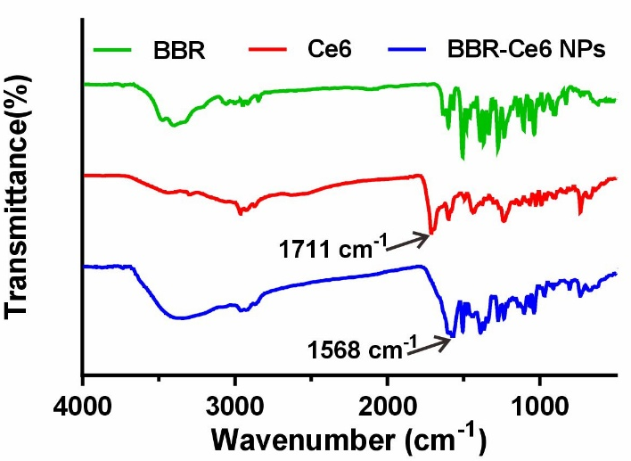
Fig. S6. FTIR spectra of BBR, Ce6, and BBR-Ce6 NPs.

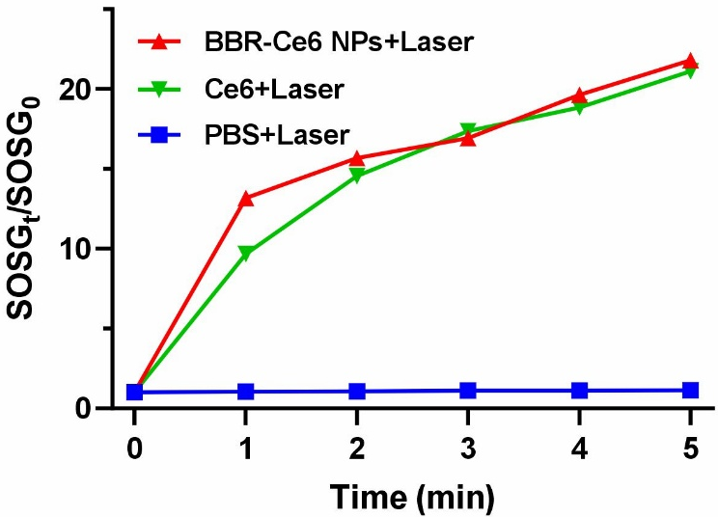
Fig. S7. ¹O₂ generation capacities of PBS, Ce6, and BBR-Ce6 NPs in the presence of laser.
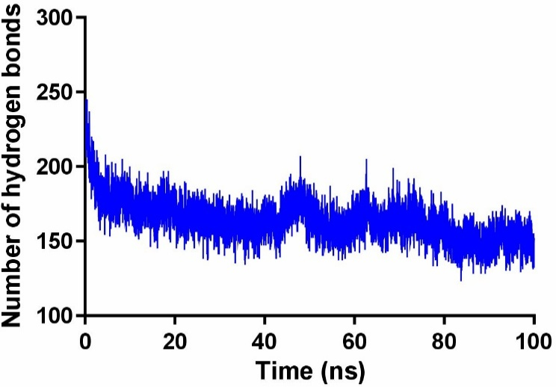
Fig. S8. The change in the number of hydrogen bonds between the complex (BBR-Ce6 NPs) and water.
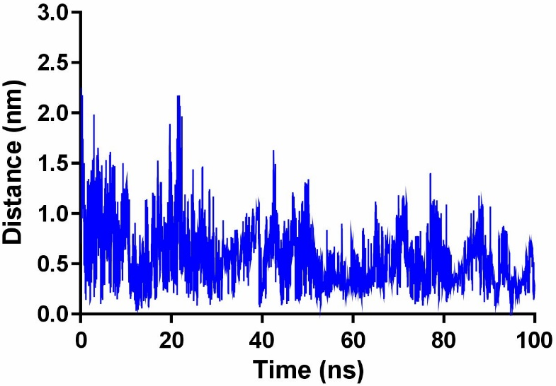
Fig. S9. The changes in centroid distance between BBR and Ce6 during the simulation.

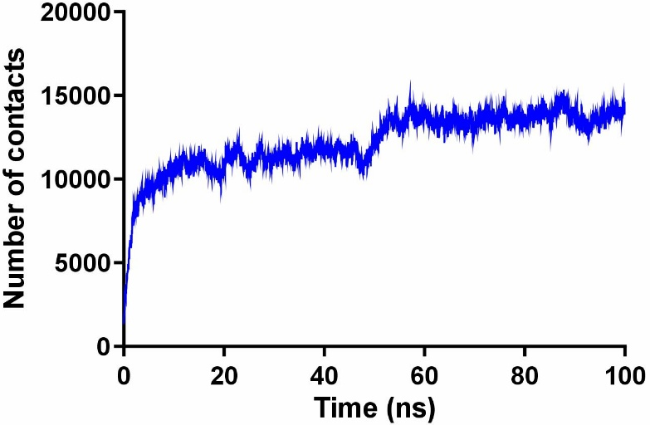
Fig. S10. The changes in contact frequency between BBR and Ce6 during the simulation.
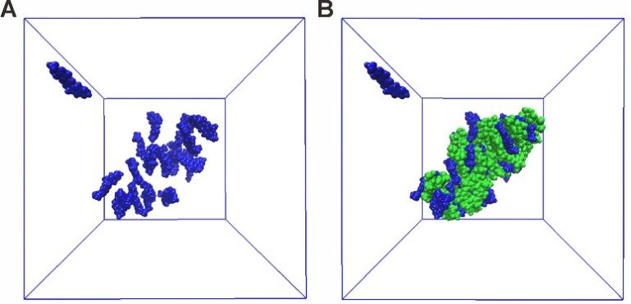
Fig. S11. (A) Molecular docking illuminations of BBR during a 100 ns molecular dynamics simulation. (2) Molecular docking illuminations of BBR/Ce6 system during a 100 ns molecular dynamics simulation.
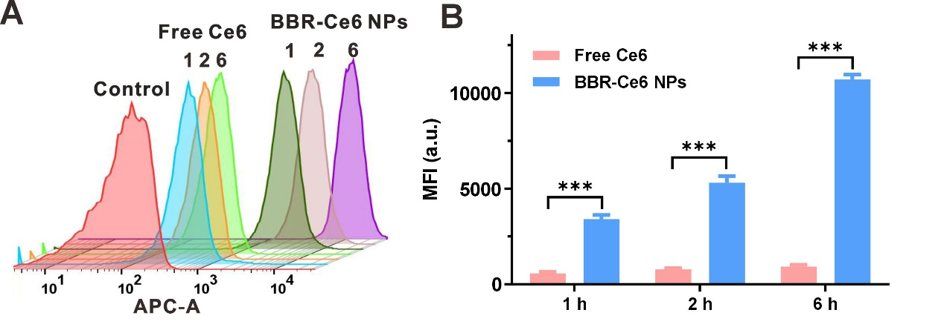
Fig. S12. Flow cytometric (A) and quantitative fluorescence (B) analysis of HepG2 cells after incubation with free Ce6 or BBR-Ce6 NPs for 1, 2, and 6 h.

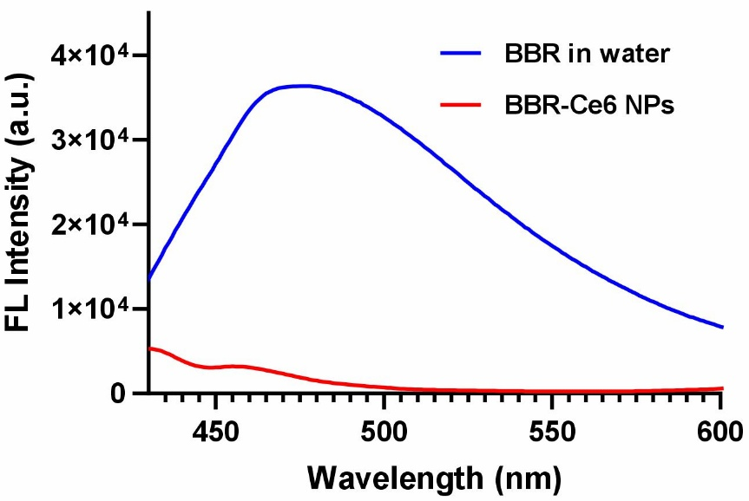
Fig. S13. Fluorescence spectra of BBR and BBR-Ce6 NPs in water.
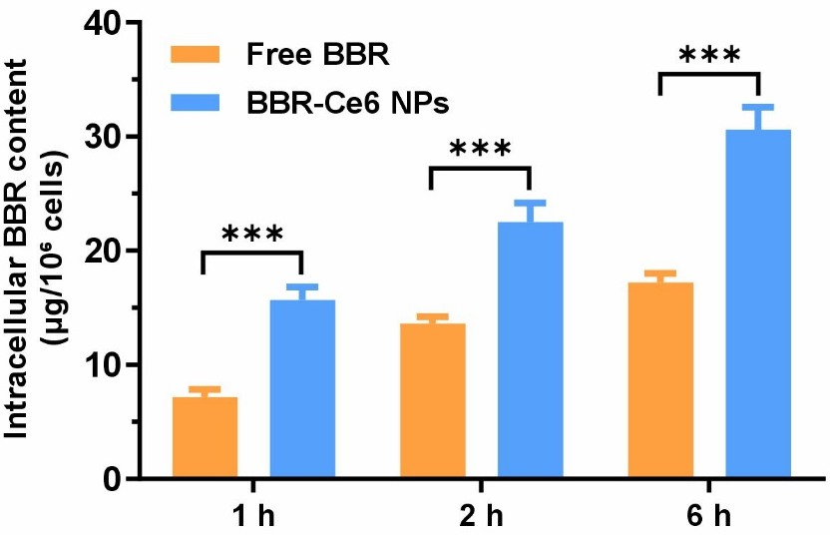
Fig. S14. The BBR content in HepG2 cells after incubation with free Ce6 or BBR-Ce6 NPs for 1, 2, and 6 h.
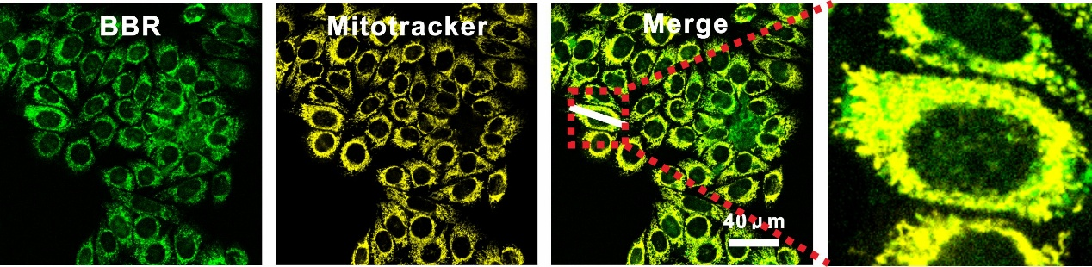
Fig. S15. Colocalized with Mitotracker after 6 h of BBR treatment.

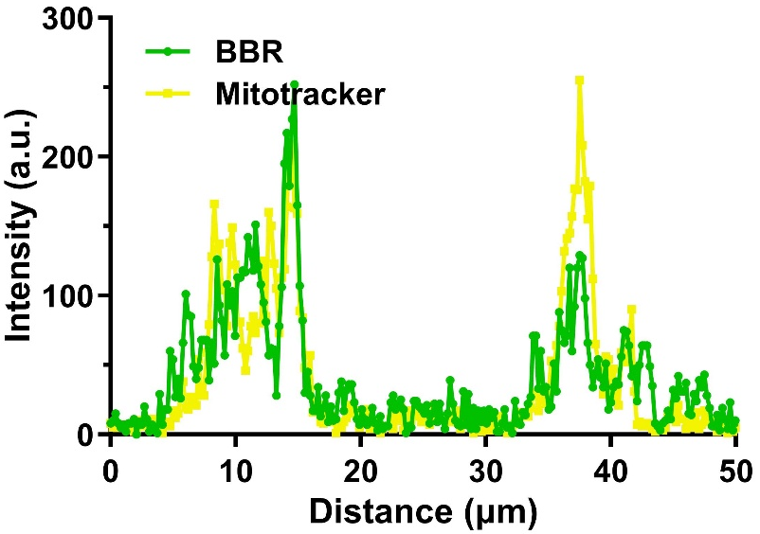
Fig. S16. The intensity profile of the region marked with white line in Fig. S15.
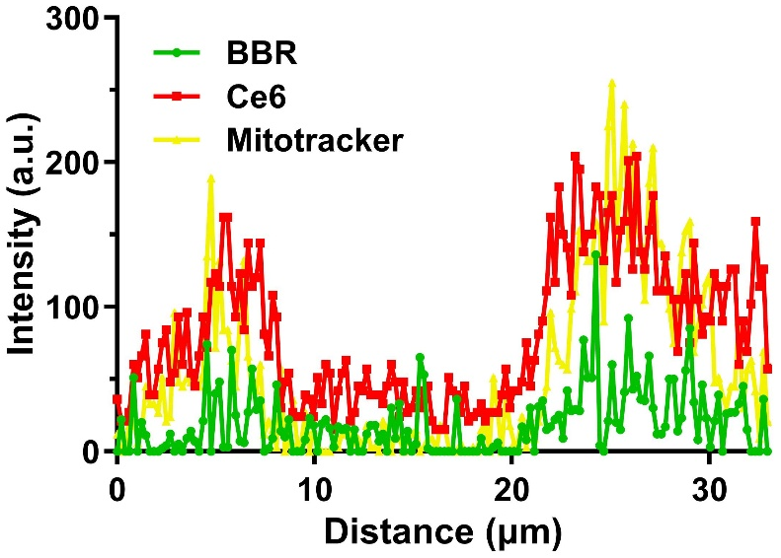
Fig. S17. The intensity profile of the region marked with white line in Fig. 3B.
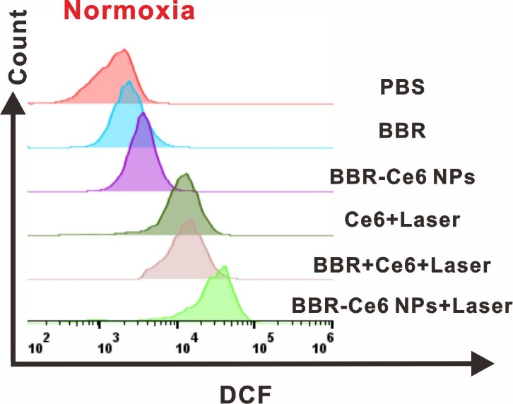
Fig. S18. Flow cytometric analysis of ROS levels in HepG2 cells after incubation with various formulations under normoxic conditions.
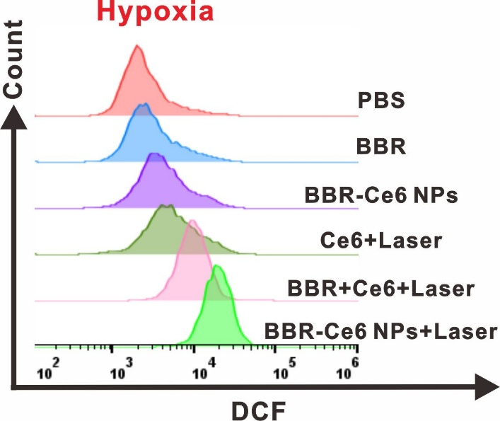
Fig. S19. Flow cytometric analysis of ROS levels in HepG2 cells after incubation with various formulations under hypoxic conditions.
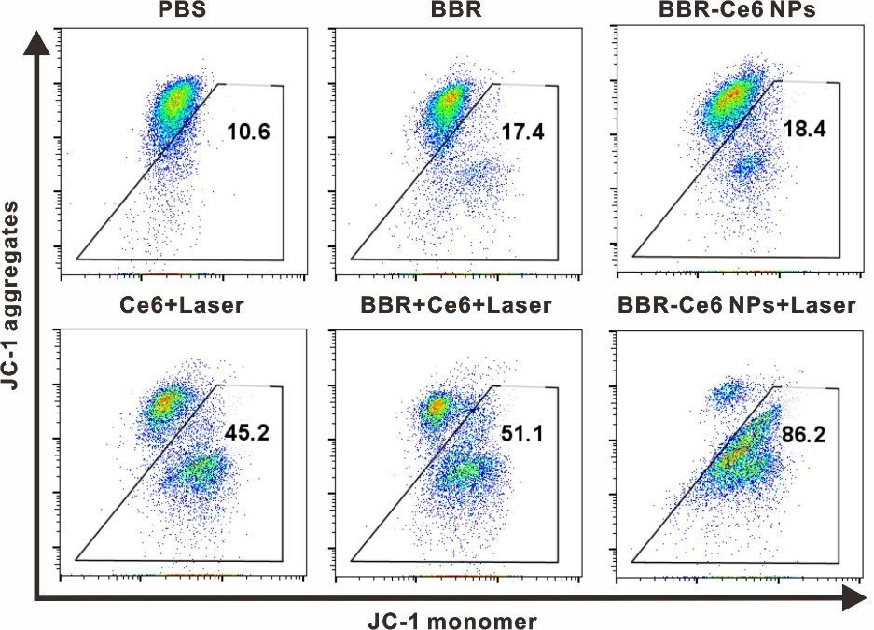
Fig. S20. Changes in mitochondrial membrane potential in HepG2 cells treated with various formulations were analyzed under normoxic conditions by using flow cytometry.

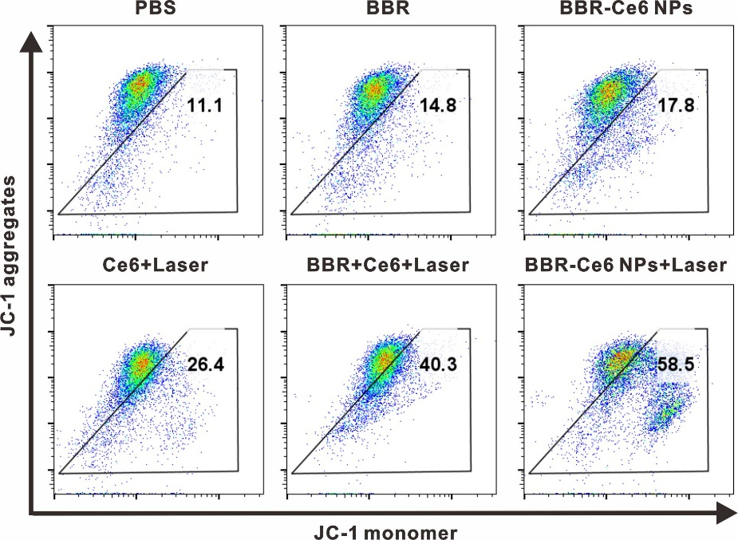
Fig. S21. Changes in mitochondrial membrane potential in HepG2 cells treated with various formulations were analyzed under hypoxic conditions by using flow cytometry.

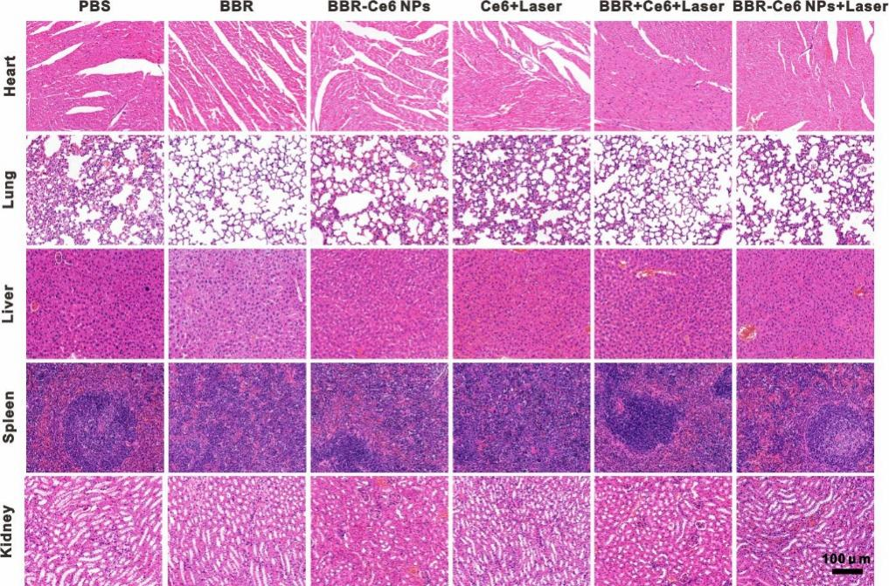
Fig. S22. H&E staining images of major organs dissected from each experiment group.

