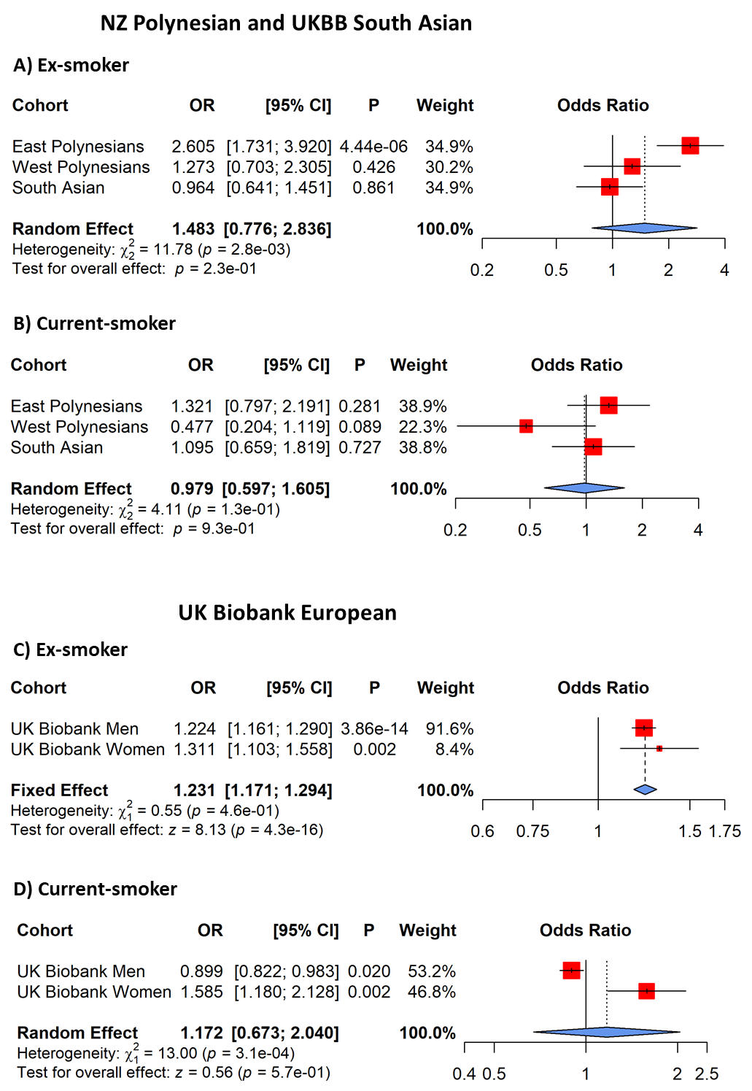
Figure S1. Adjusted odds ratios (ORs) for smoking status effect on gout in NZ Polynesian and UK Biobank South Asian populations (ex-smoker (A) and current-smoker (B)) and in men and women of the UK Biobank European population (ex-smoker (C) and current-smoker (D)).
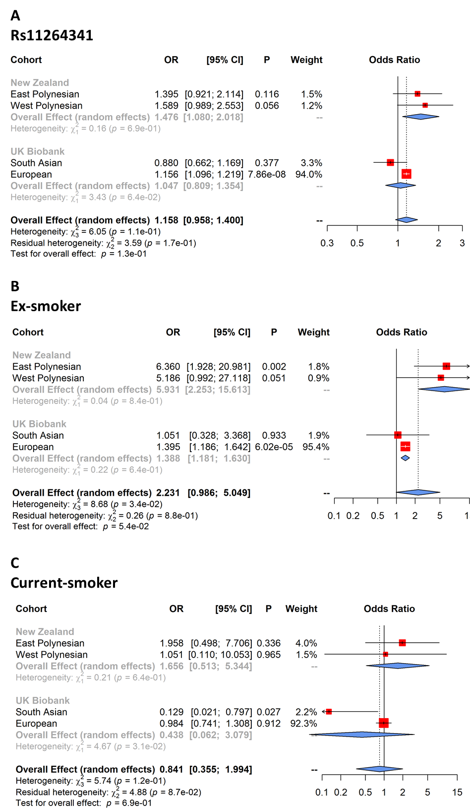

Figure S2. Meta-analysis of main effects, rs11264341 (A), ex-smoker (B) and current-smoker (C), of logistic regression model including the TRIM46 (rs11264341)*smoker status interaction term, with gout as the dependent variable. NZ East and West Polynesian and UK Biobank South Asian and European sample sets were combined by the meta-analysis. Shown is main effect of rs11264341 from model comparing ex- to never-smokers. Main effects of rs11264341 are similar in ex-smokers and current-smoker interaction models.

