Supporting Information for
Ectomycorrhizal fungi as a reservoir of salmon-derived nitrogen in riparian forests.
Journal: Mycorrhiza
Anne Y. Polyakov^{1,2*}, Erik A. Hobbie³, Gordon Holtgrieve⁴, Allen Larocque⁵, Erik Lilleskov⁶, Korena K. Mafune^{7,8}, Kristiina A. Vogt⁷, Daniel J. Vogt⁷, Andrew M. Berdahl^{1,4}
¹Quantitative Ecology and Resource Management, University of Washington; Seattle, WA, 98195, USA.
²Society for the Protection of Underground Networks, 3500 South Dupont Highway, Suite EI-101, Dover, Delaware 19901, USA
³Earth Systems Research Center, University of New Hampshire, Durham, NH, 03824, USA.
⁴School of Aquatic and Fishery Sciences, University of Washington; Seattle, Washington, 98195, USA.
⁵Pacific Forestry Centre, Canadian Forest Service, Victoria, BC, V8Z 4N9, Canada.
⁶USDA Forest Service, Northern Research Station, Houghton, MI, 49931, USA.
⁷School of Environmental and Forest Sciences, University of Washington; Seattle, Washington, 98195, USA.
⁸Department of Civil and Environmental Engineering, University of Washington; Seattle, Washington, 98195, USA.
Corresponding Author:
Anne Y. Polyakov
520 Malden Avenue East, Apt. 3
Seattle, WA 98112
631-972-5328
annep@spun.earth

Supporting text: Methods
Hansen and Happy Creeks are neighboring creeks (~1 km apart), while Yako Creek is located across Lake Aleknagik. The streams are bordered by a boreal forest dominated by white spruce and paper birch. Other vegetation includes willow (Salix spp.), Vaccinium spp., bracken fern (Pteridium aquilinum), horsetail (Equisetum arvense), fireweed (Epilobium angustifolium), and dwarf birch (Betula nana). In addition, cotton grass (Eriophorum spp.) is found close to the stream edge, while moss (Bryophyta spp.) and Alaska moss heather (Harrimanella stelleriana.) are found further away from the stream edge. Hansen Creek has stable flows with minimal flooding (Quinn et al. 2018), therefore, high flows do not distribute salmon carcasses into the riparian zone. This indicates that the dominant form of transport into the riparian zone is by brown bears (Ursus arctos), although it is possible that hyporheic transport occurs (O’ Keefe and Edwards 2003). A large proportion of sockeye salmon (Oncorhynchus nerka) at streams in our study area, are transferred to the riparian zone by brown bears, and vegetation by these stream banks receives a significant amount of MDN (Quinn et al. 2009, Helfield and Naiman 2002). Surveys have shown that 35% of salmon carcasses were found on land, 44% partially submerged, and 21% fully submerged in streams (Meehan et al. 2005). During our study, all streams had decomposing salmon carcasses, with some found concentrated at bear middens (areas where bears consistently bring carcasses to consume).
Hansen Creek was the site of a 21-year salmon carcass fertilization experiment established by (Quinn et al. 2018). From 1997 to 2018, the stream was surveyed daily for salmon carcasses throughout the annual sockeye salmon run. During these surveys, all dead salmon located in the creek and within 5 m of the right stream bank (facing downstream) were thrown within 3-6 m of the left stream bank. In addition, all pre-existing salmon on the left bank were moved to a distance of roughly 3-6 m to avoid double-counting. As a result, all salmon carcasses at Hansen Creek were located 3-6 m from the left bank of the stream, except for those relocated by wildlife. This resulted in decreased salmon carcass density on the right side of the stream and increased salmon carcass density on the left side. Before the manipulation began, each bank received 4,500 kg of salmon annually, whereas after the manipulation began, the left bank received approximately six times more salmon carcasses than the right bank, averaging 13,400 kg of salmon while the right bank averaged 2,300 kg of salmon annually (Quinn et al. 2018). This equated to 267,620 kg of salmon carcasses deposited on the left bank, contributing 8,028 kg of N and 1,356 kg of P (Quinn et al. 2018), or 0.038 kg N/m²/yr and 0.006 kg P/m²/yr (assuming deposition primarily from 1-5 m from the stream bank over 21 years). Our study took place in 2020, two years after the carcass manipulation experiment ended.
We analyzed ¹⁵N:¹⁴N, ¹³C:¹²C, %N, %C of fungal sporocarps, white spruce foliage, paper birch foliage, mineral soil and organic soil. Additionally, we genetically sequenced all fungal sporocarps to further assist in assigning functional traits and interpreting isotopic signatures, as characteristics influencing isotopic signatures of fungal sporocarps are typically genus- or species-specific. Furthermore, sequencing contributed to the characterization of fungal species in Alaska, as Alaska mycota are not well characterized and include many undescribed species (Dr. Steve Trudell, personal communication).
For the analysis of total P concentration for all samples, we used 1 g of dried sample material and digested with repeated additions of nitric acid and hydrogen peroxide. The resultant digestate was then reduced in volume while heating and diluted to a final volume of 100 mL (US EPA 1996). The solution was then analyzed for total P and 22 other elements using ICP-MS on an ICAP 6300 (Thermo Scientific Inc.).
For DNA extraction and sequencing of fungal sporocarps, we extracted fungal tissue into 0.2 mL8-strip PCR tubes. We then added 20 μL ofX-Amp (IBI Scientific, Peosta, Iowa, United States) into each well of the 8-strip tubes and heated at 80 °C for 1 h to begin DNA extraction. We added 50 μL of water to each well to create the PCR template, and performed PCR for the full ITS region using ITS1F and ITS4 primers. We created dual-index primer-master mix plates by hand or using a Opentrons OT-2 robotic pipetting platform as described (Russell 2023). Each amplification reaction contained 12.5 μL of MeanGreen 2× Master Mix (Empirical Bioscience, Grand Rapids, Michigan, USA), 9 μL water, 1.25 μL forward primer, 1.25 μL reverse primer, and 1 μL DNA template for a total PCR volume of 25 μL. The following PCR protocol was used: (i) initial denaturation at 94 °C for 60 s; (ii) 30 cycles of denaturation at 94 °C for 60 s, annealing at 51 °C for 60 s, and extension at 72 °C for 60 s; (iii) hold at 72 °C for 8 min. We used electrophoresis with a 1 % agarose gel to verify successful amplification. We pooled the resulting amplicons and created a library with the Oxford Nanopore Technologies (ONT) LSK 112 or LSK114 chemistry (Oxford Nanopore Technologies, Oxford, UK). We performed sequencing on an ONT Minion & Flongle device with a Flongle 9.4.1 or 10.4.1 flowcell.

Supplementary Section Statistical Analysis
To accurately model the effect of the salmon carcass manipulation, we considered how placement of carcasses could affect nearby trees, fungi, and soil, and how sampling the soil environment differs from sampling foliage from a tree or a fungal sporocarp. Soil is a physical substrate through which nutrients from a carcass diffuse outwards from the carcass source. Tree roots extend through the soil several meters outward from the trunk to search for nutrients, which are then taken up through directed movement through the roots, and subsequently sent to varying parts of the tree, such as the roots, stem, or foliage. Fungi form thick mats of hyphae belowground that can transfer nutrients up to several meters, and possibly further distances from a nutrient source (Beiler et al. 2015, Simard et al. 2012). In this way, the soil receives nutrients at a point and nutrients then passively diffuse through the soil, while trees and fungi actively uptake nutrients using roots or hyphae within at least a several meter-radius, thus re-distributing and accumulating nutrients from the surrounding area to a source. Thus, the area of effect from a nutrient source such as a carcass is much wider when sampling foliage or fungal sporocarps than when sampling soil, because of the uptake and directed movement of nutrients through roots and hyphae. Salmon carcasses were thrown onto the soil from 3-6 m from the bank each year in late summer, where they would decompose into the soil. It is important to evaluate whether the fungi, soil, and plants sampled along transects reasonably had access to nutrients from these decomposing salmon carcasses. Soil cores were taken at points 1, 3, and 6 m away from the stream bank. Therefore, soils sampled at 3 and 6 m were affected by carcass manipulation, and also likely the soils at 1 m as salmon nutrients potentially move through the soil towards the stream bank due to diffusion and mass flow of soluble N, and also via foliage, roots, and fungal hyphae.
Sporocarps that were sampled at the 1 m sampling location were collected (and data were averaged) across a 10 × 2 m area on each side of the soil core at 1 m, stretching 10 m away parallel to the bank on either side, and from 1-3 m perpendicularly away from the bank. Therefore, it is very likely that the fungi that produced these sporocarps had hyphae present beyond 3 m from the bank, into the carcass manipulation zone. The fungi that we sampled at the 6 m soil core plot were collected from 4-8 m away from the bank, and 10 m parallel to the bank on either side, across a 10 × 4 m area. Thus, the carcass manipulation affected fungi sampled at both the 1 and 6 m locations away from the stream bank. Plants were sampled in a 2 m radius of the soil core at each sampling location, and plants sampled in the 2 m radius around the 1 m soil core likely had roots extending into the carcass manipulation zone at 3-6 m. Thus, plants sampled at both the 1 and 6 m locations away from the stream bank were affected by the carcass manipulation. This is similar to the methodology of sampling white spruce at Hansen Creek performed by (Quinn et al. 2018), where spruce from 1-5 m from both stream banks were sampled. In addition, (Feddern et al. 2019) found that the carcass manipulation increased the ¹⁵N of the soil ammonium pool, the most likely N source for plants and fungi in this system, and that enrichment was highest at 3 m and declined with distances < 3 m. This suggests that salmon-derived N was present in larger quantities closer to the 3 m area of the manipulation. Therefore, this makes it even more likely that fungi and plants sampled from 1-3 m had the possibility of taking up MDN, and in fact could even imply that uptake of MDN could be higher for plants and fungi at the 1 m sampling location than the 6 m sampling location, due to the 1-3 m samples being closer to the 3 m site than the 4-8 m samples.

Supplementary Section Models
Models for δ¹⁵N
Fungal δ¹⁵N ~ carcass manipulation + decomposing carcass + salmon density + fungal %N + ln(Distance) + organic soil GWC + organic soil δ¹⁵N + organic soil C:N + mineral soil GWC + mineral soil δ¹⁵N + mineral soil C:N + trophic status (mycorrhizal, saprotrophic, or unknown) + (1|Genus) + (1|Stream:Transect)
White spruce δ¹⁵N ~ carcass manipulation + decomposing carcass + salmon density + white spruce %N + ln(Distance) + mean fungal δ¹⁵N + soil organic GWC + soil organic δ¹⁵N + mineral soil GWC + mineral soil δ¹⁵N + (1|Stream:Transect)
Paper birch δ¹⁵N ~ carcass manipulation + decomposing carcass + salmon density + paper birch %N + ln(Distance) + mean fungal δ¹⁵N + soil organic GWC + soil organic δ¹⁵N + mineral soil GWC + mineral soil δ¹⁵N + (1|Stream:Transect)
Organic soil δ¹⁵N ~ carcass manipulation + decomposing carcass + salmon density + ln(Distance) + organic soil %N + organic soil GWC + (1|Stream:Transect)
Mineral soil δ¹⁵N ~ carcass manipulation + decomposing carcass + salmon density + ln(Distance) + mineral soil %N + mineral soil GWC + (1|Stream:Transect)

Models for δ¹³C
Fungal δ¹³C ~ carcass manipulation + decomposing carcass + salmon density + fungal %N + ln(Distance) + trophic status + organic soil GWC + organic soil δ¹³C + mineral GWC + mineral soil δ¹³C + paper birch δ¹³C + white spruce δ¹³C + (1|Genus) + (1|Stream:Transect)
White spruce δ¹³C ~ carcass manipulation + decomposing carcass + salmon density + white spruce %N + ln(Distance) + soil organic GWC + (1|Stream:Transect)
Paper birch δ¹³C ~ carcass manipulation + decomposing carcass + salmon density + paper birch %N + ln(Distance) + soil organic GWC + (1|Stream:Transect)
Organic soil δ¹³C ~ carcass manipulation + decomposing carcass + salmon density + organic soil %N + ln(Distance) + organic soil GWC + (1|Stream:Transect)
Mineral soil δ¹³C ~ carcass manipulation + decomposing carcass + salmon density + mineral soil %N + ln(Distance) + mineral soil GWC + (1|Stream:Transect)

Models for C:N
Fungal C:N ~ carcass manipulation + decomposing carcass + salmon density + ln(Distance) + trophic status + organic soil C:N + mineral soil C:N + white spruce C:N + paper birch C:N + organic soil GWC + mineral soil GWC + (1|Genus) + (1|Stream:Transect)
White spruce C:N ~ carcass manipulation + decomposing carcass + salmon density + ln(Distance) + organic soil GWC + mineral soil GWC + (1|Stream:Transect)
Paper birch C:N ~ carcass manipulation + decomposing carcass + salmon density + ln(Distance) + organic soil GWC + mineral soil GWC + (1|Stream:Transect)
Organic soil C:N ~ carcass manipulation + decomposing carcass + salmon density + ln(Distance) + organic soil GWC + (1|Stream:Transect)
Mineral soil C:N ~ carcass manipulation + decomposing carcass + salmon density + ln(Distance) + mineral soil GWC + (1|Stream:Transect)

Supplementary Section on fungal-plant trading patterns
The dominant tree species at the study site, white spruce and paper birch, form strong mutualisms and are obligate partners with mycorrhizal fungi. Trees trade photosynthetically derived C for fungal-foraged N, with up to 80% of plant N derived from mycorrhizal fungal networks (Hobbie and Hobbie 2006, Smith and Read 2008). Since most of the fungi we collected were ectomycorrhizal fungi (85%, Table 4), C and N exchange is likely occurring in this system. However, fungal-plant trading is strongly driven by N availability, and some studies have shown that fungal N transfer to plant hosts decreases with higher soil N availability as plant hosts can attain labile N directly from the soil without the C cost associated with fungal-mediated N uptake and transfer (Jach-Smith and Jackson 2020). Other studies have shown that EMF can actually reinforce N limitation and direct uptake of nutrients is limited when EMF colonizes plants (Franklin et al. 2014). Plants were primarily N-limited in this system (Figure 3), therefore we might expect trading to be high across the entire site and potentially lower at the site of carcass manipulation. Stable isotope analysis can be used to detect the presence and intensity of fungal-plant trading due to isotopic fractionation that occurs during the trading process. After taking up N from the soil, mycorrhizal fungi create transfer compounds within the hyphae that will transfer N to plant hosts. The creation of transfer compounds fractionates against ¹⁵N, leading to plant hosts receiving ¹⁵N-depleted N, while N that remains within the hyphae is enriched in ¹⁵N (Hobbie and Hobbie 2006). This leads to mycorrhizal fungi being enriched and mycorrhizal plants being depleted in ¹⁵N relative to bulk soil and inorganic soil N. In this study, plant δ¹⁵N was lower than soil δ¹⁵N while fungal δ¹⁵N was higher than soil δ¹⁵N by similar values of ~3‰ on the salmon-depleted bank from 1-6 m (soil δ¹⁵N = 8.3‰, plant δ¹⁵N = 5.7‰, fungal δ¹⁵N = 12‰; Figure 2). This indicates that N and C exchange is occurring between mycorrhizal fungi and their plant hosts, with an average of 28% fungal N transferred to plant hosts from 1-6 m (Table S4). However, on the salmon-enhanced bank from 1-6 m, soil and plant δ¹⁵N are approximately the same, while fungi are 5‰ and 6‰ higher in δ¹⁵N than plants or organic soil, respectively (fungal δ¹⁵N = 13.56‰, plant δ¹⁵N = 8.6‰, organic soil δ¹⁵N = 7.6‰; Figure 2). At first glance, this might suggest that no fungal-plant N exchange is occurring, because we do not see the expected pattern of lower plant δ¹⁵N and higher fungal δ¹⁵N relative to soil δ¹⁵N. If fungal-plant trading were occurring, fungi would have to be drawing from a N pool considerably more enriched than the organic bulk soil pool. Based on available evidence, it is likely that fungi are taking up MDN from the ¹⁵N-enriched soil ammonium pool, and then trading this MDN with plant hosts. Although this study did not evaluate soil ammonium concentration or δ¹⁵N, we note that in 2017, organic soil δ¹⁵N and ammonium δ¹⁵N was approximately the same at 6 m on the salmon-depleted bank, while soil ammonium δ¹⁵N was approximately 3‰ higher than organic soil δ¹⁵N on the salmon-enhanced bank (Feddern et al. 2019; Table S5). This difference was due to high nitrification rates on the salmon-enhanced bank from carcass manipulation. Since soil ammonium is the dominant available N pool and is considerably enriched in ¹⁵N relative to bulk soil, it is likely that fungi are taking up MDN from this enriched pool and trading with plant hosts, leading to the patterns seen in Figure 2, with plant δ¹⁵N and fungal δ¹⁵N higher than bulk soil δ¹⁵N. In 2017, δ¹⁵N of soil ammonium averaged 11.85‰ at 1-6 m on the salmon-enhanced bank (Table S5). If we assume that soil ammonium δ¹⁵N changes by the same amount as bulk soil δ¹⁵N for each sampling location from 2017 to 2020, then soil ammonium δ¹⁵N = ~11.48‰ from 1-6 m in 2020 (Table S5). If fungi are taking up MDN from the soil ammonium pool and trading with plants at the site of carcass manipulation (soil δ¹⁵N = 11.48‰, plant δ¹⁵N = 8.6‰, fungal δ¹⁵N = 13.9‰; Figure 2), calculations show that ~20% of fungal N is transferred to plant hosts from 1-6 m on the salmon-enhanced bank. This amount is 8% less N than the 28% of fungal N transferred to plant hosts on the salmon-depleted bank from 1-6 m (Table S4), not a considerably large difference and minimal support for our hypothesis that MDN would decrease plant-fungal trading.

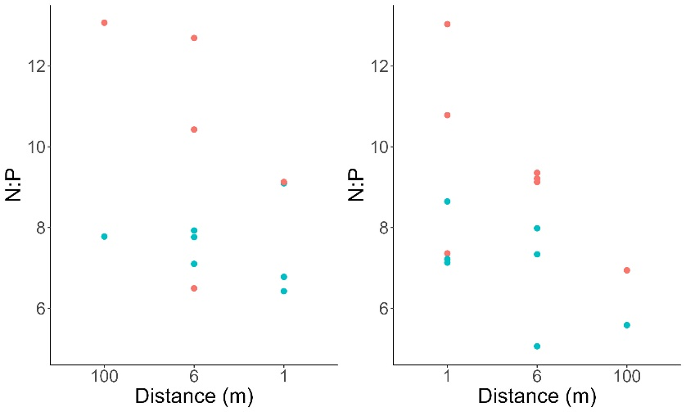

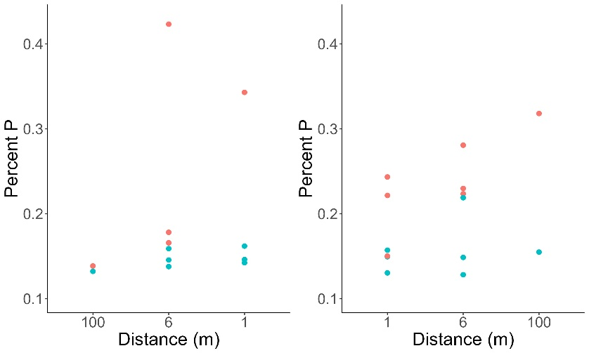

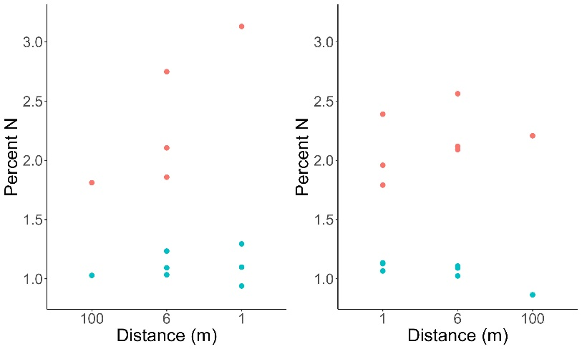

Salmon-deleted
Salmon-enhanced

Figure S1. The %P, %N, and N:P values for paper birch (red) and white spruce (blue) samples at Hansen Creek from 1-6 m on both the salmon-enhanced (SL) and salmon-depleted (SR) banks.

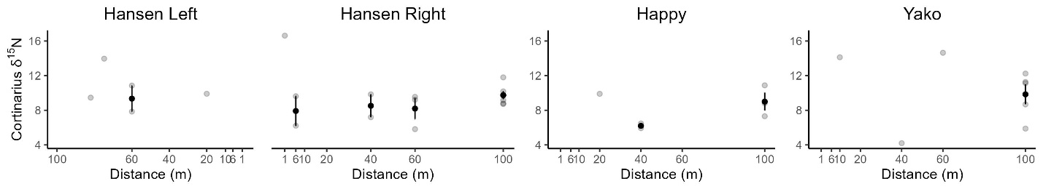
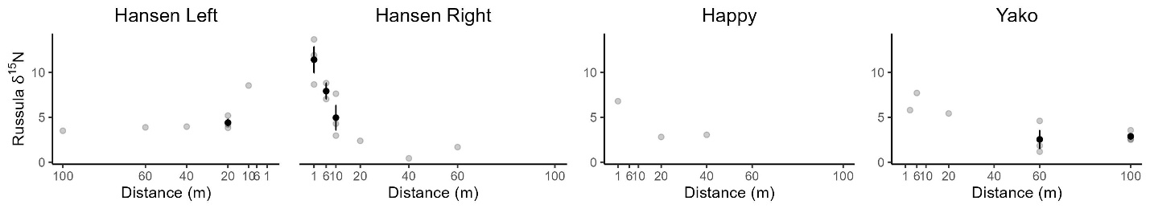
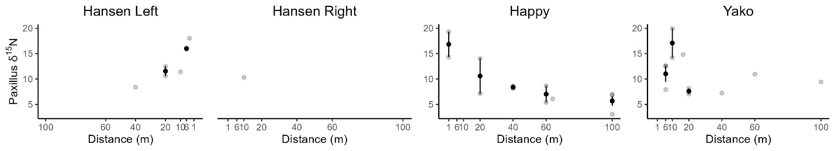
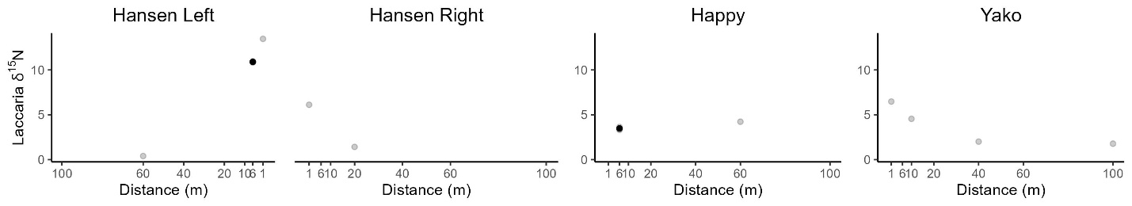
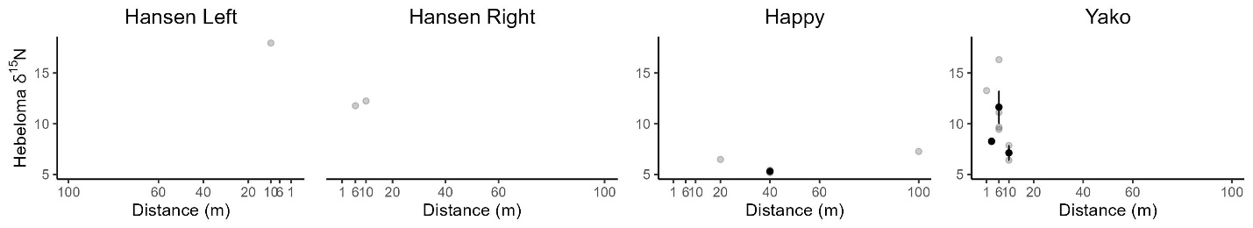
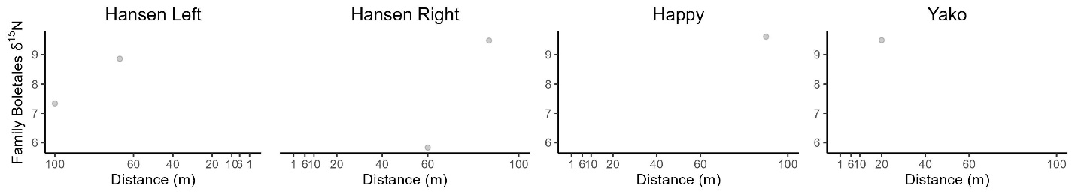
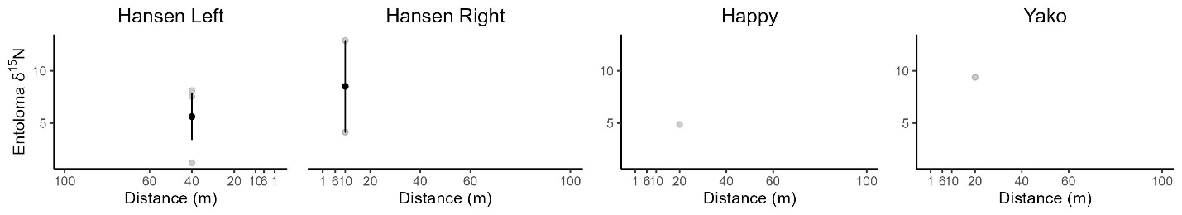
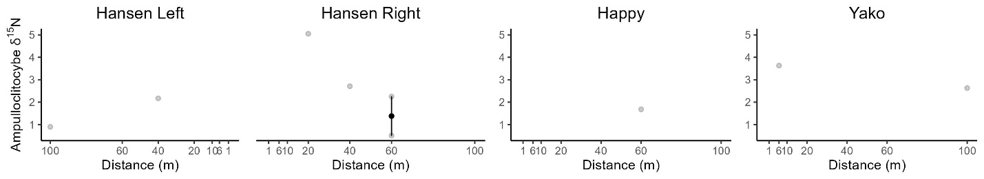
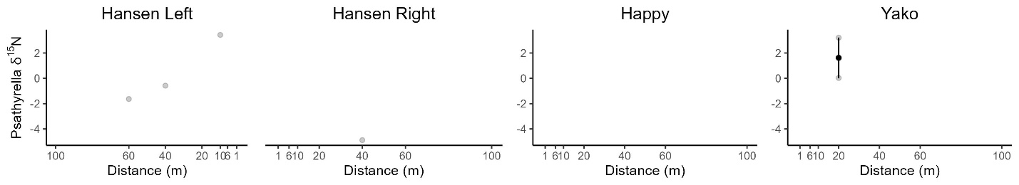
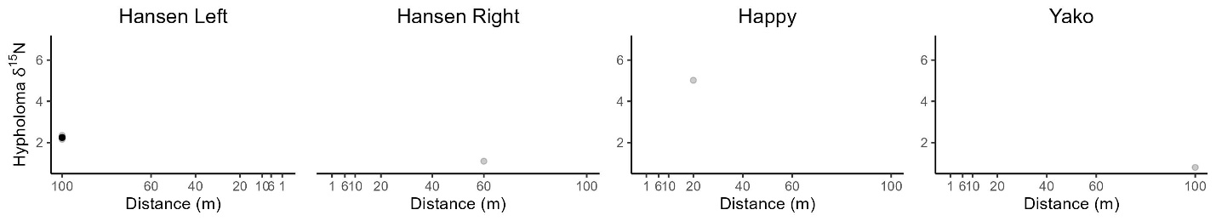
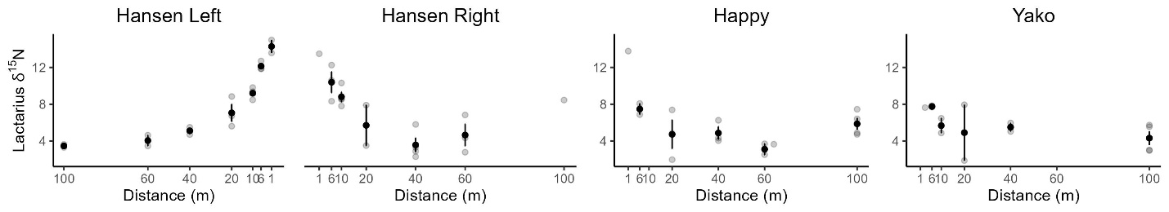
Order Boletales δ¹⁵N

Figure S2. Values of fungal δ¹⁵N by genera, distance, and side (at Hansen Creek) along three sockeye salmon streams in southwest Alaska. Genera with > 5 sporocarps are included.
Table S1. Fungal species found at three salmon streams in SW Alaska, accompanied by trophic guild and exploration type (if applicable) from three databases: FunGuild (has species-level data available, but only trophic guild), FungalTraits (has only genus-level data, both trophic and exploration type available), and Determination of Ectomycorrhizae, or DEEMY (has species-level data and trophic and exploration type information. Fungal species with numbers are new, undescribed species. ND = no data. NA = not applicable.
Species | FunGuild | FungalTraits | DEEMY | Literature
Amanita betulae | Pathotroph-Saprotroph-Symbiotroph | Ectomycorrhizal, medium distance smooth | ND
Ampulloclitocybe clavipes | Saprotroph-Symbiotroph | Litter saprotroph | ND
Apioperdon pyriforme | Saprotroph | Wood saprotroph | ND
Boletaceae (family)
Clitocybe odora | Pathotroph-Saprotroph-Symbiotroph | Litter saprotroph | ND
Clitocybe PNW06 | NA | Litter saprotroph | NA
Clitocybe sp-PNW01 | NA | Litter saprotroph | NA
Cortinarius alboviolaceus | Symbiotroph, Ectomycorrhizal | Ectomycorrhizal, medium distance fringe | ND
Cortinarius armillatus | Symbiotroph, Ectomycorrhizal | Ectomycorrhizal, medium distance fringe | Medium distance fringe
Cortinarius caperatus | Symbiotroph, Ectomycorrhizal | Ectomycorrhizal, medium distance fringe | ND
Cortinarius hirtus | Symbiotroph, Ectomycorrhizal | Ectomycorrhizal, medium distance fringe | ND
Cortinarius illibatus-AK01 | NA | Ectomycorrhizal, medium distance fringe | ND
Cortinarius modestus | Symbiotroph, Ectomycorrhizal | Ectomycorrhizal, medium distance fringe | ND
Cortinarius nigrocuspidatus | Symbiotroph, Ectomycorrhizal | Ectomycorrhizal, medium distance fringe | ND
Cortinarius pellstonianus | Symbiotroph, Ectomycorrhizal | Ectomycorrhizal, medium distance fringe | ND
Cortinarius pholideus | Symbiotroph, Ectomycorrhizal | Ectomycorrhizal, medium distance fringe | ND
Cortinarius vibratilis | Symbiotroph, Ectomycorrhizal | Ectomycorrhizal, medium distance fringe | Medium distance fringe
Cortinarius semisanguineus-PA01 | NA | Ectomycorrhizal, medium distance fringe | ND
Cortinarius subparvannulatus | Symbiotroph, Ectomycorrhizal | Ectomycorrhizal, medium distance fringe | ND
Cortinarius tabularis | Symbiotroph, Ectomycorrhizal | Ectomycorrhizal, medium distance fringe | ND
Cortinarius umbrinolens | Symbiotroph, Ectomycorrhizal | Ectomycorrhizal, medium distance fringe | ND
Cystoderma amianthinum-PA01 | Saprotroph | Litter saprotroph | ND
Cystodermella adnatifolia | Saprotroph | Litter saprotroph | ND
Entoloma cetratum | Pathotroph-Saprotroph-Symbiotroph, Ectomycorrhizal-Fungal Parasite-Soil Saprotroph-Undefined Saprotroph | Soil saprotroph and unspecified symbiotroph, ectomycorrhizal ~ 10% of species, Medium distance smooth | ND | Saprotrophic. Source: Termorshuizen, Aad J., and Mirjam T. Veerkamp. "Fungi in spontaneous stands of Scots pine (Pinus sylvestris) in drift sands." Field Mycology 13, no. 4 (2012): 118-123.
Entoloma sericatum | Pathotroph-Saprotroph-Symbiotroph, Ectomycorrhizal-Fungal Parasite-Soil Saprotroph-Undefined Saprotroph | Soil saprotroph and unspecified symbiotroph, ectomycorrhizal ~ 10% of species, Medium distance smooth | ND | Mycorrhizal. Source: Brandrud, Tor Erik, Egil Bendiksen, John Bjarne Jordal, Øyvind Weholt, Siw Elin Eidissen, Jostein Arve Lorås, Bálint Dima, and Machiel E. Noordeloos. "Entoloma species of the rhodopolioid clade (subgenus Entoloma; Tricholomatinae, Basidiomycota) in Norway." (2018).
Entoloma turbidum | Pathotroph-Saprotroph-Symbiotroph, Ectomycorrhizal-Fungal Parasite-Soil Saprotroph-Undefined Saprotroph | Soil saprotroph and unspecified symbiotroph, ectomycorrhizal ~ 10% of species, Medium distance smooth | ND | Saprotrophic. Source: Termorshuizen, Aad J., and Mirjam T. Veerkamp. "Fungi in spontaneous stands of Scots pine (Pinus sylvestris) in drift sands." Field Mycology 13, no. 4 (2012): 118-123.
Gymnopilus decipiens | Pathotroph-Saprotroph-Symbiotroph; Bryophyte Parasite-Dung Saprotroph-Ectomycorrhizal-Fungal Parasite-Leaf Saprotroph-Plant Parasite-Undefined Saprotroph-Wood Saprotroph | Wood saprotroph | ND
Hebeloma aurantioumbrinum | Pathotroph-Saprotroph-Symbiotroph; Bryophyte Parasite-Dung Saprotroph-Ectomycorrhizal-Fungal Parasite-Leaf Saprotroph-Plant Parasite-Undefined Saprotroph-Wood Saprotroph | Ectomycorrhizal; short distance delicate | ND
Hebeloma leucosarx | Pathotroph-Saprotroph-Symbiotroph; Bryophyte Parasite-Dung Saprotroph-Ectomycorrhizal-Fungal Parasite-Leaf Saprotroph-Plant Parasite-Undefined Saprotroph-Wood Saprotroph | Ectomycorrhizal; short distance delicate | ND
Hebeloma monticola | Pathotroph-Saprotroph-Symbiotroph; Bryophyte Parasite-Dung Saprotroph-Ectomycorrhizal-Fungal Parasite-Leaf Saprotroph-Plant Parasite-Undefined Saprotroph-Wood Saprotroph | Ectomycorrhizal; short distance delicate | ND
Hebeloma sordescens | Pathotroph-Saprotroph-Symbiotroph; Bryophyte Parasite-Dung Saprotroph-Ectomycorrhizal-Fungal Parasite-Leaf Saprotroph-Plant Parasite-Undefined Saprotroph-Wood Saprotroph | Ectomycorrhizal; short distance delicate | ND
Hypholoma capnoides | Pathotroph-Saprotroph; Dung Saprotroph-Plant Parasite-Soil Saprotroph-Undefined Saprotroph-Wood Saprotroph | Wood saprotroph | ND
Inocybe sp-AK01 | NA | Ectomycorrhizal; short distance delicate | NA
Laccaria glabripes | Symbiotroph, Ectomycorrhizal | Ectomycorrhizal; short distance delicate | ND
Laccaria sp-AK01 | Likely Symbiotroph, Ectomycorrhizal | Ectomycorrhizal; short distance delicate | NA
Laccaria sp-PA01 | Likely Symbiotroph, Ectomycorrhizal | Ectomycorrhizal; short distance delicate | NA
Lactarius glyciosmus | Symbiotroph, Ectomycorrhizal | Ectomycorrhizal, medium distance smooth | No information on exploration type, no rhizomorphs present
Lactarius rufus | Symbiotroph, Ectomycorrhizal | Ectomycorrhizal, medium distance smooth | No information on exploration type, rhizomorphs infrequent
Lactarius tabidus | Symbiotroph, Ectomycorrhizal | Ectomycorrhizal, medium distance smooth | ND
Lactarius turpis | Symbiotroph, Ectomycorrhizal | Ectomycorrhizal, medium distance smooth | ND
Limacella sp-L-CA01 | NA | Soil saprotroph | NA
Limacella sp-L-CO01 | NA | Soil saprotroph | NA
Lyophyllaceae sp-AK01 | NA | This family had two saprotrophic and one ectomycorrhizal genera which was medium distance fringe | NA
Melanoleuca alboflavida | Soil saprotroph | Soil saprotroph | ND
Naucoria bohemica | Pathotroph-Saprotroph-Symbiotroph; Bryophyte Parasite-Dung Saprotroph-Ectomycorrhizal-Fungal Parasite-Leaf Saprotroph-Plant Parasite-Undefined Saprotroph-Wood Saprotroph | Ectomycorrhizal; short distance delicate | ND
Naucoria sp-AK01 | NA | Ectomycorrhizal; short distance delicate | NA
Paxillus involutus | Symbiotroph, Ectomycorrhizal | Ectomycorrhizal; long distance | Long distance
Pholiota lurida | Pathotroph-Saprotroph; Dung Saprotroph-Plant Parasite-Soil Saprotroph-Undefined Saprotroph-Wood Saprotroph | Wood saprotroph | ND
Pholiota mixta | Pathotroph-Saprotroph; Dung Saprotroph-Plant Parasite-Soil Saprotroph-Undefined Saprotroph-Wood Saprotroph | Wood saprotroph | ND
Pluteus elaphinus | Pathotroph-Saprotroph; Bryophyte Parasite-Ectomycorrhizal-Litter Saprotroph-Wood Saprotroph | Litter saprotroph | ND
Protostropharia alcis | Pathotroph-Saprotroph; Dung Saprotroph-Plant Parasite-Soil Saprotroph-Undefined Saprotroph-Wood Saprotroph | Dung saprotroph | ND
Psathyrella borealis | Saprotroph; Dung Saprotroph-Plant Saprotroph-Wood Saprotroph | Wood saprotroph | ND
Psathyrella fennoscandica | Saprotroph; Dung Saprotroph-Plant Saprotroph-Wood Saprotroph | Wood saprotroph | ND
Psathyrella fibrillosa | Saprotroph; Dung Saprotroph-Plant Saprotroph-Wood Saprotroph | Wood saprotroph | ND
Pseudoclitocybe cyathiformis-02 | Pathotroph-Saprotroph-Symbiotroph; Bryophyte Parasite-Dung Saprotroph-Ectomycorrhizal-Fungal Parasite-Leaf Saprotroph-Plant Parasite-Undefined Saprotroph-Wood Saprotroph | Litter saprotroph | ND
Rhodocollybia badiialba | Wood saprotroph | Litter saprotroph | ND
Rhodocollybia butyracea | Wood saprotroph | Litter saprotroph | ND
Russula betularum | Symbiotroph, Ectomycorrhizal | Ectomycorrhizal; contact | contact
Russula claroflava | Symbiotroph, Ectomycorrhizal | Ectomycorrhizal; contact | medium distance smooth
Russula decolorans | Symbiotroph, Ectomycorrhizal | Ectomycorrhizal; contact | Contact
Russula serissima | Symbiotroph, Ectomycorrhizal | Ectomycorrhizal; contact | ND
Russula nitida | Symbiotroph, Ectomycorrhizal | Ectomycorrhizal; contact | ND
Russula paludosa | Symbiotroph, Ectomycorrhizal | Ectomycorrhizal; contact | Contact
Russula pubescens | Symbiotroph, Ectomycorrhizal | Ectomycorrhizal; contact | ND
Russula sp-AK01 | NA | Ectomycorrhizal; contact | NA
Russula viscida | Symbiotroph, Ectomycorrhizal | Ectomycorrhizal; contact | Contact
Stropharia caerulea | Pathotroph-Saprotroph; Dung Saprotroph-Plant Parasite-Soil Saprotroph-Undefined Saprotroph-Wood Saprotroph | Litter saprotroph | ND
Stropharia hornemannii | Pathotroph-Saprotroph; Dung Saprotroph-Plant Parasite-Soil Saprotroph-Undefined Saprotroph-Wood Saprotroph | Litter saprotroph | ND
Stropharia pseudocyanea | Pathotroph-Saprotroph; Dung Saprotroph-Plant Parasite-Soil Saprotroph-Undefined Saprotroph-Wood Saprotroph | Litter saprotroph | ND
Tricholoma fulvum-IN01 | NA | Ectomycorrhizal, medium distance fringe | ND
Tricholoma stiparophyllum-AK01 | NA | Ectomycorrhizal, medium distance fringe | ND
Tubaria sp-AK01 | NA | Litter saprotroph | NA
Xerocomus ferrugineus | Symbiotroph, Ectomycorrhizal | Ectomycorrhizal, long distance | ND

Additionally, one Laccaria sp-PA01 and Galerina paludosa not sampled for isotopic analysis

Table S2. Significant predictors from linear mixed models for EMF δ¹⁵N for exploration types (long distance, medium distance fringe, medium distance smooth, and short distance) from 1-100 m away along three salmon streams in SW Alaska. Models include predictive R², all predictor variables, beta coefficient estimates ± SE, P values and VIF (variance inflation factor). All models included a random effect of transect nested within stream. GWC indicates gravimetric water content.
Response variable | Conditional R² | Covariates | Value ± SE | P-value | VIF
Long distance EMF δ¹⁵N  (n = 39) | 0.82 | Intercept  Carcass manipulation  Ln(Distance) | 19.57 ± 3.09  3.52 ± 1.67  -2.22 ± 0.38 | 0.01  0.04  < 0.001 | NA  1.14  1.14
Medium distance fringe EMF δ¹⁵N  (n = 51) | 0.30 | Intercept  Decomposing carcass  Mineral soil δ¹⁵N | 9.36 ± 0.41  4.62 ± 1.41  0.47 ± 0.23 | < 0.001  0.002  0.05 | NA  1.01  1.01
Medium distance smooth EMF δ¹⁵N  (n = 90) | 0.69 | Intercept  Ln(distance)  %N  Carcass manipulation  Organic soil GWC  Organic soil δ¹⁵N  Mineral soil C:N | 8.84 ± 1.02  -0.88 ± 0.23  -0.47 ± 0.24  2.86 ± 0.99  0.46 ± 0.18  0.53 ± 0.17  -0.17 ± 0.06 | < 0.001  < 0.001  0.05  0.005  0.01  0.002  0.005 | NA  1.80  1.02  2.08  1.93  2.17  1.37
Short distance EMF δ¹⁵N  (n = 31) | 0.72 | Intercept  Ln(Distance)  Organic soil δ¹⁵N | 8.96 ± 0.72  -1.41 ± 0.24  0.44 ± 0.15 | < 0.001  < 0.001  0.008 | NA  1.31  1.31

Table S3. The %P, %N, and N:P values for four ectomycorrhizal fungal sporocarps and three organic soil samples at varying distances from the stream bank and on both the salmon-enhanced (SL) and salmon-depleted (SR) banks of Hansen Creek.
Type | Transect | Side | Distance | %P | N:P | %N
Lactarius tabidus | S6 | SL | 6 | 0.382 | 13.13 | 5.02
Lactarius tabidus | S6 | SR | 1 | 0.528 | 7.74 | 4.09
Paxillus involutus | S4 | SL | 4 | 0.791 | 5.34 | 4.23
Paxillus involutus | S1 | SR | 10 | 0.694 | 6.91 | 4.8
organic soil | S4 | SL | 1 | 0.137 | 5.13 | 0.71
organic soil | S4 | SL | 100 | 0.081 | 16.16 | 1.3
organic soil | S4 | SR | 1 | 0.115 | 22 | 2.54

Table S4. The tables below show the T_{r}(%), or %N in fungi that is transferred to plant hosts at varying distances from the stream bank on both the salmon-enhanced and salmon-depleted sides, for two scenarios: (a) this scenario assumes that fungi are incorporating N from the organic soil pool, while (b) this scenario assumes that fungi are incorporating N from soil ammonium pool or salmon carcass fluids (with an approximate δ¹⁵N of 11.5%), a nutrient pool enriched in δ¹⁵N relative to organic soil.
(b)
(a)
Distance from bank | T_{r}(%)
Distance from bank | Salmon-enhanced | Salmon-depleted
1 | 0 | 25
6 | 0 | 31
10 | 26 | 9
20 | 25 | 0
40 | 0 | 0
60 | 24 | 15
100 | 12 | 41
Distance from bank | T_{r}(%)
Distance from bank | Salmon-enhanced | Salmon-depleted
1 | 20.4 | 25
6 | 25 | 31
10 | 26 | 9
20 | 25 | 0
40 | 0 | 0
60 | 24 | 15
100 | 12 | 41

Table S5. The δ¹⁵N of (a) white spruce needles from studies in 2016 and 2020, (b) bulk soil δ¹⁵N in 2017 and 2020 from 1-20 m, and (c) soil ammonium δ¹⁵N in 2017 and predicted soil ammonium δ¹⁵N in 2020 from 1-6 m.

Year  (a) | White spruce δ¹⁵N
Year  (a) | Salmon-enhanced bank | Salmon-depleted bank
2016 | 10.7 (1-5 m) | 6.4 (1-5 m)
2020 | 8.9 (1-6 m) | 5.4

Bulk soil δ¹⁵N
(b)
Year | Distance | Salmon-enhanced bank | Salmon-depleted bank
2017 | 1 | 7.02 | 7.19
2017 | 3 | 9.17 | 7.8
2017 | 6 | 8.55 | 6.92
2017 | 10 | 8.14 | 7.27
2017 | 20 | 6.36 | 6.58
2020 | 1 | 9.15 | 9.43
2020 | 3 | 7.23 | 7.47
2020 | 6 | 7.25 | 5.92
2020 | 10 | 7.36 | 6.8
2020 | 20 | 4.07 | 4.47

(c)
Ammonium soil δ¹⁵N
Year | Distance | Salmon-enhanced bank | Salmon-depleted bank
2017 | 1 | 11.32 | 9.93
2017 | 3 | 12.51 | 10.21
2017 | 6 | 11.73 | 6.69
2017 | 10 | 9.56 | 6.53
2017 | 20 | 6.25 | 7.16
2020 (predicted) | 1 | 13.45 | 12.17
2020 (predicted) | 3 | 10.57 | 9.88
2020 (predicted) | 6 | 10.43 | 5.69
2020 (predicted) | 10 | 8.78 | 6.06
2020 (predicted) | 20 | 3.96 | 5.05

Table S6. Significant covariates from the top models for fungal, white spruce, paper birch, organic soil, and mineral soil δ¹³C from 1-100 m away from both stream banks of Hansen Creek, AK. Models include predictive R², all predictor variables, beta coefficient estimates ± SE, P values and VIF (variance inflation factor). GWC indicates gravimetric water content (g H₂O/g dry soil). All models included a random effect of transect, and fungal δ¹³C included a random effect of genus. For trophic status (mycorrhizal, saprotroph, or unknown), the intercept gives an estimate for mean mycorrhizal δ¹³C, and the coefficient for trophic status gives the difference between mycorrhizal and saprotrophic mean δ¹³C. This indicates that saprotrophic fungi have significantly higher δ¹³C than mycorrhizal fungi. NA indicates not applicable.

Response variable | Conditional R² | Covariates | Estimate ± SE | P-value | VIF
Fungi δ¹³C  (n = 131) | 0.21 | Intercept  Log_{e}(distance)  Mineral soil δ¹³C  Trophic status:saprotroph  Trophic status:unknown  Fungal %N  Decomposing carcass | -26.64 ± 0.23  0.16 ± 0.06  -0.40 ± 0.17  0.85 ± 0.23  -0.38 ± 0.29  0.19 ± 0.06  0.52 ± 0.30 | < 0.001  0.01  0.02  0.003  0.19  0.01  0.08 | NA  1.09  1.01  1.14  1.36  1.08  1.32
White spruce δ¹³C  (n = 77) | 0.22 | Intercept  Decomposing carcass | -29.78 ± 0.31  -1.00 ± 0.44 | < 0.001  0.02 | NA  NA
Paper birch δ¹³C  (n = 77) | 0.14 | Intercept  Decomposing carcass | -30.53 ± 0.36  -0.83 ± 0.43 | < 0.001  0.05 | NA  NA
Organic soil δ¹³C  (n = 97) | 0.17 | Intercept  Organic soil %N | -27.59 ± 0.10  -0.52 ± 0.12 | < 0.001  < 0.001 | NA  NA
Mineral soil δ¹³C  (n = 96) | 0.27 | Intercept  Log_{e}(distance)  Mineral soil %N | -26.94 ± 0.10  0.11 ± 0.04  -0.40 ± 0.13 | < 0.001  0.08  0.002 | NA  1.20  1.20

Supplementary References

Quinn, T. P., Helfield, J. M., Austin, C. S., Hovel, R. A. & Bunn, A. G. (2018). A multidecade experiment shows that fertilization by salmon carcasses enhanced tree growth in the riparian zone. Ecology 99 no. 11, 2433-2441.
O’ Keefe, T. C. & Edwards, R. T. (2003). Evidence for hyporheic transfer and removal of marine-derived nutrients in a sockeye stream in southwest Alaska in American Fisheries Society Symposium. American Fisheries Society, pp. 99-110.

Quinn, T. P., Carlson, S. M., Gende, S. M. & Rich, Jr., H. B. (2009). Transportation of Pacific salmon carcasses from streams to riparian forests by bears. Canadian Journal of Zoology 87 no. 3, 195-203.

Helfield, J. M. & Naiman, R. J. (2002). Salmon and alder as nitrogen sources to riparian forests in a boreal Alaskan watershed. Oecologia 133 no. 4, 573-582.

Meehan, E. P., Seminet-Reneau, E. E. & Quinn, T. P. (2005). Bear predation on Pacific salmon facilitates colonization of carcasses by fly maggots. American Midland Naturalist 153, 142–151.

U.S. EPA. (1996). “Method 3050B: Acid Digestion of Sediments, Sludges, and Soils,” Revision 2. Washington, DC.

Russell, S. D. (2023). ONT DNA Barcoding Fungal Amplicons w/ MinION & Flongle V.3. Protocols.io. dx.doi.org/10.17504/protocols. io.36wgq7qykvk5/v3.

Beiler, K. J., Simard, S. W. & Durall, D. M. (2015). Topology of tree–mycorrhizal fungus interaction networks in xeric and mesic Douglas‐fir forests. Journal of Ecology 103 no. 3, 616-628.

Simard, S. W., Beiler, K. J., Bingham, M. A., Deslippe, J. R., Philip, L. J. & Teste, F. P. (2012). Mycorrhizal networks: mechanisms, ecology and modelling. Fungal Biol Rev 26, 39–60.

Feddern, M. L., Holtgrieve, G. W., Perakis, S. S., Hart, J., Ro, H. & Quinn, T. P. (2019). Riparian soil nitrogen cycling and isotopic enrichment in response to a long‐term salmon carcass manipulation experiment. Ecosphere 10 no. 11, e02958.

Hobbie, J. E. & Hobbie, E. A. (2006). 15N in symbiotic fungi and plants estimates nitrogen and carbon flux rates in Arctic tundra. Ecology 87 no. 4, 816-822.

Smith, S. E. & Read, D. J. (2008). Mycorrhizal Symbiosis, 3rd edition. Cambridge, MA: Academic Press. doi: 10.1016/B978-0-12-652840-4.X5000-1

Jach‐Smith, L. C. & Jackson, R. D. (2020). Inorganic N addition replaces N supplied to switchgrass (Panicum virgatum) by arbuscular mycorrhizal fungi. Ecological Applications 30 no. 2, e02047.

Franklin, O., Näsholm, T., Högberg, P. & Högberg, M. N. (2014). Forests trapped in nitrogen limitation–an ecological market perspective on ectomycorrhizal symbiosis. New Phytologist 203, no. 2, 657-666.

