Supporting Information
Full-space multipolarization Janus reconfigurable intelligent metasurface with phase precompensation for bidirectional transmission and asymmetric reflection
Yajie Mu¹, Jiaqi Han¹, Zeyu He¹, Xin Wang², Xiangjin Ma³, Haixia Liu¹, Long Li¹*, and Tie Jun Cui⁴*

¹Key Laboratory of High-Speed Circuit Design and EMC of Ministry of Education, School of Electronic Engineering, Xidian University, Xi'an 710071, China
²School of Electronic Engineering, Xi’an University of Posts and Telecommunications, Xi’an 710121, China
³Department of Electrical and Electronic Engineering, The Hong Kong Polytechnic University, Hong Kong SAR, China
⁴Institute of Electromagnetic Space and the State Key Laboratory of Millimeter Waves, Southeast University, Nanjing 210096, China
*Corresponding authors. E-mail: lilong@mail.xidian.edu.cn and tjcui@seu.edu.cn

This supporting information includes:
Supplementary Notes 1-7
Figures S1-S11
Tables S1-S4

Supplementary Note 1. Parameters of the Meta-atom

The receiving patch incorporates two SMP1340 PIN diodes. The ON and OFF states of the PIN diode can be respectively equivalent to a series combination of a resistor and an inductor, and a series combination of a capacitor and an inductor, where Ln = 0.45 nH, Ron = 0.85 Ω, and Coff = 0.21 pF.
The proposed meta-atom operation modes are illustrated in Figure S1. Four distinct modes are demonstrated: backward x-pol. reflection mode, forward y-pol. reflection mode, backward x-pol. transmission mode, and forward y-pol. transmission mode. The backward x-pol. reflection and transmission modes enable initial phase modulation through microstrip length variation. In these modes, incident waves propagate through the microstrip lines before being reflected or transmitted. Conversely, the forward y-pol. reflection mode does not pass through the microstrip line at all. Consequently, its initial phase remains constant regardless of microstrip length adjustments. Notably, the electromagnetic wave passes through the microstrip line twice in backward x-pol. reflection mode, which is path 1 and path 2. However, the backward x-pol. transmission mode and forward y-pol. transmission mode only pass through the microstrip line once, which are path 2 and path 1, respectively. This configuration yields reflected initial phase shifts twice those of transmitted waves.

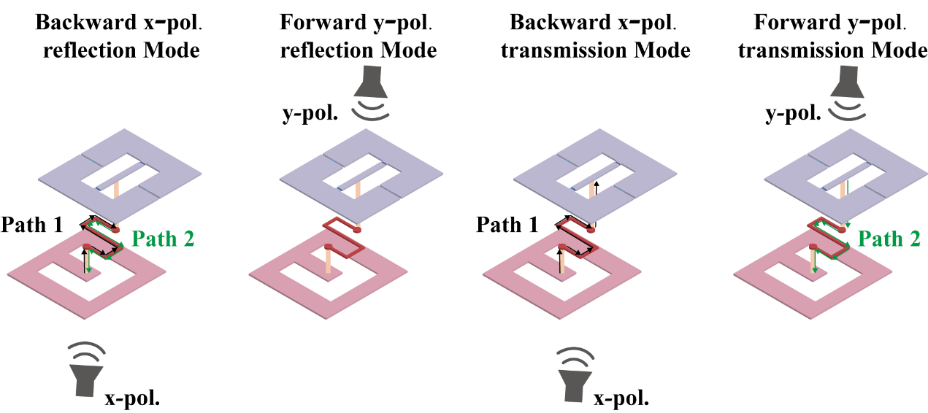
Figure S1. Meta-atom operation mode

Moreover, since the polarizations of the receiving patch and the transmitting patch are y-pol. and x-pol.. Therefore, a multi-polarization transmission-reflection meta-atom design is realized. In addition, the structural parameters of the designed meta-atom are shown in Table S1. Among them, the working status of backward x-pol. reflection mode and forward y-pol. reflection mode are shown in Table S2 and Table S3. The working status of Transmission mode is shown in Table S4.

TABLE S1
Geometric Parameters of Meta-atom
Parameters | Value | Parameters | Value | Parameters | Value
pyi | 10 mm | pxi | 7 mm | pyo | 18 mm
pxo | 16 mm | w | 1 mm | py | 17 mm
px | 16 mm | ly | 7 mm | lx | 11 mm
pl | 10 mm | wy | 3 mm | dy1 | 3.2 mm
dy2 | 3.2 mm | dx1 | p/2 | dx2 | p/2

TABLE S2
Meta-Atom for Backward x-pol. Reflection Mode
Parameters | PIN-1 | PIN-2 | State | Bit | p | Initial phase
Unit 1 | ON | ON | 11 | 1-bit | 2 mm | 0°
Unit 1 | OFF | OFF | 00 | 1-bit | 2 mm | 0°
Unit 2 | ON | ON | 11 | 1-bit | 4 mm | 90°
Unit 2 | OFF | OFF | 00 | 1-bit | 4 mm | 90°
Unit 3 | ON | ON | 11 | 1-bit | 6 mm | 180°
Unit 3 | OFF | OFF | 00 | 1-bit | 6 mm | 180°
Unit 4 | ON | ON | 11 | 1-bit | 9 mm | 270°
Unit 4 | OFF | OFF | 00 | 1-bit | 9 mm | 270°

TABLE S3
Meta-Atom for Forward y-pol. Reflection Mode
Parameters | PIN-1 | PIN-2 | State | Bit | p | Initial phase
Unit 1 | ON | ON | 11 | 1-bit | 2 mm | 0°
Unit 1 | OFF | OFF | 00 | 1-bit | 2 mm | 0°
Unit 2 | ON | ON | 11 | 1-bit | 4 mm | 0°
Unit 2 | OFF | OFF | 00 | 1-bit | 4 mm | 0°
Unit 3 | ON | ON | 11 | 1-bit | 6 mm | 0°
Unit 3 | OFF | OFF | 00 | 1-bit | 6 mm | 0°
Unit 4 | ON | ON | 11 | 1-bit | 9 mm | 0°
Unit 4 | OFF | OFF | 00 | 1-bit | 9 mm | 0°
TABLE S4
Meta-Atom for Transmission Mode
Parameters | PIN-1 | PIN-2 | State | Bit | p | Initial phase
Unit 1 | ON | OFF | 10 | 1-bit | 2 mm | 0°
Unit 1 | OFF | ON | 01 | 1-bit | 2 mm | 0°
Unit 2 | ON | OFF | 10 | 1-bit | 4 mm | 45°
Unit 2 | OFF | ON | 01 | 1-bit | 4 mm | 45°
Unit 3 | ON | OFF | 10 | 1-bit | 6 mm | 90°
Unit 3 | OFF | ON | 01 | 1-bit | 6 mm | 90°
Unit 4 | ON | OFF | 10 | 1-bit | 9 mm | 135°
Unit 4 | OFF | ON | 01 | 1-bit | 9 mm | 135°

Supplementary Note 2. Performance of the Meta-atom

Figure S2 shows magnitude and phase characteristics for forward y-pol. reflection with p varying from 2-10 mm. Thus, it can be seen that forward y-pol reflection maintains consistent initial phase regardless of delay line length. Figures S3a-b present the reflection and transmission coefficients of port 1 in the 10 state. The reflection and transmission coefficients at port 2 are identical for both 01 and 10 states. Additionally, Figures S3c-d show the reflection coefficients of port 2 in the 01 and 10 states. As demonstrated, the reflection coefficients remain consistent between these two states. Furthermore, both ports exhibit reflection coefficients below -10 dB across the 3.8-3.9 GHz frequency range.
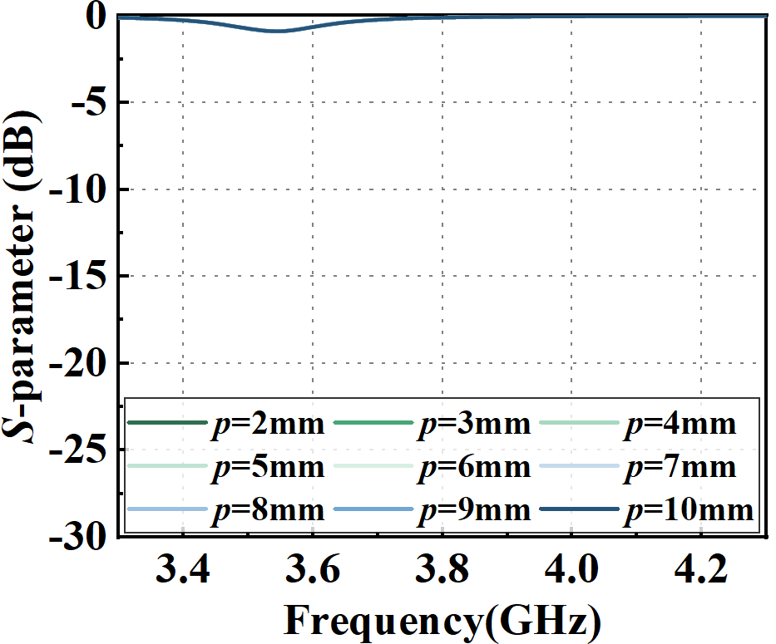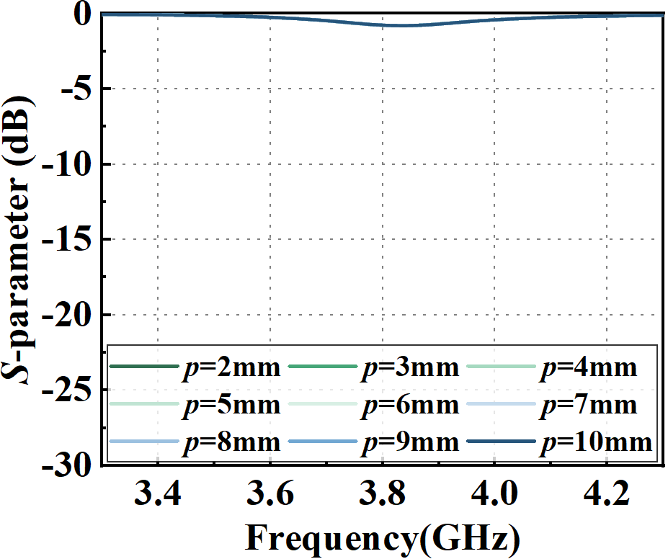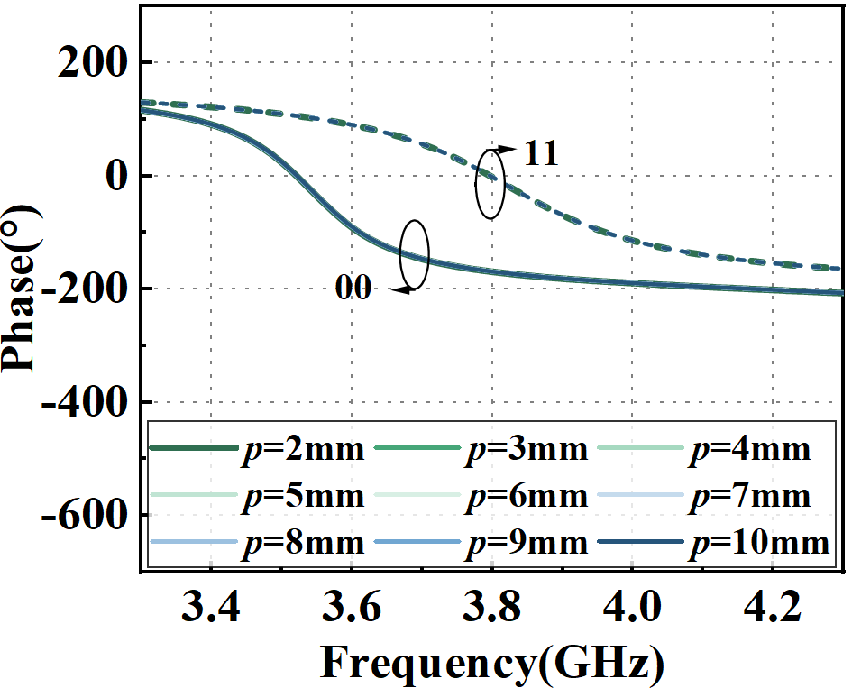
a b c
Figure S2. S-parameters of the forward y-pol. reflection mode under different p. Reflection coefficient for (a) 00, and (b) 11 states. (c) Reflection phase for 00 and 11 states.

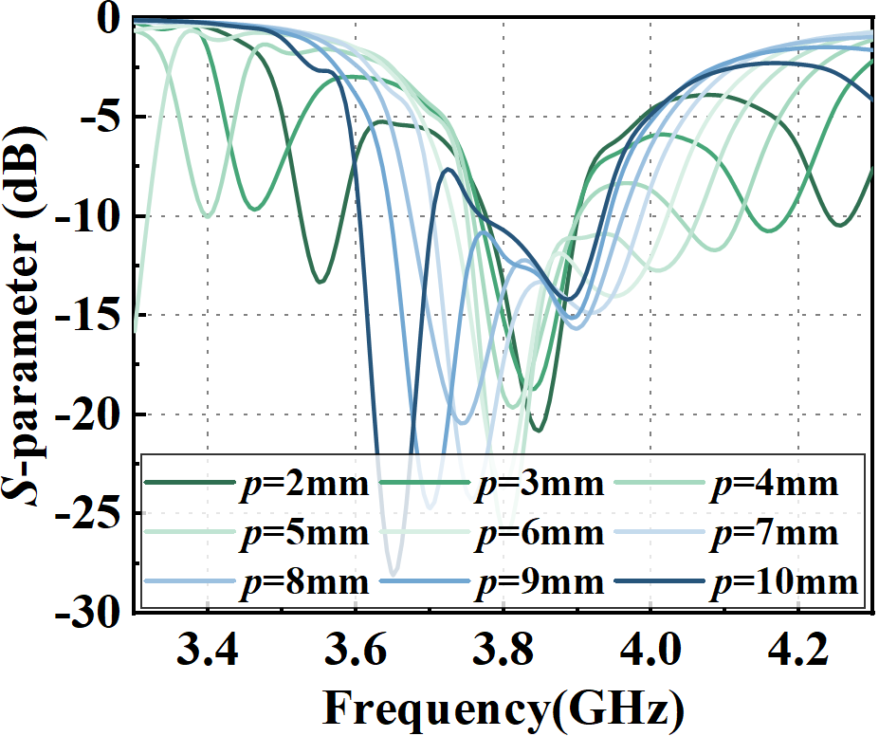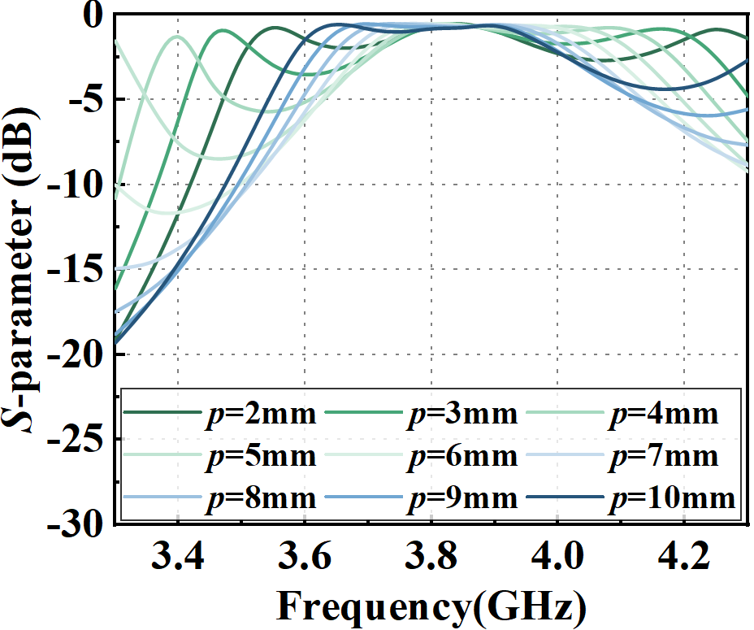
a b
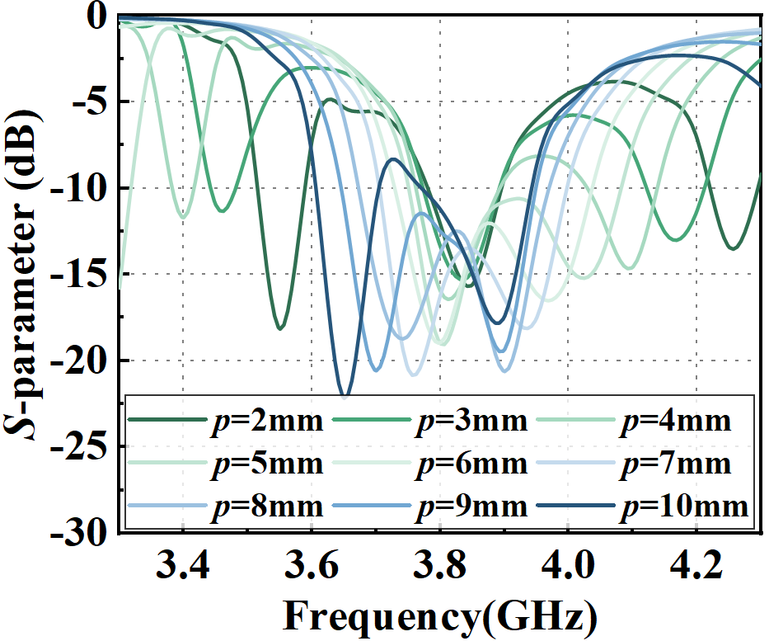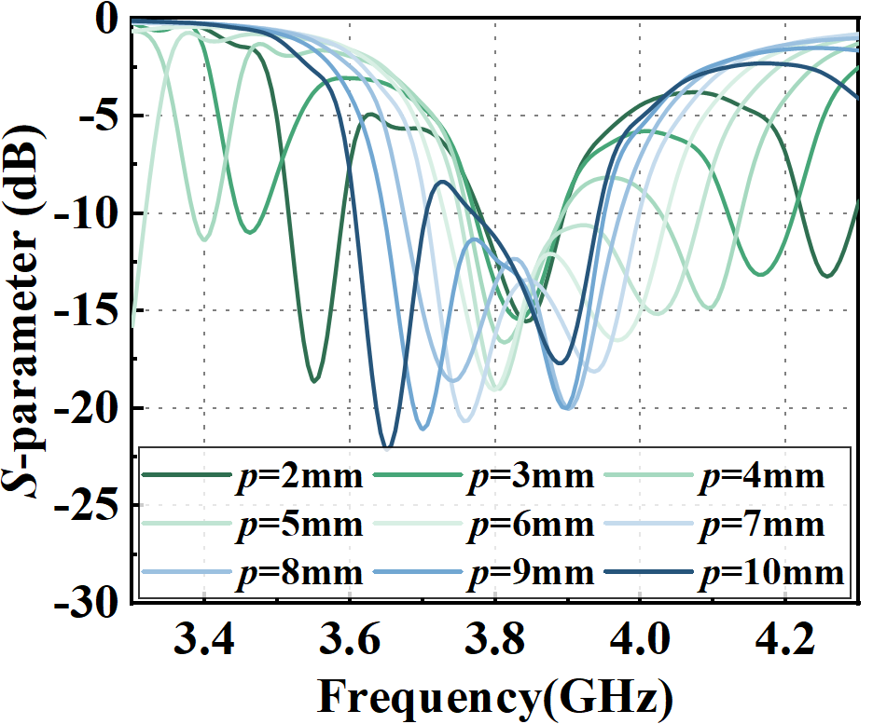
c d
Figure S3. S-parameters of the transmission mode for 01 state under different p: (a) reflection coefficient, and (b) transmission coefficient. Reflection coefficient of port 2: (a) 01, and (b) 10 states.

Supplementary Note 3. Overall Schematics of the Metasurface

The layout of the fabricated array is shown in Figure S4. It includes the receiving array, the metallic ground plane, the microstrip delay line, and the transmission array. Different layers are marked with different colors (purple, blue, red, and pink). The substrate is represented in white. The circles around the array indicate the alignment holes.

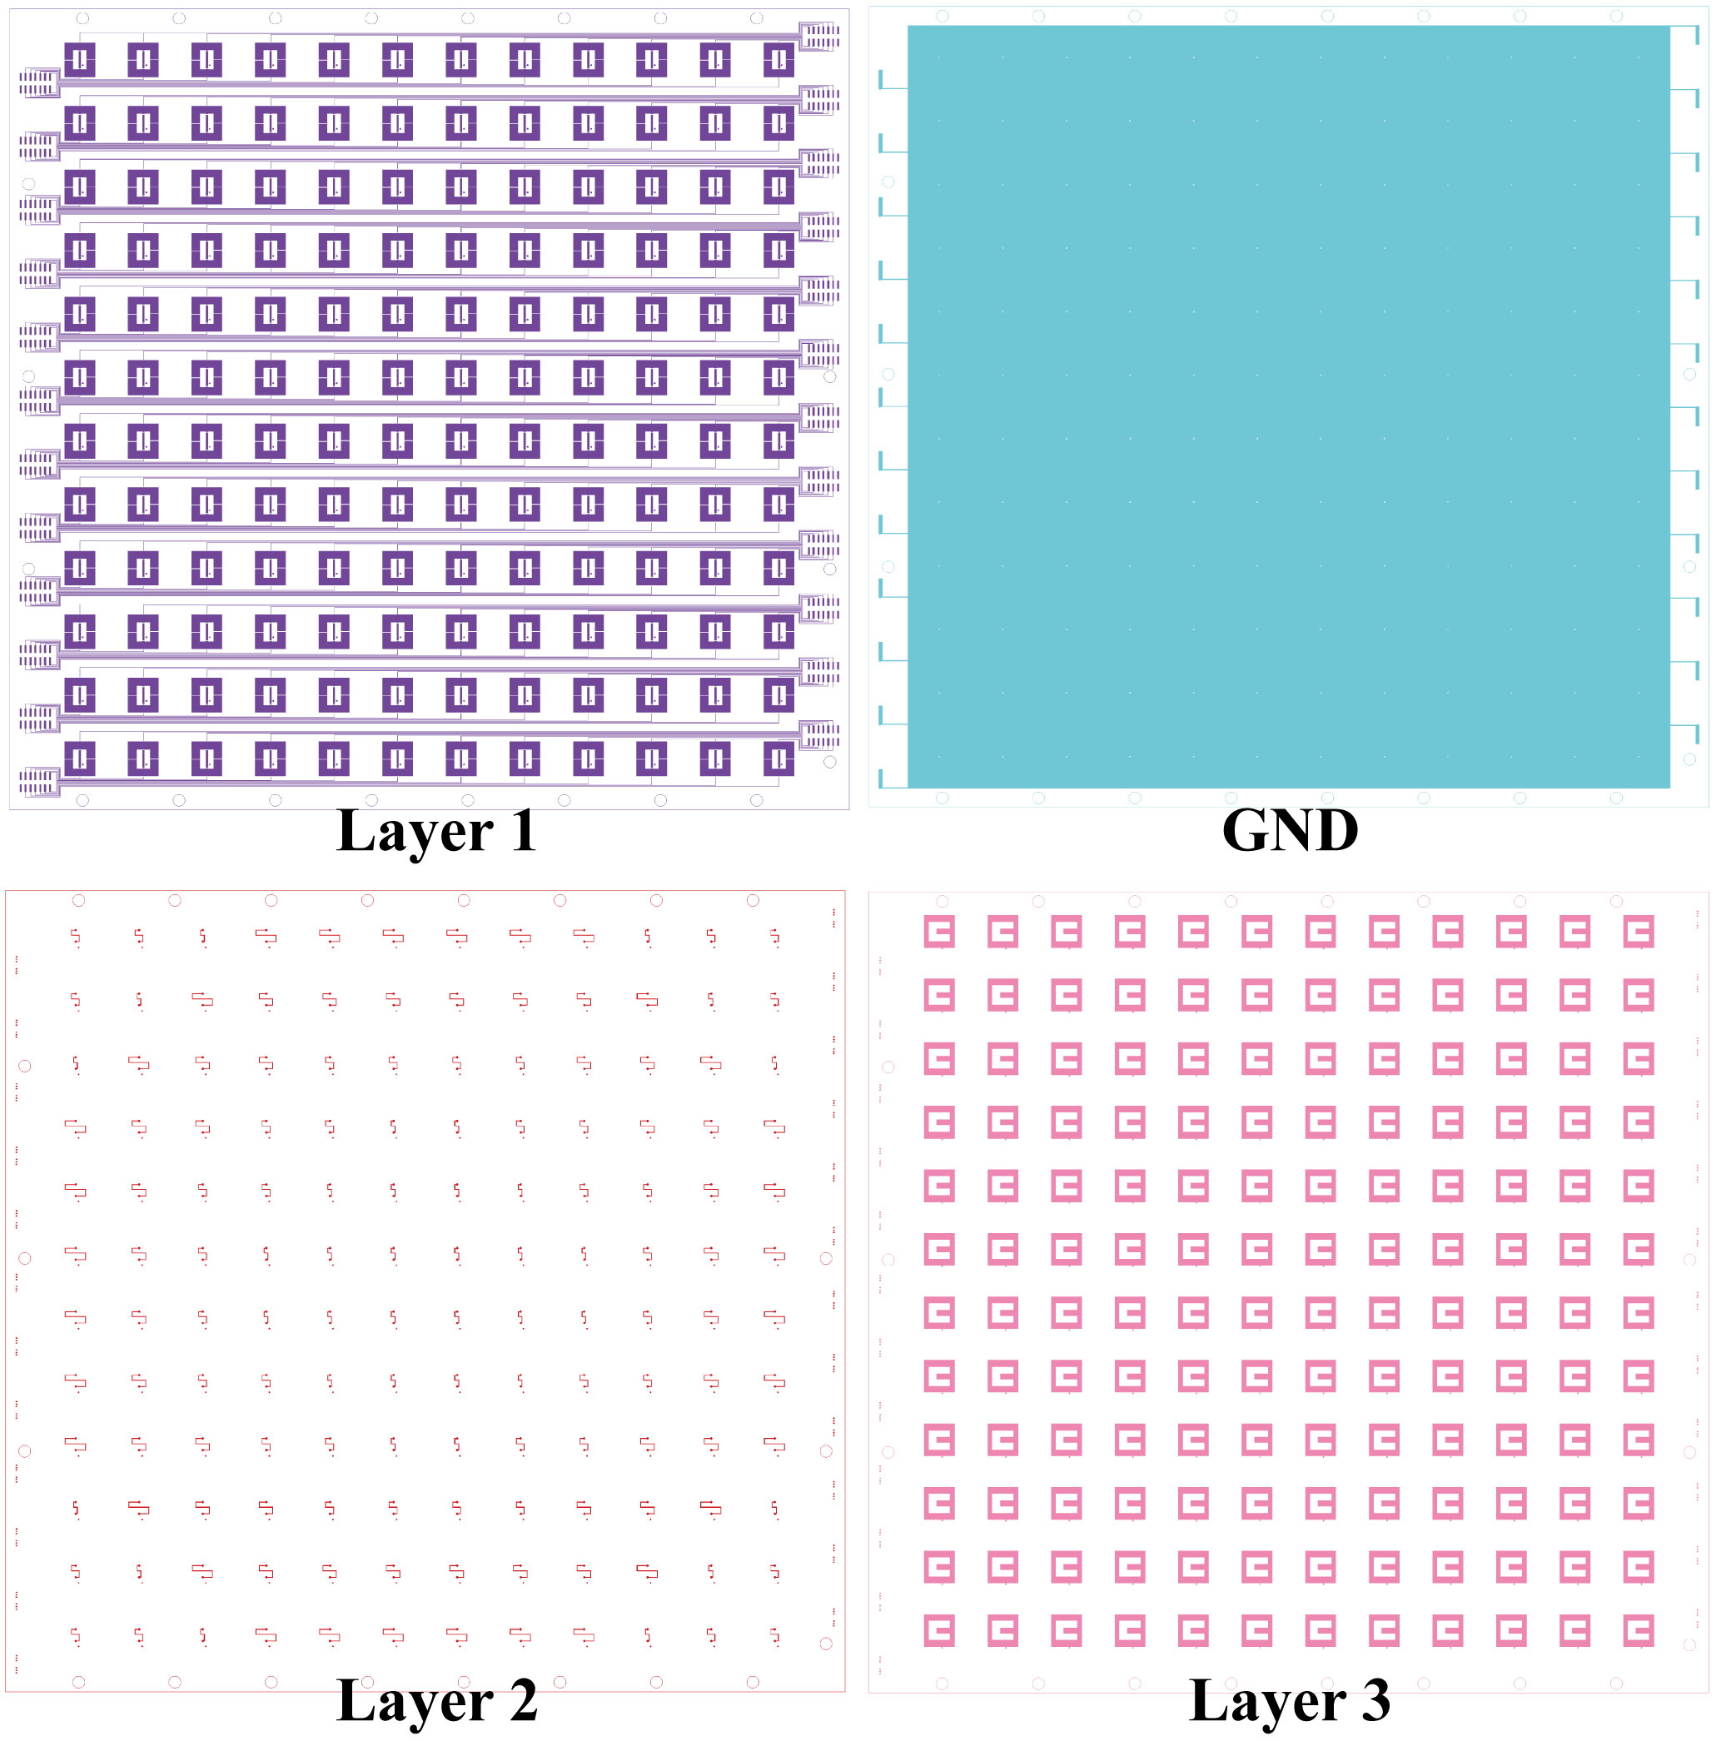
Figure S4. Fabrication Drawings of Metasurface.

Supplementary Note 4. Initial Phase Configuration of Metasurface Array
The initial phase without quantization is shown in Figure S5a. The coding matrices for the reflected mode beam scanned to 15° and 45° are shown in Figure S5b-c.
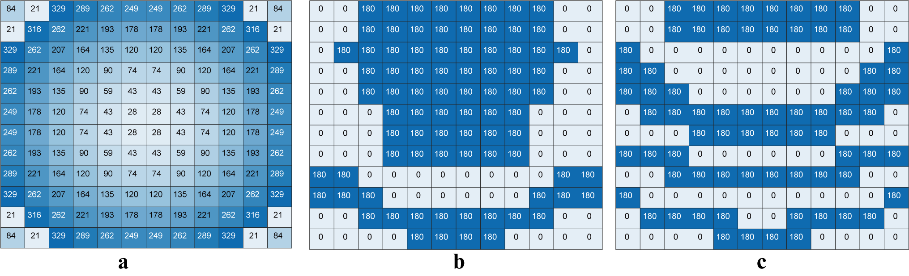
Figure S5. (a) Initial phase without quantization. Beam scanning to (b) (0°, 15°), (c) (0°, 45°) in reflection mode.
Supplementary Note 5. Reflection Mode

The simulated E-plane beam scanning in reflection mode at 3.8 GHz is shown in Figure S6a. The simulated H-plane beam scanning in reflection mode at 3.8 GHz is shown in Figure S6b. The simulated E-plane beam scanning in reflection mode at 3.9 GHz is shown in Figure S6c. The simulated H-plane beam scanning in reflection mode at 3.9 GHz is shown in Figure S6d. Figure S6 demonstrate bidirectional beam scanning characteristics. The results reveal horizontally symmetric beam scanning between forward and backward directions. Notably, forward steering operates with y-pol. while backward steering employs x-pol..
The measured E-plane beam scanning in reflection mode at 3.9 GHz is shown in Figure S7a. The measured H-plane beam scanning in reflection mode at 3.9 GHz is shown in Figure S7b. As observed, the experimental results demonstrate bidirectional beam steering in reflection mode, consistent with the simulation results. Furthermore, in the forward y-pol. reflection mode, the beam characteristics at ±60° were measured. The results indicate that the array maintains favorable beam performance even at ±60°. Thus, both simulations and experiments confirm that the proposed RIS exhibits bidirectional reflected beam-steering capabilities, with the forward reflection mode operating under y-pol. and the backward reflection mode under x-pol.
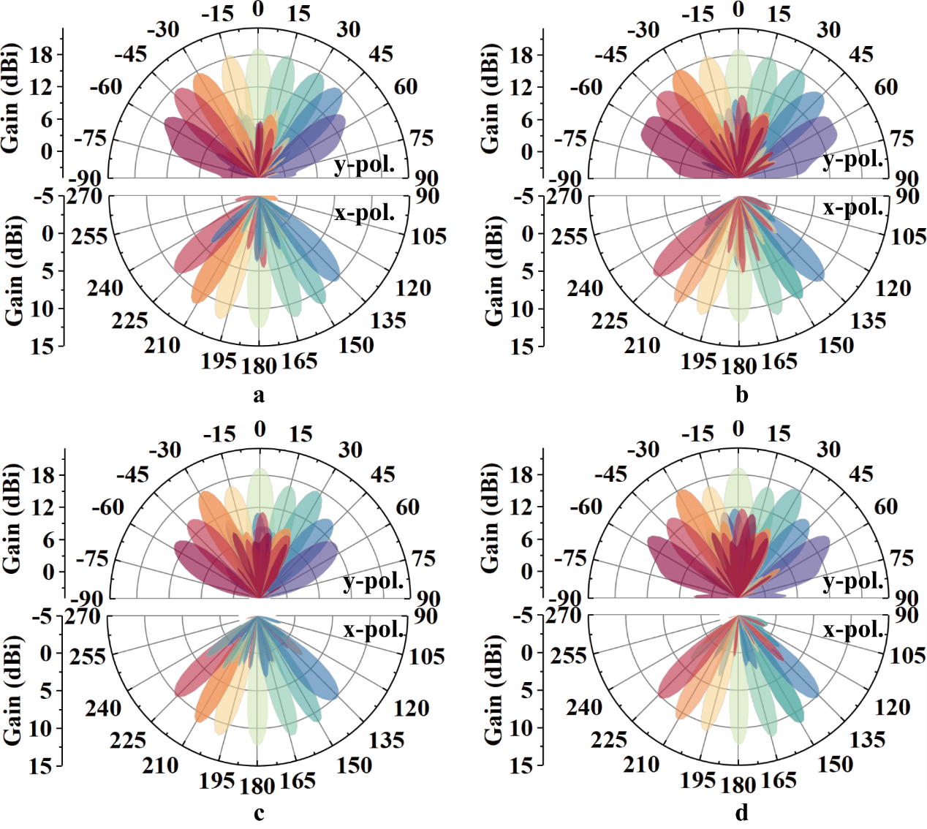
Figure S6. Simulated results in reflection mode. (a) E-plane, and (b) H-plane at 3.8 GHz. (c) E-plane, and (d) H-plane at 3.9 GHz.
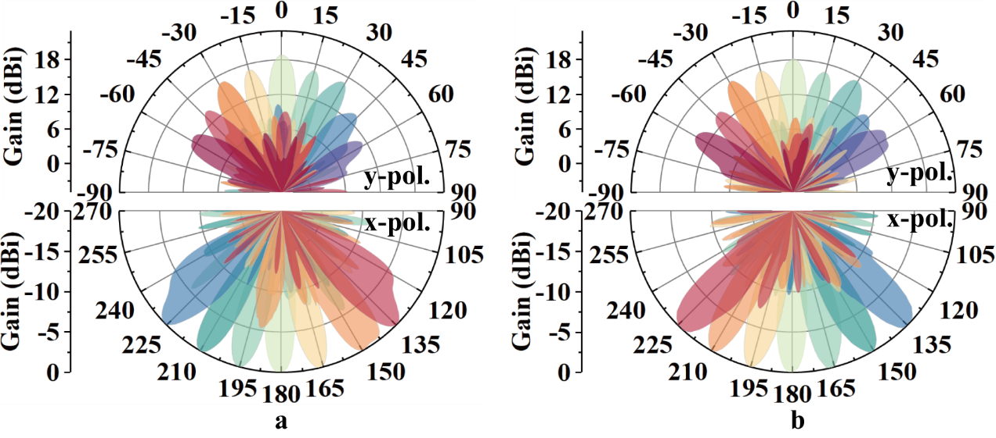
Figure S7. Measured results in reflection mode. (a) E-plane, and (b) H-plane at 3.9 GHz.

Supplementary Note 6. Transmission Mode

The phase-coding matrices in transmission mode for beam scanning at 15° and 45° are presented in Figure S8a-b. The simulated E-plane beam scanning for transmission mode at 3.8 GHz are shown in Figure S9a. The corresponding H-plane beam scanning are displayed in Figure S9b. The simulated E-plane beam scanning for transmission mode at 3.9 GHz are shown in Figure S9c. The corresponding H-plane beam scanning are displayed in Figure S9d.
The measured E-plane beam scanning results at 3.8 GHz are presented in Figure S10a. The experimental H-plane patterns appear in Figure S10b. The measured E-plane beam scanning results at 3.9 GHz are presented in Figure S10c. The experimental H-plane patterns appear in Figure S10d. Figures S10 present measured E-plane and H-plane bidirectional transmission beam scanning at 3.8 GHz and 3.9 GHz. Experimental results successfully reproduce the simulated bidirectional control. The RIS was characterized for beam scanning up to ±60°. The array maintains excellent beam characteristics even at these extreme angles.

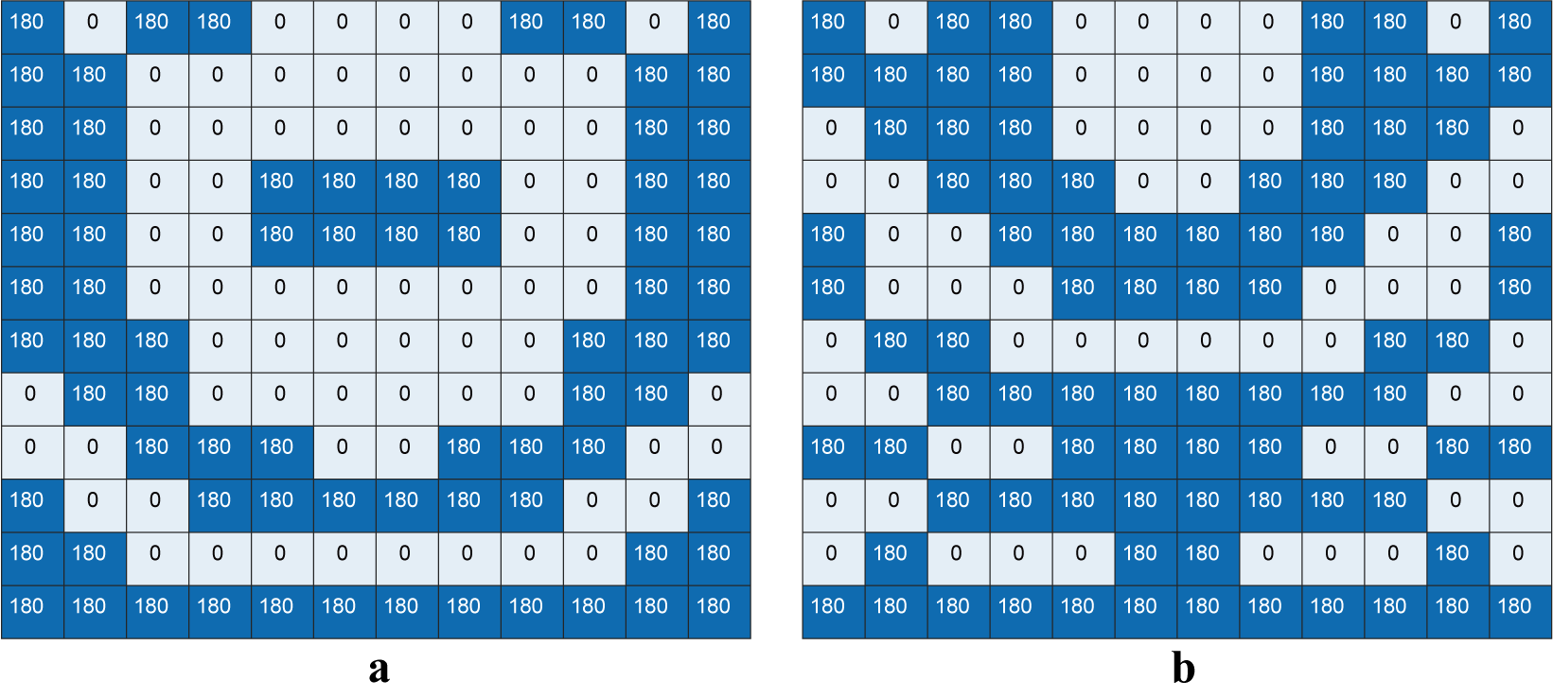
Figure S8. Beam scanning to (a) (0°, 15°), (b) (0°, 45°) in transmission mode.

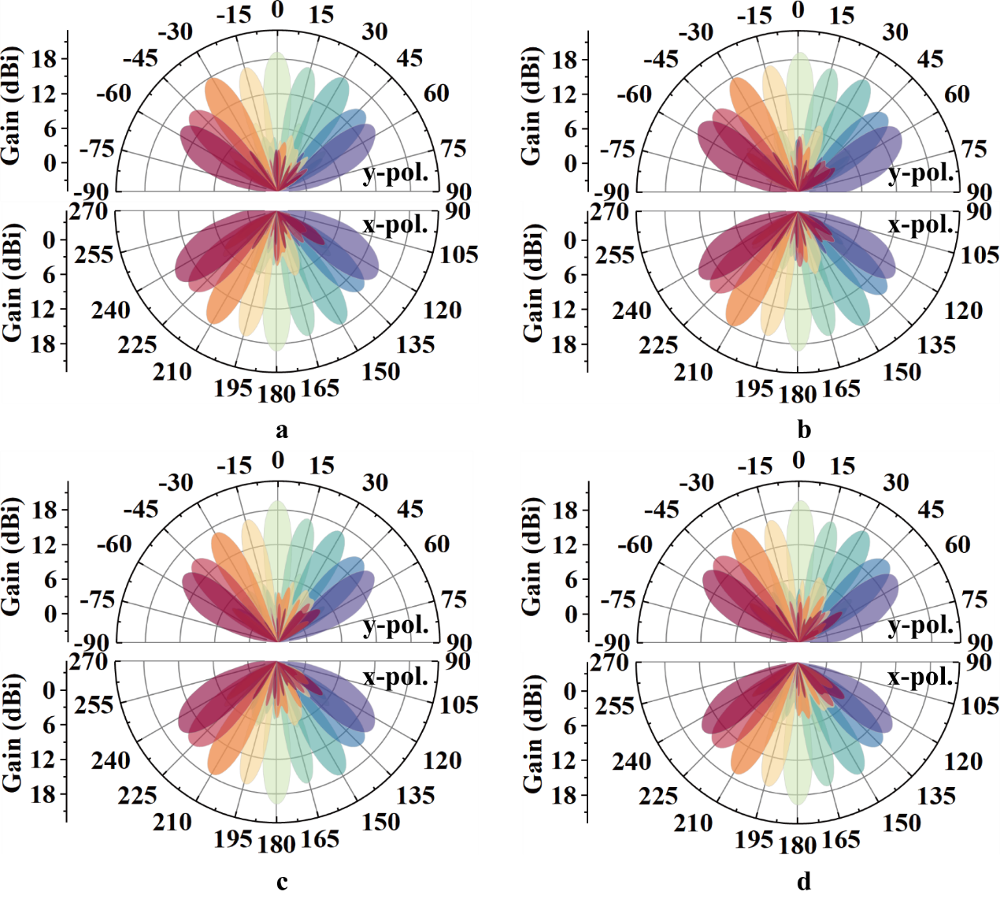
Figure S9. Simulated results in transmission mode. (a) E-plane, and (b) H-plane at 3.8 GHz. (c) E-plane, and (d) H-plane at 3.9 GHz.
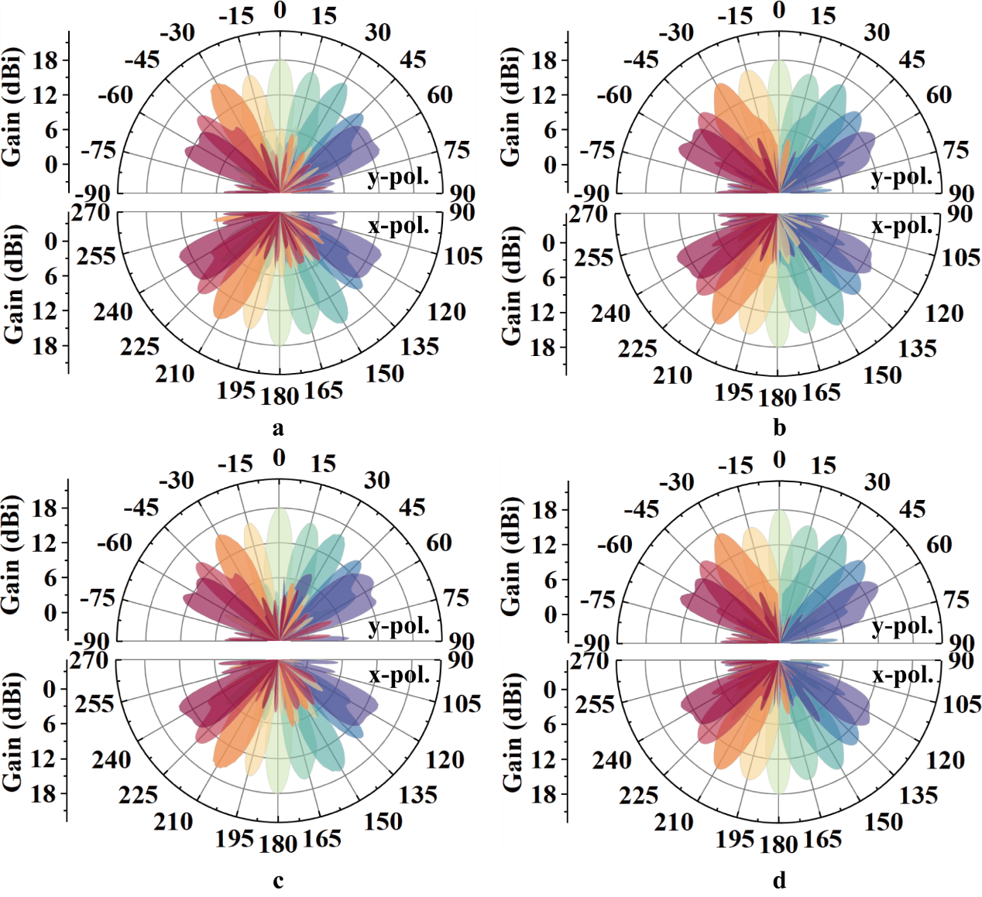
Figure S10. Measured results in transmission mode. (a) E-plane, and (b) H-plane at 3.8 GHz. (c) E-plane, and (d) H-plane at 3.9 GHz.

Supplementary Note 7. Transmission-Reflection Mode

Figure S11a shows the coding for beam scanning to 15° (reflection) and -30° (transmission). Figure S11b illustrates the array topology when the beam is scanned to 15° (reflection) and -45° (transmission), that is, the spatial distribution of the reflection and transmission mode units. Figure S11c shows the coding for beam scanning to 15° (reflection) and -45° (transmission).

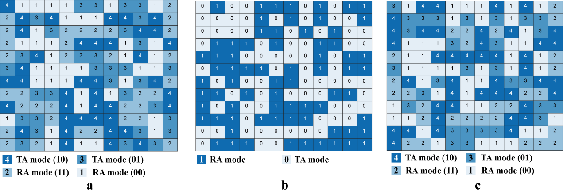
Figure S11. (a) Coding for beams scanning to 15° (forward y-pol. reflection mode) and -30° (forward y-pol. reflection mode). (b) Layout for beams scanning to 15° (forward y-pol. reflection mode) and -45° (forward y-pol. transmission mode). (c) Coding for beams scanning to 15° (forward y-pol. reflection mode) and -45° (forward y-pol. transmission mode).

