Supporting information

Synergistic plasmonic coupling in multidimensional noble metal/MXene heterostructures for simultaneous SERS profiling of multiple inflammatory cytokines

Yuao Zhou,ª Jiantong Zhan,^{b} Shuang Wang,ª Sitian Yuan,ª Guohua Qi,^{b} Huixiao Duo,*ª and Dan Sun*ª

- School of Pharmacy, Nantong University, Nantong, Jiangsu, 226001, China
- Guangdong Key Laboratory of Biomedical Measurements and Ultrasound Imaging School of Biomedical Engineering, Shenzhen University Medical School, Shenzhen University, Shenzhen, 518060, China

∗ Corresponding author.
E-mail addresses: dsun1203@ntu.edu.cn duohuixiao@ntu.edu.cn

- Experimental section
1.1. Materials and Instrumentation
Silver nitrate was sourced from Sinopharm Chemical Reagent Co., Ltd. Additional chemical reagents, including chloroauric acid trihydrate (HAuCl₄·3H₂O, 99%), sodium citrate, 4‑mercaptobenzoic acid (4‑MBA), 7‑mercapto‑4‑methyl‑2H‑pyran‑2‑one (MMC), 5,5′‑dithiobis(2‑nitrobenzoic acid) (DTNB), as well as the coupling agents EDC and NHS, were obtained from Aladdin Biochemical Technology Co., Ltd. (Shanghai, China). Cytokine standards (IL‑1β, IL‑6, IFN‑γ), lithium fluoride, hydrochloric acid, titanium aluminum carbide, and poly(dimethyldiallylammonium chloride) (PDDA, Mw = 40,000) were supplied by Titan Scientific (Shanghai, China). Ethanol was purchased from Macklin Biochemical Technology Co., Ltd. Monoclonal and polyclonal antibodies against IL‑1β, IL‑6, and IFN‑γ were acquired from Thermo Fisher Scientific Reagents Co., Ltd.
UV‑vis absorption spectra of the MXene, AgNPs, AuNPs, and MXene@Ag@Au hybrids were recorded on a PerkinElmer Lambda 750 spectrophotometer. Hydrodynamic diameter and zeta potential measurements for AuNPs and nanoprobes were conducted using a Brookhaven 90Plus Zeta dynamic light scattering (DLS) instrument. Raman spectroscopic measurements were performed on a Renishaw inVia confocal Raman microscope, equipped with a 785 nm diode laser (10 mW output) and a Synapse thermoelectrically cooled CCD detector. Excitation and signal collection were carried out through a 50× Olympus objective (NA = 0.5). Spectral acquisition covered the range of 200–1800 cm⁻¹ with an integration time of 10 s and a single accumulation. Wavenumber calibration was referenced to the 520.7 cm⁻¹ phonon band of a silicon wafer.
1.2. Preparation of MXene
The MXene powder was prepared through a selective etching process. Initially, 1 g of LiF was fully dissolved in 10 mL of concentrated HCl (12 M) under continuous magnetic stirring for 30 min. Subsequently, 1 g of Ti₃AlC₂ precursor was slowly added to the above acidic solution, and the mixture was kept at 35 °C with stirring for 24 h. After the reaction, the solid residue was collected and rinsed repeatedly with deionized water via centrifugation (5000 rpm, 5 min per cycle) until the supernatant pH approached 6. This was followed by three additional washes with ethanol under identical centrifugation conditions. The final product was dried at 60 °C in a vacuum oven overnight, affording the desired few-layer Ti₃C₂Tₓ sheets.
1.3. The finite-difference time-domain (FDTD) simulation
Electromagnetic field enhancement around the heterostructures was analyzed using commercial FDTD Solutions software. The simulation parameters were configured as follows: AuNP and AgNP diameters were set to 13 nm and 78 nm, respectively; the excitation source was a linearly polarized plane wave at 785 nm propagating along the z-axis; a gap of 2 nm was maintained between the AuNP and AgNP layers; and a fine mesh resolution of 0.5 nm was employed throughout the computational domain.
1.4. Detection of cytokines in aqueous solutions
For IL-6 detection, 200 μL of the MXene@Ag@Ab₁-IL-6 suspension and 200 μL of the AuNPs@Ab₂-IL-6@MMC probe were mixed in a 1.5-mL tube. Then, 100 μL of IL-6 standard solutions at varying concentrations (0, 0.14, 1, 3, 5, 7, 10, and 20 pg/mL) were added, and the mixture was incubated at 37 °C with stirring for 1 h. After incubation, the mixture was centrifuged at 7500 rpm for 10 min to collect the resulting MXene@Ag@Au sandwich complexes. The SERS signal from the embedded MMC reporters was subsequently measured by Raman spectroscopy.

2. The size distribution of nanomaterials
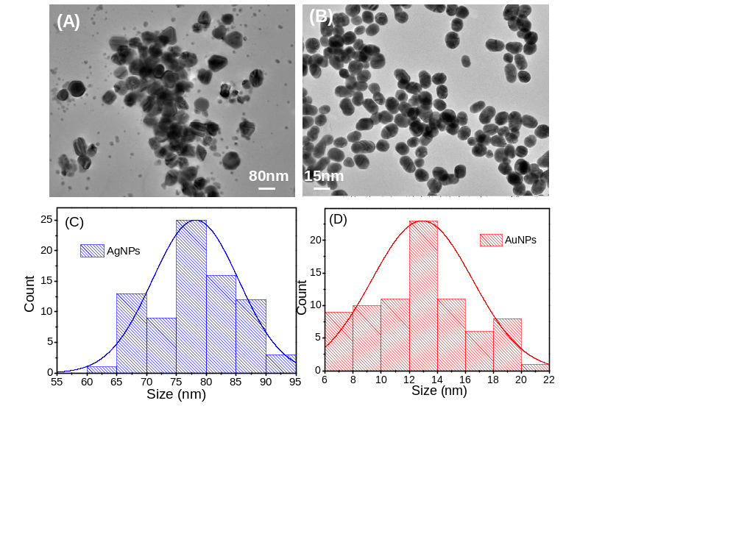
Fig. S1. The TEM images of the prepared (A) AgNPs and (B) AuNPs. The statistic particle sizes of (C) AgNPs and (D) AuNPs used in this study.
- SERS enhancement performance of multidimensional heterostructures
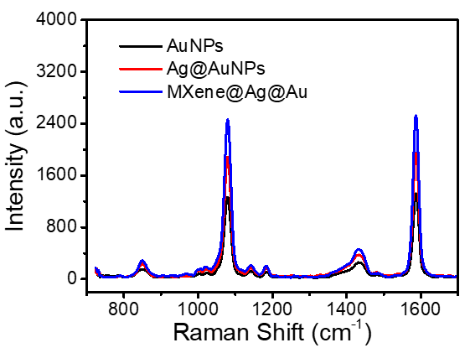
Fig. S2. Comparison of SERS spectra when 4-MBA is placed on different substrates including AuNPs, Ag@AuNPs and MXene@Ag@Au.
- Simultaneous detection of three cytokines in PBS
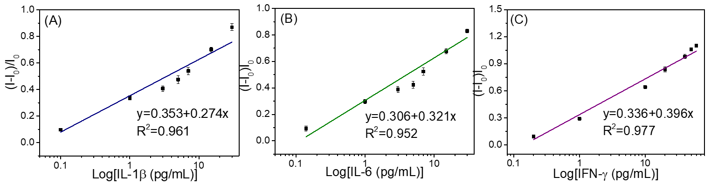
Fig. S3. (A-C) The associated SERS intensities at (I-I₀)/I₀. I₀ and I respectively represent the SERS intensities of (D) 4-MBA at 1084 cm⁻¹, (E) MMC at 1179 cm⁻¹, (F) DTNB at 1329 cm⁻¹ before and after reaction.
- Stability test of the SERS nano-sensing system
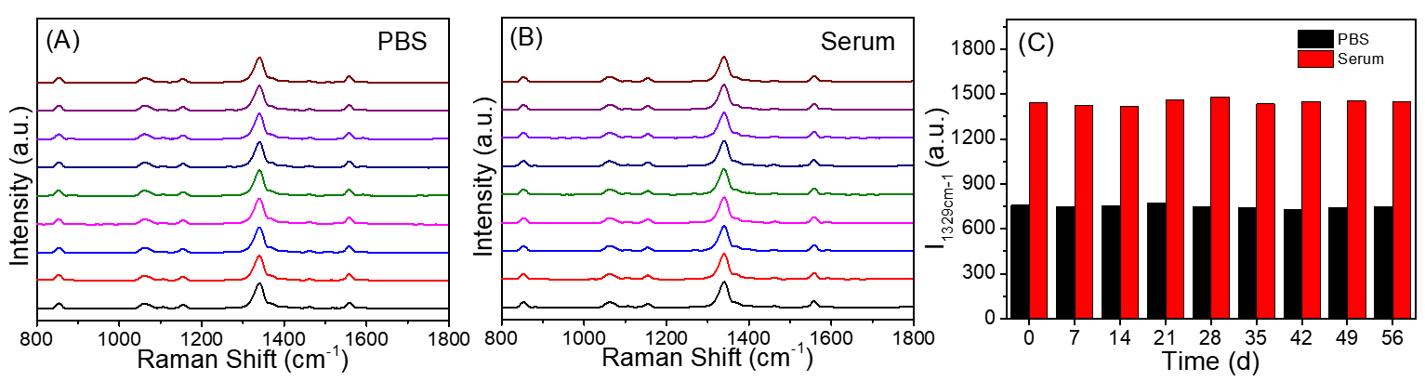
Fig. S4. SERS spectra of the nanohybrids formed by the reaction of Au@Ab₂@DTNB and MXene@Ag@Ab₁ after being placed for different periods of time (from bottom to top are 0, 7, 14, 21, 28, 35, 42, 49 and 56 days) with IFN-γ.
- Reproducibility of SERS detection
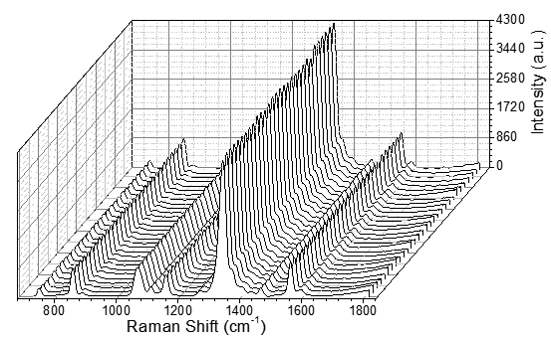
Fig. S5. SERS spectra from randomly selected 30 points on the same MXene@Ag@Au.

