LILRB2 Promotes CAR T-cell Dysfunction and Represents a Therapeutic Target in Acute Myeloid Leukemia
Authors:
Silvan Brunn¹, Morgane Chambovey¹, Nina Raymann¹, Marianna Ponzo¹, Sarah Alberio¹, Artemis Baumann¹, Laura Raas¹, Christian Pellegrino¹, Jana Maria Ellegast¹, Jeremy Deuel¹, Markus G. Manz¹, Chiara F. Magnani¹

Table of Contents
Methods 2
Supplementary Table 1 11
Supplementary Figure 1 13
Supplementary Figure 2 14
Supplementary Figure 3 16
Supplementary Figure 4 17
Supplementary Figure 5 18
Supplementary Figure 6 20
Supplementary Figure 7 21
Supplementary Figure 8 22

Methods
CAR T-cell production
Purification of T Cells from Peripheral Blood
Peripheral blood was obtained from healthy donors through the Zurich Blood Donation Service (Blutspende Zurich, Switzerland) and peripheral blood mononuclear cells (PBMCs) were isolated by density-gradient centrifugation with Ficoll-Paque Plus (#17-1440-03, Cytiva, Marlborough, MA, USA). T cells were subsequently purified using the EasySep Human T-cell Isolation Kit (#17951, Stemcell Technologies, Vancouver, Canada) according to the manufacturer’s instructions. Purified T cells were either cryopreserved or used immediately for downstream applications.

CAR T-Cell Production with LV
Lentiviral particles containing the CAR plasmid were generated by transfecting HEK293-T cells at approximately 70% confluency in a T75 flask. To produce the transfection mixture, the CAR-encoding transfer vector (4 μg), psPAX2 packaging plasmid (4 μg, #12259, Addgene, Watertown, MA, USA), and the pCAG-VSVG envelope plasmid (2.2 μg, #35616, Addgene) were mixed with 500 μL Jet-PRIME buffer and 20 μL Jet-PRIME transfection reagent (#PPT101000046, Polyplus, Illkirch, France), followed by incubation for 15 min at room temperature (RT). After 4-6 hours, the medium was replaced with fresh Dulbecco’s Modified Eagle Medium (DMEM, #11965092, Gibco, Grand Island, NY, USA) supplemented with fetal-bovine serum (FBS, 10%), Penicillin/Streptomycin (100 U/mL / 100 mg/mL) and Sodium Pyruvate (1mM, #11360039, Thermo Fisher Scientific, Waltham, MA, USA). After 2 days of culture, viral supernatants were harvested, centrifuged (400 x g, 5 min), and filtered through a 0.45 μm filter to remove cellular debris. Concentration of virus particles was achieved by adding PEG-it Precipitation Solution (SBI-LV825A-1, System Biosciences, Palo Alto, CA, USA) at a ratio of 1:5, followed by overnight incubation at 4°C, centrifugation (1500 x g, 30 min), and re-suspension of the virus pellet in cell culture medium (1:200 of the initial supernatant volume). Concentrated virus was stored at -80°C until further use.
For CAR T-cell generation, 1 x 10⁶ freshly isolated or thawed human T cells were cultured in 500 μL T-cell culture medium (Advanced RPMI 1640 (#12633012, Gibco) supplemented with FBS (10%), Glutamax (2mM, 35050061, Gibco), and Penicillin/Streptomycin (100 U/mL / 100 μg/mL)) and stimulated with 80 U/mL IL-2 (Proleukin®, Novartis, Basel, Switzerland). T-cell activation was achieved by adding anti-CD3/CD28 DynaBeads (#11131D, Thermo Fisher Scientific) at a cell-to-bead ratio of 1:1. After 14-16 hours, 15 μL concentrated virus and 8 μg/mL Polybrene Transfection Reagent (#TR-1003-G, Sigma Aldrich, St. Louis, MO, USA) were added, followed by spinoculation (1000 x g, 32°C, 60 min). The following day, viral particles were removed by centrifuging (400 x g, 5 min) the cells and re-suspending in fresh T-cell culture medium. DynaBeads were removed one day later using magnetic separation. If necessary, CAR T cells were purified on day 6 and cultured until days 10-12. Fresh medium and IL-2 were added as required based on cell density. T cells were either cryopreserved or used immediately.

CAR T-Cell Production with SB
Freshly isolated or thawed human T cells were centrifuged (400 x g, 5 min) and resuspended in electroporation medium (Advanced RPMI 1640 (#12633012, Gibco) supplemented with FBS (20%) and Glutamax (2mM, #35050061, Gibco). For each condition, 5 x 10⁶ cells were resuspended in 100 μL P3 Primary Cell Nucleofection Solution (#V4XP-3024, Lonza, Basel, Switzerland) containing 7.5 μg CAR vector and 2.5 μg SB100X transposase plasmid (#34879, Addgene). For the nucleofection control condition, cells were resuspended in 100 μL P3 Primary Cell Nucleofection Solution (#V4XP-3024, Lonza) containing 2 μL GFP control plasmid. Electroporation was performed using 100 µL Nucleocuvette® Vessels (Lonza) using the Lonza 4D-Nucleofector System with pulse code EO-115. Immediately after electroporation, cells were transferred into 6-well plates containing 4 mL pre-warmed electroporation medium and incubated under standard culture conditions. After 2 hours, half of the medium was replaced with T-cell culture medium. One day after electroporation, T cells were activated using anti-CD3/CD28 Dynabeads (#11131D, Thermo Fisher Scientific) at a cell-to-bead ratio of 1:1 and stimulated with 80 U/mL IL-2 (Proleukin®, Novartis). Beads were removed by magnetic separation after 4 days. If necessary, CAR T cells were purified on day 6 and cultured until days 10-12. Fresh medium and IL-2 were added as required based on cell density. T cells were either cryopreserved or used immediately.

Purification of CAR T cells
CAR T cells were purified between days 6 and 8 following electroporation. To this end, cells were washed twice with MACS buffer (PBS (#10010023, Gibco) supplemented with 5 mM EDTA and 0.5% FBS) and resuspended in 100 μL primary antibody solution per 1 x 10⁷ cells. Following incubation for 30 min at 4°C, cells were washed twice and resuspended in 90 μL MACS buffer + 10 μL magnetic microbeads (#130-046-702 or #130-090-485, Miltenyi Biotec) per 1 x 10⁷ cells. After an additional 30 min incubation at 4°C and a subsequent washing step, cells were purified using LS bead columns (130-042-401, Miltenyi Biotec, Bergisch Gladbach, Germany) mounted on magnetic separators. Purified CAR T cells were counted, centrifuged (400 x g, 5 min) and suspended in fresh T-cell culture medium supplemented with 80 U/mL IL-2 (Proleukin®, Novartis) at a density of 0.75-1.25 x 10⁶ cells/mL.
Cell lines
THP-1 and MOLM-14 were tested negative for mycoplasma and authenticated recently (June 2026). The human cell line authentication service of Microsynth was used. In short, profiling of the human cell lines was done using highly polymorphic short tandem repeat loci (STRs). STR loci were amplified using the PowerPlex® 16 HS System (Promega). Fragment analysis was done on an ABI3730xl (Life Technologies) and the resulting data were analyzed with GeneMarker HID software (Softgenetics). There was no detectable contamination with human origin and the data of the submitted samples matched 100% to the reference STR profiles of THP-1 (Cellosaurus, RRID:CVCL_0006_[DSMZ]) and MOLM-14 (Cellosaurus, RRID:CVCL_7916).

Cell culture
Cryovials were thawed in a pre-warmed water bath at 37°C, and the contents were transferred to 15 mL tubes. Pre-warmed thawing medium (culture medium supplemented with an additional 10% FBS) was added dropwise while gently agitating the tube to dilute the freezing medium, followed by centrifugation (400 x g, 5 min) and re-suspension of cells in thawing medium at the desired concentration. For cryopreservation, cells were centrifuged (400 x g, 5 min) and resuspended in cold, pure FBS at the desired concentration. Subsequently, 500 μL of the cell suspension was transferred to a cryopreservation vial, followed by addition of 500 μL cold freezing medium (FBS + 20% Dimethyl sulfoxide). Cryo-vials were placed in freezing-containers with a cooling rate of 1°C/min and stored at -80°C for at least 24 hours before transferring them to the vapor phase of liquid nitrogen for long-term storage.
CAR T cells were cultured in T-cell culture medium (Advanced RPMI 1640 (#12633012, Gibco) supplemented with FBS (10%), Glutamax (2mM, #35050061, Gibco), and Penicillin/Streptomycin (100 U/mL / 100 μg/mL)). Cell lines were cultured in cell line culture medium (RPMI 1640 (#11875085, Gibco) supplemented with FBS (10%) and Penicillin/Streptomycin (100 U/mL / 100 μg/mL)). Cultures were maintained at 37°C in a humidified atmosphere containing 5% CO2 and passages regularly upon reaching appropriate cell density or when medium acidification became evident.
T cells used for CAR T-cell production were isolated from healthy donor blood obtained from the Zurich Blood Collection Service (Blutspende Zurich, Switzerland). Cell lines were purchased from the American Type Culture Collection (ATCC). THP1 and MOLM14 cell lines were further modified to generate LILRB2 KO and overexpressing variants as described below.

Generation of LILRB2 KO and Overexpressing Cell Lines
LILRB2 knockout cell lines were generated using the Synthego CRISPR gene knockout kit V2 (Synthego Corporation, Redwood City, CA, USA) in combination with the SF Cell Line 4D-Nucleofector X Kit S (V4XC-2032, Lonza) according to the manufacturer’s protocol. Four days after electroporation, single-cell clones were expanded by limiting dilution. In detail, cells were diluted to a concentration of 6-12 cells/mL, and 100 μL cell suspension was seeded into each well of at least five 96-well plates. Half of the medium was replaced 1-2 times weekly. Emerging single clones were screened for LILRB2 expression by flow cytometry, and LILRB2^{low} clones were cryopreserved for further use. Successful gene disruption was confirmed by PCR amplification of the targeted LILRB2 locus followed by gel electrophoresis and Sanger sequencing (Microsynth, Balgach, Switzerland).
LILRB2-overexpressing cell lines were generated by lentiviral transduction as described above for CAR T-cell production, except that standard cell culture medium was used and no activation of cells was performed. Three days after removal of the virus particles, the transduced cell pool was analyzed for LILRB2 overexpression and subjected to limited dilution for single clone selection as described above. Outgrowing single cell clones were screened for LILRB2 expression by flow cytometry, and overexpressing clones were cryopreserved for further use.

Cytotoxicity and Safety Assays
Cytotoxic activity was assessed by co-culturing effector and target cells at defined effector-to-target (E:T) ratios. After 24 hours or 120 hours (5 days), supernatants were collected for subsequent cytokine analysis and cells were harvested for flow cytometric evaluation. For experiments assessing the impact of LILRB2 blockade, 4 µg/mL anti-LILRB2 antibody (#MAB2078, R&D; #PA5-46983, Invitrogen, Carlsbad, CA, USA) or isotype control IgG was added to each condition.
Apoptosis and necrosis were quantified using the GFP-certified apoptosis-necrosis detection kit according to manufacturer’s protocol (ENZ-51002-100, Enzo Life Sciences, Farmingdale, NY, USA). Leukemic target cells were identified either through intrinsic GFP expression or by staining with a FITC-conjugated antibody. Killing activity was calculated as follows:
$100-\frac{\%\text{live target cells in co-culture}}{\%\text{live target cells in control condition}}×100$ (1).
For quantitative analyses, antibody-based cell staining and quantitative counting beads (#7547053, Beckman Coulter, Brea, CA, USA) were combined with flow cytometry. Absolut target cell counts were calculated as:
$\frac{\text{live target cell count}}{\text{bead count}}×\text{number of beads added}$.
Killing activity was subsequently determined as:
$100-\frac{\text{absolute live target cell count in co-culture}}{\text{absolute live target cell count in control condition}}×100$.
To evaluate depletion of healthy donor PBMC or BM cell subsets, absolute subset cell counts were normalized to the non-transfected (NT) control condition and expressed as fold change. All conditions were performed in duplicate or triplicate.

Re-challenge assay
To assess effector-cell functionality following repeated antigen exposure, re-challenge assays were performed. Effector and target cells were initially co-cultured at an E:T ratio of 1:2.5 for five days, before being re-challenged with fresh target cells at the same E:T ratio. The re-challenge process was repeated every three days for a total of up to four sequential re-challenges. Effector and target cell populations were analyzed by flow cytometry at each time point, and supernatants were collected for cytokine analysis. Killing activity was calculated as described above. All conditions were performed in duplicate or triplicate.

Cytokine release measurement by ELISA
Concentrations of IFN-γ, TNF-α, IL-2 and IL-10 levels in the supernatants collected from cytotoxicity and re-challenge assays were quantified using the enzyme-linked immunosorbent assay MAX sets (#431816, #430116, #430216, #430604; Biolegend, San Diego, CA, USA) according to the manufacturer’s instructions. Samples were pre-diluted 1:100 for IFN-γ and IL-2, and 1:5 for TNF-α and IL-10. Absorbance was measured at 450 nm using a BioTek Synergy H1 plate reader (Agilent Technologies, Santa Clara, CA, USA), and analyte concentrations were determined using a five-parameter logistic standard curve fit.

RNA Sequencing
Following completion of the re-challenge assay, effector and target cell populations were sorted using a BD FACS Aria III 4L cell sorter. Sorted cells were pelleted by centrifugation at 800 x g for 5 min, and dry pellets were frozen at -80°C until RNA extraction. Total RNA was isolated using the RNeasy Micro Kit (#74004, QIAGEN, Hilden, Germany) according to the manufacturers’ protocol. RNA sequencing was performed by the Functional Genomic Center Zurich (FGCZ) using an Illumina NovaSeq X Plus platform with the Smart-seq II workflow and a sequencing depth of 500 million reads. Data processing and analysis were conducted using the SUSHI next-generation sequencing analysis framework developed at FGCZ.

Flow cytometry
Cell suspension samples were incubated with fluorophore-conjugated antibodies diluted in phosphate-buffered saline (PBS) for 20-30 min at 4°C. Following staining, samples were washed and re-suspended in PBS supplemented with 2% FBS for analysis. Cell viability was assessed using the Zombie Aqua Fixable Viability Dye Kit (#423102, Biolegend), and Flow-Count Fluorospheres (#7547053, Beckman Coulter) were used for quantitative analysis. For direct assessment of CAR surface expression, cells were incubated with biotinylated target proteins (e.g. LILRB2-Biotin, #AVI2078-050, R&D Systems; or CD117-Biotin, #AVI10931-050, R&D Systems) for 10 min in PBS, followed by incubation with a fluorophore-conjugated anti-biotin secondary antibody for 20 min. Data acquisition was performed using an LSR II Fortessa flow cytometer (BD Bioscience, San Jose, CA, USA), and analyses were conducted with FlowJo software (Version 10.10.1, FlowJo LLC, Ashland, OR, USA). Antibody staining panels and gating strategies were adapted according to the specific experimental design.

In vivo studies
NSG (NOD.Cg-Prkdc^{scid} Il2rg^{tm1Wjl}/SzJ) mice were used for all in vivo experiments. Animals were housed at the Laboratory Animal Service Center in Schlieren, Switzerland. All procedures were conducted in accordance with procedures approved by the Veterinäramt des Kantons Zürich, Switzerland (license number 121/2022).
For humanization, mice were irradiated with 100 cGy at 15 weeks of age and injected intravenously (i.v.) with 0.1 × 10⁶ hCD34⁺ umbilical cord blood cells. Development of human hematopoietic chimerism was monitored by flow cytometric analysis of PB samples.
For engraftment of AML cell lines or patient samples, adult mice (6-10 weeks of age) received sub-lethal irradiation (100 cGy) using an RS-2000 irradiator (Rad Source, USA) and were injected i.v with target cells 4-8 hours later. Depending on the leukemia, 0.1 × 10⁶ cells (MOLM14), 1 × 10⁶ cells (THP1), or up to 5 × 10⁶ cells (patient samples) were injected.
Engraftment of luciferase-expressing leukemia cell lines was monitored by bioluminescence imaging following intraperitoneal administration of D-luciferin (150 mg/kg bodyweight) (#122799-100MG, Revvity, Waltham, MA, USA). Signal acquisition was performed using an IVIS Lumina III (Perkin Elmer, Waltham, MA, USA) imaging system and analyzed with the Living Image 149 Software. For patient-derived samples, engraftment was monitored by biweekly flow cytometric analysis of human CD45 expression in PB. For therapeutic studies, mice exhibiting detectable leukemia engraftment received i.v. administration of either CAR T- or NT T cells. The number of infused CAR T cells varied according to the experimental design and is indicated in the corresponding legends.
All mice were monitored closely throughout the study and euthanized upon reaching pre-defined humane endpoint or completion of the experimental period. After irradiation, mice received antibiotics containing water for at least four weeks. Unless otherwise indicated, PB, BM and spleen samples were collected at necropsy and analyzed by flow cytometry. For the establishment of PDX samples, BM and spleen tissues were harvested under sterile conditions and cryopreserved for further use.

Supplementary Table 1
Table S1: Patient demographics and clinical characteristics
Sex | Age at Sample  Collection | WHO Diagnosis
m | 29 | AML with inv(16)(p13.1q22) or t(16;16)(p13.1;q22);CBFB-MYH11
w | 29 | AML with inv(16)(p13.1q22) or t(16;16)(p13.1;q22);CBFB-MYH11
w | 46 | AML with mutated NPM1
m | 59 | AML with mutated NPM1
w | 67 | AML with mutated NPM1
m | 61 | AML with mutated NPM1
m | 61 | AML with mutated NPM1
m | 61 | AML with mutated NPM1
w | 82 | AML with mutated NPM1
w | 46 | AML with mutated NPM1
m | 53 | AML with mutated RUNX1
m | 65 | AML with mutated RUNX1
m | 34 | AML with myelodysplasia-related changes
m | 49 | AML with t(8;21)(q22;q22.1);RUNX1-RUNX1T1
m | 56 | AML with t(8;21)(q22;q22.1);RUNX1-RUNX1T1
w | 76 | AML, NOS
m | 54 | AML, NOS
m | 77 | AML, NOS
m | 62 | AML, NOS
w | 75 | AML, NOS
m | 59 | AML, NOS
w | 60 | AML, NOS
w | 77 | AML, NOS
m | 64 | AML, NOS
m | 66 | AML, NOS

Supplementary Figure 1
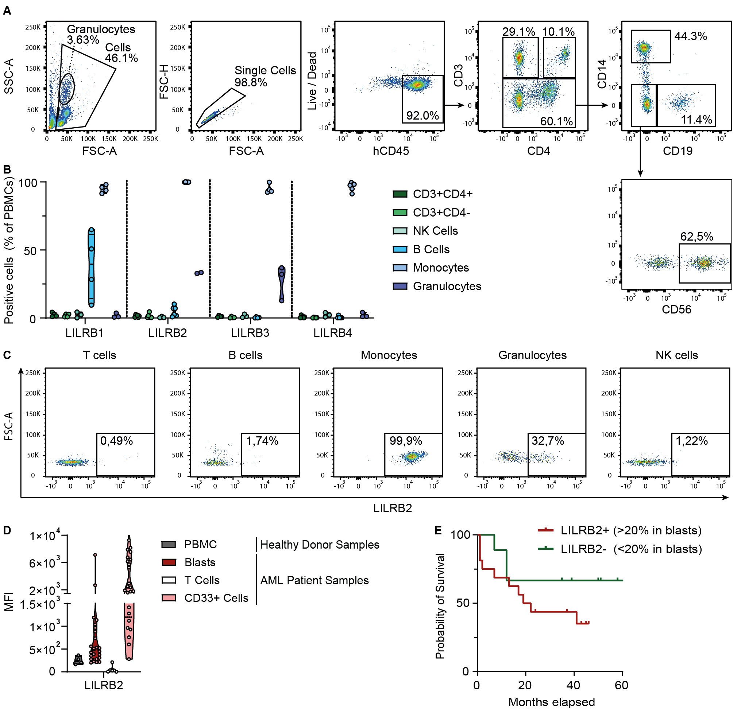
Figure S1: LILRB2 is primarily expressed on healthy monocytes, while high LILRB2 expression by blasts correlates with decreased patient survival. (A) Representative gating strategy of healthy PBMCs after analysis by flow cytometry. Cells are divided into granulocytes (high SSC-A), T cells (CD3+CD4+ and CD3+CD4-), monocytes (CD14+CD3-), B cells (CD19+CD3-), and NK cells (CD3-CD14-CD19-CD56+). (B) Expression (%) of LILRB1-4 on depicted cell subsets in healthy PBMCs (n=3-6) after analysis by flow cytometry. Data are represented as violin plots. (C) Representative flow cytometric dot-plots of LILRB2 fluorescence intensity in indicated cell types. (D) MFI of LILRB2 in healthy donor PBMCs (n=4), AML blasts (n=23), AML-associated T cells and CD33+ myeloid cells (n=23). Every dot represents an individual sample. (E) Overall survival of 25 investigated AML patients with (>20% in blasts, n=16) and without (<20% in blasts, n=9) considerable LILRB2 expression.

Supplementary Figure 2
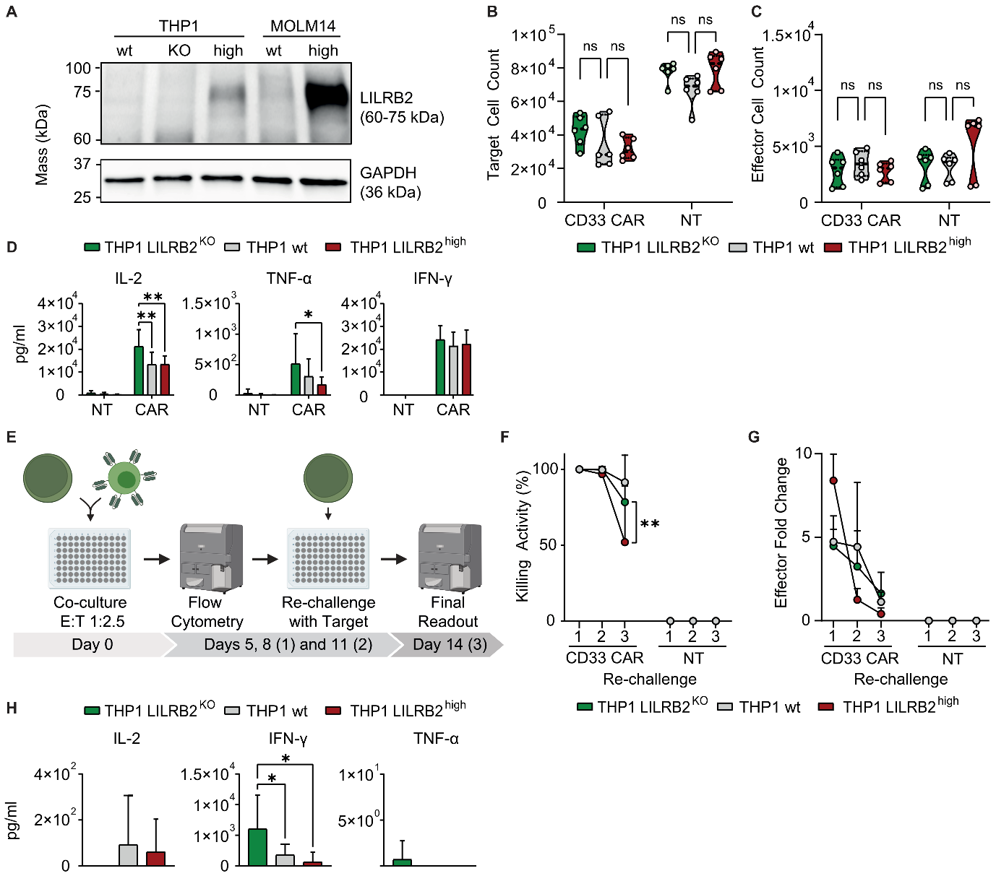Figure S2: LILRB2 expression impairs CAR T-cell functionality in long-term in vitro assays. (A) Analysis of the presence of LILRB2 protein in generated THP1 and MOLM14 cell lines. GAPDH was used as loading control. (B-+C) Flow cytometric readout of target (B) and effector (C) cell counts after a 1-day co-culture of anti-CD33 CAR- or NT T cells with THP1 wt, THP1 LILRB2 KO, or THP1 LILRB2 high cells at an E:T ratio of 1:1. Data illustrates three biological replicates with two technical replicates. (D) Analysis of cytokines in the supernatant of aforementioned co-cultures (E:T ratio 1:15) after 5 days, measured by ELISA. Mean of three biological replicates with two technical replicates ± SD. (E) Graphical representation of the re-challenge assay. (F-G) Flow cytometric readout of effector and target cells after re-challenging anti-CD33 CAR- or NT T cells three times with THP1 wt, THP1 LILRB2 KO, or THP1 LILRB2 high cell lines at an E:T ratio of 1:2.5. Data illustrates the mean of four biological replicates with two to three technical replicates ± SD. Killing activity (F) and effector fold change (G) of anti-CD33 CAR or NT cells after 1, 2, or 3 re-challenges. (H) Analysis of cytokines in the supernatant of anti-CD33 CAR T cells re-challenged with indicated tumor cells three times, measured by ELISA. Statistical analysis was performed via one-way ANOVA (B-D+H) or two-way ANOVA with Tukey’s multiple comparison (F+G); *p<0.05; **p<0.01.

Supplementary Figure 3
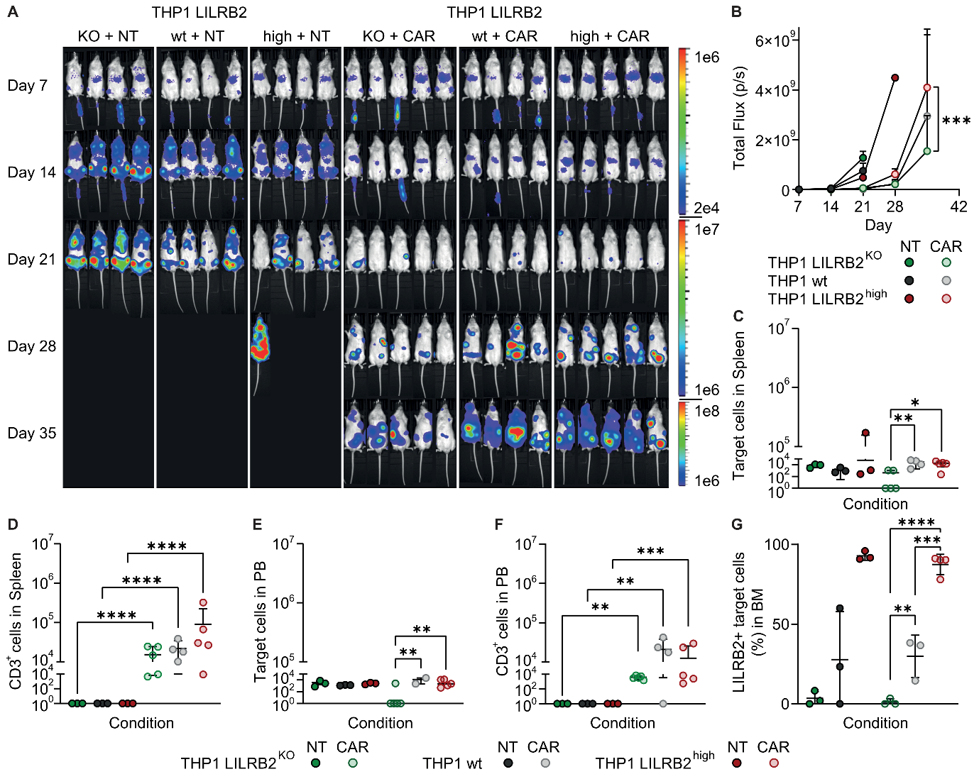
Figure S3: LILRB2 expression by the THP1 AML cell line impairs CAR T-cell functionality in vivo. NSG mice were sub-lethally irradiated and injected i.v. with 1x10⁶ THP1 wt, LILRB2 KO or LILRB2 high cells. After 9 days, mice were treated with 1x10⁶ anti-CD33 CAR+ T cells i.v. NT cell injection served as control. (A) IVIS images of mice receiving the indicated treatments. (B) Total flux (photons / second) of the depicted treatment groups at different timepoints, as measured by IVIS. (C-F) Total count of target cells in the spleen (C) or PB (E) or of hCD3+ cells in the spleen (D) or PB (F) at humane endpoint or end of the experiment (day 50), measured by flow cytometry. (G) Percentage of LILRB2 positive target cells in the BM at humane endpoint or end of the experiment (day 50), measured by flow cytometry. For C-G, every dot represents a mouse. For B, data are represented as mean ± SD (n=3-5). Statistical analysis was performed via two-way ANOVA (B) or one-way ANOVA (C-G) with Tukey’s multiple comparison; *p<0.05; **p<0.01; ***p<0.001; ****p<0.0001.

Supplementary Figure 4
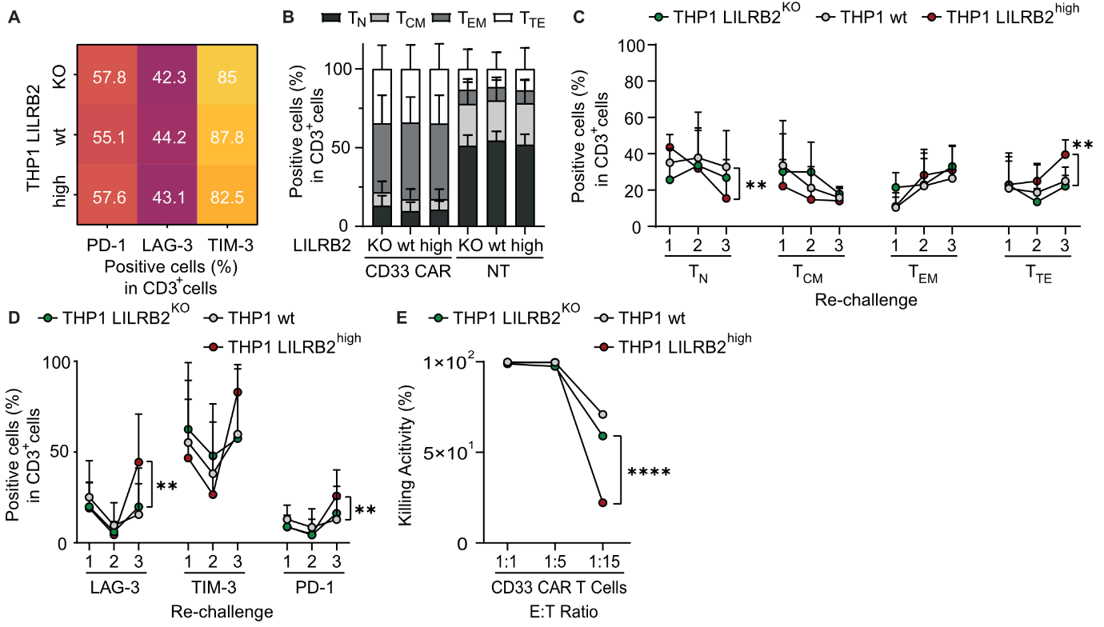
Figure S4: LILRB2 expression in AML enhances CAR T-cell differentiation and exhaustion only in long-term in vitro assays. (A+D) Percentage of hCD3+ cells expressing PD-1, LAG-3, and TIM-3 in the anti-CD33 CAR T-cell conditions after a 1-day co-culture (A) or re-challenge assay (D) with indicated tumor cells. (B+C) Percentage of naïve and stem cell memory (T_{N}), central memory (T_{CM}), effector memory (T_{EM}), and terminal effector (T_{TE}) hCD3+ cells, as defined by hCD45RA and hCD62L expression. after the indicated 1-day co-culture (B) or re-challenge assay (C) conditions. One-day co-cultures were performed at an E:T ratio of 1:1, and data illustrates three biological replicates with two technical replicates each ± SD. The re-challenge assay was performed at an E:T ratio of 1:2.5, and data shows the mean ± SD of four biological replicates, with two to three technical replicates each. (E) Killing activity of anti-CD33 CAR T cells after a 5-day co-culture with THP1 wt, THP1 LILRB2 KO or THP1 LILRB2 high cells as measured by flow cytometry. Data illustrates the mean ± SD of two technical replicates. Statistical analysis was performed via two-way ANOVA with Tukey’s multiple comparison; **p<0.01, ****p<0.0001.

Supplementary Figure 5
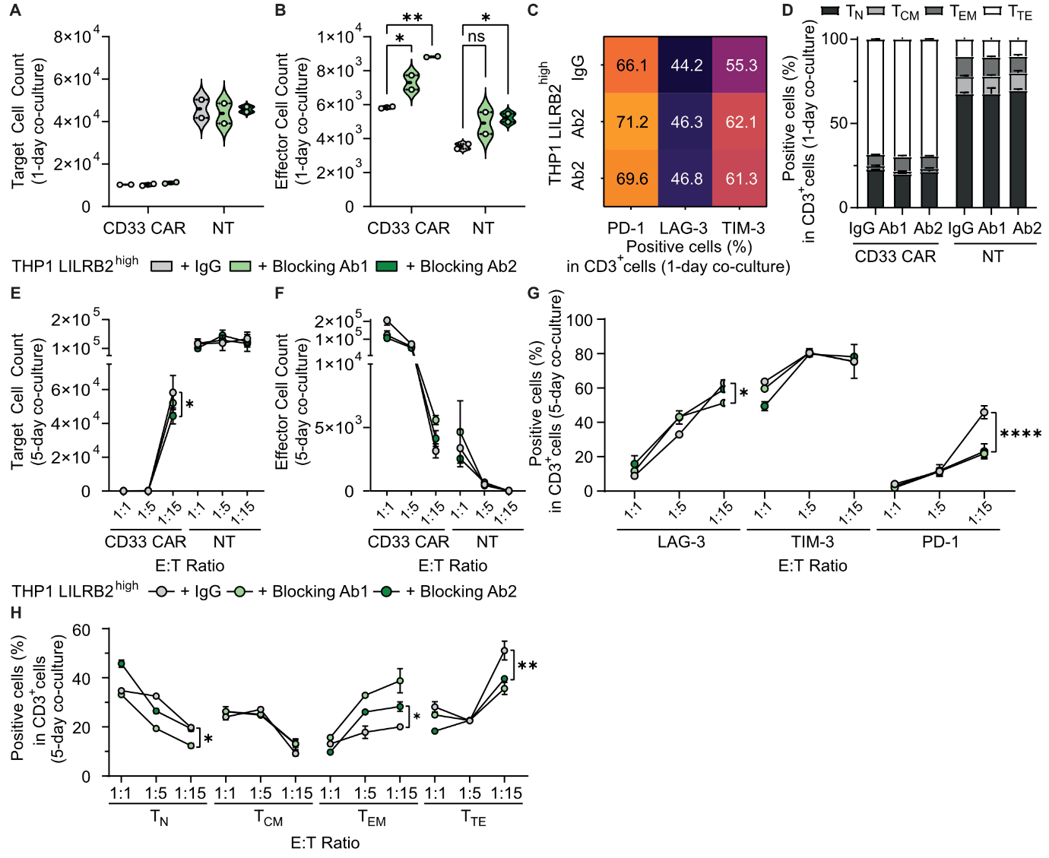
Figure S5: Antibody-mediated LILRB2 blockade partially reverses impaired CAR T-cell functionality in vitro. Flow cytometric analysis of effector and target cells after a 1-day (A-D) or 5-day (E-H) co-culture of CD33 CAR- or NT T cells with THP1 LILRB2 high cells together with LILRB2 blocking antibodies or isotype control (IgG). The 1-day co-culture was performed at an effector-to-target (E:T) ratio of 1:1, and the 5-day co-culture at the E:T ratios indicated in the graphs. Target (A) and effector (B) cell counts after 1-day co-culture. (C) Percentage of PD-1, LAG-3, and TIM-3 expression of hCD3+ cells in anti-CD33 CAR T-cell conditions treated either with IgG or LILRB2 blocking antibodies during co-culture, as indicated on the Y-axis. (D) Percentage of naïve and stem cell memory (T_{N}), central memory (T_{CM}), effector memory (T_{EM}), and terminal effector (T_{TE}) hCD3+ cells, as defined by hCD45RA and hCD62L expression, in the conditions indicated on the X-axis. Target (E) and effector (F) cell counts at indicated E:T ratios after 5-day co-culture. (G) Percentage of PD-1, LAG-3 and TIM-3 expression of hCD3+ cells in anti-CD33 CAR T-cell conditions at indicated E:T ratios. (H) Percentage of naïve and stem cell memory (T_{N}), central memory (T_{CM}), effector memory (T_{EM}), and terminal effector (T_{TE}) hCD3+ cells, as defined by hCD45RA and hCD62L expression, in anti-CD33 CAR T-cell conditions at indicated E:T ratios. The data illustrates one representative donor with two technical replicates ± SD. Statistical analysis was performed via one-way ANOVA (A-D) or via two-way ANOVA (E-H) with Tukey’s multiple comparison; *p<0.05; **p<0.01; ***p<0.001; ****p<0.0001.

Supplementary Figure 6
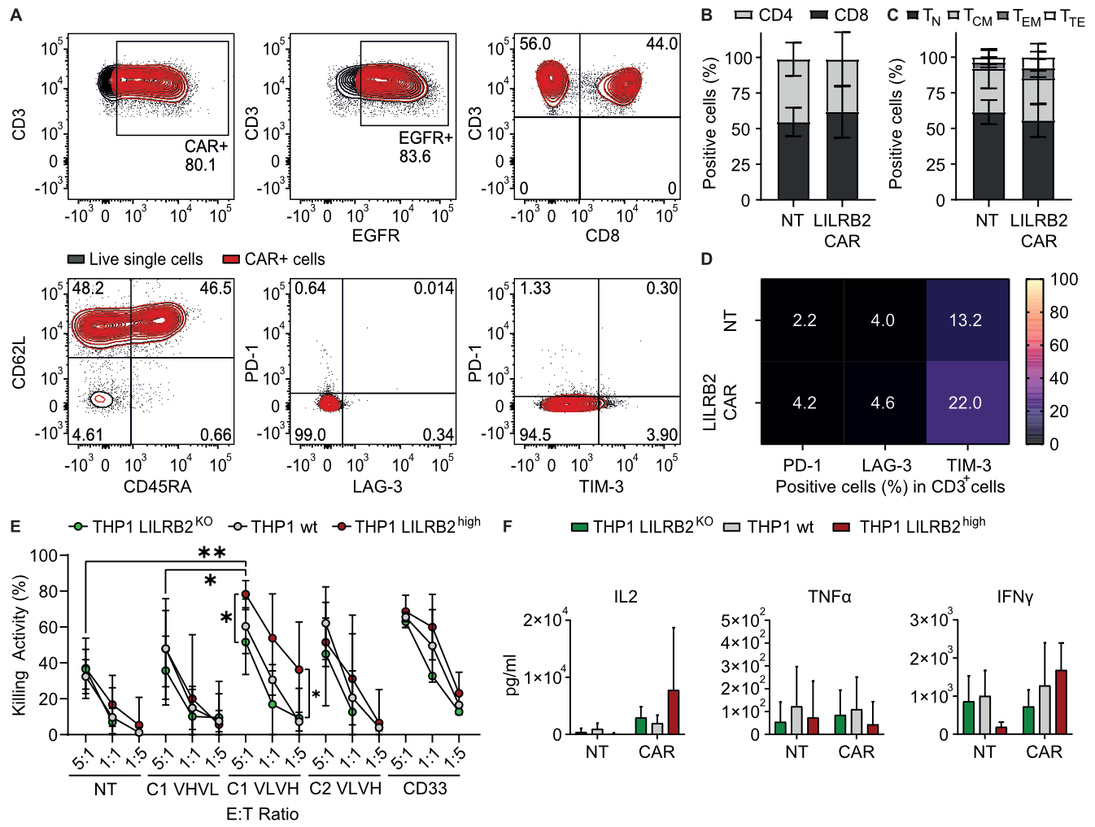
Figure S6: Anti-LILRB2 CAR T cells show potent effector function against the THP1 AML cell line in vitro. (A) Phenotypic characterization of CAR T cells by flow cytometry in one representative batch. (B+C) Percentage of (B) CD4 and CD8 cells and (C) naïve and stem cell memory (T_{N}), central memory (T_{CM}), effector memory (T_{EM}), and terminal effector (T_{TE}) cells, as defined by hCD45RA and hCD62L expression, in NT and CAR T cells. (D) PD-1, LAG-3, and TIM-3 expression (%) in CAR T and NT cells (n=9). (E) Killing activity of T cells engineered to express different anti-LILRB2 CAR constructs (C1 VHVL, C1 VLVH, C2 VLVH) after a 1-day co-culture with THP1 wt, THP1 LILRB2 KO, or THP1 LILRB2 high cells at the indicated E:T ratios. Analysis was done by flow cytometry and NT and anti-CD33 CAR T cells served as negative or positive control respectively. Data illustrates the mean ± SD of three biological replicates with two technical replicates. (F) Analysis of cytokines in the supernatant of the aforementioned co-culture with anti-LILRB2 C1 VLVH CAR T cells at an E:T ratio of 1:1, measured by ELISA. Mean of three biological replicates with two technical replicates ± SD. Statistical analysis was performed via one-way ANOVA (F) or two-way ANOVA (E) with Tukey’s multiple comparison; **p<0.01; ***p<0.001; ****p<0.0001.

Supplementary Figure 7
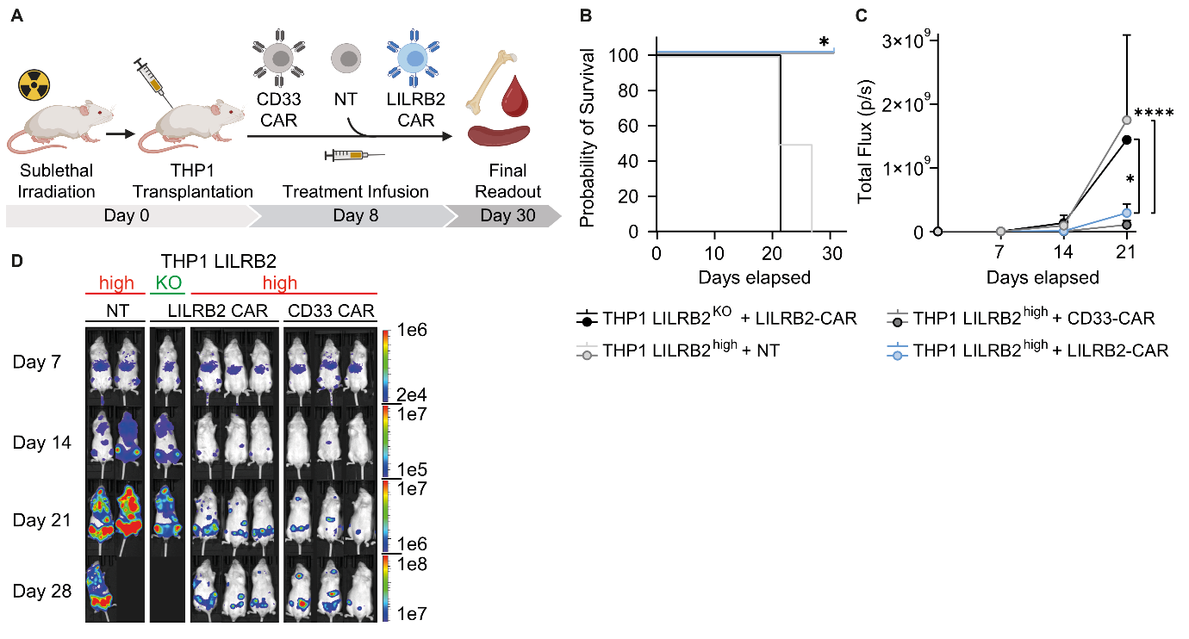
Figure S7: Anti-LILRB2 CAR T cells mediate specific effector function against the THP1 AML cell line in vivo. (A) NSG mice were sub-lethally irradiated and injected i.v. with 1x10⁶ THP1 LILRB2 high cells. One mouse was injected i.v. with 1x10⁶ THP1 LILRB2 KO cells as control. At day 8, mice were treated with 4x10⁶ anti-LILRB2 CAR+ T cells or controls i.v.. (B) Kaplan-Meier survival curves of the depicted treatment groups. (C) Total flux (photons / second) of the depicted treatment groups at different timepoints, as measured by IVIS. Data are represented as mean ± SD. (D) IVIS images of mice receiving the indicated treatments. Statistical analysis was performed via two-way ANOVA (C) with Tukey’s multiple comparison, or via Mantel-Cox test (B); *p<0.05; ****p<0.0001.

Supplementary Figure 8
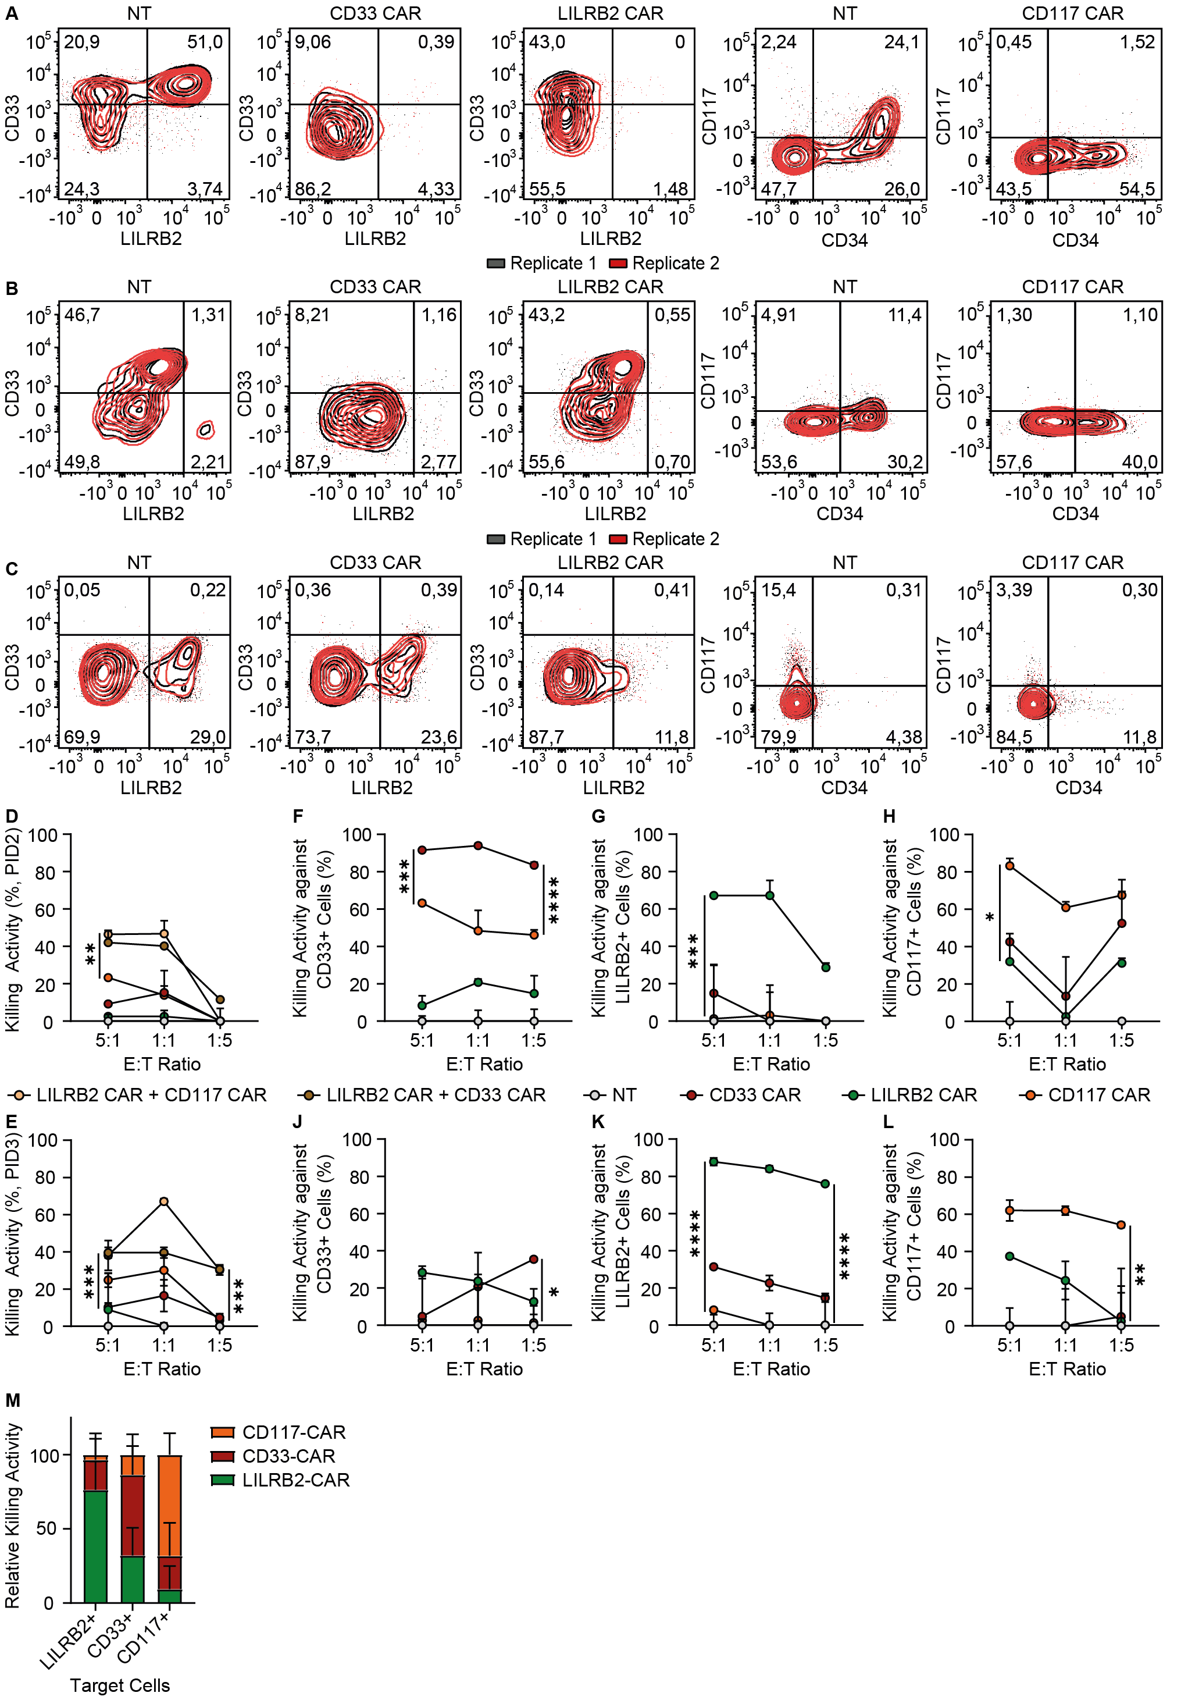
Figure S8: Anti-LILRB2 CAR T cells exhibit anti-tumor activity against patient samples in vitro, which can be further increased by the combination with anti-CD117 or anti-CD33 CAR T cells. (A-C) Contour plots of CD33, LILRB2, and CD117 expression of the AML patient samples PID1 (A), PID2 (B), and PID3 (C) after co-culture with NT, anti-CD33 CAR, anti-LILRB2 CAR, or anti-CD117 CAR T cells for 1 day at an E:T ratio of 5:1. (D-L) Killing activity of CAR T cells targeting LILRB2, CD33, CD117, and their combinations after a 1-day co-culture with the AML patient samples PID2 (D, F-H) and PID3 (E, J-L) at indicated E:T ratios, normalized to NT controls. Depicted are the total killing activities (D-E), as well as the specific killing activities against CD33+ (F, J), LILRB2+ (G, K), and CD117+ (H, L) subpopulations. Readout was done by flow cytometry. The data illustrates the mean ± SD of two technical replicates of one patient sample. (M) Relative killing activity of anti-CD33 CAR, anti-LILRB2 CAR, and anti-CD117 CAR T cells against LILRB2+, CD33+, or CD117 cells, respectively, after co-culture with PIDs 1-3 at an E:T ratio of 1:1 for 1 day. The data illustrates the mean ± SD of two technical replicates of three independent patient samples. Statistical analysis was performed via two-way ANOVA with Tukey’s multiple comparison; *p<0.05; **p<0.01; ***p<0.001; ****p<0.0001.

References
1. Magnani CF, Myburgh R, Brunn S, Chambovey M, Ponzo M, Volta L, et al. Anti-CD117 CAR T cells incorporating a safety switch eradicate human acute myeloid leukemia and hematopoietic stem cells. Mol Ther Oncolytics. 2023;30:56–71.

