Supplementary Information

for

Limited contribution of novel Carbon Dioxide Removal and Geological Carbon Storage to reducing peak warming

Anne Merfort ^{* 1,2}, Iain de Jonge-Anderson³, Tabea Dorndorf¹, Chen Chris Gong¹, Fabrice Lécuyer¹, Gunnar Luderer^{1,2}, David Klein¹, Elmar Kriegler^{1,4}, Adrian Odenweller¹, Jessica Strefler^{1,5,6}

* Corresponding author: anne.merfort@pik-potsdam.de
¹ Potsdam Institute for Climate Impact Research (PIK), Member of the Leibniz Association, 14473 Potsdam, Germany
² Global Energy Systems Analysis, Technische Universität Berlin, 10623 Berlin, Germany
³ University of Strathclyde
⁴ Faculty of Economics and Social Sciences, University of Potsdam, 14483 Potsdam, Germany
⁵ Novo Nordisk Foundation CO2 Research Center, Aarhus, Denmark
⁶ Department of Mechanical and Production Engineering, Aarhus University, Aarhus, Denmark

Supplementary Table 1
REMIND region | Regional initial capacity in 2030  in MtCO2/yr |  |  | Regional market saturation K  in MtCO2/yr
REMIND region | Slow growth | Ambitious growth | Emergency deployment | Regional market saturation K  in MtCO2/yr
CAZ | 24.8 | 38.9 | 53 | 276
CHA | 9.7 | 11.1 | 12.5 | 1540
EUR | 14.4 | 26.2 | 38 | 602
IND | 0 | 0 | 0 | 868
LAM | 10.6 | 10.6 | 10.6 | 1145
MEA | 13.6 | 15.5 | 17.5 | 1541
NEU | 9.2 | 13.2 | 17.3 | 147
OAS | 7.8 | 10 | 12.1 | 1155
REF | 0 | 0 | 0 | 721
SSA | 0.1 | 0.3 | 0.6 | 1443
USA | 52.5 | 93.8 | 135 | 1250
S-Table 1: Regional initial capacities in 2030 per logistic growth scenario, derived from applying failure rates to project announcements. Regional market saturation derived from maximum GCS deployment in near-term constrained REMIND scenarios.

Supplementary Figure 1
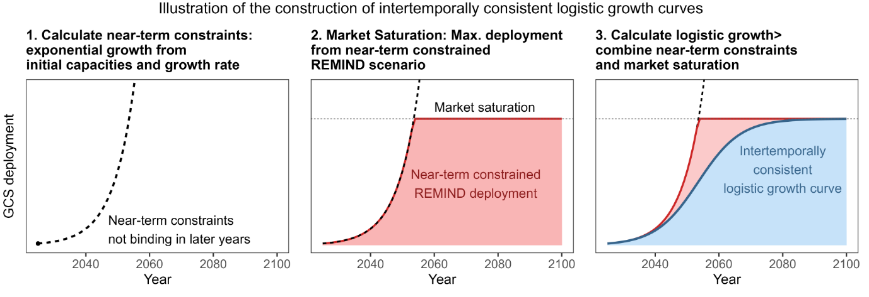
S-Figure 1: Illustration of the iterative approach to derive intertemporally consistent GCS upscaling curves.

Supplementary Table 2
Optimistic assumption  (presented in main text) | Less optimistic variation | Effect on global market saturation of GCS  (optimistic: 16 GtCO2/yr)
Full cooperation and financing capacities for net-negative emissions.  Explanation: One region’s continued positive emissions can be compensated without friction by other region’s net-negative emissions. Negative CO2 emissions will be renumerated with the full carbon price. | Tax on regional net-negative emissions (REMIND default assumption)  Explanation: This mechanism reflects the | reduces to 8.3 Gt CO2/yr.
Low TRL nCDR options are available (OAE requires GCS) | Low TRL nCDR options not available (less CO2 supply for GCS) | reduces to 12.5 GtCO2/yr
High carbon price of 500$/tCO2 in 2050. | Lower Carbon price 250 $/tCO2 in 2050 | reduced to 10 GtCO2/yr
High carbon price of 500$/tCO2 in 2050. | High carbon price reached later in 2070 | no reduction of market saturation
Low CO2 transport and storage costs of 12$/tCO2 | Higher CO2 transport and storage costs of 20$/tCO2 | reduces to 13 GtCO2/yr

Supplementary Figure 2
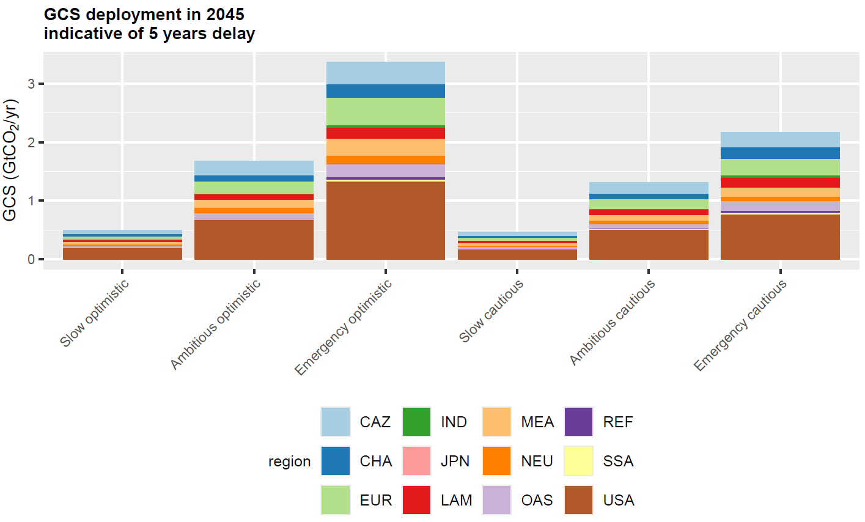
S-Figure 2: In order to understand the consequences of another 5 years of GCS upscaling inaction, it is useful to look at the GCS deployment in 2045. These numbers represent logistic upscaling with only 15 years of time.

Supplementary Note 1
Why regionalisation matters for global upscaling dynamics of GCS:
In this example with globally uniform growth rates, taking only a global perspective on starting values and market saturations too might overestimate the mid-term deployment.
Aggregating the regional starting values and regional market saturations and solving the logistic growth function afterwards generally yields equal or larger values than solving logistic growth curves for each region individually and aggregating the results afterwards. In fact, only for equal ratios of regional or global y0 to K are the sums of logistic growth curves and the logistic growth curves of aggregated inputs identical.
Intuitively speaking, regions with larger initial capacity announcements (Europe, Canada, USA) might not have an equally larger market saturation. Hence in these regions, growth slows down, the sooner they approach their market saturation. On the other hand, regions with little to no announced capacities today still have large market potentials, if climate change mitigation was to be taken seriously and, in these regions, fast growth is hampered by small starting values.
In Supplementary Figure 3 we show that the difference between both ways to obtain global results might lead to a difference of up to 30% and hence underscores the necessity to take regional bottlenecks into account, especially for benchmark numbers such as 2050 GCS deployment for net-zero targets.
We want to highlight that there is a trade-off between higher and lower regional granularity in the logistic growth analysis. Higher granularity captures discrepancies between early mover’s project announcements (or the lack thereof) and potential future GCS demand in that region but underestimates inter-regional cooperation, inter-regional spill-over effects and learning and shared infrastructure. In particular, REMIND assumes full cooperation within a region and no trade between regions.

Supplementary Figure 3
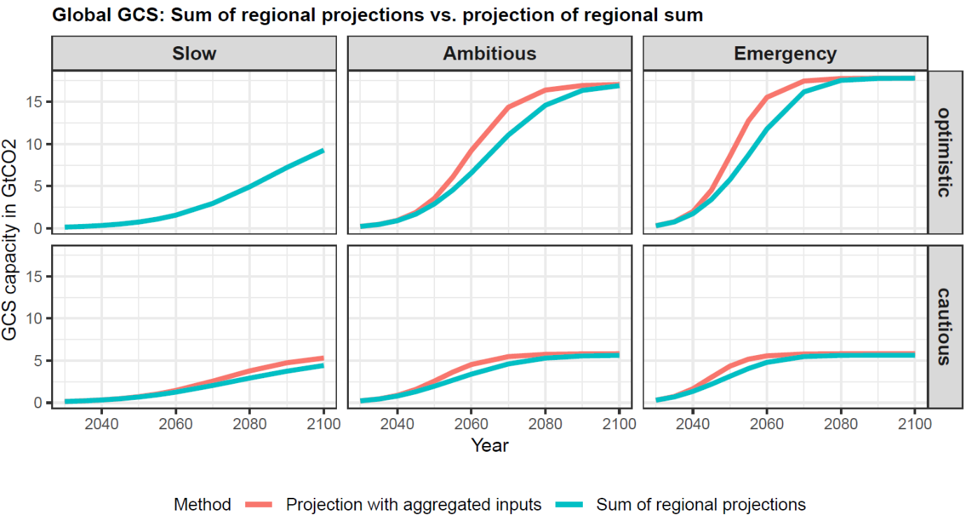
S-Figure 3: Comparison of the result of the global logistic growth model calculated with aggregated input parameters y0 and K (red) with sum of regionalised projections (blue) (as presented in this work). Regionalisation reduces expectations in 2050 as regions with large project announcements are not necessarily the regions with large market saturation. See also Supplementary Note 1.

Supplementary Table 3
REMIND  region | Countries
CAZ | Australia, Canada, Heard Island and McDonald Islands, New Zealand, Saint Pierre and Miquelon
CHA | China, Hong Kong, Macao, Taiwan, Province of China
EUR | Aland Islands, Austria, Belgium, Bulgaria, Cyprus, Czech Republic, Germany, Denmark, Spain, Estonia, Finland, France, Faroe Islands, United Kingdom, Guernsey, Gibraltar, Greece, Croatia, Hungary, Isle of Man, Ireland, Italy, Jersey, Lithuania, Luxembourg, Latvia, Malta, Netherlands, Poland, Portugal, Romania, Slovakia, Slovenia, Sweden
IND | India
JPN | Japan
LAM | Aruba, Anguilla, Argentina, Antarctica, Antigua and Barbuda, Bonaire, Sint Eustatius and Saba, Bahamas, Saint Barthelemy, Belize, Bermuda, Bolivia, Plurinational State of, Brazil, Barbados, Bouvet Island, Chile, Colombia, Costa Rica, Cuba, Curacao, Cayman Islands, Dominica, Dominican Republic, Ecuador, Falkland Islands (Malvinas), Guadeloupe, Grenada, Guatemala, French Guiana, Guyana, Honduras, Haiti, Jamaica, Saint Kitts and Nevis, Saint Lucia, Saint Martin (French part), Mexico, Montserrat, Martinique, Nicaragua, Panama, Peru, Puerto Rico, Paraguay, South Georgia and the South Sandwich Islands, El Salvador, Suriname, Sint Maarten (Dutch part), Turks and Caicos Islands, Trinidad and Tobago, Uruguay, Saint Vincent and the Grenadines, Venezuela, Bolivarian Republic of, Virgin Islands (British), Virgin Islands (U.S.)
MEA | United Arab Emirates, Bahrain, Algeria, Egypt, Western Sahara, Iran, Islamic Republic of, Iraq, Israel, Jordan, Kuwait, Lebanon, Libya, Morocco, Oman, Palestine, State of, Qatar, Saudi Arabia, Sudan, Syrian Arab Republic, Tunisia, Yemen
NEU | Albania, Andorra, Bosnia and Herzegovina, Switzerland, Greenland, Iceland, Liechtenstein, Monaco, Macedonia, the former Yugoslav Republic of, Montenegro, Norway, Svalbard and Jan Mayen, San Marino, Serbia, Turkey, Holy See (Vatican City State)
OAS | Afghanistan, American Samoa, French Southern Territories, Bangladesh, Brunei Darussalam, Bhutan, Cocos (Keeling) Islands, Cook Islands, Christmas Island, Fiji, Micronesia, Federated States of, Guam, Indonesia, British Indian Ocean Territory, Cambodia, Kiribati, Korea, Republic of, Lao People's Democratic Republic, Sri Lanka, Maldives, Marshall Islands, Myanmar, Mongolia, Northern Mariana Islands, Malaysia, New Caledonia, Norfolk Island, Niue, Nepal, Nauru, Pakistan, Pitcairn, Philippines, Palau, Papua New Guinea, Korea, Democratic People's Republic of, French Polynesia, Singapore, Solomon Islands, Thailand, Tokelau, Timor-Leste, Tonga, Tuvalu, United States Minor Outlying Islands, Viet Nam, Vanuatu, Wallis and Futuna, Samoa
REF | Armenia, Azerbaijan, Belarus, Georgia, Kazakhstan, Kyrgyzstan, Moldova, Republic of, Russian Federation, Tajikistan, Turkmenistan, Ukraine, Uzbekistan
SSA | Angola, Burundi, Benin, Burkina Faso, Botswana, Central African Republic, Cote d Ivoire, Cameroon, Congo, the Democratic Republic of the, Congo, Comoros, Cape Verde, Djibouti, Eritrea, Ethiopia, Gabon, Ghana, Guinea, Gambia, Guinea-Bissau, Equatorial Guinea, Kenya, Liberia, Lesotho, Madagascar, Mali, Mozambique, Mauritania, Mauritius, Malawi, Mayotte, Namibia, Niger, Nigeria, Reunion, Rwanda, Senegal, Saint Helena, Ascension and Tristan da Cunha, Sierra Leone, Somalia, South Sudan, Sao Tome and Principe, Swaziland, Seychelles, Chad, Togo, Tanzania, United Republic of, Uganda, South Africa, Zambia, Zimbabwe
USA | United States

Supplementary Figure 4
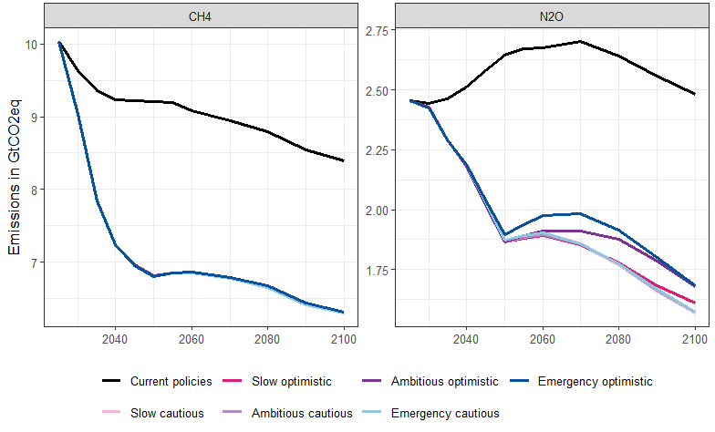
S-Figure 4: CH4 and N2O emissions across scenarios from the sectors agriculture, energy supply, fossil fuel extraction, land-use change, transport and waste management.

Supplementary Note 2

REMIND CDR technologies implementation description

Direct Air CO₂ Capture and Utilization/Storage (DACCU/DACCS)
Technology flavors/configurations
DAC is represented in the energy system model of REMIND, and is represented as one generic technology: a low-temperature DAC process with energy requirements following Climeworks specifications. CO2 Utilisation and Storage are modelled separately (see description CO2 transport and Storage).
Input
Energy inputs
DAC uses 400 kWh electricity/tCO2 for ventilation during the capture phase and 1600 kWh thermal energy/tCO2 during the recovery phase.
Output
DAC provides CO₂ for the value chain. The model can endogenously decide whether the captured CO2 shall be used for synthetic gases or liquids (CCU) or if it should be permanently stored geologically (DACCS).
Infrastructure
DACCS requires CO2 transport and storage infrastructure (see detailed description in corresponding section).
Timing and permanence
CO2 captured by DAC is assumed to be rereleased in the same timestep if it is used for synthetic fuels (DACCU) and assumed to be stored permanently in geological formations (DACCS). For DACCS, timing is immediate and storage is considered permanent.
Costs and deployment constraints
Learning: DAC is implemented with endogenous learning for capital investment costs. Starting from an initial cost assumption, global cumulative deployment reduces these costs with a defined learning rate: Every doubling in installed capacity reduces costs by 15% until exogenously defined floor costs are achieved.
Upscaling penalty: Non-linear upscaling of any technology in REMIND comes with “adjustment costs” penalty.

Bioenergy with Carbon Capture and Usage/Storage (BECCS/BECCU)
Technology flavors/configurations
Bioenergy supply (from lignocellulosic purpose grown energy crops and agricultural and forestry residues) is supplied by MAgPIE or a MAgPIE emulator in REMIND stand-alone runs.
Primary energy biomass is used in REMIND for energy i) supply-side BECCS:
REMIND represents four energy supply side conversion routes: Biomass to 1) electricity, 2) hydrogen, 3) liquid fuels (Fischer Tropsch Synthesis), 4) biogas.
or ii) Industry BECCS:
Combustion of final energy hydrocarbon fuels in industry (primarily to supply industrial heat demand) can be coupled with carbon capture and storage. If such fuels are of biogenic origin, this results in industry BECCS. This is represented by marginal abatement cost curves for applying carbon capture to industry emissions.
Input
Biomass supply for energetic purposes
- residues (fixed potential with small costs)
- and purpose grown bioenergy crops (MAgPIE has a representation of a generic grassy and a generic tree species).

Output
Energy supply-side BECCS:
Energy output depends on conversion route: Electricity, biogas, hydrogen or liquid fuels (diesel).
Industry BECCS:
Provides industrial high temperature heat at stationary combustion sites.
All BECCS activities provide captured CO2 for the CCUS value chain. The model can endogenously decide whether the captured CO2 shall be used for synthetic gases or liquids or if it should be permanently geologically stored. (See dedicated chapter on CO2 transport and storage)
Emissions
Carbon uptake in above ground biomass of bioenergy crops as well as rerelease upon harvest/combustion are not explicitly modelled as overall emission balance is zero.
But bioenergy crop induced direct and indirect land-use and land-use-change CO2 emissions as well as associated CH4 and N2O emissions are accounted for in MAgPIE (or in MAgPIE emulator).
On the energy system side, biomass is accounted as carbon neutral and REMIND does not account for other technology specific non-CO2 emissions.
Infrastructure
BECCS requires CO2 transport and storage infrastructure (see detailed description in corresponding section).

Timing and permanence
Capture and storage or usage (+release) are immediate and we assume that geologic storage of CO₂ is permanent.

Deployment and resource constraints
Exogenous learning, CAPEX and OPEX costs decline over time in a pre-defined manner.
REMIND suppresses excessive biomass demand with an additional sustainability tax that scales with total biomass use.
Non-linear upscaling of any technologies comes with “adjustment costs”.

Regional differentiation
Biomass availability is region-specific and derived from MAgPIE.
Energy prices arise endogenously from the energy system model in REMIND. In particular, the value of secondary energy or energy services supplied by BECCS to a specific regions decarbonisation is essential for BECCS competetiveness.

Enhanced Weathering

Technology flavors/configurations
We base the implemented EW process on the mining, grinding and spreading of basalt exclusively on agricultural cropland. Interactions with agricultural production are not modelled.

Input
Basalt, but material flows are not endogenized, as it is assumed to be abundantly available world wide.
Electricity for grinding, depending on the grain size. Smaller grain sizes -> higher electricity demand -> faster weathering. Default grain size is 20 micrometers.
Liquid fuels for transportation and spreading on agricultural land

Timing and permanence
Timing:
The weathering process follows an exponential decay that depends on the grain size and climatic conditions. We represent climatic conditions with two stylised weathering rates that represent “fast decay” in humid and warm climate and “moderate decay” in humid and temperate climate.
Permanence:
We assume CO2 to be stored permanently and irreversibly.

Deployment and resource constraints
Application is limited to 15 kg unweathered ground stone per square meter on a maximum area of 50% of regional cropland.
Deployment can scale up at a maximum growth rate of 15% per year.

Regional differentiation
Regions have varying potentials (resulting from a combination of climate dependent decay rates and cropland availability) depending on total cropland area in warm and humid climate and temperate humid climate respectively. Furthermore, transport costs scale differently depending on regional basalt availabilities in relation to suitable croplands.

Biochar
Technology flavors/configurations
Biochar is represented by four different industrial scale pyrolysis configurations in the energy system model of REMIND. Biomass feedstock is identical to BECCS feedstock and modelled by MAgPIE or MAgPIE emulator in REMIND stand-alone runs.
There are three system setups that reflect established biochar production processes:
biochar without energetic co-production
biochar with heat co-production
biochar with combined heat and power co-production
and one early stage production process:
biochar with liquids co-production (integrated with Fischer-Tropsch Synthesis)
Input
Biomass supply (identical to BECCS) for energetic purposes relevant for biochar is modelled by MAgPIE and can either be
- residues (fixed potential with small costs)
- and purpose grown bioenergy crops (MAgPIE has a representation of a generic grassy and a generic tree species).

Output
Biochar output:
The produced biochar primarily delivers carbon removal but we also assign a (generic) material value to it that reflects its value in applications in the agricultural or construction sector.
Energy output:
Additionally, biochar may co-produce energy depending on the specific technology route (see Technology flavors/configurations)

Emissions
Direct and indirect LU and LUC emissions of bioenergy crop production are modelled in MAgPIE and are reflected in the MAgPIE emulator. No additional emissions are represented in the energy system model of REMIND.

Timing and permanence
Non-permanence of biochar is accounted for in a reduction of the removal efficiency upon biochar production. That is, only the share of carbon that is expected to be stable for 400 years is accounted as removal.

Deployment and resource constraints
Competition for biomass resources with BECCS limits biochar deployment (robust endogenous model outcome).
REMIND suppresses excessive biomass demand with an additional sustainability tax that scales with total biomass use.
Non-linear upscaling of all technologies comes with “adjustment costs” penalty.
OAE
Technology flavors/configurations
REMIND considers ocean liming with quicklime and application across the exclusive economic zones via ships. In this process CaO is produced from CaCO3 (analogue to the cement production). For that remind can either use an established off-the-shelf calciner that uses gas for the heat supply. Conventional calciners will be combined with carbon capture (capture rate 90%) to avoid additional CO2 emissions. Furthermore, electric calciners, which are currently at a lower TRL, are available with cost reduction due to endogenous learning.

During the calcination, CO2 process emissions occur that are also captured (with 90% capture rate). Captured CO2 can either be used (CCU) or stored geologically. Utilisation and Storage are modelled separately (see description CO2 Utilisation and CO2 Storage respectively).

Input
CaCO3 (Flows are not endogenized, as it is abundantly available world wide)
Electricity for grinding, air separation, CO2 compression (996 MJ/tCaO)
Liquid fuels for transportation and spreading in the ocean (2600 MJ/tCaO in the pessimistic scenario, 770 MJ/tCaO in the optimistic scenario)
Either electricity or H2 for novel calciner (3100 MJ/tCaO)
Or gas for traditional calciner (3100 MJ/tCaO)

Output
OAE provides CO₂ for the CCUS value chain. The model can endogenously decide whether the captured CO2 shall be used for synthetic gases or liquids or if it should be permanently geologically stored.

Emissions
If heat for the calciner is supplied by gas, we assume it is captured with a capture rate of 90%. Other upstream emissions from energy supply are accounted for on the supply side.
Process emissions from calcination are assumed to be captured with a capture rate of 90%.
REMIND does not account for other technology specific emissions.

Timing and permanence
There are two processes that lead to CO2 uptake in the ocean. The shift in alkalinity enhances the diffusion of atmospheric CO2 into the ocean. Second, the quicklime reabsorbs CO2 to go back to CaCO3.
For both processes, absorption of atmospheric CO2 into the ocean is currently assumed to happen within the same time step (i.e. 5 or 10 years). However, we acknowledge that this is an uncertain assumption and equilibration may take longer.

Deployment and resource constraints
Non-linear upscaling of any technology in REMIND comes with “adjustment costs” penalty.
OAE application is constrained to a critical concentration of 250 µmol Ca(OH)2 discharged per 1 kg seawater, applied to the first two meters of seawater depth, only in the exclusive economic zones, leading to a global maximum of 5 GtCO2 removed from OAE.

Regional differentiation
Potentials vary depending on the regions geological storage capacities and size of the EEZ.

CO2 Transport and Storage
Technology flavors/configurations
CO2 transport and storage is represented in REMIND by a generic lump-technology, considering transportation by pipelines and distinguishing storage in onshore and offshore aquifers.
Input
Electricity for CO2 conditioning, transportation and injection.
Emissions
Leakage from CO2 capture and transportation:
We assume 1% of captured CO2 leaks back to the atmosphere. We do not consider leakage from the geological reservoir back to the atmosphere. Justification (see Timing and Permanence subsection)
Infrastructure

We assume CO2 transportation in pipelines and full cooperation within a REMIND region. However, there is no inter-regional CO2 transport. CO2 that is captured in one region cannot be transported to and stored in another region.

Timing and permanence
We do not consider leakage from the geological reservoir back to the atmosphere. Justification:
While there is the risk of leakage, the quantifiable effect for mitigation pathways appears to be small according to Alcalde et al. 2018 DOI: 10.1038/s41467-018-04423-1. "An unrealistic scenario, where CO2 storage is inadequately regulated, estimates that more than 78% will be retained over 10,000 years." Relating these numbers to REMIND scenarios:
Let R(t) be the fraction remaining after time t with (simplified) constant leakage rate k:
R(t)=e^(kt)
with R(10 000) = 0.78
leakage rate k = 0.0025% / yr
After 100 years, this leads to a loss of 0.25% from the reservoirs
so in the "unrealistic scenario" for every 400 GtCO2 stored, 1 GtCO2 leaks after 100 years.

