Figures
Figure S1. Kaplan-Meier curves stratified by age groups. Number at risk shown below X-axis; Log-rank χ²=1.57, P=0.666, no significant difference among groups.
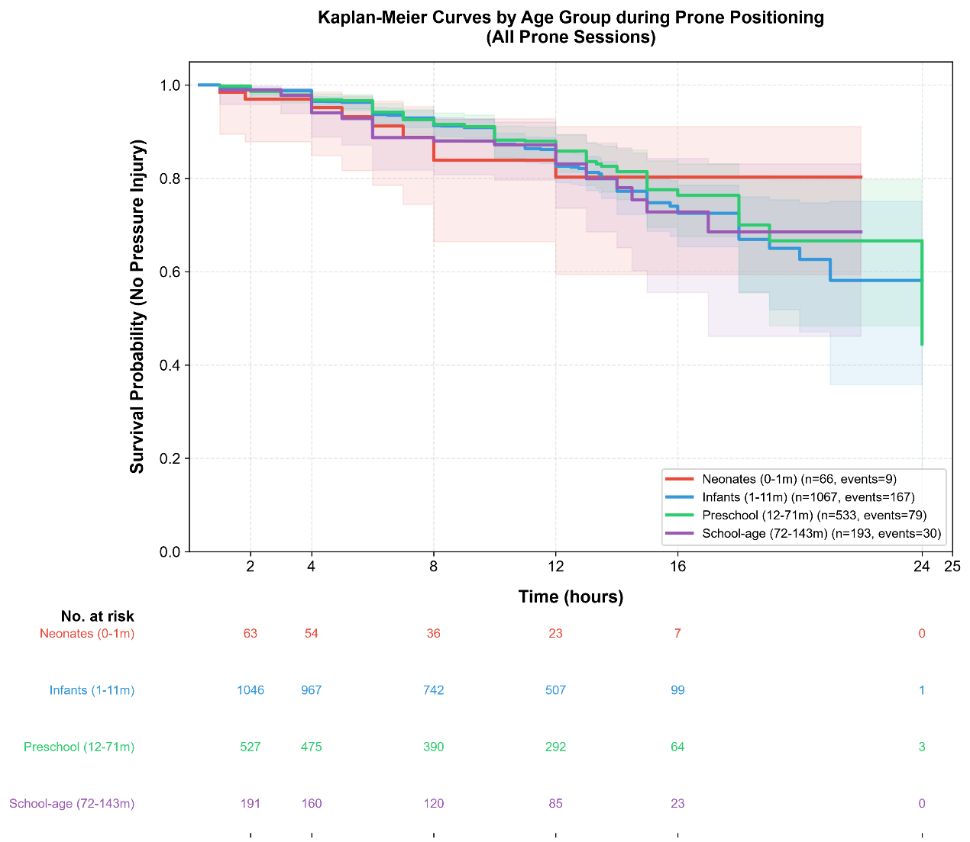
Figure S2. Adjusted marginal mean heart rate during prone positioning. Error bars: 95% CI; dashed line: baseline level.
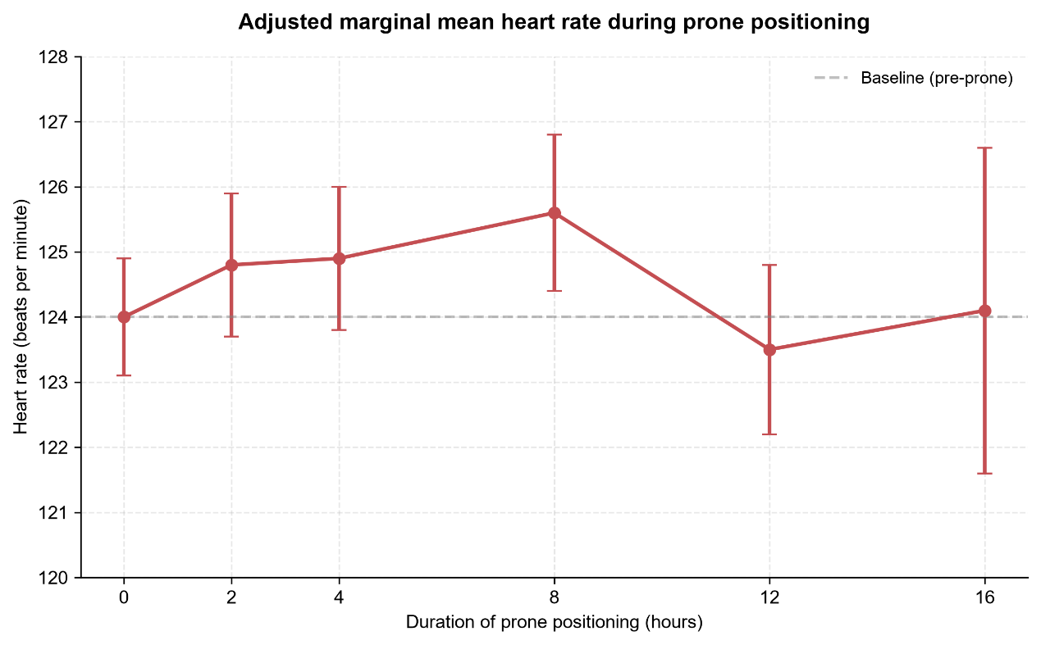
Figure S3. Adjusted marginal mean MAP during prone positioning. Error bars: 95% CI; dashed line: baseline level.
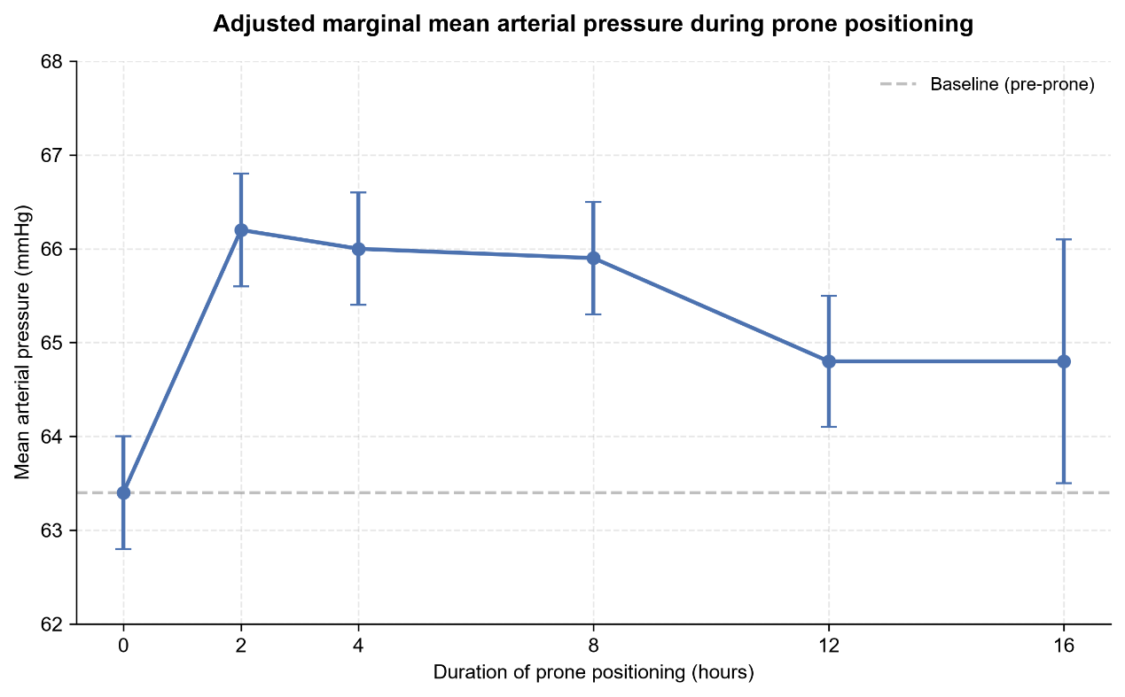

Figure S4. Forest plot of P/F ratio absolute changes from baseline. Green: P<0.01 after Bonferroni correction; gray: no significance.
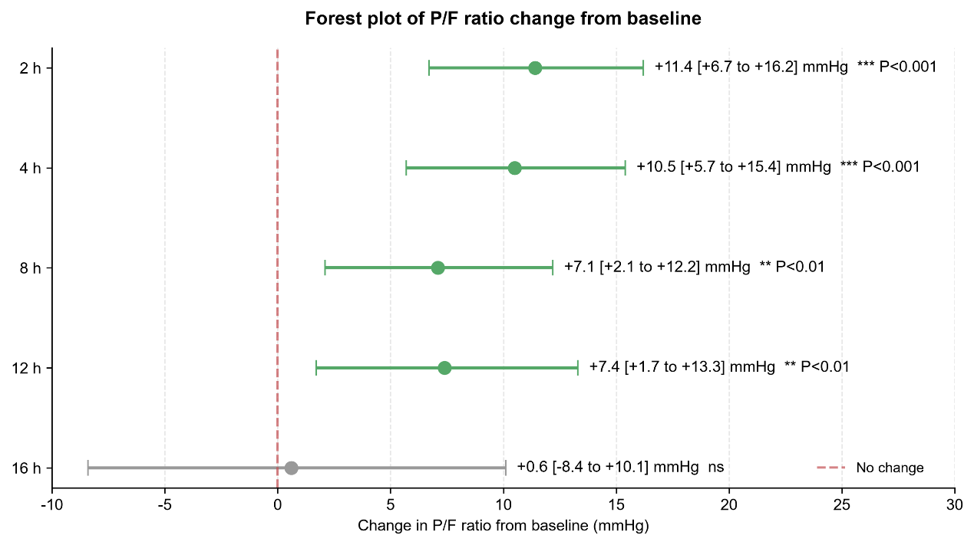
Figure S5. P/F ratio changes stratified by age groups. Shaded area: optimal oxygenation window (2-4h).
