Supplementary Material
Rapid diagnostics of actionable mutations in acute myeloid leukemia using amplicon nanopore sequencing

DNA extraction - cohort A & C
Genomic DNA was isolated from bone marrow, whole blood, or cryopreserved viable cells, with EZ1 DNA Blood Kit (QIAGEN) on the EZ1 Advanced XL (QIAGEN) according to manufacturer’s instructions.

Cohort B - CLL patients (Avicenne Hospital)
All patients with CLL diagnosis from Avicenne University Hospital (HUPSSD, AP-HP) provided informed consent and were enrolled in a “B-cell lymphoproliferative disorders” cohort (DC 2009 936). CLL cells were isolated from peripheral blood using the Ficoll method, and flow cytometry analysis confirmed leukemia purity of >80% in all cases. For short-read sequencing, Ion Torrent technologies (Genexus system) were used with a VAF of 1% as recommended by the GBMHM. Raw data were aligned using different bioinformatic tools such as GATK (RRID:SCR_001876) or the Genexus software (V6.8.2.0). Minimal average base coverage depth was around 5000x, with a minimal coverage for variant calling at 1000x with at least 10 variant reads and a VAF cut-off of 1%.
Cohort B- AML patients (Saint Antoine Hospital)
DNA samples were obtained from seven patients at Saint-Antoine Hospital (APHP-Paris) with secondary AML (3 post-polycythaemia vera AMLs, 3 post-essential thrombocythemia and 1 post-primary myelofibrosis AML, with a median age of 74 years. Targeted NGS analysis was performed at diagnosis of AML, using DNA samples extracted from bone marrow and Illumina MiSeq method according to the manufacturer’s recommendations. Bioinformatic analysis for alignment and variant identification was carried out by Sophia Genetics. Minimal coverage depth was around 500x and VAF of 1-2%.
DNA quantification
Genomic DNA was quantified using the Qubit™ 3.0 Fluorometer (Thermo Fisher Scientific) with the Qubit™ 1X dsDNA High Sensitivity Assay Kit (Cat. No. Q33231) or the Qubit™ 1X dsDNA Broad Range Assay Kit (Cat. No. Q33266), according to the manufacturer's instructions. Briefly, 1 μL of DNA was mixed with 199 μL of Qubit working solution in Qubit™ Assay Tubes (Thermo Fisher Scientific, Cat. No. Q32856), incubated for 2 min at room temperature, and quantified.

Primer preparation
Custom primers (Integrated DNA Technologies) were resuspended in TE buffer (10 mM Tris-HCl, pH 8.0, 0.1 mM EDTA). Multiplex primer pools were prepared in nuclease-free water to a final concentration of 10 μM for each primer according to Supplementary Table 4.

Multiplex PCR amplification
. Target regions for each sample was amplified in three separate multiplex PCR reactions corresponding to three primer pools. Each PCR reaction contained 25 μL Platinum™ SuperFi™ II Green PCR Master Mix (2X; Invitrogen, Cat. No. 12369050), 10 μL of the appropriate 10 μM primer pool, 100 ng genomic DNA (up to 15 μL), and nuclease-free water to a final volume of 50 μL. PCR amplification was performed on a C1000 Touch Thermal Cycler (Bio-Rad) using the following cycling conditions: initial denaturation at 98°C for 3 min; 25 cycles of 98°C for 10 s, 60°C for 15 s, and 72°C for 2 min; followed by a final extension at 72°C for 5 min and a hold at 4°C.

Amplicon purification and quality control
Amplicons from the three multiplex PCR reactions were pooled in equimolar amounts for each sample and purified using a 1X volume of AMPure XP beads (Beckman Coulter, Cat. No. A63881) according to the manufacturer's instructions. DNA was eluted in 14 μL nuclease-free water. Purified amplicons were quantified using the Qubit dsDNA assay as described above. Samples containing more than 150 fmol DNA were processed for library preparation. Amplicon size distribution was assessed when required using the D5000 ScreenTape assay on a TapeStation 4200 instrument (Agilent Technologies).

Nanopore library preparation
Libraries for individually sequenced samples, using either Flongle flow cells (FLO-FLG114) or single-use of MinION flow cells (FLO-MIN114), were prepared with the Ligation Sequencing Kit V14 (Oxford Nanopore Technologies [ONT], SQK-LSK114) according to protocol ACDE_9163_v114_revR_29Jun2022, with omission of the DNA control sample.

Libraries for multiplex sequencing or sequencing on reused MinION flow cells were prepared using the Native Barcoding Kit 24 V14 (SQK-NBD114.24) according to protocol NBA_9168_v114_revR_30Jan2025 with the following modifications: the DNA control sample was omitted, bead clean-up elution volumes after end repair and barcoding were reduced to 9 μL and 31 μL, respectively, and post-ligation elutions were performed at 37°C with shaking at 400 rpm using a ThermoMixer C (Eppendorf).

Following sequencing, MinION flow cells were washed using the ONT FlowCell Wash Kit (EXP-WSH004) according to the manufacturer's instructions and stored at 4°C for reuse. Under our laboratory conditions, individual MinION flow cells were routinely reused up to five times over approximately one month without substantial loss of sequencing performance.

Nanopore sequencing
Sequencing runs were configured with a maximum duration of 72 h using super-accurate basecalling (400 bps). Modified basecalling, barcode trimming, and dual-end barcode filtering were disabled. Where required, reads were aligned during acquisition to the GRCh38_no_alt_analysis_set reference genome. FASTQ and BAM files were written every 10 min, while POD5 files were generated every hour or after every 5 × 10^8 sequenced bases.

For a detailed description of the method, see the protocol provided in the Supplementary Methods.

Data analysis
A bioinformatic analysis of the sequence data was conducted using the pipeline neville_mx_amplicon (https://github.com/clinical-genomics-uppsala/neville_mx_amplicon.git). The pipeline is based on hydra-genetics and has a high level of modularity. The bioinformatic tools, for instance Dorado, are run in containers that can easily be updated to the latest or most suitable version of the tool. We refer to the configuration https://github.com/clinical-genomics-uppsala/neville_mx_amplicon/blob/985ea0f4ff6cc5ecd66b72b10a16dac8f39aa683/config/config.yaml to see what options exactly were used for each tool and software.

Steps in the analysis
The software MinKNOW delivers basecalled fastq files and aligned BAM files after increasing sequencing times. However, to perform custom basecalling, filtering and curation of the data, the basecalling and alignment are implemented de novo with selected settings. This feature offers enhanced flexibility in the selection of basecalling models that can be applied to the raw data (POD5 files) and how the fastq files are filtered, irrespective of the MinKNOW version installed on the computer which is connected to the sequencing device. In this study, the custom demultiplexing and basecalling of the raw data (POD5 files) were performed with Dorado (v1.1.1) (1). The basecalling model employed was "dna_r10.4.1_e8.2_400bps_sup@v5.2.0."
Following the basecalling and demultiplexing of the reads (in the case of MinION flowcells), the pipeline utilizes Dorado (v1.1.1) to trim the reads, filters them based on their quality and on their length with Filtlong (v0.2.1, RRID:SCR_024020) (2). Given the size range of the designed amplicons, reads that are shorter than 2000 bp or longer than 4000 bp since they may be either sequences that are truncated, or chimeric sequences. Following this filter, Filtlong computes the average Phred quality for each retained read and discards the reads that have a score below 30. At the base level though, some bases may have a quality below 30. Last, among the reads that survive the previous filters, Filtlong ranks them by its internal score (higher-quality reads and longer reads are preferred) and keeps only the top 75% of bases. After filtering, the pipeline aligns the remaining reads to the human reference GRCh38.75 using Dorado, that itself relies on minimap2.
The quality of the analysis steps is assessed in the pipeline with dedicated steps and specific tools, such as Sequali (0.12.0), Mosdepth (v0.3.2), and Picard (v2.25.4, RRID:SCR_006525) (3-5). Eventually, a report with MultiQC (v1.25.1, RRID:SCR_014982) (6) that aggregates various metrics from several tools, is created. These metrics include the Q-score of the basecalled reads before and after filtering, the distribution of the read length, the GC content, and the counts of on-target bases using Picard. The report also includes the mean coverage across each of the 15 amplicons and across the targeted exons using Mosdepth. The coverage is utilized as a surrogate to estimate the number of curated reads that are retained in the analysis for each target amplicon. For one thing, the objective is to assess whether the amplified reads are well-balanced between the amplicons within each pool. For instance, if a pool involves 5 targets, each amplicon is expected to represent ca. 20% of the reads in this pool. Whenever the percentage of reads for an amplicon is much higher than the anticipated proportion, it signifies that the amplicon in question has, for some reason, become predominant during the multiplexed PCR. Conversely, an amplicon might be disfavored in the PCR stage against the other targets, resulting in a low number of amplified reads. Both cases may indicate that some changes should be made in the wet lab protocol. Furthermore, the objective is to evaluate that the number of reads across the pools is also balanced. That is, each of the 3 pools should ideally yield about 1/3 ~ 33% of the total number of curated reads. Last, the MultiQC report lists what versions of the different tools were run.
Variant calling is performed in the curated data with various callers. Small nucleotide variants (SNV) and smaller insertions and deletions (indels) are called using ClairS-TO (v0.4.0), Deepsomatic (v1.9.0), and VarDict (v1.8.3) (7-9). We used very low VAF minima in the different variant callers (0.05% for both SNVs and indels for ClairS-TO, 0.01% for both SNVs and indels for Deepsomatic, and 0.02% for VarDict) to be able to investigate the sensitivity and the reliability of the analysis. Sniffles2 (v2.6.1) (10) is used as a complement to detect structural variants that are at least 3 bp-long. Sniffles2 efficiently calls structural variants that have 5-20% VAF but as far as we have found, its model is not well-suited for detecting variants below 5% VAF. The reason for using that many different callers is to combine their strengths, as our data have particular features, namely somatic variants called in amplicon data from ONT sequencing in tumor-only samples. To our knowledge, there is no variant caller that has been specifically designed to take all those features into account. VarDict has an amplicon mode but has been originally developed for short-read data which have other patterns of sequencing errors than the ONT long-read data. VarDict is also known to produce many false positives when calling low-VAF variants (11). ClairS-TO is specifically trained to call somatic variants from ONT data in tumor-only samples, however the training model was setup with WGS data, which have a much lower coverage and duplication rate than our amplicon data. The same applies to Deepsomatic and Sniffles2. Tumor-only variant calling relies on using default panels of normals (PoN) in ClairS-TO and Deepsomatic, among others gnomAD, dbSNP, 1000 genomes project (1000 G) PoN, and Consortium of Long Read Sequencing Database (CoLoRSdb). The variants that are identified as germline variants, based on their frequency in the reference exomes combined population from the public database gnomADe, are removed from the VCF file. If the variant is found in other reference populations from other databases at VAF > 2 %, it is retained in the VCF file, but it is marked with a specific flag to indicate its frequent occurrence. Protein coding variants are reported, but they are flagged as intronic if they are located in an intron. Eventually, among the variants that are reported, the ones with VAF < 3% should be regarded carefully as they could be confused with noise, especially if they are indels of 1-2 bp that were called by VarDict or by Deepsomatic. To limit the number of false positive calls, mainly generated by VarDict and Deepsomatic at low VAF, we restricted whenever possible variant calling to the exonic regions only. Moreover, VarDict was not executed in the TP53 exons and the NPM1 target excluded from variant calling with Deepsomatic as the callers would generate too much noise in those respective regions.
Phasing of selected variants in TP53
Phasing requires the variants to be located in the same amplicon. We implemented a script that filters the reads which span the positions of the variants to be phased and extract the alleles found at those positions. Among the filtered reads, the script returns the counts of reads that show the reference or the alternate alleles in the positions of interest in the form of a truth table with the XOR-operator. For example, with two variants, the script calculates the counts of reads that show the reference allele for both variants, the alternate allele for both variants, and the reference allele for one variant but the alternate allele for the other one.
Estimation of the noise in the data that are used for variant calling
After analyzing several samples, we could observe recurrent calls in some positions that were deemed to be artifacts. Other variants are found randomly but may still be considered as artifacts or noise, typically 1-3 bp indels with VAF < 10% called by VarDict or Deepsomatic, as they likely derive from usual sequencing errors in ONT data.
To estimate what sensitivity we can expect in variant detection, we analyze the background noise in quality-filtered alignments in selected hotspot positions (chr13:28018505, chr13:28018497, chr13:28018503, chr5:171410539, chr2:208248388, chr2:208248389, and chr15:9008870).
We create a background cohort with patient samples from our sequencing experiments on MinION flow cells. To avoid actual true calls to be included in the noise, we additionally list separately the samples which have a known hotspot mutation to exclude them from the cohort when calculating the noise at the corresponding position.
The background noise is defined per hotspot from the distribution of per-sample variant allele fractions (VAFs) across the samples in the background cohort that do not carry the hotspot mutation. In each hotspot position, we count the occurrences of the reference and the non-reference bases in reads from filtered and aligned BAM files. Per hotspot and per sample, the VAF is computed as the ratio of non-reference allele to the read depth. We report then the median VAF, the standard deviation (SD) in VAF and a 5*SD threshold in the background cohort.
Identification of artifacts in variant calls
An artifacts cohort is derived from the background cohort described previously. If a sample was sequenced in several runs, only one of the runs is retained for the background cohort. We exclude the dilution series from the background cohort for this reason. We define as artifacts the somatic variants that are repeatedly called in the samples in the artifacts cohort introduced above, with any VAF, and at least 4 times. Some calls might match the definition of both background noise and artifact. The artifacts are relative to a specific caller and for each position that is reported, the number of observations of the call, the median VAF, and its standard deviation are given.

Supplementary Figures

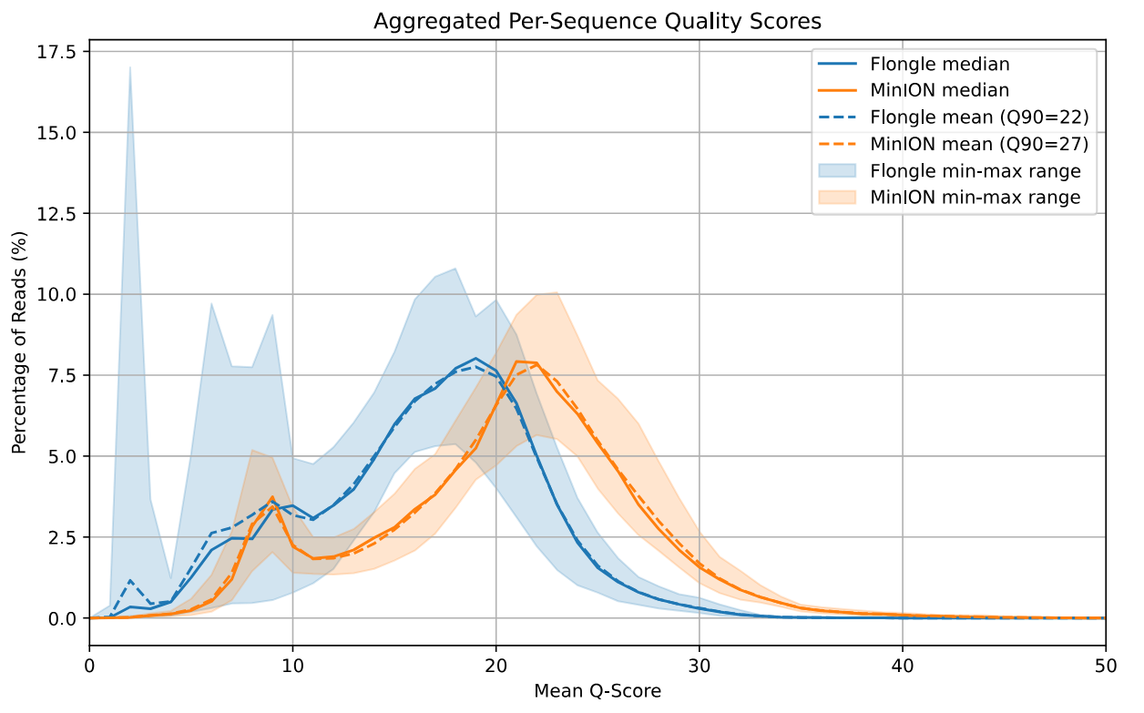
Supplementary Figure 1. Q-scores for all sequencing runs on ONT, excluding failed runs. Flongle runs (n=21) Q-scores in blue, MinION runs (n=8) in orange. Quality exhibits larger variation between Flongle runs and is more stable between MinION runs, which in general has greater mean median Q-score (21.4) than Flongle (17.5).

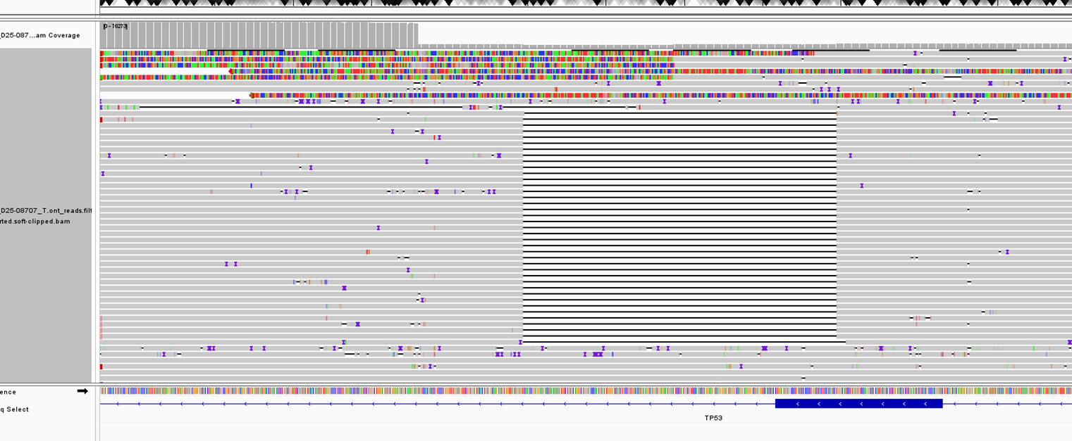
Supplementary figure 2. IGV-snapshot showcasing the variant NM_000546.6:c.1062_1100+161del in patient UU_LRS32 that was manually curated.
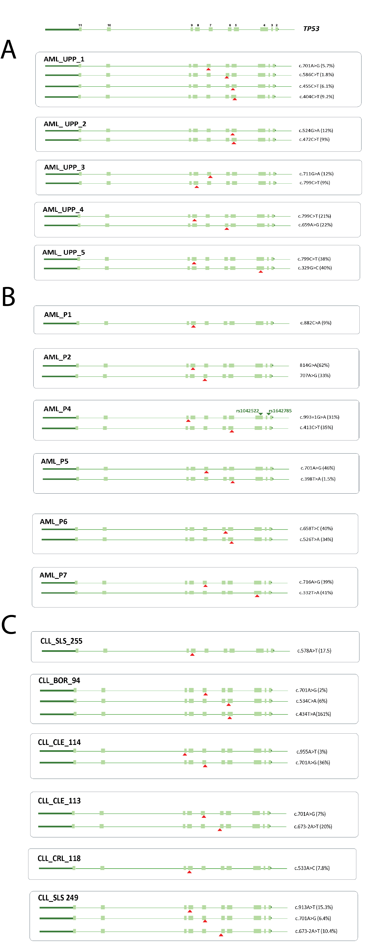
Supplementary figure 3. Summary of TP53 variants phasing in AML (A and B) and CLL (C) Patients. Each somatic TP53 variant is shown as a red triangle. Variant ID and VAF issued from the Nanopore analysis are shown in the right part of the figure.

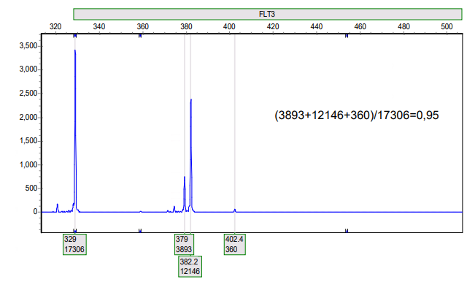
Supplementary Figure 4. FLT3-ITD PCR capillary electrophoresis analysis of patient UU_SOC14 with clinically reported allele ratio of 0.95. Three separate ITDs were detected. The ITD with a peak at 379 was not detected by the LRS panel.

References
1. Oxford Nanopore Technologies. Dorado: Oxford Nanopore's Basecaller. v1.1.1. ed.
2. Wick R. Filtlong: quality filtering tool for long reads v0.2.1 ed.
3. Vorderman RHP. Sequali: efficient and comprehensive quality control of short- and long-read sequencing data. Bioinform Adv. 2025;5(1):vbaf010.
4. Pedersen BS, Quinlan AR. Mosdepth: quick coverage calculation for genomes and exomes. Bioinformatics. 2018;34(5):867–8.
5. Institute B. Picard Toolkit. v2.25.4 ed2019.
6. Ewels P, Magnusson M, Lundin S, Kaller M. MultiQC: summarize analysis results for multiple tools and samples in a single report. Bioinformatics. 2016;32(19):3047–8.
7. Chen L, Zheng Z, Su J, Yu X, Wong AOK, Zhang J, et al. ClairS-TO: a deep-learning method for long-read tumor-only somatic small variant calling. Nat Commun. 2025;16(1):9630.
8. Lai Z, Markovets A, Ahdesmaki M, Chapman B, Hofmann O, McEwen R, et al. VarDict: a novel and versatile variant caller for next-generation sequencing in cancer research. Nucleic Acids Res. 2016;44(11):e108.
9. Park J, Cook DE, Chang PC, Kolesnikov A, Brambrink L, Mier JC, et al. DeepSomatic: Accurate somatic small variant discovery for multiple sequencing technologies. bioRxiv. 2024.
10. Smolka M, Paulin LF, Grochowski CM, Horner DW, Mahmoud M, Behera S, et al. Detection of mosaic and population-level structural variants with Sniffles2. Nat Biotechnol. 2024;42(10):1571–80.
11. Dudley JN, Hong CS, Hawari MA, Shwetar J, Sapp JC, Lack J, et al. Low-level variant calling for non-matched samples using a position-based and nucleotide-specific approach. BMC Bioinformatics. 2021;22(1):181.

PROTOCOL:

Kits and reagents
- Platinum™ SuperFi II Green PCR Master Mix (2X) (Invitrogen™, 12369050)
- Primers, Integrated DNA Technologies (Supplementary table 1)
- Ampure XP beads for DNA clean up (Beckman Coulter, A63881)
- Native barcoding kit 24 V14 (Oxford Nanopore Technologies, SQK-NBD114.24)
- Native Barcoding Auxiliary Kit V14 (Oxford Nanopore Technologies, EXP-NBA114)
- Ligation Sequencing Kit V14 (Oxford Nanopore Technologies, SQK-LSK114)
- Flowcell priming kit (Oxford Nanopore Technologies, EXP-FLP004)
- Flowcell wash kit (Oxford Nanopore Technologies, EXP-WSH004)
- Flongle Sequencing Expansion (Oxford Nanopore Technologies, EXP-FSE002)
- Qubit 1X dsDNA - high sensitivity (Q33231)
- Qubit 1X dsDNA -broad range (Q33266)
- NEB Blunt/TA Ligase Master Mix (M0367)
- NEBNext Ultra II End repair/dA-tailing Module (E7546)
- NEBNext Quick Ligation Module (E6056)
- UltraPure™ BSA 50 mg/ml, (Invitrogen™, AM2616) when using MinION Flow Cells

Consumables
- Flongle Flowcells (Oxford Nanopore Technologies, FLO-FLG114)
- MinION Flowcells (Oxford Nanopore Technologies, FLO-MIN114)
- 0.2 ml PCR tubes
- 1.5 ml tubes
- Qubit™ Assay Tubes (ThermoFisher scientific, Q32856)
- Nuclease free water
- Ethanol 100%
- Filtered sterile pipette tips, 1-1000 μl

Equipment
- Pipettes 0.5 – 1000 μl
- Rotator mixer
- Thermomixer C (Eppendorf) or similar heatblock for incubations
- Micro benchtop centrifuge
- Vortex mixer
- Thermocycler, C1000 (Biorad)
- PromethION 2 Solo (Oxford Nanopore Technologies)
- Computer workstation according to recommendations from Oxford Nanopore Technologies (We used a Dell Precision 5860 Tower, with 24 cores, intel Xeon W7-2595X and a NVIDIA A6000 GPU)
- Qubit 3.0 fluorometer (ThermoFisher scientific)
- Tapestation 4200 (Agilent)

DNA quantification
According to the manufacturer’s instructions:
- Mix 199 μl Qubit 1X dsDNA (Broad range or High Sensitivity) Working Solution with 1 μl extracted DNA in a Qubit Assay Tube by vortexing.
- Incubate for 2 minutes and measure DNA concentration using the Qubit fluorometer.

Primer mixes
Resuspend stock IDT primers in TE buffer (10 mM Tris pH 8.0, 0.1 mM EDTA). Create multiplex primer mixes with a final concentration of 10 μM according to Supplementary table 1, using nuclease free water.

Multiplex PCR
- Set up PCR reactions according to the following (3 reactions/sample – one for each primer mix):
Component | Final concentration | 50-μL rxn
2X Platinum™ SuperFi™ II  PCR Master Mix | 1X | 25 μL
Multiplex Forward & Reverse primer pool (10 μM) 1,2, or 3 | 2 μM | 10 μL
Template DNA | 100 ng Genomic DNA | Up to 15 μL (adjust with nfH20)
Nuclease free water | - | To 50 μL

- Mix reactions thoroughly by pipetting and centrifuge briefly.

- Set up the following program on a Thermocycler (we used a BioRad C1000):
 | PCR Program
Temperature | Time | Cycles
98℃ | 3 min
98℃ | 10 sec
60℃ | 15 sec | 25 cycles
72℃ | 2 min
72℃ | 5 min
4℃ | forever

Pool the 3 pools of amplicons equimolarly per sample and concentrate using Ampure XP beads:
1. Equilibrate AMPure XP beads to room temperature for at least 30 minutes.
2. Vortex beads thoroughly until homogeneous.
3. Add 1× volume AMPure XP beads to Amplicon pool.
4. Mix thoroughly and incubate at room temperature for 5 minutes.
5. Place tubes on magnetic rack for 5 minutes or until solution clears.
6. Remove and discard supernatant.
7. Wash beads twice with 80% ethanol while on magnet.
8. Remove residual ethanol using a 10 µl pipette tip.
9. Air dry beads for 30 seconds to 1 minute, avoid over-drying.
10. Remove tubes from magnet and add 14 ul nuclease-free water to the sample for elution. Resuspend beads.
11. Incubate 2 minutes at room temperature.
12. Place on magnet and transfer eluate to clean tube.
Measure DNA concentration according to the Qubit protocol, continue to library prep if molarity exceeds 150 fmol.
To ensure fragments of the right size have been amplified a D5000 analysis on the Tape Station 4200 can be made.

Library preparation
For single samples on the Flongle flowcell or single-uses of the MinION flowcell the SQK-LSK114 kit was used according to protocol version ACDE_9163_v114_revR_29Jun2022, with the following modifications:
- DNA control sample was excluded.

For multiplex runs or for reuse of the MinION flowcell the SQK-NBD114.24 kit was used according to protocol version NBA_9168_v114_revR_30Jan2025, with the following modifications:
- DNA control sample was excluded.
- Elution after ligations were done at 37°C on a thermomixer at 400 rpm.
- Elution volume after End Prep bead clean-up was 9 µl.
- Elution volume after Barcoding bead clean-up was 31 µl.
After sequencing, MinION flowcells can be washed using the EXP-WSH004 and stored at 4°C for reuse. We managed to reliably use single flowcells 5 times during the period of a month, but even more is possible.

Sequencing parameters:
Run limit:72 hrs
Basecalling: Super-accurate basecalling 400 bps
Modified basecalling: Off
Trim barcodes: Off
Barcode both ends: Off
Alignment reference: GRCh38_no_alt_analysis_set.fasta (optional)
FASTQ data output: One file every 10 minutes
POD5 data output: One file per hour, or 500000000 bases per batch
BAM file output: On
BAM data output: One file every 10 minutes

