Supplementary Figure S1. LASSO feature selection
A. Ten-fold cross-validation curve
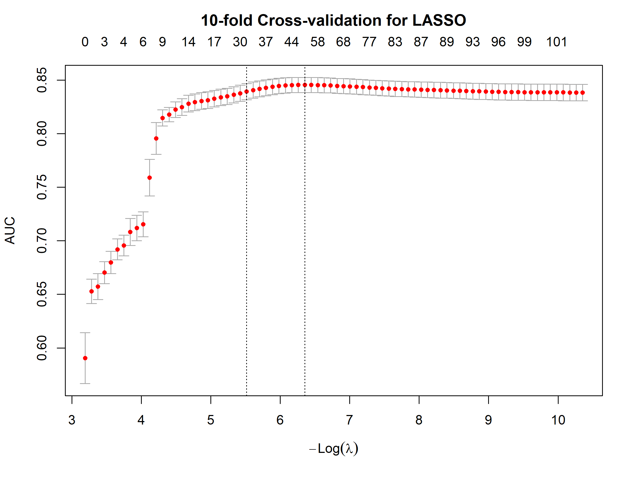
B. LASSO coefficient path plot
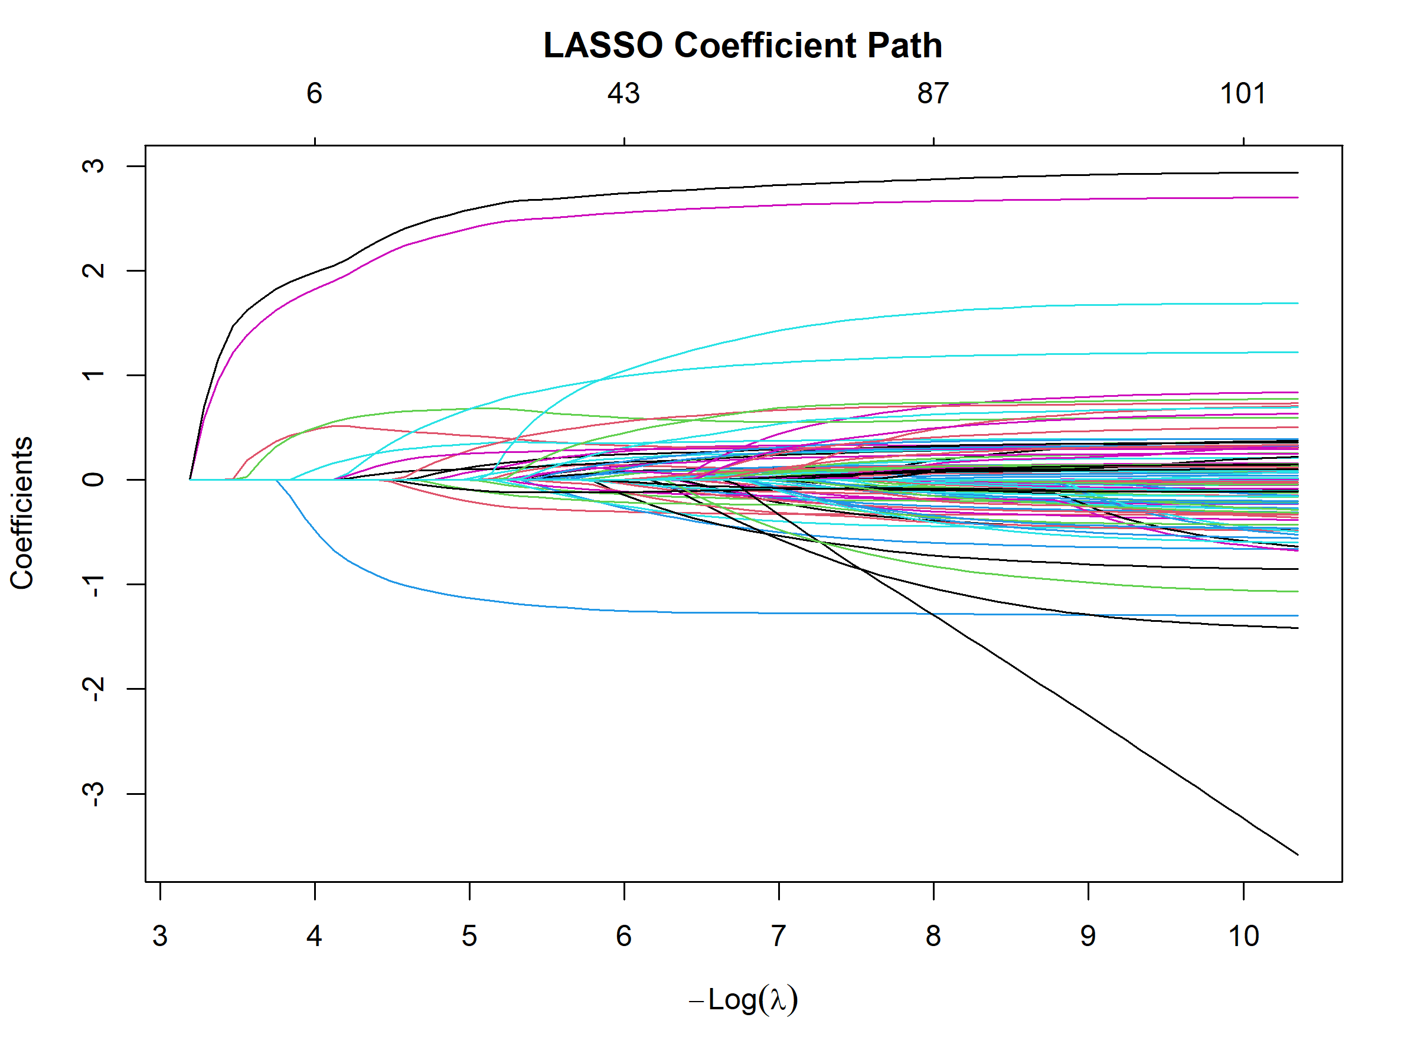

Supplementary Table S2. Non-zero coefficients retained using the λ1se criterion
Predictor level | LASSO coefficient
Recent Child Anxiety: level 4 | 2.6845
Recent Child Anxiety: level 3 | 2.5024
Family History of Suicide: no evident abnormality | -1.2101
Recent Child Anxiety: level 2 | 0.8708
Caregiver Education Level: level 4 | 0.6859
Somatization: abnormal | 0.6416
Age Group: 15–18 years | 0.4588
Mood Disorders: abnormal | 0.3654
Social issues: abnormal | 0.3551
Weekday Sleep Duration: normal | -0.2820
Family Conflict: moderate | 0.2778
Parental Anxiety: severe anxiety | 0.2389
Bladder Bowel Dysfunction: present | 0.2029
ODD: abnormal | 0.2020
Family Cohesion: high | -0.1738
Daytime sleepiness: abnormal | 0.1433
Neurotic behavior (N): abnormal | 0.1353
Night Awakening: abnormal | 0.1201
Parental Anxiety: normal | -0.1185
Age Group: 5–9 years | -0.1154
Family Conflict: high | 0.1117
Weekend Sleep Duration: normal | -0.0904
Age Group: 5–8 years | -0.0823
Age Group: 9–14 years | 0.0675
Gestational Age: level 2 | 0.0674
Birth Weight: level 4 | -0.0583
Daily Secondhand Smoke Exposure: level 2 | 0.0558
Parental Marital Status: level 3 | 0.0462
Sleep maintenance: abnormal | 0.0279
Gestational Age: level 4 | -0.0157
Sleep-Disordered Breathing: abnormal | 0.0103

