Supplementary Exhibit S2: Green Channel Episode — Documentary Evidence Summary
Putian University Affiliated Hospital, September 2021
Supporting manuscript: “Administrative Primacy as an Interpretive Framework…” | Author: Dingnan Cai | Target: BMC Health Services Research

Overview
This supplementary exhibit provides the documentary evidence summary for the Green Channel administrative exception episode described in the main manuscript (Domain 3). In accordance with research ethics best practice, this exhibit presents: (1) a documentary timeline summarising the institutional sequence of events derived from publicly available sources; (2) a document summary table describing key information from relevant institutional records, together with redacted reproductions of the three underlying documents that contain personal data (direct identifiers masked prior to inclusion); and (3) an unaltered reproduction of the radiology department staff scheduling table, which contains no patient personal data.
All information analysed in this exhibit is derived from materials that entered the public domain through official media reporting, judicial proceedings, or subsequent public dissemination. No direct access to hospital information systems, confidential archives, or patient medical records was used in the preparation of this exhibit. References correspond to the main manuscript reference list. The four documents are:
Table S2-1. Overview of documents referenced in this exhibit.
Exhibit | Document Type | Date | Evidentiary Function
S2-A | Green Channel examination request form (检查申请单) | 13 September 2021 | Establishes that the Green Channel exception was formally authorised, permitting the subject to access hospital facilities and undergo CT examination while the nucleic acid test result was pending
S2-B | PCR nucleic acid test positive report (核酸检测阳性报告) | Ordered: 12 Sep 2021 Sampled: 13 Sep 2021 Reported: 14 Sep 2021 | Confirms SARS-CoV-2 positivity of the same individual; establishes the temporal gap between hospital access (13 Sep) and result confirmation (14 Sep)
S2-C | Hospital Information System screenshot (医院信息系统截屏) | 13 September 2021 | Internal hospital system record of the same patient encounter; corroborates the examination request form and documents the institutional classification of the visit as emergency (急诊)
S2-D | Radiology department staff scheduling table (影像科排班表) | 14–19 September 2021 | Contemporaneous institutional document showing multiple staff positions marked for quarantine/isolation (隔) beginning 14 September 2021 — the day following result confirmation — documenting the staff isolation cascade that resulted from the Green Channel decision
Document provenance statement：The records summarised in Exhibits S2-A to S2-C were not obtained through direct access to hospital information systems, confidential institutional archives, or patient medical records. These materials had previously entered the public domain through public reporting, judicial proceedings, and subsequent public dissemination. Because the underlying records contain personal medical information, direct identifiers (patient name, national ID number, telephone number) have been redacted prior to reproduction; no unredacted document image appears anywhere in this exhibit. De-identified images are reproduced in Section 3, alongside the factual information necessary to reconstruct the institutional sequence of events.

Section 1: Documentary Timeline of the Green Channel Episode
The following timeline is reconstructed from publicly available official media reporting. Each event is attributed to its source.

Table S2-2. Documentary timeline of the Green Channel episode.
Date / Time | Event | Evidentiary Basis | Source
12 Sep 2021 17:48 | Nucleic acid (NAT) test ordered/requested for subject individual at Putian University Affiliated Hospital | Application timestamp recorded on laboratory report | Public reporting [28]
13 Sep 2021 22:00 | Nucleic acid (NAT) sample collected from subject individual at Putian University Affiliated Hospital | Sample collection timestamp recorded on laboratory report; subject subsequently confirmed as SARS-CoV-2 positive | Public reporting [28]
13 Sep 2021 | Subject accesses hospital and undergoes chest CT examination under ‘Green Channel’ (绿色通道) administrative exception while NAT result remains pending | Examination request form and hospital information system record described in public media reporting; Green Channel annotation documented | Public reporting [21, 28]
13 Sep 2021 23:00 | Specimen received by hospital laboratory | Specimen receipt timestamp documented in public reporting | Public reporting [28]
14 Sep 2021 22:28 | NAT result (positive) reported and reviewed by supervising physician | Report timestamp documented in public reporting; 23.5 hour gap between specimen receipt and report noted | Public reporting [28]
14 Sep 2021 onward | More than 200 physicians at the hospital classified as close contacts; mandatory isolation initiated; hospital clinical operations including ICU suspended | Documented in Health Affairs (健康界) public reporting | Health Affairs [28]
14–19 Sep 2021 | Radiology department staff scheduling table shows multiple positions marked ‘隔’ (isolation/quarantine) beginning 14 September 2021 | Contemporaneous institutional scheduling document; reproduced in Section 3 of this exhibit | Institutional record [28]
7 Oct 2021 | Official lockdown lifted; outbreak declared contained | NHC official communication | NHC [8]
Post-7 Oct 2021 | ICU restoration timeline: standard terminal disinfection for tertiary ICU requires 14–21 days post-clearance; full restoration timeline not publicly documented | Standard clinical protocol; primary records required for verification | Standard protocol; primary records unavailable

Note: The timeline is reconstructed from publicly reported documentary sources and is presented to summarize the sequence of events relevant to Domain 3 of the main manuscript.

Section 2: Document Summary Table
The following table (Table S2-3) summarizes key records relevant to the Green Channel episode. Because the underlying records contain personal medical information, direct identifiers have been redacted prior to reproduction. Factual information necessary for the reconstruction of the institutional sequence of events is summarized. Documents S2-A through S2-C contain personal data; direct identifiers have been redacted prior to reproduction. Document S2-D (scheduling table) contains no patient personal data and is reproduced in Section 3.
Table S2-3. Document summary and reproduction status of institutional records referenced in this exhibit.
Ref | Document Type | Date | Key Information Documented | Public Source | Reproduction Status
S2-A | Publicly reported examination request record (检查申请单摘要) Putian University Affiliated Hospital | 13 Sep 2021 | Green Channel authorisation annotation; examination requested: chest CT multi-planar reconstruction (plain scan); requesting department: New District Emergency Department; clinical diagnosis: fever; acute pharyngolaryngitis | Fujian Health News [21]; Health Affairs [28] | Redacted reproduction in Section 3: patient name and telephone number masked prior to inclusion; other fields unaltered.
S2-B | Publicly reported laboratory record (核酸检测记录摘要) Putian University Affiliated Hospital | Sampled: 12 Sep 2021 Issued: 13 Sep 2021 23:00 Reviewed: 14 Sep 2021 22:28 | Test method: PCR fluorescent probe; specimen: nasopharyngeal swab; result: positive (+); collection-to-report interval: approximately 24.5 hours (order-to-report interval: approximately 53 hours) | Public reporting [28] | Redacted reproduction in Section 3: patient name, national ID number, and telephone number masked prior to inclusion; result and timestamps unaltered.
S2-C | Publicly reported Hospital Information System record summary (医院信息系统记录摘要) Internal record | 13 Sep 2021 | Application number: 61449599; patient classification: emergency (急诊); requesting department: New District Emergency Department; examination: chest CT multi-planar reconstruction; consistent with S2-A across all key fields | Fujian Health News [21] | Redacted reproduction in Section 3: patient name masked prior to inclusion; other fields, including application number, unaltered and cross-validate S2-A.
S2-D | Radiology department staff scheduling table (影像科工作人员排班表) | 14–19 Sep 2021 | Multiple staff positions marked ‘隔’ (isolation) from 14 September 2021; department-wide isolation pattern consistent with close-contact quarantine protocol following case confirmation | Institutional record circulated in official media [28] | REPRODUCED in Section 3 of this exhibit. Contains no patient personal data; no redaction required.

Cross-validation note: The application number (61449599) documented in S2-A (examination request form) and S2-C (hospital information system record) is identical across both documents, confirming that they record the same institutional encounter and that the Green Channel exception was formally processed through standard hospital administrative channels rather than being an informal access event.

Exhibit S2-A: Green Channel Examination Request Form

Figure S2-A

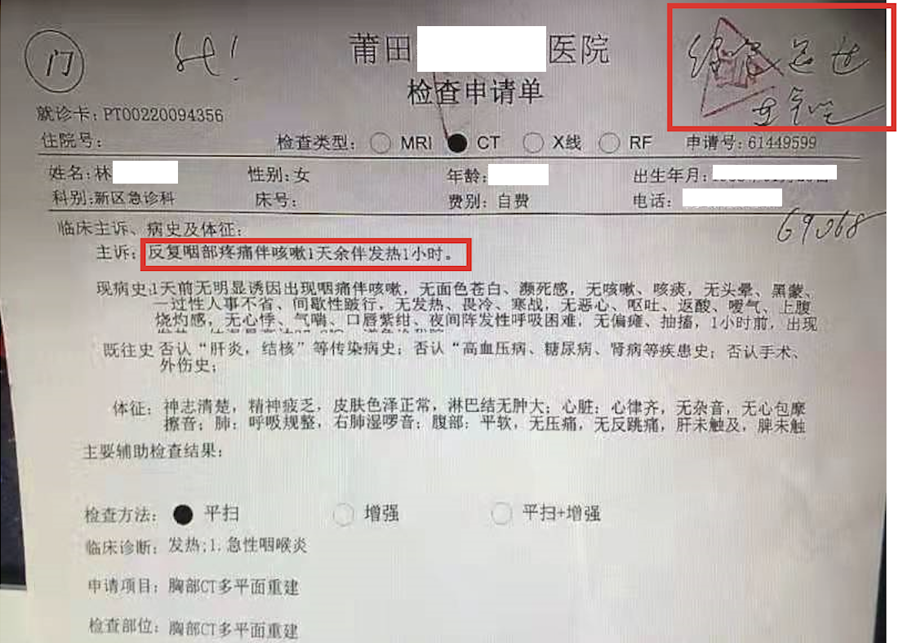
Figure S2-A caption: Medical examination request form (检查申请单), Putian University Affiliated Hospital, 13 September 2021. This is an unaltered photograph of the original document except that the patient name, date of birth, and telephone number have been redacted (white-boxed) prior to inclusion; all other fields, including the handwritten Green Channel (绿色通道) annotation in the upper right corner and the recorded chief complaint, are reproduced exactly as they appear in the source document. A full field-by-field English translation is provided in Table S2-4 below. Source: Fujian Health News [21]; Health Affairs [28].

Document Identification
Table S2-4. Field-by-field document identification for Exhibit S2-A (Green Channel examination request form).
Field | Value
Document type | Medical examination request form (检查申请单)
Issuing institution | Putian University Affiliated Hospital (莆田学院附属医院)
Date of issue | 13 September 2021
Examination requested | Chest CT multi-planar reconstruction (胸部CT多平面重建)
Scan method | Plain scan (平扫)
Requesting department | New District Emergency Department (新区急诊科)
Clinical diagnosis recorded | Fever; acute pharyngolaryngitis (发热；急性咽喉炎)
Green Channel annotation | Handwritten approval notation visible in upper right corner of form, consistent with Green Channel (绿色通道) authorisation practice

Interpretive Annotation
Green Channel Protocol. The handwritten annotation in the upper right corner of the form constitutes a Green Channel authorisation. The Green Channel (绿色通道) protocol was an administrative exception mechanism used during the outbreak to permit designated personnel to access hospital facilities without completing the full infection prevention screening and quarantine procedures required under the NHC Technical Guidelines for COVID-19 Infection Prevention in Healthcare Settings (3rd Edition, 2021). The approval of this form on 13 September 2021 permitted the subject to access the CT examination facility on that date.
Timing relative to NAT result. The examination request form is dated 13 September 2021. The NAT test had been ordered the previous day (12 September 2021, 17:48), but the nasopharyngeal swab was not actually collected until 13 September 2021 at 22:00 (see Exhibit S2-B) — the same date as the CT examination. The specimen was received by the laboratory at 23:00 that same day, and the result confirming SARS-CoV-2 positivity was not reported until 14 September 2021 at 22:28. The Green Channel exception therefore permitted hospital access on the date of, and around the time of, specimen collection, well before the result was reported and while the subject was a pending-result contact.
Clinical presentation at time of access. The clinical diagnosis recorded on the request form is ‘fever; acute pharyngolaryngitis’ — a presentation consistent with, but not specific to, COVID-19. The request for chest CT in the context of a febrile upper respiratory presentation, during an active outbreak with a pending nucleic acid result, raises the question of whether standard infection prevention triage protocols were applied before granting hospital access.

Exhibit S2-B: PCR Nucleic Acid Test Positive Report

Figure S2-B
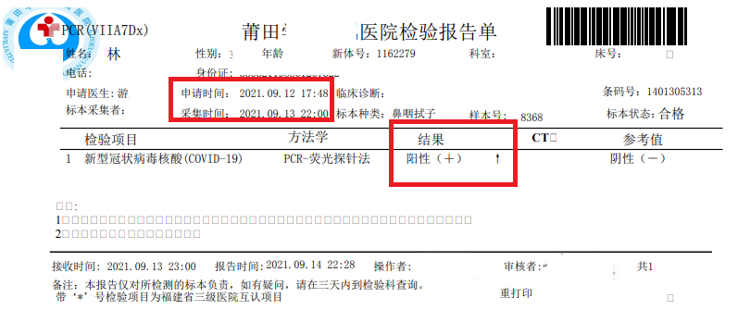
Figure S2-B caption: PCR nucleic acid test report (核酸检测报告单), Putian University Affiliated Hospital. This is an unaltered photograph of the original document except that the patient name, national ID number, and telephone number have been redacted (white-boxed) prior to inclusion; the test method, specimen type, result, and all timestamps are reproduced exactly as they appear in the source document. A full field-by-field English translation is provided in Table S2-5 below. Source: public reporting [28].

Document Identification
Table S2-5. Field-by-field document identification for Exhibit S2-B (PCR nucleic acid test report).
Field | Value
Document type | Laboratory test report (检验报告单)
Issuing institution | Putian University Affiliated Hospital (莆田学院附属医院)
Test method | PCR fluorescent probe method (PCR-荧光探针法)
Pathogen tested | Novel coronavirus nucleic acid (新型冠状病毒核酸, COVID-19)
Specimen type | Nasopharyngeal swab (鼻咽拭子)
Application (order) timestamp | 12 September 2021, 17:48
Sample collection timestamp | 13 September 2021, 22:00
Specimen receipt timestamp | 13 September 2021, 23:00
Report timestamp | 14 September 2021, 22:28
Result | Positive (+) by PCR fluorescent probe; negative (-) by CT value threshold

Interpretive Annotation
Confirmation of SARS-CoV-2 positivity. This report confirms that the subject individual tested positive for SARS-CoV-2 by PCR fluorescent probe method. The positive result on the nasopharyngeal swab specimen is the laboratory confirmation underlying the subsequent infection control response documented in Exhibits S2-D.
Critical temporal gap. The gap between sample collection (13 September, 22:00) and report (14 September, 22:28) spans approximately 24.5 hours (the NAT test had been ordered earlier, on 12 September at 17:48, but the specimen was not actually collected until 13 September). On 13 September 2021, the subject accessed the hospital under the Green Channel exception documented in Exhibit S2-A. This temporal gap is the mechanism by which the administrative exception generated the exposure event: the Green Channel authorisation was granted before the laboratory result was available to inform the decision.
Institutional responsibility. The report bears the signatures of both the issuing technician and the reviewing physician, indicating institutional processing of the result record. The 23.5 hour interval between specimen receipt (23:00, 13 September) and the report (22:28, 14 September) is noted as part of the event chronology and raises questions regarding the timeliness of institutional response during an active outbreak.

Exhibit S2-C: Hospital Information System Screenshot

Figure S2-C
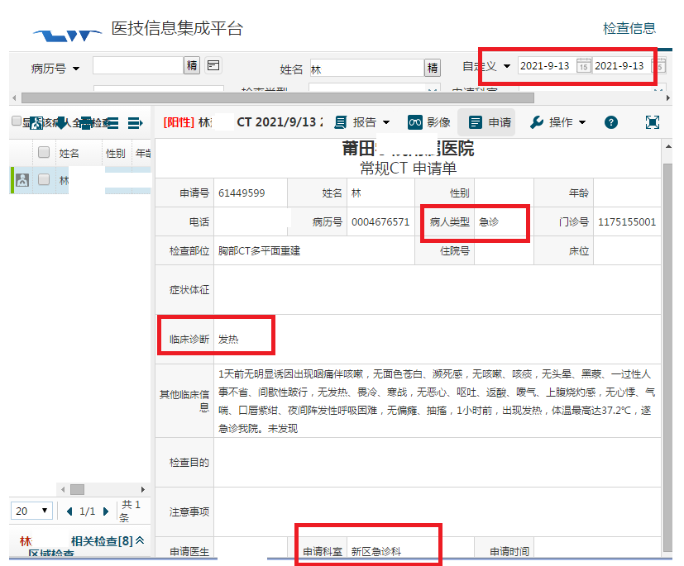
Figure S2-C caption: Hospital Information System screenshot, Medical Technology Information Integration Platform (医技信息集成平台), Putian University Affiliated Hospital, 13 September 2021. This is an unaltered screenshot of the original system record except that the patient name has been redacted (white-boxed) prior to inclusion; the application number, patient classification, requesting department, and clinical diagnosis are reproduced exactly as they appear in the source record. A full field-by-field English translation is provided in Table S2-6 below. Source: Fujian Health News [21].

Document Identification
Table S2-6. Field-by-field document identification for Exhibit S2-C (Hospital Information System screenshot).
Field | Value
Document type | Hospital Information System (HIS) internal record screenshot (医技信息集成平台截屏)
System name | Medical Technology Information Integration Platform (医技信息集成平台)
Issuing institution | Putian University Affiliated Hospital (莆田学院附属医院)
Record date | 13 September 2021
Examination requested | Chest CT multi-planar reconstruction (胸部CT平面重建)
Application number | 61449599
Patient classification | Emergency (急诊)
Requesting department | New District Emergency Department (新区急诊科)
Clinical diagnosis | Fever (发热)

Interpretive Annotation
Internal system corroboration. This screenshot from the hospital’s internal Medical Technology Information Integration Platform constitutes an independent institutional record of the same patient encounter documented in Exhibit S2-A. The matching application number (61449599), date (13 September 2021), examination type (chest CT multi-planar reconstruction), and requesting department (New District Emergency Department) confirm that the examination request form (S2-A) was processed and entered into the hospital’s information system — establishing that this was not an informal or undocumented access event, but a formally processed hospital encounter.
Emergency classification. The HIS record classifies the patient as ‘emergency’ (急诊). This classification is relevant to the Green Channel authorisation: the emergency designation may have been the administrative basis on which the Green Channel exception was approved, as the protocol was intended to facilitate access for personnel with urgent clinical needs. The classification therefore documents the administrative justification for the exception, while raising the question of whether the emergency designation was appropriate given the known epidemiological context (active outbreak, pending nucleic acid result).
Institutional record integrity. The existence of this internal HIS record, consistent with the external examination request form, indicates that the Green Channel exception and the resulting hospital access were processed through normal institutional administrative channels. This is significant because it establishes that the exception was not an informal deviation but a formally authorised and institutionally recorded administrative decision — directly relevant to the Administrative Primacy analysis in the main manuscript.

Section 3: Radiology Department Staff Scheduling Table (Exhibit S2-D)

Figure S2-D
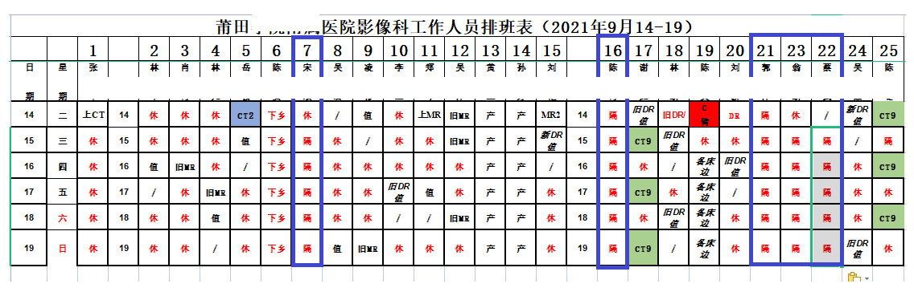
Figure S2-D caption: Radiology Department Staff Scheduling Table (影像科工作人员排班表), Putian University Affiliated Hospital, 14–19 September 2021. Multiple staff positions are marked with the character ‘隔’ (isolation/quarantine, highlighted in orange/red) beginning 14 September 2021, the day following confirmation of the COVID-19-positive case. This contemporaneous institutional document provides evidence of a staff isolation cascade temporally associated with the Green Channel episode. Source: Institutional record circulated in official media coverage of the 2021 Fujian outbreak ^{[28]}. This document contains no patient personal data.

Annotation Key for Figure S2-D
Table S2-7. Annotation key for Chinese-language terms visible in Figure S2-D.
Character | Pinyin | Full Chinese Term | English Meaning | Significance in Context
隔 (orange/red highlight) | gé | 隔离 (gélí) | Quarantine / Isolation | Staff member placed under mandatory close-contact (密接) isolation per COVID-19 protocol; begins appearing 14 Sep 2021
CT | CT | CT检查 | CT Examination Shift | Staff assigned to CT examination duties
休 | xiū | 休息 | Rest / Day Off | Scheduled day off
値 | zhí | 值班 | On-call / Duty Shift | Regular scheduled shift
旧MR | jiū MR | 旧MR室 | Old MRI Suite | Assignment to older MRI scanning unit
MR产 | MR chǎn | MR产房 | MRI Maternity Unit | Assignment to maternity MRI unit
新DR | xīn DR | 新DR室 | New DR Suite | Assignment to newer digital radiography unit
/ | N/A | N/A | Not scheduled | No shift assigned for this date

Interpretive Notes
Temporal onset. The ‘隔’ notation appears across multiple Radiology Department staff positions beginning 14 September 2021, precisely one day after the Green Channel-authorised hospital access (13 September) and the same day as the formal review of the positive NAT result (14 September, 22:28). This timing is consistent with standard Chinese COVID-19 close-contact identification and isolation protocol: once a positive case is confirmed, all individuals who shared the same space within the defined exposure window are classified as close contacts and placed under mandatory isolation.
Institutional significance. Unlike media reports, which are secondary sources, this scheduling table is a primary institutional administrative document generated by the hospital during the outbreak period itself. Its entry into the public record through official media coverage makes it a contemporaneous self-record of the institutional consequences of the Green Channel decision, with higher evidentiary weight than retrospective accounts. The document supports the main manuscript’s characterisation of Medical Resource Displacement: the staff isolation pattern it records is consistent with the broader service disruption described in public reporting ^{[28]}.
Scope limitation. This scheduling table documents the Radiology Department specifically. The broader isolation of more than 200 physicians across departments, described in public reporting ^{[28]}, cannot be confirmed from this table alone; the table provides departmental-level corroboration of the wider institutional pattern described in media accounts.

Section 4: Integrated Evidentiary Summary
The documentary evidence summarised in this exhibit supports the causal sequence described in Domain 3 of the main manuscript through the following chain:
- The examination request form (S2-A) and hospital information system record (S2-C), cross-validated by matching application number (61449599), establish that the Green Channel exception was formally authorised and institutionally processed on 13 September 2021, permitting hospital access while the subject’s NAT result was pending.
- The NAT report (S2-B) establishes that the subject was SARS-CoV-2 positive, and that the result was not available at the time of the Green Channel authorisation — creating the exposure window during which close-contact exposure within the hospital could subsequently occur.
- The radiology department scheduling table (S2-D) provides contemporaneous institutional documentation that a department-wide staff isolation cascade commenced on 14 September 2021, the day of result confirmation, consistent with the close-contact isolation protocol and with the public reporting of more than 200 physician isolations ^{[28]}.

No single document in this chain is sufficient to establish the full causal sequence independently. Together, these materials provide a contemporaneous documentary record relevant to the events described in Domain 3 of the main manuscript. The documents are presented to assist readers in evaluating the underlying documentary sources and chronology.

References (corresponding to main manuscript reference list)
8. National Health Commission of the People’s Republic of China. Daily COVID-19 outbreak situation reports: Fujian Province, September–October 2021. Available from: http://www.nhc.gov.cn/xcs/yqfkdt/list.shtml
21. Fujian Health News (福建卫生报). Children in isolation suits undergoing CT examination at Putian designated hospital [in Chinese]. Published September 2021. Available from: https://health.fjsen.com/
28. Health Affairs (健康界). Putian frontline report: hospital infection control escalation and temporary service suspension [in Chinese]. Published September 2021. Available from: https://www.cn-healthcare.com/article/20210915/content-560168.html

