Effect of growing season, Trichoderma and clinoptilolite applications on the potentially toxic elements (PTEs) uptake by Cucumis melo L.
Matteo Brecchia, Enrico Buscaroli*, Martina Mazzon, Sonia Blasioli, Ilaria Braschi
Department of Agricultural and Food Sciences - University of Bologna, viale Giuseppe Fanin 40 – 40127 Bologna
Corresponding author: enrico.buscaroli@unibo.it; ORCID: 0000-0002-8414-0814
SUPPORTING INFORMATION

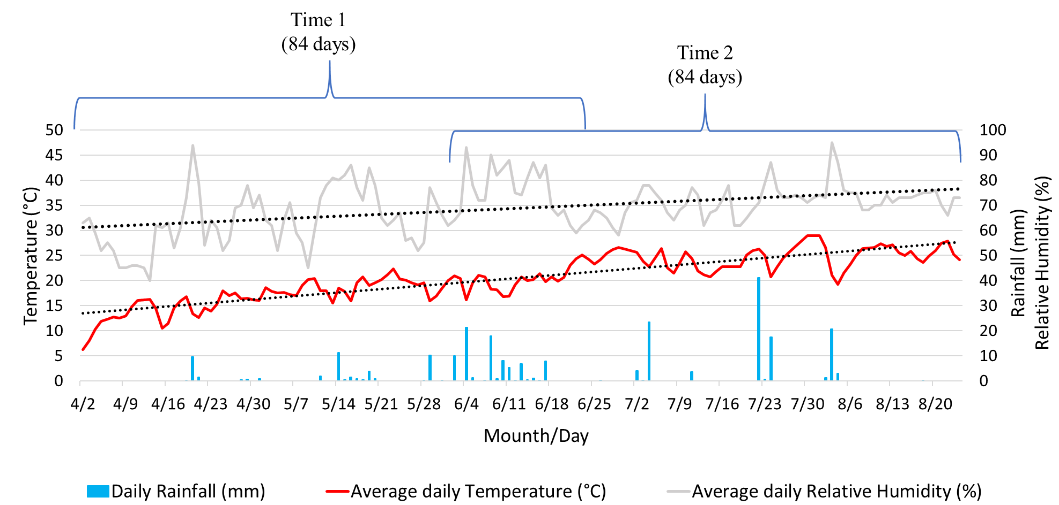
Figure SI1. Graph of average temperature, average relative humidity, and daily rainfall from April 2 to August 24, 2020. The duration of the two growing periods (Time 1 and 2) is indicated.

Table SI1. Fertilizers, pesticides, and products used for treatments.
Trade name |  | Dosage
Trade name |  | (kg or L ha⁻¹)
Fertilizers | Composition | Time 1 | Time 2
Lieta Veg, Agriges | N = 2.5% | 20 | 70
Examine L®, K&A | N = 3% | 80 | 100
New Ferstim Idro, Scam | NPK = 6-12-0 | 24 | -
Idrocomplex New Blu, Scam | NPK = 20-20-20 | 20 | 20
Pesticides | Active ingredients
Volare® Bayer | fluopicolide + propamocarb (62.5 + 625 g L⁻¹) | 3.2 | 3.2
Presidium One®, Gowan Italia | zoxamide + dimethomorph (180 + 180 g L⁻¹) | 6 | 6
Zoxium® 240 SC, Gowan Italia | zoxamide (240 g L⁻¹) | 3 | 3
Poltiglia Disperss®, UPL Italia | copper sulfate (Cu = 20%) | 42 | 42
Thiopron®, UPL Italia | sulfur (825 g L⁻¹) | 40 | 0
Products used for treatments | Composition
Tusal® (Liquid for fertigation) | Thricoderma atroviride T11 + T. asperellum T25 (0.5+ 0.5%) | 1 | 1
Clinogold, BHYP®  (pellet - soil conditioner) | Clinoptilolite (95%) | 150 | 150
Clinogold, BHYP®  (powder for fertigation) | Clinoptilolite (95%) | 10 | 10
Rock powder, Midori®  (powder for foliar action) | Clinoptilolite (83-94%) | 8 | 8

Table SI2. Physical and chemical characterization of 0-30 cm topsoil samples. In brackets, DTPA extractable metal content expressed as a percentage of the total amount. Errors are expressed as a standard deviation.
Parameter | Soil samples
 | 1 | 2 | 3 | 4 | Average
pH H₂O | 8.80 ± 0.01 | 8.80 ± 0.01 | 8.80 ± 0.01 | 8.80 ± 0.01 | 8.80 ± 0.01
pH CaCl₂ | 7.90 ± 0.01 | 8.00 ± 0.01 | 8.10 ± 0.01 | 8.10 ± 0.01 | 8.00 ± 0.01
EC (ds m⁻¹) | 0.151 ± 0.004 | 0.143 ± 0.003 | 0.145 ± 0.006 | 0.154 ± 0.001 | 0.148 ± 0.002
TOC (%) | 1.329 ± 0.008 | 1.429 ± 0.029 | 1.412 ± 0.117 | 1.535 ± 0.019 | 1.426 ± 0.018
TN (%) | 0.193 ± 0.003 | 0.210 ± 0.008 | 0.205 ± 0.003 | 0.226 ± 0.004 | 0.229 ± 0.005
Carbonates (%) | 7.952 ± 0.420 | 7.251 ± 1.055 | 8.210 ± 1.087 | 7.798 ± 0.776 | 7.803 ± 0.834
Textural class (USDA) | Silty Clay Loam | Silty Clay Loam | Silty Clay Loam | Silty Clay Loam
Metal (mg kg⁻¹) |  |  |  |  |  | Italian threshold concentration in soils*
Cr | 208.2 ± 2.9 | 212.1 ± 2.7 | 197.0 ± 4.2 | 205.6 ± 2.0 | 205.0 ± 2.9 | 150
Cr | (0.01%) | (0.01%) | (0.01%) | (0.01%) | (0.01%) | 150
Cu | 114.1 ± 1.4 | 91.3 ± 0.5 | 99.2 ± 3.9 | 72.4 ± 0.8 | 87.6 ± 1.8 | 100
Cu | (11.84%) | (10.20%) | (12.25%) | (10.05%) | (11.08%) | 100
Pb | 33.8 ± 4.6 | 33.4 ± 6.2 | 35.4 ± 1.8 | 36.1 ± 0.8 | 35.0 ± 3.0 | 200
Pb | (6.88%) | (7.93%) | (7.48%) | (7.73%) | (7.51%) | 200
*D.Lgs. Nº46 01/03/2019

Table SI3. Physical and chemical characterization of irrigation water. Error expressed as a standard deviation. In bracket the analytical method Detection Limit (DL) value of the analytical method.
Parameter |  | Water samples
Parameter | Sampling date | 15/04/2020 | 15/05/2020 | 15/06/2020 | 15/07/2020 | 15/08/2020
pH |  | 9.5 ± 0.1 | 8.0 ± 0.1 | 8.2 ± 0.1 | 8.4 ± 0.1 | 8.2 ± 0.1
EC (dS m⁻¹) |  | 0.479 ± 0.040 | 0.286 ± 0.008 | 0.279 ± 0.007 | 0.271 ± 0.010 | 0.258 ± 0.005
Suspended solids (mg L⁻¹) |  | 81 ± 1.0 | 83 ± 1.0 | 83 ± 1.0 | 93 ± 1.0 | 90 ± 1.0
Cr (mg L⁻¹) | Filtered water | < DL (0.001) | < DL (0.001) | < DL (0.001) | < DL (0.001) | < DL (0.001)
Cr (mg L⁻¹) | Suspended solids | 0.012 ± 0.015 | 0.049 ± 0.001 | 0.049 ± 0.001 | 0.030 ± 0.001 | 0.034 ± 0.001
Cr (mg L⁻¹) | Total | 0.012 | 0.049 | 0.049 | 0.03 | 0.034
Cu (mg L⁻¹) | Filtered water | 0.006 ± 0.001 | 0.003 ± 0.001 | 0.003 ± 0.001 | 0.016 ± 0.001 | 0.016 ± 0.001
Cu (mg L⁻¹) | Suspended solids | 0.008 ± 0.001 | 0.024 ± 0.001 | 0.024 ± 0.001 | 0.010 ± 0.001 | 0.010 ± 0.001
Cu (mg L⁻¹) | Total | 0.014 | 0.027 | 0.027 | 0.026 | 0.026
Pb (mg L⁻¹) | Filtered water | < DL (0.003) | < DL (0.003) | < DL (0.003) | < DL (0.003) | < DL (0.003)
Pb (mg L⁻¹) | Suspended solids | 0.003 ± 0.001 | 0.010 ± 0.001 | 0.010 ± 0.001 | 0.010 ± 0.001 | 0.016 ± 0.001
Pb (mg L⁻¹) | Total | 0.003 | 0.010 | 0.010 | 0.010 | 0.016
Ca (mg L⁻¹) | Filtered water | 12.72 ± 0,290 | 35.69 ± 0.17 | 35.69 ± 0.17 | 17.35 ± 0.001 | 16.19 ± 0.406
Ca (mg L⁻¹) | Suspended solids | 17.72 ± 1.000 | 18.79 ± 1.000 | 18.79 ± 1.000 | 31.10 ± 1.000 | 32.43 ± 1.000
Ca (mg L⁻¹) | Total | 30.44 | 54.48 | 54.48 | 48.45 | 48.62
Si (mg L⁻¹) | Filtered water | 0.156 ± 0.010 | 0.643 ± 0.010 | 0.643 ± 0.010 | <DL (0.001) | <DL (0.001)
Si (mg L⁻¹) | Suspended solids | 0.471 ± 0.001 | 0.524 ± 0.001 | 0.524 ± 0.001 | 0.491 ± 0.001 | 0.481 ± 0.001
Si (mg L⁻¹) | Total | 0.627 | 1.167 | 1.167 | 0.491 | 0.481

Table SI4 Total metal content (mg kg⁻¹) of fertilizers, pesticides and tested products used during both growing seasons. Errors are expressed as a standard deviation. In brackets, bioavailable-to-plant metal content expressed as a percentage of the total content. DL: Detection Limit
Fertilizers | Metal
Fertilizers | Cr | Cu | Pb | Ca | Si
Lieta Veg | 1.180 ± 0.271 (64.41%) | 4.904 ± 1.263 (38.15%) | <DL | 425.5 ± 32.45  n.a. | 2.448 ±0.052  n.a.
Examine L | 1.470 ± 0.111 (67.81%) | 2.079 ± 0.000 (10.08%) | 0.510 ± 0.053 (0.00%) | 8545 ± 361.2  n.a. | 17.74 ±0.122  n.a.
New Ferstim Idro | 1.769 ± 0.266 (40.58%) | 0.295 ± 0.107 (0.00%) | <DL | 472.2 ± 20.53  n.a. | 34.61 ± 1.660  n.a.
Idrocomplex New Blu | 1.851 ± 0.012 (92.83%) | <DL | <DL | 123.0 ± 19.85  n.a. | 36.60 ± 0.212  n.a.
Pesticides
Presidium One | 5.45 ± 1.887 (2.31%) | 2.639 ± 0.763 (48.16%) | <DL | 314.7 ± 98.67  n.a. | 10750 ± 2.3000  n.a.
Volare | 0.474 ± 0.002 (19.31%) | 1.428 ± 0.084 (48.16%) | <DL | 262.8 ± 86.82  n.a. | 8351 ± 34.70  n.a.
Zoxium | 7.57 ± 0.422 (0.86%) | 1.343 ± 0.361 (100.0%) | <DL | 2212 ± 128.2  n.a. | 11433 ± 203.2  n.a.
Thiopron | 0.427 ± 0.142 (0.00%) | 4.996 ± 1.597 (4.00%) | <DL | 409.1 ± 2.183  n.a. | 12966 ± 800.4  n.a.
Poltiglia Disperss | 9.33 ± 0.216 (2.39%) | 19099 ± 19.30 (38.66%) | 4.283 ± 1.110 (0.00%) | 74722 ± 943.3  n.a. | 1424 ± 660.4  n.a.
Clinoptilolites
Clinogold (pellet) | 6.879 ± 0.248 (1.72%) | 3.846 ± 1.181 (1.76%) | 38.62 ± 1.578 (0.00%) | 1990 ± 68.05  n.a. | 31557 ± 825.8  n.a.
Clinogold (fertigation) | 10.12 ± 0.432 (0.00%) | 8.350 ± 1.209 (3.95%) | 20.65 ± 1.520 (16.7%) | 1877 ± 8.143  n.a. | 30968 ± 965.0  n.a.
Rock Powder (foliar action) | 13.76 ± 0.000 (0.00%) | 10.29 ± 0.000 (14.3%) | 30.92 ± 1.050 (13.0%) | 1825 ± 180.0  n.a. | 31363 ± 762.6  n.a.
Tusal | 4.318 ± 0.374 (0.00%) | 7.603 ± 0.873 (19.93%) | 47.62 ± 0.429 (0.00%) | 843.6 ± 1.810  n.a. | 1054 ± 67.71  n.a.
DL | 0.001 | 0.001 | 0.010 | 0.010 | 0.030
n.a.: not available (no official procedure to assess the potentially bioavailable-to-plant fraction is suitable).

Table SI5. Volume (m³) of irrigation water monthly used for each field portion corresponding to each treatment (0.1 ha dimension).
Time 1
April 2-30 | May 1-30 | June 1-25
12.8 | 13.6 | 12.0
Time 2
 |  | June 1-30 |  | July 1-31 | August 1-24
 |  | 18.7 |  | 14.5 | 10.2

