Appendix D.
Fig. D.1. Predicted Cumulative Incidence by Outcome at the Mean of the Predictors Selected with the Individual Outcome Method in the Case-study Data using simulations (lighter color) of Scenario 2 with Case-study Levels of Censoring (darker color: mean of simulations)
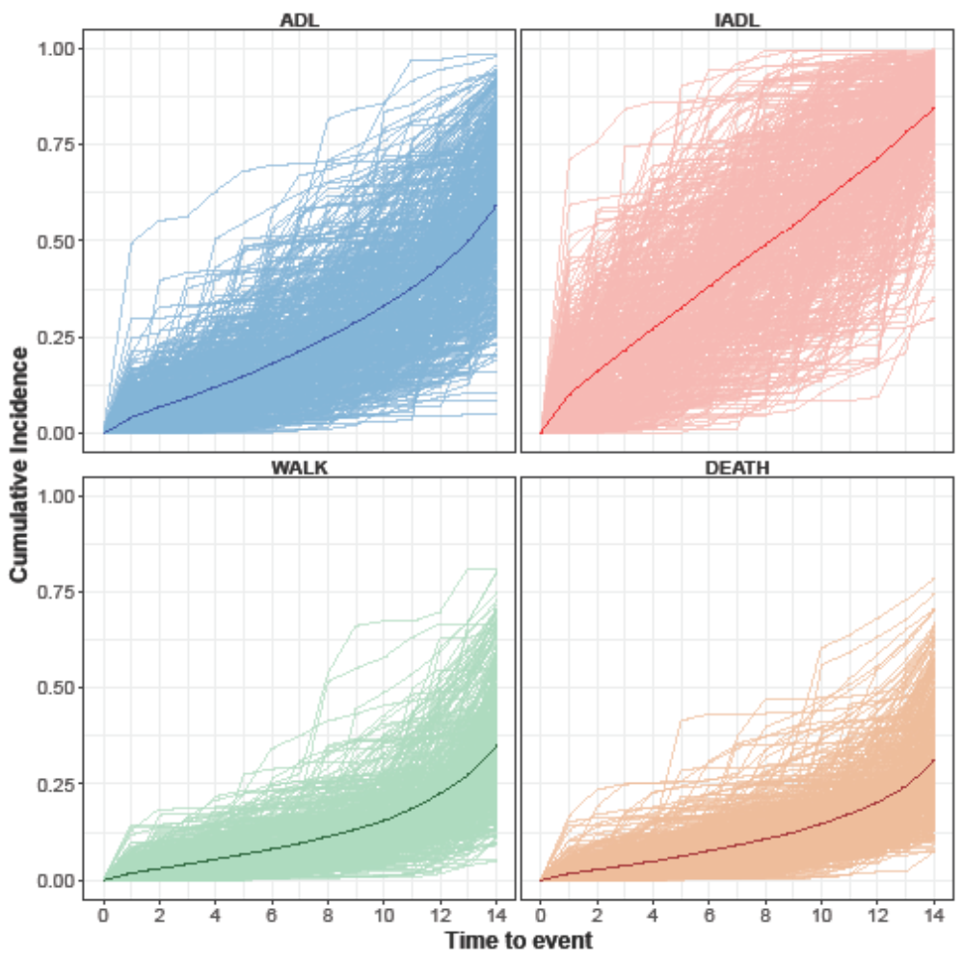

Legend:
ADL: time to first Activities of Daily Living (ADL) dependence
Case-study levels of censoring: ADL= 66.55%, IADL= 64.98%, WALK=81.90%, DEATH=31.87%
DEATH: time to death
IADL: time to first Instrumental Activities of Daily Living (IADL) difficulty
Scenario 2: simulated data generated using the outcome specific non-zero coefficients corresponding to those obtained with the Individual Outcome method in the case-study data
WALK: time to first mobility dependence

Fig. D.2. Predicted Cumulative Incidence by Outcome at the Mean of the Predictors Selected with the Individual Outcome Method in the Case-study Data using simulations (lighter color) of Scenario 2 with 25% Censoring (darker color: mean of simulations)
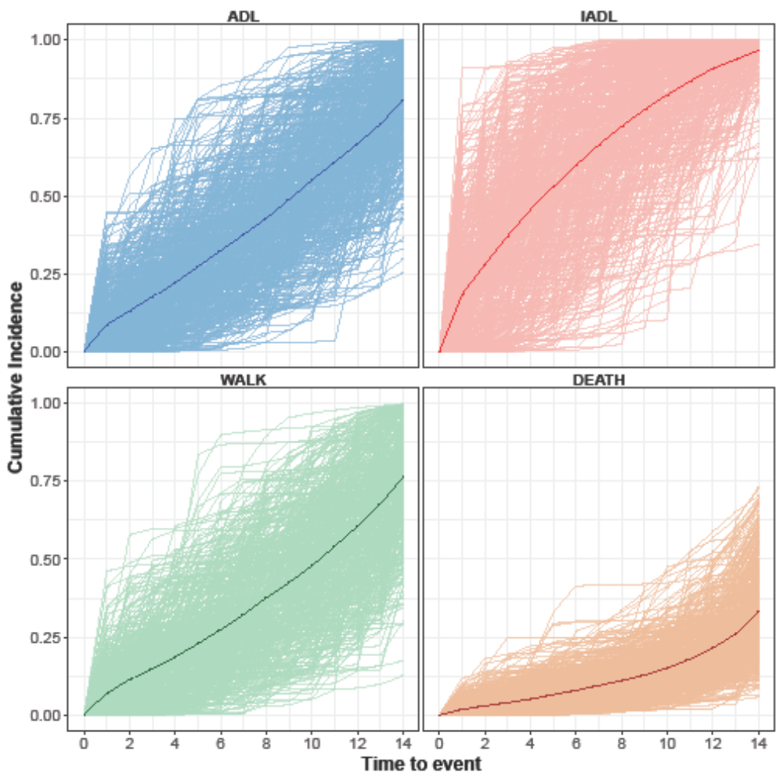

Legend:
ADL: time to first Activities of Daily Living (ADL) dependence
DEATH: time to death
IADL: time to first Instrumental Activities of Daily Living (IADL) difficulty
Scenario 2: simulated data generated using the outcome specific non-zero coefficients corresponding to those obtained with the Individual Outcome method in the case-study data
WALK: time to first mobility dependence

Fig. D.3. Predicted Cumulative Incidence by Outcome at the Mean of all 39 Candidate Predictors in the Case-study Data using simulations (lighter color) of Scenario 3 with Case-study Levels of Censoring (darker color: mean of simulations)
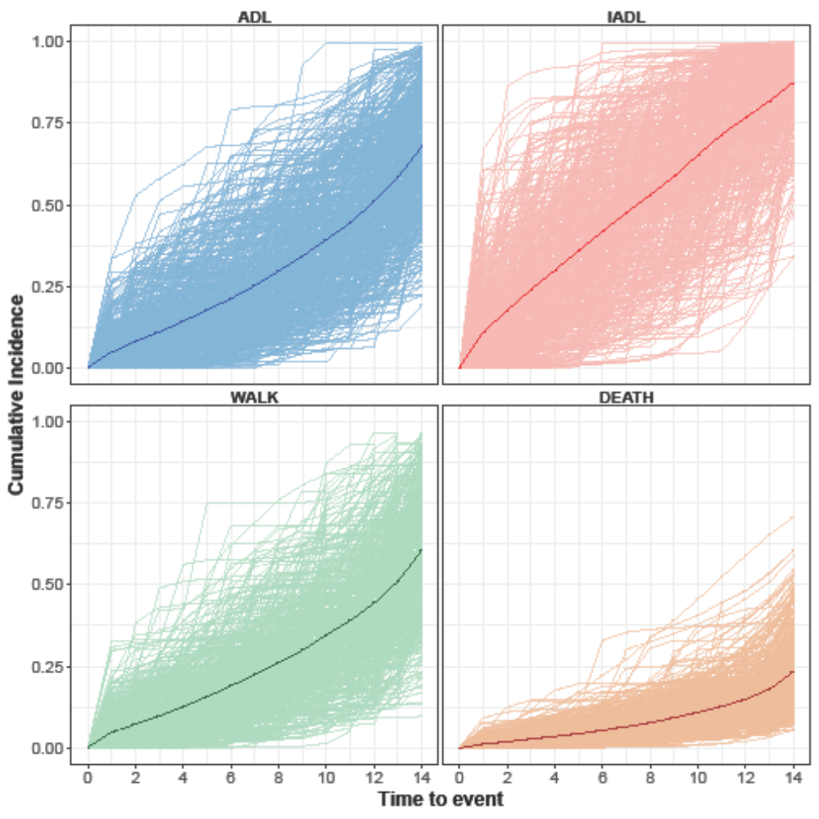

Legend:
ADL: time to first Activities of Daily Living (ADL) dependence
Case-study levels of censoring: ADL= 66.55%, IADL= 64.98%, WALK=81.90%, DEATH=31.87%
DEATH: time to death
IADL: time to first Instrumental Activities of Daily Living (IADL) difficulty
Scenario 3: simulated data generated using non-zero coefficients for all 39 candidate predictors using estimates from the case-study data
WALK: time to first mobility dependence

Fig. D.4. Predicted Cumulative Incidence by Outcome at the Mean of all 39 Candidate Predictors in the Case-study Data using simulations (lighter color) of Scenario 3 with 25% Censoring (darker color: mean of simulations)
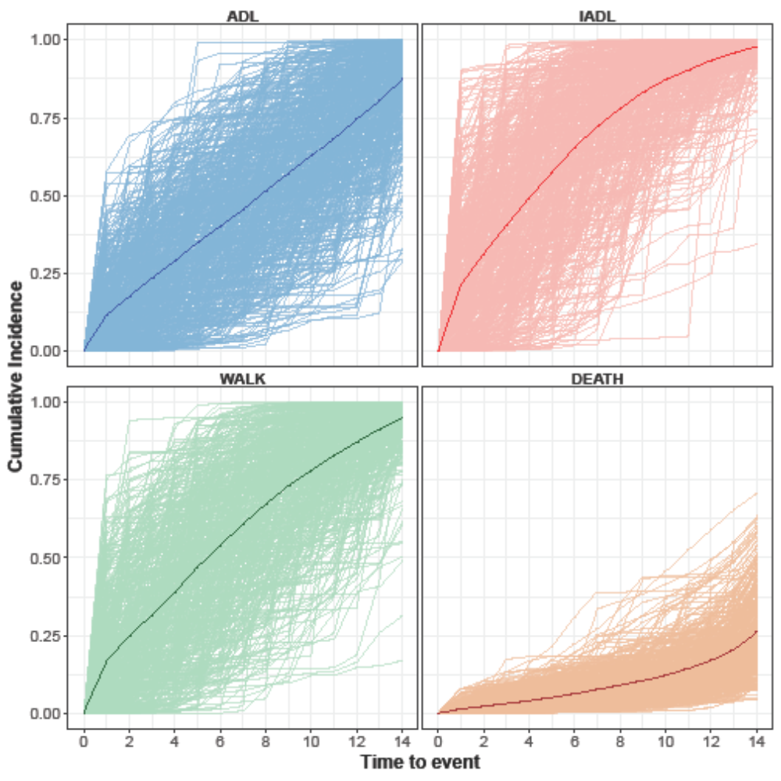
Legend:
ADL: time to first Activities of Daily Living (ADL) dependence
DEATH: time to death
IADL: time to first Instrumental Activities of Daily Living (IADL) difficulty
Scenario 3: simulated data generated using non-zero coefficients for all 39 candidate predictors using estimates from the case-study data
WALK: time to first mobility dependence

