APPENDICES

Appendix A: UR Research Ethical Clearance for data collection




Appendix B: City of Kigali Permission Approval to collect data
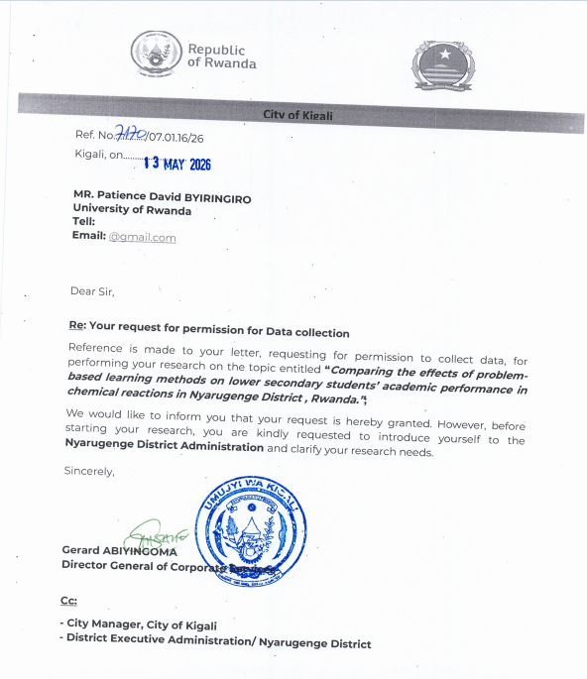

Appendix C: Attendance list of students respondents
Yes= Participated, No= Did not paricipate
S/N | Student Code | Class | School | Student Questionnaire | Pre-test | Post-test
1 | SR001 | S2 | School A | Yes | Yes | Yes
2 | SR002 | S2 | School A | Yes | Yes | Yes
3 | SR003 | S2 | School A | Yes | Yes | Yes
4 | SR004 | S2 | School A | Yes | Yes | Yes
5 | SR005 | S2 | School A | Yes | Yes | Yes
6 | SR006 | S2 | School A | Yes | Yes | Yes
7 | SR007 | S2 | School A | Yes | Yes | Yes
8 | SR008 | S2 | School A | Yes | Yes | Yes
9 | SR009 | S2 | School A | Yes | Yes | Yes
10 | SR010 | S2 | School A | Yes | Yes | Yes
11 | SR011 | S2 | School A | Yes | Yes | Yes
12 | SR012 | S2 | School A | Yes | Yes | Yes
13 | SR013 | S2 | School A | Yes | Yes | Yes
14 | SR014 | S2 | School A | Yes | Yes | Yes
15 | SR015 | S2 | School A | Yes | Yes | Yes
16 | SR016 | S2 | School A | Yes | Yes | Yes
17 | SR017 | S2 | School A | Yes | Yes | Yes
18 | SR018 | S2 | School A | Yes | Yes | Yes
19 | SR019 | S2 | School A | Yes | Yes | Yes
20 | SR020 | S2 | School A | Yes | Yes | Yes
21 | SR021 | S2 | School A | Yes | Yes | Yes
22 | SR022 | S2 | School A | Yes | Yes | Yes
23 | SR023 | S2 | School A | Yes | Yes | Yes
24 | SR024 | S2 | School A | Yes | Yes | Yes
25 | SR025 | S2 | School A | Yes | Yes | Yes
26 | SR026 | S2 | School A | Yes | Yes | Yes
27 | SR027 | S2 | School A | Yes | Yes | Yes
28 | SR028 | S2 | School A | Yes | Yes | Yes
29 | SR029 | S2 | School A | Yes | Yes | Yes
30 | SR030 | S3 | School A | Yes | Yes | Yes
31 | SR031 | S3 | School A | Yes | Yes | Yes
32 | SR032 | S3 | School A | Yes | Yes | Yes
33 | SR033 | S3 | School A | Yes | Yes | Yes
34 | SR034 | S3 | School A | Yes | Yes | Yes
35 | SR035 | S3 | School A | Yes | Yes | Yes
36 | SR036 | S3 | School A | Yes | Yes | Yes
37 | SR037 | S3 | School A | Yes | Yes | Yes
38 | SR038 | S3 | School A | Yes | Yes | Yes
39 | SR039 | S3 | School A | Yes | Yes | Yes
40 | SR040 | S3 | School A | Yes | Yes | Yes
41 | SR041 | S3 | School A | Yes | Yes | Yes
42 | SR042 | S3 | School A | Yes | Yes | Yes
43 | SR043 | S3 | School A | Yes | Yes | Yes
44 | SR044 | S3 | School A | Yes | Yes | Yes
45 | SR045 | S3 | School A | Yes | Yes | Yes
46 | SR046 | S3 | School A | Yes | Yes | Yes
47 | SR047 | S3 | School A | Yes | Yes | Yes
48 | SR048 | S3 | School A | Yes | Yes | Yes
49 | SR049 | S3 | School A | Yes | Yes | No
50 | SR050 | S3 | School A | Yes | Yes | Yes
51 | SR051 | S3 | School A | Yes | Yes | Yes
52 | SR052 | S3 | School A | Yes | Yes | Yes
53 | SR053 | S3 | School A | Yes | Yes | Yes
54 | SR054 | S3 | School A | Yes | Yes | Yes
55 | SR055 | S3 | School A | Yes | Yes | Yes
56 | SR056 | S3 | School A | Yes | Yes | Yes
57 | SR057 | S3 | School A | Yes | Yes | Yes
58 | SR058 | S2 | School B | Yes | Yes | Yes
59 | SR059 | S2 | School B | Yes | Yes | Yes
60 | SR060 | S2 | School B | Yes | No | Yes
61 | SR061 | S2 | School B | Yes | Yes | No
62 | SR062 | S2 | School B | Yes | Yes | Yes
63 | SR063 | S2 | School B | Yes | Yes | Yes
64 | SR064 | S2 | School B | Yes | Yes | Yes
65 | SR065 | S2 | School B | Yes | Yes | Yes
66 | SR066 | S2 | School B | Yes | Yes | Yes
67 | SR067 | S2 | School B | Yes | Yes | Yes
68 | SR068 | S2 | School B | Yes | Yes | No
69 | SR069 | S2 | School B | Yes | Yes | Yes
70 | SR070 | S2 | School B | Yes | Yes | Yes
71 | SR071 | S2 | School B | Yes | No | Yes
72 | SR072 | S2 | School B | Yes | Yes | Yes
73 | SR073 | S2 | School B | Yes | Yes | Yes
74 | SR074 | S2 | School B | Yes | Yes | Yes
75 | SR075 | S2 | School B | Yes | Yes | Yes
76 | SR076 | S2 | School B | Yes | Yes | Yes
77 | SR077 | S2 | School B | Yes | No | Yes
78 | SR078 | S2 | School B | Yes | Yes | Yes
79 | SR079 | S2 | School B | Yes | Yes | Yes
80 | SR080 | S2 | School B | Yes | No | Yes
81 | SR081 | S2 | School B | Yes | No | Yes
82 | SR082 | S2 | School B | Yes | Yes | Yes
83 | SR083 | S2 | School B | Yes | Yes | Yes
84 | SR084 | S2 | School B | Yes | Yes | Yes
85 | SR085 | S2 | School B | Yes | Yes | Yes
86 | SR086 | S2 | School B | Yes | Yes | Yes
87 | SR087 | S3 | School B | Yes | Yes | Yes
88 | SR088 | S3 | School B | Yes | Yes | Yes
89 | SR089 | S3 | School B | Yes | Yes | Yes
90 | SR090 | S3 | School B | Yes | Yes | Yes
91 | SR091 | S3 | School B | Yes | Yes | Yes
92 | SR092 | S3 | School B | Yes | Yes | Yes
93 | SR093 | S3 | School B | Yes | Yes | Yes
94 | SR094 | S3 | School B | Yes | Yes | Yes
95 | SR095 | S3 | School B | Yes | Yes | Yes
96 | SR096 | S3 | School B | Yes | Yes | Yes
97 | SR097 | S3 | School B | Yes | Yes | Yes
98 | SR098 | S3 | School B | Yes | Yes | Yes
99 | SR099 | S3 | School B | Yes | Yes | Yes
100 | SR100 | S3 | School B | Yes | Yes | Yes
101 | SR101 | S3 | School B | Yes | Yes | Yes
102 | SR102 | S3 | School B | Yes | Yes | Yes
103 | SR103 | S3 | School B | Yes | Yes | Yes
104 | SR104 | S3 | School B | Yes | Yes | Yes
105 | SR105 | S3 | School B | Yes | Yes | Yes
106 | SR106 | S3 | School B | Yes | Yes | Yes
107 | SR107 | S3 | School B | Yes | Yes | Yes
108 | SR108 | S3 | School B | Yes | Yes | Yes
109 | SR109 | S3 | School B | Yes | Yes | Yes
110 | SR110 | S3 | School B | Yes | Yes | Yes
111 | SR111 | S3 | School B | Yes | Yes | Yes
112 | SR112 | S3 | School B | Yes | Yes | Yes
113 | SR113 | S3 | School B | Yes | Yes | Yes
114 | SR114 | S3 | School B | Yes | Yes | Yes
115 | SR168 | S3 | School B | Yes | No | Yes
116 | SR166 | S2 | School B | Yes | Yes | Yes
117 | SR167 | S2 | School B | Yes | Yes | Yes
118 | SR115 | S2 | School C | Yes | Yes | Yes
119 | SR116 | S2 | School C | Yes | Yes | Yes
120 | SR117 | S2 | School C | Yes | Yes | Yes
121 | SR118 | S2 | School C | Yes | Yes | Yes
122 | SR119 | S2 | School C | Yes | Yes | Yes
123 | SR120 | S2 | School C | Yes | Yes | Yes
124 | SR121 | S2 | School C | Yes | Yes | Yes
125 | SR122 | S2 | School C | Yes | Yes | Yes
126 | SR123 | S2 | School C | Yes | Yes | Yes
127 | SR124 | S2 | School C | Yes | Yes | Yes
128 | SR125 | S2 | School C | Yes | Yes | Yes
129 | SR126 | S2 | School C | Yes | Yes | Yes
130 | SR127 | S2 | School C | Yes | Yes | Yes
131 | SR128 | S2 | School C | Yes | Yes | Yes
132 | SR129 | S2 | School C | Yes | Yes | Yes
133 | SR130 | S2 | School C | Yes | Yes | Yes
134 | SR131 | S2 | School C | Yes | Yes | Yes
135 | SR132 | S2 | School C | Yes | Yes | Yes
136 | SR133 | S2 | School C | Yes | Yes | Yes
137 | SR134 | S2 | School C | Yes | Yes | Yes
138 | SR135 | S2 | School C | Yes | Yes | Yes
139 | SR136 | S2 | School C | Yes | Yes | Yes
140 | SR137 | S2 | School C | Yes | Yes | Yes
141 | SR138 | S2 | School C | Yes | Yes | Yes
142 | SR139 | S2 | School C | Yes | Yes | No
143 | SR140 | S2 | School C | Yes | Yes | Yes
144 | SR141 | S3 | School C | Yes | Yes | Yes
145 | SR142 | S3 | School C | Yes | Yes | Yes
146 | SR143 | S3 | School C | Yes | Yes | Yes
147 | SR144 | S3 | School C | Yes | Yes | Yes
148 | SR145 | S3 | School C | Yes | Yes | Yes
149 | SR146 | S3 | School C | Yes | Yes | Yes
150 | SR147 | S3 | School C | Yes | Yes | Yes
151 | SR148 | S3 | School C | Yes | Yes | Yes
152 | SR149 | S3 | School C | Yes | Yes | Yes
153 | SR150 | S3 | School C | Yes | Yes | Yes
154 | SR151 | S3 | School C | Yes | Yes | Yes
155 | SR152 | S3 | School C | Yes | Yes | Yes
156 | SR153 | S3 | School C | Yes | Yes | Yes
157 | SR154 | S3 | School C | Yes | Yes | Yes
158 | SR155 | S3 | School C | Yes | Yes | Yes
159 | SR156 | S3 | School C | Yes | Yes | Yes
160 | SR157 | S3 | School C | Yes | Yes | Yes
161 | SR158 | S3 | School C | Yes | Yes | Yes
162 | SR159 | S3 | School C | Yes | Yes | Yes
163 | SR160 | S3 | School C | Yes | Yes | Yes
164 | SR161 | S3 | School C | Yes | Yes | Yes
165 | SR162 | S3 | School C | Yes | Yes | Yes
166 | SR163 | S3 | School C | Yes | Yes | Yes
167 | SR164 | S3 | School C | Yes | Yes | Yes
168 | SR165 | S3 | School C | Yes | Yes | Yes
169 | SR169 | S3 | School D | Yes | Yes | Yes
170 | SR170 | S3 | School D | Yes | Yes | Yes
171 | SR171 | S3 | School D | Yes | Yes | Yes
172 | SR172 | S2 | School D | Yes | Yes | Yes
173 | SR173 | S2 | School D | Yes | Yes | Yes
174 | SR174 | S2 | School D | Yes | Yes | Yes
175 | SR175 | S2 | School D | Yes | Yes | Yes
176 | SR176 | S2 | School D | Yes | Yes | Yes
177 | SR177 | S2 | School D | Yes | Yes | Yes
178 | SR178 | S2 | School D | Yes | Yes | Yes
179 | SR179 | S2 | School D | Yes | Yes | Yes
180 | SR180 | S2 | School D | Yes | Yes | Yes
181 | SR181 | S2 | School D | Yes | Yes | Yes
182 | SR182 | S2 | School D | Yes | Yes | Yes
183 | SR183 | S2 | School D | Yes | Yes | Yes
184 | SR184 | S2 | School D | Yes | Yes | No
185 | SR185 | S2 | School D | Yes | Yes | Yes
186 | SR186 | S2 | School D | Yes | Yes | Yes
187 | SR187 | S2 | School D | Yes | Yes | Yes
188 | SR188 | S2 | School D | Yes | Yes | Yes
189 | SR189 | S2 | School D | Yes | Yes | Yes
190 | SR190 | S2 | School D | Yes | Yes | Yes
191 | SR191 | S2 | School D | Yes | Yes | Yes
192 | SR192 | S2 | School D | Yes | Yes | Yes
193 | SR193 | S2 | School D | Yes | Yes | Yes
194 | SR194 | S2 | School D | Yes | Yes | Yes
195 | SR195 | S2 | School D | Yes | Yes | Yes
196 | SR196 | S2 | School D | Yes | Yes | Yes
197 | SR197 | S2 | School D | Yes | Yes | Yes
198 | SR198 | S2 | School D | Yes | Yes | Yes
199 | SR199 | S2 | School D | Yes | Yes | Yes
200 | SR200 | S2 | School D | Yes | Yes | Yes
201 | SR201 | S2 | School D | Yes | Yes | Yes
202 | SR202 | S2 | School D | Yes | Yes | Yes
203 | SR203 | S3 | School D | Yes | Yes | Yes
204 | SR204 | S3 | School D | Yes | Yes | Yes
205 | SR205 | S3 | School D | Yes | Yes | Yes
206 | SR206 | S3 | School D | Yes | Yes | Yes
207 | SR207 | S3 | School D | Yes | Yes | Yes
208 | SR208 | S3 | School D | Yes | Yes | Yes
209 | SR209 | S3 | School D | Yes | Yes | Yes
210 | SR210 | S3 | School D | Yes | Yes | Yes
211 | SR211 | S3 | School D | Yes | Yes | Yes
212 | SR212 | S3 | School D | Yes | Yes | Yes
213 | SR213 | S3 | School D | Yes | Yes | Yes
214 | SR214 | S3 | School D | Yes | Yes | Yes
215 | SR215 | S3 | School D | Yes | Yes | Yes
216 | SR216 | S3 | School D | Yes | Yes | Yes
217 | SR217 | S3 | School D | Yes | Yes | Yes
218 | SR218 | S3 | School D | Yes | Yes | Yes
219 | SR219 | S3 | School D | Yes | Yes | Yes
220 | SR220 | S3 | School D | Yes | Yes | Yes
221 | SR221 | S3 | School D | Yes | Yes | Yes
222 | SR222 | S3 | School D | Yes | Yes | Yes
223 | SR223 | S3 | School D | Yes | Yes | Yes
224 | SR224 | S3 | School D | Yes | Yes | Yes
225 | SR225 | S3 | School D | Yes | Yes | Yes
226 | SR226 | S3 | School D | Yes | Yes | Yes
227 | SR227 | S3 | School D | Yes | Yes | Yes

Appendix D: Classroom Observation Checklist
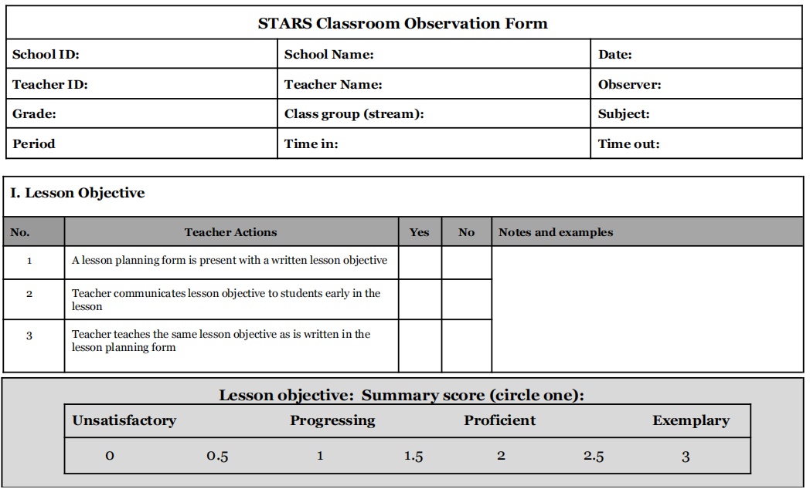
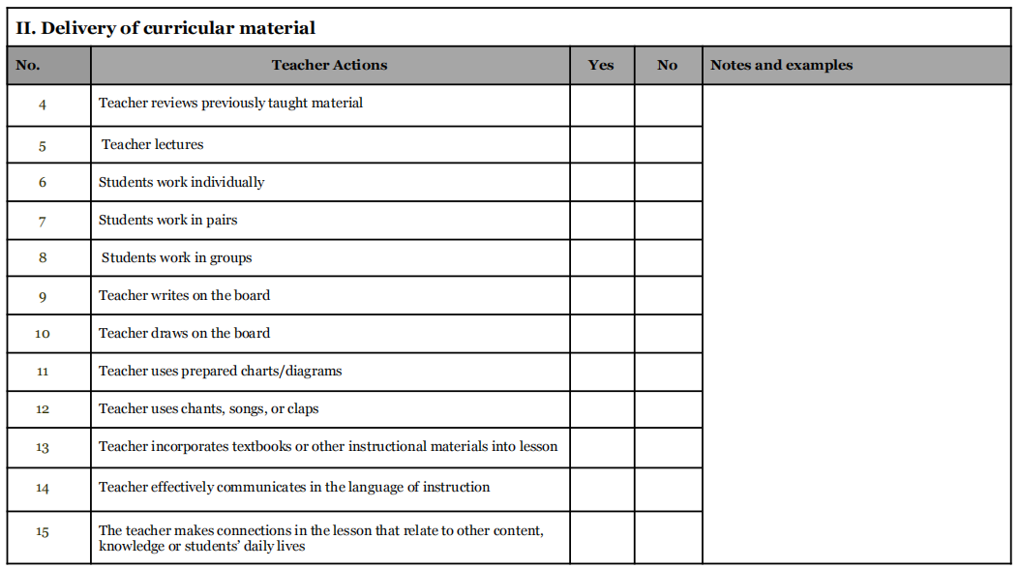
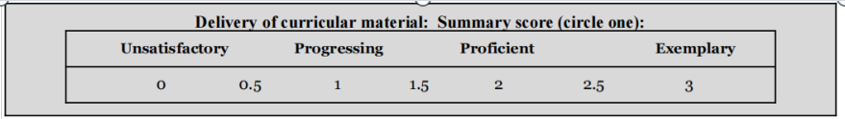
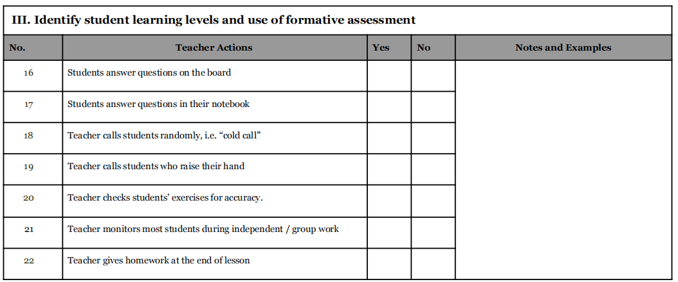
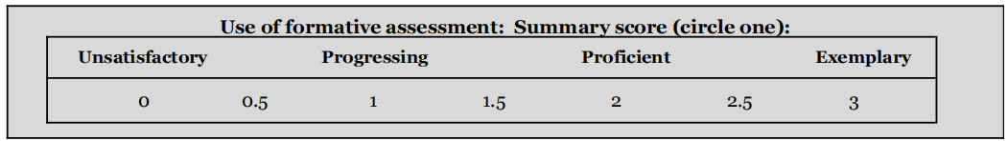
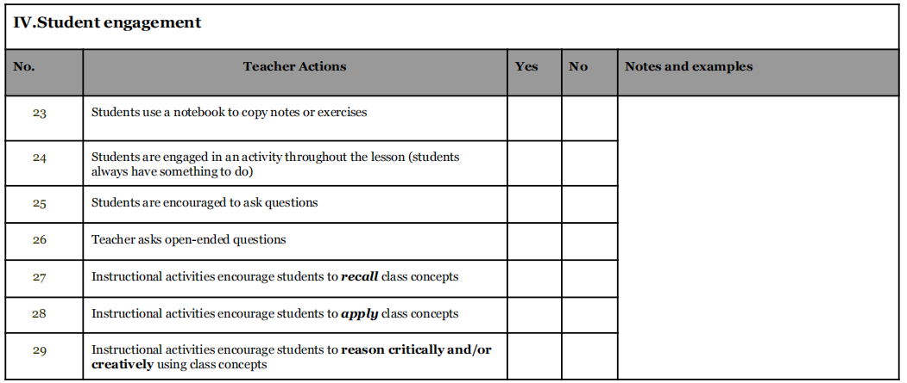
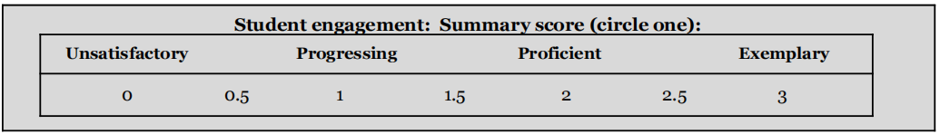
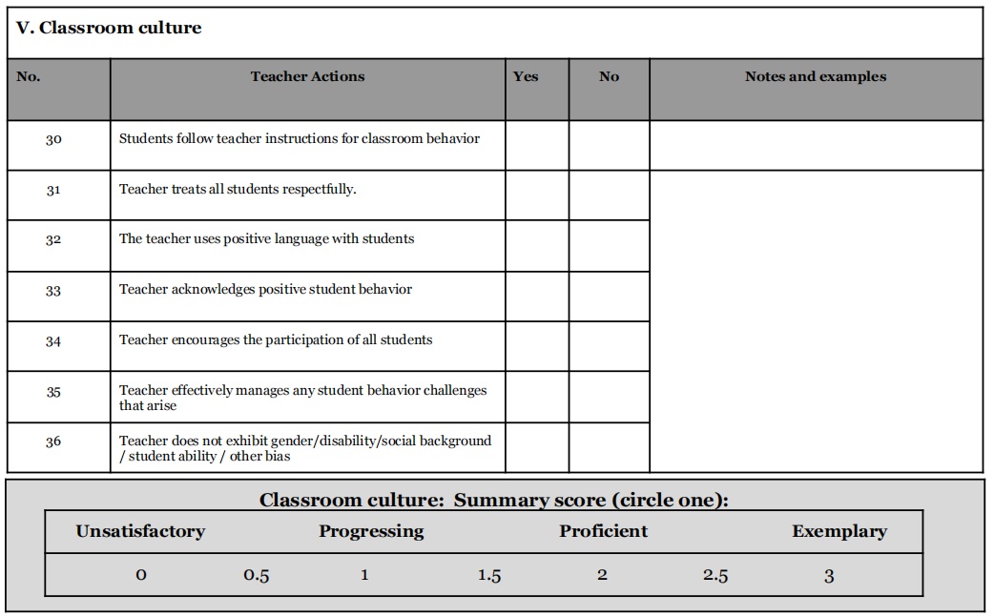
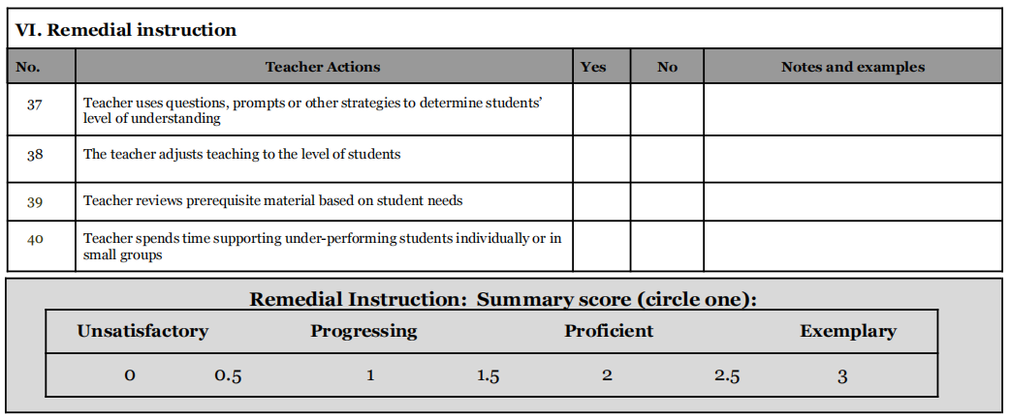

Appendix E: Chemistry Achievement Tests
Appendix F1: Chemistry Achievement Test S2 Pre-test
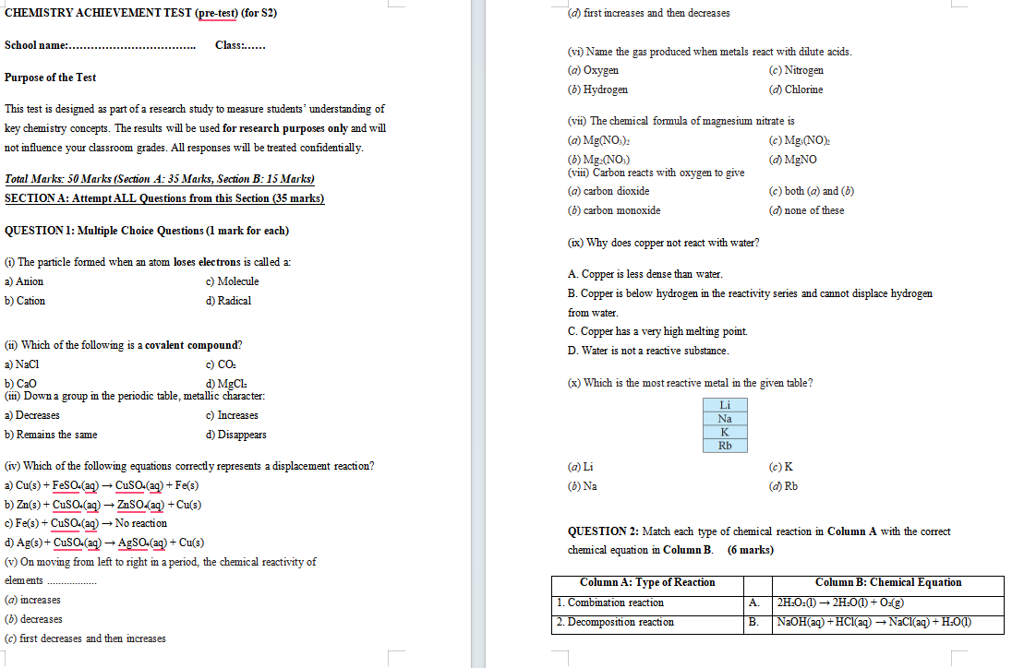

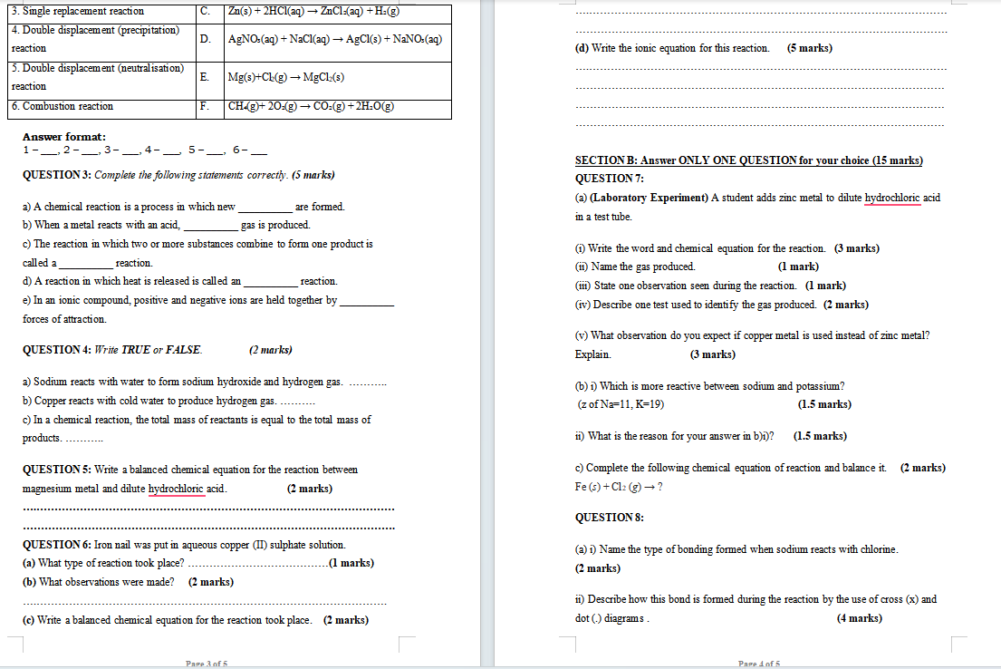
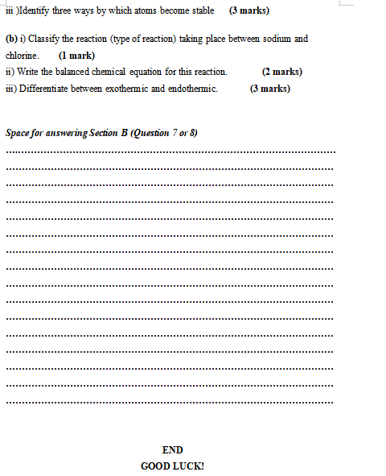
Appendix E2: Chemistry Achievement Test S2 Post-test
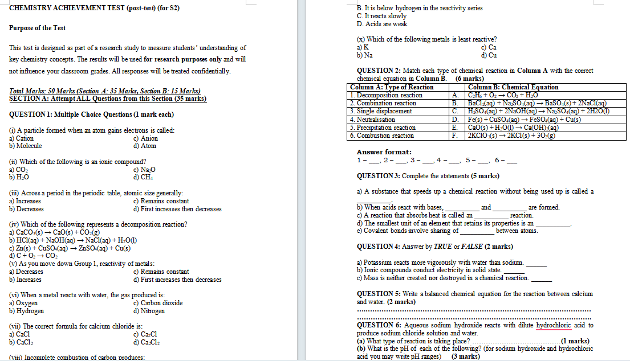
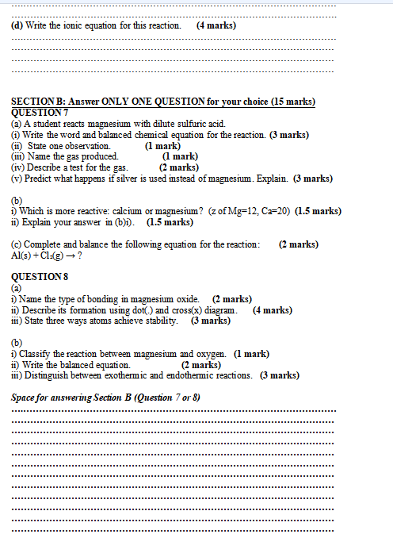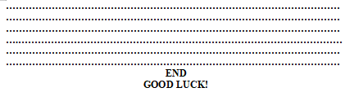
Appendix E3: Chemistry Achievement Test S3 Pre-test
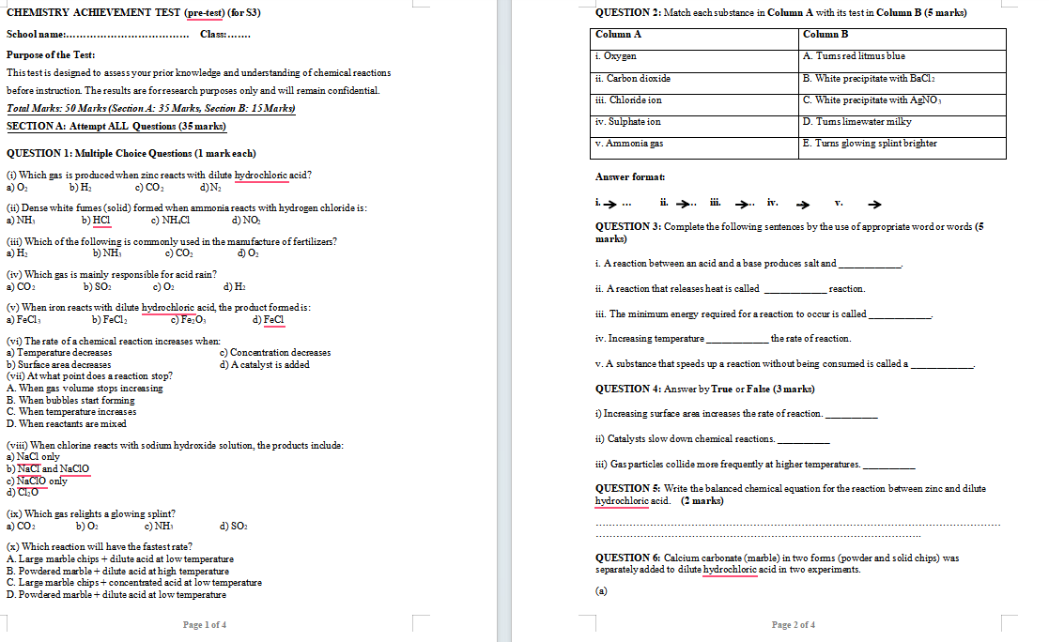

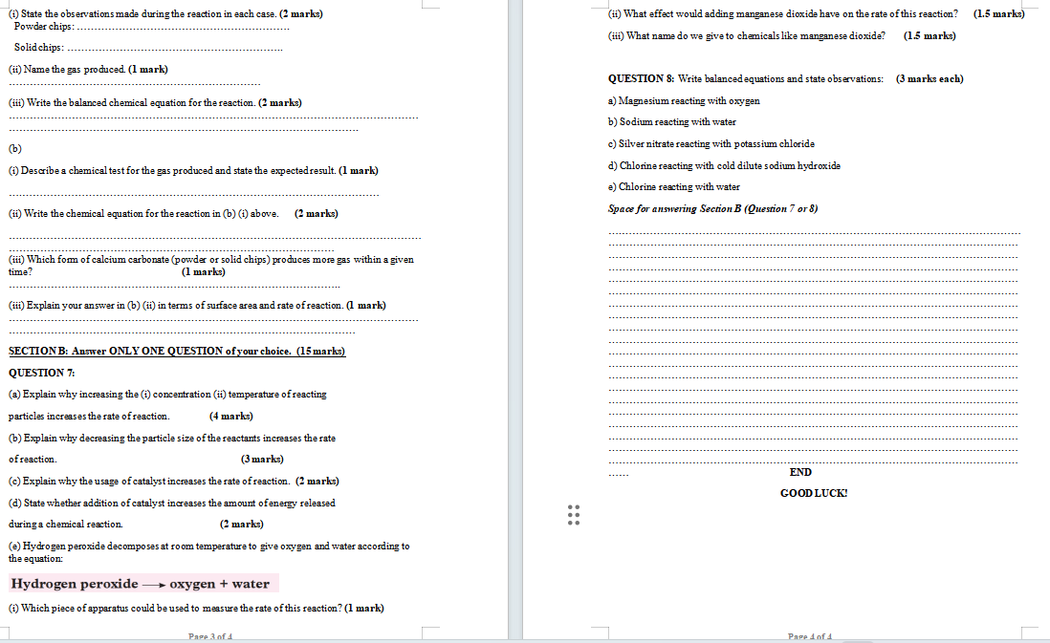

Appendix E4: Chemistry Achievement Test S3 Post-test
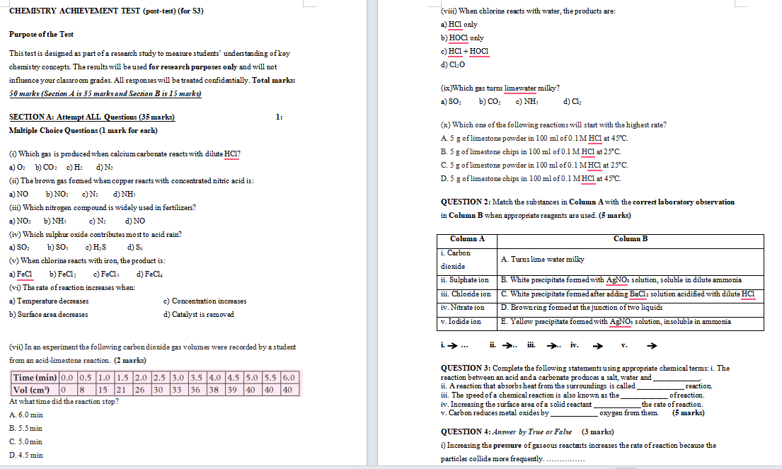
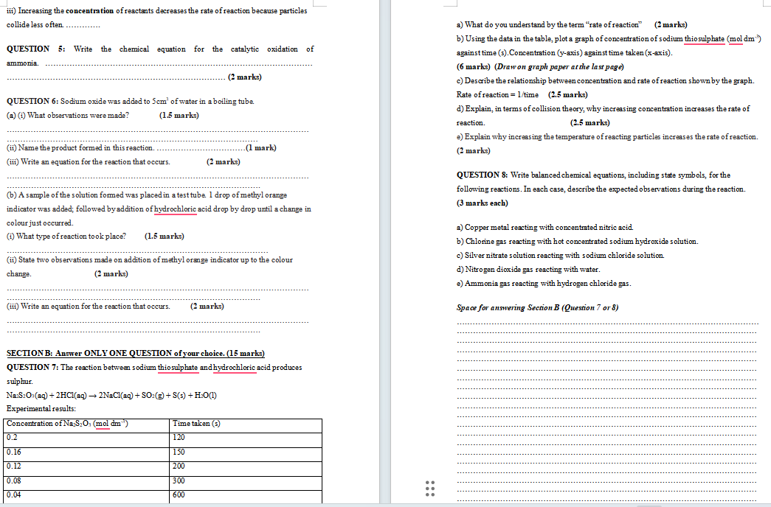

Appendix F: Informed Consent Form

