Table 1. Cephalometric landmarks and measurements used in this study.
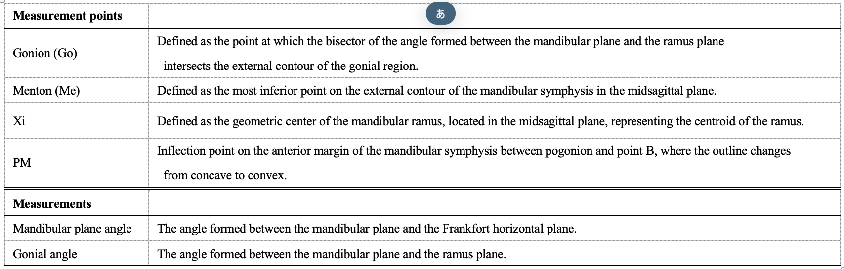

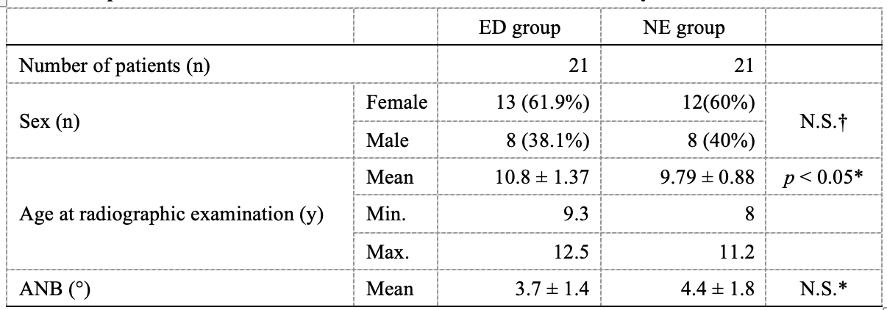
Table 2. Cephalometric landmarks and measurements used in this study.

*: Student's t test N.S.: Not statistically significant difference
†: Chi-square test

Table 3. Comparison of panoramic radiographic measurements between the ED and NE groups.
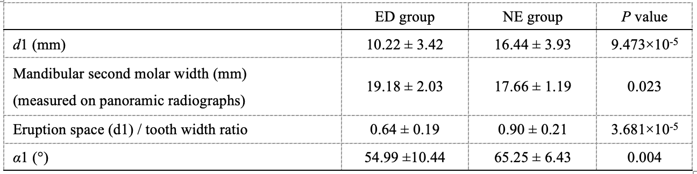

Data are presented as mean ± S.D.
Statistical analyses were performed using Student’s t-test.
Statistical significance was set at p < 0.05 and p < 0.01.

Table 4. Comparison of lateral cephalometric measurements between the ED and NE groups.
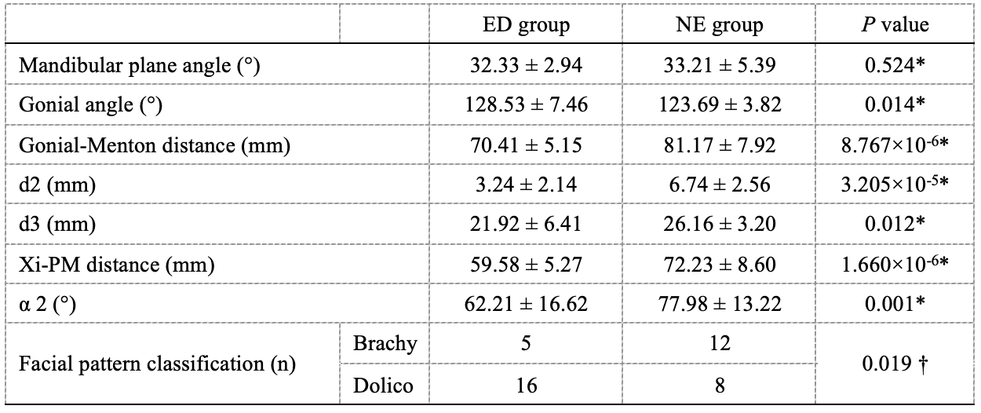
Data are presented as mean ± S.D.
*: Statistical analyses were performed using Student's t-test.
†: Statistical analyses were performed using Chi-square test.

Table 5. Multivariable logistic regression analysis of factors associated with mandibular second molar eruption disturbance.
