Supporting Information
A supramolecular pyroptosis nanogenerator based on non-covalent interactions for cancer immunotherapy
Dan Wu,^{a,*} Kunmin Ping,ª Yibin Cao,ª Borui Zhao,ª Yanrong Yang,ª Jie Zhou,ª Xinyang Yu^{b} Chunyang Yu,^{c,*} and Shaolong Qi^{b,*}
ª State Key Laboratory of Advanced Separation Membrane Materials, Zhejiang Key Laboratory of Advanced Polymer Materials Modification and Application Technology, College of Materials Science and Engineering, Zhejiang University of Technology, Hangzhou 310014, P. R. China.
E-mail: danwu@zjut.edu.cn
^{b} Jilin Provincial International Joint Research Center for Lymphatic Vascular Disease, China-Japan Union Hospital of Jilin University, Changchun 130033, P. R. China
E-mail: qishaolong@jlu.edu.cn
^{c} State Key Laboratory of Synergistic Chem-Bio Synthesis, School of Chemistry and Chemical Engineering, Shanghai Key Laboratory of Electrical Insulation and Thermal Aging, Shanghai Jiao Tong University, 800 Dongchuan Road, Shanghai 200240, P. R. China.
E-mail: chunyangyu@sjtu.edu.cn
^{d} MOE Joint International Research Laboratory of Pancreatic Diseases, The First Affiliated Hospital, Zhejiang University School of Medicine, Hangzhou 310003, P. R. China.
* Corresponding authors.

Materials and method
Materials
All reagents were commercially available and used as supplied without further purification. Solvents were either employed as purchased or dried according to procedures described in the literature. ¹H NMR spectra were recorded on a Bruker Avance DMX 400 spectrometer. 2D NOESY spectra were acquired on a Bruker Avance III-600 spectrometer. UV-Vis spectra were obtained with a UV-1900 spectrophotometer (Shimadzu, Japan). FTIR spectra were recorded on a Nicolet 6700 spectrometer (Thermo Fisher Scientific, USA). ITC was performed on a VP-ITC system (Malvern Panalytical, UK). Hydrodynamic size and zeta potential were determined using a Nano Brook Omni analyzer (Brookhaven Instruments, USA). XRD was performed on an Ultima IV diffractometer (Rigaku, Japan). XPS was conducted on an ESCALAB220i-XL spectrometer (Thermo Fisher Scientific, UK). TEM images were acquired with an HT7800 microscope (Hitachi, Japan) operating at 120 kV. Elemental mapping images were acquired using a Talos F200X G2 field-emission transmission electron microscope (Thermo Scientific, Czech Republic) operating at 200 kV. The absorbance measurements in MTT, LDH, IL-1β, and IL-18 assays and chemiluminescence intensity measurements in ATP assay were performed using a Synergy H1 (Bio Tek, USA). HPLC analyses were carried out on an Agilent 1260 Infinity II system (Agilent Technologies Inc., USA). ICP-MS measurements were obtained with an ICP-9800 spectrometer (Shimadzu, Japan). Flow cytometry was performed on a BD FACS Canto II cytometer (Becton Dickinson, USA), and data were analyzed with FlowJo software. CLSM images were captured using an STELLARIS 5 (Leica, Germany). Fluorescence images were captured using a Nikon TS2-FL inverted microscope (Japan). In vivo fluorescence imaging was performed on an IVIS Spectrum system (PerkinElmer, USA). Western blot was carried on a Tanon 5200 imaging system (Tanon, China).

Methods
Optimization of mineralization conditions for SNPs@CaCO₃
DAC (0.42 mg), Ad-G (1.5 mg), CUR (0.08 mg), PEG-b-PMAA (1.4 mg) and CD-COOH (4.1 mg) were respectively dissolved in DMSO at volumes of 25 μL, 37.5 μL, 200 μL, 120 μL and 67 μL. The solutions were combined and stirred at 60 ºC for 2 h. Following this, CaCl₂ solution (3.09, 6.18 or 12.36 mg/mL, 375 μL) was added to the mixture under vigorous stirring for 12 h. Subsequently, Na₂CO₃ solution (2.95, 5.9 or 11.8 mg/mL, 375 μL) was slowly introduced, and stirring was continued for 12, 24, or 48 h. The resulting product was obtained by vacuum freeze-drying to yield SNPs@CaCO₃.
Drug loading capacity (DLC) and encapsulation efficiency (EE) were calculated using Equations (1) and (2), respectively.
DLC (%) = Mass of drugs encapsulated within SNPs@CaCO₃/Total mass of SNPs@CaCO₃ × 100% (1)
EE (%) = Mass of drugs encapsulated within the SNPs@CaCO₃/Total mass of drug fed × 100% (2)
Job's plot analysis
Aqueous solutions of CUR (0.1 mM) and β-CD (0.9 mM) were mixed at varying molar ratios to achieve a constant total molar concentration of 1.0 mM. After sonication for 5 min, the UV spectra of all solutions were recorded, and the absorbance at 425 nm was plotted as a function of R, where R = [CUR]/[CUR] + [β-CD].
In order to evaluate the binding ability of CUR to β-CD, the Benesi–Hildebrand equation (Eq (1)) was used to calculate the association constant (K_{a}) based on the continuous variation (Job’s plot) data. The liner relation between 1/(A-A₀) and 1/[CUR] can be obtained through corresponding changes of absorbance intensity. Through UV-vis absorbance titration of β-CD with CUR, fitting curve is obtained as 1/(A-A₀) = 52.81/[CUR] + 11.46 (K = 2.17 × 10⁵ M⁻¹; R² = 0.983) (Figure. S7).
$\frac{A_{max}-A_{0}}{A-A_{0}}=\frac{1}{K[CUR]}+1$ (1)
$\frac{1}{A-A_{0}}=\frac{b}{[CUR]}+a(a=\frac{1}{A_{max}-A_{0}};b=\frac{1/K}{A_{max}-A_{0}})$ (2)
$K=\frac{a}{b}$ (3)
where A₀ and A_{max} are the absorbance of the blank sample and that at a 1:1 molar ratio of β-CD to CUR, respectively; K is the binding constant; Eq. (2) is a simple variant of Eq. (1) and K value can be easily obtained (Eq. (3)).
Evaluation of solubility enhancement of CUR upon β-CD complexation
A series of CUR standard solutions were prepared in ethanol at concentrations of 0, 1.25, 2.5, 5.0 and 10.0 μg/mL. The absorbance of each solution was measured at 425 nm using a UV-Vis spectrophotometer, and a calibration curve was constructed by plotting absorbance against concentration.
CUR (50 mg) and β-CD⊃CUR (50 mg) were respectively dispersed in 10 mL of distilled water. The suspensions were shaken under light-protected conditions at room temperature for 48 h to achieve dissolution equilibrium. After centrifugation at 10,000 rpm for 10 min, the supernatants were collected, and their absorbance was measured at 425 nm. The CUR concentration in each supernatant was calculated using the calibration curve to determine the solubility enhancement.
CUR leakage from SNPs@CaCO₃
Aqueous suspensions of SNPs@CaCO₃ (-PEG-b-PMAA) (12 mg/mL) and SNPs@CaCO₃ (12 mg/mL) were separately loaded into dialysis bags (MWCO: 1000 Da) and vibrated at 37 ºC. After 48 h, 1 mL of the external buffer was collected from each system. The concentration of CUR leaked into the buffer was subsequently quantified using UV-Vis spectroscopy.
Determination of DAC-to-CUR loading ratios in SNPs@CaCO₃
SNPs@CaCO₃ nanoparticles loaded with DAC and CUR at theoretical [DAC]/[CUR] ratios of 10, 8, 6, 3, and 1 were prepared. To determine the actual loading ratios, the nanoparticles were dissolved in deionized water (50 mL) and dialyzed for 1 h. The dialysate was collected, and the concentration of CUR was determined by UV-Vis spectrophotometry based on absorbance at 425 nm using a pre-established calibration curve. The concentration of DAC was determined by HPLC. The actual DAC/CUR ratios were then calculated from the quantified concentrations of both components.
Optimization of the DAC-to-CUR ratio based on intracellular Ca²⁺ levels
4T1 cells were seeded in 24-well plates at a density of 5 × 10⁴ cells/well, and allowed to adhere overnight. The culture medium was then replaced with fresh DMEM containing SNPs@CaCO₃ (1.2 mg/mL) with theoretical [DAC]/[CUR] ratios of 10, 8, 6, 3, and 1. After 12 h of incubation, the cells were stained with Fluo-4 AM at 37 ºC for 30 min. The CLSM images were taken using a confocal laser scanning microscope.
Morphological characterization
The hydrodynamic size and surface charge of the nanoparticles were measured by dynamic light scattering, and their morphology was characterized using transmission electron microscope.
Drug release profile of SNPs@CaCO₃
Initially, a 10 mM sodium acetate aqueous solution was prepared and adjusted to various pH values using acetic acid to create a series of buffer solutions. Subsequently, SNPs@CaCO₃ aqueous solutions (12 mg/mL) were loaded into dialysis bags (MWCO: 1000 Da) and vibrated at 37 ºC. At predetermined time intervals, 1 mL of the external buffer was sampled and immediately replaced with an equal volume of fresh buffer. The concentrations of released DAC and Ca²⁺ in the sample solutions were then quantified using HPLC and ICP-MS, respectively.
Cell uptake of SNPs@CaCO₃
First, 4T1 cells were seeded in 24-well plates at a density of 5 × 10⁴ cells/well, and allowed to adhere overnight. Then 4T1 cells were cultured with BODIPY-labeled SNPs@CaCO₃ solutions (1.2 mg/mL) for 1, 2, 4, 8 and 12 h, respectively. Subsequently, cells were incubated with LysoTracker for 10 min, followed by DAPI staining for 15 min. After staining, 4T1 cells were washed with PBS and fixed with fresh 4.0% paraformaldehyde for 15 min. The CLSM images were taken using a confocal laser scanning microscope.
Mechanistic studies on cellular uptake of SNPs@CaCO₃
First, 4T1 cells were seeded in 96-well plates at a density of 1 × 10⁴ cells/well, and allowed to adhere overnight. Then 4T1 cells were subjected to different uptake-inhibiting conditions. The experimental groups were designed as follows:
Control (CON): Incubation with BODIPY-labeled SNPs@CaCO₃ (1.2 mg/mL) at 37 ºC for 4 h.
TEA: Pretreatment with TEA (1 mM) at 37 ºC for 1 h followed by incubation with BODIPY-labeled SNPs@CaCO₃ (1.2 mg/mL) at 37 ºC for 4 h.
NH₄Cl: Pretreatment with NH₄Cl (50 mM) at 37 ºC for 1 h followed by incubation with BODIPY-labeled SNPs@CaCO₃ (1.2 mg/mL) at 37 ºC for 4 h.
Nigericin: Pretreatment with nigericin (5 μg/mL) at 37 ºC for 1 h followed by incubation with BODIPY-labeled SNPs@CaCO₃ (1.2 mg/mL) at 37 ºC for 4 h.
Metabolic inhibitors: Pretreatment with 2-deoxy-D-glucose (50 mM) and oligomycin (5 μM) at 37 ºC for 1 h followed by incubation with BODIPY-labeled SNPs@CaCO₃ (1.2 mg/mL) at 37 ºC for 4 h.
4 ºC: Incubation with BODIPY-labeled SNPs@CaCO₃ (1.2 mg/mL) at 4 ºC for 4 h.
After treatment, BODIPY-labeled SNPs@CaCO₃ medium was removed, and 50 μL of DMSO was added to each well to lyse the cells. Absorbance at 670 nm was measured using a microplate reader.
Evaluation of cytotoxicity
4T1 cells were seeded in 96-well plates at a density of 1 × 10⁴ cells/well, and allowed to adhere overnight. The medium was then aspirated and replaced with fresh DMEM containing the following formulations: PBS, DAC (0.042 mg/mL), CUR + Ca²⁺ (CUR: 0.008 mg/mL; Ca²⁺: 0.23 mg/mL), CUR + DAC + Ca²⁺ (CUR: 0.008 mg/mL; DAC: 0.042 mg/mL; Ca²⁺: 0.23 mg/mL) or SNPs@CaCO₃ (1.2 mg/mL, CUR: 0.008 mg/mL; DAC: 0.042 mg/mL; Ca²⁺: 0.23 mg/mL). After 12 h of treatment, the medium was removed, and cells were incubated with 100 μL of MTT solution (0.5 mg/mL) for 4 hours. Subsequently, the MTT solution was carefully aspirated, and 150 μL of DMSO was added to each well to dissolve the intracellular formazan crystals. Absorbance at 490 nm was recorded using a microplate reader.
Live/dead dual-staining
4T1 cells were seeded in 96-well plates at a density of 1 × 10⁴ cells/well, and allowed to adhere overnight. The medium was then aspirated and replaced with fresh DMEM containing the following formulations: PBS, DAC (0.042 mg/mL), CUR + Ca²⁺ (CUR: 0.008 mg/mL; Ca²⁺: 0.23 mg/mL), CUR + DAC + Ca²⁺ (CUR: 0.008 mg/mL; DAC: 0.042 mg/mL; Ca²⁺: 0.23 mg/mL) or SNPs@CaCO₃ (1.2 mg/mL, CUR: 0.008 mg/mL; DAC: 0.042 mg/mL; Ca²⁺: 0.23 mg/mL). After 12 h of treatment, the medium was removed, and cells were stained with Calcein AM (2.0 mM, 100 μL) and propidium iodide (5.0 mM, 100 μL) in the dark at 37 ºC for 20 min. Fluorescence images were acquired using an inverted fluorescent microscope.
Programmed cell death analysis
4T1 cells were seeded in 96-well plates at a density of 1 × 10⁴ cells/well, and allowed to adhere overnight. The medium was then aspirated and replaced with fresh DMEM containing the following formulations: PBS, DAC (0.042 mg/mL), CUR + Ca²⁺ (CUR: 0.008 mg/mL; Ca²⁺: 0.23 mg/mL), CUR + DAC + Ca²⁺ (CUR: 0.008 mg/mL; DAC: 0.042 mg/mL; Ca²⁺: 0.23 mg/mL) or SNPs@CaCO₃ (1.2 mg/mL, CUR: 0.008 mg/mL; DAC: 0.042 mg/mL; Ca²⁺: 0.23 mg/mL). After 12 h of treatment, the medium was removed, and the cells were stained with fluorescein isothiocyanate (2.0 μL) and propidium iodide (5.0 μL) in the dark at 37 ºC for 20 min. The programmed death manner of cells was subsequently analyzed using CLSM and flow cytometry.
Intracellular ROS detection
4T1 cells were seeded in 24-well plates at a density of 5 × 10⁴ cells/well, and allowed to adhere overnight. The medium was then aspirated and replaced with fresh DMEM containing the following formulations: PBS, DAC (0.042 mg/mL), CUR + Ca²⁺ (CUR: 0.008 mg/mL; Ca²⁺: 0.23 mg/mL), CUR + DAC + Ca²⁺ (CUR: 0.008 mg/mL; DAC: 0.042 mg/mL; Ca²⁺: 0.23 mg/mL) or SNPs@CaCO₃ (1.2 mg/mL, CUR: 0.008 mg/mL; DAC: 0.042 mg/mL; Ca²⁺: 0.23 mg/mL). After 12 h of treatment, the medium was removed, and the cells were stained with 2′,7′-dichlorofluorescin diacetate (DCFH-DA) in the dark at 37 ºC for 30 min. Subsequently, intracellular ROS level was assessed based on fluorescence intensity using confocal laser scanning microscope.
JC-1 staining
4T1 cells were seeded in 24-well plates at a density of 5 × 10⁴ cells/well, and allowed to adhere overnight. The medium was then aspirated and replaced with fresh DMEM containing the following formulations: PBS, DAC (0.042 mg/mL), CUR + Ca²⁺ (CUR: 0.008 mg/mL; Ca²⁺: 0.23 mg/mL), CUR + DAC + Ca²⁺ (CUR: 0.008 mg/mL; DAC: 0.042 mg/mL; Ca²⁺: 0.23 mg/mL) or SNPs@CaCO₃ (1.2 mg/mL, CUR: 0.008 mg/mL; DAC: 0.042 mg/mL; Ca²⁺: 0.23 mg/mL). After 12 h of treatment, the medium was removed, and the cells were stained with 100 μL of JC-1 working solution at 37 ºC for 30 min. Following staining, cells were washed with JC-1 staining buffer. Fluorescence images were acquired using a confocal laser scanning microscope.
Intracellular Ca²⁺ detection
4T1 cells were seeded in 24-well plates at a density of 5 × 10⁴ cells/well, and allowed to adhere overnight. The medium was then aspirated and replaced with fresh DMEM containing the following formulations: PBS, DAC (0.042 mg/mL), CUR + Ca²⁺ (CUR: 0.008 mg/mL; Ca²⁺: 0.23 mg/mL), CUR + DAC + Ca²⁺ (CUR: 0.008 mg/mL; DAC: 0.042 mg/mL; Ca²⁺: 0.23 mg/mL) or SNPs@CaCO₃ (1.2 mg/mL, CUR: 0.008 mg/mL; DAC: 0.042 mg/mL; Ca²⁺: 0.23 mg/mL). After 12 h of treatment, the medium was removed, and the cells were stained with Fluo-4 AM at 37 ºC for 30 min. Fluorescence images were acquired using a confocal laser scanning microscope.
IL-1β and IL-18 secretion
4T1 cells were seeded in 96-well plates at a density of 1 × 10⁴ cells/well, and allowed to adhere overnight. The medium was then aspirated and replaced with fresh DMEM containing the following formulations: PBS, DAC (0.042 mg/mL), CUR + Ca²⁺ (CUR: 0.008 mg/mL; Ca²⁺: 0.23 mg/mL), CUR + DAC + Ca²⁺ (CUR: 0.008 mg/mL; DAC: 0.042 mg/mL; Ca²⁺: 0.23 mg/mL) or SNPs@CaCO₃ (1.2 mg/mL, CUR: 0.008 mg/mL; DAC: 0.042 mg/mL; Ca²⁺: 0.23 mg/mL). After 12 h of treatment, the culture supernatants were collected, and the levels of IL-1β and IL-18 were quantified using the corresponding commercial ELISA kit according to the manufacturer's instructions.
LDH level analysis
4T1 cells were seeded in 96-well plates at a density of 1 × 10⁴ cells/well, and allowed to adhere overnight. The medium was then aspirated and replaced with fresh DMEM containing the following formulations: PBS, DAC (0.042 mg/mL), CUR + Ca²⁺ (CUR: 0.008 mg/mL; Ca²⁺: 0.23 mg/mL), CUR + DAC + Ca²⁺ (CUR: 0.008 mg/mL; DAC: 0.042 mg/mL; Ca²⁺: 0.23 mg/mL) or SNPs@CaCO₃ (1.2 mg/mL, CUR: 0.008 mg/mL; DAC: 0.042 mg/mL; Ca²⁺: 0.23 mg/mL). After 12 h of treatment, the release of LDH into the culture medium was quantified using a commercial LDH assay kit according to the manufacturer's instructions.
Western blot
4T1 cells were seeded in 24-well plates at a density of 5 × 10⁴ cells/well, and allowed to adhere overnight. The medium was then aspirated and replaced with fresh DMEM containing the following formulations: PBS, DAC (0.042 mg/mL), CUR + Ca²⁺ (CUR: 0.008 mg/mL; Ca²⁺: 0.23 mg/mL), CUR + DAC + Ca²⁺ (CUR: 0.008 mg/mL; DAC: 0.042 mg/mL; Ca²⁺: 0.23 mg/mL) or SNPs@CaCO₃ (1.2 mg/mL, CUR: 0.008 mg/mL; DAC: 0.042 mg/mL; Ca²⁺: 0.23 mg/mL). After 12 h of treatment, cells were lysed in RIPA buffer supplemented with protease inhibitor cocktail. Protein concentration was determined using the Pierce BCA Protein Assay Kit, and samples were denatured at 95 ºC for 5 min in Laemmli buffer containing 150 mM DTT. Equal amounts of protein (20 µg) were separated on 4 to 15% SDS-PAGE gels and transferred onto 0.45 µm pore polyvinylidene difluoride membranes. Membranes were blocked with 3% bovine serum albumin (BSA) and then incubated at 4 ºC with the following primary antibodies: rabbit anti-GSDME-N (1:1000), rabbit anti-caspase-3 (1:1000) and mouse anti-β-actin (1:5000). After washing, membranes were incubated for 1 h at room temperature with horseradish peroxidase (HRP)-conjugated secondary antibody (1:3000). Protein bands were visualized using Western Lightning Chemiluminescence Reagent Plus and imaged with a ChemiDoc Touch Imaging System.
HMGB1 and CRT staining
4T1 cells were seeded in 24-well plates at a density of 5 × 10⁴ cells/well, and allowed to adhere overnight. The medium was then aspirated and replaced with fresh DMEM containing the following formulations: PBS, DAC (0.042 mg/mL), CUR + Ca²⁺ (CUR: 0.008 mg/mL; Ca²⁺: 0.23 mg/mL), CUR + DAC + Ca²⁺ (CUR: 0.008 mg/mL; DAC: 0.042 mg/mL; Ca²⁺: 0.23 mg/mL) or SNPs@CaCO₃ (1.2 mg/mL, CUR: 0.008 mg/mL; DAC: 0.042 mg/mL; Ca²⁺: 0.23 mg/mL). After 12 h of treatment, the medium was removed, and the cells were washed with PBS and fixed with 4% paraformaldehyde for 10 min. The cells were subsequently incubated with primary antibodies against CRT and HMGB1 for 1 h at room temperature. Following three washes with PBS, cells were stained with FITC- or Cy5-conjugated secondary antibodies for 1 h. Nuclei were counterstained with DAPI for 10 min, and images were acquired using a confocal laser scanning microscope.
ATP level analysis
4T1 cells were seeded in 96-well plates at a density of 1 × 10⁴ cells/well, and allowed to adhere overnight. The medium was then aspirated and replaced with fresh DMEM containing the following formulations: PBS, DAC (0.042 mg/mL), CUR + Ca²⁺ (CUR: 0.008 mg/mL; Ca²⁺: 0.23 mg/mL), CUR + DAC + Ca²⁺ (CUR: 0.008 mg/mL; DAC: 0.042 mg/mL; Ca²⁺: 0.23 mg/mL) or SNPs@CaCO₃ (1.2 mg/mL, CUR: 0.008 mg/mL; DAC: 0.042 mg/mL; Ca²⁺: 0.23 mg/mL). After 12 h of treatment, extracellular ATP levels in the culture supernatant were measured using a commercial ATP assay kit according to the manufacturer's instructions.
DCs maturation in vitro
Bone marrow-derived dendritic cells (BMDCs) were isolated from the femur and tibia of mice. BMDCs were then incubated for 12 h with supernatants collected from 4T1 cells previously treated for 12 h with the following formulations: PBS, DAC (0.042 mg/mL), CUR + Ca²⁺ (CUR: 0.008 mg/mL; Ca²⁺: 0.23 mg/mL), CUR + DAC + Ca²⁺ (CUR: 0.008 mg/mL; DAC: 0.042 mg/mL; Ca²⁺: 0.23 mg/mL) or SNPs@CaCO₃ (1.2 mg/mL, CUR: 0.008 mg/mL; DAC: 0.042 mg/mL; Ca²⁺: 0.23 mg/mL). After incubation, BMDCs were harvested, stained for 30 min with anti-CD11c-FITC, anti-CD86-PE and anti-CD80-APC antibodies, and analyzed by flow cytometry to assess DCs maturation.
Pharmacokinetic study
All animal care and experimental procedures were conducted in agreement with the guidelines approved by the Animal Ethics Committee of Zhejiang University of Technology (Ethics Approval No: 20231017140). 6 healthy SD rats (7 weeks) were randomly divided into 2 groups and intravenously injected with 1.0 mL of either DAC (1.0 mg/kg) or SNPs@CaCO₃ (28 mg/kg, DAC: 1.0 mg/kg; CUR: 0.17 mg/kg; Ca²⁺: 5.52 mg/kg). At designed time points, blood samples (300 μL) were collected from the orbital sinus and centrifuged for at 4000 rpm 5 min. Serum was separated, and DAC concentration was quantified using HPLC.
In vivo fluorescence imaging
4T1 tumor-bearing mice were intravenously administered with 200 μL of BODIPY-labeled SNPs@CaCO₃ (28 mg/kg, DAC: 1.0 mg/kg; CUR: 0.17 mg/kg; Ca²⁺: 5.52 mg/kg). At predetermined time points, mice were anesthetized and imaged using an in vivo imaging system (λ_{ex} = 710 nm, λ_{em} = 760 nm). After the final in vivo scan, mice were euthanized, and major organs along with tumor tissues were excised for ex vivo imaging.
Antitumor therapy
Female BALB/c mice (7 weeks) were purchased from Hangzhou Keling Biotechnology Co., Ltd. All animal experiments were conducted in accordance with the approved protocol (Ethics Approval No: 20231017140) of the Animal Experimental Center of Zhejiang university of Technology. 4T1 cells (1 × 10⁶ cells in 100 μL PBS) were subcutaneously injected into the left flank of mice. When tumor volumes reached approximately 100 mm³, tumor-bearing mice were randomly divided into 5 groups (n = 5) and i.v. administered 100 μL of the following formulations on days 0, 3 and 6: PBS, DAC (1.0 mg/kg), CUR + Ca²⁺ (CUR: 0.17 mg/kg; Ca²⁺: 5.52 mg/kg), CUR + DAC + Ca²⁺ (DAC: 1.0 mg/kg; CUR: 0.17 mg/kg; Ca²⁺: 5.52 mg/kg) or SNPs@CaCO₃ (28 mg/kg, DAC: 1.0 mg/kg; CUR: 0.17 mg/kg; Ca²⁺: 5.52 mg/kg). Tumor dimensions were measured every 2 days, and tumor volume were calculated using the formula V = (length) × ( width)²/2. After treatments, mice were euthanized, and main organs (heart, liver, spleen, lung, kidney, tumor-draining lymph node) together with tumor tissues were collected. Tumor samples were divided for multiple analyses:
- One portion was homogenized and filtered to prepare single-cell suspensions for flow cytometry after staining with anti-CD3ε-PE, anti-CD4-FITC, anti-CD8a-PE-Cy7, anti-CD25-APC and anti-FoxP3-PE antibodies.
- Another portion was used for RNA extraction, and the expression of relevant genes (Tox, Tet1, Kdm1a, Kdm1b, Kdm4c and Kdm5a) was analyzed by RT-PCR.
- A third portion was fixed, paraffin-embedded and sectioned for H&E staining, immunofluorescence detection of Ki67, CRT, HMGB1, Foxp3, CD4, CD8 and CD56, and WB to examine pyroptosis-related protein expression.
Tumor-draining lymph nodes were processed into single-cell suspensions and stained with anti-CD11c-FITC, anti CD80-PE and anti-CD86-APC antibodies for flow cytometry. During the treatment period, blood samples were collected on days 1, 3 and 7, and serum levels of TNF-α, INF-γ and IL-6 were quantified using corresponding ELISA Kits.
Establishment of 4T1 metastatic model and therapeutic evaluation
Female BALB/c mice (7 weeks) were purchased from Hangzhou Keling Biotechnology Co., Ltd. All animal experiments were conducted in accordance with the approved protocol (Ethics Approval No: 20231017140) of the Animal Experimental Center of Zhejiang university of Technology. To establish the metastatic model, mice were i.v. injected with 4T1-Luc cells (2 × 10⁶ cells in 100 μL of PBS) and then randomly divided into 5 groups. On days 0, 3 and 6, each group received an intravenous injection of 100 μL of one of the following treatments: PBS, 𝛼PD-L1 (5.0 mg/kg), CUR + DAC + Ca²⁺ (DAC: 1.0 mg/kg; CUR: 0.17 mg/kg; Ca²⁺: 5.52 mg/kg), SNPs@CaCO₃ (28mg/kg, DAC: 1.0 mg/kg; CUR: 0.17 mg/kg; Ca²⁺: 5.52 mg/kg) or SNPs@CaCO₃ + 𝛼PD-L1 (33mg/kg, DAC: 1.0 mg/kg; CUR: 0.17 mg/kg; Ca²⁺: 5.52 mg/kg; 𝛼PD-L1: 5.0 mg/kg). To monitor metastasis progression and therapeutic response, mice were i.p. injected with D-luciferin (150 mg/kg) and imaged 10 min later using an IVIS Lumina XR III system in bioluminescence mode. After the treatment, mice were euthanized. Lungs were collected, fixed in 4% paraformaldehyde, and photographed. Lung tissues were then subjected to H&E staining for histological analysis.

DPD simulations：
The dissipative particle dynamics (DPD) method is a particle-based mesoscale simulation technique that includes explicit solvents. It was first introduced by Hoogerbrugge and Koelman^{[1]} in 1992 and improved by Español and Warren^{[2]}. In DPD method, one bead represents a group of atoms. The bead’s internal degrees of freedom are integrated out and replaced by converse pairwise dissipative and random forces. Meanwhile, the motion of all the DPD beads obeys Newton’s equation of motion.
where r_{i}, v_{i} and m_{i} denotes the position vector, velocity vector and mass of bead i respectively, and f_{i} is the force acting on bead i.
A. Interactions between DPD Beads. In DPD method, the force F_{ij} exerted on bead i by bead j is consisted of a conservative force$F_{ij}^{C}$, a dissipative force$F_{ij}^{D}$and a random force$F_{ij}^{R}$. Thus, the total force f_{i} is given by
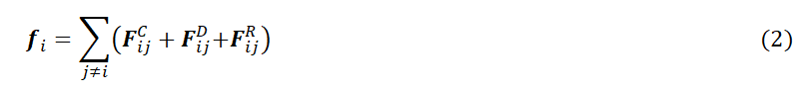
where the sum runs over all other beads within the cutoff radius r_{c}. And the conservative force $F_{ij}^{C}$, dissipative force $F_{ij}^{D}$and random force $F_{ij}^{R}$are given by
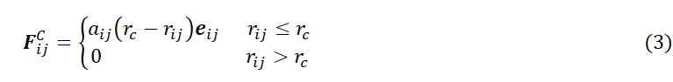
where $a_{ij}$ is a constant that describes the maximum repulsion between two interacting beads.$r_{ij}$ is the distance between beads i and j. are the velocities of beads i and j, respectively. γ and σ are the amplitudes of dissipative and random forces, respectively. is a randomly fluctuating variable. ω^{D} and ω^{R} are r-dependent weight functions for dissipative and random forces, respectively. According to the fluctuation-dissipation theorem, ω_{ij}^{D}(r)=[ω_{ij}^{R}(r)]² and σ²=2γk_{B}T (σ=3 and γ=4.5). The following simple form of ω^{D} and ω^{R} was chosen by Groot and Warren[3]:
Also, the chain beads of polymers are connected by a harmonic bond:
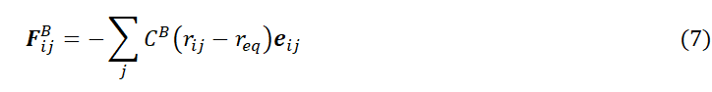
where $C^{B} and r_{eq}$ denotes the bond rigidity and the equilibrium bond length, respectively. Here, the most common and reliable values ($C^{B}=4.0$ and $r_{eq}=0$)[3-4] were adopted in our simulations.
B. Model and Interaction Parameters.
Considering to keep the volume of the coarse-grained particles substantially the same, the following coarse-graining scheme was used to construct simulation models. The simple coarse-grained models of the components used in this study are shown in Figure 2a.
The DPD interaction parameters (αij) can be estimated based on the relationship between α and the Flory-Huggins parameters χ established by Groot and Warren^{[3]},
where α_{ii}=25 is for the same type of bead. In this paper, molecule CD-COOH is composed of 7 type A particles. Considering the stable complex formed between CD-COOH and Ad-G, the two are modeled as single molecule in the simulation (A7-D2-E2, as shown in Figure S1). PEG-COOH is coarse-grained into B9C9. During the simulation, we defined the interaction parameters between particles based on their compatibility. For incompatible particles, the interaction parameter was set to 50, while for compatible beads, the parameter ranged from 26 to 30. Considering the strong electrostatic interactions between beads F and G, their interaction parameter was defined as 5. The interaction parameters between particles A/B/C and F/G were set to 10. The detailed interaction parameters are listed in Table S1. Then, the DPD simulations were carried out in the NVT ensemble in a cubic box (40×40×40) under periodic boundary conditions. The system number density was set to 3. For simplicity, the cutoff radius R_{c}, the bead mass m, and the temperature k_{B}T are taken as the units of the simulations, i.e., R_{c}=m=k_{B}T=1; thus, the time unit τ= (mR_{c}²/k_{B}T)^{1/2}=1. The GWVV algorithm was used to integrate motion equation [3] with ∆t = 0.04. During the simulation, the experimental procedure was divided into three steps: first, the co-self-assembly of molecules CD-COOH/PEG-COOH in solution; followed by the addition of Ca²⁺ into the system; and finally, the introduction of CO₃²⁻ ions. The first step underwent 1.0 million steps of DPD simulation, while second and third steps involved 0.5 million steps of DPD simulation each. All the DPD simulations were performed by using Pygamd package^{[4]}. Periodic boundary conditions were applied. The trajectory was visualized by the OVITO Basic program (version 3.10.4)^{[5]}.
Table 1. Repulsive parameters (a_{ij}) between beads for DPD simulation used in this work.
 | A | B | C | D | E | F | G | S
A | 25.00
B | 26.00 | 25.00
C | 26.00 | 50.00 | 25.00
D | 26.00 | 50.00 | 40.00 | 25.00
E | 30.00 | 50.00 | 40.00 | 30.00 | 25.00
F | 10.00 | 10.00 | 10.00 | 50.00 | 50.00 | 25.00
G | 10.00 | 10.00 | 10.00 | 50.00 | 50.00 | 5.00 | 25.00
S | 30.00 | 26.00 | 50.00 | 50.00 | 50.00 | 26.00 | 26.00 | 25.00
Statistical analysis
All experiments were investigated at least three times, and the data was shown as mean ± standard deviation. Statistical significance was calculated via ordinary one-way ANOVA with a Tukey’s test. *p < 0.05; **p < 0.01; ***p < 0.001.
Synthesis of Ad-G
1-Adamantylcarboxylic acid (180 mg, 1.0 mmol) was dissolved in dimethyl formamide (DMF, 2.0 mL). 1-Ethy1-3-dimethylaminopropyl carbodiimide (EDC, 191.7 mg, 1.0 mmol) was added, and the mixture was stirred for 1 h at room temperature to activate the carboxyl group. In a separate flask, acyclovir (338 mg, 1.5 mmol) was dissolved in DMF (20 mL), and 4-dimethylaminopyridine (DMAP) (183 mg, 1.5 mmol) was added. After stirring at room temperature for 10 min to activate the hydroxyl group, this solution was transferred via a syringe into the reaction vessel containing the activated adamantylcarboxylic acid. The resulting mixture was stirred continuously for 72 h. Upon completion, the mixture was extracted with saturated brine. The combined organic layers were dried over anhydrous sodium sulfate, and the solvent was removed under reduced pressure. The crude product was purified by silica-gel column chromatography (eluent: MeOH/DCM = 1:2) to afford the target compound Ad-G. The ¹H NMR spectrum of Ad-G is shown in Figure S1. ¹H NMR (400 MHz, DMSO-d₆): δ = 7.81 (s, 1H), 6.60 (s, 2H), 5.34 (s, 2H), 4.09–4.07 (m, 2H), 3.66–3.64 (m, 2H), 1.94–1.92 (m, 3H), 1.78–1.77 (d, 4H), 1.68–1.62 (m, 10H).
Synthesis of CD-COOH
β-CD (2.5 g, 2.0 mmol), succinic anhydride (6.0 g, 60.0 mmol) and 4-dimethylaminopyridine (122 mg, 1.0 mmol) were dissolved in DMF (50 mL). The mixture was stirred at 65 °C for 12 h, cooled to room temperature, and then slowly poured into diethyl ether (400 mL) to precipitate the product. The resulting precipitate was collected via centrifugation, washed with acetone (3 × 100 mL), and dried under vacuum to afford CD-COOH. The ¹H NMR spectrum of CD-COOH is shown in Figure S2. The ¹H NMR (400 MHz, DMSO-d₆): δ = 5.43-4.63 (m, 3H), 4.37 (m, 2H), 3.91 (m, 2H), 3.65-3.49 (m, 1H), 2.58-2.47 (m, 8H).

Synthesis of PEG-b-PMAA
Poly(ethylene glycol) 4-cyano-4-(phenylcarbonothioylthio)pentanoate (MeO-PEG₂₀₀₀-CTA) (20 mg, 10 μmol), methacrylic acid (MAA) (17.22 mg, 0.2 mmol) and azobisisobutyronitrile (AIBN) (0.328 mg, 2 μmol) was dissolved in 1,4-dioxane (2 mL). The reaction mixture was stirred at 70 °C for overnight. After reaction, the polymerization was quenched by cooling in an ice-water bath and then slowly poured into diethyl ether (40 mL) to precipitate the product. The resulting precipitate was collected via centrifugation, washed with diethyl ether (3 × 40 mL), and dried under vacuum to afford PEG-b-PMAA. The ¹H NMR spectrum of PEG-b-PMAA is shown in Figure S3. ¹H NMR (400 MHz, DMSO-d₆): δ =12.08 (s, 25H), 7.96 (s, 5H), 3.62–3.43 (m, 186H), 1.95–1.42 (m, 50H), 1.25–0.79 (m, 75H).
References:
[1] P. Hoogerbrugge, J. Koelman, Simulating microscopic hydrodynamic phenomena with dissipative particle dynamics. Europhys. Lett. 1992, 19, 155.
[2] P. Espanol, P. Warren, Statistical mechanics of dissipative particle dynamics. Europhys. Lett. 1995, 30, 191.
[3] R.D. Groot, P.B. Warren, Dissipative particle dynamics: Bridging the gap between atomistic and mesoscopic simulation. J. Chem. Phys. 1997, 107, 4423.
[4] Y. Zhu, H. Liu, Z. Li, H. Qian, G. Milano, Z. Lu, GALAMOST: GPU-accelerated large-scale molecular simulation toolkit, J. Comput. Chem. 2013, 34, 2197-2211.
[5] A. Stukowski, Visualization and Analysis of Atomistic Simulation Data with OVITO-the Open Visualization Tool. Modell. Simul. Mater. Sci. Eng. 2010, 18, 015012.

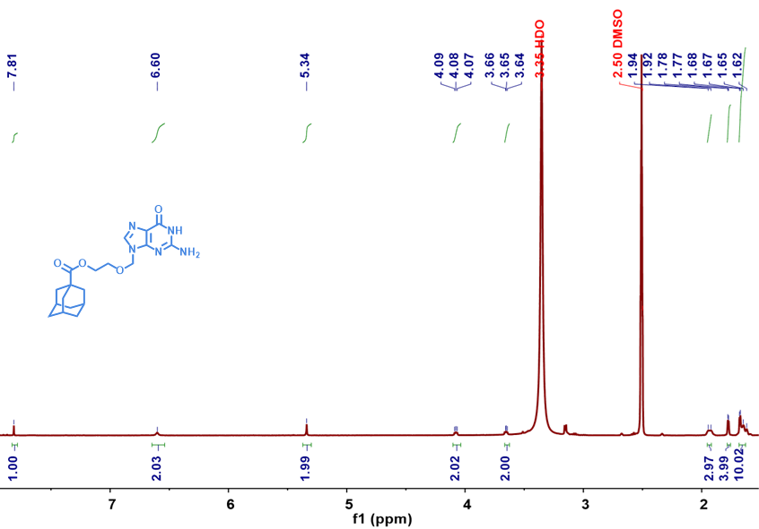
Figure S1. ¹H NMR spectrum of Ad-G.
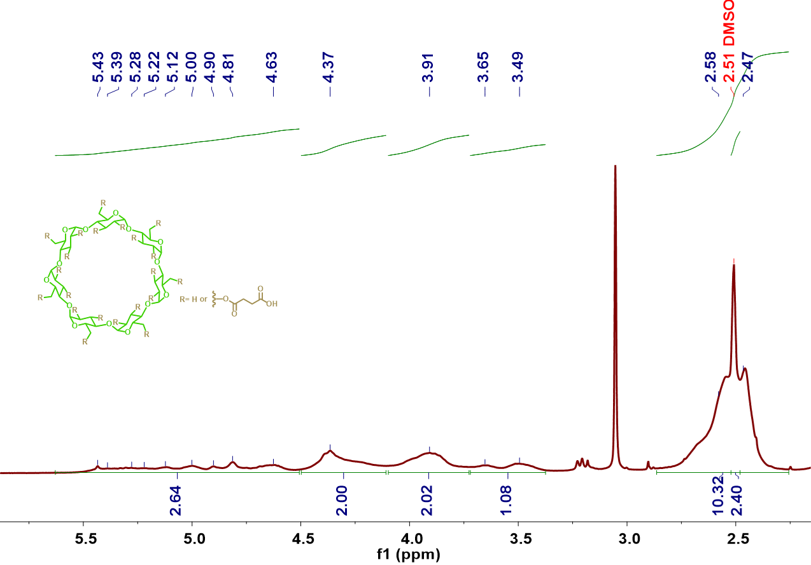
Figure S2. ¹H NMR spectrum of CD-COOH.

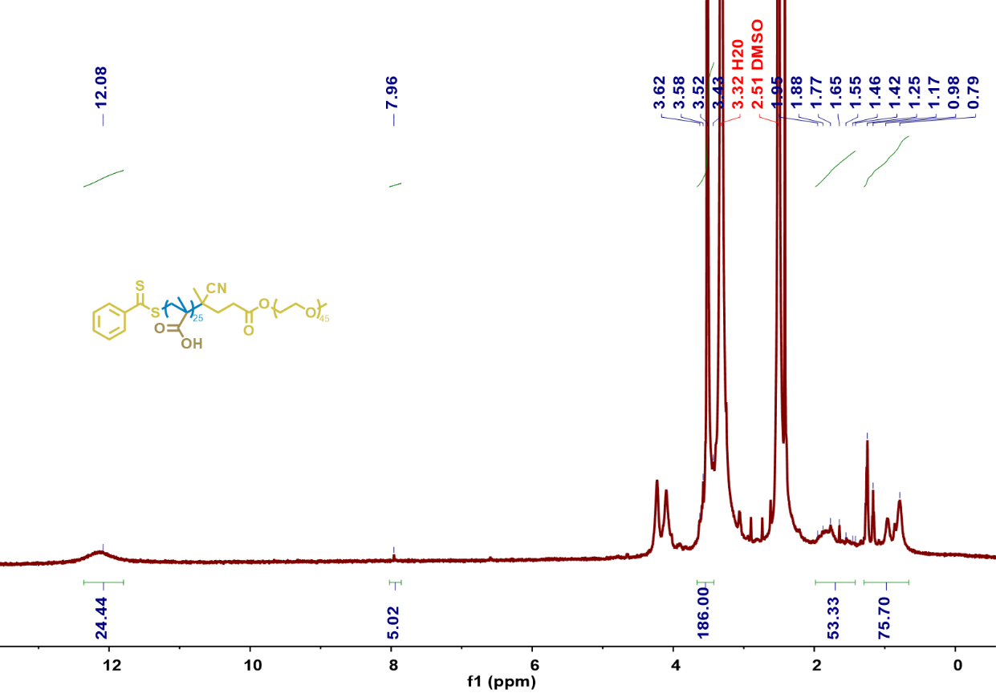
Figure S3. ¹H NMR spectrum of PEG-b-PMAA.
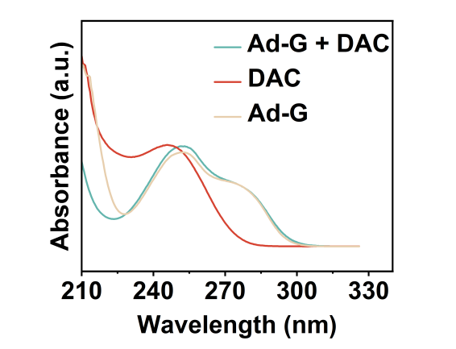
Figure S4. UV-vis absorption spectra of Ad-G, DAC and Ad-G + DAC.
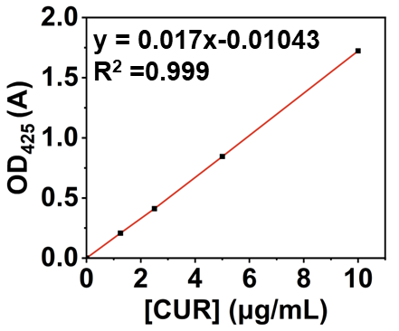
Figure S5. Calibration curve for the quantification of CUR by UV-Vis spectrophotometry.

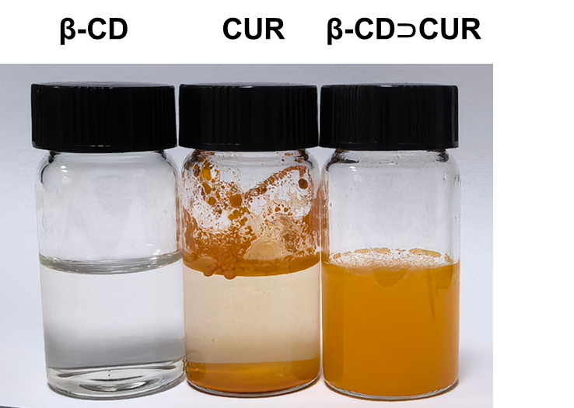
Figure S6. Photographs of aqueous solutions of β-CD, CUR and β-CD⊃CUR.
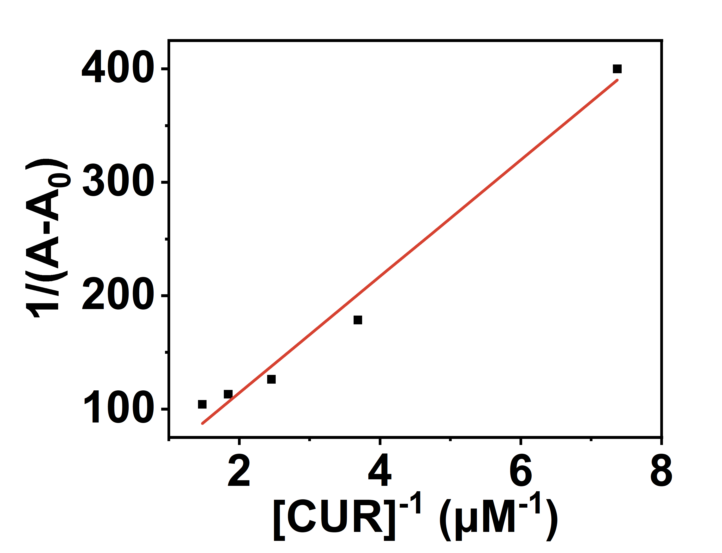
Figure S7. Benesi-Hildebrand plot based on a 1:1 mode between β-CD and CUR.

Table S1. Optimization of mineralization conditions for SNPs@CaCO₃ preparation.
Groups | CaCl₂ concentration (mg·mL⁻¹) | Na₂CO₃ concentration (mg·mL⁻¹) | Stirred time (h) | PDI
i | 3.09 | 2.95 | 12 | 0.36
ii | 6.18 | 5.90 | 12 | 0.264
iii | 6.18 | 5.9 | 24 | 0.197
iv | 6.18 | 5.90 | 48 | 0.213
v | 12.36 | 11.80 | 48 | 0.203

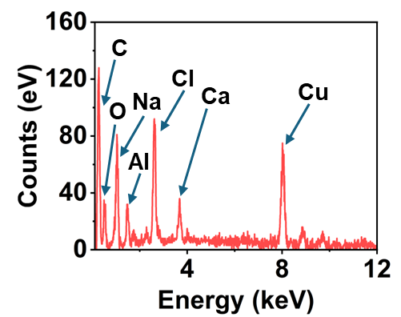
Figure S8. EDX spectroscopy of SNPs@CaCO₃.

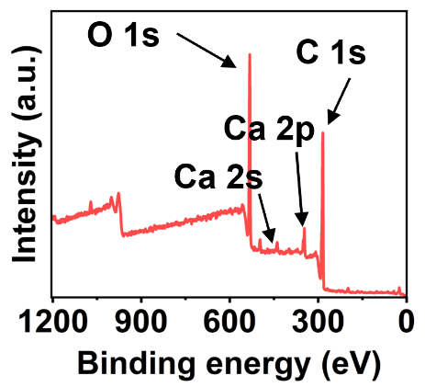
Figure S9. XPS spectrum of SNPs@CaCO₃.

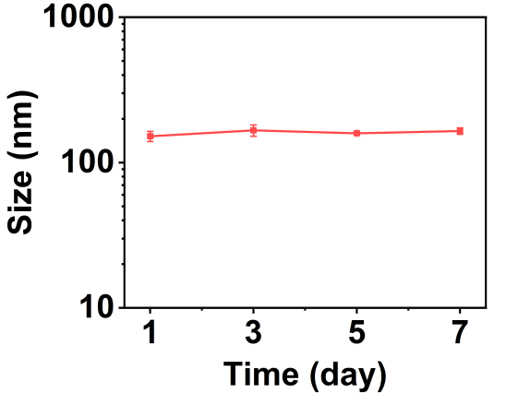
Figure S10. Stability of SNPs@CaCO₃ in PBS over 7 days monitored by DLS.

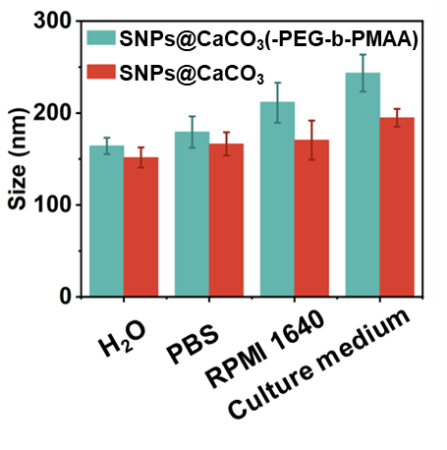
Figure S11. Stability of SNPs@CaCO₃ and SNPs@CaCO₃ (-PEG-b-PMAA) in different media over 24 h monitored by DLS.

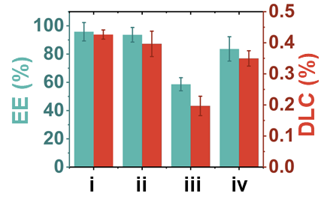
Figure S12. Comparative analysis of EE and DLC for CUR across different carriers. i: SNPs@CaCO₃, ii: SNPs@CaCO₃ (-Ad-G), iii: SNPs@CaCO₃ (-β-CD), iv: SNPs@CaCO₃ (-CaCO₃).

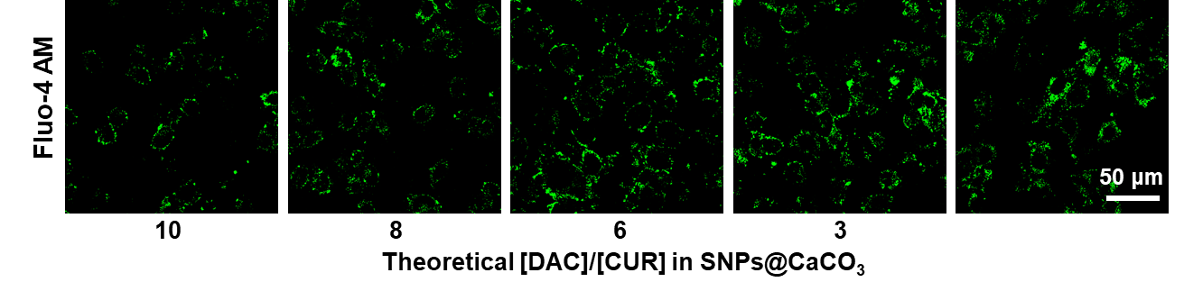
Figure S13. Intracellular Ca²⁺ levels measured by Fluo-4 AM staining

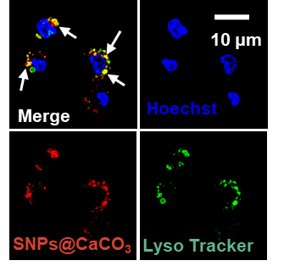
Figure S14. CLSM images of 4T1 cells following 8 h incubation with SNPs@CaCO₃.

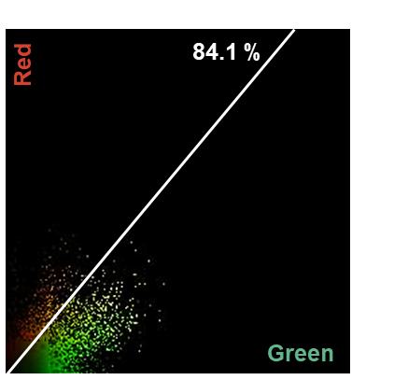
Figure S15. The colocalization analysis of 4T1 cells following 8 h incubation with SNPs@CaCO₃, stained for lysosomes (Lyso Tracker) and nuclear (Hoechst).

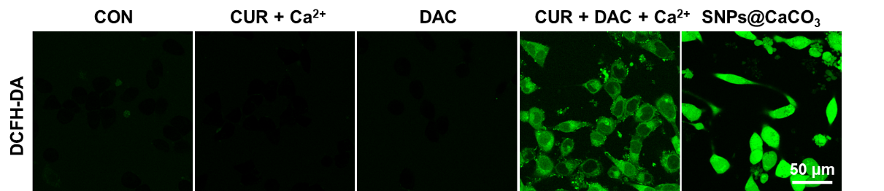
Figure S16. CLSM images of 4T1 cells stained with DCFH-DA probe.

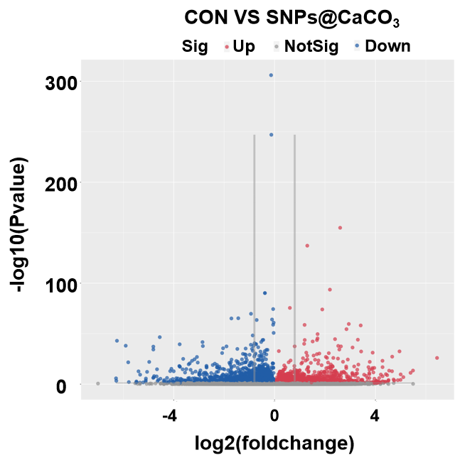
Figure S17. Volcano plot showing differentially expressed genes associated with demethylation between the CON group and the SNPs@CaCO₃ group.

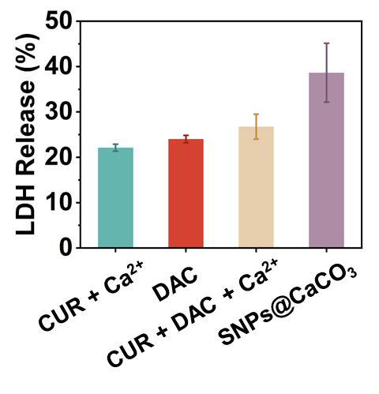
***
Figure S18. Quantification of LDH release from 4T1 cells following different treatments.

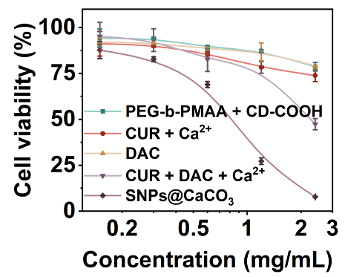
Figure S19. Viability of 4T1 cells after different treatments.

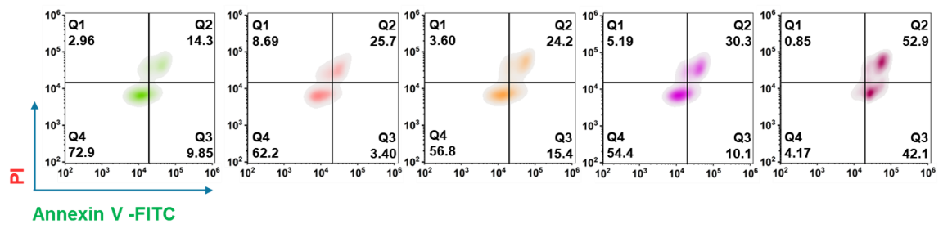
Figure S20. Flow cytometry analysis of 4T1 cells stained with Annexin V-FITC and PI.

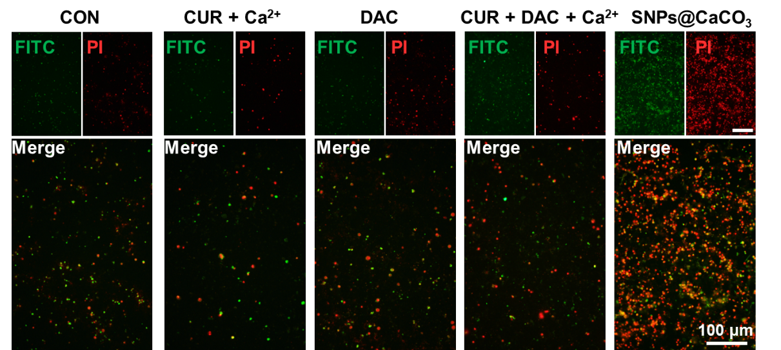
Figure S21. CLSM images of 4T1 cells stained with Calcein-AM and PI.

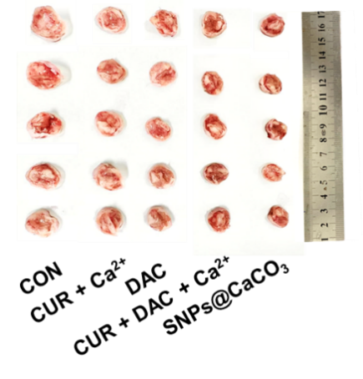
Figure S22. Representative images of tumor tissues following different treatments.

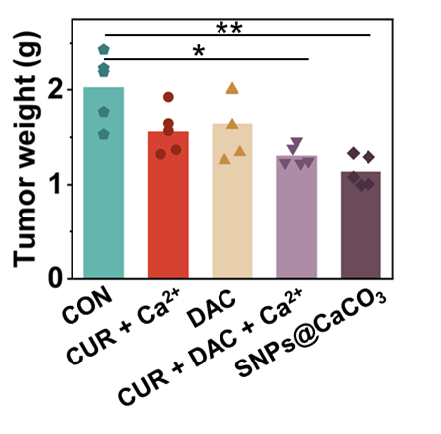
Figure S23. Average tumor weight of mice after different treatments.

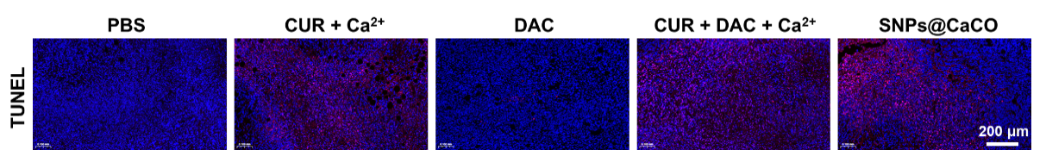
Figure S24. Immunofluorescence staining of TUNEL of tumor tissues after different treatments.

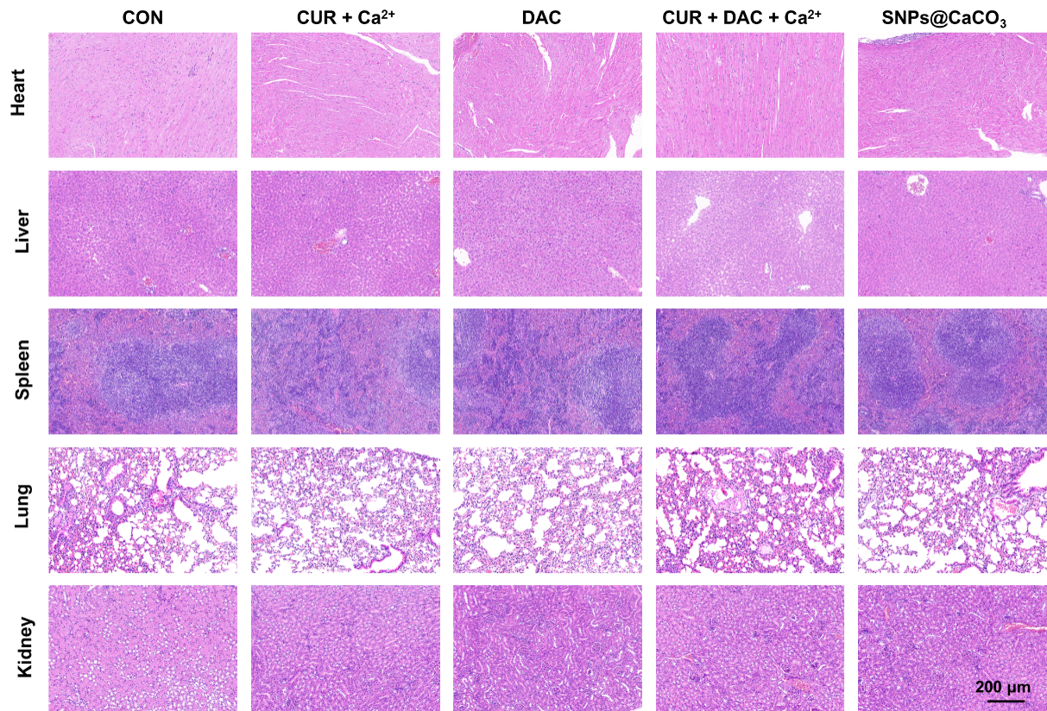
Figure S25. H&E staining of main organs of mice after different treatments.

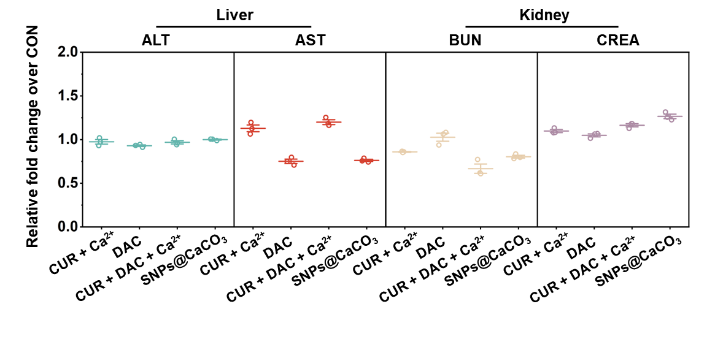
Figure S26. Assessment of hepatic and renal function parameters following different treatments.

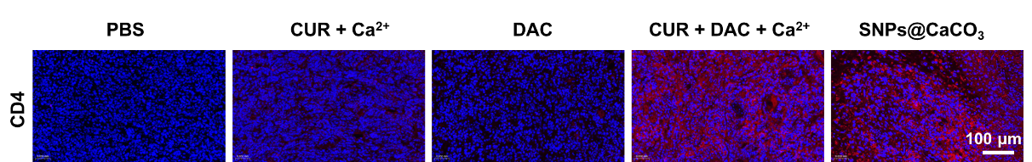
Figure S27. Immunofluorescence staining of CD4⁺ T cells of tumor tissues after different treatments.

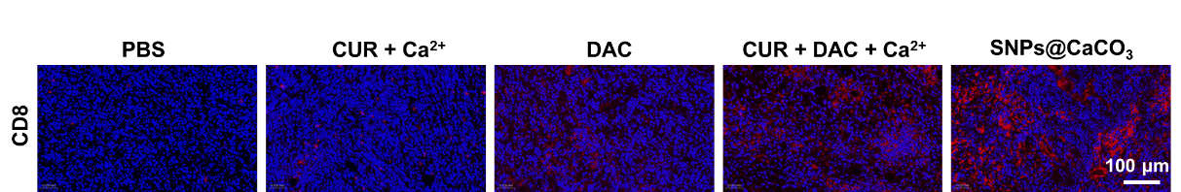
Figure S28. Immunofluorescence staining of CD8⁺ T cells of tumor tissues after different treatments.

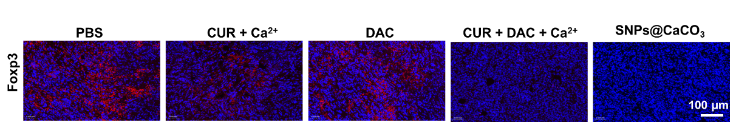
Figure S29. Immunofluorescence staining of Foxp3 of tumor tissues after different treatments.

