Table of contents

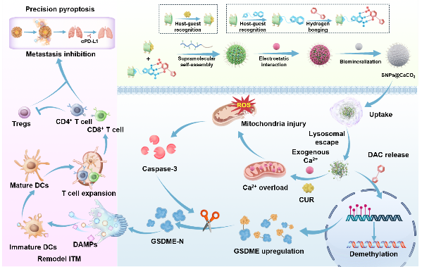
A supramolecular pyroptosis nanogenerator (SNPs@CaCO₃) is developed, which hierarchically integrates molecular glue-templated drug stabilization and controlled biomineralization to enable precise pyroptosis. This system synergistically induces pyroptosis through Ca²⁺/CUR-mediated Ca²⁺ overload and caspase-3 activation, coupled with DAC-driven epigenetic upregulation of GSDME. In vivo, SNPs@CaCO₃ reverses the immunosuppressive tumor microenvironment by promoting pyroptosis-elicited lymphocyte infiltration. Furthermore, when combined with 𝛼PD-L1 therapy, it effectively suppresses orthotopic tumors and eliminates lung metastases without systemic toxicity, highlighting a precise supramolecular strategy for advanced cancer immunotherapy.

