Selenium nanoparticles as slow-release fertilizers
for mustard plants

Rewati Dixitª, Norbert Jordan^{b}, Rohan Jain^{c,*}

ªWaste Treatment Laboratory, Department of Biochemical Engineering and Biotechnology, Indian Institute of Technology Delhi, Hauz-Khas, New Delhi, India – 110016
^{b}Helmholtz-Zentrum Dresden-Rossendorf e.V., Institute of Resource Ecology, Bautzner Landstrasse 400, 01328, Dresden, Germany
^{c}Helmholtz-Zentrum Dresden-Rossendorf e.V., Helmholtz Institute Freiberg for Resource Technology, Bautzner Landstrasse 400, 01328, Dresden, Germany

*Corresponding Author
Name: Rohan Jain
Address: Helmholtz-Zentrum Dresden-Rossendorf e.V., Helmholtz Institute Freiberg for Resource Technology, Bautzner Landstrasse 400, 01328, Dresden, Germany
Email: r.jain@hzdr.de; rohanjain.iitd@gmail.com

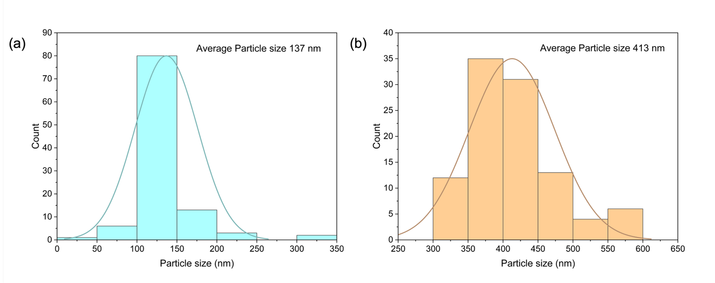
Figure S1. Particle size distribution of biogenic selenium nanoparticles (BioSeNPs) produced by (a) E. coli and (b) Anaerobic granular sludge.

Table S1. Mass balance for Se release kinetics
Se | Selenite | Selenate | BioSeNPs@E. coli | BioSeNPs@Anaerobic granular sludge
% Se in Soil | 35.0 | 12.7 | 96.7 | 91.7
Standard deviation for % Se in soil | 2.0 | 1.5 | 1.2 | 2.1
% Se in Leachate | 63.6 | 86.3 | 3.4 | 9.6
Standard deviation for % Se in leachate | 1.1 | 1.9 | 2.4 | 3.6
Total % Se | 98.6 | 99.0 | 100.1 | 101.3
Standard deviation for total % Se | 2.1 | 3.3 | 1.3 | 1.7

Table S2. Mass balance for Se uptake by mustard plants
Se | Selenite | Selenate | BioSeNPs@E. coli | BioSeNPs@Anaerobic granular sludge
%Se in soil | 42.7 | 20.4 | 70.3 | 67.4
Standard deviation for % Se in soil | 5.6 | 3.5 | 4.8 | 1.2
% Se in Leachate | 37.4 | 53.1 | 4.6 | 8.1
Standard deviation for % Se in leachate | 2.8 | 3.6 | 1.7 | 2.0
%Se in plant root | 11.5 | 10.8 | 11.2 | 11.1
Standard deviation for % Se in plant root | 3.2 | 2.5 | 1.3 | 1.7
% Se in plant shoot | 7.5 | 15.7 | 17.3 | 13.0
Standard deviation for % Se in plant shoot | 1.1 | 2.3 | 2.1 | 2.2
Total % Se | 99.1 | 99.2 | 103.4 | 99.6
Standard deviation for total % Se | 1.4 | 2.3 | 2.4 | 2.0

(Note: The calculated selenium mass balance ranged between 95% and 105% in Tables S1 and S2, which represents an acceptable recovery window for trace elements in complex matrix conditions. The results are consistent with observations in other studies (e.g., zinc, copper, and palladium systems) [1–3]. Minor overestimation is attributed to carbon-induced plasma enhancement during ICP-MS analysis. [4, 5])

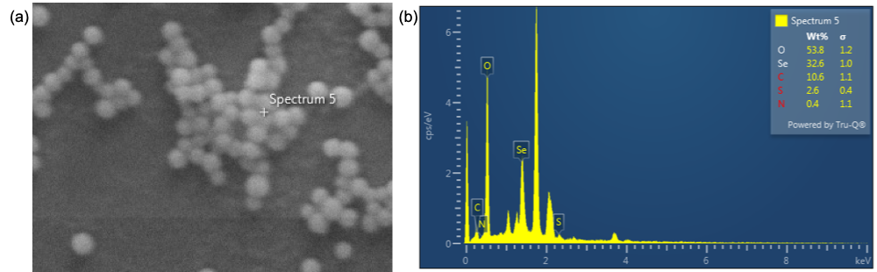
Figure S2. (a) SEM image of BioSeNPs produced by E. coli, (b) EDX spectra of BioSeNPs produced by E. coli showing the presence of Se (32.6±1.0%), O (53.8±1.2%), C (10.6±1.1%), S (2.6±0.4%), N (0.4±1.1%).

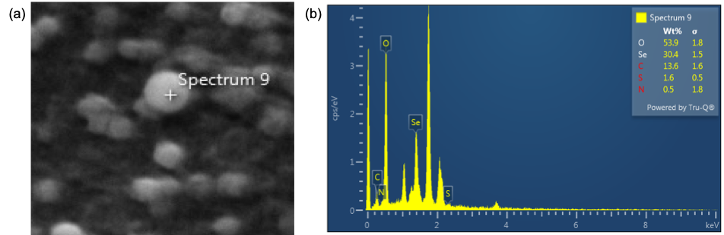
Figure S3. (a) SEM image of BioSeNPs produced by anaerobic granular sludge, (b) EDX spectra of BioSeNPs produced by anaerobic granular sludge showing the presence of Se (30.4±1.5%), O (53.9±1.8%), C (13.6±1.6%), S (1.6±0.5%), N (0.5±1.8%).

References
1. Gao X, Rodrigues SM, Spielman-Sun E, et al (2019) Effect of Soil Organic Matter, Soil pH, and Moisture Content on Solubility and Dissolution Rate of CuO NPs in Soil. Environ Sci Technol 53:4959–4967. https://doi.org/10.1021/acs.est.8b07243
2. Hodomihou NR, Feder F, Legros S, et al (2020) Zinc Speciation in Organic Waste Drives Its Fate in Amended Soils. Environ Sci Technol 54:12034–12041. https://doi.org/10.1021/acs.est.0c02721
3. Beggio G, Roman M, Mitrano DM, et al (2025) A standardized soil-based biotest to investigate the phytoavailability of nanoplastics. Environ Sci Nano 12:3896–3903. https://doi.org/10.1039/d5en00328h
4. Larsen EH, Sturup S (1994) Carbon-enhanced Inductively Coupled Plasma Mass Spectrometric Detection of Arsenic and Selenium and Its Application to Arsenic Speciation
5. Dai Z, Ding J, He J, et al (2025) Quantitative analysis of selenium and mercury in biological samples using LA-ICP-MS. J Anal At Spectrom 40:2095–2106. https://doi.org/10.1039/d5ja00169b

