Supplementary Figure 7. Case7 A) T2WI, B) T1WI, C) DWI, D) Evaluated the images of readers a–e.

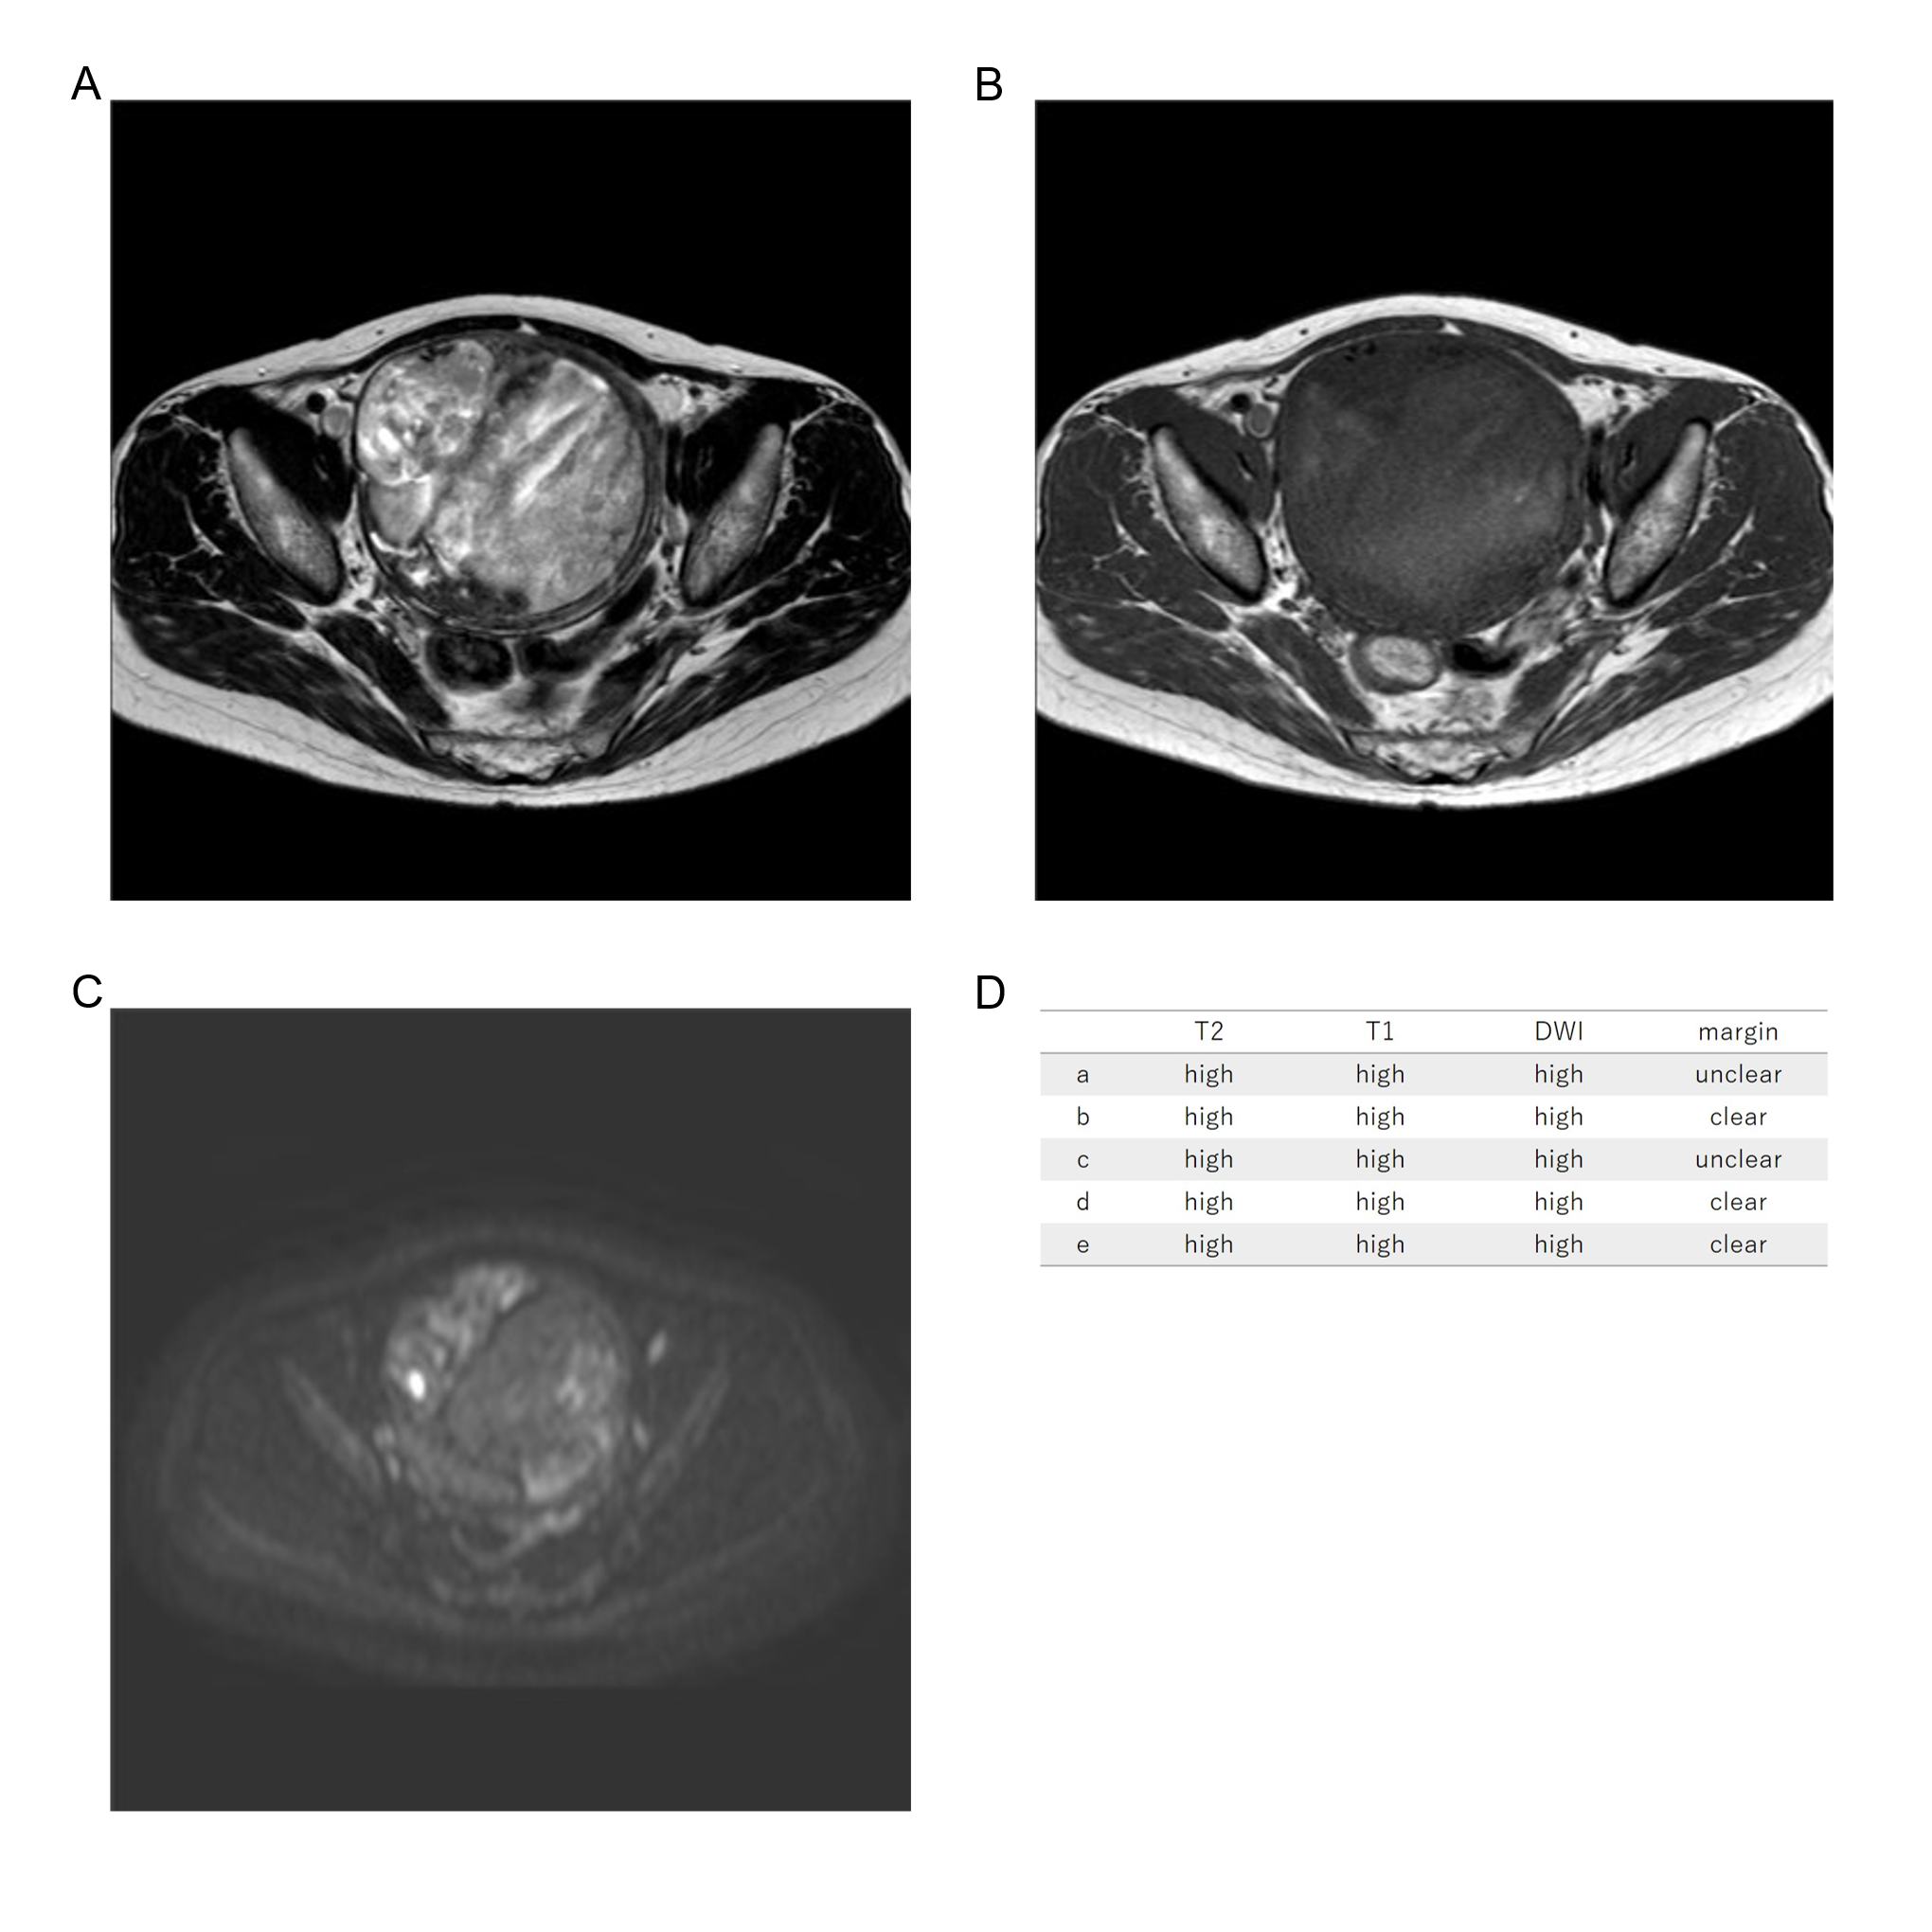
Sixty-five years old, low grade ESS, high T2WI intensity, high T1WI intensity, high DWI intensity, clear margin, LDH 197IU/L.

