Supplementary Figure 29. Case29 A) T2WI, B) T1WI, C) DWI, D) Evaluated the images of readers a–e.

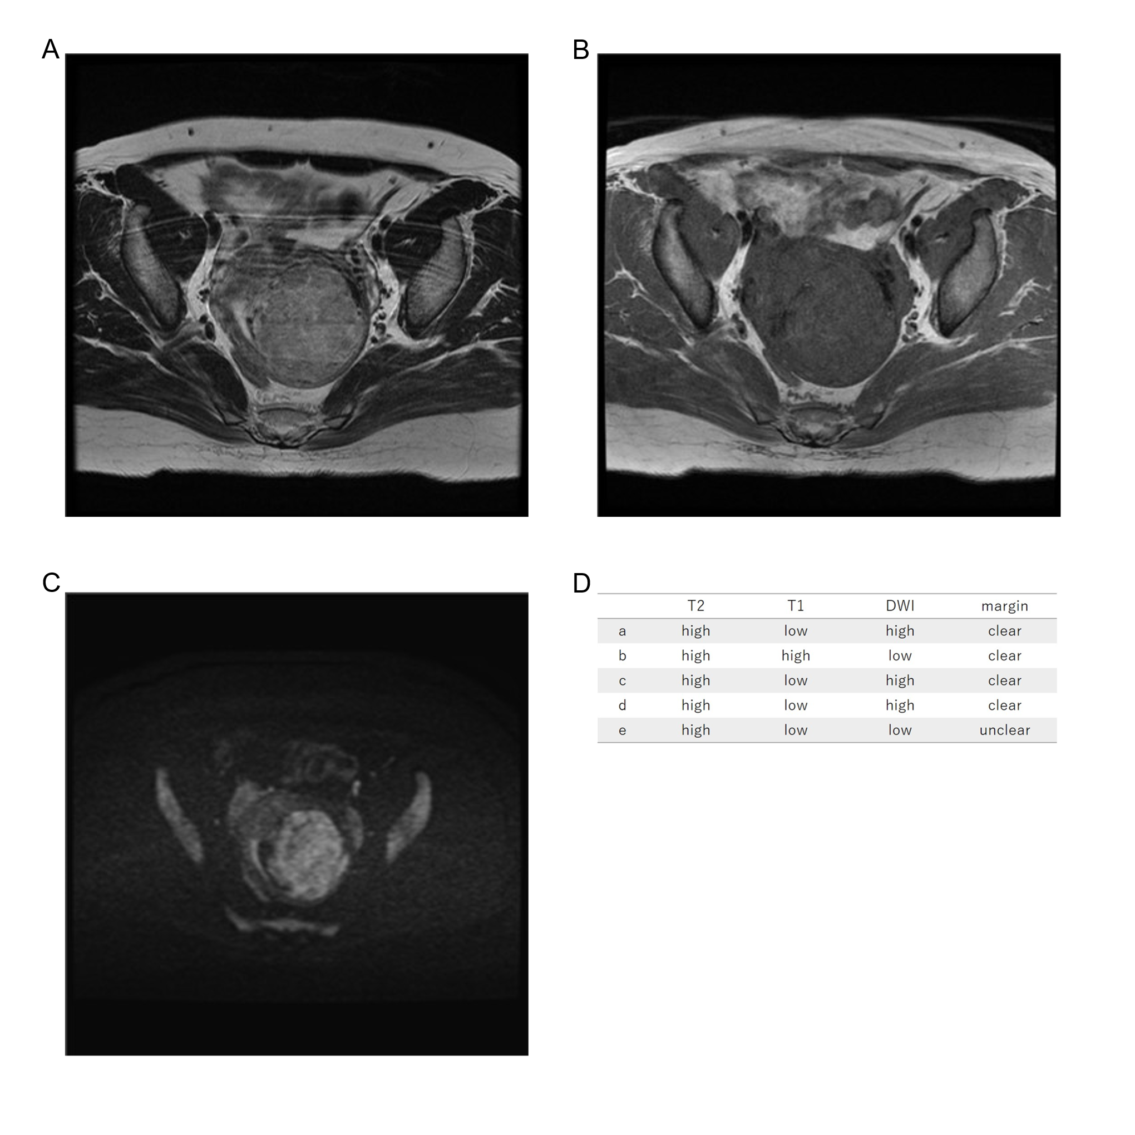
Forty-four years old, leiomyoma, high T2WI intensity, low T1WI intensity, high DWI intensity, clear margin, LDH 162IU/L. We reviewed the images and determined that the T2WI was Oguchi4.

