Supplementary Figure 15. Case15 A) T2WI, B) T1WI, C) DWI, D) Evaluated the images of readers a–e.

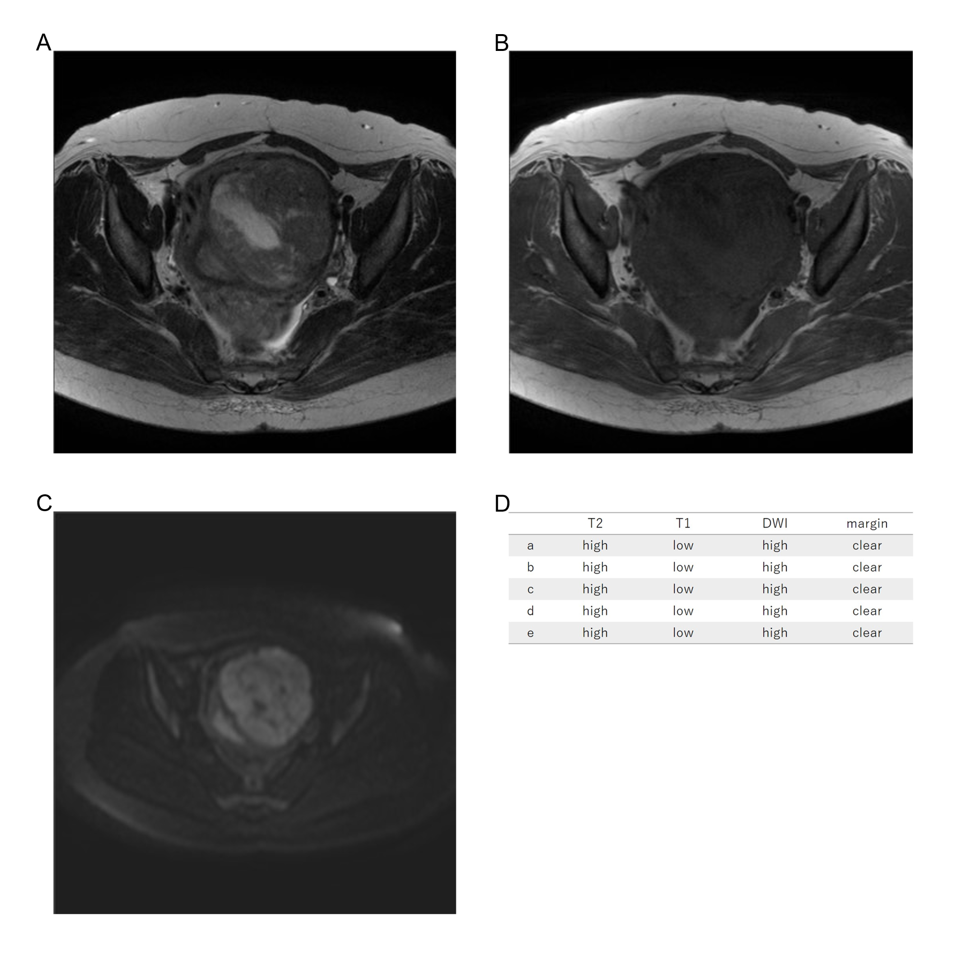
Forty-two years old, leiomyoma, high T2WI intensity, low T1WI intensity, high DWI intensity, clear margin, LDH 272IU/L.

