Supplementary Figure 4. Case4 A) T2WI, B) T1WI, C) DWI, D) Evaluated the images of readers a–e.

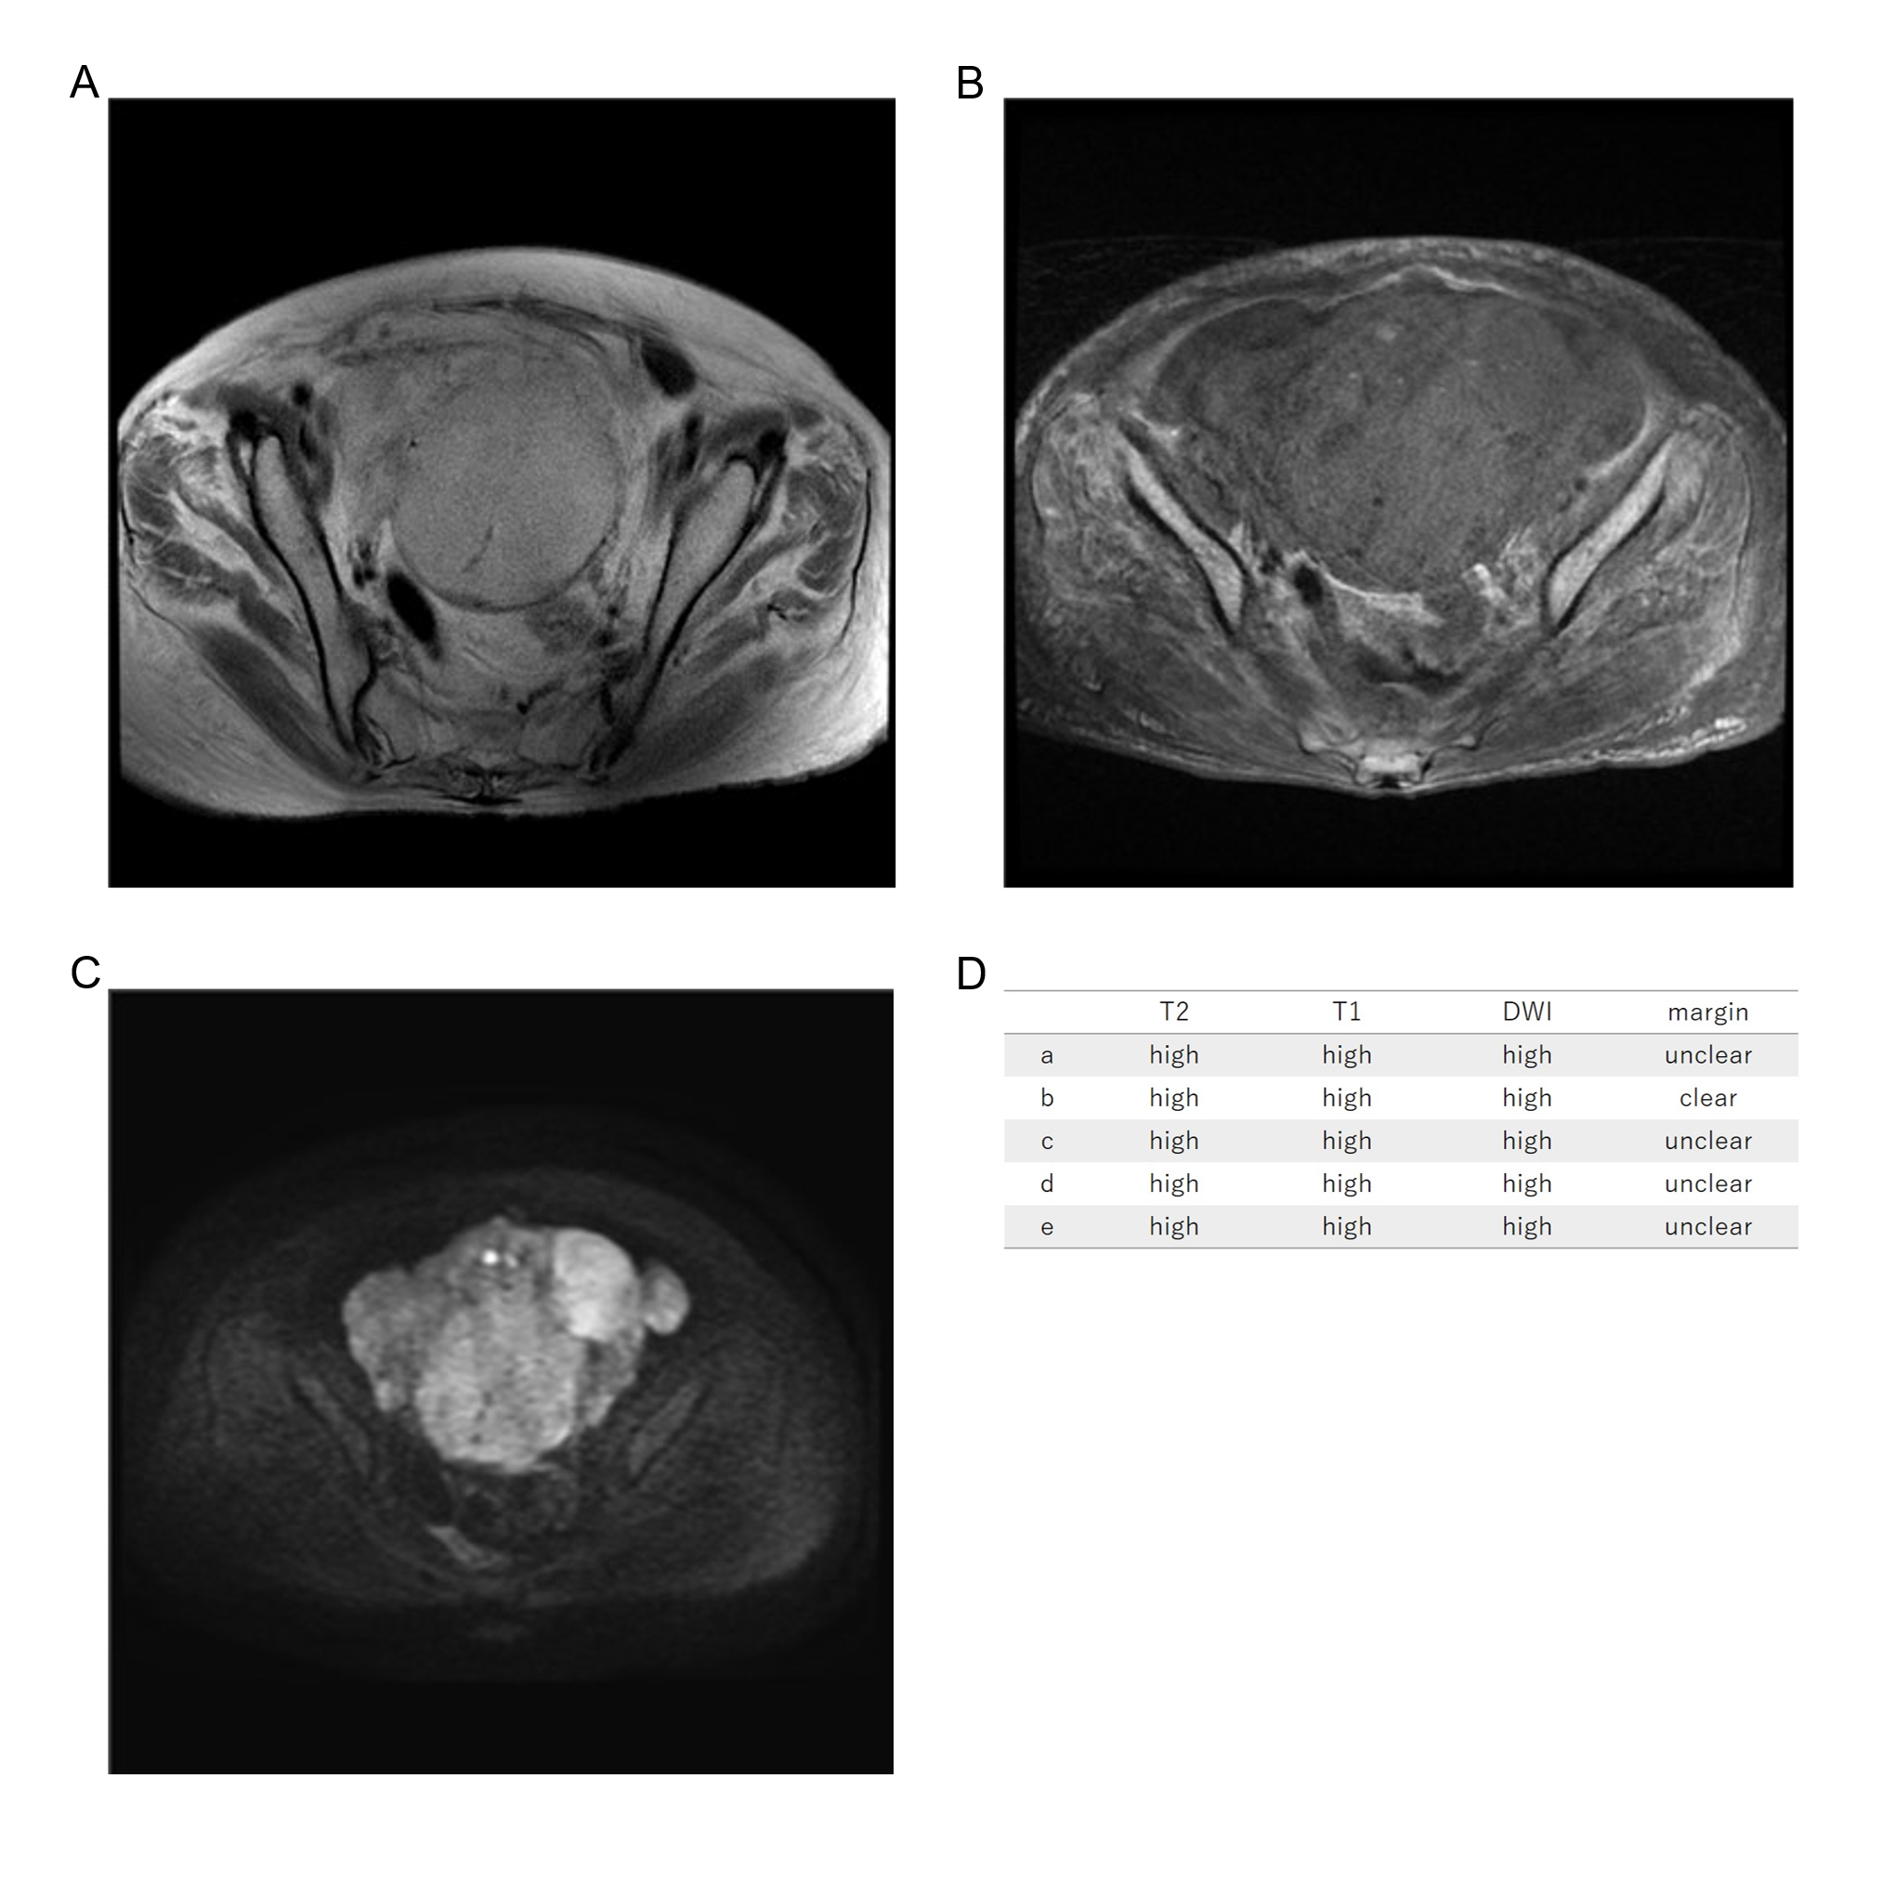
Seventy-four years old, leiomyosarcoma, high T2WI intensity, high T1WI intensity, high DWI intensity, unclear margin, LDH 203IU/L.

