Supplementary Figure 28. Case28 A) T2WI, B) T1WI, C) DWI, D) Evaluated the images of readers a–e.

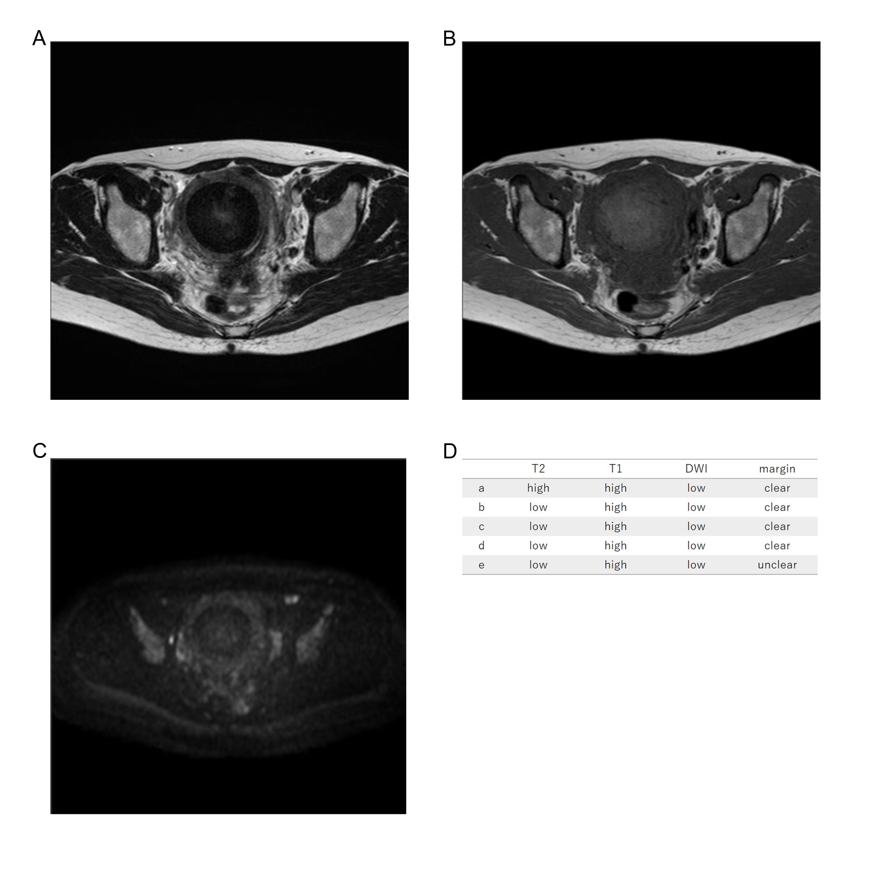
Fifty-two years old, leiomyoma, low T2WI intensity, high T1WI intensity, low DWI intensity, clear margin, LDH 189IU/L.

