Supplementary Figure 16. Case16 A) T2WI, B) T1WI, C) DWI, D) Evaluated the images of readers a–e.

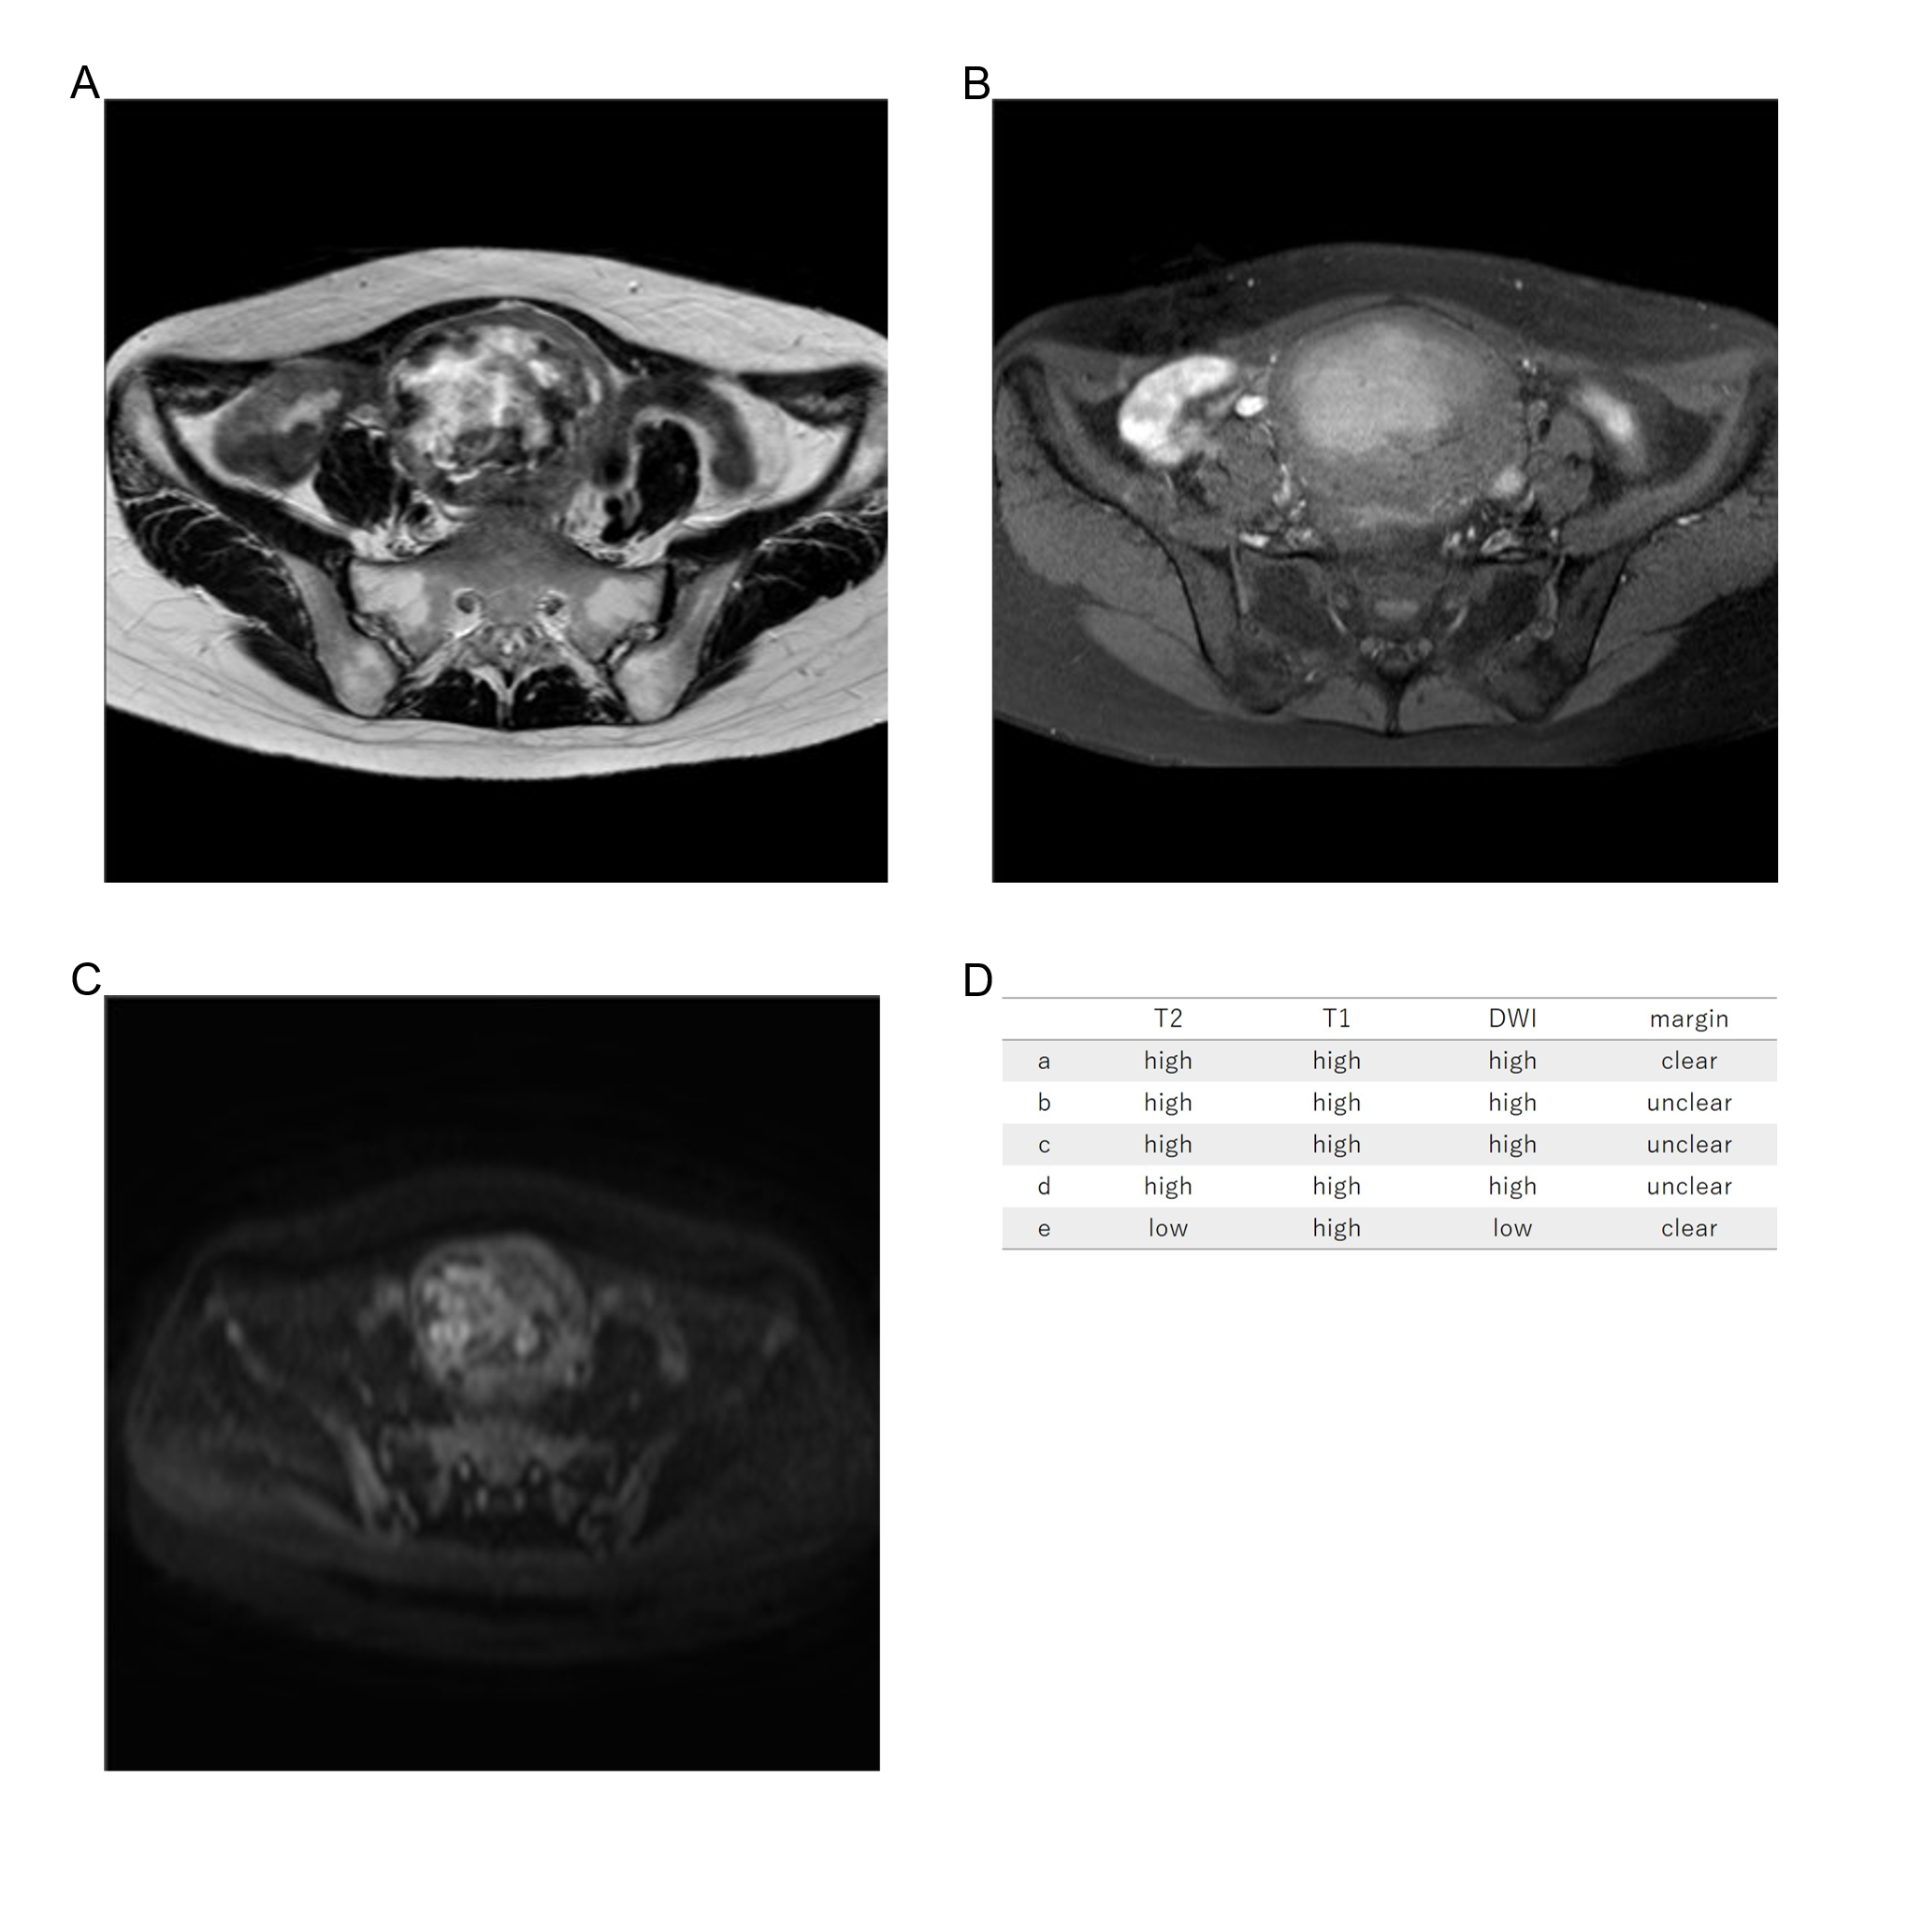
Thirty-one years old, leiomyoma, high T2WI intensity, high T1WI intensity, high DWI intensity, unclear margin, LDH 158IU/L.

